MODULE TITLE: Workplace culture and its impact on organisation
MODULE CODE: BMSK5005

Student ID: 1605672
Student Name: Mohammed Miah
Module tutor: Mr M Rahman

Table of Contents
Executive summery 1
1. Introduction 2
1.1 About GSK UK 3
2. Organisation culture and its Impact 4
2.1 Formal and informal relationship 6
2.2 Establishing a culture of sustainability within the Workplace 7
2.3 Aligning personal goal 8
2.4 Corporate social and environmental responsibility 8
2.5 Communication and building relationship 9
Barriers to effective functioning in GSK UK 10
Overcoming the barriers 10
3. SWOT Analysis 11
4. PESTEL analysis 13
5. Conclusion 17
Reference 18
Appendix 20

List of figure
Figure 1 Hofstede cultural dimension 4
Figure 6 Communication channel of GSK UK 9
Figure 2 SWOT analysis 11
Figure 3 PESTEL analysis 13
Figure 4 GDP growth of UK 14
Figure 5 Employment rate in UK 15

An Essay on Workplace Culture and its Impact

Executive summery
Organisational culture and belief reflect the policy, procedure, and principles of the organisation that an employee has to maintain. The culture of an organisation helps to increase the performance of the employee. GSK UK is a healthcare and pharmaceutical industry that make vaccines and medicine for the customer from worldwide. Hofstede identified some cultural dimensions which exist in the decision making of an organisation regarding employee section. GSK UK should focus on cultural sustainability within the organisation through some consideration. The PESTEL and SWOT analysis showed the internal and external environment impact on the organisation and its culture.

1. Introduction
Organisational culture is a belief, value and interaction policy within the organisation. This determines the react of an employee in various situations. The culture of an organisation reflects the beliefs, value and rules that made to provide a structured environment for the employee. The organisational culture of GSK delivers a favourable work environment to employee and professionals. Organisational values, vision norms, belief and system create a structured environment within the workplace that employees have to maintain. The policies and procedures of the organisation included staff requirement policy, payment procedure, rule and regulation within the organisation, behaviour maintaining policy, employee relation maintenance etc.

Cultural of an organisation influences employee to behave formally and respect each other. The employee and professional are motivated to maintain the culture that has been set by rules, principles and regulation. The rules of GSK refer to the dress code and expected behaviour from the employee. The regulation and principle set the objective of being here and reason of performance. The employee of the company has to behave considering their role. The organisational structure shows the power distribution and decision-making power of the professionals. The employees are responsible to communicate with customers and others with soft tones. The employees have to communicate with other professionals. The fair policies have to maintain by all employee.

The employee act, consumer act, environment act, health and safety act has been maintaining by the organisation. GSK has a fair payment policy method for all level of employee. The behaviour of the company toward competitors and client is ethical. The organisation makes an ethical decision which will not harm the competitors and customer. The organisation does not use adulterate ingredients in their vaccines and medicine. They provide quality consumer good which will not harm the customer which is a part of ethical behaviour toward the consumer. The wage of the employee is calculated by the wage act of UK.

Maintaining culture is necessary for the healthy operation of the organisation. The employee who does not maintain the culture is the reason of conflict among the workplace. The goal setting should be clear so that the employee can understand the objective. GSK also use informal and informal communication channel where relationship building and employee satisfaction is the main purpose. This report focuses on organisational cultural, formal and informal relationship, corporate social and environmental responsibility, communication and building relationship and Hofstede cultural model.

1.1 About GSK UK
GSK UK is a pharmaceutical company that is operating business based on the London. The revenue of this organisation is 30.186 million in 2017 which shows the success of the organisation. This healthcare organisation is providing services to worldwide with the quality product. The employee of the organisation is 99,300 which are engaged with different activities within the company. The company created a structured culture for the employee to perform better and increase sales. The formal and informal communication channel within the organisation needs to communicate properly with the people. This report has been made on GSK UK organisations’ culture. The culture and belief of the organisation have been critically evaluated. Hofstede cultural dimension, PESTEL, SWOT analysis, communication channel, formal and informal relationship, barriers of function, personal value and belief has been discussed here.

2. Organisation culture and its Impact
The organisation has a specific guideline for the healthcare, strategic plan, job description, data protection and responsibility. GSK has some believes and values that influence employees to think in the same way about their responsibility. Considering the Hofstede cultural dimension, the culture of the organisation can evaluate. This model shows the thinking about the employees for appointing in the organisation. Hofstede found out some characteristics about the culture of people who comes from the different state.

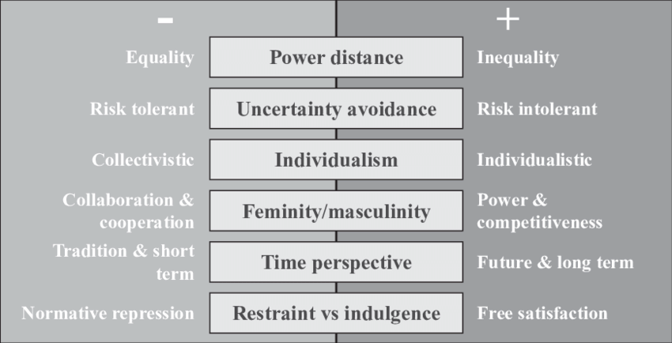
Figure 1 Hofstede cultural dimension
Source: (Kottak et al. 2014)
The figure shows the behaviour of employee and organisation because of cultural effect. Hofstede mentioned six dimension of culture that exists in an organisation while making the decision for employment. This has an effect on the GSK UK decision making also as described below-

Power distance: This degree shows the unequal decision making for the people and power distribution. The people who come from less power country will be dominated by high power country. For instance, the people come from Malaysia will not appoint as a manager or for a higher role. But, the people from the USA can be in the higher position of the organisation as their country has power economically and politically. In GSK UK, the power distance does not affect the organisations’ operation. The organisation does not believe in discrimination. So, they distribute the power of the position based on talent and skill.

Uncertainty avoidance: The people who come from the high-risk society are acceptable for the challenging task. This dimension mentions that how people can cope up with the unknown situation. This degree shows the tolerance of society for ambiguity. Some society uses strict regulation, behaviour codes, and the law where some society uses less strict regulation, thoughts and law. People from strict society cannot think creatively, they just maintain the rules and regulation, discussed by Thompson et al. (2018). GSK prefer the people for idea generation who came from less strict society. Because, they are tend to provide different thoughts and ideas. For staff requirement, the organisation seeks strict society people as the staffs have to maintain the rules for repetitive work.

Individualism vs. collectivism: The individual society people are tending to work with full dedication as they already loose ties from their family. They prefer to contribute their role on the organisation and they give priority to the work over people. Collective society people give first priority to their family while contributing their role in the organisation. They remain loyal to the group and the person of the organisation. GSK prefer an employee who comes from collective society. Because they can manage people well and perform group task effectively.

Femininity vs. masculinity: Hofstede thinks that people from femininity society count women equal to the men. They think women can participate in challenging work as men do. The masculinity society thinks women are assertive but less than men, discussed by Britton et al. (2018). They still think women and men have a gap in performance in society. GSK prefer employee for femininity society because the organisation founded that women can perform better. They can be a manager, supervisor, specialist in many sectors. The organisation does not discriminate between men and women. They are given the same priority and attention of the organisation.

Time perspective: This degree shows that the society which prefers a long-term goal, is pragmatic and thrifty. These people are usually expert in problem-solving decision making. The short-term goal user has no economic development and emphasis on principle making. GSK prefer long-term goal setting society as they can bring success to the organisation. They are creative and critical thinker which is much needed for plan making.

Restrain and indulgence: This degree refers that emotion of people toward work people of restraining society and indulgence society. According to Edwards et al. (2018), indulgent society people are tending to provide a joyful environment to the employee. And they believe that employee can find satisfaction in their work if they get support from the organisation to fulfil their desire. GSK prefer indulgence society people. They can do an effective performance if they get some motivation from the organisation. Restrain society people emphasis on regulation, principle, the behaviour of the employee etc. they think human need to control their emotion to get success.

2.1 Formal and informal relationship
The relationship of GSK UK within the organisation is formal that means the employee of the different department work for a common purpose. Their relationship is legal and formal where rules and policies have been written to maintain by the employees. According to Eagleton (2018), the top management of the organisation deliberate the rules and policies of the organisation which known as culture. The work allocation, delegating, work assigned etc. is done by the top level management. The objective of formal relationship establishment is achieving the goal of GSK UK. The hierarchical structure shows the formal relationship and command chain.

The information relationship within GSK UK exists in the department behind the wall. People interact with each other friendly and cooperate in the working. The interpersonal relationship influence to meet and associate people within the department. The manager of GSK has to motivate employee making an informal relationship. GSK UK creates a favourable and friendly environment for the employee where a member can work and communicate with each other spontaneously. Informal relationship helps to identify the psychological needs of an employee through talking.

The organisation can adapt strategy and leadership approach to handle and overcome the situation. The performance of the company and organisation culture depends on the business environment, discussed by Baron (2013). Here, the organisation should consider the SWOT and PESTLE analysis to get a proactive strategy and decision. Making information relationship will help to provide effective motivation. The formal relationship also needs to exist in the GSK UK so that the objective can achieve through a structure.

2.2 Establishing a culture of sustainability within the Workplace
To establish cultural sustainability within the organisation, GSK should monitor the policies. The organisation has created awareness among the employee and professionals. It will help to find out the value of culture within the organisation. Here, the organisation can orient the employee and give a briefing in every month about the culture. The regulation, principles, the law has to maintained by the employee (Shaikh (2015). Employee is from a different country have specific cultural dimension. So, they need to follow the rules of the organisation. The regulation and principle should not be critical that employee cannot understand. The regulation and rule should be simple for the employee that makes comfort to them.

The manager of the GSK UK should set the priority for the employee. For instance, providing quality service will be the first objectives of the employee. Here, the employee will maintain the culture of the organisation to provide quality service. The manager should provide feedback of every employee who are maintaining the rules and who are not, elaborated by Worthington et al. (2018). This will work as an alarm for the employee to behave considering the organisation’s culture. Here, the manager has to be a critical observer to provide feedback.

Whatever the organisation have to operate, they ensure the positive impact on the society and employee. GSK UK has dress code and principle of behaviour within the organisation, customer and third party. The organisation is an emphasis on the relationship with the customer, client and employee. They ensure that everything is doing fairly. The produce quality products and provides quality service over the global.

2.3 Aligning personal goal
The manager of GSK UK has to motivate employee to aligning the personal goal with the organisational goal. This will increase the engagement of the employee and achieve the goal in short time. Motivational strategy can increase the employee engagement in the performance. Kottak et al. (2014) defined that reward scheme can be a tool for motivating the employee to maintain the culture. Here, the manager of GSK UK should reward people who maintain the rules and regulation within the organisation well. This will increase the participation of employee to maintain the culture efficiently. For Make realisation, the manager of GSK UK can make realisation to the employee as they are the part of the organisation. The employee performance reflects the organisation success. So, realising them regarding this factor, they can be influenced to aligning personal goal with organisational goal.

2.4 Corporate social and environmental responsibility
GSK committed with the employee to provide a better working environment so that they can provide the best performance. The principle and regulation of the organisation create a friendly environment for the customer and employee. The organisation works with integrity performing corporate responsibility, according to Baggini (2012). They have own wage policy so that the employee get equal benefit after performing their role. A business organisation in the UK has to perform the responsibility toward society and the environment. The service that GSK provide, do not harmful for the environment. Almost 99,300 employees are working in this organisation.

The organisation is helping society to enhance the lifestyle and this is also contributing in the GDP. Many social programs are doing by the organisation as voluntary, charity donation, sponsorship etc. GSK focuses on the corporate and social responsibility at work as social recognition and welfare for the society. Every person in GSK UK is treated with respects and they have equal opportunity. The corporate cultural value of the organisation is managing well so that the company can create a sustainable cultural value, elaborated by Ringleb et al. (2018). The social and environmental responsibility is also performing well to increase the brand value of the organisation.

2.5 Communication and building relationship
The employees and professional of the GS UK use some communication channel to communicate. The communication channel uses to make good relationship and share the information related to the organisation. The employee of the organisation uses formal, informal and unofficial communication channel.
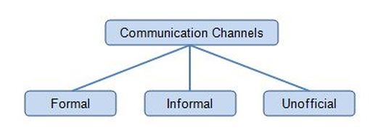
Figure 2 Communication channel of GSK UK
Source: (Gezon et al. 2014)
Formal communication channel: This channel assists to send information regarding policies, goals and objectives. The massage flowed by a chain of command either top-bottom or bottom-top. The flow of the information can be from manger to subordinates and worker from the manager. For example, the business plan and annual report of the organisation transfer bottom to top level using a formal relationship. Other examples can be review meeting, survey result etc.

Informal communication channel: This channel disrupts the formal flow of command. The manager of the company has to identify the effective communication channel for the employee for the best communication, discussed in Copdchoices.gsk.com, (2018). For the teamwork and training program, the manager has to communicate informally with the employee. This channel is outside of the formal communication and chain of command. The manager has to create a balance between the communication channels.

Unofficial communication channel: This refers the interpersonal communication within people. This communication channel creates when an employee engages with ‘Grapevine’ discussion. This type of communication arises when people of the group translate their friendship outside of the company.

Barriers to effective functioning in GSK UK
GSK UK faces some barriers when they the manager worked with the employee. When the manager is allocating the activity, he felt cultural barriers. The employee comes from a different culture and region, discussed by Thompson et al. (2018). Their belief, value and attitude are different also. That is why the manager faced the cultural barrier when functioning. Poor communication is in the core of the communication barrier. To allocate the work and teamwork need effective communication within the manager and employee. Poor communication creates a barrier to motivating employee and manages the operation effectively. Disobeying the discipline also is a reason for facing a problem when functioning.

Overcoming the barriers
To overcome the barriers, the manager should influence an employee to maintain the organisational culture, elaborated by Britton et al. (2018). The organisation should have a specific dress code where the employee will not be discriminated by the social level. There should be one common language for all employees and employers will communicate with the same language. GSK will set the principle for the employees’ behaviours and attitude.

The communication should be effective to overcome the misunderstanding. The manager should be expert to understand the psychology of the employee which will help to motivate end to communicate effectively. The cultural gap can be removed by proper communication and mutual understanding.

3. SWOT Analysis
The business environment of GSK UK influences to perform better or less than expected. The internal environment can control to increase service quality and productivity, mentioned by Shaikh (2015). But the external environment cannot be controlled by GSK UK. For instance, if the organisation wants to perform higher or increase productivity, the company have to focus on the competitors’ innovation and technology factors. The PESTLE analysis and SWOT analysis of GSK UK will show the impact of the external and internal environment in the operation of the organisation.

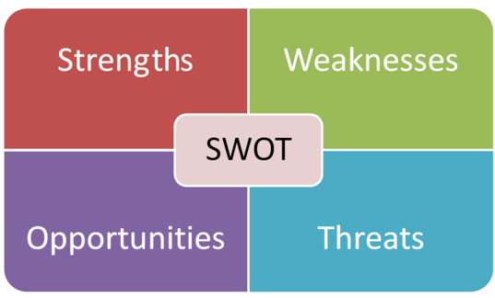
Figure 3 SWOT analysis
Source: (Baggini, 2012)
Strengths: the strength of GSK UK provides the success and increased the value.
GSK UK operating its business globally with a high-quality product. The people from different country accepted the organisation as a quality service and medical provider. This organisation has strong recognition within the country and international market. The distribution network of this organisation is stronger than the competitors. The sales rate is growing and the organisation reached the maturity stage. Because of the strong network of sale and distribution, the business expansion has been possible. Strong R&D GSK is a pharmaceutical and healthcare company which develop research on various diseases. Stern (2015) mentioned that the organisation focused on the development of the research with various technologies. It increases the business expansion which is the strength of the company in the market.

Weaknesses: GSK also has some weaknesses while operating its business within the global. The weaknesses of the organisation may include various issues. Fraud allegations, in some country, the fraud people selling the product with the name of GSK brands. They are promoting their prescription unlawfully. They charging a high price for the medicine and do not deliver the safety data report. This is damaging the company brand image. Vaccines and medicine of the organisation are making by another organisation. This increases the competition in the global market. Some product of the company also reached in the maturity stage. So, it will affect in future in the sales rate of the company.

Opportunity: To expand the business and portfolio, GSK UK has some opportunity. The company need to use this opportunity for business growth. The opportunity for this healthcare and pharmaceutical is many. GSK UK expanded its business and product inorganically. The organisation collaborated HIV and ViiV with the Pfizer. The acquisition and collaborate helped to expand the portfolio of the organisation and market share also. GSK UK can use the same strategy again to expand the portfolio and business.
The demand of the healthcare service and in increasing in the market. The people form global want quality product at a reasonable price, mentioned by Stanford (2010). GSK UK can deliver healthcare service and drugs with reasonable price. The growth of technology in increasing in the UK business market. With the help of new technology, research and development can be effective for drug innovation. GSK UK is focusing on the technology to innovate something new for the R&D innovation.

Threats: The threats bring a challenge for an organisation which has to face strategically with planning. Here, GSK UK needs to act proactively to face the challenges. There are different threats. The price of the drug can increase anytime and government can keep restriction to import the drugs from a foreign country. Here, GSK UK has to consider the prices change to rate and possible impact of changes in product price. The global competition is increasing and the investor investing in this sector intensely. They know the global demand for drugs and this is the profitable industry. That is why they are entering the market with new strategy making which can be a treat for the GSK to lose the suppliers and customer.

4. PESTEL analysis
GSK UK is operating its activity across the globe and the business effect by the political, economic, social and environmental factors. The PESTEL analysis of the organisation will help to identify the impact of external factors in the operation of Unilever.

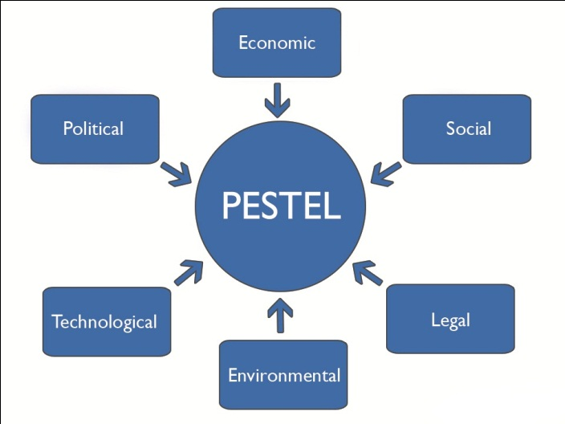
Figure 4 PESTEL analysis
Source: (Baron, 2013)
Political factors: The operation of the organisation mostly affected by the political factors of a country. Every country, the government has some rules and regulation for the business. GSK UK has to maintain the regulation for the government that has been made for trade, expansion of business and quality control. The political relation is the most important things for the business. After leaving EU, the business environment of the UK becomes critical, mentioned in Tradingeconomics.com, (2018). Some investors from the EU took back their investment form the UK.

GSK UK faced this problem too but this situation has been handled well by the organisation. Still, there is a risk of potential threats for EU. Now, the government of the UK gave an opportunity of free trading. Although this opportunity is growing, the organisation must identify the challenges related to politics. GSK UK can expand the business considering free trade relation.

Economic factors: This factor shows the GDP growth, productivity, labour market, interest and inflation rate etc. The economic condition of UK is steady after Brexit problem. The labour market is the shortage but productivity is increasing. GSK UK operation is affected by this situation. Shortage labour market is the barrier of appointing skilled employee and professional. As this organisation is a pharmaceutical, consumer goods and biotechnology industry, the productivity rate has contribution is GDP.

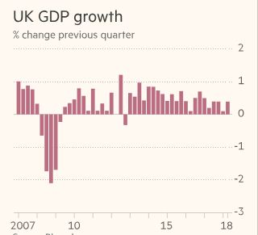
Figure 5 GDP growth of UK
Source: (Tradingeconomics.com, 2018)
The economic performance of the country has a direct impact on the organisation’s operation. The inflation rate affects the product price of the organisation, also in the wages. The government sets some restriction for the market economic growth. Increasing tax rate has an impact on the company revenue, said by Mumford (2016). GSK UK has to maintain the regulation of for the business.

Social factor: Currently, the lifestyle of the people in the UK has been developed. The household price also decreased which refer that the spending capacity of the consumer increased. People are becoming educated and receiving a higher degree for the better living. The employment rate of the UK also increased which is a positive impact on the livelihood of the people.
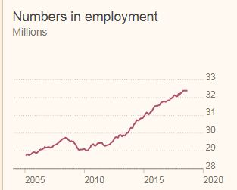
Figure 6 Employment rate in UK
Source: (Tradingeconomics.com, 2018)
The people can spend their income on consumer goods and care to receive. Here, GSK UK has an opportunity to snatch the customer attention toward their organisation. UK people are now much concern about healthcare and quality service. GSK UK can influence consumer providing quality healthcare service and medicine to the people. Contributing to social work can increase the recognition of the organisation which is a tool for increasing productivity and sales. The organisation should provide service based on the cultural tend. For instance, if a customer comes from a different region, he should not treat as the local residents.

Technological factors: The government is investing in the technology sector to invent the digital machine for the purpose of greater service. This sector has a positive and negative impact on the GSK UK operation. Technological factors assist people to invent new things and use it to increase productivity. The technological environment of UK is enhancing through innovating new device. Gskpro.com, (2018) mentioned that using upgrade technology, productivity can increase in less time. GSK UK should use upgrade technology whenever it invents. Otherwise, competitors can grab the opportunity to increase productivity. So, the organisation must have a good relationship with the supplier. This will help to get an advanced machine when it comes to the market. The advanced technology brought the culture of being highly productive.

Environmental factors: The environmental factor of GSK UK is favourable for the business. As people are becoming aware of the quality service and health care, they want to receive services from the reputed healthcare centre. GSK UK provides equality medicine and service to the customer. The brand of this organisation is a plus point for business expansion and customer attraction. The environmental factor is influencing to expand the healthcare and medicine centre. The government made favourable business policy for healthcare centre so that the people can take quality and necessary services. The demandable environment of the medicine and healthcare influenced the organisation to perform higher and make productive situation within the organisation.

Legal factor: The act and law that has been made by the government of UK, have to maintain by the business organisation. GSK UK also maintains the law and rules of business operation within and outside of the country. There has some law e.g. consumer, employment, fraud, copyright, payment etc. GSK UK is responsible for delivering health and safety environment to the employee to work better, mentioned by Gezon et al. (2014). The employee has some rights that organisation will give e.g. healthy environment, work safety, payment, discrimination etc.

These laws should maintain by the organisation to have better workflow and performance. The consumer law describes that organisation is responsible to provide a hazardless product that can harmful for the consumer. The organisation can no sell their product at higher price than fixed by the law. The employee will be not discriminate in the organisation and they will be paid that government specified. To export or import the materials of GSK, they will maintain the formalities as specified by the law.

5. Conclusion
GSK UK provides a favourable environment to the employee include policy, culture, regulation and principles. The culture of the GSK and the effect of it on the organisational, performance have been evaluated critically. The Hofstede demonstrated the cultural difference and impact of it in the decision making of the organisation. The impact of culture on GSK performance, barriers to effective functioning and the possible way to overcome it has been demonstrated also. The external and internal environment of the organisation, communication channel to build relationship and share information also discussed to evaluate the cultural impact critically.

Reference
Baggini, J. (2012). Ethics. London: Quercus.
Baron, D. (2013). Business and its environment. Boston: Pearson.
Campling, J. (2008). Management. Milton, Qld.: John Wiley & Sons Australia.
Copdchoices.gsk.com. (2018). Home | GSK UK. [online] Available at: http://copdchoices.gsk.com/en-gb/ [Accessed 11 Nov. 2018].
Eagleton, T. (2018). Culture. New Haven, CT: Yale University.
Gezon, L. and Kottak, C. (2014). Culture. New York: McGraw-Hill.
GSK accused of pay-for-delay deals in the UK. (2013). PharmacoEconomics & Outcomes News, 677(1), pp.2-2.
GSK faces investigation by UK Serious Fraud Office. (2014). The Pharmaceutical Journal.
Gskpro.com. (2018). Vaccines. [online] Available at: https://gskpro.com/en-gb/therapy-areas/vaccines/ [Accessed 11 Nov. 2018].
Hills, J. (2013). Wealth in the UK. Oxford: Oxford University Press.
Meiners, R., Ringleb, A. and Edwards, F. (2018). Legal environment of business. Boston, MA, USA: Cengage Learning.
Mumford, L. (2016). The Culture of Cities. Open Road Media.
Saleem Shaikh. (2015). Business Environment. Pearson India.
Stanford, N. (2010). Organisation culture. London: Profile.
Stern, R. (2015). Kantian ethics. New York: Oxford University Press.
Tradingeconomics.com. (2018). United Kingdom GDP Growth Rate | 1955-2018 | Data | Chart | Calendar. [online] Available at: https://tradingeconomics.com/united-kingdom/gdp-growth [Accessed 11 Nov. 2018].
Tradingeconomics.com. (2018). United Kingdom Unemployment Rate | 1971-2018 | Data | Chart | Calendar. [online] Available at: https://tradingeconomics.com/united-kingdom/unemployment-rate [Accessed 11 Nov. 2018].
Worthington, I., Britton, C. and Thompson, E. (2018). The Business Environment. Harlow, United Kingdom: Pearson Education Limited.

Appendix
GSK revenue distribution
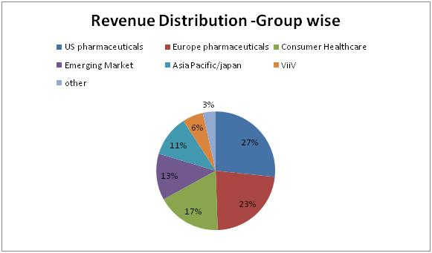

GSK UK share value analysis
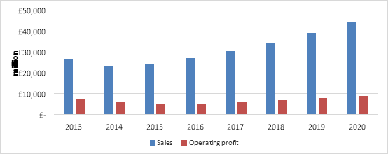

GSK UK financial financial performance
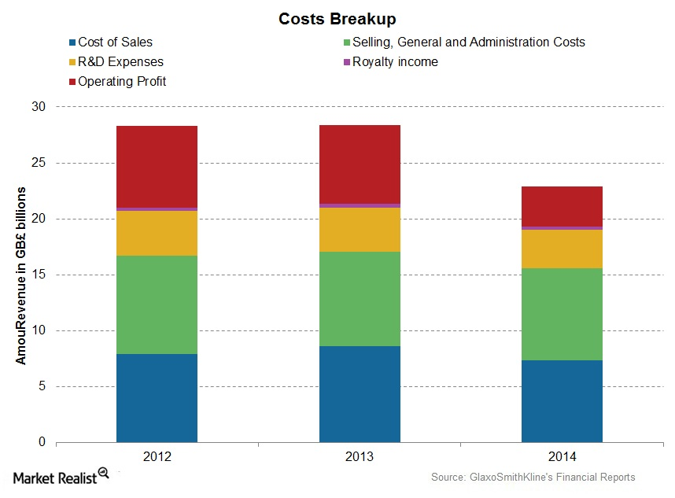

GSK UK company profile
Revenue | £30.186 billion (2017)
Operating income | £4.087 billion (2017)
Net income | £2.169 billion (2017)
Number of employees | 99,300 (2016)

