Title: Supporting Jenny: A Community Support Plan Using Bowlby’s Attachment Theory
Module: Psychology in Health and Social Care (LCHS4010)
Student Name: Zawadi Nibigira
Student ID: 2435451
Lecturer: Shepherd Ziko
Programme: Certificate of Higher Education in Health and Social Care
Assessment: Assessment 1 – Individual Presentation

Slide 1
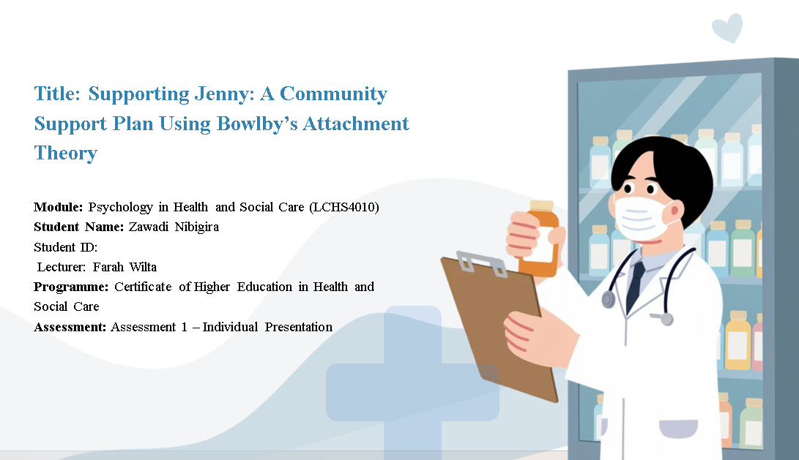

Slide 2
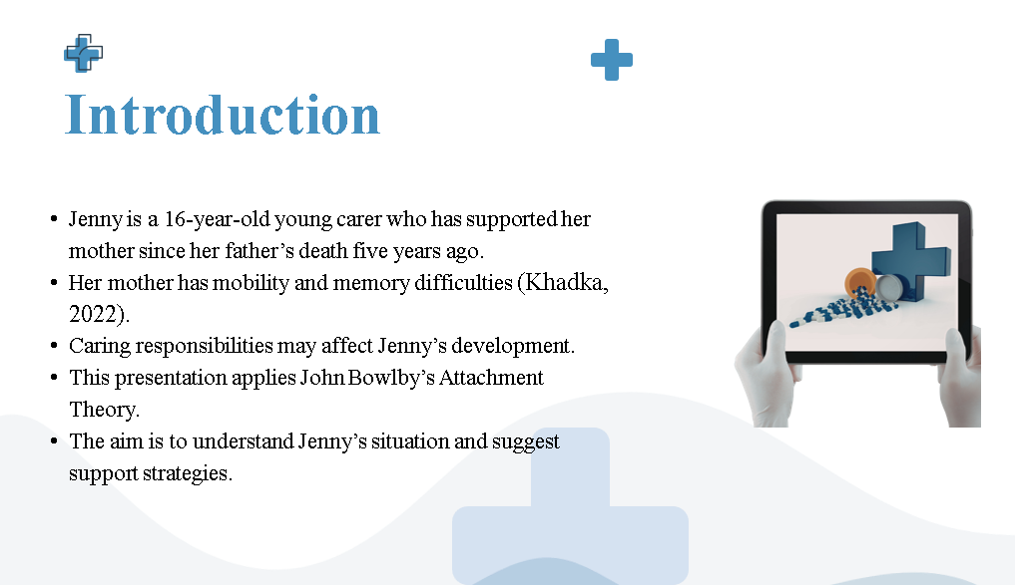
Speaker Note: This presentation is going to address the case of a sixteen-year-old young carer, Jenny, who had to support her mother and raise her father, who died five years ago. Jenny used to be the primary caregiver in the family. After his death, Jenny's mother developed difficulties in mobility and memory, and this means that Jenny assumed more responsibility at home over time. Consequently, Jenny currently offers emotional as well as practical assistance to her mother. Young carers may face difficulties in their careers due to the conflicting, demanding roles in care and education, social living, and personal wellbeing. Young carers are often subjected to emotional and psychological stress because of the added responsibility at a young age (Khadka, 2022). This presentation will use Attachment Theory, which was developed by John Bowlby, to learn how the experiences can affect her development. Attachment Theory is concerned with how relationships with caregivers form in the early stages and influence the development of emotional security as well as social development (Fleming, 2018). This presentation will examine the case of Jenny based on the lens of Attachment Theory and recommend suitable support mechanisms that will enhance her overall wellbeing and growth.

Slide 3
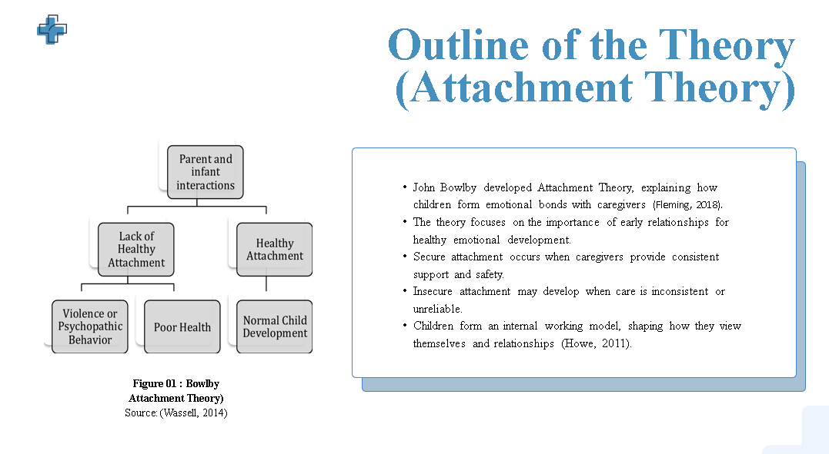

Speaker Note: Attachment Theory is an ideology developed by John Bowlby to explain how children form close emotional attachments to their caregivers. Bowlby regarded these early relationships as a key in determining emotional development and wellbeing (Fleming, 2018). Attachment can be defined as the emotional bond developing between a child and his or her primary caregiver. A secure attachment is achieved when caregivers are consistently responsive and sensitive to the child's needs. Safe attachment makes children feel safe and secure, and this enables them to discover the world and build confidence. But in case of inconsistent or unreliable caregiving, children may form insecure attachment. This can result in anxiety, lack of security or trusting others. The other significant phenomenon in the theory is the inner working model. Howe (2011) states that children form internal beliefs regarding others and themselves, dependent on early attachment experiences. These ideologies affect the way people perceive relationships in their lives. Consequently, childhood attachment may have long-lasting impacts on emotional status, behaviour and social interaction.

Slide 4
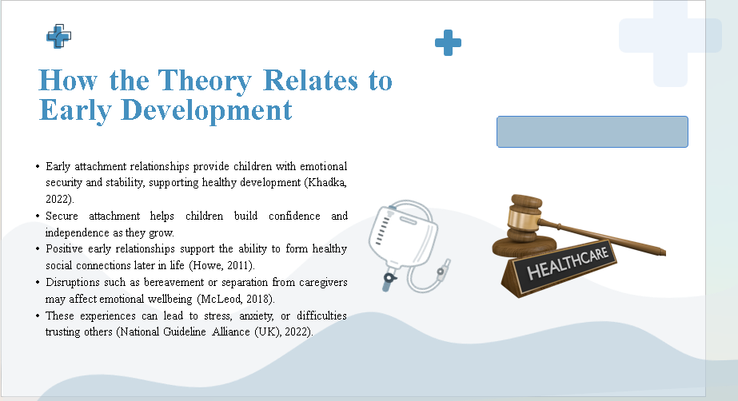
Speaker Note: Attachment Theory underlines the sensitivity of early relationships in the development of poor health. Secure attachments bring children emotional stability and security (Khadka, 2022). Children are also likely to grow up confident and independent when they feel safe and supported. Good affection with the caregivers will also enable the children to develop good social skills and enhance their capability of establishing healthy relationships in the future (Howe, 2011). However, such disruption of attachment relationships can have a negative impact on emotional wellbeing. Bereavement events or separation from caregivers can lead to stress, anxiety, or a feeling of emotional insecurity (McLeod, 2018). According to the National Guideline Alliance (UK) (2022), children who have survived a loss might be at increased risk of emotional hardships. These concepts are useful in explaining how Jenny may grow up because of the experiences she goes through.

Slide 5
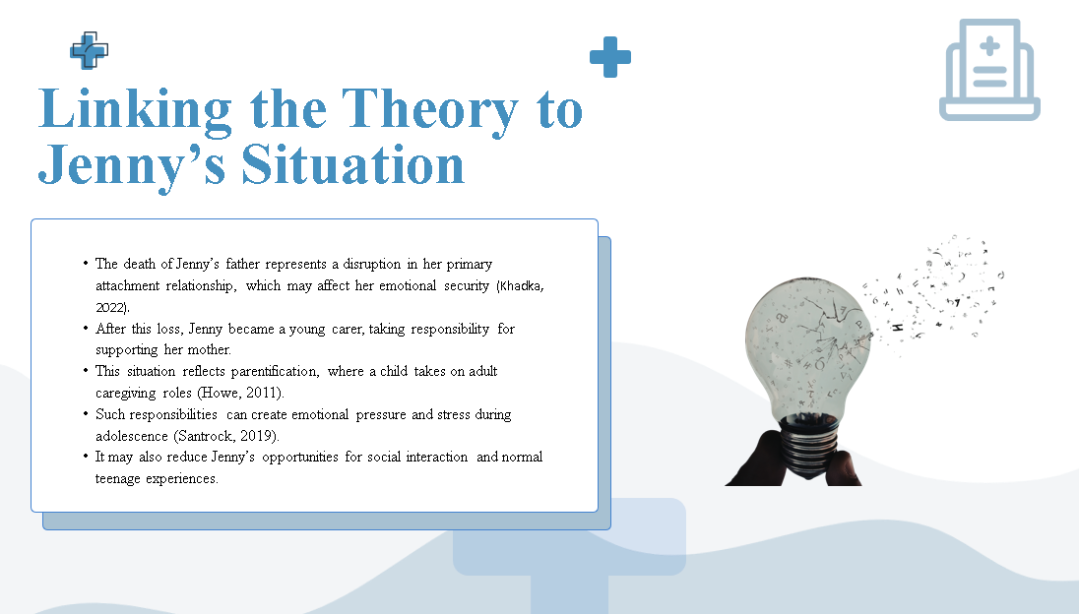

Speaker Note: The Attachment Theory can also be applied when discussing Jenny, since the loss of her father derailed the primary attachment relationship. The loss of a caregiver may influence emotional security and stability (Khadka, 2022). It is after this loss that Jenny had to support her mother. This is parentification, a scenario where a child assumes caregiving roles of an adult (Howe, 2011). Despite the fact that sometimes the responsibility of taking care of the family could improve relations, it might be associated with pressure and tension, as the tasks and obligations can be overwhelming. Adolescence is the age when people are trying to establish their identity and create social relations. Santrock (2019) argues that young people should have a chance to get acquainted with peers and concentrate on education. Such opportunities may be inhibited by the caregiving role that Jenny can play, which can cause stress, fatigue, and decreased socialisation.

Slide 6
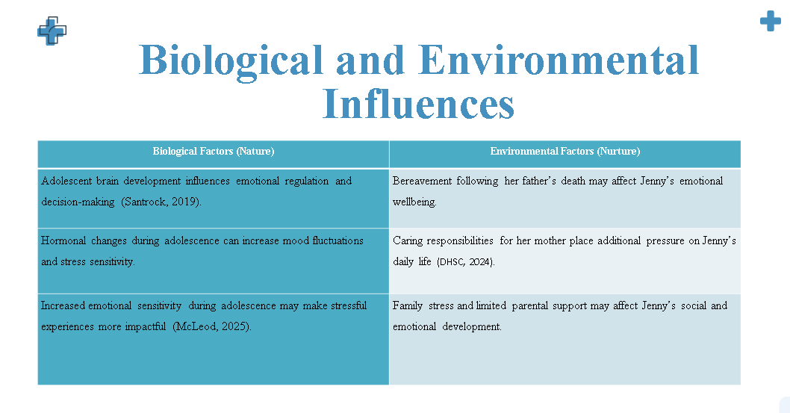

Speaker Note: The biological and environmental factors affect the development of Jenny. Adolescence is also a period of great brain development biologically. During this stage, the emotional control and decision-making areas are still developing in the brain (Santrock, 2019). Emotional sensitivity and mood variation can be enhanced by hormonal changes as well. McLeod (2025) states that due to these developmental changes, adolescents can have more intense emotional responses. The experiences of Jenny are also affected by environmental factors. One significant life event that can have an impact on her emotional wellbeing is the death of her father. Moreover, the role of a young carer serves as additional pressure on Jenny. The Department of Health and Social Care (2024) notes that young carers typically have to deal with the challenge of an education and care balance. Parental pressure and lack of support in the family may then influence emotional and social development in Jenny.

Slide 7
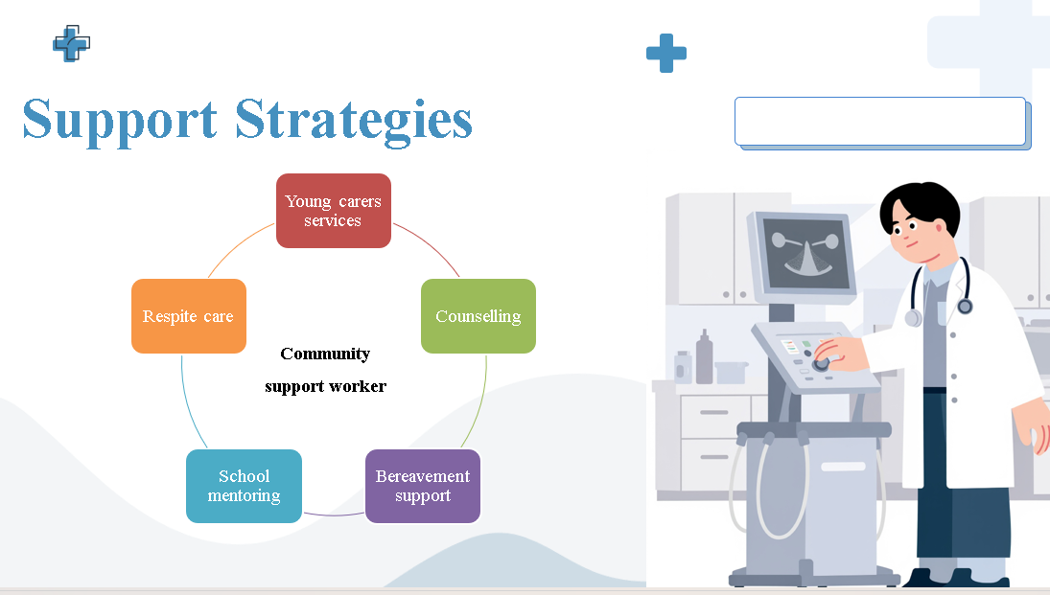
Speaker Note: A number of support measures would assist Jenny in dealing with her duties and enhancing her wellbeing. Some advice, emotional support and the opportunity to meet other young carers can be offered in young carer services (DHSC, 2024). This has the ability to diminish isolation. Counselling may assist Jenny to open up the emotions and establish coping mechanisms. Bereavement support can assist her to cope with the grief she is experiencing due to the death of her father. Moreover, school mentoring can offer advice and encouragement of a reputable adult. Lastly, Jenny can have the mother of her little sister respite so that Jenny can have time to concentrate on school, friendships, and personal wellbeing (Guy-Evans, 2024). These are the strategies which demonstrate the concepts of Attachment Theory, as they are the stable and supportive relationships.

Slide 8
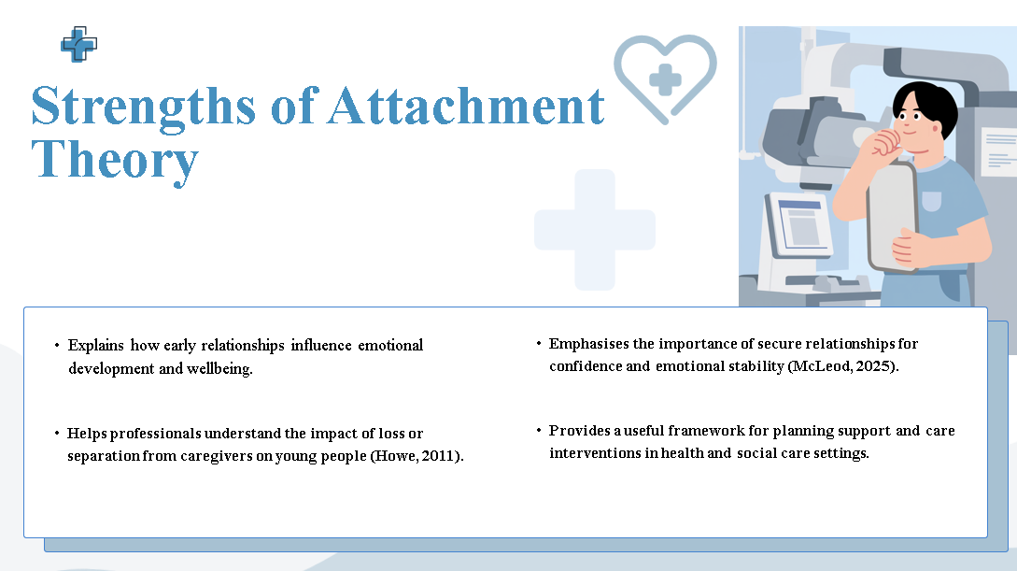
Speaker Note: Attachment Theory possesses some of the strengths. It discusses the impact of early relations on the development and wellbeing of emotions. The theory equally assists the professionals in explaining the emotional effects of the loss of the caregiver (Howe, 2011). Moreover, it also highlights the role of safe relationships in creating emotional and confidence stability (McLeod, 2025). Attachment Theory is therefore applicable in the planning of support and interventions in health and social care.

Slide 9
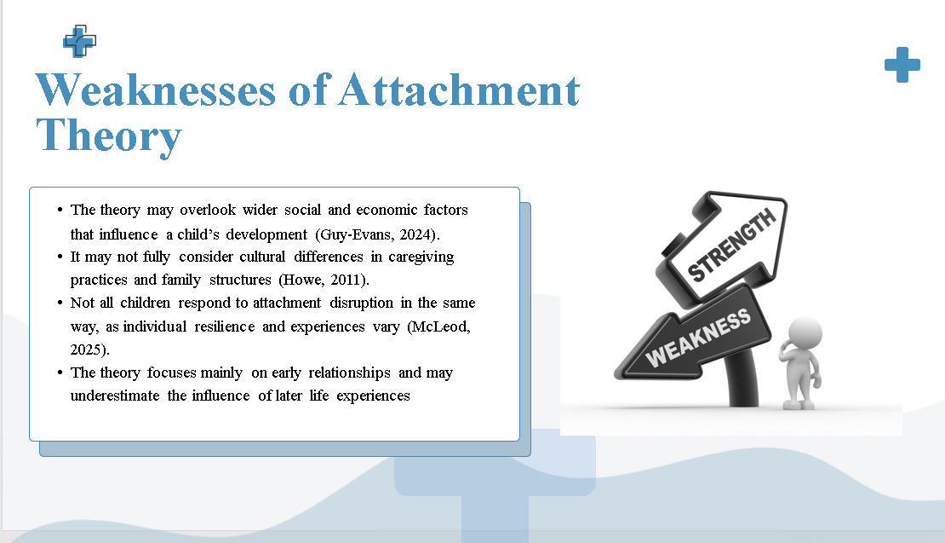
Speaker Note: Despite its advantages, the theory is also limited. It can ignore larger social and economic forces that affect development (Guy-Evans, 2024). The theory also might not take into account the cultural variations in parenting and caregiving behaviours (Howe, 2011). Moreover, not every child reacts to the violation of attachment in a similar manner due to varying resilience among people (McLeod, 2025). Lastly, the theory primarily emphasises early life events, and it can under estimate effect of events later in life.

Slide 10
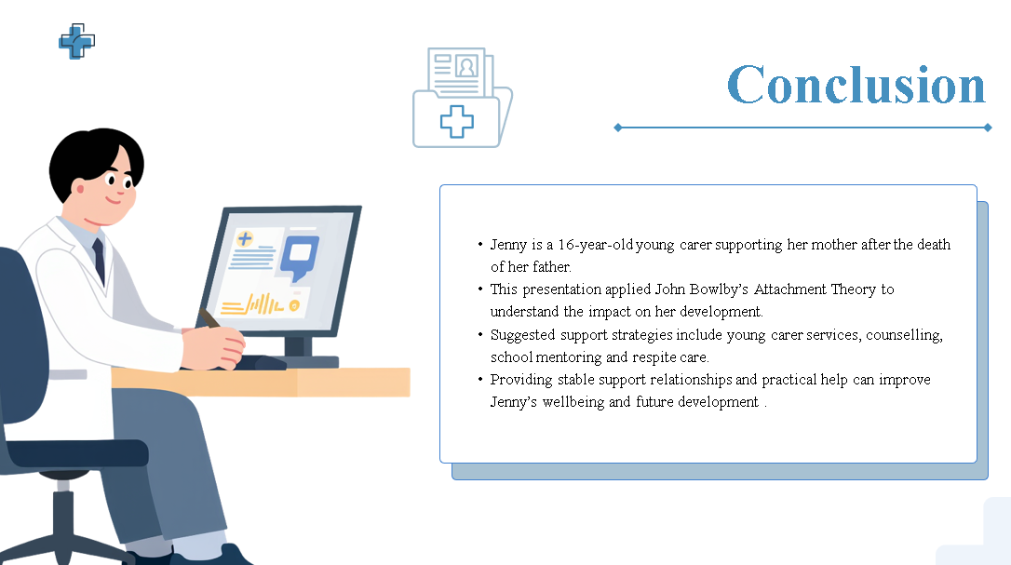
Speaker Note: The case of Jenny shows that young carers go through a hard time. Due to her father's death, Jenny had to play a major role in helping her mother. The application of the Attachment Theory of Bowlby assists in understanding how violation of attachment relationships may influence emotional development. Young carer services, counselling, school mentoring and respite care can be made available to support Jenny to enhance her wellbeing. Jenny will be able to further develop healthily and positively with proper support and stable relationships.

Slide 11
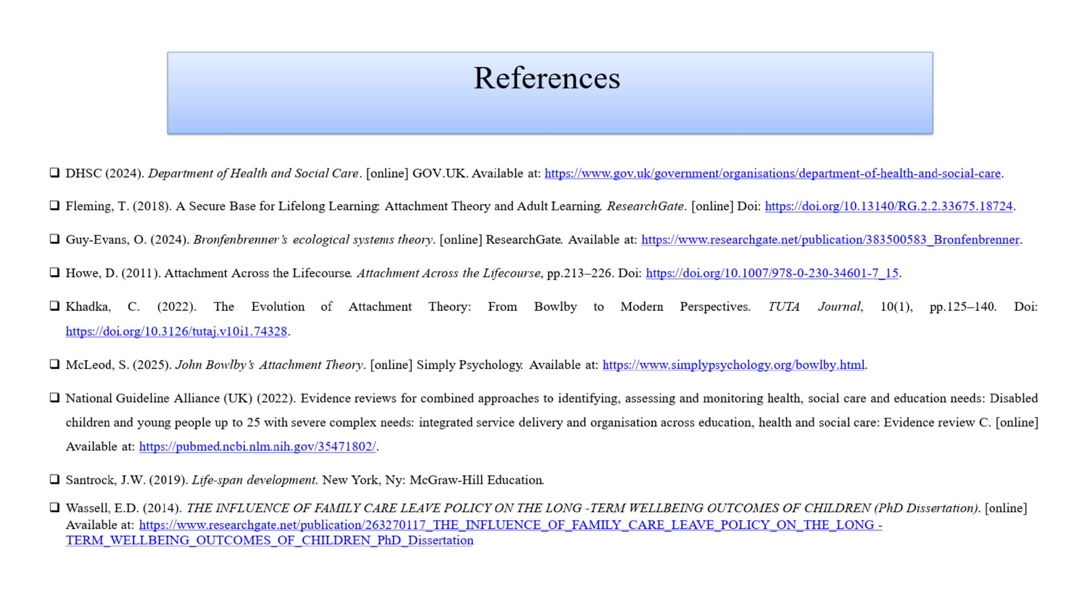

Speaker Note:
DHSC (2024). Department of Health and Social Care. [online] GOV.UK. Available at: https://www.gov.uk/government/organisations/department-of-health-and-social-care.
Fleming, T. (2018). A Secure Base for Lifelong Learning: Attachment Theory and Adult Learning. ResearchGate. [online] Doi: https://doi.org/10.13140/RG.2.2.33675.18724.
Guy-Evans, O. (2024). Bronfenbrenner’s ecological systems theory. [online] ResearchGate. Available at: https://www.researchgate.net/publication/383500583_Bronfenbrenner.
Howe, D. (2011). Attachment Across the Lifecourse. Attachment Across the Lifecourse, pp.213–226. Doi: https://doi.org/10.1007/978-0-230-34601-7_15.
Khadka, C. (2022). The Evolution of Attachment Theory: From Bowlby to Modern Perspectives. TUTA Journal, 10(1), pp.125–140. Doi: https://doi.org/10.3126/tutaj.v10i1.74328.
McLeod, S. (2025). John Bowlby’s Attachment Theory. [online] Simply Psychology. Available at: https://www.simplypsychology.org/bowlby.html.
National Guideline Alliance (UK) (2022). Evidence reviews for combined approaches to identifying, assessing and monitoring health, social care and education needs: Disabled children and young people up to 25 with severe complex needs: integrated service delivery and organisation across education, health and social care: Evidence review C. [online] Available at: https://pubmed.ncbi.nlm.nih.gov/35471802/.
Santrock, J.W. (2019). Life-span development. New York, Ny: McGraw-Hill Education.
Wassell, E.D. (2014). THE INFLUENCE OF FAMILY CARE LEAVE POLICY ON THE LONG-TERM WELLBEING OUTCOMES OF CHILDREN (PhD Dissertation). [online] Available at: https://www.researchgate.net/publication/263270117_THE_INFLUENCE_OF_FAMILY_CARE_LEAVE_POLICY_ON_THE_LONG-TERM_WELLBEING_OUTCOMES_OF_CHILDREN_PhD_Dissertation.

