

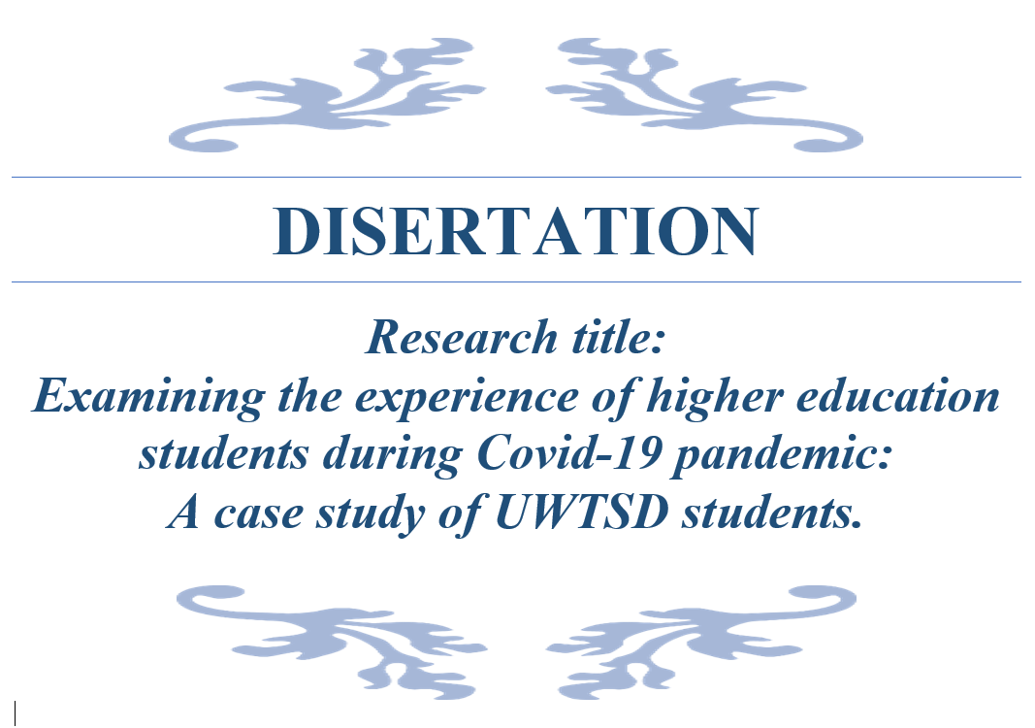

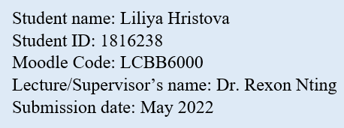

Abstract
The Corona virus pandemic affected various aspect of human endeavours, such as businesses in regard of productions of goods and services, as well the management and the calendar of educational institutions across the world.
Purpose - This paper aims at assessing how has the pandemic shaped the learning experience of Higher education (HE) students at UWTSD, how this experience shaped their perception and how they perceive the short-and-long terms of the pandemic in comparison between face-to-face and e-learning.
Design, Methodology, and approach - This research employed quantitative approach in collecting data from 50 students currently studying at level 6 in Business Management program of study. Google form survey and Excel were used to collect, processed, analyse, and summarise the data to become meaningful and to find insights that will contribute for future studies.
Findings - The findings from this research suggest that designing and implementing E-learning education program shaped positive experience for most of the students at UWTSD, even though to some extend many of the students’ employment status was affected by COVID-19, and the small number of respondents experienced issues with devices and poor connection. The students’ perception of the short-and-long terms effects of the pandemic and their readiness to embrace them. Another finding is they perceive their online experience to some extend better as significant number of the respondents owned electronic devices and did not experience issues with their internet connection. However, there were small number of students, who had some issues. Finally, the research discovered that most of the respondents are adult students from Bulgaria and Rumania and that big proportion of the respondents are female. Moreover, technology used in e-learning, the pastoral and academic support provided by UWTSD significantly contributed to students to perceive their online experience to be enhanced during the pandemic (COVID-19) and that majority are likely to continue online form of education in the future and recommend the university.
Research limitations and implications - The findings from this research will be very beneficial for future study and especially to the university managements and administration in case of other emergency decisions of exploring and implementing e-learning programs of HE for students from different backgrounds. Research on this topic is new and still at infancy stage, and the full view of majority students is not fully studied at this time. Currently only the short-term impact can be explored and examined as this is new phenomena. For the long-term only can be guessed or forecast at this moment, but for exact long-term impact future studies will need to be conducted in few years’ times.
Practical implications - The results from this research suggest some valuable insights that policymakers, regulators, university and university faculty and staffs can beneficiate by reviewing and improve and update the service performance of the universities and gain better understanding of students’ needs, enhance the transition into e-learning, and improve student experience at UWTSD in case of emergency situations in the future, such as pandemic(COVID-19)
Originality and value - This research improves individual’s understanding of e-learning system usage, the vital importance of technology, lecturers’ readiness, the communication and collaboration between lecturer and students, and among peers, and how this affect the learning experience of HE students at UWTSD, the effect in term of comparison of e-learning and face-to-face with focus on the short-term effects, as this COVID-19 pandemic is a new phenomenon. To the best knowledge of the researcher research to examine student experience regarding the transition from on-campus to e-learning have not been done at UWTSD. This study could be used by UWSTD HE faculty staff and police makers to use the findings and to come up with strategies that will improve the quality and service of e-learning to enhance students’ transition to e-learning in future unpredictable events.

Acknowledgement
I would like to express my deepest gratitude for helping me with this research project to my Supervisor Dr. Rexon Nting, for his support, guidance, and feedbacks during the duration of this research project as he was very approachable and flexible with the timing of our scheduling meetings. And not only for this project but also for being my lecturer in the previous two years in Accounting and Management Accounting lecturer from which I learn a lot of useful lessons that I believe will contribute to my future career.
Furthermore, I would like to thank the following people:
- To lecturers Tushara and Dr. Anupam, who conducted Dissertation support classes via MC Teams and were very approachable for questions and guidance of how to write proposal and dissertation. And to all Lecturers, who contributed to my HE, who supported and guided me through the different subjects and who were always approachable, dedicated and for their feedbacks, these made my learning experience at UWTSD to exceed my expectations.
- The students at level 6, who were willing to take the time and participate in my Survey, without whom I would not have any primary data to use for my dissertation.
- My classmates from whom I have learned a lot, and especially with those who were part of my group assignments and presentations.
- And finally, but not least to my family and friends, who supported me during these three years of study.

Autor’s Declaration
I, hereby declare that this dissertation research is entirely my own work, and all the sources used in this research paper are fully acknowledged. It has not been submitted in parts or fully, by me or any other person, for the purpose of obtaining grade/mark. I understand the ethical implication and this dissertation meets the requirements of the UWTSD and British Educational Research Association (BERA).

Key words: Covid-19, Lockdown, E-learning, Undergraduate, HE, UWTSD, Pandemic, Experience, Perception, Social Distancing, HE institutions, Students Funding, Pastoral and Academic, Community of inquiry, Distance learning, Tuition, Education reforms, Education quality

Abbreviations:
HE – HE
UWTSD – University of Wales Trinity Saint David
COI – Community of inquiry
COVID-19 – SARS-CoV-2/ Corona Virus disease 2019
TAM – Technology acceptance model
EU -European Union
UK- United Kingdom

Technical terms for this study are used with the same connotation and as a synonym.
E-learning, Distance learning, online learning,
On-campus, in-person, face-to-face, presence, attending physically.

Table of Contents
1. Chapter I. INTRODUCTION 8
1.1. Background 9
1.2. Problem Statement 9
1.3. Research Questions 9
1.4. Research Aims and objectives 10
1.5. Research Significance 10
1.6. Chapter Summary 10
2. Chapter II. LITERATURE REVIEW 11
2.1. Historical evolution of HE reforms in the UK 11
Institution funding and Students financial support 11
Service quality and student expectation and experience 12
E-Learning evolution and meaning 12
Quality of e-learning 13
Advantages and disadvantages of E-learning 13
2.2. Practical response of HE to COVID-19 pandemic and lockdown 14
Challenges for online teaching and learning 14
2.3. Post Covid-19 reforms and impact on education sector 14
Technology and opportunity for teaching and learning 14
Research gaps 15
2.4. Theoretical frameworks 15
2.4.1 Community of Inquiry (COI) Framework 15
2.4.2. Technology acceptance model (TAM) 16
2.4.3. Maslow’s hierarchy of need 17
2.5. Conceptual framework 18
Hierarchy of need 18
3. Chapter III. METHODOLOGY 19
3.1. Introduction 19
3.2. Research Design 19
3.3. Research Approach 20
3.4. Research Strategy 21
3.5. Type of investigation 21
3.6. Data Collection Methods 22
3.7. Questionnaire 22
3.8. Validity and reliability 23
3.9. Research instruments 24
3.10. Sample size and Sample type 24
3.11. Sampling methods 25
3.12. Data Analysis technique and interpretation 25
3.13. Ethical Consideration 25
4. Chapter IV. FINDING AND ANALYSIS 25
4.1. Introduction 25
4.2. Survey Findings 26
4.3. Result, Analysis and Discussion 27
4.3.1. Survey results and analysis 27
4.3.2. Discussion 42
Introduction 42
Testing the hypothesis 42
5. Chapter V. Conclusions, Recommendations & implications 45
5.1. Conclusion 45
5.2. Addressing the objectives 45
5.3. Recommendation, limitation, and Implications 47
5.3.1. Recommendation 47
5.3.2. limitations 48
5.3.3. Implications 49
REFERENCES 50
APPENDIXES 56
APPENDIX A. .The consent form. 56
APPENDIX B. Information form template 57
APENDIX C. Survey Questionary 58

Chapter I. INTRODUCTION
The number of students pursuing undergraduate degree is increasing significantly as this indicates the significant importance of Higher Education degree of students in UK. According to HESA (2021) the number of students is more than two million. As this is accomplished through attending universities, including UWTSD, in a physical form.
A virus emerged at the end of 2019 identified as SARS-CoV-2 which is respiratory disease that originated in Wuhan, China. The World Health Organisation (WHO) defined it as a Global pandemic on March 12, 2020(Grennan, 2019, WHO, 2020). The government observing the transmission and mortality rate in the community they had to put in place restrictions and lockdown in attempt to contain the virus first locally in Hubei province and later the rest of the country (BBC, 2020). By the end of February and the beginning of March some Europe countries, including Italy, France, and Spain, enforced also imposed lockdowns and various measures to prevent the spread of the COVID-19 virus. These included restrictions travel, social activities, and wearing of masks (ACAS, 2021). These measures negatively impacted many industries, health and tourism businesses and Education (Ugur & Akbiuik, 2020). Additionally, the General director of UNESCO Audrey Azoloulay declared “Never before have we witnessed educational disruption on such a large scale” (UNESCO, 2020)
Due to the government regulations, education in UK was affected and had to close. The Schools and Universities, including UWTSD, were instructed to move toward online learning using platforms such as MC Teams and ZOOM. The creation of a virtual learning environment allowed students to continue their learning process, however due to the pandemic many students experienced issues with poor internet connections, and lack of digital devise to use (McKie, 2020). Additionally, the pandemic has affected the well-being of many people, including students across the world, who were negatively impacted emotionally, physically, and mentally caused by the uncertainty and financial instability (Nununnabi et al., 2020).
The pandemic (Covid-19) forced decision to be taken and implemented in any aspect of life, and some of them will contribute to change of education and the course of history (Demuyakor, 2020). E-learning is not something new or an ad hoc solution to on-campus education (Bao, 2020), as many universities already have been steadily introducing and implementing online courses and programs into their institutions, such as Harvard, MIT, Cambridge, etc. (Picciano, 2017)
Filius et al., (2019)and Bao (2020) argue that significant investing and planning is needed for deploying e-learning, because teacher, students and faculties need to be trained, and additional resources will be needed. Another factor is to be accessible and available for students from all background, otherwise this will not work (Demuyakor, 2020) Therefore, the Universities should evaluate these and other issues, such as whether students own mobile devices and strong and reliable connection prior implementing e-learning (Demuyakor, 2020). Another key factor for the success of e-learning depends on whether pupils are willing and accepting the use of the e-platforms, such as MC Teams (Almaiah et al., 2020)
COVID-19 Pandemic highlighted the need for changes in the way education is done and the need for technology innovation to be implemented to improve the efficiency and effectiveness of the education system and delivery to enhance the student e-learning experience during and post pandemic (Rashid, & Yadav, 2020).

Background
The form of education in most of the HE institutions is face-to-face with some exception of few universities, who provide online, hybrid or synchronized learning experience for their students. Due to COVID-19 most of the universities were forced to develop and implement online form of teaching and learning as there were no other alternative in response to Government restrictions and ensuring the safety of faculty and students and in attempt the virus to be contained. UWTSD following the government guidance had to introduce, develop, and implement instantaneous in the middle of the term the whole learning and teaching process and everything that entails in other to be able to accomplish the transition from on-campus to online from scratch as this did not exist prior to COVID-19.

Problem Statement
The ‘forced’ and instantaneous transition to e-learning and closure of educational facilities and campuses across the globe significantly increased the delivery of virtual classes, courses, however there were some unavoidable and unpredictable issues, as COVID-19 pandemic is a new phenomenon, and found many institution, lecturers, students, and university staff untrained in the use of technology for teaching, learning, and performing their duties (Walsh et al., 2021). Most of them had to learn as the Pandemic locations expanded around the world and transition to e-learning was in progress globally and in UK. The UWTSD had to quickly create online education system from scratch so the teaching and learning process is not disrupted.

Research Questions
Main research question: How has the pandemic shaped the learning experience of HE students at UWTSD?
- Sub-question 1: What are their experiences during the pandemic and how have they shaped their perceptions?
- Sub-questions 2: How do they perceive the effects(short-and-long) of the pandemic and their own readiness to embrace them?
- Sub-question 3: How they perceive their experience compering the face-to-face and online learning (blended) experience?

Research Aims and objectives
Purpose of the study
The aim of this study is to examine the complications and impact of this on students learning process, the academical and pastoral, which are an integral part of learning experience for undergraduate students.
Objectives:
The objectives are:
- Examine the learning experience of HE students at UWTSD during Covid-19 pandemic.
- Find out the short-and-long effects of the pandemic and their readiness to embrace them.
- A comparison between face-to-face, online learning experience as well blended learning experience
Hypotheses:
- H1 The interactions Lecturer-student, student-content and student-student in e-learning environment significantly contribute to positive HE students experience and the notion of being full time students.
- H2 Issues with availabilities and accessibility of technologies and reliable network are significant barrier for HE students to transition into e-learning
- H3 – The loss of employment or reduced working hours leads to HE education student to be significantly less motivated toward study and achievement of their goals.
- H4 – Face-to-face learning process is better than E-learning

Research Significance
The significant of this study
It is vital to examine the experience of HE students during Covid-19 pandemic to enhance both students and HE institutions can acute better understanding to meet the changes brought along by the pandemic and any such challenges in the future.

Chapter Summary
This paper is organized in the following order:
Chapter I Introduction – This chapter starts with (1)introduction to the research topic, (2) background of this study, (3) problem statement, followed by the (4)reseach questions, (5)the aim, objectives, which include the purpose and significance of this research.

Chapter II Literature review – Includes information regarding the review of the existing literature and the frameworks, COI, TAM and Malsow hierarchy of need are applied on e-learning to improve the understanding of the perception of students’ experieince thought the forced transition and their readiness, attitude to imbrace it and the driving factors of their motivation.

Chapter III Methodology – Consist the research design, approach and strategy. It ilustrates the type of invstiigation and data collection methods and the used research instruments. The sample size, sample type and the sample methods are discussed in this chapter.

Chapter IV Data collection and analysis – The results of the conducted Survey are presented, and analysed through the use of Quantitative approach findings and insights are identified and discussed.

Chaper V Conclusion, Recommendation and Limitations - In this chapter final conclusions and recommendations are provided for future researches to be used. Moreover, the objectives of this research are addressed. Limitations of the research are identifyied and listed which can be used by future researchers.

Chapter II. LITERATURE REVIEW

2.1. Historical evolution of HE reforms in the UK
The establishment of the HE in the UK was the result of the Further and Higher Education Act 1992 which unified colleges and universities under HE. Most of the UK’s Higher education degree are taken place by students attending physically the HE institutions and only small part is accomplished through blended or e-learning methods, which includes distance learnings, video recordings, and synchronise learning. The number of students in the UK pursuing HE degree had continuously increased over the years. For the academic 2017-2018, the total number of students increased by 1.1% to 2, 341,425 students compared to the previous year as the mature student (aged above 21) represents 58.7% of the total number of students (UniversitiesUK, 2019)

Institution funding and Students financial support
The Duty of Higher Education Funding bodies in UK are responsible for distributing the Government money among HE institutions and allocated it to operations such as staff development, capital expenditure. Since Higher Education Act 1998 the HE Institutions are allowed to collect annual upfront tuition fee from the students additionally to the government funding to meet their needs.
The grants were removed, and the loans were increased due to the implementation of maintenance loans, and Higher Education Act 2004 making not only UK but also EU citizens eligible to this type funding. However, this did not decrease the desire of individuals to enrol in HE under the various available education forms. The urge to attain a HE degree in UK at the cost of getting in significant debts is the notion and believe of better opportunities to lend a higher-skill job in UK or abroad. (Hubble, 2010).

Service quality and student expectation and experience
As a business entity universities are constantly striving to provide their clients, e.g., students, with the best possible services. They also rely on effective marketing tools such as word-of-mouth to attract and retain their existing students (Alshbili, 2021)
The quality of service provided by universities has become a popular topic in the literature. As students are the primary customers of a university, the perceived quality of service has become an important issue for the management of HE institutions Lewis & Booms (1883, p.100) stated that the quality of service is a measured of how well a service provider matches the expectations of their customers. Other experts also believe that perceived service quality is related to the customer's opinion about a product or service (Brochado, 2009). Furthermore, if education provided by the HE is regarded as a service, then it should provide all the standard features of service offerings, to measure quality, it is vital for HE to continuously improve the quality of their services. (Alshbili., 2021).
One of the tools used to measure the quality is the National Student Survey (NSS). The aim is to gather feedback from the students about their Academic learning and pastoral supports educational experience (NSS, 2022). Another tool is the ranking of the universities in UK, which is based on quality of education, subjects, location, cost of living, student satisfaction, research ranking, percentage of international students, etc., where UWTSD is ranking 83 out of 132 Universities in UK. (SI+UK, 2022). UWTSD as one of the many universities prior to COVID-19 had campus-based teaching and learning form of education, however this suddenly had to change because of COVID-19 pandemic and transition to online form of education.

E-Learning evolution and meaning
Over the past decade distance education has greatly impacted the way universities deliver their courses which has been around for over a century, while traditional way continued to rely on paper-based curriculums and materials. The evolution of distance learning can be attributed to various factors, such as the rise of digital learning tools and the internet network and digital devices development as the technologies become an indispensable and inevitable part in teaching and learning (Okoye et al., 2021)
King et al. (2001) defined distance learning as a process where teachers and students are separated by distance and sometimes by time(Distance_Learning, 2006; King et al., 2001). E-learning education is a method of learning that involves communicating with one another through various online platforms (Rasiah, 2014) and to be considered as an online at least 80% is delivered online (Demuyakor, 2020).
The traditional model of distance/online learning model of distance education has been characterized by one-way transmission of knowledge between students and lecturers. With the emergence of new platforms and technologies, the concept of two-way communication is gaining momentum through various digital platforms, such as e-platforms, wikis, instant messaging, MC teams and chats. Despite the increase of technologies there is still scepticism among some traditional educators regarding the quality of e-learning and lack of understanding about the various elements of the live classroom experience that can be replicated in an online environment. (Milheim, 2012).

Quality of e-learning
Some of the critics regarding the quality value and effectiveness of e-learning, such as Bollinger and Wasilik (2008) reported that it will significantly depend on the educational experience of faculties. (Bolliger & Wasilik, 2009). However, some researcher reported conflicting results in the performance of online students while others reported that the difference is not significant compared to on-campus (Daymont & Blau, 2008). On the other hand, from conducted research findings showed that online students performed better because were better organised, control their study, and completed their task with less supervisions(Picciano, 2017). However, there were issues, such as poor or expensive network, content, teaching methodology, available learning resources and learning/study environment (Demuyakor, 2020). Furthermore, the report published between 1996 and 2002 by Olson and Wisher after analysing 47 online courses, they concluded that although e-learning may seem to be an improvement over the face-to-face, further thoroughly investigation is needed before drawing conclusions (White, 2017).
The student perception of education value is measured by their educational experience at the University or college. According to the American Distance Education Consortium (ADEC), student satisfaction is the most important factor that can influence students' decision to continue with their education (Bolliger & Wasilik, 2009)

Advantages and disadvantages of E-learning
Some of the advantages of the online courses are generally considered more cost-effective, provide better access and flexibility. However, many institutions cite various barriers to their use, such as the lack of faculty acceptance and the high costs associated with developing and delivering online courses (Allen & Seaman, 2007), Moreover lack of familiarity with the roles and responsibilities of instructors (Nalliveettil & Hasan, 2019) .The student's confidence in the online learning environment is also linked to the student's performance. According to Hartman (2000) student satisfaction is highly correlated with faculty satisfaction. Which agrees with the empirical findings of the National Education Association (NEA, 2000) conducted study becomes clear that about 75% of faculty members are satisfied with distance education.

2.2. Practical response of HE to COVID-19 pandemic and lockdown
In response to the COVID-19 outbreak, universities implemented e-learning programs, which allows students to access it and use it anywhere and at any time, by using electronic device. Cancelling all physical classes and shutting down campuses help with the social distancing or physical separation to reduce the transition of the virus (Hodges et al, 2020.), which caused significant change in HE students’ work and academic life (Mseleku, 2020). Some of this include establishment of online learning, new ways of academic support and communication(Gonzalez et al., 2020). Some students had to return home, with limited or no opportunity to meet friends, colleagues and attend social gatherings or traveling which left some of them to feel isolated and stranded(Browning et al., 2021). Students without financial assistance, because of unemployment or lower income have experience a variety of difficulty to support themselves and their education. The uncertainty caused by the pandemic made students to feel anxiety, frustration, and fear for their future learning, finance, and career (Brooks et all, 2020)

Challenges for online teaching and learning
The sudden and ‘forced’ transition from tradition class-based learning to e-learning brought many significant challenges into HE universities, even for university who had already implemented blended/ hybrid or simultaneously teaching-learning systems (Mseleku, 2020). The literature shows that, the transition, and adjustments of students and academics to e-learning encountered challenges such as, academic staff were required to work/study from home, issues with network, Inconducive physical space and environment, lack of resources and devices, and physical and mental health related issues(Gillis & Krull, 2020) (Mseleku, 2020). Milheim (2012) adds content and methodologies are not suitable for e-learning, poor interaction, and support from lecturer-students, and among peers. Some of these factors might become a significant challenge for students with low-income. E-learning is likely to widen the existing inequalities and lack of resources even further (Pokhrel & Chhetri, 2021; . Vahid et al. (2020) in his article writes despite the rising popularity of e-learning online learning is not suitable for all type of studies, for example biology, chemistry, physics scientist.(Mseleku, 2020). However, because of COVID-19 even those type of studies moved to partially or fully to e-learning.

2.3. Post Covid-19 reforms and impact on education sector

Technology and opportunity for teaching and learning
The technology advancement in the last two decades, their implementation and usage in education will be the main source of redesign of the HE. And by 2030 some predicted that e-learning will be as good as face-to-face (Demuyakor, 2020) because of the opportunities and the full potential of technology can enhance to innovative and creative methods of teaching and learning and improve the communication and collaborations. (Henriksen et al., 2021).
COVID-19 pandemic created opportunities and the rise of new technologies showed promise in boosting the online classroom’s community and student collaboration (Choi et al., 2020). Lecturers can additionally contribute by improving their methodologies (Baber, 2020), create effective teaching tools (Pokhrel & Chhetri, 2021), which will help make online learning more satisfying and engaging as e-learning is becoming integral part of education (Trowler, 2010) However, the accessibility and affordability of these platforms are still a challenge for many students (Tauhidah et al., 2021).

Research gaps
The review of the literature conducted by the researcher revealed that most of the undertaken studies about e-learning are with focus on the students’ perception towards e-learning, the use of e-learning systems and technologies during Covid-19. However, studies with focus on examining HE students’ perceptions of their experience during Covid-19 and assessing the academic and pastoral support received by the students throughout and during this transition have been limited. Through this study the researcher will attempt to examine the experience of HE students’ during COVID-19 pandemic at UWTSD, London campus.

2.4. Theoretical frameworks

2.4.1 Community of Inquiry (COI) Framework
The COI framework is a framework that aims to create a meaningful learning experience through the development of three interdependent presences: social, cognitive, and teaching, which are being used by online education institutions to create dynamic, academic, and effective online environment (Fiock, 2020)
Teaching presence is the Lecturer-student relationship which entails the teaching structure, methods and resources and interaction to create community climate, and improves both the social and cognitive presence (Garrison et al. 2010)
Cognitive presence is the student interaction with the content. The role of the students is to engage with the learning content, share ideas and asking questions, participate in activities provided by the lecturer individually and in groups (Nolan-Grant, 2019)
Social Presence involves interaction among peers. Social aspect of learning which is formal and informal community environment build through communicating in a way that gain trust and develop relationship between students.
The three aspects can be observed and mearsure to monitor the student engagement and e-learning experience and signifiantly efect students’ sense as part of learning community(See fig.1)

Fig.1. COI Framework
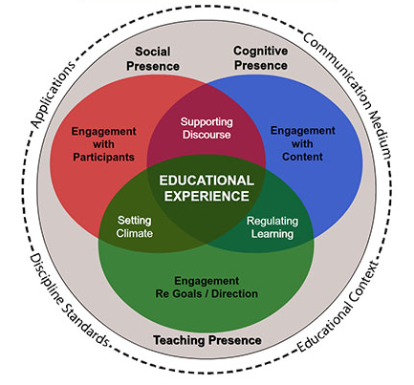
SOURCE: Garrison et al., (2000).

Literature has already successfully utilized the COI framwork to evaluate variious online educational scenarios. However, there is less evidence that suggests that the framework is being used to design strategies that aim to enhance student engagement. (Nolan-Grant, 2019). Another important factor is HE students’ perception of the technologies in the e-leaning process.

2.4.2. Technology acceptance model (TAM)
The rapidly advancement in technology and the benefits and opportunities they unfold, such as flexibility and accessibility as a supplement to the on-campus are still to be seen. However, to explore the potential of e-learning first the students must be able to familiarize themselves and adopt technology with learning purposes.
Use of technology
There are four type of learning approaches such as individual learning, collaborative learning, informal learning and situated learning see (fig.2) Through these approaches students can passed their study, collaborate with others using gadgets at the students’ convenience (Cheon et al., 2012)
Additionally, from a study conducted in Pakistan identified the system characteristic, self-efficacy as factors that the student attitude toward technology (Ji et al., 2019) . Furthermore, another four main challenges were identified in the existing literature, which are individual, technological, cultural and course challenges, which differ from one country to another because of the readiness, culture, and context (Almaiah et al., 2020). Still, the main challenge for developing country remains the poor network infrastructure and content development.
Acceptance of technology
Exploring TAM revealed that student willingness and readiness of accepting and using technologies to e-learning, is based on their experience of using computers, enjoyment, anxiety. (Almaiah et al., 2020). E-learning is achieved through using of various type of computer technologies, mobile devices and is flexible and unique in terms of location and time. (Ji et al., 2019)
Perception of technology
The perception of technology is based on attitudes of users toward new technologies, how easy, helpful, and straightforward is their use, and previous experience by the user and the connection between system design and people’s behaviour. (Saleh et al., 2022).

Fig. 2. TAM and student approaches
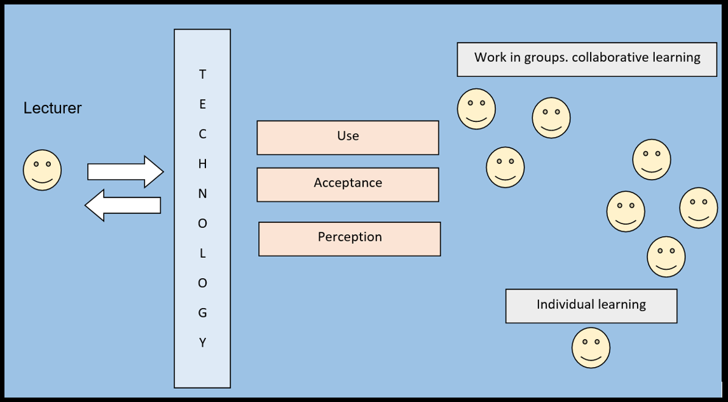
Source: Liliya Hristova

2.4.3. Maslow’s hierarchy of need
Abraham Maslow’s as a psychologist it influenced his research as the concept of motivation is at the heart of his research work with focus on self-esteem, social-behaviour, and dominance. While he did not apply his ideas in an educational setting, still his work was focused on how learning and learning experience is impacted by these factors. (Maslow & Groshong, 1934).
Abraham Maslow (1943) proposed a hierarchy of needs model, which he said would help researchers understand how individuals meet their goals. The model featured five goals, and it would serve as a framework for future studies on motivation. The five level of need are (1) psychological (the basic need, such as water, air,), (2) safety, such as security, familiar environment, protection from harm, (3) belonging, which include belong to group, family, relationships with partner, children, friends, (4) self-esteem, achievement and recognition desire, and prestige, (5) self-actualization, which referred to the self-fulfilment (Maslow, 1943)

2.5. Conceptual framework

Hierarchy of need
The model has been applied in various settings and can be applied to e-learning to measure the satisfaction of students’ experience in e-learning environment though understanding the factors affecting their experience (Milheim, 2012)
First level - Essential basic needs
In general people to survive/ to be alive they have basic needs as Maslow (1943) implies as physiological needs (see fig. 3). In e-learning these basic needs referred to books, materials, appropriate technology and computer, access to strong and reliable internet. As Bennet et al. (1999) stated that institutions have responsibilities to provide the necessary tools and resources.
Second level – Safety
The concept of safety refers to the feeling of comfort and familiarity because without this, people feel anxious and uncertain. The lecturer can play vital role in preparing and establishing a safe and comfortable environment for students though consistency, course design and materials content made available to students to familiarise with it (Milheim, 2012)
Third level – Belonging/ relationships
The goal of individuals to be part of group, be accepted by others in e-learning through communication and collaboration among themselves and with the lecturer. Palloff and Pratt (2005) “In the online environment, collaboration can be seen as the cornerstone of the educational experience. Just about everything that students engage in online, from participation on a discussion board to working in small groups, can be viewed as collaborative"(p. 334)”. Some of the steps in cultivating the student-lecturer and student-student relationship is through acquaintance, creating open and none-judgemental e-environment. Additionally, as Furnborough and Truman, (2009) lecturer contribute by teaching, answering to student questions, giving feedbacks while Students are obliged to be prepared and to participate.
Forth level – Self-esteem
Self-esteem implies to individuals need to be valued and respected by others. Self-esteem is hard to be achieved and especially in e-learning environment. The most fundamental part are strong community of collaboration, learning, sense of respect, being valued and appreciated (Curtis and Lowson, 2001).
Fifth level – Self Actualization
Maslow (1943) describes this level as the ‘urge to grow, the pressure to self-actualize, the quest for one’s identify” (p. 307). In e-learning environment the role of the lecture is crucial in guiding and supporting students toward their strive for self-actualization and their own learning. In 2005, Nash advocated for the use of various tools and resources to help students visualize and get a better sense of self and to enhance their e-learning experience. The technologies can contribute the e-learning process to be more personalized and meaningful.
Fig.3 Maslow’s Hierarchy of need and e-learning. 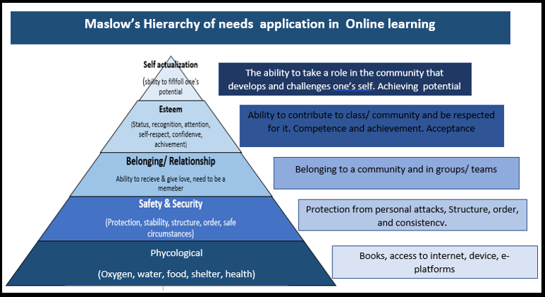
Source: Milheim, K. L (2012)., Amended by Liliya Hristova

Chapter III. METHODOLOGY

Introduction
Research Methodology involves carrying out a study’s design, which ensures that the results of a study are added and addressed the research objectives, by using the research methods, approaches, techniques, and interpretation of the gathered data.

Research Design
The research onion which was suggested by Sanders et al. (2007) contributes to researchers to create a research design following the research onion framework as a guide through the six main layers (see fig.4)

Fig. 4. Research Onion
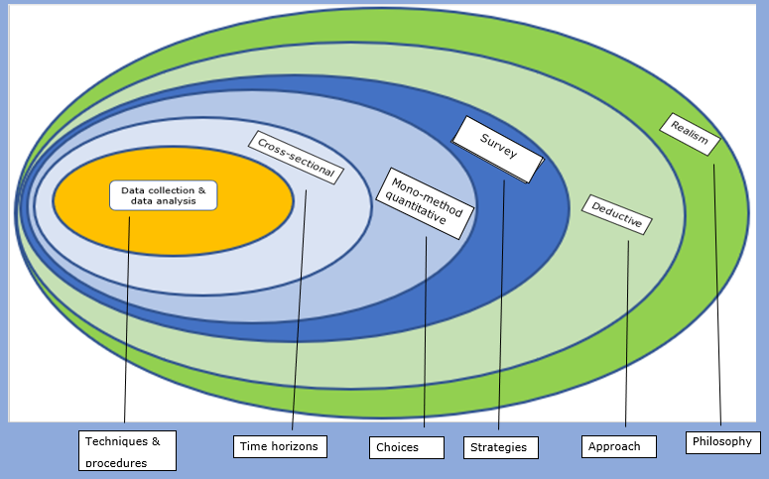
Source: Sanders et al., (2019) Amended by Liliya Hristova

Research Approach
The objective of this study is to collect primary and secondary data. The methods used for this study is a quantitative method, which involves using various statistical techniques to gather data, which will reveal trends and opinions (Sanders et al., 2019), and will be presented and illustrated in figures, charts, and graphs (Stockemer, 2019; Morse & Ogachi, 2021). Quantitative method uses closed-ended questions and the goal for this method is to find-out underlying reasons, problems, patterns, test the causal relations, and how certain facts of event or a situation affect people by finds averages, make predictions and the findings can be generalized to a wider population (Williams, 2021).
The advantages of using quantitative method it produces objective data, which can be communicated in systematic scientific way through use of numbers and statistics, which can be replicated in future studies by other researchers. The researcher goes through the scientific method to come up with hypothesis. Then researcher uses deductive reasoning and analysing the collected data to determine if the data supports or rejects the hypothesis (Williams, 2021). However, the disadvantages of the quantitative method: can oversimplify, dismissed, or belittle individual’s experience by generalising, and not acknowledging the expectations and bias of the researcher in the design of the research (Hammarberg et al., 2016).
The qualitative methods use open-ended questions, and the objectives is to find in detail answers to the questions Why, How, What, etc. The data is collected by interviews, observations, focus groups. The collected data is interpretated by the researcher, which makes this method very subjective, with possible assumptions, prejudice, and bias, which is the disadvantage of the qualitative method (Hammarberg et al., 2016). Furthermore, Qualitative method use a small sample, which might result in data to not be representative for the wider population, it might also not be objective, and influenced by the researchers’ own intentionally bias, experience and opinion (Hammarberg et al., 2016). One of the advantages of Qualitative approach is it explore thoroughly the respondent personal experience, belief, and attitudes. Another advantage is as a subjective reality through the participants perceptions and is a smooth way to achieve the objective of the research(Almaiah et al., 2020)

Research Strategy
Strategy
The researcher will identify the students, who will be part of the study out of the population. They are selected according to the requirements for this study and will answer to a customized questionnaire which aim is to address the objectives and testing the hypothesis. The survey is known as a trustworthy, economic, and effective method for conducting research, which can be performed as many times as needed. Survey is a good method for collecting data as it caches the thoughts and opinion of large number of individuals at one point in time, which align with the topic of this research. To be effective the survey needs to be sent to participants, who are willing to fill out to collect the necessary data, which can be processed and analysed (Rea & Parker, 2014; Stockemer, 2019). One of the risks of how relevant and useful the data is shared by the respondents is their honesty or worries of sharing their opinions while filling out the questionaries (Sanders et al, 2007).
Participants
The number of participants selected for this study is 50 students, who were nonrandomly /intentionally selected meeting particular requirements (Terrel, 2016), such as to be currently studying at UWTSD in Business Management course at level 6 term 1,2 and 3 at the time when the study is conducted, which is the most appropriate for this particular research.

Type of investigation
The study had been conducted through researching the existing literature, e.g., secondary research and gathering primary data, e.g., collecting data through Cross-sectional Survey.

Secondary Research
Secondary research refers to the exiting literature, which is already published and consist of answer, studies, findings from previous researchers. The data is available in the form of books/ test books, research papers, journals, in e-libraries, websites (McMillen & Weyers, 2010).
The topic of this research is current and relevant, which means that many of the literature is UpToDate, but as a new phenomenon COVID-19 is new topic which is still undergoing studies by many students, academic scholars, and researchers around the globe, who are trying to research different aspect of the pandemic, such as the impact on HE. The disadvantages of collecting secondary data are the literature do not always consist of the specific information the researcher is looking for, it is time consuming to go through the existing literature in order the researcher to find relevant information, and for some topic the literature could be out-of-date (Sanders et al., 2007; Hox, 2005)

Primary research
The primary data is referring to directly collecting data by the researcher as the aim is to answer the research questions, test hypothesis truthfulness or falsity and achieve the objectives of the research. For this study this will be achieved by using Questionnaire which will be sent to the selected sample to examine what were the experience of the sample. The advantages are the researcher can collect relevant information, control what data to be shared, and used in the study. The disadvantage of this method it is time consuming, costly, and the findings can be misleading, because of participant’s dishonesty or errors in filling out the questionnaire (Sanders et al., 2007; Hox, 2005). For this study secondary and primary data was gathered and analysed to answer the research question of this study and to address the objectives.

Data Collection Methods
This research adopted deductive research strategy and a quantitative method was used. The Survey created on Google Docs was used to collect data through sending a link to the selected sample’s emails together with “Consent Form” (see Appendix A) and the “Information sheet” (see Appendix B) file-documents, which explain in detail what is the research about, what type of data and how the shared data will be stored and used. To guarantee the anonymity and confidentiality of the respondents they have been given unique ID code (see Appendix A and Appendix B)

Questionnaire
The focus on this survey is to examine the online experience of HE students during COVID-19 pandemic and the factors that impacted their experience. This study employs a cross-sectional type of survey where the number of undergraduate students selected sample participated in the online survey, conducted for two weeks, from 15. 03.2022 to 30.03.2022. The structure of the questions is close-ended questions and statements, with written optional answers, and the participants had to only tick the answer which is the most relevant to them or their opinion. The survey consists of 19 questions and at the beginning of the Survey there is a short reminder and information for the participants on how the data will be used and the requirements for participating in the Survey (See Appendix C). The questions and statement’s purpose are to address the objectives of this research and to answer the research questions. The disadvantage of using closed-ended question is limiting the participants way of responds (Reja et al., 2003.).

Validity and reliability
Construct validity is the idea of this research is to examine the student e-learning experience during COVID-19 pandemic and to be done the investigating approach was undertaken to examine it. This approach implies quantitative method was used to collect the data by creating questionnaire where the selected sample (n=50) can answer. The internal validity was achieved through Identifying key factors (variables and their causal relationship by creating hypotheses the research questions and objective were addressed. Moreover, and to find out to what extend the findings from the conducted research can be generalised to other groups or relevant setting. How representative is the findings of the selected sample to the population, which is how the external validity is achieved(Middleton,2019).
Reliability of the research is to what extend the collection techniques and analytic procedures would reproduce consistent outcomes if replicated by other researchers or repeated in another case. The main reason for ensuring that the research is reliable is to find-out if using similar sample to this research, with the similar techniques and analytic procedures and at different time is it going to result in different findings. The main concerns that are taken into considerations are researchers bias by keeping objectivity during the research. And the other two are participants error and bias, which are avoided through informing the sample regarding the Survey and freedom to choose their answers Another factor is the Researcher’s bias which was taken into consideration in creating the survey and collecting and analysing the data. (Middleton,2019).
The researcher used one of the most common statistic determinant Cronbach’s alpha to check the consistency of measurements, such as multiple-question Likert scale used in this research. The variable answer ranking of Likert scale 5 (see table1) were converted to numbers to do the calculation using Excel with the formula for Cronbach’s alfa ( see bellow). The result is illustrated below in table 2 the consistency of the measurement, e.g., the Survey.

Table 1. Liker scale
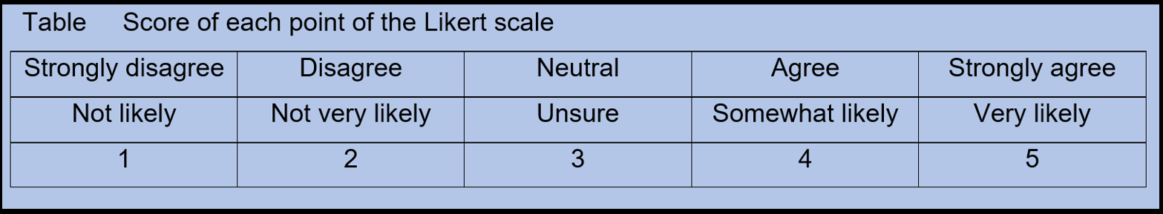

Cronbach’s alpha formula:


Table 2. Results and interpretation
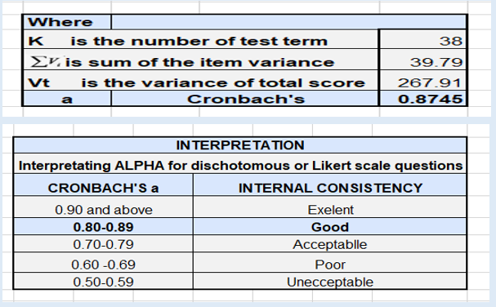
From the conducted calculation the result of Cronbach’s Alpha is 0.8745, which means the design questionary is GOOD enough to measure accurately internal consistency of the variables of interest, which contributes to reliability of this and allowing consistency for future analysis.

Research instruments
Research is a systematic process that involves collecting and analysing data using research instruments, such as survey, to transform data into useful information (Wilkinson, 2000). The research instrument for this study is a Survey, which was distributed to the selected sample(n=50).

Sample size and Sample type
The sample size for this study is not important by itself as long the information contribute to answer the research questions to achieve success in finding trends and patterns that will emerged (Saunders et al., 2019). The data collection will be terminated once patterns and trends in percentage, or the collected data outcomes becomes steady and does not change the outcomes. At that point the collected data will be enough to support the researcher in answering the research questions.
The number of students currently studding at UWTSD London campus which is around 2000 students of which around 800 are enrolled to study Business management program of study and are currently at 4th, 5th, and 6th level out of which is the population, the student of interest, for this study are approximately 100 students (N = 100) at their final year of study at 6th level in 1st, 2nd and 3rd term. Out of this is the selected sample size of 50 students (n=50) that are the subject of the study.

Sampling methods
The sample for this study was nonrandomly chosen to include students who meet the requirements of this study, who were studying on-campus and had to transition to e-learning because of COVID-19.

Data Analysis technique and interpretation
Data analysis will depend on the selected method and nature of the data. The method could be quantitative, qualitative, or mixed methods. As each method used different techniques to analyse and interpretate the data. For example, the quantitative method uses statistical data based on numeric values, while qualitative data is focus on gathering deeper insights and try to understand, explain, and answer the questions such as Why. Moreover, the mixed method is a combination of Qualitative and Quantitative methods and the findings from this method will contain deeper meaning and insights and better picture of the research topic.(Plante et al., 1994)

Ethical Consideration
The study is conducted in a manner that is acceptable to the UWTSD university. The students who participate in the study, were informed regarding the study and how their information will be treated with respect, confidentially and with compliance to the British Educational Research Associations (BERA, 2018), GDPR (2018) and Data Protection Act (2018). Additionally, before the study begins, the participants will be asked to complete the “Consent form” provided by the study facilitator in which is clearly stated key points such as (1) the participants can withdraw at any time, (2) the information provided by them will be treated with sensitivity and without regard to their gender, race, religion, or disability, (3) the information is gathered on voluntary based and no one should feel coursed, (4) the behaviour and methods adhere to honesty, professionalism. and to the objectives of this study and there is not bias or prejudices, and if any concerns and enquiry arise will be addressed accordingly in a professional manner.

Chapter IV. FINDING AND ANALYSIS

Introduction
The aim of this chapter is to analyse the collected data from the Survey and the impact from online learning on HE students during COVID-19 pandemic. The Survey consists of 19 questions and statements as the first 9 questions require demographic information of the sample size and the other 10 are with focused on pastoral support and academic learning experience of the students at 6 level (See Appendix C). The data is then analysed and visualized in various charts and graphs. Furthermore, as the method used is quantitative for this study is descriptive, which helps the researcher to find patterns and trends. and then the answers can be generalized to the population

Survey Findings
PART ONE - Demographic questions 1-8.
The key findings regarding the demographic questions revealed that most of the students at level 6 enrolled in Business Management program of study are ‘adult students’, aged above 24 nearly 80% as the proportion of Female (78%) is significantly higher than the proportion of male (22%). Another finding is the employment status of the students as part-time or full-time employees represent nearly 80%(n= 33). During Covid-19 one way or another more than half 53%(n=22) of the respondents’ employment was affected while 39% (n=16) continue to work. More than half the respondents(n=22) have previous experience in HE (Q5) and Q11 revealed that most of the respondents (n=30) have previous e-learning experience. However, it is not clear what part of this e-learning experience is of courses or HE studies. The nationality of the respondents in Business Management is mostly from Bulgaria and Rumania (n=37), and small proportion is from North Macedonia and other countries as this is reflected in the high percent of respondents identifying themselves as white (92,7%).

PART TWO - PASTORAL SUPORT Questions 9-10
Significant proportion of the respondents Agree (A) or Strongly Agree (SA) that IT services were helpful and MC Teams very good platform to use. Q14 complements the notion of MC Teams virtual classes for more than half of the respondents to determined ‘excellent’. Regarding Lecturers’ overall teaching it was delivered in a way to be understood by them, more than half (n=23) of the respondents are ‘very pleased’ with the teaching process(Q11) and majority(n=36) of the students consider lecturers were ‘more supportive’ (Q14).
Regarding E-library and Moodle content provided in various form (Q11) almost half of the respondents consider to be sufficient and helpful(Q10). UWTSD have taken sufficient measures for their physical and mental safety(Q10) as well were communicated in a timely manner regarding any changes related to their study.

PART THREE – ACADEMIC LEARNING Questions 11 – 19
More than half of the respondents(n=25) feel confident with Technology and count on their internet connection strength. This confidence in technology must come from significant number of respondents owning various Electronic Devices, own (n=33), belong to the family (n=6) and previous experience with E-learning. And only one of the respondents borrowed and another hired their device. However, the fact that most of the students owned electronic devices still some of them missed e-classes due to issues with technology or poor connection. About the virtual learning environment, the time management was good and significant number of respondents were able to communicate with their classmates (student-student interaction) before or after the classes. Respondents indicated that they were better prepared and participated more in class, which give them the notion to feel full-time students, even though they were physically at their home where majority according to the responses were in a room or office intended to be use during e-learning classes. However, small number of respondents were disturbed during e-classes by household members.
(Q16) The main concerned were regarding their current study issues and future education, followed by personal finances, family, relationship, eating habits, mental health, and similar pandemic in the future. The least concerned is regarded toward their physical activities and health.
(Q17) Regarding the student performance more than half of the students feel motivated to achieve their goals and to study and experienced personal growth from e-learning. However, 1/3 of the respondents (n=13) consider that their lack of discipline is the obstacle for their e-learning success and some D or SD (n=16) with this statement.
(Q18) Studying online in the future 62% (n=25) are likely or very likely to study online in the future, based on the significant number of the respondents can be assumed that they had positive experience pleased/ satisfied by the transition to e-learning, which is confirmed by the next question (Q19) answers where 69.7% (n=29) are likely or very likely to recommend UWTSD. However, some 12% (n=5) not likely to study online, 19.5% (n=8) are not likely to recommended UWTSD can assumed that they for some reason/s have negative experience. And the rest are 25% (n=10) are that are unsure can be interpreted as neither positive not negative.
One surprising finding of this research is the number of participants , who indicate neutral position to some of the questions and statements as in some cases is half or one third of the respondents.

Result, Analysis and Discussion

Survey results and analysis

PART ONE – DEMOGRAFIC INFORMATION
QUESTION 1. WHAT IS YOUR AGE?
Data revealed that most of the respondents age range is in four categories (18-24, 25-30, 31-35 and above 36). The smallest number of respondest is the yongest group range aged 18-25 are 12.2%,(n= 5), and the largest is the oldest group range, above 36 with 41.5% (n= 17) respondents. The sample size represent the proportionaly the age groups as significant number of the participants are adults students aged above 25.
Table 3.
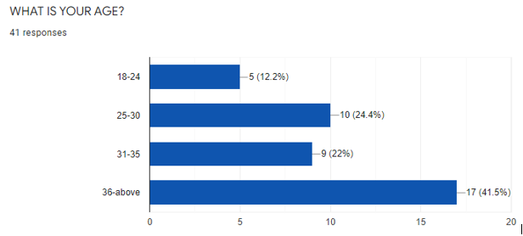
QUESTION 2. WHAT IS YOUR GENDER?
The data analisys in table 2 ilustrates the proportion of female gender at level 6 is significantly higher than male, with 78% (n= 32) female and only 22% (n=9)
Table 4.
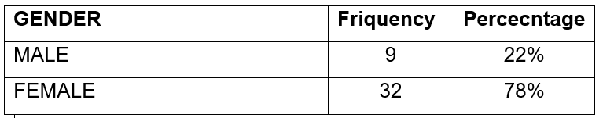
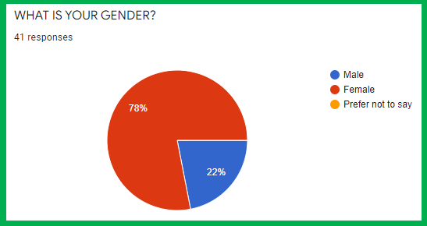

QUESTION 3. WHAT IS YOUR EMPLOYMENT STATUS?
As majority of the students are adult students most of them are part of the work force in UK as 41% as a full-time and 26.8% as part employee and 12,2% as self-employed, which means in total 80% of the sample respondents are working. And approximately 19% are unemployed, as half of them are looking for job and the other half are not.
Table 5.
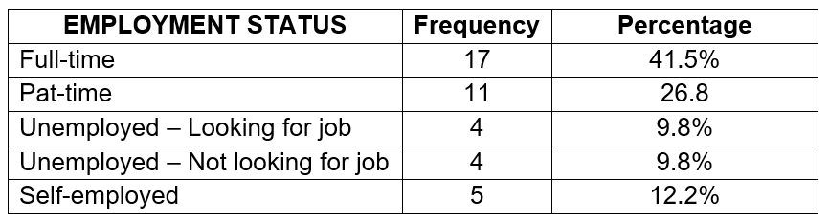
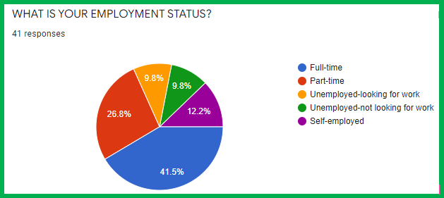

QUESTION 4. WAS YOUR EMOLYMENT STATUS AFFECTED BY THE COVID-19 PANDEMIC?
For 34.1% did not change as a result from the pandemic COVID-19, however nearly half of the respondents’ employment status was affected as 29.3% were temporary unemployed or on furlough scheme, and another 14.6% have lost their job, and a few 4.9% had salary or hours cut. Approximately 10% lost their job prior to the pandemic and 7.3% respond other reasons, which are not given as an answer option.
Table 6
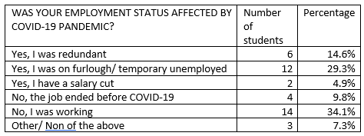
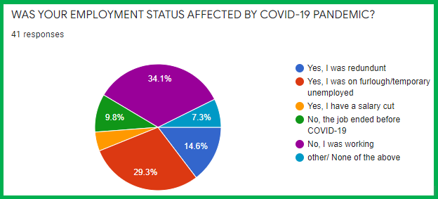
QUESTION 5. WHAT IS YOUR EDUCATION LEVEL?
A significant number of the respondent regarding their level of education are with high school diploma (43.9%), College degree (14.6%), or Bachelor degree (39%), And only 1 person is with Master degree, which means that more than half of the respondents have previous experience in HE.
Table 7
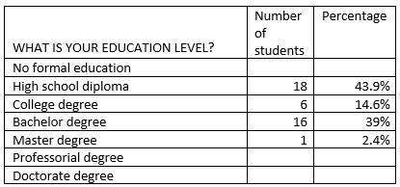
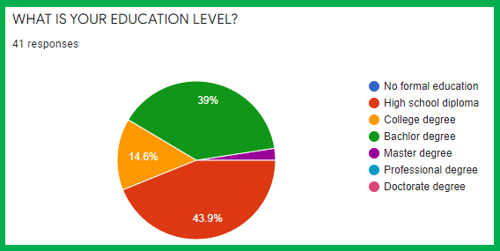

QUESTION 6. WHAT IS YOUR LEVEL OF STUDY?
There are three terms at level 6 in Business management with approximately 30 students in each. The questionnaire was sent to them selected sample of 50 students. The most active respondents are from term 3 followed by term 2 and only one respondent from term 1, which means that the best representativeness of the population at level 6 is for term 3 students.
Table 8
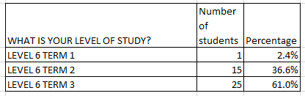
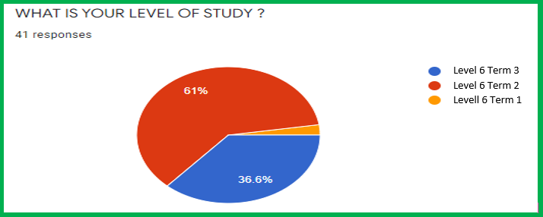

QUESTION 7. WHAT IS YOUR NATIONALITY?
Most of the respondent’s nationality is Bulgarian (53%), followed by Rumanians (36%), North Macedonian (7.3%) other nationalities. This represents the percentage for the rest population of students studding Business Management at UWTSD.
Table 9
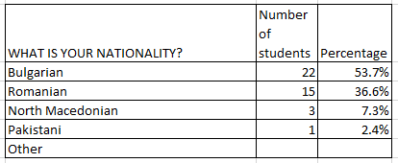
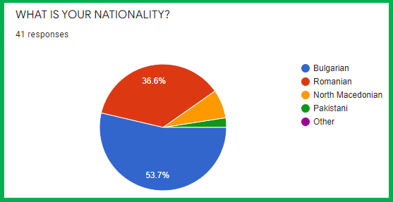

QUESTION 8. WHAT IS YOUR ETHNICITY?
The respondents regarding their ethnicity they identify themselves as white 92.7% (n=38) and only few 4.9%(n=2) identify themselves as other and only 2.4% (n=1) respondent prefers not to say.
Table 10
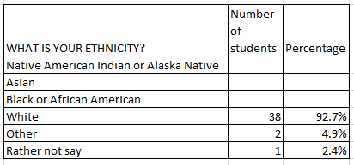
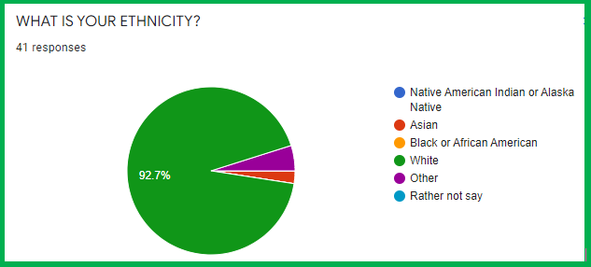

PART TWO – PASTORAL SUPPORT
QUESTION 9. TO WHAT EXTENT ARE THESE STATEMENTS RELEVANT TO YOU?
The type of question is Likert scale of five containing a combination of statements that will give option to students to indicate to what extend (ranking) the materials and platform for the online classes enhanced their experience of e-learning during COVID-19. Regarding the first statement more than half of the respondents (n=21) A or SA that the content on Moodle platform were helpful. While 13 D, and 1 SD. Some (n=7) responded as neutral, which means neither agree nor disagree with the statement.
Regarding Lecturers’ overall teaching in a ways student to understand the lectures respondents (n=15) A, and some (n=5) SA with this statement, while others(n=6) Disagree, and the rest (n=15) are neutral. Regarding MC Teams usefulness majority of the respondents A (n=25), or SA (n=9) and small number stay neutral (n=3) or disagree (n=5) with that statement. And finally, regarding the IT services during COVID-19 most respondents A(n=20) or SA (n=12) with the statement and only 9 of them are neutral.
Table 11
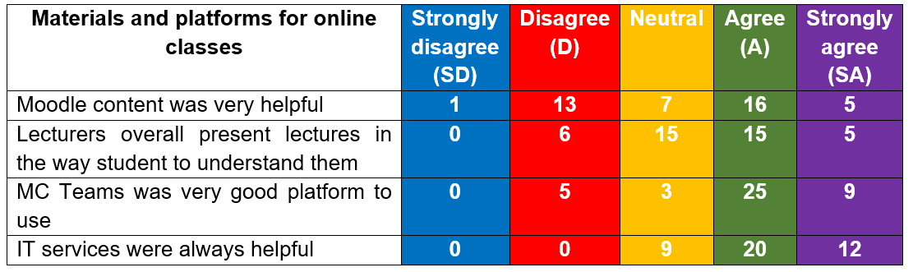

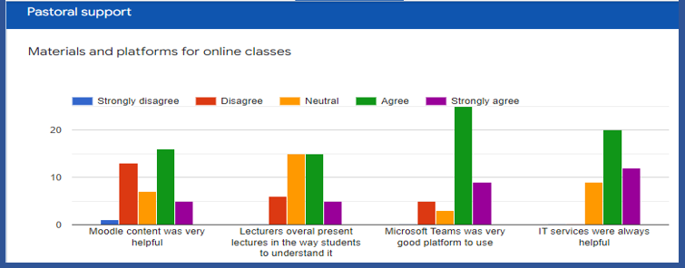

QUESTION 10. TO WHAT EXTENT ARE THESE STATEMENTS RELEVANT TO YOU?
The distribution of answers regarding the changes to students’ classes was done by UWTSD in a timely manner as most of the respondents A (n=15) or SA(n=9) to this statement. While the rest D(n=6) or SD (n=1) with the statement and some (n=7) are neutral. Regarding the student physical safety, majority A (n=22) or SA (n=9) with that statement. And only small part is neutral (n=7) or D (n=2) or SD (n=1). About the overall teaching process significant number of the respondents are pleased and A (n=15) or SA (n=8) to the statement. And only some respondents D (n=9) or SD (n=1) to the statement. As for respondents Well-being majority consider that UWTSD has taken sufficient steps and A (n=16) or SA (n=11) to that statement. Only few (n=2) respondents D, while some (n=11) take neutral position. One of the respondence of this survey missed to give their answer to this statement, which does not change the outcome in this case. Regarding the resources provided by the UWTSD many of the respondents A (n=20) or SA (10) to this statement. Moreover, regarding the online library many A (n=17) or SA (n=9) that the resources are sufficient in the online library and only small number D (n=3) or SD (n=2) with the statement.
Table 12
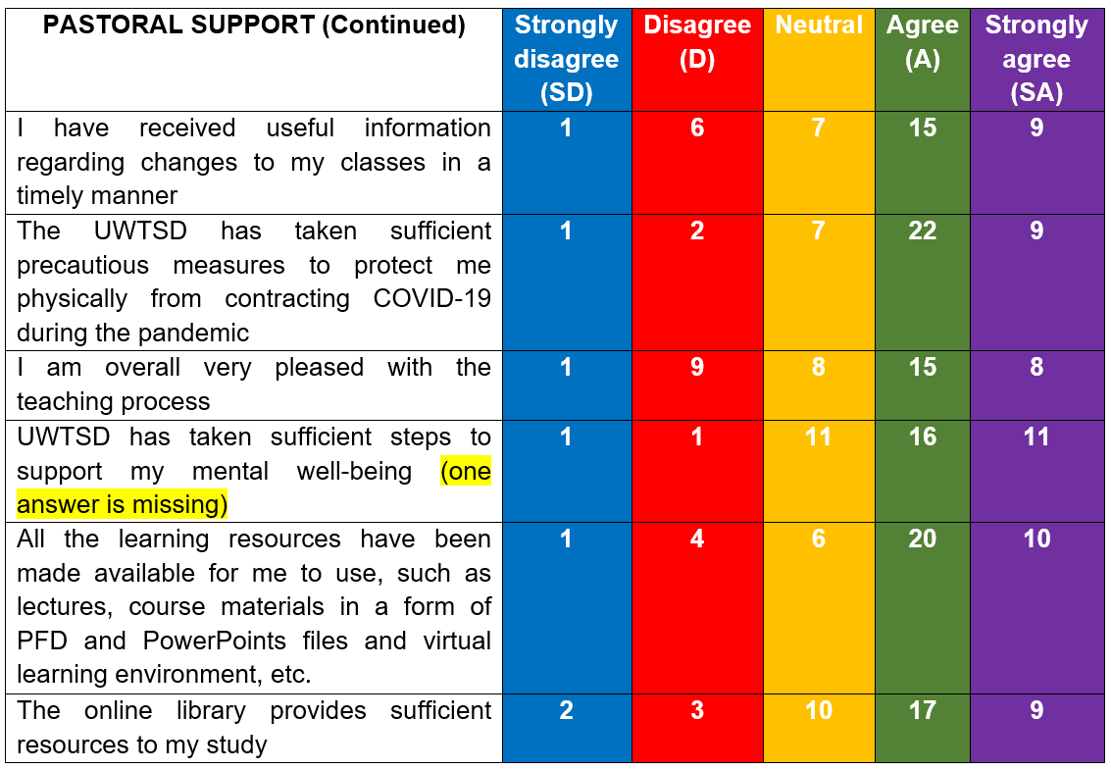
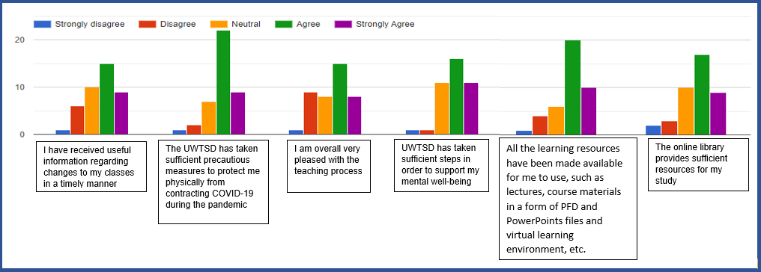

PART THREE – ACADEMIC LEARNIING
QUESTION 11. TO WHAT EXTENT ARE THESE STATEMENTS RELEVANT TO YOU?
Significant number of the respondents A (n=17) or SA (n=8) feel confident in their technology knowledge and use of technology and only small part Disagree(n=5) or SD (n=1), while some(n=11) neither agree nor agree. Regarding respondent’s previous experience with online courses or classes many of them responded (n=32) agree and (n=8) strongly agree to the statement. 9 out of 41 students experienced issues with technology or poor connection as result they missed some classes on MC teams. While the rest (n=25) had no issues and could rely on their internet connection(n=26).
Table 13
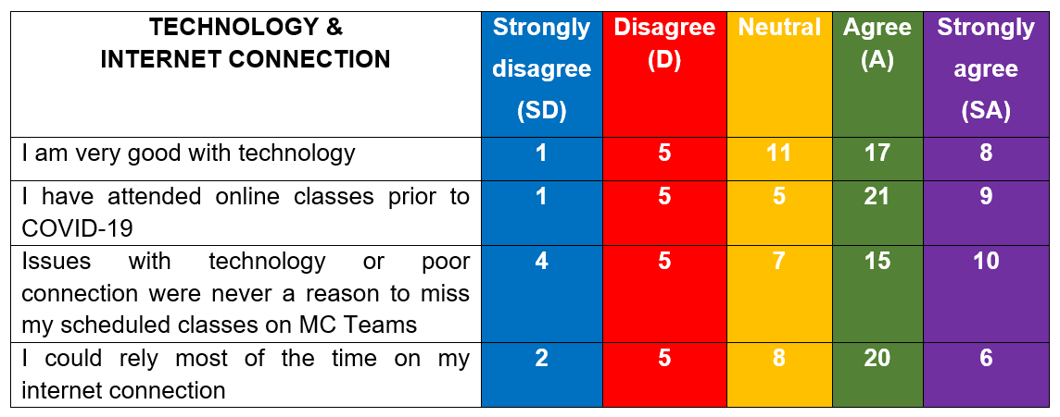
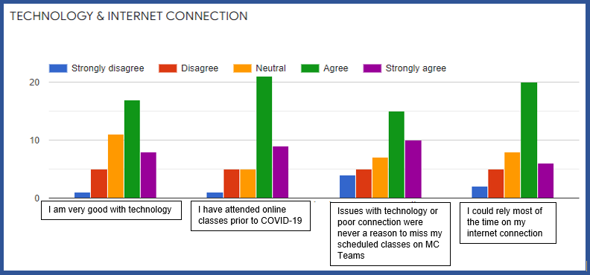

QUESTION 12. WHAT DEVICES WERE USED FOR MY LECTURES?
Regarding the devices used during their classes almost half of the respondents answer they used Laptop (43.9%) and rest used either their Mobile phones (14.6%), Tables (14.6%), or Computer (12.2%) and some have used all of the mentioned devices (14.6%).
Table 14
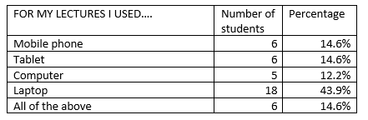
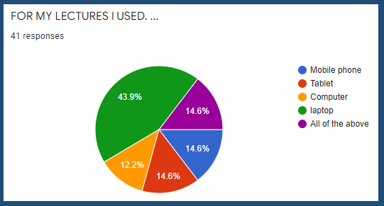

QUESTION 13. TO WHOM DO THESE DEVICES BELONG TO?
This question gives more details to whom the devises belong, and significant percentage of the respondents (80.5%) have used their own devices during classes, and some (14.6%) have used devices that belong to the family (and only two students do not possess electronic devices, as one of them borrowed and the other rented the device. As most of the respondents are adult students, who work that is not surprising that most of the respondents poses electronic devices.
Table 15
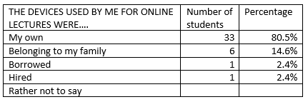
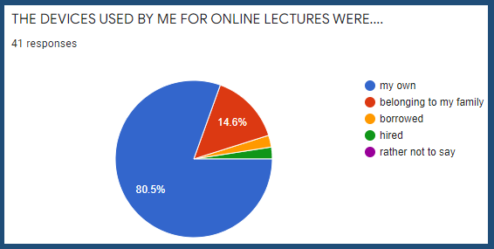
QUESTION 14. TO WHAT EXTENT ARE THESE STATEMENTS RELEVANT TO YOU?
As the pandemic forced the closure of educational institutions, students attended virtual classes and based on their responses some(n=15) of them consider they were better prepared for classes and increased their(n=22), participation in class. While some of them disagree or are neutral. Majority (n=32) of the students believe that classes were with proper time management which is one of the factors most of them to feel that the virtual classes were excellent and to feel full-time student (n=28). Majority of the respondents (n=27) still were able to communicate with their classmate before or after the classes, based on the respondents’ answers can be assumed that respondents experienced formal and informal socialising experience and building trust and relationship among peers. And here one of the respondents skipped one of the statements.
Table 16
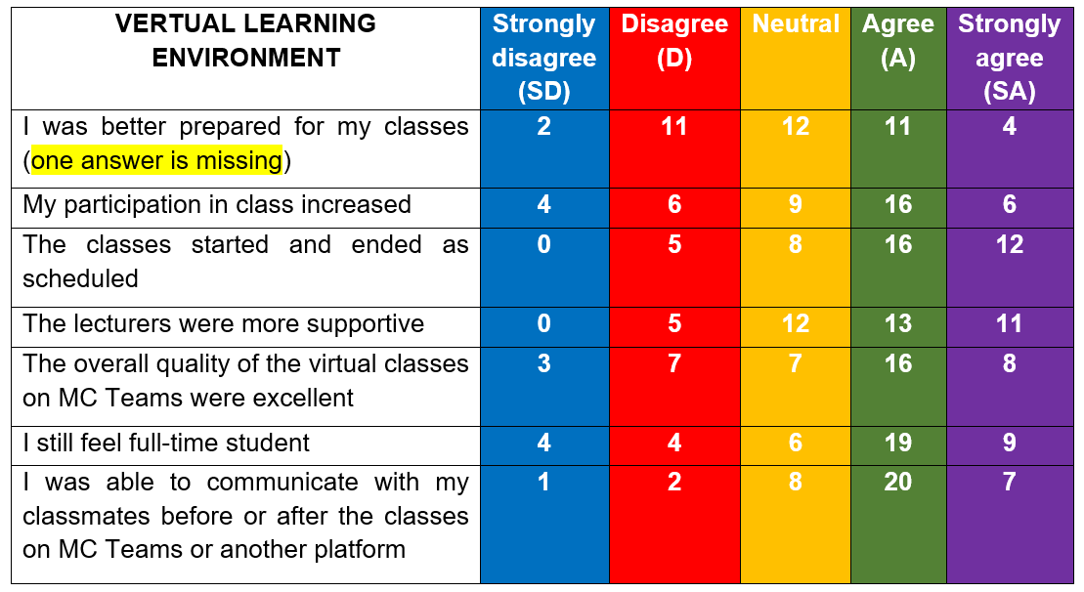
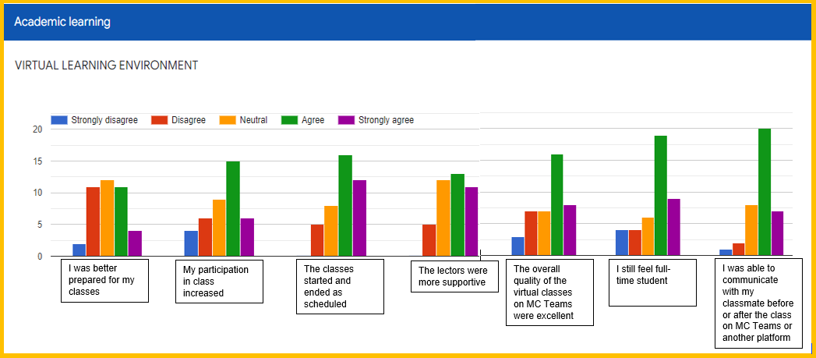
QUESTION 15. TO WHAT EXTENT ARE THESE STATEMENTS RELEVANT TO YOU?
Regarding the home environment conditions based on the answers considerable number of the respondents(n=29) were able to use own room, or office during classes. However, half of them(n=24) indicated that they disagree with the statement for being disturb during classes by household member and few were disturbed.
Table 17
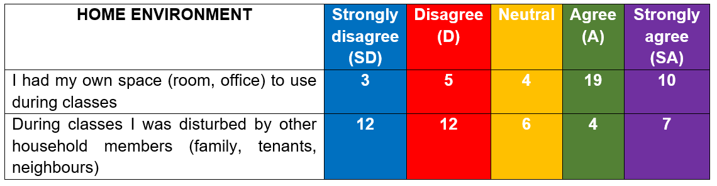
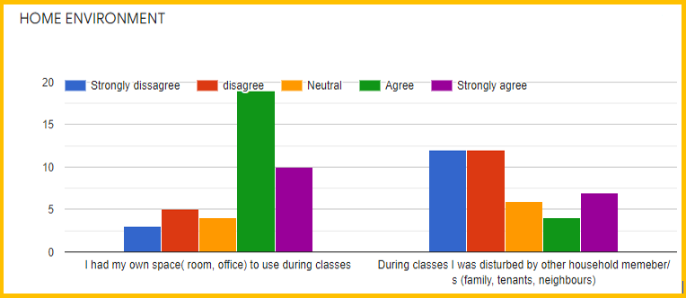
QUESTION 16. TO WHAT EXTENT ARE THESE STATEMENTS RELEVANT TO YOU?
Regarding the statements Mental and Physical health more than half of the respondents the main concern they have is related to their current and future education. Fallowed by concerns regarding finances, personal relationships, eating habits, and the least concerns the student had of their sport activities, and other pandemic in the future. Which can be explained with the big percentage of the respondents who continue to work or received government financial support during the pandemic and their financial stability was not significantly impacted. While some were neutral to the factors impacting their mental or physical health.
Table 18
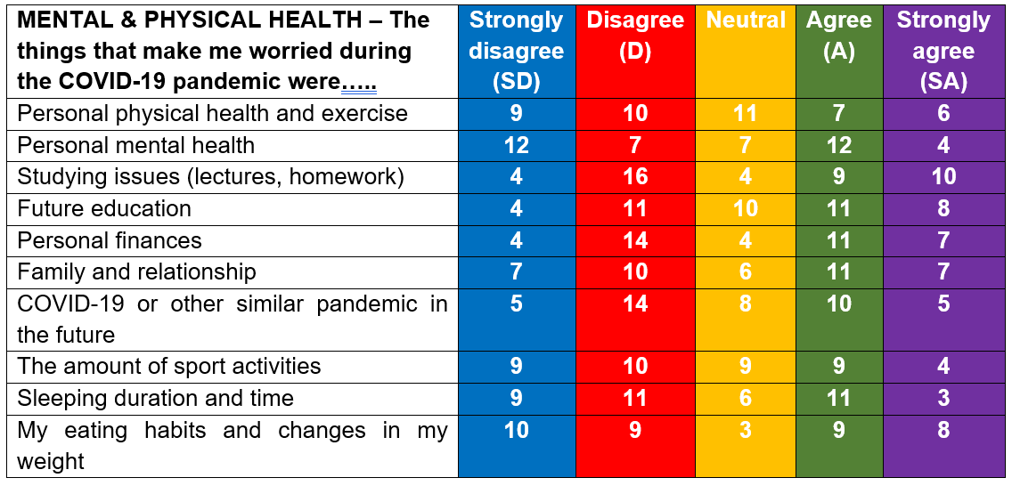
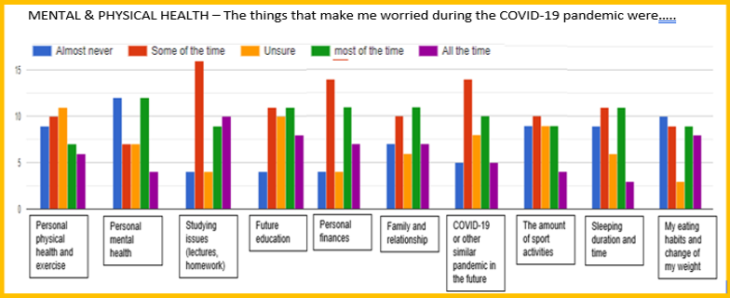
QUESTION 17. TO WHAT EXTENT ARE THESE STATEMENTS RELEVANT TO YOU?
To the question regarding their performance the respondent consider that their personal discipline was not an obstacle to their e-learning performance as thirteen of them disagree and 3 strongly disagree and 12 are neutral. However, 7 out of 41 respondents agree and another 6 strongly agree to the statement. Some (n=18) considered that this was an opportunity for them to experience personal growth and majority to become more motivated in achieving their goals and to study. However, there are still respondents who neither agree nor disagree with these statements.
Table 19
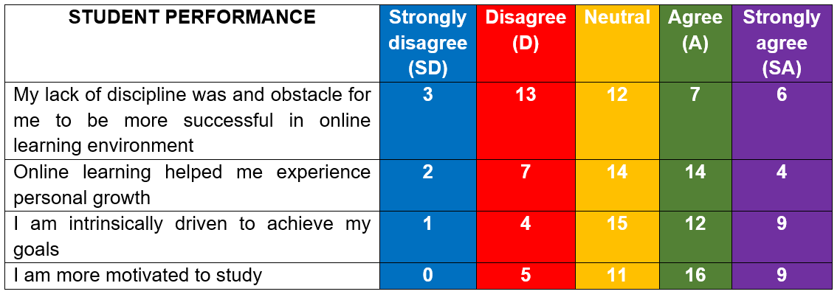
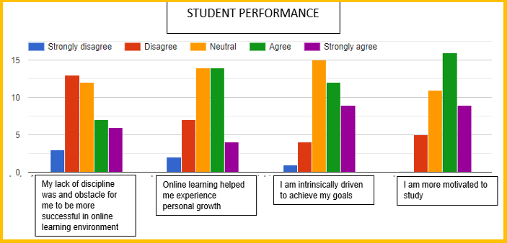
QUESTION 18. HOW LIKELY ARE YOU TO CONTINUE LEARNING/STUDYING ONLINE IN THE FUTURE?
On this question many of the respondents are very likely (35%) or somewhat likely (27.5%) to continue studying online in the future, while some (25%) are neutral, and small percentage are not very likely (10%) to study online in the future. Based on the answers significant percentage of the respondents do not mind studying online in the future.
Table 20
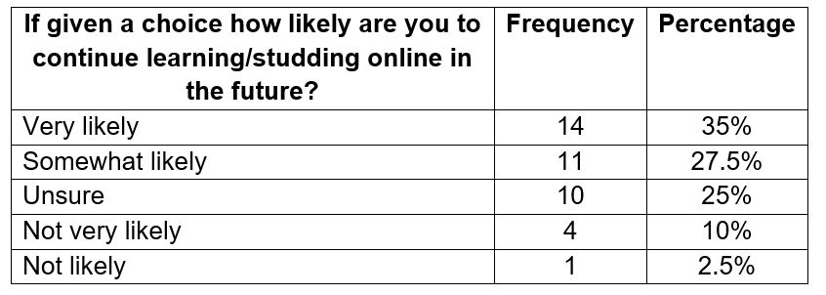
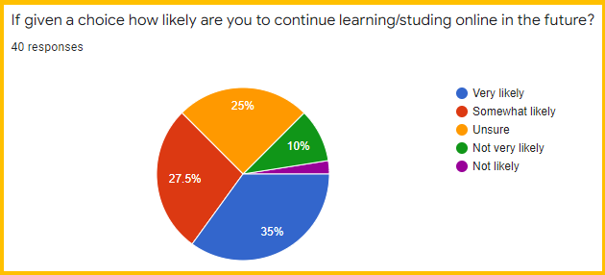
QUESSTION 19. HOW LIKELY ARE YOU TO RECOMMEND UWTSD TO A FRIEND OR COLLEAGUE?
On the question how likely they are you to recommend UWTSD to a friend or colleague 31.7% responded very likely, and 39% somewhat likely. Based on their responds can be assumed that sizeable number of the respondents had positive experience during their study at UWTSD. However, some of the respondents (17.1%) are not very likely to recommend the university and some are neutral (9.8%).
Table 21
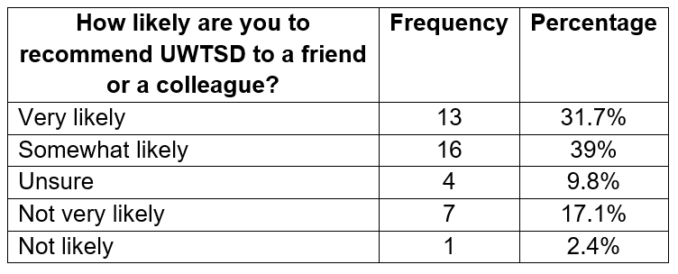
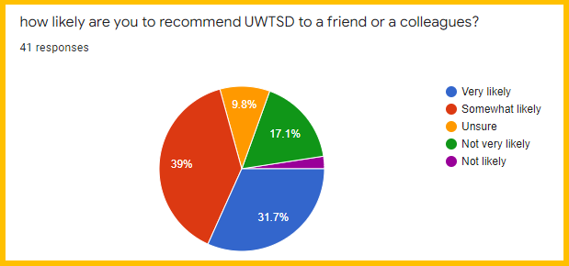

Discussion

Introduction
The focus of this chapter is to analyse the primary and secondary data collected, which will be used to address the objectives of this research and test the hypothesis weather they are true or false.

Testing the hypothesis
Hypothesis are claim or statement that the researcher wants to test. They are two types of Hypotheses Null (Ho) and Alternative (Ha or H1). The Null hypothesis is the currently accepted value for parameters or general accepted knowledge and the opposite is the Alternative Hypothesis (Ho or H1), which are challenging the Null Hypothesis by assessing the accepted parameters or the general accepted knowledge. There are two outcomes of investigation which are Reject the Null Hypothesis or Fail to reject the Alternative hypothesis. Testing the hypothesis is equal to the expected and expressed relationship between variables and the difference between group variables. Testing the Hypothesis will provide key take aways of the key findings relevant to the research question and objectives (Lehman & Romano, 2005)
The word ‘Significant’ is added to the hypothesis to ensure that the findings are “Real” and not due to a chance The designed hypothesis must be (1) consistent with prior observations and research, (2) reasonable explaining of events that already occurred or that will occur in the future, (3) stated clear and concisely and (4) be testable (Terrell, 2016).
H1 The interactions Lecturer-student, student-content and student-student in e-learning environment significantly contribute to positive HE students experience and the notion of being full time students.
The Academic and Pastoral support are represented through the services provided at the University for the emotional and mental well-being of students in HE, which is complexed and multi-faceted. While Academic support is the variety of educational methods and services provided to students to enhance their learning experience and progress. (Marshal, 2019)
The existing literature and as Garrison, (2008) stats the COI Framework is comprehensive and recognise the importance of community in HE and is built on two fundamental ideas: inquiry and community. A community of inquiry appropriately connects the three elements social presence, teaching presence and cognitive presence, in other words the three interactions Lecturer-student, student-student, and student-content which are the determinant of constructing deep and meaningful educational experience for the HE students (Garrison and Vaughan, 2008)
The results of the primary study (Q9-10) revealed that structure of teaching and learning were develop and implemented where students were provided by UWTSD with the necessary resources to support their e-learning using various materials. Additionally, the students were able to use e-library, MC Teams and be supported by IT. Furthermore, the quality of the interactions between the students and lecturer, the student and the resources provided (content) and the interaction among peers were the three key factors that influenced their perception of being full-time students. Moreover, the engagement was higher based on the two factors indicated by students. First, they increased their participation and second, they were better prepared which is supported by the Maslow’s hierarchy of need, which implies to students being more engaged and motivated to study and achieve goals once their basic needs were met. Based on these can be concluded that this hypothesis is true.
H2 Issues with availabilities and accessibility of technologies and reliable network are significant barrier for HE students to transition into e-learning
From the existing literature and studies where TAM framework was applied revealed that the most significant factors for students’ transition to e-learning are their acceptance and use of technology and attitudes of the user toward technology (Al-Emran & Shaalan, 2021)
And from other studies related to the forced and sudden transition from in-person to e-learning revealed that some of the main factors that prevent students from doing so are the lack of devices and poor network connections. This is contrary to the findings of the primary study, which found that the factors that affect students’ accessibility to e-learning were not related to their lack of devices or poor network connection as most of them owned devices and reliable network (Q12-13),and therefore, this hypothesis proved to be false for UWTSD HE students’ sample.

H3 – The loss of employment or reduced working hours leads to HE education student to be significantly less motivated toward study and achievement of their goals.
The sudden reduction of working hours or redundancy would lead to less or no income to meet the physical basic needs as per Maslow’s hierarchy of need. Which implies that students will become more concerned, and they are likely to become more anxious and stressed out as a result. Half of the students were not working, however, 68% (n=28) continue to receive income from work or furlough scheme.
Meeting the basic needs of Maslow’s hierarchy of need (1943) will give them opportunity to work on the next step in the hierarchy of needs, which is security and belonging. In the context of e-learning the basic needs refers to content, access to internet, device to use and e-platform. The result from the Survey demonstrated that the basic need for e-learning were provided by UWTSD(Q9-10), and substantial number of the respondents( owned devices and had confidence using them as well their internet is reliable(Q12-13). So, it is not surprising that respondents of the survey consider to be more motivated to study and to achieve their goals as 2/3 of them continue to receive income and were able to focus on other things than to meet the basic needs, which agree with Maslow’s hierarchy of need. Therefore, this hypothesis is true.

H4 – Face-to-face learning form of education is better E-learning
The finding from a Survey conducted in India with 440 HE students regarding on-campus and e-learning and the perception of the students showed that male student is more inclined toward e-learning compared to female, who preferred in-person classes (Zulfiqar et al.2020)
Regarding E-learning Cook, (2009) through his meta-analysis and findings reports that e-learning is better than on-campus. Moreover, the existing literature where on-campus and online learning are compared the fallowing findings are e-learning is more effective than traditional learning due to its ability to provide students with a wider variety of skills and knowledge.
Unlike regular education, online education is not required students to attend the university as they can use technology, internet, and electronic devices to attend virtual classes. Moreover, students can access variety of provided resources at any time and from any location. In-person education is interaction face-to-face while online is communication through emails, chat rooms, and video calls using e-platforms such as MC Teams. Furthermore, Online education is more flexible and more affordable as it does not require students to pay travel expenses in comparison to on-campus learning (Zulfiqar, et al.,2020). Blended learning or synchronised learning is also said to be more effective and can be adopted and well accepted by the learners and lecturers.
The findings from the primary research showed that students were more engaged, ready, and motivated, even though their concerns regarding their physical and mental health. They can access the learning materials, and additionally to use the e-library. Moreover, IT support is provided and e-platform to be used. Changes were communicated in a timely manner. The HE students were able to communicate through e-platforms. The number of students who are most likely to continue to study online in the future is significant, based on the mention factors can be assumed that e-learning is better at least for the respondents at UWTSD. Therefore, can be said that the hypothesis is false

Chapter V. Conclusions, Recommendations & implications
It is important that all individuals involved in the design and delivery of virtual courses have the necessary knowledge and skills to ensure that their student have satisfying learning environment, and positive experience. (Milheim, 2012)

Conclusion
The objective of this study was to examine the He education students during COVID-19 pandemic. Based on the above finding and discussion becomes clear that one of the key importance of student experience is the provided pastoral and academic support and additionally the technology and the three fundamental presences of COI framework. The acceptance and accessibility of internet and possessiveness of electronic device play crucial role to shaping the student experience.

Addressing the objectives
Critical review on existing literatures
The study was carried out using primary and secondary data as the main objective of the study was to analyse the existing literature of online learning experience during COVID-19. Many authors expressed their views on the effects of the pandemic on students' online experiences in HE. One of them is Demuyakor (2020) whose study findings demonstrate that student supported the initiative of e-learning, although some issues such as availability. reliability, affordability and accessibilities of the internet connection and resources was and obstacle to some students. Several authors in their studies mentioned in their researchers highlight that COVID-19 caused many aspects of the learning and teaching process to change, and the issues encountered by students and faculties. However, the existing literature in the last two decades mentioned how distance learning, e-learning, steadily is introduced to the education sectors, but this change drastically because of the pandemic, which boosted the online education as it forced, HE education institutions to adopt e-learning, as there was no other alternative for education process to continue.
Furthermore, the objectives of this study were address further and the hypothesis were tested to find out to what extend the factors that impacted and affected the online experience of HE students at UWTSD during the COVID-19 pandemic.
Research objective 1 and Research question 1
The students experience during the pandemic identified key factors that shaped their perception. Despite the pandemic and the uncertainty that it brought on all aspect of life the UWTSD various academic and pastoral support services were designed to help students manage their emotional, mental, and physical health. These include support services, ensuring the safety of the students and faculty, providing sufficient resources and e-platform, and learning and teaching online structure of education.
The first main objective of this research was to examine the experience of HE students at UWTSD during COVID-19 and how it shaped their perception. The finding from this research shows that the perception of the students was shaped by few key factors the three presence Social, Cognitive, and Teaching presence, which were fundamental part of shaping the students’ perception. The First Hypothesis supports these findings of the primary research based on the results such as the interaction student-student, lecturer-student and student-content contributed HE students at UWTSD to have positive perception of the transition and e-learning during the pandemic.
Research objective 2 and Research question 2
The Second objective is to find the short-and-long term of the pandemic and the readiness of HE students to embrace it, which will help to answer the research question 2. COVID-19 is a new, and it is too early to find the long-term effect it has on the participants of this study. Regarding the short-term due to COVID-19 many aspects of students’ way how they live and study. Some of the key findings from the primary research showed that all students were one way, or another affected by the pandemic and the restrictions it brought. All of them had to adopt e-learning , using technologies, as from the result the findings indicate that some students had no previous e-learning experience, they are owner of electronic devices and feel confidence using technology. Exploring
TAM and the after testing the second hypothesis regarding accessibility and availability of technologies issues with the network the finding show that it was not applicable to significant number of respondents of the primary research at UWTSD level 6. Regarding the motivation and engagement of the students the findings show that they were more motivated, prepared, and engaged although the changes in their personal life, such as employment status, uncertainty and concerns regarding their current and future education, family relationship and Well-being. Most of the respondent identified themselves as Bulgarian and Rumanian majority of the respondents are mature student, working, and big proportion are female. Despite the changes in their employment status most of them continue to receive income, which means that their basic needs were covered, so they could focus on aspects of higher level of Maslow hierarchy of need.
Research objective 3 and Research question 3
The third objective of this study is regarding HE student’s perception of e-learning and on-campus learning experience. Findings show that some of the students already had experience in on-campus and e-learning prior to COVID-19, which means to some extent they already had formed expectations and as adult students have mature experience in life too. From the conducted primary research and testing the hypothesis H4 the findings indicate that the pastoral and academic support provided by UWTSD was sufficient, also they were able to communicate with peers via technology. The virtual classes created, and the structure based on the respondents indicates that they feel full-time students. Moreover, the access and convenience the technology enhance their desire for most of the respondents to study online in the future. From the research study and testing of the hypothesis can be assumed that e-learning is more desirable option for students, because the students received very good quality of service and Pastoral and Academic support during the transition from Face-to-face to E-learning.

Recommendation, limitation, and Implications

Recommendation
- E- Learning -UWTSD to continue improving their online classes, train staff and students

- Teams, and some face-to-dace
Blended teaching and learning – Some of the classes might be delivered through MC
- Synchronize learning and teaching –The availability simultaneously the learning and teaching process to be done at the same time for students who preferred either e-learning or face-to-face form of education.

- Pre-recorded lessons – The lectures can be pre-recorded and share in Moodle in a video format file for HE students to be able to listen to the lectures at most convenient time. As student might be disrupted, or issue with their connection or lack of devices.

- The presented frameworks TAM, COI, and Maslow’s hierarchy of needs, in this study can be used in improving the services of online learning and teaching process and increase the motivation of the HE students in order to enhance the learning and teaching experience.

- Other methodology can be used such as qualitative and mixed methods to explore from another perspective and find more insights regarding, HE student’s experience as each method has its own advantages and disadvantages. .

- Other subject (sample) groups can be study such as level 4 and 5, or students from other programs of study, such as Cloud computing and Leadership and management.

- The male perspective can be further explored with focus research regarding their perception and experience as from the current primary research the male representativeness is in minority.

limitations
Conducting research does not always go as planned or predicted, because it required a lot of work, it is sometime impacted by factors outside of the control of the researcher and various obstacles might appear while carrying out the study (Terrell, 2016).
The first limitation is as mentioned earlier COVID-19 is new event and all the literature is current however, the disadvantage is with less peer revies, and the researcher has to make judgment to filter the publications regarding the research topic to find credibility of the authors.
The second is this is not representative of students who are currently at 4th and 5th level as they started their study at UWTSD at the beginning or during COVID-19 pandemic in online form. or student who are studding other subjects such as Cloud computing and Leadership management as they were not the focus of this research. From the conducted research can only be generalize to HE students’ population at level six in Business Management.
The third limitation is the research design and methodology. As each method has its own strength and weaknesses it will result in different findings and results. There will be limitation associate with each method, which cannot be avoided, so the researcher choice is the method to align with the research topic, objectives, and research questions.
The fourth limitation is the lack of research experience and bias
As this is the first research conducted by the researcher and first time using this methodology the researcher is aware regarding the potential bias and assumption that might play role and in order to avoid it or mitigate it, the main solution was to stay focus in being objective during the duration of the research.
The fifth limitation is the fixed time for conducting the survey. The participants were given two weeks period in which they were required/ invited to fill out Questionnaire.
Th sixth limitation is the long-term effects and if or how the perception of the sample change as this is one-time research.

Implications
In 2020, HE institutions introduced and implemented online education as a form of education in response to COVID-19, which showed that the future of education could be online. Despite the advantages of the technology and of online education, there are still issues that need to be resolved in order e-leaning to be sustainable and successful. Furthermore, this study can be used nd the new knowledge it provides by the faculty, HE staffs, lecturers, policy maker and other researchers to gain insights and better understanding of student experience, which could be used in forming strategies to enhance the students experience and to be prepared in case of emergency situations in the future.

REFERENCES
ACAS(2021). Coronavirus (COVID-19): advice for employers and employees [Online] Available at: https://www.acas.org.uk/coronavirus (Accessed on 3.12.2021)
Al-Emran, and Shaalan, K (2021), “Recent advances in Technology Acceptance Models and Theories”, pdf(978-3-030-64987-6). Published by Springer Cham, NY, USA.
Allen, I.E., & Seaman, J. (2007, October).Online nation: Five years of growth in onlinelearning.Needham, MA: Sloan-C. Retrieved December 28, 2008, from http://www.sloan-consortium.org/publications/survey/pdf/online_nation.pdf
Almaiah, M. A., Al-Khasawneh, A., & Althunibat, A. (2020). Exploring the critical challenges and factors influencing the E-learning system usage during COVID-19 pandemic. Education and Information Technologies, 25(6), 5261–5280. https://doi.org/10.1007/s10639-020-10219-y
Alshbili, I. (2021). Measuring International Students’ expectations and perceptions of education services in the UK HE institutions using SERVQUAL. https://www.researchgate.net/publication/349119909
Baber, H. (2020). Determinants of students’ perceived learning outcome and satisfaction in online learning during the pandemic of COVID19. Journal of Education and E-Learning Research, 7(3), 285–292. https://doi.org/10.20448/JOURNAL.509.2020.73.285.292
Bao, W. (2020). COVID-19 and online teaching in HE: A case study of Peking University. https://doi.org/10.1002/hbe2.191
BBC (2020). China coronavirus: Lockdown measures rise across Hubei province, 23 January 2020.[Online] Available at: .https://www.bbc.com/news/world-asia-china-51217455 (Accessed on 1.12.2021).
Bennett, S., Priest, A. M., & Macpherson, C. (1999). Learning about online learning: An approach to staff development. Australian Journal of Educational Technology, 15(2), 270-221.http://www.ascilite.org.au/ajet/ajet15/bennett.htm
BERA (2018). “Ethical Guidelines for Educational Research”, 4th edition. [Online] Available at: https://www.bera.ac.uk/publication/ethical-guidelines-for-educational-research-2018 (Accessed 15.10.2021)
Bolliger, D. U., & Wasilik, O. (2009). Factors influencing faculty satisfaction with online teaching and learning in HE. Distance Education, 30(1), 103–116. https://doi.org/10.1080/01587910902845949
Brochado, A. (2009). Comparing alternative instruments to measure service quality in HE. Quality Assurance in Education, 17(2), 174–190. https://doi.org/10.1108/09684880910951381
Brooks, S. K., Webster, R. K., Smith, L. E., Woodland, L., Wessely, S., Greenberg, N., & Rubin, G. J. (2020). The psychological impact of quarantine and how to reduce it: Rapid review of the evidence. The Lancet, 395(10227), 912–920. https://doi.org/10.1016/S0140-6736(20)30460-8 [Crossref], [PubMed], [Web of Science ®], [Google Scholar]
Browning, M. H. E. M., Larson, L. R., Sharaievska, I., Rigolon, A., McAnirlin, O., Mullenbach, L., Cloutier, S., Vu, T. M., Thomsen, J., Reigner, N., Metcalf, E. C., D’Antonio, A., Helbich, M., Bratman, G. N., & Alvarez, H. O. (2021). Psychological impacts from COVID-19 among university students: Risk factors across seven states in the United States. PloS One, 16(1), e0245327. https://doi.org/10.1371/journal.pone.0245327
GDPR (2018). General Data Protection Regulation (DGPR). [Online] Available at: http://gdpr-info.eu/ (Accessed on 17.11.21)
Cheon, J., Lee, S., Crooks, S. M., & Song, J. (2012). An investigation of mobile learning readiness in HE based on the theory of planned behavior. Computers and Education, 59(3), 1054–1064. https://doi.org/10.1016/j.compedu.2012.04.015
Choi, B. Y., Song, S., & Zaman, R. (2020, September 28). Smart Education: Opportunities and Challenges Induced by COVID-19 Pandemic : d Study]. 2020 IEEE International Smart Cities Conference, ISC2 2020. https://doi.org/10.1109/ISC251055.2020.9239063
Gov.Uk (2018). Data Protection Act 2018. [Online] Available at: https://www.gov.uk/data-protection (Accessed on. 20.12.2021).
Curtis, D. D., & Lawson, M. J. (2001). Exploring collaborative online learning. Journal of Asynchronous Learning Networks, 5(1), 21-34.Retrieved from http://www.sloanconsortium.org/sites/default/files/v5n1_curtis_1.pdf
Daymont, T., & Blau, G. (2008). Student Performance in Online and Traditional Sections of an Undergraduate Management Course.
Demuyakor, J. (2020). Coronavirus (Covid-19) and online learning in higher institutions of education: A survey of the perceptions of ghanaian international students in China. Online Journal of Communication and Media Technologies, 10(3). https://doi.org/10.29333/ojcmt/8286
Distance_Learning. (2006).
Filius, R. M., Renske, |, de Kleijn, A. M., Uijl, S. G., Frans, |, Prins, J., Harold, |, van Rijen, V. M., Diederick, |, & Grobbee, E. (2019). Audio peer feedback to promote deep learning in online education. https://doi.org/10.1111/jcal.12363
Furnborough, C., & Truman, M. (2009). Adult beginner distance language learner perceptions and use of assignment feedback. Distance Education,30(3), 399-418.doi:10.1080/01587910903236544
Fiock, H. S. (2020). Designing a Community of Inquiry in Online Courses. In International Review of Research in Open and Distributed Learning (Vol. 21).
Garrison, D. R., Anderson, T., & Archer, W. (2000). Critical inquiry in a text-based environment: Computer conferencing in HE model. The Internet and HE, 2(2-3), 87-105.
Garrison, D. & Vaughan, N.(2008). “Blended Learning in HE- framework, Principles and Guidelines”, pdf. Published by Jossey-Bass, San Francisco, CA, USA.
Gillis, A., & Krull, L. M. (2020). COVID-19 Remote Learning Transition in Spring 2020: Class Structures, Student Perceptions, and Inequality in College Courses. Teaching Sociology, 48(4), 283–299. https://doi.org/10.1177/0092055X20954263
Gonzalez, T., de la Rubia, M. A., Hincz, K. P., Comas-Lopez, M., Subirats, L., Fort, S., & Sacha, G. M. (2020). Influence of COVID-19 confinement on students’ performance in HE. PLoS ONE, 15(10 October). https://doi.org/10.1371/journal.pone.0239490
Grennan, D., JAMA Network (2019). What is Pandemic? ([Online] Available at https://jamanetwork.com/journals/jama/article-abstract/2726986 (Accessed on 13.12.2021.
Hartman, J. Dziuban, C. and Moskal, P., (2000). Faculty satisfaction in ALNs: A dependet or indeppendet variable. Journal of Asynchronous Learning Networks, 4(3), pp. 155-179
Hammarberg, K., Kirkman, M., & de Lacey, S. (2016). Qualitative research methods: When to use them and how to judge them. Human Reproduction, 31(3), 498–501. https://doi.org/10.1093/HUMREP/DEV334
Henriksen, D., Creely, E., Henderson, M., & Mishra, P. (2021). Creativity and technology in teaching and learning: a literature review of the uneasy space of implementation. Educational Technology Research and Development, 69(4), 2091–2108. https://doi.org/10.1007/s11423-020-09912-z
HESA (2021) HE student enrolments by level of study 2015/16 to 2019/20. [Online] Available at: https://www.hesa.ac.uk/data-and-analysis/sb258/figure-3 (Accessed on 01.12.2021)
Hodges, et al (2020). The difference between emergency remote teaching and online learning. [Online[ Available at: https://er.educause.edu/articles/2020/3/the-difference-between-emergency-remote-teaching-and-online-learning (Accessed on 21.11.2021)
Hox, J. and B. H. (2005). Data Collection, Primary vs. Secondary. Encyclopedia of Ssocial Management, 1(http://joophox.net/publist/ESM_DCOL05.pdf), 593–599.
Hubble, S. (2010). Reform of HE funding in England. http://www.universitiesuk.ac.uk/Publications/Documents/HigherEducationInFactsAndFiguresSummer2010.pdf.
Ji, Z., Yang, Z., Liu, J., & Yu, C. (2019). Investigating users’ continued usage intentions of online learning applications. Information (Switzerland), 10(6). https://doi.org/10.3390/info10060198
King, F. B., Young, M. F., Richmond, K., & Schrader, P. G. (2001). Defining distance learning and distance education. https://www.researchgate.net/publication/228716418
Lehman & Romano (2005). “Testing Statistical Hypotheses” 3rd edition, Pdf. Published by Springer, NY, USA
Lewis, R.C. & Booms, B.H. 1983). “The marketing aspects of service quality”, in Berry, L. Shostack. G. and Upah, G. (Eds), Emerging Perspectives on Services Marketing, AmericanMarketing Association, Chicago, II, pp. 99-107.
Maslow, A. H., & Groshong, E. (1934). Influence of differential motivation on delayed reactions in monkey, pdf. Journal of Comparative Psychology, 18(1), 75-83.doi:10.1037/h0073338
Maslow, A. H. (1943). Theory of motivation. Psychological Review, 50(4), 370-396.doi:10.1037/h0054346
Marshal, S. (2019). “A handbook for teaching and learning in HE Enhancing Academic”5th edition, pdf. Published by Tylor and Francis, London, UK.
McMillen & Weyers (2010). “How to write Dissertation & Project Reports”, Pdf. Published by Pearson, Prince Hall. England
McKie, Time HE(2020). Lack of study space and poor connection hinder online learning, September 3,2020. [Online] Available at: https://www.timeshighereducation.com/news/lack-study-space-and-poor-connections-hinder-online-learning (Accessed on 2.12.2021)
Middleton,2019). Reliability vs Validity in research/ Differences. Types and Examples”. [Online] Available at: https://www.scribbr.com/methodology/reliability-vs-validity/?fbclid=IwAR06aYdytzPhI1tmvRu0BE0ltqV9NGRNToJRddbNmHHNuk_TKg9BOFmupNI (Accessed on 11.03.2022)
Milheim, K. L. (2012). Toward a Better Experience: Examining Student Needs in the Online Classroom through Maslow’s Hierarchy of Needs Model. In MERLOT Journal of Online Learning and Teaching (Vol. 8, Issue 2).
Morse, S., & Ogachi, D. (2021). “A guide to Dissertation Writing” (1st edition), Pdf. University of Central Lancashire, Preston, UK.
Mseleku, Z. (2020). A Literature Review of E-Learning and E-Teaching in the Era of Covid-19 Pandemic. In International Journal of Innovative Science and Research Technology (Vol. 5, Issue 10). www.ijisrt.com
Nalliveettil, G. M., & Hasan, M. (2019). CHALLENGES AND IMPLICATIONS OF VIRTUAL E-LEARNING PLATFORM IN EFL CONTEXT: PERCEPTIONS OF TEACHERS. www.eajournals.org
Nash, S. S. (2005). Learning objects, learning object repositories, and learning theory: Preliminary best practices for online courses. Interdisciplinary Journal of Knowledge and Learning Objects, 1, 217-228.Retrievedfrom http://www.ijello.org/Volume1/v1p217-228Nash.pd
NSS, (2022). About NSS. [Online] Available at:) https://www.thestudentsurvey.com/about-the-nss/. (Accessed on 15.02.2022
Nununnabi, M., Almusharraf, N. and Aldeghaither, D(2020). Mental health and well-being during COVID-19 pandemic in HE. Evidence from G20 countries. Journal of Public Health Research, 9 (Supp 1).
Nolan-Grant, C. R. (2019). The community of inquiry framework as learning design model: A case study in postgraduate online education. Research in Learning Technology, 27. https://doi.org/10.25304/rlt.v27.2240
Okoye, K., Rodriguez-Tort, J. A., Escamilla, J., & Hosseini, S. (2021). Technology-mediated teaching and learning process: A conceptual study of educators’ response amidst the Covid-19 pandemic. In Education and Information Technologies (Vol. 26, Issue 6, pp. 7225–7257). Springer. https://doi.org/10.1007/s10639-021-10527-x
Palloff, R. M., & Pratt, K. (2005). Collaborating online: Learning together in community. San Francisco, CA: Jossey-Bass
Picciano, A. G. (2017). Theories and frameworks for online education: Seeking an integrated model. In Online Learning Journal (Vol. 21, Issue 3, pp. 166–190). The Online Learning Consortium. https://doi.org/10.24059/olj.v21i3.1225
Plante, E., Kiernan, B., & Betts, J. D. (1994). Method or Methodolotry. Language, Speech, and Hearing Services in Schools, 25(1), 52–54. https://doi.org/10.1044/0161-1461.2501.52
Pokhrel, S., & Chhetri, R. (2021a). A Literature Review on Impact of COVID-19 Pandemic on Teaching and Learning. HE for the Future, 8(1), 133–141. https://doi.org/10.1177/2347631120983481
Pokhrel, S., & Chhetri, R. (2021b). A Literature Review on Impact of COVID-19 Pandemic on Teaching and Learning. HE for the Future, 8(1), 133–141. https://doi.org/10.1177/2347631120983481
Rea & Parker (2014). “Designing and conducting survey research: A comprehensive guide. Published by Wiley, San Francisco, USA
Rashid, S and Yadav, S.S., (2020).Impact of Covid-19 pandemic on HE and research Indian Journal of Human Development’, 12(2), pp.340-343.
Reja, U., Manfreda, K. L., Hlebec, V., & Vehovar, V. (2003). Open-ended vs. Close-ended Questions in Web Questionnaires.
Sanders, M., Lewis, P. & Thornhill, A. (2007). “Research Methods for Business Students”. Upper Saddle River, NJ. Pearson Education
Saunders, M., Lewis, P, Thornhill, A. (2019). “Research methods for business students, 8th edition, Pdf. Published by Pearson Education Limited, Harlow, UK
Saleh, S. S., Nat, M., & Aqel, M. (2022). Sustainable Adoption of E-Learning from the TAM Perspective. Sustainability, 14(6), 3690. https://doi.org/10.3390/su14063690
SI+UK, (2022). UK University Rankings 2022. [Online] Available at: https://www.studyin-uk.in/uk-study-info/university-rankings/ (Accessed on 2.03.2022)
Stockemer, D. (2019). Quantitative Methods for the Social Sciences”, Pdf. Published by Springer, NY.USA
Terrel, S. (2016). “Writing a proposal for your dissertation – Guidelines and Examples”, Pdf. Published by The Guilford Press, New York, USA.
Tauhidah, D., Nur, U., Dwi Jayanti, A., Rahmasiwi, A., Pamungkas, R., & Saifulloh, A. (2021). Utilization of e-learning platforms by lecturers during the COVID-19 pandemic in Indonesia. 7(3), 198–207. https://doi.org/10.22219/jpbi.v7i1.16816
Trowler, V. (2010). Student engagement literature review.
Ugur, N. and Akbiuik, A. (2020). Impact of COVID-19 on global tourism industry: A cross regional comparison. Turism Management Perspetive 36 (2020) 100733. [Online] Available at: https://reader.elsevier.com/reader/sd/pii/S2211973620301112?token=31C23A3748F7AD67943C4591F2449CE0B1C4E9EA3252CAEB7D22DCFDD6B13965BC9856C2498F6BB2CE708F24EB3EB65C&originRegion=eu-west-1&originCreation=20211207022007 (Accessed on 11.12.2021)
UNESCO, 2020). COVID-19. [Online] Available at: https://en.unesco.org/news/unesco-rallies-international-organizations-civil-society-and-private-sector-partners-broad (Accessed on 15.03.2022)
UniversitiesUK, (2019). Higher-education-facts-and-figures-2019. [Online[ available at: https://www.universitiesuk.ac.uk/sites/default/files/field/downloads/2021-08/higher-education-facts-and-figures-2019.pdf (Accessed on April 29, 2022) from
Rasiah, R. R. (2014). Transformative HE Teaching and Learning: Using Social Media in a Team-based Learning Environment. Procedia - Social and Behavioral Sciences, 123, 369–379. https://doi.org/10.1016/j.sbspro.2014.01.1435
Walsh, L. L., Arango-Caro, S., Wester, E. R., & Callis-Duehl, K. (2021). Training faculty as an institutional response to covid-19 emergency remote teaching supported by data. CBE Life Sciences Education, 20(3). https://doi.org/10.1187/cbe.20-12-0277
White, S. (2017). Critical success factors for e-learning and institutional change-some organisational perspectives on campus-wide e-learning Su White.
Williams, T. (2021) Why is Quantitative Research important? Blog in Doctoral jurney June 14, 2021. [Online] Available at: https://www.gcu.edu/blog/doctoral-journey/why-quantitative-research-important (Accessed on 15.03.2022).
Wilkinson, D. (Ed.). (2000). The Researcher's Toolkit: The Complete Guide to Practitioner Research (1st ed.). Routledge. https://doi.org/10.4324/9780203185124
WHO (2020). WHO announces COVID-19 outbreak a pandemic. [Online] Available at: https://www.euro.who.int/en/health-topics/health-emergencies/coronavirus-covid-19/news/news/2020/3/who-announces-covid-19-outbreak-a-pandemic (Accessed 28.11.2021)
Zulfiqar, M. S. ., Siddiqui, G. K. . and Mahmood, S. . (2020) “A Comparison Between Online and on-campus Classes: Taking University Students’ Perspective”, Review of Education, Administration & Law, 3(2), pp. 157-163. doi: 10.47067/real.v3i2.48.

APPENDIXES

APPENDIX A. .The consent form.
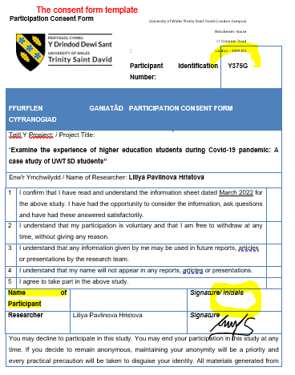
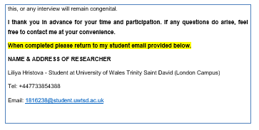

APPENDIX B. Information form template

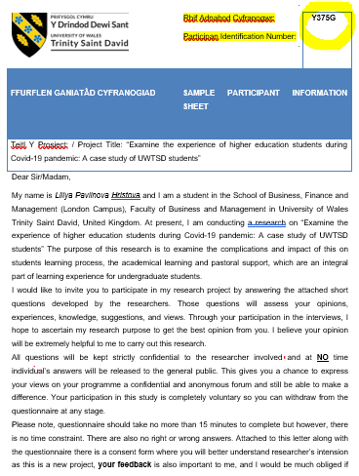
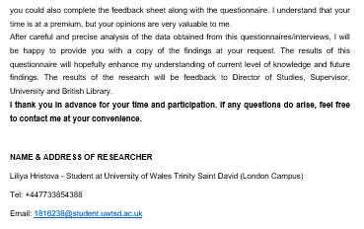

APENDIX C. Survey Questionary
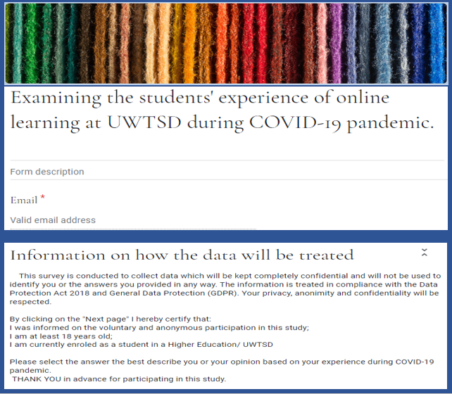

PART ONE – DEMOGRAFIC INFORMATION
QUESTION 1. What is you age?

QUESTION 2.. What is your gender?
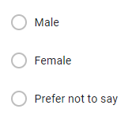

QUESTION 3. What is your employment status?
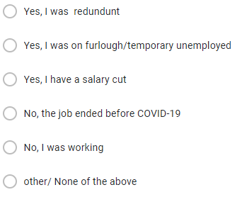
QUESTION 4. Was your employment affected by the COVID-19 Pandemic/.
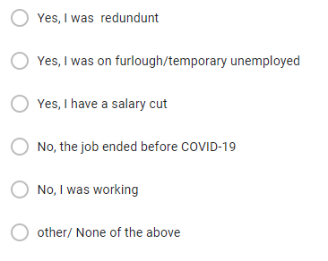
QUESTION 5. What is your education level?
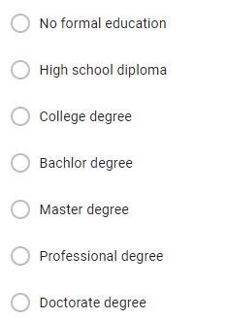
QUESTION 6. What is your level of study?

QUESTION 7. What is your nationality?
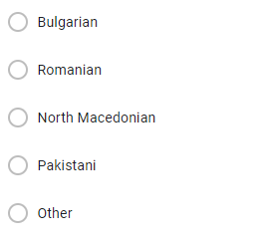
QUESTION 8. What is your ethnicity?
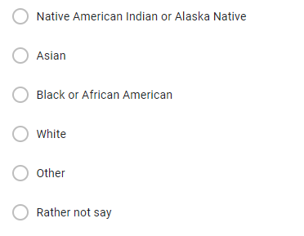
PART TWO – PASTORAL SUPPORT
QUESTION 9. To what extent are these statements relevant to you?
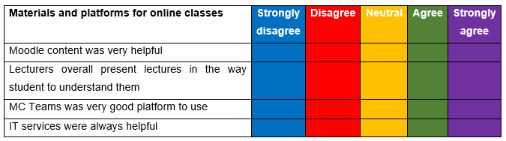
QUESTION 10. To what extent are these statements relevant to you?
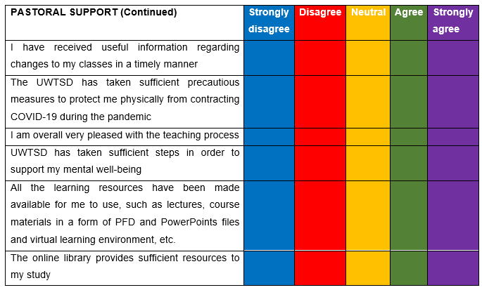

PART THREE– ACADEMIC LARNING
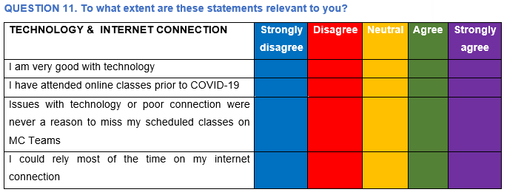

QUESTION 12. What devices did you use for my lectures?
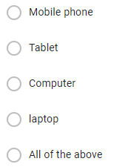
QUESTION 13. To whom do these devices belong to?


