Name
Student number
PERSONAL DEVELOPMENT PLAN
Learning in the Digital Era – BMPL4007/BMPS4009

Table of Contents
Task 1 - Reflection 2
Task 2 – Personal Development Plan 5
Reference list 10

Task 1 - Reflection
Gibbs Reflective Cycle
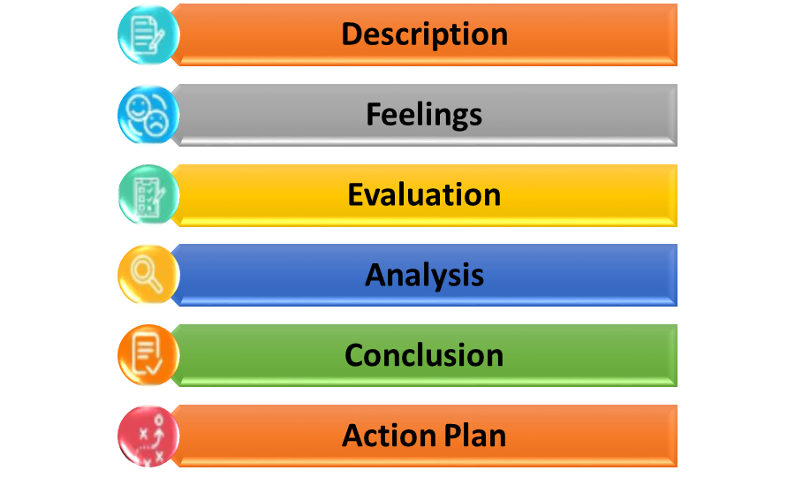
Figure 1: Gibbs Reflective Cycle
(Source: Developed by the Author)
Description- Online digital technology assists the candidates in the exchange, collection as well as analysis of information. In digital education, I shall be able to conveniently access online recorded lectures as well as utilize them as a reference related to my business management course. Moreover, this could further assist me in understanding the subject effectively along with speeding up the whole studying method. Online digital technology inspires the candidates in inventing practical approaches to studying as well as in what ways it has been going to facilitate them in the career they wish to continue (Tekkol and Demirel, 2018, p.2324). It has been much easier along with convenient for me in accessing extra reading materials as well as other online studying sources. Through digital technology I would be able to enhance and improve my literature skills, transferable skills concerning life and professional practice, practical skills, understanding along with knowledge skills, intellectual as well as psychological skills and many more while learning business management.
Feelings- I feel that by using digital technology, I could develop and improve my knowledge of business management which could help me in my career progression in the future and assist in accomplishing my goals. Furthermore, one of the efficient benefits of digital learning has been that it assists in increasing candidate accountability (Whitton and Langan, 2018). In addition, by providing me more control over my personal learning and education, in what ways I have been learning it along with what I have been learning, they can have more accountability over my growth, development and advancement as well. Moreover, with online safety, digital education could teach digital roles and responsibilities to the students that can interact with information morally online.
Evaluation- I have been able to grow and develop my literature skills, practical skills, transferable skills related to professional practice and life, and intellectual skills in this digital era. As stated by Lord et al., (2019), digital technology has assisted students in accessing the learning materials full time, obtaining more resources, building peer societies, benefitted from the latest digital studying strategies, personalised studying, effective engagement, benefitted collaboration and several others. These have been the things which went well. I have not been able to maintain as well as manage my time properly and this has been the thing that did not go well.
Analysis- By setting my learning and professional goals, I shall be able to fulfil my desire in studying business management with the efficient assistance of digital technology. Practical studying has assisted me in studying more critically as well as has supported me in remembering information concerning an enhanced amount of time. Furthermore, practical learning has been the capacity of a learner for grasping a thought and idea that has been increased more by performing than by hearing regarding it (Simpson, 2018). I think that due to low inspiration, attempting balancing, forgetting to assign, not taking sufficient rest as well as lack of organisation, I have not been able to improve my time management skills while learning.
Conclusion- I have learned to improve my cognitive skills, literature skills, intellectual skills, transferable skills, knowledge skills as well as understanding skills with the help of digital technology in my business management degree course. In addition, as cited by Ammigan and Jones, (2018, p.284), digital technology has made education more engaging along with communication for learners. With the help of digital technology, I have been able to access an extensive range of resources along with information which was not available in traditional classrooms. By understanding how I have been presently spending my time, making use of an everyday schedule template for planning my day, breaking bigger projects towards actionable along with small tasks as well as setting effective objectives and goals for measuring my performance, I could improve and develop my time and time-management skills while learning business management.
Action Plan
Objectives | Specific | Measurable | Achievable | Realistic | Time-bound
Enhancing my knowledge in business management. | Reading newsletters as well as listening to podcasts (McCutcheon et al., 2018, p.31). | Recognising the level of talent needed in obtaining my goal, I can increase my knowledge of business management. | By creating my personal objective and checking my aims I could develop my talent in business management. | By sharpening my learning skills and possessing a powerful base of knowledge, I can improve my knowledge in studying in the digital era. | 3 months
Improving time management skills in learning. | By creating a plan, setting up a personalised routine and restricting distractions I can develop my time management skills. | By tracking my progress across the duration of my objective for identifying whether I accomplish my aim or not, I can measure and grow my time management skills for learning in the future in the digital age. | By remaining organised, emphasising one task, practising decisions making and taking a break, I could improve my time management skills. | By setting a realistic goal, I could obtain knowledge in a rational amount of time with the needed skills along with resources. | 4 months

Task 2 – Personal Development Plan
Student Name |  | Student Number |  | Module |  | Code
 |  |  |  | Learning in the Digital Era |  | BMPL4007  BMPS4009
What goals do I want to achieve? | How will I measure my progress? |  | What resources or support will I need? |  | How is the objective relevant to my personal aspirations? | What is the timeframe for the achievement of my goals?
Specific | Measurable |  | Achievable |  | Relevant | Timebound
Developing time management skills by studying business management. | By becoming more effective as well as productive, enhancing project scopes and studying strategies for avoiding procrastination, I can develop along with measure my time management skills in education in a digital age. Creating a list could assist me in emphasising the tasks I require to obtain for finishing my tasks on time. |  | Proper time management enables the candidates in finishing more in less time since their attention has been emphasised in learning as well as they are not wasting valuable time on distractions during the digital period (Trenkic and Warmington, 2019, p.350). In addition, effective utilisation of time minimises stress since I could tick off products from my to-do lists. By beginning early, setting up deadlines, setting SMART goals as well as creating a priority list, I could improve my time management skills in learning. The resources and assistance I need are writing an everyday to-do list, performing a time audit, utilizing correct devices, 80/20 law, and studying to assign tasks. |  | As opined by Hockings et al., (2018, p.146), proper time management skills have been mainly effective for university and college learners since they have to deal with a lot of subjects, assignments, exams, extracurricular and many more. Moreover, managing time crucially could assist me in becoming more organised, and confident as well as studying most effectively. | 6 months
Increasing talent in business management. | Information regarding candidate studying can be evaluated via indirect as well as direct measures (Phillips and Johnson, 2022). Furthermore, utilizing evaluations in measuring studying could assist me in understanding my talent as well as understand my prospect in assisting me in obtaining the studying objectives. For example, practical exams have been a better process for evaluating my skill levels in business management. |  | The activities, devices or tools, exams as well as processes could identify my learning level and what I have studied and developed. In addition, the knowledge along with learning skills could be obtained via listening towards the faculty, learning books, reading at the website, following e-learning, practical experience or via instructions as well. For example, by reading various contents, inventing social media, interacting with experts, describing content to others, and reading magazines and newspapers, the learning goals of the candidate could be achieved. By developing a talent development program and following the learning checklist, I could achieve my goals in studying. |  | Factual talent and knowledge increase analytical methods such as reasoning as well as problem-solving. Moreover, acquiring knowledge as well as putting it towards practice has been elemental towards studying and has been the most fruitful means to study to build on what I know concerning my knowledge of business management in the digital period. | 5 months
Improving transferrable skills in learning. | As evidenced by Rigamonti et al., (2020, p.471), one of the effective ways in determining valuable transferable skills in learning business management has been to read via work or job postings as well as recognise the skills highlighted. This could facilitate me a lot in my studies. |  | I could communicate the outcomes of my learnings appropriately as well as flexibly. Moreover, with my logical as well as structured arguments, I could begin as well as finish my tasks, course of actions and strategies whether working together or individually at presentation along with the organisation. |  | My educational assignments, projects, discussions and essays could offer me information, facts as well as evidence of the transferable skills along with qualities essential for employment needing the exercise of some personal roles and responsibilities along with intelligibility and fluency of expression. | 7 months
Assessing knowledge and understanding skills. | Evaluation includes improving along with developing that could enable me in describing my skills, talent, knowledge as well as capabilities and then assessing such activities for evidence of how effectively I have obtained the studying results related to business management in the digital age. Furthermore, assessments have been vital towards candidate studying as well as assisting the learners in describing their talent and knowledge of a given subject matter. |  | The assistance and resources I require are scenarios, case studies, demonstration as well as observation checklists, evidence plans, field learnings, research projects, third-party information collection devices, holistic evaluations, replications, role plays, activities along with questions both formative and summative and similar others. These resources would help me in gaining knowledge on business management in the future years with the assistance of digital technology. |  | The entire goal of evaluating learning has been to identify the efficiencies of studying business management as well as see whether the performance goals have been met or not (Qiu et al., 2022, p.453). By planning my learning goals properly, I could achieve success in the future concerning my career progression and advancement, By evaluating understanding along with knowledge expertise and skills, I can improve my studying knowledge and proficiencies. | 4 months

Reference list
Journals and Books
Ammigan, R. and Jones, E., 2018. Improving the student experience: Learning from a comparative study of international student satisfaction. Journal of Studies in International Education, 22(4), pp.283-301.https://journals.sagepub.com/doi/pdf/10.1177/1028315318773137
Hockings, C., Thomas, L., Ottaway, J. and Jones, R., 2018. Independent learning–what we do when you’re not there. Teaching in Higher Education, 23(2), pp.145-161.https://www.tandfonline.com/doi/abs/10.1080/13562517.2017.1332031
Lord, R., Lorimer, R., Babraj, J. and Richardson, A., 2019. The role of mock job interviews in enhancing sport students’ employability skills: An example from the UK. Journal of Hospitality, Leisure, Sport & Tourism Education, 25, p.100195.https://www.sciencedirect.com/science/article/pii/S1473837618301953
McCutcheon, K., O’Halloran, P. and Lohan, M., 2018. Online learning versus blended learning of clinical supervisee skills with pre-registration nursing students: A randomised controlled trial. International journal of nursing studies, 82, pp.30-39. https://www.sciencedirect.com/science/article/pii/S0020748918300488
Phillips, E. and Johnson, C., 2022. Ebook: How to Get a PhD: A Handbook for Students and Their Supervisors 7e. McGraw-Hill Education (UK).https://books.google.com/books?hl=en&lr=&id=3GB7EAAAQBAJ&oi=fnd&pg=PR16&dq=learning+skills+of+students+in+uk&ots=RmNN7CHcuv&sig=rWef3s7tXkL0YEjA5P9Glip2Bb4
Qiu, F., Zhang, G., Sheng, X., Jiang, L., Zhu, L., Xiang, Q., Jiang, B. and Chen, P.K., 2022. Predicting students’ performance in e-learning using learning process and behaviour data. Scientific Reports, 12(1), p.453.https://www.nature.com/articles/s41598-021-03867-8
Rigamonti, L., Dolci, A., Galetta, F., Stefanelli, C., Hughes, M., Bartsch, M., Seidelmeier, I., Bonaventura, K. and Back, D.A., 2020. Social media and e-learning use among European exercise science students. Health promotion international, 35(3), pp.470-477.https://academic.oup.com/heapro/article-abstract/35/3/470/5487286
Simpson, O., 2018. Supporting students in online, open and distance learning. Routledge.https://books.google.com/books?hl=en&lr=&id=h3l0DwAAQBAJ&oi=fnd&pg=PT10&dq=learning+skills+of+students+in+uk&ots=JsqpLm-9Ds&sig=j0untRzHWgryQgttHPdiiWbLLmc
Tekkol, İ.A. and Demirel, M., 2018. An investigation of self-directed learning skills of undergraduate students. Frontiers in psychology, p.2324.https://www.frontiersin.org/articles/10.3389/fpsyg.2018.02324/full?_ga=2.62392165.874682590.1642809600-861143907.1642809600
Trenkic, D. and Warmington, M., 2019. Language and literacy skills of home and international university students: How different are they, and does it matter?. Bilingualism: Language and Cognition, 22(2), pp.349-365.https://www.cambridge.org/core/journals/bilingualism-language-and-cognition/article/language-and-literacy-skills-of-home-and-international-university-students-how-different-are-they-and-does-it-matter/D20CF9E9823BA7C50364D257B4F30BDB
Whitton, N. and Langan, M., 2018. Fun and games in higher education: an analysis of UK student perspectives. Teaching in Higher Education.https://www.tandfonline.com/doi/shareview/10.1080/13562517.2018.1541885

