

“I send TikTok videos instead of trying to say how I feel. It’s easier than talking face-to-face because you don’t worry too much about how the other person reacts.”

“THE IMPACK OF TIKTOK ON UK TEENAGERS’ OFFLINE SOCIAL SKILLS”
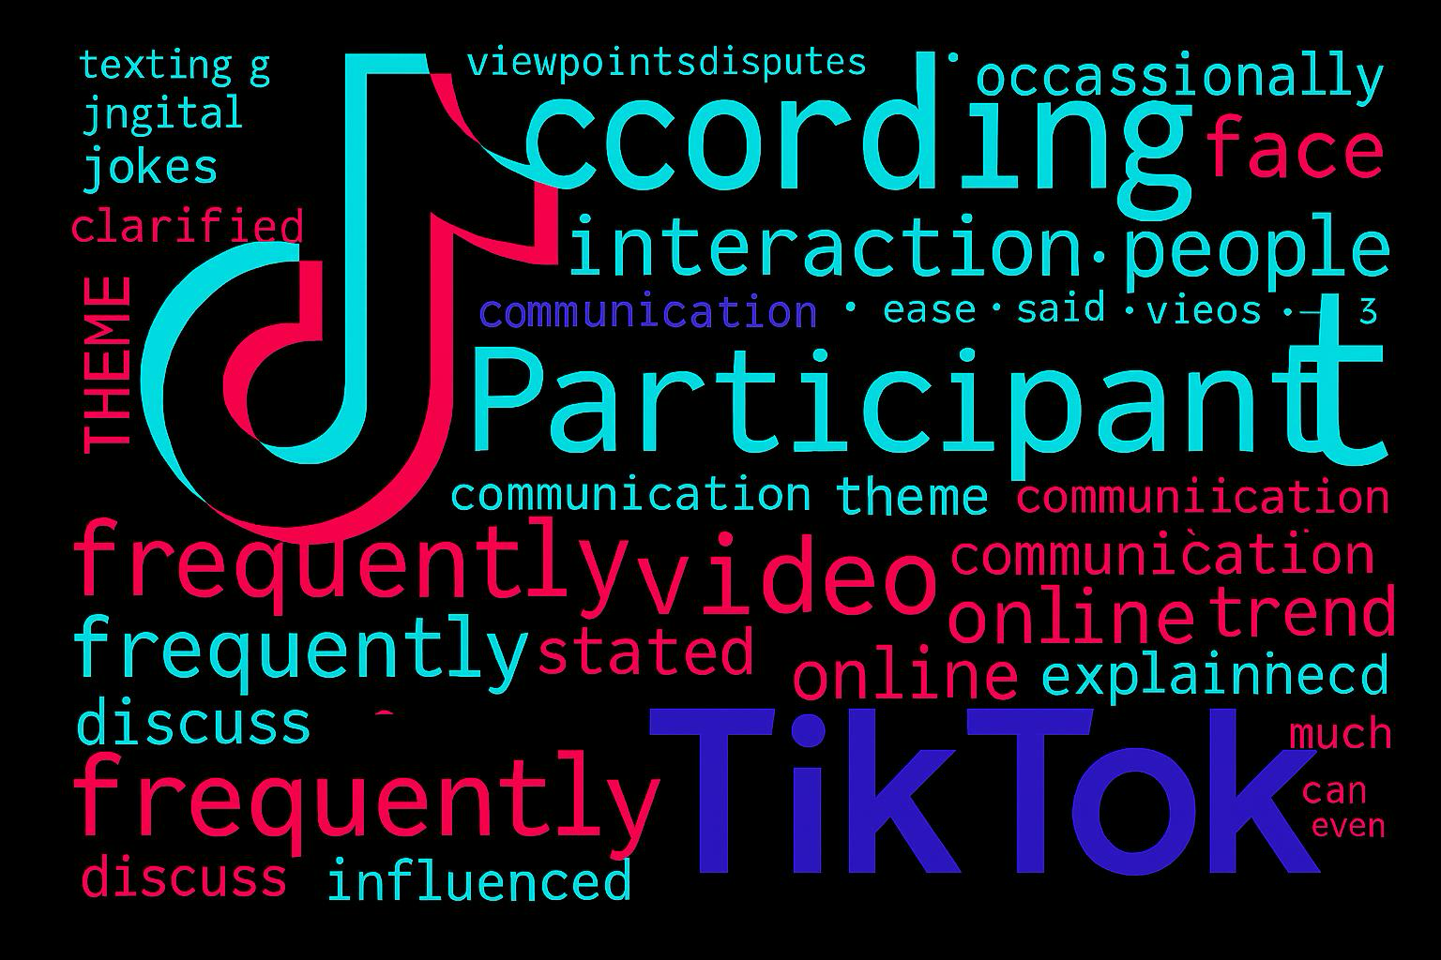
RESERCH FINDINGS

- Preference for online communication
- Many teenagers felt comfortable expressing themselves online than face-to-face.
- Increased Social awareness
- Influences on conflict and problem-solving.
- Differences between content creators and viewers
- Phone distraction and addictive patterns.

Conclusion

Teenagers' creative thinking, shared humour, digital expression, and social awareness can all be improved by TikTok. But it would also restrict in-person encounters, which would hinder the growth of critical abilities like empathy, active listening, and effective communication. Depending on whether teens are passive consumers or active content providers, the effect varies, and each group exhibits distinct communication strengths and limitations. While maintaining robust offline social engagement, promoting balanced digital habits can assist optimise the platform's advantages.

Introduction
Teenagers in the UK have become more creative and communicative due to the rapid expansion of digital media, especially TikTok's algorithm-driven films. Concerns regarding the development of offline social skills, such as empathy, face-to-face communication, and emotional control, have been highlighted by its extensive use. This is particularly important throughout adolescence, which is a crucial time for the development of interpersonal skills that support successful relationships and future leadership qualities. Despite these worries, there is still a dearth of research that particularly looks at how TikTok affects the development of offline social skills among teens in the UK. This study attempts to fill this significant gap.
METHODOLOGY
Research design
Qualitative primary research approach was selected to generate rich, formed insights, into teenagers’ experiences.
Sampling
Convenience sampling and snowball method was used, 10 UK teenagers between the age of 17 ang 19 participated.
Data collection/ data analysis
- Semi-structured interviews’ conducted over several days.
- Thematic analysis following Braun & Clark’s six step framework
Familiarization of data, Coding, Generating themes, Reviewing themes, Defining and naming themes, Interpretation.

