Student Name: Lloyd Pennington
Course Name: Business Information Technologies
Module: Business Information Technologies
Assignment Name: Data warehouse build / Data Governance: Part 2
Assignment Deadline: 17/05/2019

Contents
Data Governance 3
Policy, Standards and Strategy 3
ETL 3
Information Governance Policy 3
Data Quality 3
Privacy, Compliance and Security 4
Encryption 4
Role-based access 4
Data Architecture and Data Integration 4
Bibliography 5
Figures 6

Data Governance
Data Governance is defined as the [1]“…overall management of the availability, usability, integrity and security of data used in an enterprise…” Data Governance would have many different features that need to be understood and applied to make sure that the data is available, usable, secured and validated. So, examples of these various features would be these;

Policy, Standards and Strategy
Firstly there is the Policy, Standards and Strategy; the following items would be considered when it comes to the policy standards and strategy of the data warehouse. The following items are the ETL process and the information governance policy.

ETL
ETL stands for Extraction, Transform and Load, each word being a step in creating a data warehouse and making sure that the data has no errors and is validated so that the data warehouse will work and not break. In the case of UKAEA the ETL process should be used as in line with the prototype that was created.
Extraction would be the step in which the data was extracted from the data sources, in this case the extraction of the data would fall under the user downloading the UKAEA data from the .Gov website.
The transform section of the ETL process is the process where the data would be changed, aesthetically, to match the database needs, in this case on of the needs was to remove the duplicate data and insert that data into the data warehouse, as seen in figure 4. This was done with all the dimension tables in the workbooks.
The load section being the final process of the ETL process, and it about the process of inserting the data into the database/data warehouse. This section, being the final section, will be inserting the cleaned and transformed data, not the data from the original data source.

Information Governance Policy
Information Governance Policy can be defined as [2]
“Information Governance is a framework for handling personal information in a confidential and secure manner to appropriate ethical and quality standards…”
UKAEA would have to adhere to the rules of information governance as if they were to not follow through with the policy then there can be many different consequences. Examples of consequences would be the data of the people getting out and this could cause various issues for the people, i.e. their private information would be leaked and therefore free for anyone to use. A different consequence, more relating to UKAEA would be prosecution and/or fines of some kind. To not get these fines or prosecuted UKAEA would have to adhere to the rules and policies of data governance.

Data Quality
Secondly there is the quality of the data. The data quality was poor when it came to the original dataset; this was mainly due to missing data, wrongfully entered data and titles being entered incorrectly. This would be expected as the data being used is a rather large data set, UKAEA Monthly Data. Apart from the small amount of poor original data there was not an issue with the actual data.
In terms of the data quality within the prototype data warehouse it would seem to be of good quality. This is mainly to do with the necessary corrections that were implemented in the data sources, i.e. removing data with no values or removing wrongfully entered data; an example of this would be there was a February data entry in the April source system.
Now that the data has been rectified the data quality did increase and because of this there was the option for reporting and querying, this would not have been possible with the original messy data as there would have been some errors in the results of the query, therefore making the data quality poor.

Privacy, Compliance and Security
Thirdly, there is the privacy, compliance and security of the data.

Encryption
Encryptions are one method of maintaining privacy, compliance and the overall security of the data because the encryption would allow an extra layer of protection against anyone who would want to view the data. Encryption would be defined as [3]
“Data encryption translates data into another form, or code, so that only people with access to a secret key (formally called a decryption key) or password can read it.”
So in terms of what UKAEA could do with their data, one method would be to encrypt the data, even if it is a simple password, because there would be sensitive financial information on the spreadsheets and on the data warehouse and the encryption could stop unwanted access to that information.

Role-based access
A role based or User based access for the data would not be a bad idea either. This would mean that anyone who has the right level of access can access the records, therefore meaning that not everyone in the company can access the records. This could even be a feature where only the financial department can access the financial aspects, while the receptionist can only access the forms, reports and queries. This is what UKAEA could implement, a form of a role system where any department needing to access the NetAmount and insert the data can do so while other departments would not be allowed to access them.

Data Architecture and Data Integration
As previously mentioned, there was a need for the cleaning of the original data set. There were three types of errors in the original data set, for example there was no data entry in some parts of the June 2018 workbook, see figure 1, while in the April workbook there was a February 2018 record entered, see figure 2, finally in all the workbooks there was an issue with the heading “NetAmount”. This would have caused an issue with the Load stage of the ETL process, see figure 3.
As there were three source systems the method for loading the data was to remove all the duplicates for each dimension heading and then to copy and paste them into a new excel workbook. This was done to compare the data to the other months easier than if putting all the data in one workbook at a time – this was also easier to query and report off.

Bibliography

[1] | techtarget, “data governance (DG),” techtarget, [Online]. Available: https://searchdatamanagement.techtarget.com/definition/data-governance . [Accessed 15 May 2019].
[2] | Corporate Information Governance, “england.nhs.uk,” [Online]. Available: https://www.england.nhs.uk/wp-content/uploads/2016/12/information-governance-policy-v4.0.pdf. [Accessed 15 May 2019].
[3] | C. Settles, “Role-based Access vs. User-based Access,” technologyAdvice, 23 October 2014. [Online]. Available: https://technologyadvice.com/blog/information-technology/role-based-access-vs-user-based-access/. [Accessed 15 May 2019].

Figures
Figure 1
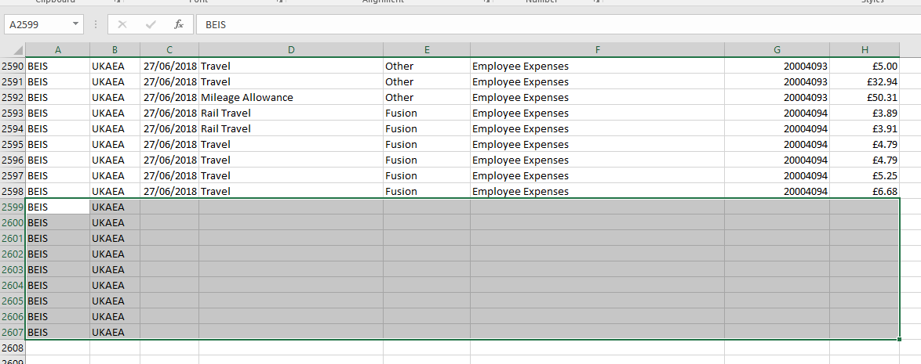
Figure 2
Figure 3


Figure 4


