

LOCATION: Swansea | LLEOLIAD: abertawe
LEVEL 4 | LEFEL 4
EXAMINATION PERIOD | CYFNOD ARHOLIADAU
January 2023 | IONAWR 2023

MODULE CODE: Enter ACDA4011
CHEMISTRY (OME) HNC

TIME: 2 HOURS

answer all Questions 1 Through 10. NO BLUE BOOK.

Equipment or materials required – None
Adnoddau neu ddefnyddiau sydd eu hangen - Dim

DO NOT change Margins/Headers/Footers/Layout of Cover page
Font: Times New Roman
Headings: 14px and BOLD
Body text: 12px

REFERENCE SHEET FOR ACDA4011 CHEMISTRY OME (HNC)
FINAL EXAM
ANSWERS
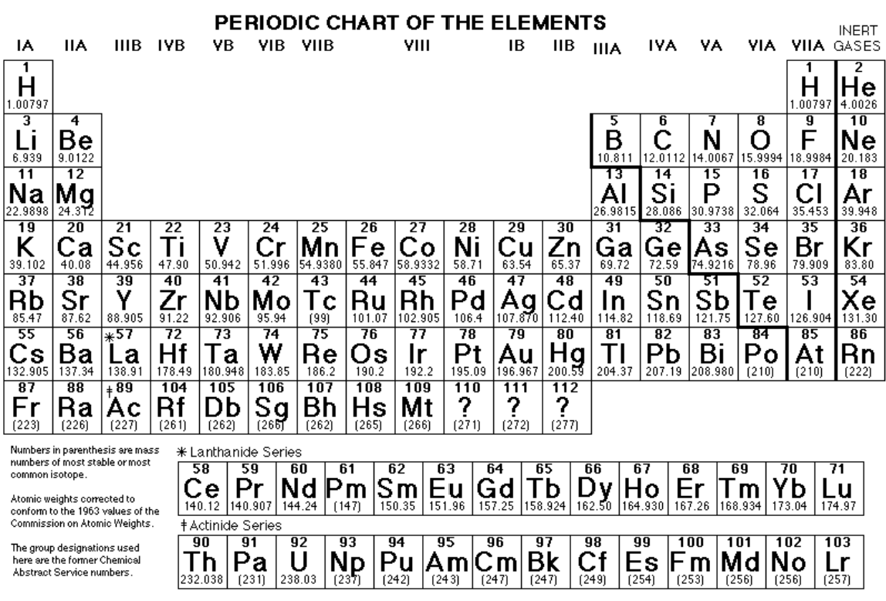

PHYSICAL CONSTANTS:
C = 3.0 x 10⁸ m/s (speed of light)
R_{H} = 3.29 x 10¹⁵ s⁻¹ (Rydberg constant)
h = 6.6 x 10⁻³⁴ Js (Plank’s constant)
1 amu = 1.66 x 10⁻²⁴ kg (atomic mass unit)
N_{A} = 6.02 x 10²³ Avogadro’s number
R = 0.0821 L-atm/mol-K gas constant
R = 8.314 J-mol/K
0 degC = 273 K
1 atm = 101.3 kPa = 101,325 Pa = 760 mm Hg = 760 torr = 14.7 lb/in2 (psi)

ACDA4011 CHEMISTRY OME (HNC) FINAL EXAM

NAME_____________________________________ DATE_______________

SHOW ALL WORK. USE CORRECT UNITS AND SIGNIFICANT DIGITS. YOU MAY SHOW YOUR WORK ON THE BACK OF THE SHEET BUT INDICATE YOUR ANSWER ON THE FRONT.
PERIODIC TABLE AND REFERENCE DATA CAN BE TORN OFF OF THE EXAM
THERE ARE 10 QUESTIONS, 100 POINTS TOTAL (PLUS ANY EXTRA CREDIT EARNED IN THE CLASS). TIME 120 min

QUESTION 1:
For each of the following statements determine if it is TRUE or FALSE.
T F
__√__ ____ (2p) Multiple bonds are shorter and stronger than single bonds between the same atoms
____ __√__ (2p) The elements in the periodic table are arranged in the order of increasing number of electrons.
__√__ ____ (2p) In 1 mole of water there are 6.02 x 10²³ atoms of oxygen.
____ __√__ (2p) Ideal gas equation describes well the behaviour of gases when the pressure and temperature of this gas tend to 0 atm and 0 K, respectively.
____ __√__ (2p) Activation energy of nitrocellulose and RDX is 86 kJ/mol and 199 kJ/mol, respectively. RDX is less stable than nitrocellulose.
_√___ ____ (2p) The C₂H₄ molecule has six bonding electron pairs and no lone pairs.
____ __√__ (2p) For a hypothetical reaction A + B C that is a second order in A, doubling the concentration of A will double the rate of the overall reaction.
__√__ ____ (2p) All combustion reactions are exothermic.
_√___ ____ (2p) Volume of gas produced in the detonation process decreases when the oxygen balance becomes less negative.
____ _√___ (2p) The formula of potassium perchlorate is KClO₃.

QUESTION 2:
- (4p) Draw the Bohr model for a chlorine atom. Specify the number of orbits and indicate the position of all subatomic particles within the atom and their charges.
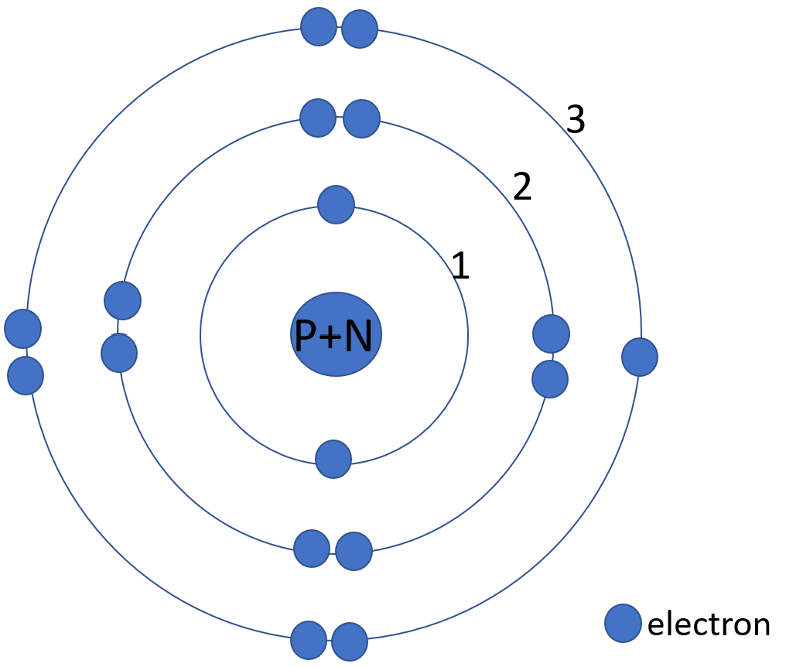
There are 3 orbits (energy levels) that accommodate 17 electrons (negative charge); 2 electrons in orbit 1, 8 electrons in orbit 2 and 7 electrons in orbit 3. Protons (positive charge, P) and neutrons (0 charge, N) are localised in the nucleus.

- (3p) Give the definition of the term Mass Number and explain why for Cl atom the average atomic mass is 35.453.
The mass number is the total number of protons and neutrons in the nucleus.
The average atomic mass of an element is the sum of the masses of its isotopes, each multiplied by its natural abundance.
……………………………………………………………………………………………………………………..………………………………………………………………………………………………………………………………………………………………………………………………………………………………………………………………………………………………………………………………
- (2p) How many protons and neutrons are there in chlorine-37?
P + N = 37. In chlorine atom there are 17 protons (atomic number = 17), so N = 20 neutrons.
…………………………………………………………………………………………………………………………………………………………………………………………………………………………………………………………………………………………………
d) (2p) What will be the charge on chlorine atom when the outer shell is a complete octet?
-1. Chloride ion Cl⁻ will form.
……………………………………………………………………………………………………………………………………………………………………………………………………………………………………………………………………………………………………

QUESTION 3:
Many fireworks contain metal compounds that emit visible light. The colour given by calcium species at the wavelength of 616 nm is orange-red.
- (3p) Calculate the energy of one photon of green? Orange-Red? light emitted by calcium atom. Show your calculations.
E = hv and v = c/λ.
For Ca, ν is (3x10⁸ m/s / 616 x 10⁻⁹ m) 4.87 x 10¹⁴ 1/s and E is (6.63 x 10⁻³⁴ J-s x 4.87 x 10¹⁴ 1/s) 3.23 x 10⁻¹⁹ J
…………………………………………………………………………………………..…………………………………………………………………………………………………………………………………………………………………………………………………………………………………………………………………………………………………………………………………………………………

- (3p) Write the full and shorthand electron configuration for calcium and show ALL the electrons in orbitals.
Full electron configuration: Ca (20 electrons) 1s²2s²3p⁶3s²3p⁶4s²
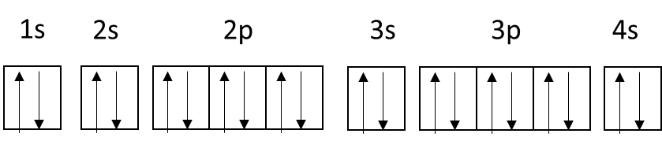
Shorthand electron configuration: [Ar]4s²
…………………………………………………………………………………………………………………………………………………
- (3p) The colours seen in fireworks are a result of the emission of visible light. State how these colours are produced.
Electrons are excited and absorb energy as they move to a higher energy level. When they relax/return to a lower level this energy is given out as energy in the visible part of the electromagnetic spectrum.
………………………………………………………………………………………………………………………………………………………………………………………………………………………………………………………………………………………………………………………………………………………………………………………………………………………………………………………

QUESTION 4:
(4p) Consider only the three elements: S, Se, Cl.
- Which one is most metallic?
………Se………………………………………………………………………………………………………………………………………………………………………………………………………………………………………………………………………………………
- Which one has the greatest electronegativity?
………Cl…………………………………………………………………………………………………………………………………………………………………………………………………………………………………………………………………………………………
- Which one has the highest ionisation energy?
………Cl…………………………………………………………………………………………………………………………………………………………………………………………………………………………………………………………………………………………
- Which one has the smallest atomic radius?
………Cl…………………………………………………………………………………………………………………………………………………………………………………………………………………………………………………………………………………………

QUESTION 5:
When ammonium nitrate and magnesium metal are mixed in a stoichiometric ratio, they form a pyrotechnic composition that decomposes to form magnesium oxide, water vapour and nitrogen gas.
- (2p) Write a balanced equation showing all products for the decomposition of this mixture.
NH₄NO₃ + Mg N₂ + 2H₂O + MgO
……………………………………………………………………………………………………………………………………………………………………………………………………………………………………………………………………………………………………………………………………………………………………………………………………………………………………………………….
- (2p) What percentage of magnesium, by mass, is contained in the stoichiometric mixture?
Mass of one mole of magnesium is 24.0 g. Total mass of the stoichiometric mixture is: 2N + 4H + 3O + Mg = 28.0 + 4.0 + 48.0 + 24.0 = 104.0 g. wt% of Mg = (24/104)x100% = 2.3%
……………………………………………………………………………………………………………………………………………………………………………………………………………………………………………..…………………………………………………………………………………………………………………………………………………………………………………………………………………………………………………………………………………………………………………………………………………………
- (3p) Using the standard heats of formation listed below, calculate the heat of reaction for molar quantities of the reactants. Is this process exothermic or endothermic? Explain
Ammonium nitrate (solid) -365 kJ/mol
Magnesium oxide (solid) -601 kJ/mol
Water (gas) - 242 kJ/mol
Δ_{rxn}H° = ΣΔ_{f}H° (products) - ΣΔ_{f}H° (reactants)
Δ_{rxn}H° = [0 + (2 × (-242)) + (-601)] – [(-365) + 0]= - 720 kJ/mol
Δ_{rxn}H° is negative so the reaction is exothermic (heat is released to surroundings)
…………………………………………………………………………………………..……………………………………………………………………………………………………………………………………………………………………………………………………………………………………………………………………………………………………………………………………………………………………………………………………………………………………………………………………………………………………………………………………………………………………………………………………………………………………………………………… d) (3p) How does the heat of reaction from this reaction compare with 2.8 kJg⁻¹ provided by one gram of TNT.
720 kJ of heat is released for the following quantities of reactants/products:
80 g + 24 g ⇌ 28 g + 36 g + 40 g = 104 g.
720 kJ for 104 g is 6.9 kJ/g. This is higher than TNT.
…………………………………………………………………………………………..………………………………………………………………………………………………………………………………………………………………………………………………………………………………………………………………………………………………………………………………………………………………………………………………………………………………………………………………………………………………………………………………………………………………………………………………………………………………………………………………………………………………………………………………………………………………………………………………………………….

QUESTION 6:
Some high explosives have the general formula C_{a} H_{b} N_{c} O_{d}. The oxidiser (O) and the fuel (C, H) are present in the same molecule. Nitrogen atoms are present, so there is a highly exothermic production of hot N₂ gas.
- (4p) For an unknown explosive of general formula C_{a} H_{b} N_{c} O_{d} and a molar mass of 152 g/mol, determine the coefficients a, b c and d if 152 g of this material decomposes to form 44.8 dm³ of CO₂, 44.8 dm³ of H₂O, and 22.4 dm³ of N₂.
C_{a} H_{b} N_{c} O_{d} a CO₂ + b/2 H₂O + c/2 N₂
If the molar mass of this explosive is 152 g, it corresponds to 1 mol decomposed.
22.4 L is a volume of 1 mol of a gas, so there are 2 moles of CO₂, 2 moles of H₂O, and 1 mol of N₂ formed as the result of decomposition of 1 mol of unknow explosive.
1 mol C_{a} H_{b} N_{c} O_{d} 2 mol CO₂ + 2 mol H₂O + 1 mol N₂
So, a = 2, b = 4, c = 2 and d = 6. The formula of this explosive is C₂H₄N₂O₆
………………………………………………………………………………………………………………………………………………………………………………………………………………………………………………………………………………………………………………………………………………………………………………………………………………………………………………………………………………………………………………………………………………………………………………………………………….

- (2p) Which of the produced gases will move fastest and explain why?
MM CO₂ = 44 g/mol, MM H₂O = 18 g/mol, MM N₂ = 28 g/mol. According to Graham’s law, heavy gas molecules take longer to move because they move slower than light molecules. H₂O will move fastest because it’s the lightest of the three gases produced.
……………………………………………………………………………………………………………………………………………………………………………………………………………………………………………..………………………………………………………………………………………………………………………………………………………………………………………………………………………………………………………………………………………………………………………………………………………………………………………………………………………………………………………………………………………………………………………………………………………………………………………………………………………………………………………………………………………………………………………………………………………………………………………………………………….
- (3p) The oxygen balance of an explosive is the mass of oxygen either in excess (the balance is positive) or in deficit (the balance is negative) of that required for complete oxidation of C and H. The oxygen balance is expressed as a percentage of the oxygen weight over the molar mass of the explosive. Calculate the oxygen balance for explosive with the formula determined in part a).
$$=\left(\frac{16}{MM}\right) \left[d-\left(2a) -(\frac{b}{2}\right)\right] 100\%=0\%$$
…………………………………………………………………………………………………………………………………………………………………………………………………………………………………………………………………………………………………………………………………………………………………………………………………………………………………………………………………………………………………………………………………………………..………………………………………………………………………………………………………………………………………………………………………………………………………………………………………………………………………………………………………………………………………………………………………………………………………………………………………………………………………………………………………………………………………………………………………………………………………………………………………………………………………………………………………………………………………………………………………………………………………………….

QUESTION 7:
A simple chemical equation for the combustion of gun powder can be written as:
2 KNO₃ + S + 3 C K₂S + 3 CO₂ + N₂
- (4p) Assuming that the reaction above can be carried out at STP, how many grams of CO₂ are formed from the decomposition of 45 g of KNO₃?
MM KNO₃ = 101 g/mol so 45 g KNO₃ is the mass of (45/101) 0.445 mol of KNO₃
MM CO₂ = 44 g/mol
According to the stoichiometry of this reaction, 2 moles of KNO₃ produce 3 moles of CO₂, so 0.445 mol of KNO₃ produces ((0.445 mol KNO₃ x 3 mol CO₂)/2 mol KNO₃) 0.668 mol of CO₂
If 1 mol of CO₂ has a mass of 44 g, 0.668 mol of CO₂ will have a mass of (0.668 mol x 44 g/mol) 29.4 g
………………………………………………………………………………………………………………………………………………………………………………………………………………………………………………………………………………………………………………………………………………………………………………………………..………………………………………………………………………………………………………………………………………………………………………………………………………………………………………………………………………………………………………………………………………………………….
- (4p) How many litres of gas products would form from the decomposition of 45 g of potassium nitrate at STP?
As found in part c) 45 g of KNO₃ produces 0.668 mol CO₂.
According to the stoichiometry of this reaction, 2 moles of KNO₃ produce 1 mol of N₂, so 0.445 mol of KNO₃ (calculated in part b)) produces ((0.445 mol KNO₃ x 1 mol N₂)/2 mol KNO₃) 0.223 mol of N₂
CO₂ and N₂ are both considered to behave like an ideal gas, so there is no difference between them and total number of moles of gas produced in this reaction is (0.668 mol CO₂ + 0.223 mol N₂) 0.891 mol of gases.
At STP 1 mole of an ideal gas occupies a volume of 22.4 L, so 0.891 mol of gas will occupy (0.891 mol gas x 22.4 L) 20.0 L.
…………………………………………………………………………………………………………………………………………………………………………………………………………………………………………………………………………………………………………………………………………………………………………………………………………………………………………………………………………………………………………………………………………………..……………………………………………………
c) (4p) 45 g KNO₃ at STP is heated to 100 degC and the pressure is reduced to 700 mmHg. What is the new volume of the gases? Use the appropriate gas laws to support your answer.
At STP T = 0 degC (273 K) and P = 1 atm (760 mm Hg)
100 degC = 373K
Initial volume of gases was found in c) as 20.0 L
According to Charles’s law volume of gas increases with temperature.
According to Boyle’s law, the volume increases when the pressure decreases.
To show the above effects, the following fractions have to be used (for temperature change 373 K/273 K) and (for pressure change 700 mm Hg/760 mm Hg) and the new volume is: (20.0 L x (373 K/273 K) x (700 mm Hg/760 mm Hg)) 29.7 L
…………………………………………………………………………………………………………………………………………………………………………………………………………………………………………………………………………………………………………………………………………………………………………………………………………………………………………………………………………………………………………………………………………………..………………………………………………………………………………………………………………………………………………………………………………………………………………………………………………………………………………………………………………………………………………………………………………………………………………………………………………………………………………………………………………………………………………………………………………………………………………………………………………………………………………………………………………………………………………………………………………………………………………….

QUESTION 8:
The phase diagram of an unknown compound X, is shown below:
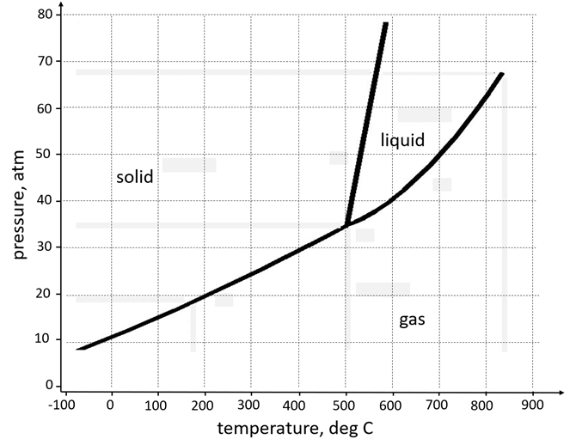
- (2p)
- What is the value of temperature and pressure at a critical point? What is the term used to describe the state of substance X above this point?

Critical point T = ~930 deg C, P = ~68 atm ; supercritical fluid
……………………………………………………………………………………………………………………………………………………………………………………………………………………………………………………………………………………………………………………………………………………………………………………………………………………………………………………………………………………………………………………………………………………………
- (2p) If you stored a bottle containing compound X on the work desk in the lab, what phase would it most likely be in?
At normal conditions of T = 25 deg C and P = 1 atm, substance X is a gas
……………………………………………………………………………………………………………………………………………………………………………………………………………………………………………………………………………………………………………………………………………………………………………………………………………………………………………………….
- (2p) If a sample of pure X is to be a mixture of liquid and gas, which point marks the sample's lowest possible temperature and pressure? Name all transitions occurring at this specific temperature and pressure.
Triple point, T = 500 deg C, P = 35 atm; melting (fusion)-freezing, boiling (evaporating)-condensation, sublimation-deposition
……………………………………………………………………………………………………………………………………………………………………………………………………………………………………………………………………………………………………
- (2p) Can compound X be boiled at 200 deg C? Why?
No, because no liquid phase exists at this temperature and pressure
………………………………………………………………………………………………………………………………………………………………………………………………………………………………………………………………………………………………………………………………………………………………………………………………………………………………………………………
- (2p) What is the vapour pressure of substance X at 700 deg C?
50 atm
……………………………………………………………………………………………………………………………………………………………………………………………………………………………………………………………………………………………………………………………………………………………………………………………………………………………………………………
- Does the melting point of X increase, decrease or stay the same as the pressure is increased?
The melting point slightly increases when the pressure goes up.
………………………………………………………………………………………………………………………………………………………………………………………………………………………………………………………………………………………………………………………………………………………………………………………………………………………………………………………

QUESTION 9:
- (4p) The normal boiling point is 100°C for H₂O and –33.3°C for NH₃, even though the two molecules have almost identical atomic weights. Explain this difference in terms of intermolecular forces, using words or pictures, or both.
H₂O has 2 nonbonding electron pairs whereas NH₃ has only one. H₂O has more H-bonding capability resulting in a higher boiling point.
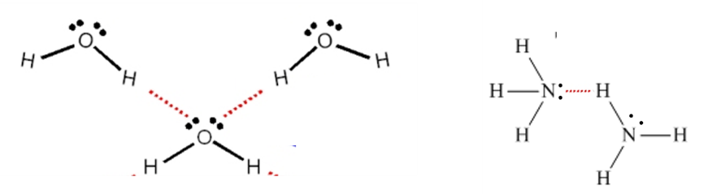

b) (3p) Give ONE specific example of how might water react to give undesirable performance from OME devices? Explain why. To answer this question, refer to your assignment.
Water misbehaves in several ways to prevent the functioning of OME articles.
- Corrosion of metals. Especially magnesium in pyrotechnic compositions
  - Causes loss of performance , gassing
  - Surface effect! Low volume of material affected.
- Production of Phosphine in RP munitions
  - Need for encapsulated Phosphorus
  - No metals in compositions
  - Don’t use copper components
- Causes gassing and therefore cavities in PU bound explosives.
- Reaction with Azides to form hydrazoic acid. This then attacks the copper in brass detonator cases and explosions result.
  - Cu Azide can burn to detonation as a thin film.

QUESTION 10:
An explosive, RDX has an enthalpy of detonation of -1106 kJ mol⁻¹.
- (3p) Sketch the reaction profile (“energy” vs. “progress of reaction”) showing the reactants, products, activated complex, enthalpy of detonation and the activation energy
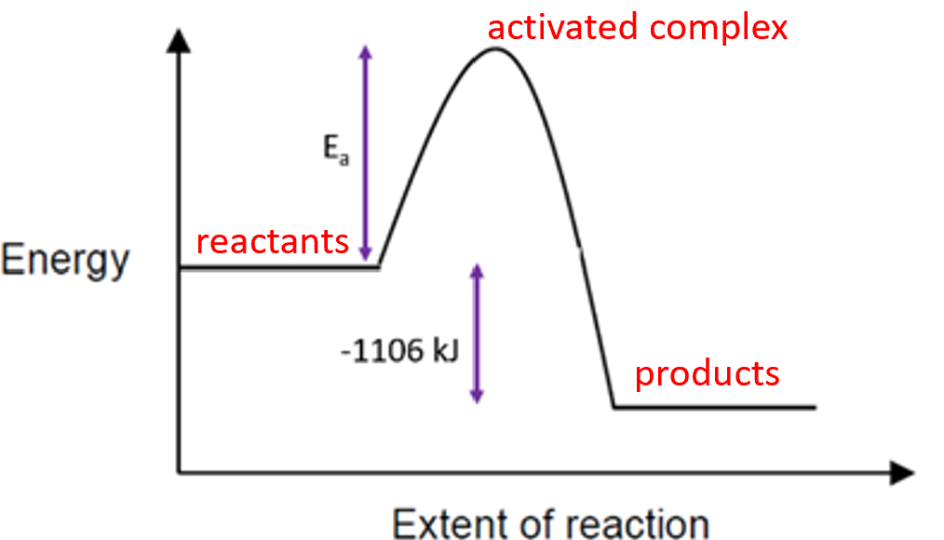

- (3p) Using the Arrhenius equation k = A exp(-E_{a} / RT) to support your answer, explain the relationship between activation energy, E_{a}, and the fraction of colliding molecules that result in a reaction.
molecules do not react
exp(-E_{a} / RT) is a measure of the fraction of colliding molecules that result in a reaction;
if E_{a} = 0 then exp(-E_{a} / RT) = 1 and all molecules collide; if exp(-E_{a} / RT) >> 1 then E_{a} >> RT (high E_{a}) so the majority of colliding molecules do not react
…………………………………………………………………………………………..………………………………………………………………………………………………………………………………………………………………………………………………………………………………………………………………………………………………………………………………………………………………………………………………………………………………………………………………………………………………………………………………………………………………………………………………………………………………………………………………………………………………………………………………………………………………………………………………………………….

EXTRA CREDIT (if earned in class): ………………………………………….

