MSc Public Health and Social Care in Practice
Module name: Population Health and Digital Health Promotion (LCHS7009)
Assignment Title: Component 1 – 2 Blogs
Lecturer: Dr. Ping Wu
Student Name: Varshini Velmurugan
Student Number: 2531984

BLOG 1

Can AI Companions Reduce Loneliness Among Older Adults?
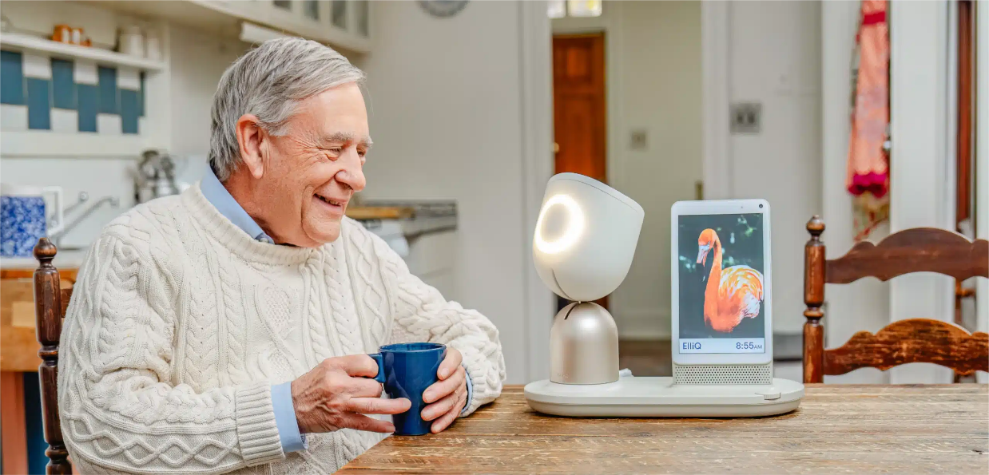
Exploring how ElliQ is transforming digital health promotion for healthy aging.
Introduction
Imagine spending days without having a meaningful conversation. Loneliness and social isolation is not something that happens once a while for many older people, it's a daily occurrence. These issues have been increasingly identified as significant public health concerns, linked to depression, anxiety, cognitive decline, cardiovascular disease, and diminished quality of life (Manchana, 2021; World Health Organization, 2025). Digital health technologies are emerging as innovative ways to support independence, social connectedness and healthy ageing in the midst of an aging population. One of these innovations is ElliQ, the social companion robot designed to support older adults through conversation, wellbeing coaching and family engagement, with the help of an AI. This blog provides a critical evaluation of ElliQ as a digital health promotion intervention, with focus on the benefits and limitations of the intervention to address loneliness among older adults.

Why Are Loneliness and Social Isolation Public Health Priorities?
Loneliness is an individual's perception of social isolation, which is characterized by having fewer social connections (Jutai & Tuazon, 2021). These issues are likely to occur in older age, as there is an increase in the likelihood of being a retired person, bereaved, living with a chronic disease, having reduced mobility and living alone (Manchana, 2021). Loneliness not only impacts on emotional well-being, it also drives up health care utilization and is linked to worse physical and mental health. This impact has led health care organisations to seek digital health technologies that foster social interaction and autonomy.
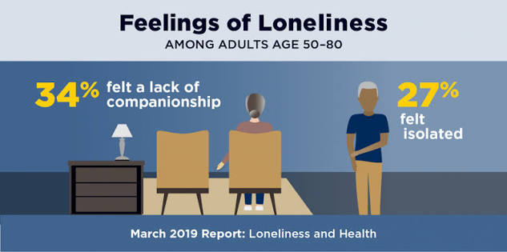
Figure 1. The older we get, the more we may feel alone.
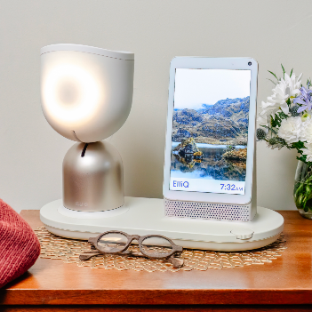
What is ElliQ?
ElliQ is designed with special needs for older adults, unlike conventional voice assistants. It was developed by Intuition Robotics and features AI, voice interaction, machine learning capabilities that start conversations, motivate physical activity, remind of medications, offer cognitive games and allow for video calls with family members (Broadbent et al., 2024). ElliQ is not simply a waiting tool, but rather a proactive one that can interact and motivate healthy habits with users during the day, and minimize feelings of isolation. Studies also show that older people have experienced increased emotional support and social interaction after interacting with the system (Kang, Kim and Pelish, 2026).

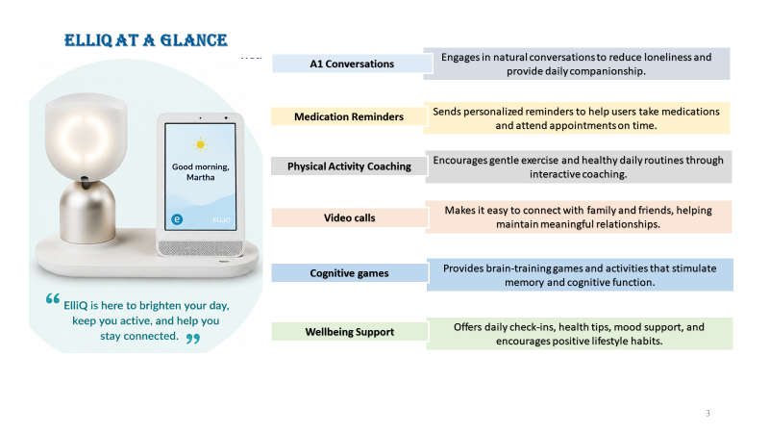

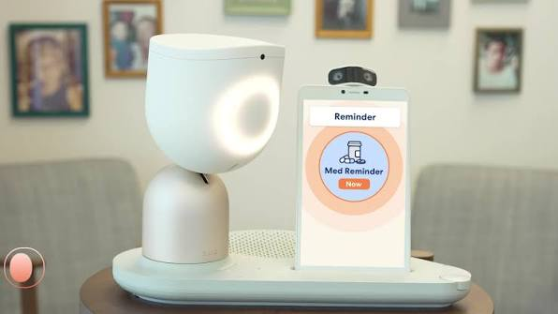
Benefits and Challenges
Benefits of ElliQ
Why ElliQ is a valuable digital health intervention?
✅ Reduces loneliness and social isolation: Provides regular conversations and emotional companionship, helping older adults feel more socially connected.
✅ Promotes healthy ageing: Encourages physical activity, healthy routines, and daily wellbeing through personalised coaching.
✅ Supports medication adherence: Sends reminders for medications and healthcare appointments, improving self-management.
✅ Strengthens family connections: Enables video calls and communication with family and friends, reducing feelings of isolation.
✅ Encourages independent living: Supports older adults in maintaining their independence while remaining engaged in everyday life.

Challenges
Despite its benefits, ElliQ has some limitations. Older adults who are less savvy with technology may struggle to use AI technologies (Hoffman, 2026). There is a concern regarding privacy and data security due to the device handling personal data (Emmer De Albuquerque Green, 2024). Furthermore, some users may not be able to access the technology due to the cost of the technology and the requirement for reliable internet access (Ali-Hassan, Eloulabi and Keethakumar, 2020). Thus, ElliQ is not a replacement for human relationships or professional care, but should complement them.
Recommendations
Governments and healthcare providers should enhance digital literacy initiatives, make AI technologies more accessible, and reinforce privacy measures to maximize the potential of AI companions. Further, future AI systems need to be multilingual and better connected to health care providers and community services to enhance equity and person-centred care.
Conclusion
ElliQ is proof that AI can be used for a more positive and engaging social interaction and personalised wellbeing support to combat loneliness and promote healthy ageing. Although it is a great technology, it will ultimately be successful if it is accessible, ethically applied, and is used to augment, not supplant, human care.
References
Ali-Hassan, H., Eloulabi, R. and Keethakumar, A. (2020) 'Internet non-use among Canadian Indigenous older adults: Aboriginal Peoples Survey (APS)', BMC Public Health, 20(1). https://doi.org/10.1186/s12889-020-09659-5
Broadbent, E., Loveys, K., Ilan, G., Chen, G., Chilukuri, M.M., Boardman, S.G., Doraiswamy, P.M. and Skuler, D. (2024) 'ElliQ, an AI-Driven Social Robot to Alleviate Loneliness: Progress and Lessons Learned', The Journal of Aging Research & Lifestyle, 13, pp. 22–28. https://doi.org/10.14283/jarlife.2024.2
Emmer De Albuquerque Green, C. (2024) 'Defining responsible use of AI chatbots in social care for older adults', Nature Aging, 4(6), pp. 745–747. https://doi.org/10.1038/s43587-024-00636-w
Hoffman, S. (2026) 'Editorial: Health literacy and digital health literacy among older adults: Public health interventions', Frontiers in Public Health, 13. https://doi.org/10.3389/fpubh.2025.1764365
Jutai, J. and Tuazon, J. (2021) 'Technology and Social Isolation, Loneliness, and Health Inequities Among Older Adults', Innovation in Aging, 5(Supplement_1), pp. 924–924. https://doi.org/10.1093/geroni/igab046.3346
Kang, S.Y., Kim, J.K. and Pelish, K. (2026) 'Interaction with ElliQ, an AI-Driven Social Companion Robot among Older People', Gerontechnology. https://doi.org/10.4017/gt.2026.25.2.1419.3
Manchana, S. (2021) Interrelationships of Physical Activity, Loneliness and Social Support among Older Adults: Health and Wellbeing in Later Life. Academia Letters. https://doi.org/10.20935/AL3478
World Health Organization (2025) Mental health of older adults. Available at: https://www.who.int/news-room/fact-sheets/detail/mental-health-of-older-adults
BLOG 2

Lumora AI: An Intelligent Digital Companion for Healthy Ageing
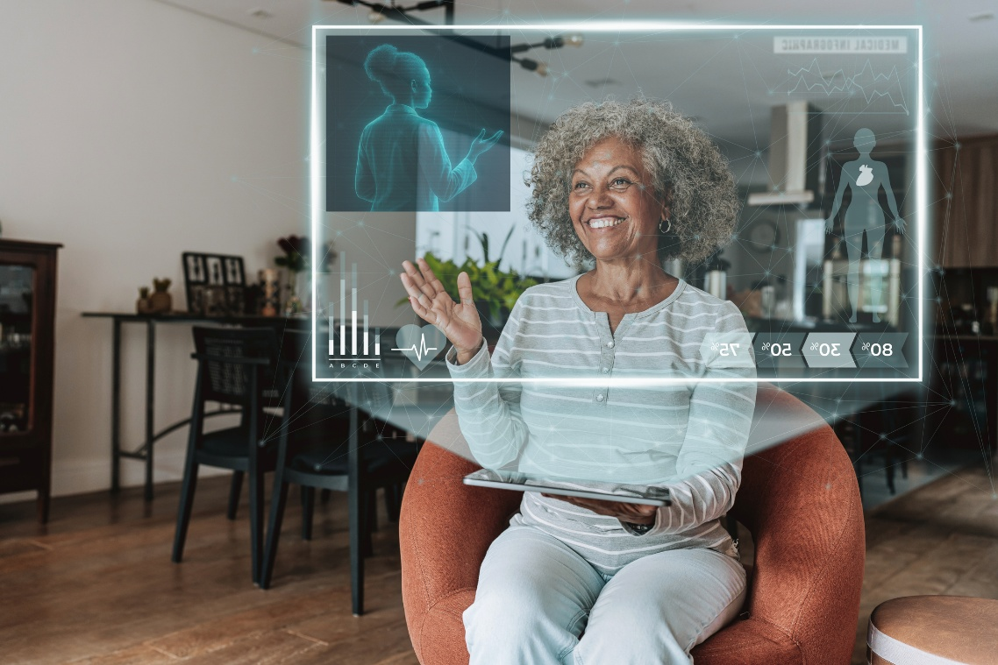
Designing an AI-powered digital health intervention to reduce loneliness and promote well-being among older adults.
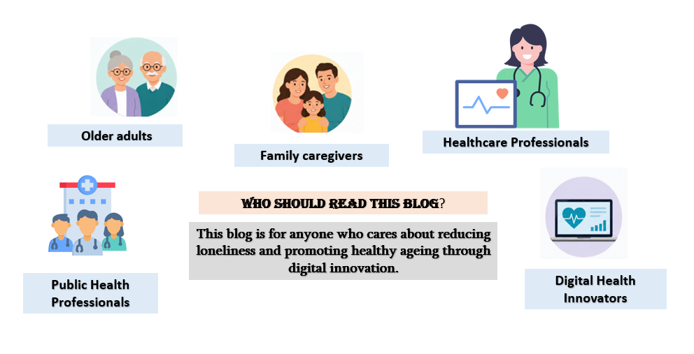
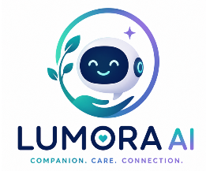
Introduction
AI companions like ElliQ have demonstrated the potential to alleviate loneliness among older adults, yet technological challenges such as digital literacy, cost, and accessibility, as well as concerns regarding privacy, still restrict their adoption. This blog introduces Lumora AI, an innovative digital health intervention to help older adults age healthily with personalized emotional support, health promotion, and enhanced social connections. Lumora AI is designed to enhance wellbeing through the use of AI and person-centred care, while also promoting independent living.

What is Lumora AI?
Lumora AI is an AI-based digital companion that is proposed to help older people who are feeling lonely and socially isolated. Using conversational AI, voice recognition, and personalised health monitoring, Lumora AI provides daily conversations, medication reminders, physical activity coaching, mood check-ins, and cognitive games. It is also multilingual, voice-first, offline-accessible and secure, unlike many technologies in existence. A number of features are built to ensure digital health is more inclusive, accessible and easier to use for older adults of varying digital confidence.

How Could Lumora AI Improve Public Health?
Lumora AI empowers healthy ageing by engaging users with daily behaviour change and custom health reminders along with emotional support. The user-friendly design and international language support lower digital exclusion, and the integration of healthcare and mood monitoring enables earlier recognition of concerns to wellbeing. Instead of a technology oriented around companionship, Lumora AI enables older adults, families and healthcare providers to work together to promote one's health, offering a more comprehensive approach to health promotion. It can enhance quality of life and mitigate the harmful impacts of loneliness when integrated with existing health and social care services.

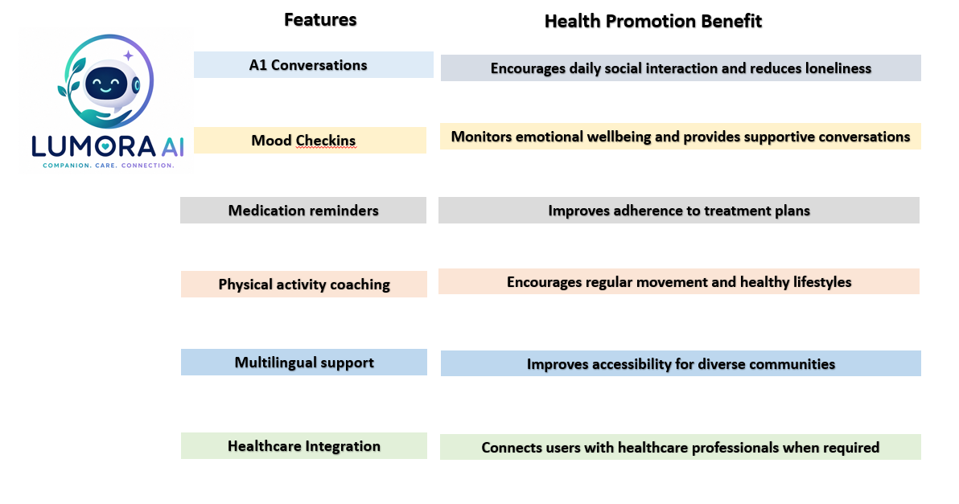

Benefits and Challenges Challenges
Benefits of Lumora AI
While Lumora AI offers several benefits, it also has some drawbacks. Older adults might not be digitally literate and need to be trained to effectively utilize the technology. Data privacy concerns, cyber security, and the expense of the AI device and internet connection could also impact adoption. Moreover, AI has proven to be no substitute for human connections or for professional health care, and faulty suggestions or technical problems can undermine its usefulness if not monitored appropriately.
Lumora AI has the potential to provide several advantages for the promotion of public health for older adults. It can help to alleviate loneliness by offering meaningful discussions, emotional support, reminders for taking medication, tracking physical activity, offering guidance on nutrition and health education. Through daily wellbeing monitoring and providing necessary information to caregivers (with consent), Lumora AI also offers support for independent living, enhances information about health and wellbeing, and facilitates early awareness of potential health issues.
Recommendations
To maintain the usability, price affordability, cultural diversity, and ethical approach of Lumora AI, older adults, caregivers, and healthcare workers must be involved in the development process moving forward. Enhancing digital literacy initiatives, bolstering privacy safeguards, and increasing affordable internet connectivity will further drive digital adoption and create an opportunity to enhance public health benefits, maximizing the impact.
Conclusion
Lumora AI showcases how AI can transcend from mere companion to a comprehensive digital health promotion solution. It can provide emotional support, health monitoring, and improved community engagement, which can help to lower loneliness, promote healthier habits, and maintain independence, while also augmenting, not replacing, human care.
References
Ali-Hassan, H., Eloulabi, R. and Keethakumar, A. (2020) 'Internet non-use among Canadian Indigenous older adults: Aboriginal Peoples Survey (APS)', BMC Public Health, 20(1). https://doi.org/10.1186/s12889-020-09659-5
Broadbent, E., Loveys, K., Ilan, G., Chen, G., Chilukuri, M.M., Boardman, S.G., Doraiswamy, P.M. and Skuler, D. (2024) 'ElliQ, an AI-Driven Social Robot to Alleviate Loneliness: Progress and Lessons Learned', The Journal of Aging Research & Lifestyle, 13, pp. 22–28. https://doi.org/10.14283/jarlife.2024.2
Emmer De Albuquerque Green, C. (2024) 'Defining responsible use of AI chatbots in social care for older adults', Nature Aging, 4(6), pp. 745–747. https://doi.org/10.1038/s43587-024-00636-w
Jutai, J. and Tuazon, J. (2021) 'Technology and Social Isolation, Loneliness, and Health Inequities Among Older Adults', Innovation in Aging, 5(Supplement_1), pp. 924–924. https://doi.org/10.1093/geroni/igab046.3346
Manchana, S. (2021) Interrelationships of Physical Activity, Loneliness and Social Support among Older Adults: Health and Wellbeing in Later Life. Academia Letters. https://doi.org/10.20935/AL3478

