Database Analysis and Design

James Brooks
HND Student at Pembrokeshire College
Haverfordwest, United Kingdom
144818@Pembrokeshire.ac.uk

Table of Contents

1. Introduction 3
2. Evidence 3
2.1. Entity Relationship Diagram 3
2.2. Level 0 Data Flow Diagram 4
2.3. Context Diagram 5
2.4. Tables and Fields 5
2.5. Forms 7
2.6. Relationships 9
2.7. Queries 10
2.8. Buttons 10
2.9. User guide 11
A. Start up from the main menu 11
B. Printing off invoices 11
C. Finding Customer records 11
D. Creating a new order 12

1. Introduction

In this assignment the report has been requested to create a database for a catering business called Celtic Caterers which is located in central Swansea. They mainly provide catering services in their base location and the surrounding area however they have since expanded and have stores in Neath, Port Talbot, Llanelli and Carmarthen. For this reason, Celtic Caterers have requested that the database that the report will create will provide a designed invoice that the user can view on screen and print off, they would also like to view a record of transactions when purchases are made, additionally it is required that the database provide a option to query information when catering events are booked.

2. Evidence

2.1. Entity Relationship Diagram

Below is an illustration of the layout and structure of the data base in the form of an entity relationship diagram which is designed to illustrate the different entities that each table will have and what degree of a relationships each of the tables will share.
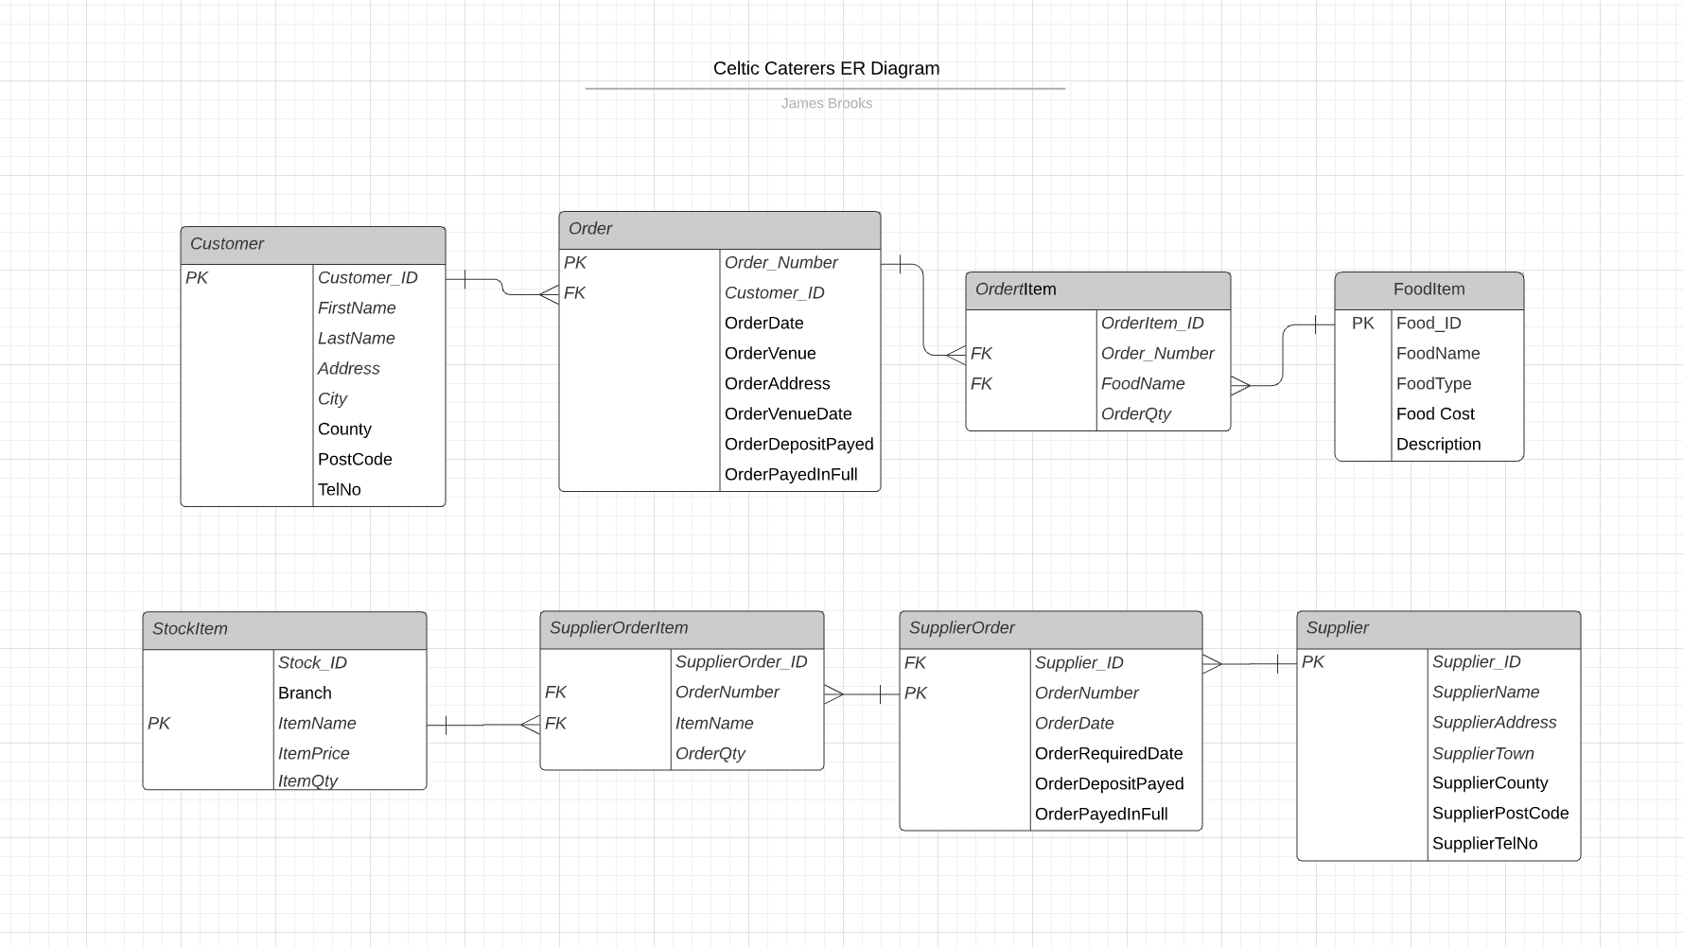
Fig 1. Image of an ER Diagram showing the structure and relationships of the Celtic Caters Database

2.2. Level 0 Data Flow Diagram
Below is a Level 0 Data Flow diagram which illustrates how the system will operate together from the very beginning of customers requesting their orders down to the company reordering stock from the supplier.
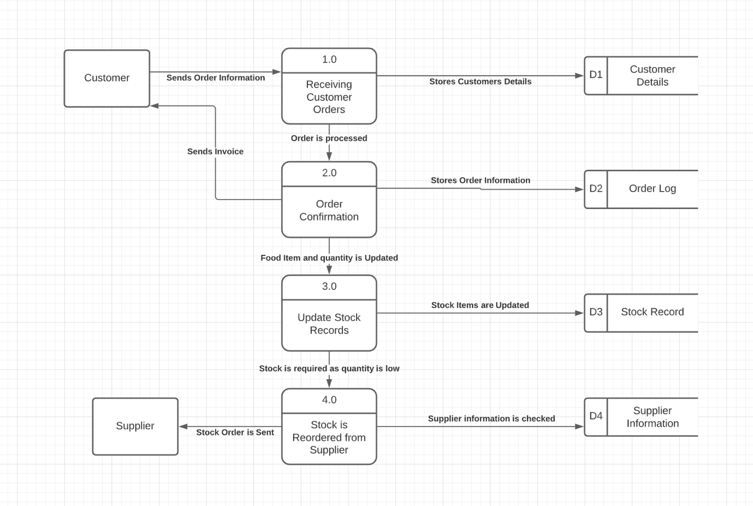
Fig 2. Image of a Level 0 Data Flow Diagram showing the flow of data and processes in the Celtic Caters Database.

2.3. Context Diagram
This report has included a Context diagram briefly illustrating the flow of data in the database between the three main entities.
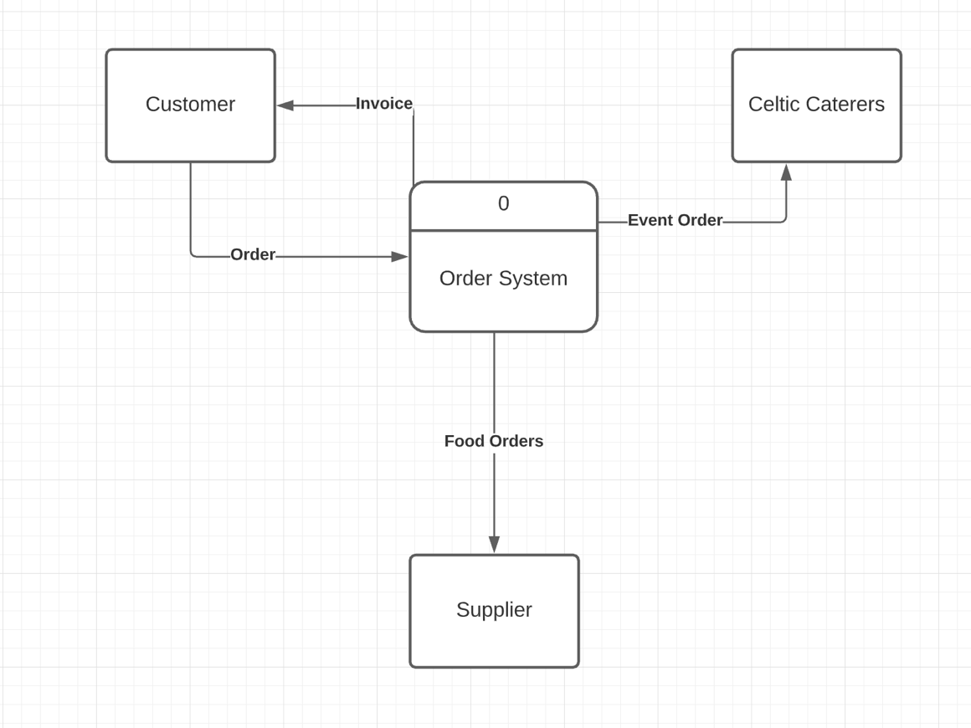

Fig 3. Image of a Context Diagram showing the flow of data in the Celtic Caters Database.

2.4. Tables and Fields

Below this report has include screengrabs of the individual tables in the database showing the key fields with the inputted data. These screengrabs accurately show what data is needed for the database to work effectively for Celtic Caterers.

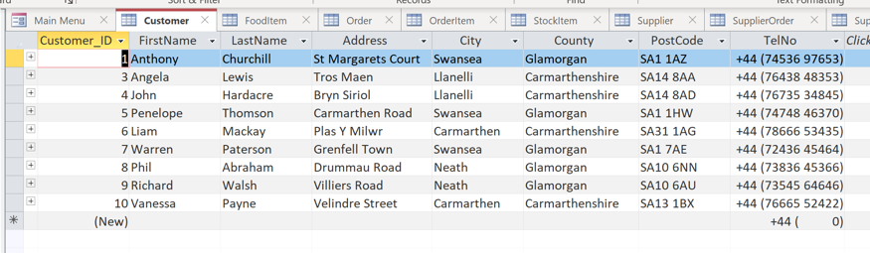

Fig 4.1. Screengrab of the “Customer” table in the database.

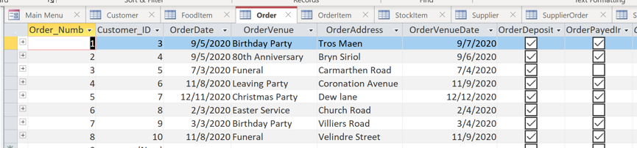

Fig 4.2. Screengrab of the “Order” table in the database.

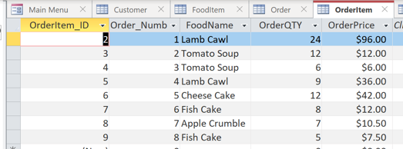

Fig 4.3. Screengrab of the “OrderItem” table in the database.
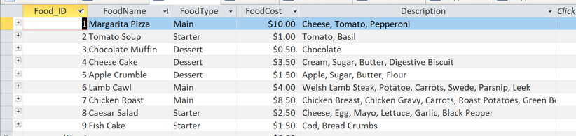

Fig 4.4. Screengrab of the “FoodItem” table in the database.

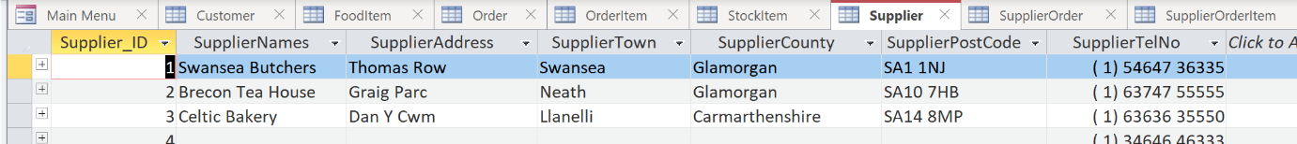

Fig 4.5. Screengrab of the “Supplier” table in the database.

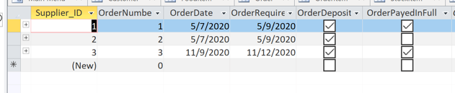

Fig 4.6. Screengrab of the “SupplierOrder” table in the database.

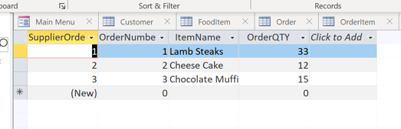

Fig 4.7. Screengrab of the “SupplierOrderItem” table in the database.

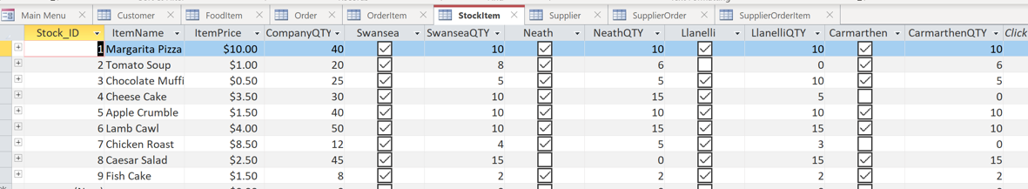

Fig 4.8. Screengrab of the “StockItem” table in the database.

2.5. Forms

This report has inserted five screengrabs of the three forms in the Celtic Caters Database. The first form is the master form called “Customer Order” which is for finding specific customer details such as name, address, postcode, order number and date as well as whether the order deposit has been paid and the order paid in full. This report includes an embedded form that shows a breakdown of the order showing what was ordered and what quantity. A second Form is also a master form called “Order Invoice” this form is designed to show a summary of the order in terms of what was ordered, what quantity, and total cost to the customer. It additionally has an embedded form like the first form which shows the total price of the customer’s order. The final form titled ‘Bookings” is designed for employees of Celtic caters to submit new orders for existing and new customers into the database.
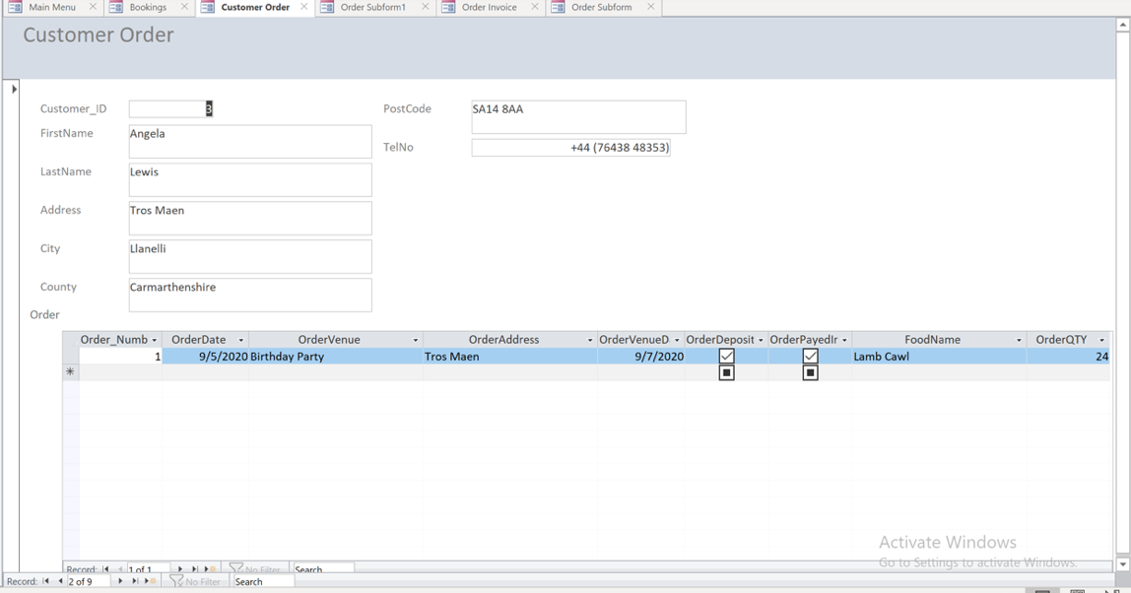

Fig 5.1. Screengrab of the “Customer Order” master form.
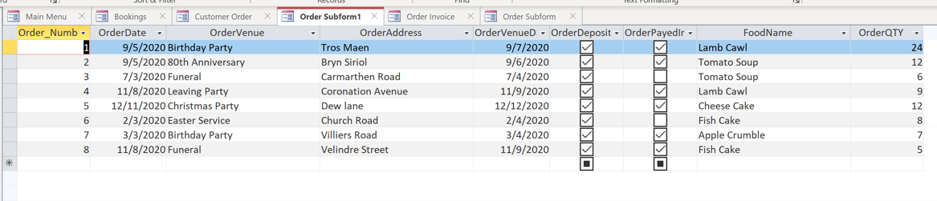

Fig 5.2. Screengrab of the “Customer Order” embedded form.

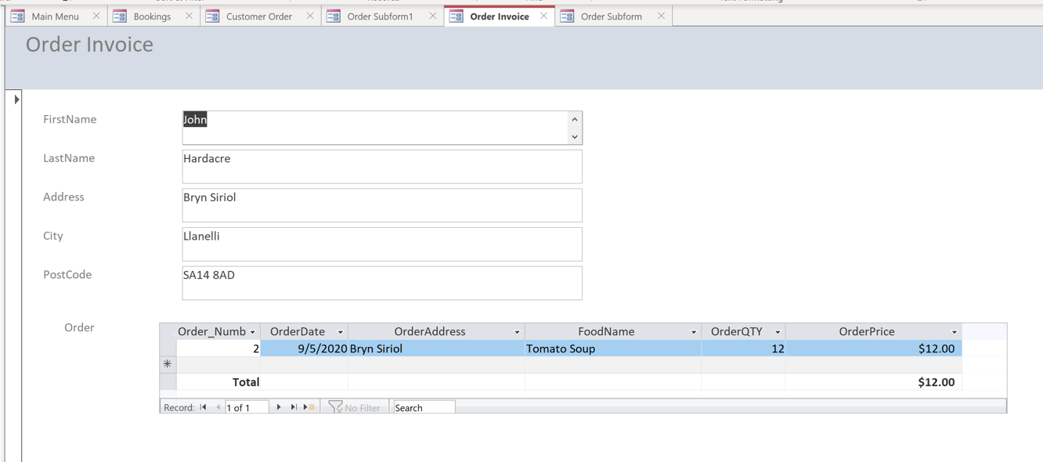

Fig 5.3. Screengrab of the “Order Invoice” master form.

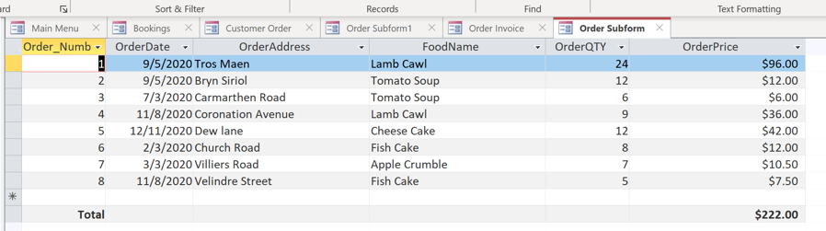

Fig 5.4. Screengrab of the “Order Invoice” embedded form.

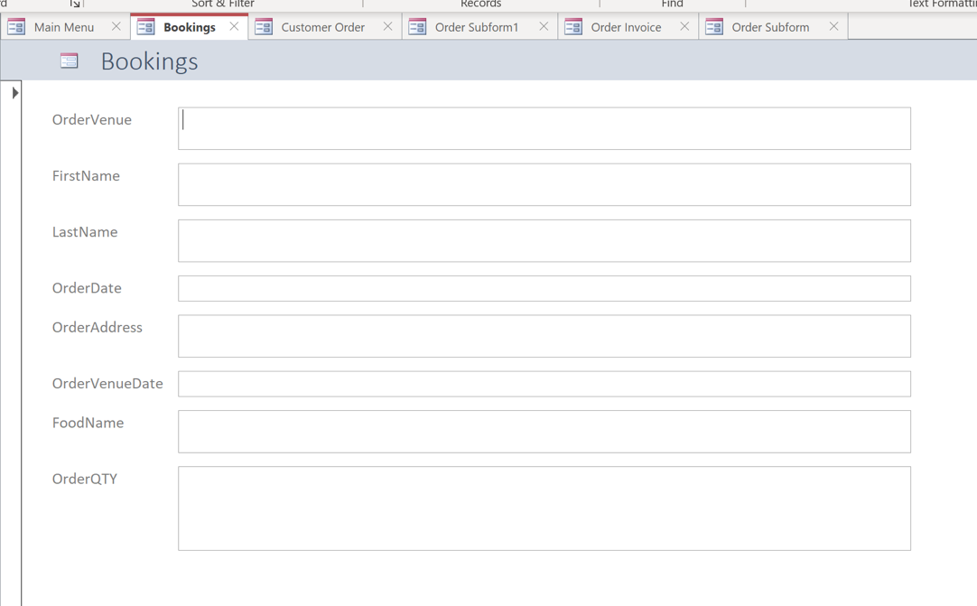

Fig 5.5. Screengrab of the “Bookings” form.

2.6. Relationships

Below is a screengrab of the relationships between each table in the Celtic Caterers database. It accurately shows how each table is connected through their primary and foreign keys, for example, see how the “Customer” table “Customer_ID” field links directly to the “Order” tables “Customer_ID” field using a One-to-Many link this is because a customer’s ID can have many orders linked to it but only one order number can be linked to a customer’s ID.
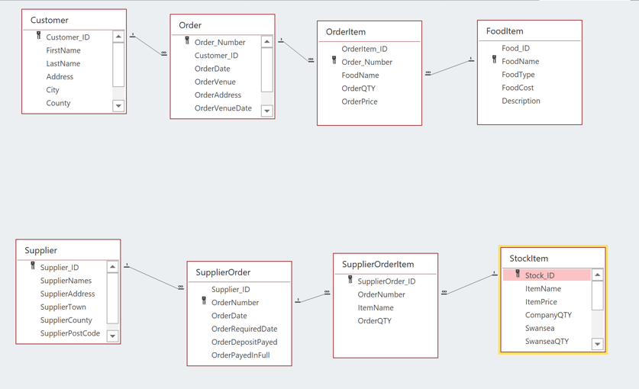

Fig. 6. Screengrab of the relationships in the Celtic Caterers database.

2.7. Queries
This report has included an additional screengrab showing a query of individual booking so that Celtic Caters can trace back orders for their venues, this query shows data such as the customer’s name, the order date, the orders address and what food was ordered and in what quantity.

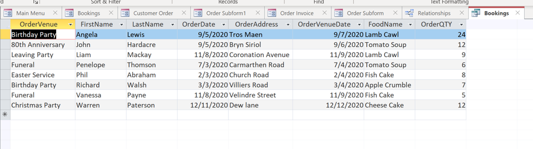

Fig 7. Screengrab of the Booking query.

2.8. Buttons
This report has included a screengrab illustrating one of the buttons main functions which are printing off selected Forms and reports for Celtic Caters to keep in a paper format, such as invoices and Supplier orders, the second buttons in the database is to find certain records as customer order numbers or Venue dates. The third button is for employees to create new orders for customers, and the final button is to quit the database application when the user is finished.
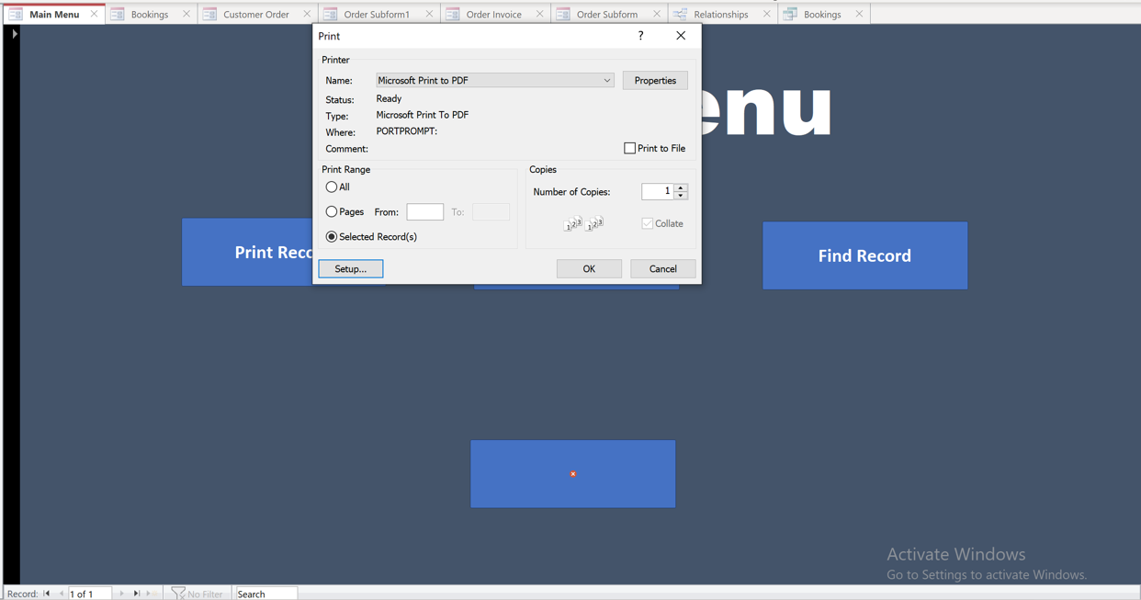

Fig 8. Screengrab of the “Print Record” button performing it’s set function.

2.9. User guide
In this section, the report will provide a brief user guide in using the database successfully.
This guide will cover the following:
- Startup from the main menu
- Printing off invoices
- Finding Customer records
- Creating a new Order
- Exiting the application

A. Start up from the main menu
Startup from the main menu when opening the Microsoft Access database, the user will be greeted with the main menu page as shown in Fig 9.1. From this page, the user can perform four distinct actions, print reports, create new orders, locate specific orders and forms, and exit the application.

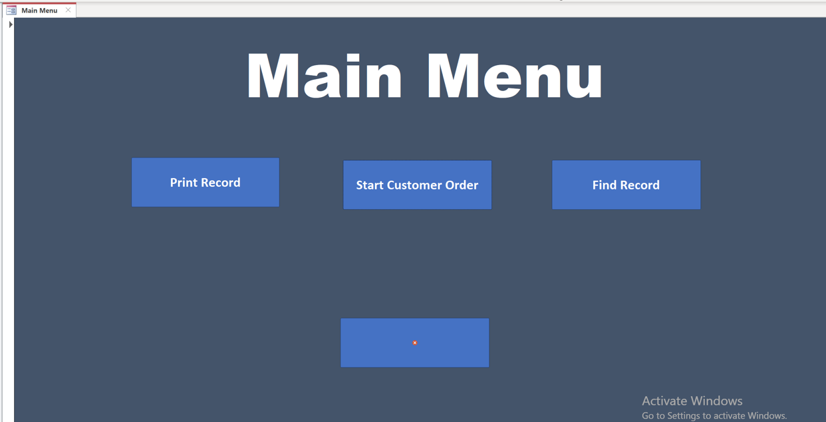

Fig 9.1. Screengrab of the databases main menu showing the four separate function buttons.

B. Printing off invoices
To print off an order invoice the user simply needs to select the “Print Record” button on the main menu, the database will then ask the user to find the order number that they want to print, once selected the user must select a printing location then print as seen in Fig 8.

C. Finding Customer records
To locate a specific record the user can select the “Find Record” button on the main menu which will then take the user to the “Customer Order” form where they can select the field they are searching for i.e., order numbers, customer ID’s and/or venue locations they can then proceed by selecting the “Find Record” button in that form which will show all the data that fits into the chosen criteria.

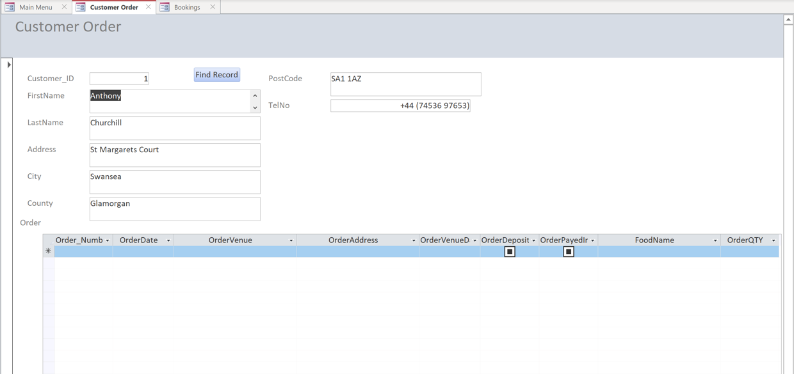

Fig 9.2. Screengrab of the “Customer Order” form showing how to find information in the database.

D. Creating a new order
To create a new order for a customer the user can select the “Start Customer Order” button which will take the user to a fresh “Customer Order” form where they can fill in the necessary information for Celtic Caters to provide their services.
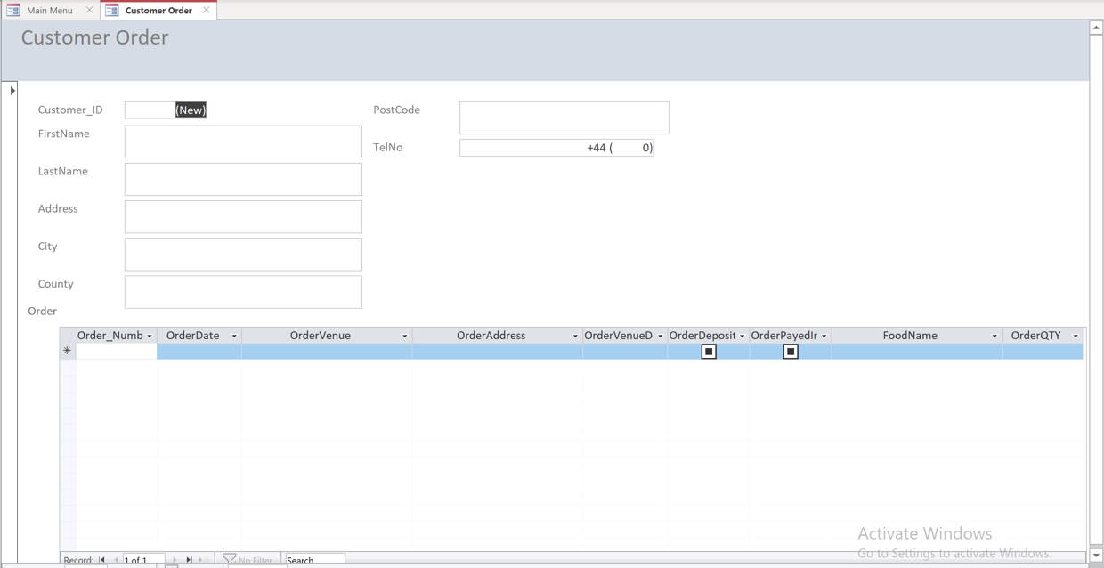

Fig 9.3. Screengrab of the blank “Customer Order” form showing how to input new order details for the database.

E. Exiting the application
Exiting the application is as simple as selecting the red “X” button on the bottom of the main menu as seen in Fig 9.1.

