IOANA GABRIELA BODNAR
Student number:1817471
Module name: International Financial Management
Lectures name :ISAIAH OINO

Table of Contents
Introduction................................................................................................................................3
Dividend distribution policy of Apple Inc.................................................................................3
Market hypothesis theory..........................................................................................................5
Appraising projects methods.....................................................................................................5
Conclusion................................................................................................................................7
References................................................................................................................................8

Introduction
International financial management is the management of finance in an environment of international business that is making money and trading through the exchange of foreign currency and it is also known as international finance. Control and treasury are two major functions of international financial management. International finance assists in calculating change rates of several currencies of countries. It plays a major role to improve the profitability of companies and enhancing the overall value of organizations or firms. This report will outline the dividend distribution policy of Apple Inc and critically evaluate the efficient market hypothesis theories in the context of Apple. It will also evaluate and analyse methods of appraising projects of Apple Inc.
Company overview- Apple Inc
Apple Inc. designs sell and manufacture media and mobile devices, portable digital music players and personal computers. Apple also sells services and a wider range of related software. They sell their products through their retail stores, direct sales force, third-party retailers and online stores. The company has its own total equity of US$63.090 million and total assets of US$351.022 million in 2021.

Dividend distribution policy of Apple Inc
The dividend distribution policy develops the principles to ascertain amounts that can be distributed to equity shareholders as dividends by the organization and allow the organization to strike balance between retained earnings and payout (Schwarz, 2018). It also helps to address the future needs of the organization. This policy is adopted by the organizations for paying out the dividends to their shareholders. The policy is also utilized by Apple (Hussein, 2021). Apple has raised their quarterly cash dividend annually beginning in 2012. The company managed to raise quarterly dividends by nearly 10 per cent. The company executed share buybacks, which made it cheaper for them to pay high cash dividends per share (Kanakriyah, 2020).
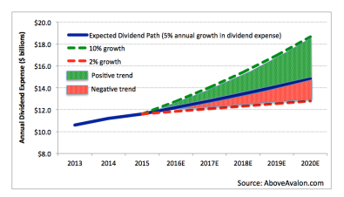
Figure 1dividend path of Apple, source-(Li, 2021)
The growth of the dividend of the company is about 10 per cent but the growth in the expenses has only 5 per cent because of the policy of share buybacks (Schwarz, 2018). In the following years, the dividend payouts of the company will fluctuate around 5 per cent, ranging from 2 per cent to 10 percentages. The company increased their dividend expectation in the green zone (Vasilaki and Tsakalidis 2019).
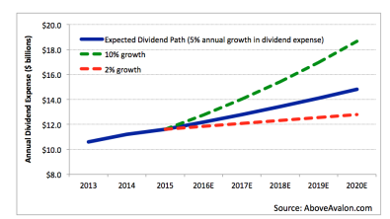
Figure 2dividend path of Apple, source-(Li, 2021)
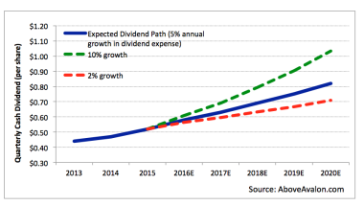
Figure 3dividend path of Apple, source-(Li, 2021)
In the above image, the red line shows the 2 per cent growth rate and the green line shows the 10percent growth rate. The above image shows the dividend path of Apple (Vasilaki and Tsakalidis, 2019). As per the above give image, the company raises their dividend expenses by 5% per cent in 2016 (Hussein, 2021).
The major disadvantage of the stable dividend policy is that investors do not see any increment in the dividend in boom years. As per the constant dividend policy, an organization pays a percentage of their earnings as dividends every year (Schwarz, 2018). A stable dividend policy is not good for investors as in this policy dividends remain the same in profitable years. It affects the attitude of investors as well as the financial standing of the organization (Vasilaki and Tsakalidis, 2019).

Market hypothesis theory
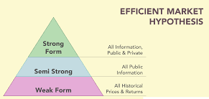
Figure 4Market hypothesis theory, source-(James and Valenzuela, 2020)

As per the effective market hypothesis, theory share prices reflect all information of a company. This theory hypothesizes that stocks trade at their fair market value on the exchange (James and Valenzuela, 2020). The theory is utilized by Apple as well. The theory helps Apple to maintain that market prices effectively reflect an underlying value of assets involving the cash, hard assets, liabilities and intangible assets of the company. The theory provides different versions -semi-strong, weak and strong (Umeno, 2021). The weak form of theory suggests that stock prices of today reflect all the past prices and semi-strong from version submits that because public information is one of the important parts of a current stock price, investors cannot use either fundamental or technical analysis (Ying et al., 2019). The strong form describes that all information, not public and public, is completely accounted for in the prices of current stock.
The theory states that when any kind of new information comes into the market. It maintains that all stocks of Apple are perfectly priced as per their inherent investment properties. It has some assumptions as well which affects its effectiveness (Ying et al., 2019). It assumes financial security is always priced accurately and this implies that stocks are never overvalued and undervalued which is not always true. The theory has some limitations as well such as overreaction, overconfidence, information bias and representative bias (Umeno, 2021). It needs technical and fundamental work which waste the time of the management and the chances of errors in this calculation are also high (James and Valenzuela, 2020).

Appraising projects methods
The appraisal includes a careful analysing and evaluating of the basic data, methodology and assumptions utilised in the preparation of a project. There are seven methods of project appraisal that can be utilized by a company (Ademu, 2017). These methods of appraisal are- technical methods, social methods, economic methods, financial methods, commercial methods, institutional methods, legal methods (Le, 2021).
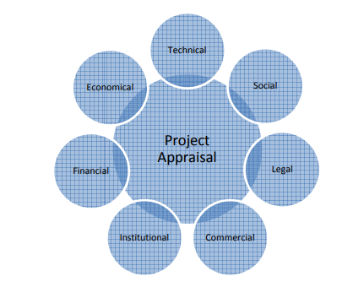
Figure 5project appraisal methods, source-(Ademu, 2017)
All these methods are utilized by Apple to appraise projects. In all these projects appraising methods, a financial appraisal is one of the most used appraising methods (Le, 2021). Apple uses this appraising method to evaluate the profitability of projects. Following details are measured in the financial appraisal method-
- Net present value
- Total cost
- Return on investment
- CBR
- IRR
- Opportunity costs
- Other costs
Apple uses the net present value appraisal method to calculate the return in the project and make decisions accordingly. NVP represents the percentage of recovery of the capital cost in its project life period. The benefit-cost ratio is also part of this appraisal method and helps the company to evaluate the cost-benefit of the company. The internal rate of return is also utilized by Apple to major the profitability of the project. The rate of interest shows the "effective interest earned on the investment in the project". The second method of appraising projects is commercial appraisal which is also used by Apple (Ademu, 2017). It measures the scope and demand of the project among the recipients and the future demand of supply. It includes the assessment of market scenario and current demand, which allows the project to obtain adequate demand (Kanakriyah, 2020).
These projects appraising methods have some disadvantages as well which affect their efficiency. The biggest disadvantage of these appraising methods is that it avoids the size of projects during the comparison of projects (Le, 2021). It avoids the future costs of projects as well and does not provide accurate information about projects. The reinvestment rates are also avoided by these appraising methods which is also the limitation of these methods. Some of these appraising methods are based on assumptions. The concept of IRR and NPV are difficult for some people and has high chances of human errors (Kanakriyah, 2020). It does not provide information on profit or yield and is not a universal application as well. Companies need to use those methods carefully as per their requirement and must consider the disadvantages of each project appraising method before making the final decision.

Conclusion
International finance assists in calculating change rates of several currencies of countries. Control and treasury are two major functions of international financial management. A dividend distribution policy is adopted by the organizations for paying out the dividends to their shareholders. Apple has raised their quarterly cash dividend annually beginning in 2012. The company executed share buybacks, which made it cheaper for them to pay high cash dividends per share. . As per the constant dividend policy, an organization pays a percentage of their earnings as dividends every year. In the following years, the dividend payouts of the company will fluctuate around 5 per cent, ranging from 2 per cent to 10 percentages. There are seven methods of project appraisal that can be utilized by a company. In all these projects appraising methods, a financial appraisal is one of the most used appraising methods. Apple uses this appraising method to evaluate the profitability of projects. It measures the scope and demand of the project among the recipients and the future demand of supply.
References
Ademu, M.H., 2017. Application of Accounting Methods and Techniques in Appraising Rival Projects in Situations of Risk and Uncertainty (Doctoral dissertation).
Hussein, S.S., 2021. The relationship between intangible assets and dividend policy. Tikrit Journal of Administration and Economics Sciences, 17(54 part 1).
James, K.R. and Valenzuela, M., 2020. The efficient IPO market hypothesis: theory and Evidence. Journal of Financial and Quantitative Analysis, 55(7), pp.2304-2333.
KANAKRIYAH, R., 2020. Dividend policy and companies' financial performance. The Journal of Asian Finance, Economics, and Business, 7(10), pp.531-541.
Le, S., 2021, December. The Applications of NPV in Different Types of Markets. In 2021 3rd International Conference on Economic Management and Cultural Industry (ICEMCI 2021) (pp. 1054-1059). Atlantis Press.
Li, Y., 2021. Analysis on Improvement of Ownership Structure and Dividend—Take Apple as an Example. In E3S Web of Conferences (Vol. 235, p. 01024). EDP Sciences.
Schwarz, D., 2018. The ability of listed companies to optimize their capital structure, shape their distribution policy and fight hostile takeovers by repurchasing their own shares. Entrepreneurship and Sustainability Issues, 6(2), p.636.
Umeno, K., 2021. Elucidation of Chaotic Market Hypothesis Based on Ergodic Theory. In Creative Complex Systems (pp. 165-187). Springer, Singapore.
Vasilaki, M. and Tsakalidis Jr, G., 2019. Apple Inc. Equity Valuation.
Ying, Q., Yousaf, T., Akhtar, Y. and Rasheed, M.S., 2019. Stock investment and excess returns: a critical review in the light of the efficient market hypothesis. Journal of Risk and Financial Management, 12(2), p.97.

