Student name: Faiza Hersi

Student number:1913455

Module Code: BMHP5015_BIRM

Assignment title: E-Portfolio Evidence of Learning

Lecturer: Dr. Tayo Korede
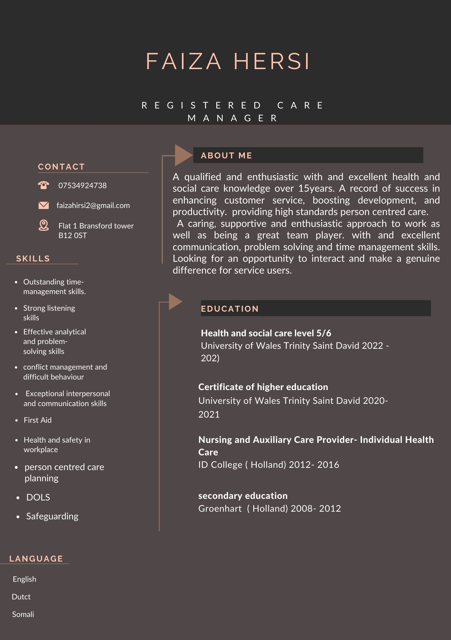
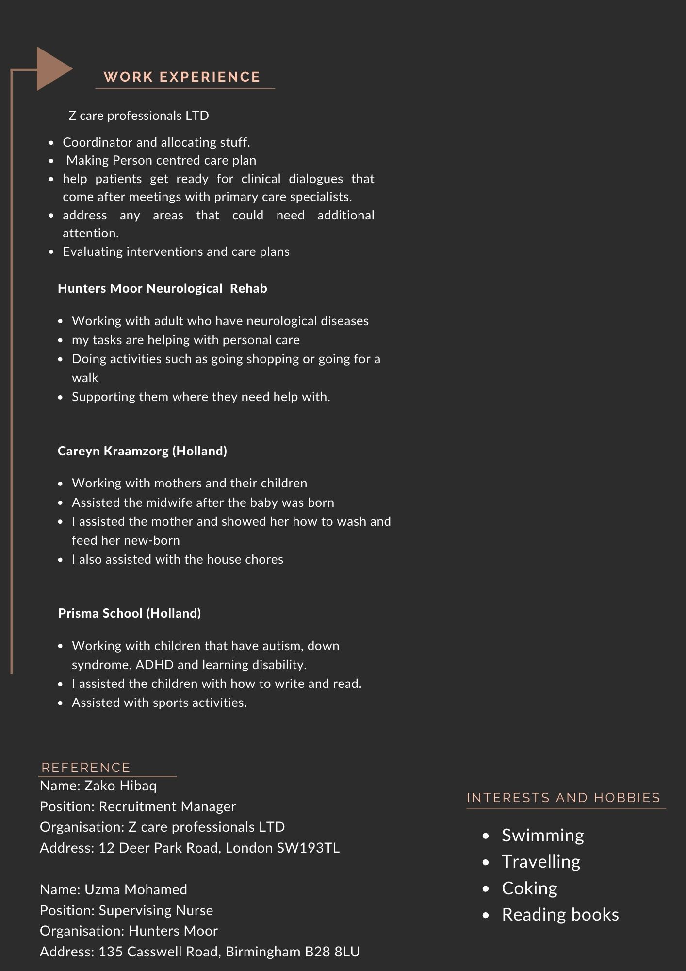
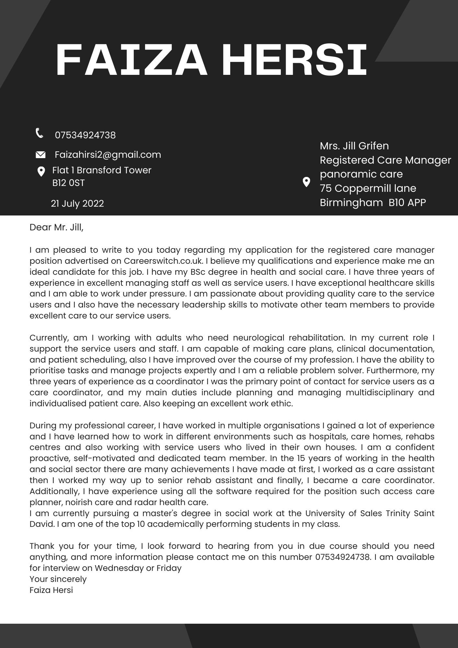
Dear Mrs, Jill Griffin

