Lecturer: Philippa Fitzgerald
Student: Eugen Gherasim
Student ID: 2242387
Word count: 399
Menu Engineering
Food & Beverage Operations BMIH4002

Part 1
Situated in the heart of London, Hotel Trinity is a luxurious 4-star city centre hotel and a distinguished member of the chain of Trinity Hotel (Taik and Kiss, 2022). The concept of a restaurant is not merely a place to dine; it provides an immersive gastronomic experience that serves both residents and international travellers (Lee et al, 2021). With a wider and thoughtfully crafted menu, a dedication to sustainability and seasonality and a strategy of pricing that ensures accessibility, Hotel Trinity aims to offer exceptional experiences of dining while respecting the environment as well as the diverse preferences of guests.
The restaurant of Hotel Trinity is more than just a place to dine; it is an immersive gastronomic experience (Lee et al, 2021). The chain's commitment to quality, combined with its wider portfolio of properties across different regions, has made it a trusted name in the hospitality sector (Okumus et al, 2020).
The restaurant concept of Hotel Trinity is designed to serve a wider base of audience. Tourists can savour British classics such as Beef Wellington and Fish and Chips and explore different flavours inspired by the multicultural heritage of the city (Zamyatina and Solntseva, 2019). For business travellers, the restaurant offers a sophisticated setting for meetings and networking events. Locals, on the other hand, are not forgotten (Walker, 2021). It offers a convenient and high-quality option for dining for Londoners who appreciate a touch of sophistication in their experiences of culinary (Lee et al, 2021). The restaurant caters as a hub for collections, celebrations, and special events.
The menu choices of Hotel Trinity are a careful selection that mirrors the multicultural essence of the city while paying homage to the classic cuisine of the British (Cui et al, 2020). These dishes ensure that guests can enjoy familiar tastes while in London on Christmas Eve.
Hotel Trinity values sustainability and sources ingredients locally whenever possible (Lang and Lemmerer, 2019). This not only supports the community but also ensures the freshness and quality of the dishes.
The Christmas menu at Hotel Trinity involves a wider variety of vegetarian as well as vegan options to serve wider preferences and lifestyles of the dietary (Grummon et al, 2021).
The menu of the bar complements the offerings of the culinary with signature wines and an array of local craft beers that make it a perfect spot for after-work gatherings (Boccia and Cseh, 2021).

PART-2- MENU DESIGN
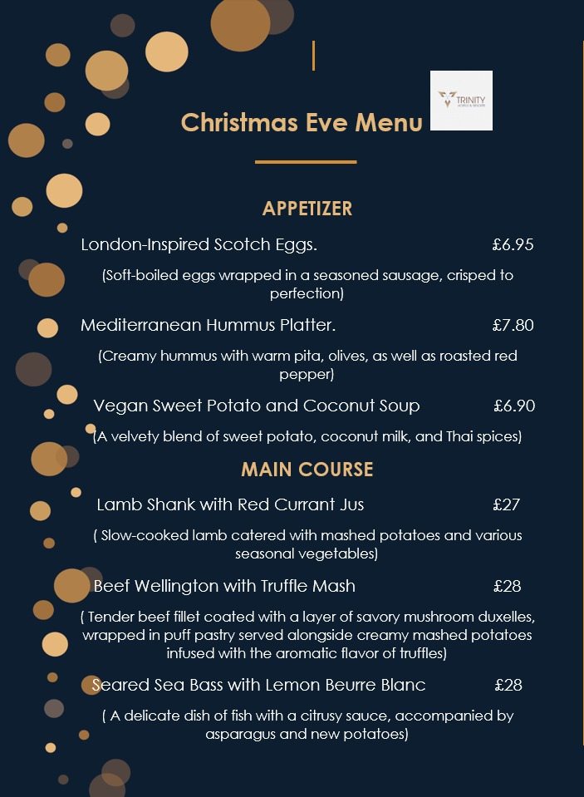

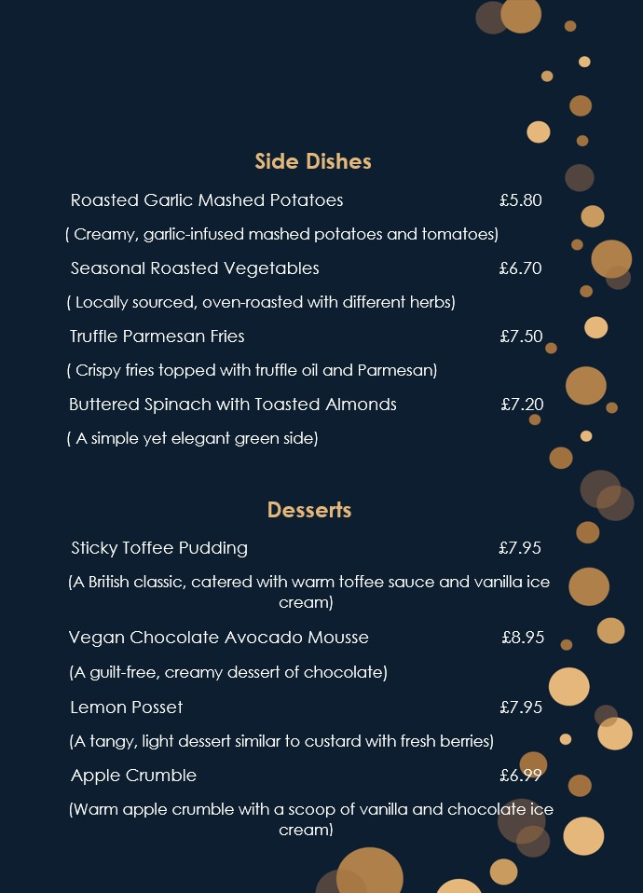

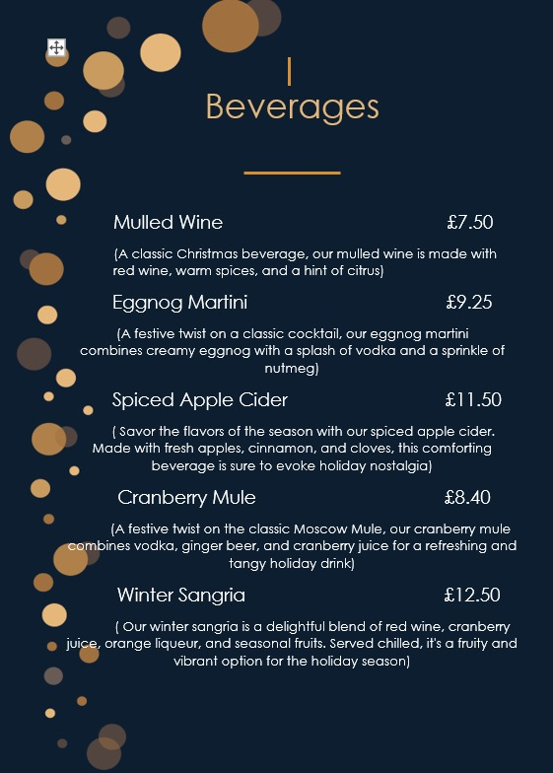

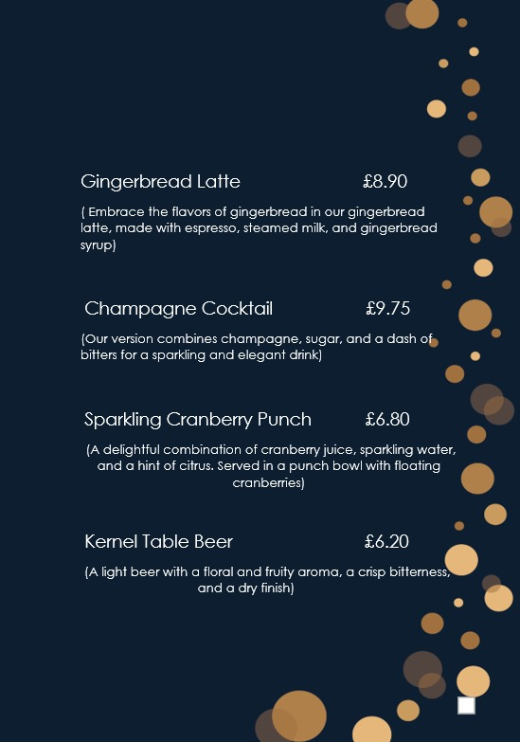

REFERENCES
Boccia, M. and Cseh, M., 2021. Full-service restaurants as learning organizations: a multiple-site case study. The Learning Organization, 28(4), pp.413-427.
Cui, L., Wu, Y., Liu, S., Zhang, Y. and Zhou, M., 2020. MuTual: A dataset for multi-turn dialogue reasoning. arXiv preprint arXiv:2004.04494.
Grummon, A.H., Petimar, J., Soto, M.J., Bleich, S.N., Simon, D., Cleveland, L.P., Rao, A. and Block, J.P., 2021. Changes in the calorie content of menu items at large chain restaurants after implementation of calorie labels. JAMA Network Open, 4(12), pp.e2141353-e2141353.
Lang, M. and Lemmerer, A., 2019. How and why restaurant patrons value locally sourced foods and ingredients. International Journal of Hospitality Management, 77, pp.76-88.
Lee, P.Y., Koseoglu, M.A., Qi, L., Liu, E.C. and King, B., 2021. The way of influencer marketing: Evidence from a restaurant group. International Journal of Hospitality Management, 98, p.103022
Okumus, B., Taheri, B., Giritlioglu, I. and Gannon, M.J., 2020. Tackling food waste in all-inclusive resort hotels. International Journal of Hospitality Management, 88, p.102543.
Rybak, G., Villanova, D., Burton, S. and Berry, C., 2023. Examining the Effects of Carbon Emission Information on Restaurant Menu Items: Differential Effects of Positive Icons, Negative Icons, and Numeric Disclosures on Consumer Perceptions and Restaurant Evaluations. Journal of the Association for Consumer Research, 8(3), pp.000-000.
Taik, S. and Kiss, B., 2022. Selective and optimal dynamic pricing strategy for residential electricity consumers based on genetic algorithms. Heliyon, 8(11).
Walker, J.R., 2021. The restaurant: from concept to operation. John Wiley & Sons.
Zamyatina, N.A. and Solntseva, O.G., 2019, December. Hotel tech ecosystem: adaptations to online distribution. In Institute of Scientific Communications Conference (pp. 194-204). Cham: Springer International Publishing.

