Reflective Essay based on research study participation
Research Log
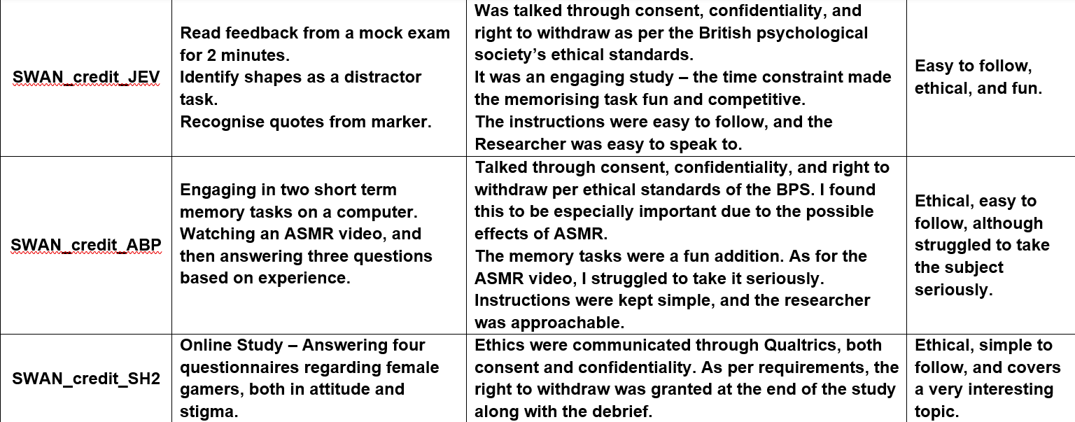
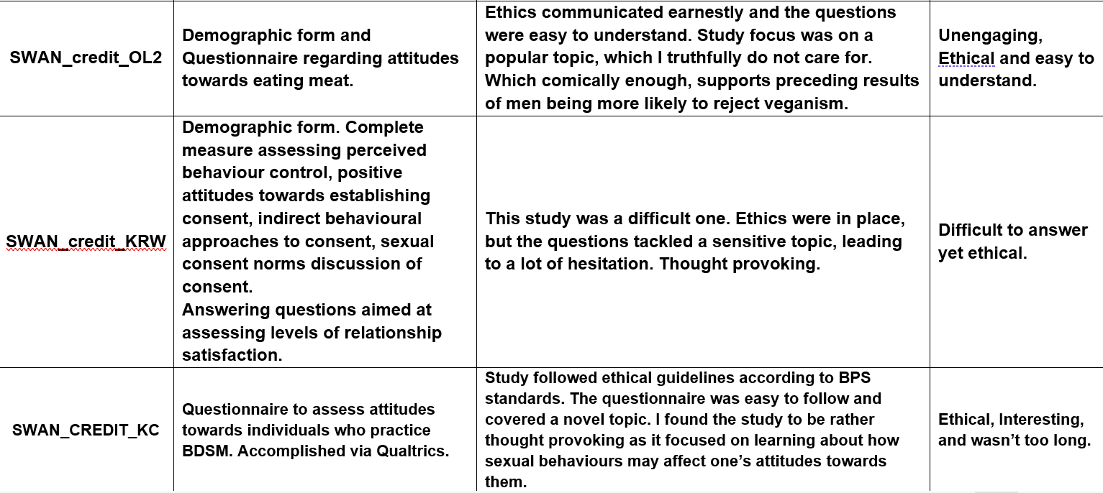

At the time of writing this, I have accomplished six hours of mandatory participation in psychological research. During this time, I have had the opportunity to partake in a wide array of studies which have investigated an assortment of intriguing facets within our world, within a variety of methods. Due to this, I will begin to reflect on a selection of these research studies and pinpoint where their strengths, weaknesses, and overall engage-ability lies.
During my participation of these studies, I have had the opportunity to take part in research at home via Qualtrics. In which, many of them have consisted of online questionnaires. For instance, one of these studies that I participated in, investigated the perception of women and gaming, along with the stigma that is associated with the two together. With that being said, I found that the study’s focus area was interesting and was happy to take part. Moreover, when going through the brief, I found it to be very simple and easy to follow and informed me of what I was going to do and asked for my consent. Upon completion of the questionnaires, I was then offered the opportunity to withdraw from the study if I was unhappy with my answers being used for data collection. Therefore, I can safely say that this study followed the ethical guidelines set out by the British Psychological Society to a concise manner (Research Board, 2021).
Throughout the process of filling out the questionnaire, at no point did I feel uncomfortable about providing my honest answers as I had a genuine interest in learning more about the topic. In terms of my opinion on the nature of the study, I felt as though that a quantitative study was the correct direction to take, as an impersonal approach to such a sensitive topic would yield in more accurate results. Although, I feel as though the study itself was a little too long, with all participants being required to answer four full-length questionnaires. Due to this, I could not help but feel like that some of the questions had been repeated and were simply worded differently. As a result, I could feel my engagement begin to diminish towards the end of the study, thus leading me to the assumption that perhaps this study could have benefitted from a purge of repetition as a means of maintaining general participant engagement. In sum, I do believe that this was a strong study, one that was not only ethical, but also had a clear objective in mind. While I do believe that the study lasted longer than it needed to, I still felt invested in the research and was ultimately happy to see it to completion.
In comparison to this, the next two studies were undertaken in the Super labs. The first one consisted of a memorising task regarding feedback on a mock exam. After which, I was given a distractor task in which I had to identify a variety of shapes for around a minute before having to attempt a memory recall task in which I was tasked with identifying the previous lecturer comments from an assortment of other remarks. In terms of ethics, all factors were communicated adequately at the beginning of the study, with the sole exemption being the right to withdraw, which was discussed at the end, thus precisely adhering to the BPS ethical guidelines (BPS Ethics Committee, 2021). I feel there is little objective criticism that I can offer. Although in terms of subjectivity, I felt as though my engagement was never gripped throughout the study, more so due to the subject of the research paired with the domination of education within my own life, thus, I fear my own results were rather lack-luster (Tamura et al., 2022).
With the Second Lab study, I found quite the opposite in terms of engagement. Like the previous studies mentioned, this one communicated an informed consent and rights to withdraw at the correct spaces within the study (BPS Ethics Committee, 2021). Where this one differs is in its originality. To begin with, its focus topic was on ASMR, a rather niche topic yet intriguing. Moreover, the researcher makes an original choice and allows for the participants to experience an ASMR video/audio. It would be little surprise to me if this action resulted in a loss of a few participants, as I can imagine that ASMR may evoke a range of responses, not all of them being positive (Guo et al., 2019). I struggled to take the video seriously, and as a result, in the coming questionnaires on the opinions towards ASMR, my honest responses were not positive. With that in mind, while I may have failed in finding peace from the video, I did appreciate the step away from the conventional research formula (Tamura et al., 2022). As at this point, I had taken part in a plethora of research studies, all of which had taken the form of simple questionnaires, which, while being efficient in garnering a wide array of data, it begins to lose participant engagement. Such a risk was circumvented with myself, as I felt that the small addition of the ASMR video/audio made for a pleasant stimulus to keep the study memorable and charming.
In conclusion, each study mentioned above possessed some strengths and weaknesses which the others could not. Whilst the Online study was convenient, in which I could complete at my own leisure I found that the longer it went on, the less engaged I became (Guo & Zhu, 2019). Moreover, I found the topic area to be the most interesting compared to the others, thus attributing to a completion with accurate results. In contrast this, I fear that the former Lab study received less accurate results due to its topic failing to grip me, thus leading to a lack of engagement from myself. In contrast, the second lab study, was found to be unique and fun to take part in. Therefore, it should be stated that whilst possible, researchers should aim to add a unique method to their research study to maintain participant retention (Guo & Zhu, 2019).

Reference List
Research Board. (2021). Ethics Guidelines for internet mediated research. British Psychological Society. https://www.bps.org.uk/guideline/ethics-guidelines-internet-mediated-research

BPS Ethics Committee. (2021). Code of ethics and conduct. British Psychological Society. https://www.bps.org.uk/guideline/code-ethics-and-conduct

Guo, Y., & Zhu, Y. (2019). Psychological detachment and research performance: Work engagement as a mediator. Social behaviour and personality, 47(10), 1 – 9. https://doi.org/10.2224/sbp.8277

Tamura, A., Ishii, R., Yagi, A., Fukuzumi, N., Hatano, A., & Sakaki, M. (2022). Exploring the within-person contemporaneous network of motivational engagement. Learning and Instruction, 81(1), 101649 – 101649. https://doi.org/10.1016/j.learninstruc.2022.101649

