BUSINESS DEVELOPMENT PROPOSAL
Jensen Huang’s Entrepreneurial Leadership at NVIDIA
A Proposed Partner-Delivered Enterprise AI Deployment Opportunity

Programme | MBA International Business
Module Code | LCMB7037
Student Name | Jeel Bhratbhai anghan
Student ID | 2522449
Profs name | Eno Maycock
Submission Milestone | Week 5 proposal submission
Word Count | Approximately 2,500 words (excluding references, tables and figures)

Table of Contents
Proposal Overview 3
1. INTRODUCTION AND PROPOSAL OVERVIEW 4
2. AIM, OBJECTIVES, RESEARCH QUESTIONS, COMPANY AND IDEA DESCRIPTION 5
Research Aim and Objectives 6
3. PROPOSED METHODOLOGY 7
Search, Screening and Data-Extraction Protocol 8
4. MARKET RESEARCH AND VALIDATION 9
Market Validation Indicators 10
5. KEY RISKS AND MITIGATION 12
Risk Register 12
6. PROJECT TIMELINE (GANTT CHART) 14
References 16

Proposal Overview
Element | Planned approach
Core case | NVIDIA Corporation and Jensen Huang; proposed partner-delivered enterprise AI deployment opportunity using accelerated computing, networking and software.
Research design | Qualitative secondary case study using academic, company, regulatory and industry evidence.
Period | Primary strategic evidence from 2020–2025, with emphasis on the shift toward accelerated computing, AI platforms and ecosystem development.
Key theories | Entrepreneurial leadership, dynamic capabilities, innovation capability, strategic agility and ecosystem/platform logic.
Main outputs | Evidence-led assessment of target customers, value proposition, competitor alternatives, partner roles, market validation, risks and implementation milestones.

1. INTRODUCTION AND PROPOSAL OVERVIEW
This business development proposal evaluates whether NVIDIA could extend its accelerated-computing proposition through partner-delivered enterprise AI deployment packages that combine GPUs, networking, systems and software for organisations moving AI from pilots into production. The proposal uses Jensen Huang’s leadership as a strategic lens, but its practical output is an evidence-based assessment of the opportunity, target buyers, delivery partners, value proposition and implementation risks. The study is not designed to address all possible dimensions of NVIDIA’s performance. Instead, it is to be concentrated on the mechanisms whereby entrepreneurial leadership can influence technological development, innovations, adaptation and ecosystem creation in a dynamic industry (NVIDIA Corporation, 2025; Felicetti, Corvello and Ammirato, 2024).
There is no doubt that the business situation makes it timely. According to Stanford HAI, global corporate AI investments have already exceeded $252.3 billion in 2024 and private generative-AI investments – $33.9 billion in the same year, showing how big and fast the opportunity space in relation to AI technology is becoming (Stanford HAI, 2025). Gartner reports about 81.7% growth of worldwide AI-processing semiconductor market up to $135.3 billion in 2024 and states that NVIDIA controls more than 50% of that market, explaining why NVIDIA can serve as a good case of how innovation and strategy make the sources of competitive positioning (Gartner, 2025). McKinsey also claims that 72% of companies surveyed in early 2024 used AI in at least one of their business functions, pointing out that AI adoption moves from experimentation towards widespread adoption (McKinsey, 2024).
The data provided by NVIDIA itself show the dynamics of strategic and technological changes. While Data Center revenues went up from $10.6 billion in 2022 fiscal year to $15 billion in 2023 fiscal year, $47.5 billion in 2024 fiscal year and $115.2 billion in 2025 fiscal year, the company progressed from Ampere to Hopper and Blackwell architecture and from GPUs to networking, systems and software (NVIDIA Corporation, 2022; NVIDIA Corporation, 2023; NVIDIA Corporation, 2024; NVIDIA Corporation, 2025). These figures provide market context; the proposal tests customer demand, deployment value and differentiation rather than treating revenue growth as proof of causation.
The central proposition is that NVIDIA’s business-development opportunity should be assessed as an integrated offer of architecture, networking, software and partner ecosystem rather than as a single product. Entrepreneurial leadership is associated with future orientation, innovations and organizational adaptation while the theory of dynamic capabilities focuses on sensing, seizing and reconfiguration of resources (Dabić et al., 2021; Qin and Lingfeng, 2021; Scheuer and Thaler, 2023).

2. AIM, OBJECTIVES, RESEARCH QUESTIONS, COMPANY AND IDEA DESCRIPTION
The proposal evaluates the feasibility and strategic fit of a partner-delivered enterprise AI deployment proposition using NVIDIA’s accelerated-computing capabilities, while examining how Huang’s leadership may enable or constrain it. Target customers are enterprises with complex AI workloads, with system integrators and cloud providers as potential delivery partners.
The objectives are to:
- To examine Huang’s entrepreneurial leadership in opportunity development;
- To assess NVIDIA’s core GPU, networking and software capabilities for enterprise AI deployment;
- To validate customer need, market demand and value proposition;
- To compare competitors and potential delivery partners; and
- To assess commercial, operational and regulatory risks to feasibility.
The sequence moves from leadership and capability fit to market validation and opportunity feasibility without assuming causation.
The research questions are:
- How could Huang’s leadership shape the proposed enterprise AI offer?
- Which NVIDIA capabilities best support its customer value proposition?
- What does market and competitor evidence say about demand and differentiation?
- Which risks could limit commercial feasibility?
The questions suit qualitative case analysis because they focus on decisions, capabilities, narratives and organisational responses.
NVIDIA provides a relevant basis for this opportunity because its accelerated-computing model combines processors, interconnects, systems, software, libraries, APIs and services. According to NVIDIA, its Data Center platform integrates computing and networking offerings with AI software and services, whereas Blackwell, NIMs, AI Blueprints, Spectrum-X, NVLink, Omniverse and robotics platforms feature in the company's description of the wider technology ecosystem of 2025 (NVIDIA Corporation, 2025). Also, the $7 billion Mellanox acquisition was finalized in April 2020 with NVIDIA getting high-performance networking technology that added to its end-to-end computing proposition (NVIDIA, 2020).
The following conceptual framework will be used in conducting the study: entrepreneurial leadership and vision shape opportunities recognition and resources orchestration, which form innovation priorities and ecosystem, whose capabilities facilitate organization's sensing and responding to technological changes. In this way, the processes of sensing, seizing and responding to environmental opportunities generate competitive advantages. Meanwhile, environmental dynamism, regulation, supply chain conditions and competition will be considered as boundary conditions rather than excluded from consideration. This approach is consistent with the literature on the link between entrepreneurial leadership, dynamic capabilities, innovation and strategic agility (Dabić et al., 2021; Ferreira, Coelho and Moutinho, 2020; Sultana, Akter and Kyriazis, 2022).

Research Aim and Objectives
Objective | How it will be assessed
1. Entrepreneurial leadership | Code vision, opportunity recognition and ecosystem building.
2. Enterprise AI offer | Map GPU, networking, system and software fit for AI deployment.
3. Customer need and value | Compare customer needs, adoption indicators and value proposition.
4. Competitors and partners | Compare competitor alternatives and potential partner roles.
5. Feasibility and risk | Assess commercial, technical, regulatory and supply-chain risks.
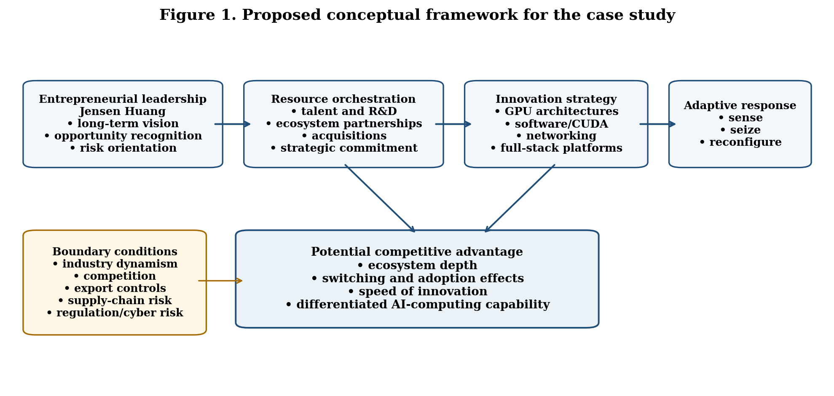
Figure 1. Proposed conceptual framework for analysing leadership, innovation and competitive advantage.
(Self-Created)

3. PROPOSED METHODOLOGY
The proposed research will adopt a qualitative secondary case study design, aligning with the provided outline. The unit of analysis is the strategic development of NVIDIA between 2020 and 2025, which will be explained based on the organisational decisions made during this time period, not personal assumptions and interpretations of Jensen Huang's personality and personal motivations. Case study design is suitable for the research because the posed research questions address the interplay between entrepreneurship and innovation, strategic decisions and innovation within an organisation operating in the technology field. Documentary analysis allows comparing evidence from various sources (Felicetti, Corvello and Ammirato, 2024).
Sources will include peer-reviewed journal articles, NVIDIA annual and investor reports, SEC reports, NVIDIA press releases, and quality industry sources, including Stanford HAI, McKinsey, Deloitte, Gartner and the World Economic Forum. The search of academic literature will be performed in Scopus, Web of Science, ScienceDirect, SpringerLink, Emerald and Google Scholar. The search strings will include combinations of keywords like "entrepreneurial leadership AND innovation", "strategic decision-making AND competitive advantage", "dynamic capabilities AND technological change", "NVIDIA AND AI strategy", "GPU ecosystem AND competitive advantage". The source window will prioritise evidence published in 2020–2025, retaining older foundational theory only where essential.
Evidence data will be extracted into an evidence matrix which will contain fields for source, date, type of evidence, strategic event, leadership/innovation theme, supporting quotation/factual evidence, relation to research questions and limitations. Further, thematic analysis will code evidence into groups such as long-term vision, opportunity identification, calculated risk-taking, innovation investment, ecosystem orchestration, vertical integration, strategic agility, organisational learning, competitive advantage, regulation, supply chain and sustainability. Sources will be rated for authority, transparency, recency, traceability and corroboration; conflicting claims will be logged, checked against original disclosures and independent evidence, and reported with limitations (Scheuer and Thaler, 2023; Zhang et al., 2023).
Triangulation will be key for validation. For instance, a strategic assertion by NVIDIA will not be considered as evidence of competitive advantage, but will rather be verified against independent evidence in terms of market development, theoretical framework or industry practice. Moreover, the study will differentiate correlation and causality. Even though there may be very strong market results achieved while Huang was leading the organisation, these cannot alone prove the causative role of his leadership in the achievement of these results. Rather, evidence will be sought about the convergence of results from decisions, technological breakthroughs, organisational capabilities and external market reactions. This is critical because secondary case studies are often prone to hindsight bias and corporate story-telling.
A drawback of the study is that internal decision-making processes and interviews with employees of NVIDIA cannot be observed. Another drawback is the possibility of bias in company-generated evidence. These limitations will be dealt with through triangulation and explicit coding guidelines and critical comparison of the evidence. The risk of ethical issues is minimal since the data used will be public documentary material.

Search, Screening and Data-Extraction Protocol
Stage | Inclusion criteria | Exclusion criteria
Source identification | 2020–2025; peer-reviewed or identifiable institutional source; directly relevant to NVIDIA, enterprise AI deployment, customers, partners or competitors. | Undated/anonymous promotional claims; irrelevant topics.
Quality screening | Authority, transparent methods, publication date, traceable claims and corroboration against original or independent sources. | Unsupported promotional claims, untraceable figures, duplicate evidence and sources with unclear provenance.
Analysis | Evidence can be mapped to at least one research question or theoretical theme. | Evidence with no analytical relevance to the case.
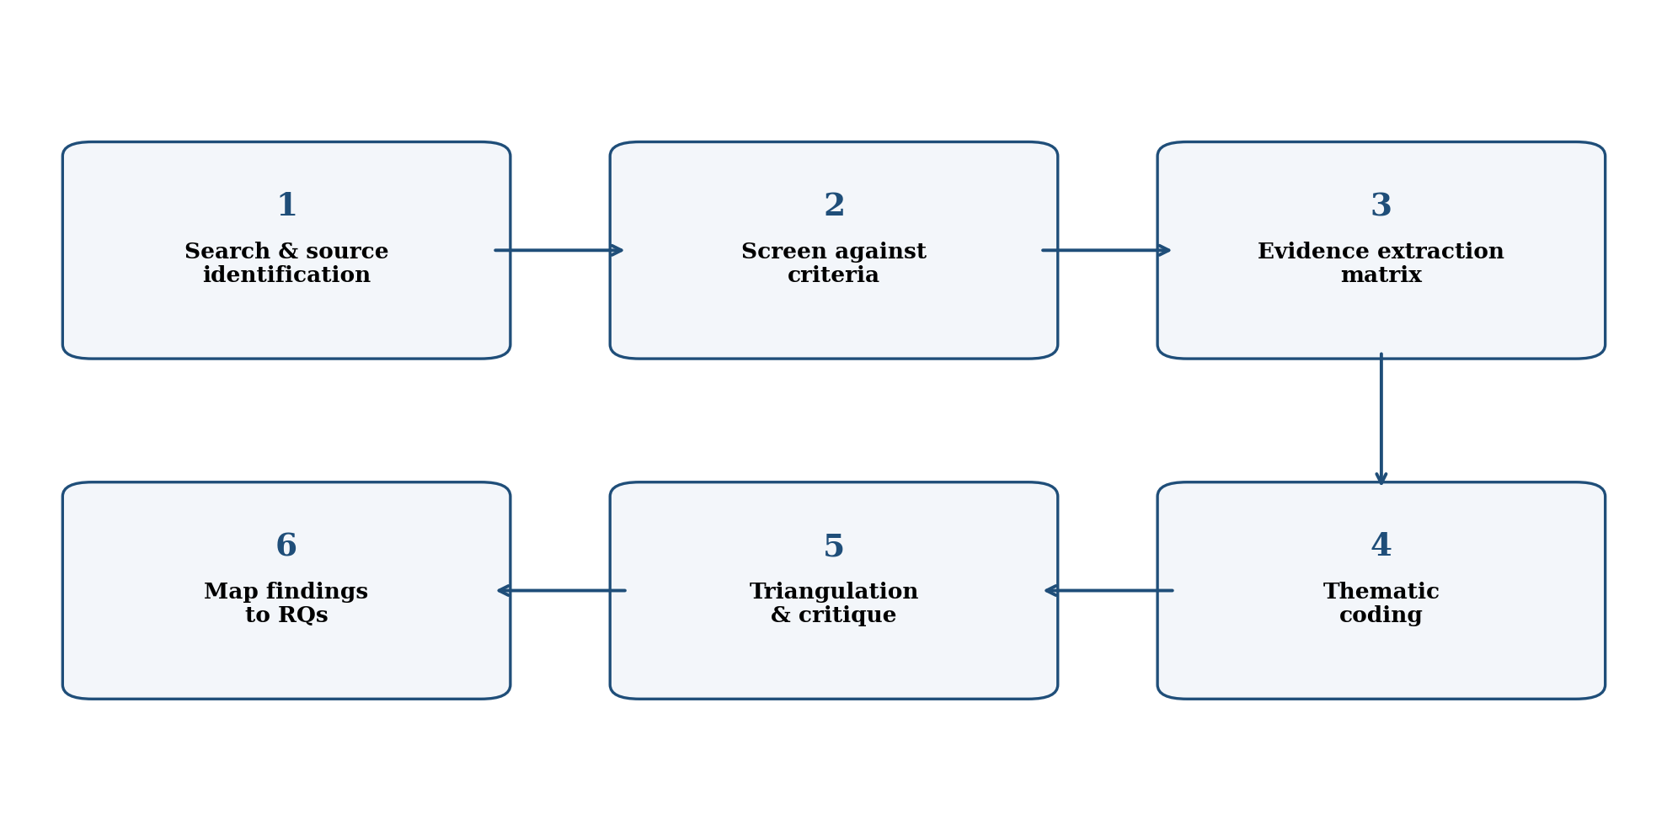
Figure 3. Secondary qualitative case-study workflow
(Self-Created)

4. MARKET RESEARCH AND VALIDATION
Market validation will show whether the market environment provides strategic significance to the research problem and reveal the outside pressures against which NVIDIA’s leadership can be analyzed. According to the information presented, there is a rapid growth in the amount of both AI investment and required infrastructure. Stanford HAI estimates $252.3 billion of global corporate AI investment in 2024, as well as $33.9 billion of generative-AI private investment (Stanford HAI, 2025). In the beginning of 2024, McKinsey reveals that 72% of organizations use AI in at least one of their business functions, as opposed to 55% in 2023, which demonstrates a wider range of users (McKinsey, 2024). Deloitte’s 2024 reports identify barriers around data, scaling, governance and risk, suggesting that deployment support may be a customer need; the proposal will test whether a partner-delivered offer addresses it (Deloitte, 2024a; Deloitte, 2024b).
As for the opportunity within the semiconductor market, according to the estimates of Gartner, AI-processing semiconductors accounted for $135.3 billion globally in 2024 after 81.7% growth and demonstrated NVIDIA’s more than 50% share (Gartner, 2025). As an industry estimate, this validates market scale rather than willingness to buy; the proposed offer still requires evidence on enterprise needs, costs and alternatives.
It is particularly interesting to use the indicator of the progression in Data Center revenue in order to show both the demand of the market for the company’s AI computing platforms and the history of architectural and ecosystem decisions made. The Data Center revenue per fiscal year has grown from $6.7 billion in 2021 to $10.6 billion in 2022, $15.0 billion in 2023, $47.5 billion in 2024, and $115.2 billion in 2025 (NVIDIA Corporation, 2021; NVIDIA Corporation, 2022; NVIDIA Corporation, 2023; NVIDIA Corporation, 2024; NVIDIA Corporation, 2025). These revenues contextualise market scale but do not establish demand for the proposed offer, which requires separate customer and integration-cost evidence.
The following themes are the most promising as regards strategic validation: platform depth, developer ecosystem, networking, and speed of product transition. According to the GTC 2024 materials, NVIDIA reported nearly five million developers and about 40,000 organizations working with NVIDIA, as well as more than 3,300 GPU-accelerated applications (NVIDIA, 2024a). Mellanox provided high-performance networking solutions for the company in 2020, and Blackwell contributed another transition in the system-level technologies in 2024 (NVIDIA, 2020; NVIDIA, 2024b). This supports testing an integrated offer for enterprise IT/AI teams, delivered with cloud or integration partners and benchmarked against rival accelerators and in-house chips on price, performance, software fit and availability.
The opportunity will be tested against four propositions: enterprise demand exists for integrated deployment support; NVIDIA’s combined hardware, networking and software can offer differentiation; partners can deliver the offer reliably; and commercial feasibility remains credible after competition, governance, supply-chain and product-transition risks are considered. These are propositions to test, not assumptions of success (Sultana, Akter and Kyriazis, 2022; Ravet-Brown, Furtner and Kallmuenzer, 2024).

Market Validation Indicators
Indicator | Latest evidence used | What it validates | Source
Global corporate AI investment | US$252.3bn in 2024 | Market scale; offer-specific demand remains unproven | Stanford HAI (2025)
Private generative-AI investment | US$33.9bn in 2024 | GenAI funding momentum; buyer demand untested | Stanford HAI (2025)
Organisations using AI | 72% in at least one function, early 2024 | Potential enterprise demand and deployment need | McKinsey (2024)
AI-processing semiconductors | US$135.3bn in 2024; 81.7% growth | Accelerator growth; differentiation requires testing | Gartner (2025)
NVIDIA developer ecosystem | Nearly 5m developers; ~40,000 companies | Platform depth for partner-enabled delivery | NVIDIA (2024a)
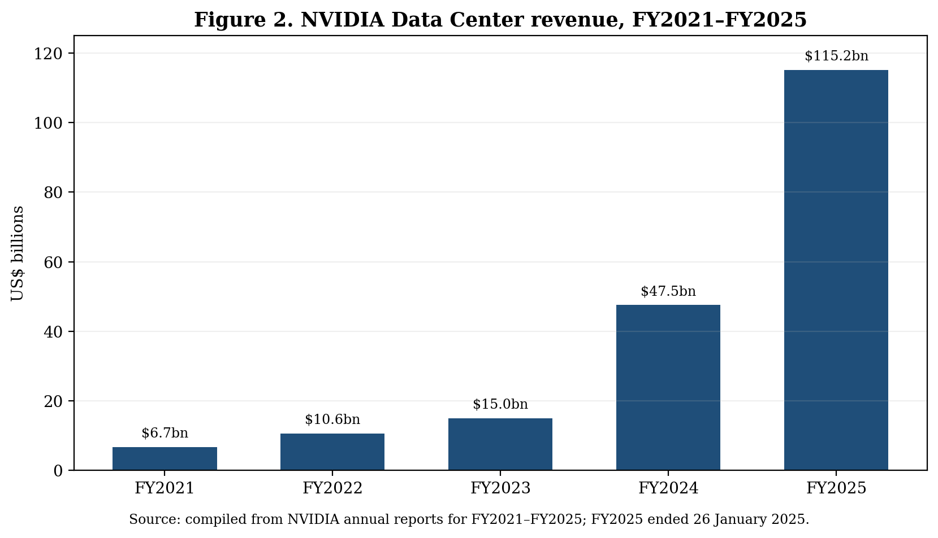
Figure 2. NVIDIA Data Center revenue, FY2021–FY2025
(Source: NVIDIA, 2021-2025)
The series is used as contextual evidence of market and platform expansion, not as proof of leadership causation.

5. KEY RISKS AND MITIGATION
Risk priority will use likelihood × impact (1 = low, 2 = medium, 3 = high); scores 6–9 are high priority, and 4 is medium. The main technological risk is the rapid obsolescence of the technology, there is a fast-changing architecture of AI and models, and therefore the success of the platform requires continuous innovation, as opposed to just one generation of the hardware. NVIDIA's shift from Ampere and Hopper architectures to Blackwell as well as Deloitte's findings suggest that the organizations find it hard to make the rapid transition from experimentation phase to scale (NVIDIA Corporation, 2025; Deloitte, 2024b). For the research, the mitigation will include looking at NVIDIA's cadence, software compatibility and ecosystem reinforcement as opposed to product specifications alone.
The competition risk is also significant. NVIDIA's 2025 filing notes the presence of intense competition in accelerated computing, software and networking and suggests that the competitors may be working with alternative technologies or architectures (NVIDIA Corporation, 2025). For this reason, in the course of the dissertation, NVIDIA's strategy will be compared to alternative ways of approaching accelerator and computing ecosystems, which have reliable documentation. The goal here is not to rank the firms, but rather identify mechanisms that can support or impair the position of the firm.
There are also a substantial supply chain and geopolitical risk, because advanced semiconductors require special manufacturing capabilities and there are risks associated with export controls preventing access to some markets. Indeed, NVIDIA's filings mention that export control has already impacted the competitive position of the firm and the concentration of the supply chain has left it exposed to disruption and policy changes (NVIDIA Corporation, 2025). Resilience, product redesign, geographic diversification and ecosystem diversification will be analyzed as possible responses to the problem without assuming that any one particular mitigation can eliminate the risk.
There can also be increased regulatory and responsible-AI risk as the number of deployed AI systems increases. As Stanford HAI points out, the activity around AI related policy is increasing and WEF considers the cybersecurity and emerging technologies among the most important strategic risks (Stanford HAI, 2024; WEF, 2024). As such, governance, compliance and trust will be considered as strategic factors influencing innovation speed and market access.

Risk Register
Risk | Likelihood | Impact | Mitigation / research response | Evidence base
Technology obsolescence | Medium (2) | High (3) | Track architecture cadence, software compatibility and ecosystem reinforcement. | NVIDIA (2025); Deloitte (2024b)
Intense competition | High (3) | High (3) | Use documented competitor strategies for balanced comparison; avoid ranking firms. | NVIDIA (2025); Gartner (2025)
Supply-chain concentration | Medium (2) | High (3) | Assess manufacturing dependence, diversification and resilience. | NVIDIA (2025)
Export controls / geopolitics | High (3) | High (3) | Analyse product adaptation, geographic exposure and policy constraints. | NVIDIA (2025)
Cybersecurity / governance | Medium (2) | High (3) | Evaluate governance and cyber resilience as strategic boundary conditions. | WEF (2024); Stanford HAI (2024)
Founder-attribution bias | Medium (2) | Medium (2) | Triangulate leadership claims with organisational, ecosystem and external evidence. | Dabić et al. (2021); Shiferaw et al. (2023)
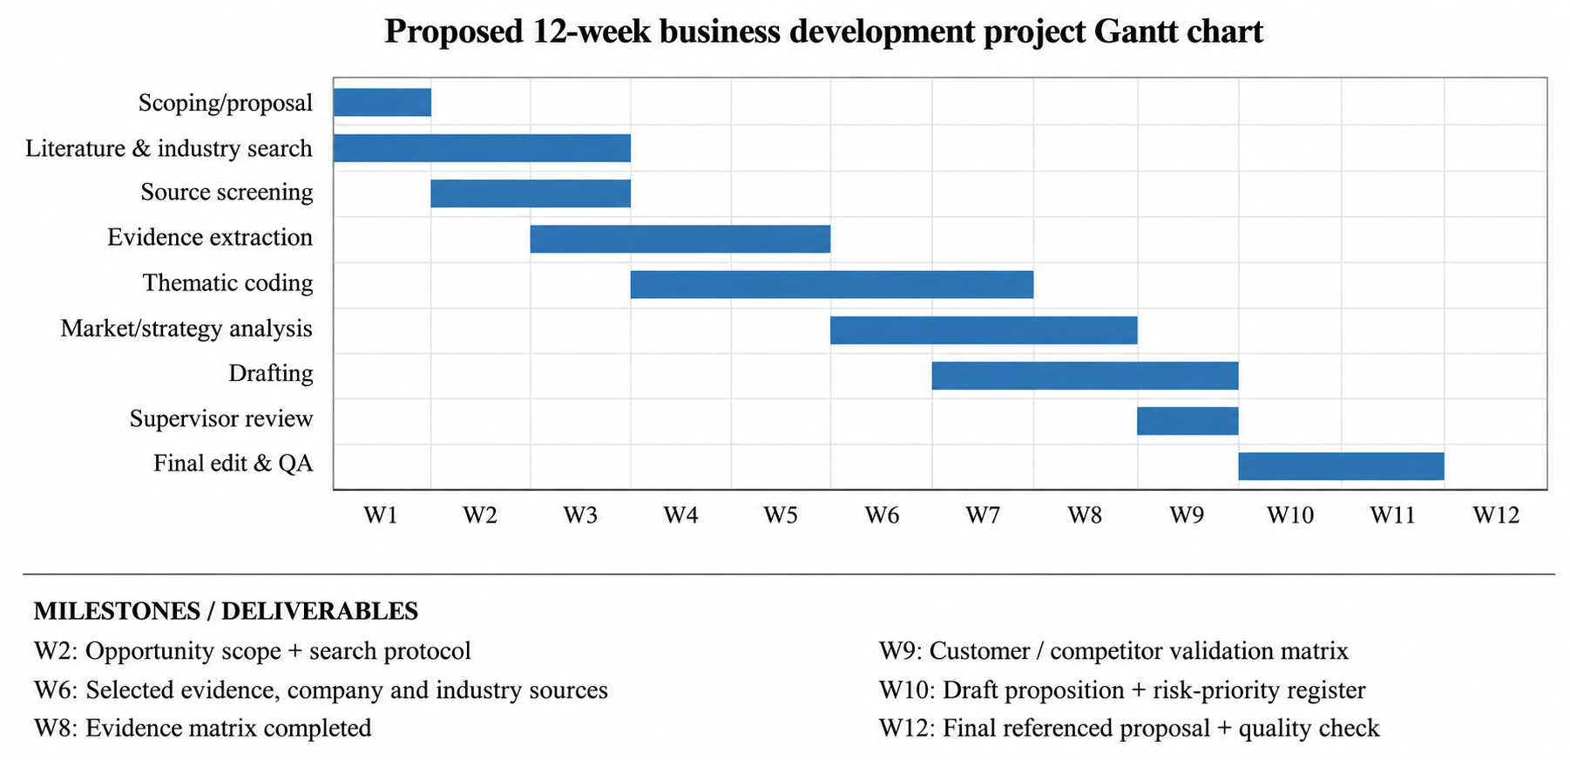
Figure 4. Proposed 12-week business development project Gantt chart with milestones and deliverables.
(Self-Created)

6. PROJECT TIMELINE (GANTT CHART)
The project is scheduled for completion within 12 weeks of project approval. Week 1-2 complete project scoping and search protocol (deliverable 1). Weeks 2-4 complete academic, company, industry and competitor searches and produce the evidence screening result in Week 4 (deliverable 2). Weeks 4-6 complete the evidence matrix (deliverable 3). Weeks 5-8 complete thematic coding and triangulation. Weeks 7-9 complete the evaluation of target customers, alternatives, partner and market fit (deliverable 4 – opportunity-validation matrix). Weeks 9-10 complete draft of proposition and risk prioritisation (deliverable 5). Weeks 10-11 allow for reviewing and integration; Week 12 complete referencing, quality assurance and the final report (deliverable 6).
This schedule allows the analysis to start before all searches are done but still leaves enough time for final check. The Week 5 milestone is submission of the proposal and the initial opportunity-validation plan. All further milestones are flexible depending on supervisor’s feedback; the table represents a feasibility schedule rather than guaranteed plan of implementation.
In summary, this proposal evaluates customer need, value, competitors, partner delivery and market fit for a specific enterprise AI opportunity without assumption of commercial success.

References
Dabić, M., Stojčić, N., Simić, M., Potočan, V., Slavković, M. and Nedelko, Z. (2021) ‘Intellectual agility and innovation in micro and small businesses: the mediating role of entrepreneurial leadership’, Journal of Business Research, 123, pp. 683–695. https://doi.org/10.1016/j.jbusres.2020.10.013 (Accessed: 27 September 2026).
Deloitte AI Institute (2024a) The State of Generative AI in the Enterprise: Now Decides Next. https://www.deloitte.com/in/en/services/consulting/research/state-of-generative-ai-in-enterprise.html (Accessed: 27 September 2026).
Deloitte AI Institute (2024b) The State of Generative AI in the Enterprise: Q4 2024. https://www.deloitte.com/us/en/what-we-do/capabilities/applied-artificial-intelligence/content/state-of-generative-ai-in-enterprise.html (Accessed: 27 September 2026).
Felicetti, A.M., Corvello, V. and Ammirato, S. (2024) ‘Digital innovation in entrepreneurial firms: a systematic literature review’, Review of Managerial Science, 18, pp. 315–362. https://doi.org/10.1007/s11846-023-00638-9 (Accessed: 27 September 2026).
Ferreira, J., Coelho, A. and Moutinho, L. (2020) ‘Dynamic capabilities, creativity and innovation capability and their impact on competitive advantage and firm performance: the moderating role of entrepreneurial orientation’, Technovation, 92–93, 102061. https://doi.org/10.1016/j.technovation.2018.11.004 (Accessed: 27 September 2026).
Gartner (2025) Market Share: AI Processing Semiconductors by End Market, Worldwide, 2024. https://www.gartner.com/en/documents/6645534 (Accessed: 27 September 2026).
McKinsey & Company (2024) The state of AI in early 2024: Gen AI adoption spikes and starts to generate value. https://www.mckinsey.com/capabilities/quantumblack/our-insights/the-state-of-ai-2024 (Accessed: 27 September 2026).
NVIDIA (2020) NVIDIA Completes Acquisition of Mellanox, Creating Major Force Driving Next-Gen Data Centers. https://nvidianews.nvidia.com/news/nvidia-completes-acquisition-of-mellanox-creating-major-force-driving-next-gen-data-centers (Accessed: 27 September 2026).
NVIDIA (2024a) NVIDIA GTC 2024 Highlights. https://images.nvidia.com/nvimages/gtc/pdf/gtc24-spring-best-of-highlight.pdf (Accessed: 27 September 2026).
NVIDIA (2024b) NVIDIA Blackwell Platform Arrives to Power a New Era of Computing. https://nvidianews.nvidia.com/news/nvidia-blackwell-platform-arrives-to-power-a-new-era-of-computing (Accessed: 27 September 2026).
NVIDIA Corporation (2021) Annual Report / Form 10-K for fiscal 2021. https://www.sec.gov/Archives/edgar/data/1045810/000104581021000010/nvda-20210131.htm (Accessed: 27 September 2026).
NVIDIA Corporation (2022) Annual Report / Form 10-K for fiscal 2022. https://www.sec.gov/Archives/edgar/data/1045810/000104581022000067/nvda2022definitiveproxysta.htm (Accessed: 27 September 2026).
NVIDIA Corporation (2024) Annual Report / Form 10-K for fiscal 2024. https://www.sec.gov/Archives/edgar/data/1045810/000104581024000104/nvda-20240514.htm (Accessed: 27 September 2026).
NVIDIA Corporation (2025) Annual Report / Form 10-K for fiscal 2025. https://www.sec.gov/Archives/edgar/data/1045810/000104581025000095/nvda-20250512.htm (Accessed: 27 September 2026).
Qin, L. and Lingfeng, Y. (2021) ‘How Entrepreneurial Leadership Improves Organizational Innovation Performance in Uncertain Environment’, Science & Technology Progress and Policy, 38(9), pp. 117–123. https://doi.org/10.6049/kjjbydc.2020010204 (Accessed: 27 September 2026).
Ravet-Brown, T.E., Furtner, M. and Kallmuenzer, A. (2024) ‘Transformational and entrepreneurial leadership: a review of distinction and overlap’, Review of Managerial Science, 18, pp. 493–538. https://doi.org/10.1007/s11846-023-00649-6 (Accessed: 27 September 2026).
Rubio-Andrés, M., Linuesa-Langreo, J., Gutiérrez-Broncano, S. and Sastre-Castillo, M.A. (2024) ‘How to improve market performance through competitive strategy and innovation in entrepreneurial SMEs’, International Entrepreneurship and Management Journal, 20, pp. 1677–1706. https://doi.org/10.1007/s11365-024-00947-9 (Accessed: 27 September 2026).
Scheuer, L.J. and Thaler, J. (2023) ‘How do dynamic capabilities affect performance? A systematic review of mediators’, European Management Journal, 41(6), pp. 914–931. https://doi.org/10.1016/j.emj.2022.12.006 (Accessed: 27 September 2026).
Shiferaw, R.M., Birbirsa, Z.A. and Werke, S.Z. (2023) ‘Entrepreneurial leadership, learning organization and organizational culture relationship: a systematic literature review’, Journal of Innovation and Entrepreneurship, 12, 38. https://doi.org/10.1186/s13731-023-00305-z (Accessed: 27 September 2026).
Stanford HAI (2024) The 2024 AI Index Report. https://hai.stanford.edu/ai-index/2024-ai-index-report (Accessed: 27 September 2026).
Stanford HAI (2025) The 2025 AI Index Report: Economy. https://hai.stanford.edu/ai-index/2025-ai-index-report/economy (Accessed: 27 September 2026).
Sultana, S., Akter, S. and Kyriazis, E. (2022) ‘How data-driven innovation capability is shaping the future of market agility and competitive performance?’, Technological Forecasting and Social Change, 174, 121260. https://doi.org/10.1016/j.techfore.2021.121260 (Accessed: 27 September 2026).
Zhang, J., Chen, Y., Li, Q. and Li, Y. (2023) ‘A review of dynamic capabilities evolution—based on organisational routines, entrepreneurship and improvisational capabilities perspectives’, Journal of Business Research, 168, 114214. https://doi.org/10.1016/j.jbusres.2023.114214 (Accessed: 27 September 2026).
World Economic Forum (2024) Global Cybersecurity Outlook 2024. https://www.weforum.org/publications/global-cybersecurity-outlook-2024/ (Accessed: 27 September 2026).
World Economic Forum (2025) The Future of Jobs Report 2025. https://www.weforum.org/publications/the-future-of-jobs-report-2025/ (Accessed: 27 September 2026).

