Project Proposal on Employee Engagement


Researcher – Bethan Haf Johnson
Student Number – 1700522
Module Code – M5X01921

Executive Summary
The purpose of this report is to investigate the topic employee engagement and a chosen theme within the topic of flexibility. The report introduces a hotel within the industry and focuses on a current issue within employee engagement. The report discusses the benefits of flexibility as well as how flexibility can be used within the hotel industry, using theories and other reliable sources of information. The report highlights good and bad practice of flexibility within the hotel industry using relevant case studies and examines how important it is for hotels to ensure good practice. Further to this, the report discusses and identifies the three key stakeholders of hotels and describes the stakeholders influence on employee engagement. The report also evaluates and describes the advantage of primary research methods and outlines why they are good methods for the researcher to use.
The report concludes that employee engagement is important for any organisation to be effective and efficient. The report identifies that stakeholders are a large influence in employee engagement, therefore they should help drive employee engagement by using methods adapted from Marriott. Importantly, the report concludes that without engaged employees, organisations would be inefficient and unsuccessful, as a hotel cannot operate well without engaged employees.

Contents Page
Section | Page Number
1.0 Terms of Reference | 4
2.0 Procedure | 5
3.0 Findings | 6
3.1 Task One – Hilton Hotels & Resorts | 6
3.2 Employee Engagement – Flexible Working | 6
3.3 Task Two – Flexible Working Good Practice | 8
3.4 Flexible Working Bad Practice | 9
3.5 Task Three – Key Stakeholders | 9
3.6 Task Four - Advantages of Primary Research Methods | 11
4.0 Task Five - Conclusion - Recommendations | 12
5.0 Reference List | 13

- Terms of Reference
The following report was requested by the Manager of Hilton Hotel on 5th June 2018 and has been compiled by the HR Advisor. The purpose of the report is to undertake an investigation of the issue of employee engagement. The main issue of employee engagement is flexibility; the main advantages of flexible working include, staff being used more efficiently, cost savings and maintaining the service of the organisation. The main disadvantages of flexible working include, not many promotion opportunities, demotivated employees and a cost to the company due to staff training. The report will be submitted on 6th July 2018.

- Procedure
The following sources have been used by the researcher to gather secondary research for the report; textbooks, websites and journals.

- Findings
The following findings will discuss employee engagement and a chosen theme within the topic of employee engagement will be discussed further.
  - Task One - Hilton Hotels & Resorts
Hilton Hotels & Resorts is multinational brand of hotels that started in 1919 by Conrad Hilton. They have over 4,900 hotels in over one hundred countries and have over 169,000 people employed within the company. (Hilton, 2017). Due to the size of the company and having so many employees, Hilton need to have procedures in place to increase employee engagement.
  - Employee Engagement – Flexible Working
Employee engagement is important for organisations as it makes a more efficient workplace. CIPD (2017) describes employee engagement, “Employee engagement brings together a range of established concepts, including job satisfaction, motivation, work effort, organisational commitment, shared purpose, energy and ‘flow’.” This illustrates how employee engagement can increase employee motivation, and thus creating a more efficient workforce.
In the hospitality industry it is important to have a high rate of employee engagement, as it can be a tiring and stressful industry to work in. Therefore, managers must have efficient ways to increase and maintain their employee engagement. In the 2009 ‘Engaging for Success’ report, Macleod, D and Clarke, N established four enablers that organisations should use to increase employee engagement, these four enablers included, strategic narrative, engaging managers, employee voice and integrity. (Engage for Success, 2018). Organisations within the hospitality industry should therefore use these four enablers and relate them to their organisation to engage their staff.
One of the main issues within employee engagement is flexibility. Ayling, L (2017) defines flexible working as, “‘Flexible working’ describes a type of working arrangement which gives a degree of flexibility on how long, where, when and at what times employees work.” There are different types of flexible working that organisations must keep in mind and chose the one that best suits the needs of the organisation. Atkinson (1984) as cited in Torrington, D et al, (2009) put together the flexible firm model, which is shown in the diagram below. The model shows the three types of flexibility which include, numerical flexibility, temporal flexibility and functional flexibility.
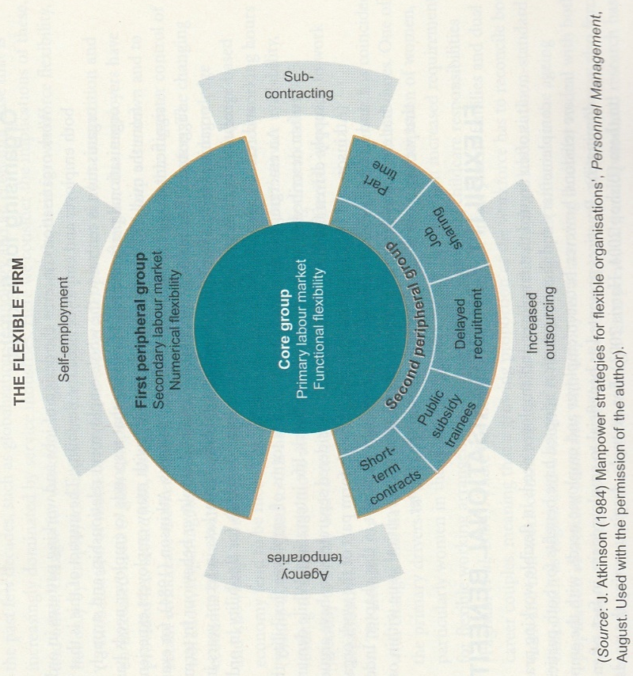
Using these types of flexible working within the hospitality industry is vital for employee engagement, as hotels do not want to have a decrease in their employee retention rate due to the hotel not being able to give their staff flexible working hours.
Flexible working is a good method of employee motivation and employee engagement, as it has many benefits for employees. The CIPD (2016) Employee Outlook report outlines the benefits of flexible working for employees. “The top three most frequently cited benefits are that it helps employees reduce the amount of stress/pressure they feel under (29%), it enables better work– life balance (54%) and it has been a factor in them staying with their current employer (28%).” This shows how flexible working is a big factor in employee retention and engagement.
  - Task Two – Flexible Working Good Practice
An example of a hotel that ensures good practice in flexible working is Marriott International. The organisation uses flexible working to motivate associates and give them a good work life balance, so that they are more engaged in their job role and give the highest standard of service. “Marriott found that the implementation of workplace flexibility resulted in greater productivity, even though employees worked fewer hours. Marriott focused on promoting "efficiency and effectiveness" in its employees, rather than "face time."” (Workplace Flexibility, 2018). This shows how Marriot is successfully using flexibility as a method of employee engagement and is one of the reasons why Marriott Internationals associate engagement score is 96 percent, which is 22 percent higher than the industry average. (People Matters, 2017)
Another hotel that ensures good practice in flexible working is Hilton Hotels. The organisation has produced an app called ‘Hilton@Home’ which allows flexibility by staff being able to work from home. The app allows staff to create flexible work schedules, has a positive environmental impact as less people are commuting to work and allows staff to have a good work life balance. (Walker, K 2008). “The program’s flexibility, thorough self-managed training and on-line connectivity help attract a high-caliber, diverse work force who appreciates the value proposition of work from home.” (Walker, K 2008). This demonstrates how Hilton Hotels want to promote and use flexibility to their advantage. This will therefore increase employee motivation and engagement, thus creating a better guest experience.
  - Flexible Working Bad Practice
Although most organisations aim to ensure good practice in flexible working, sometimes bad practice can happen. It is argued that flexible working can be bad for the health of staff. “Flexible working practices can do more harm than good to workers because they encourage an “always on” culture that can have a heavy psychological toll, experts have warned.” (Jowit, J 2016). This illustrates how flexible working may work for some staff, but it can have a negative health impact on others.
An example of a hotel that has been criticized for bad practice is the Park Plaza hotel in London. Staff who have zero-hour contracts were given more work for no extra pay. “Now, they clean 15 to 17 bedrooms in seven and a half hours a day; more work, less pay.” (Roberts, Y 2015). The extra work can cause stress, as well as not giving them a fair work life balance. Zero-hour contracts are a method of flexible working; therefore, staff being given more work and no extra pay is not giving them the benefits of flexible working. “Zero hours are a flexible “choice” for employees and low pay is only an entry point.” (Roberts, Y 2015). This illustrates how staff on zero hours should be paid more when they have been on a zero-hour contract for a long period of time, therefore Park Plaza was not ensuring good practice in flexible working and treating their staff unfairly.
  - Task Three – Key Stakeholders
Stakeholders are an important part of any organisation. Freeman as cited in Gossy, G (2008) defines a stakeholder, “A stakeholder in an organisation is any group or individual who can affect or is affected by the achievement of the organisations objectives.”
Hilton Hotels stakeholders can be split into two categories; internal and external stakeholders. Their internal stakeholders include, employees and shareholders. Whereas their external stakeholders include, customers, communities, suppliers, media and the government. (Dudovskiy, J 2012). The three main stakeholders that will be discussed are, employees, customers and communities.
Employees are a stakeholder that is affected by employee engagement. It is important that employees are engaged as they will want to provide the best service that they can to guests, due to them being motivated and engaged. Organisations with engaged employees are more efficient and productive, therefore employee engagement is important for employees as stakeholders. Weinger, A (2015) states, “When employees are engaged at work, they feel a connection with the company. They believe that the work they’re doing is important and therefore work harder.” This demonstrates how when employees are engaged, they feel that they are a valued member of an organisation and are making a difference with the work that they are doing; thus, making them more motivated and engaged. This is an important reason as to how employee engagement affects stakeholders such as employees.
Customers are also a stakeholder that is affected by employee engagement. Customers hotel experiences are affected by employee engagement, as if the employees are not engaged then they are not giving the guest the best service or experience. Therefore, guests would be likely to not stay again at a hotel if the employees are not engaged. Best Western hotels are an example of a hotel that found a correlation between employee engagement and guest satisfaction by conducting a survey. “The results revealed a 0.4 correlation between hotel employee engagement index scores and guests’ intent to recommend the hotel to other travelers.” (Hospitality Technology, 2017). This clearly shows how customers are a stakeholder that is affected by employee engagement, which is why it is important for hotels to have employees that are engaged.
Finally, the community is a stakeholder that is affected by employee engagement. The community is an important stakeholder, as they heavily support businesses within the community. If employees are engaged, then they will work hard for organisations that gives back to its community. “That whole piece of community, and that involvement, is absolutely critical for any company in today’s world. If you don’t, you’re not going to engage your staff at all.” (Jostle, 2018). This illustrates how engaged staff will help their organisations give back to communities, as it is important for the organisation to follow their values and help stakeholders such as the community, thus engaging staff.
  - Task Five - Advantages of Primary Research Methods
Primary research is a good method of research as it allows the researcher to conduct research that has not been done before and is original. This allows the researcher to discover new information that may not have been known before. The most common methods of primary research are questionnaires and interviews.
One of the advantages of questionnaires is that they are less time consuming, due the researcher getting an instant response from them. Jones, S et al, (2008) state the advantages of questionnaires, “These include the mainly low cost of data collection, and processing, and the minimal training required by the person administrating them. They can reach much larger numbers of a target population than would be possible using interviews.” This clearly illustrates how questionnaires would be a good method of primary research for the researcher to use, as it keeps costs down and can quickly reach many people.
Another method of primary research which would be effective for the researcher to use is interviews. Bell, J (2010) states one of the advantages of interviews, “One major advantage of the interview is its adaptability. A skilful interviewer can follow up ideas, probe responses and investigate motives and feelings.” This illustrates how interviews are a good method to use as the researcher can take the answers given, to relate them specifically back to their research to get the answers that they require. Another advantage of interviews is that they can be less time consuming, as the interviewer is in control of when the interview is terminated. “In the interaction between interviewer and interviewee enough clues can be given that the end of the interview is near, for example by shuffling the papers and turning off the tape recorder.” (Opdenakker, R 2006). This demonstrates how the researcher would be able to use their time more effectively by using interviews. They can terminate the interview when they have gathered all the information they need to know, so that they can continue to use their time to complete other tasks related to the research.
- Task Four - Conclusion – Recommendations
To conclude, it is clearly shown that flexibility is an important aspect in employee engagement and has an affect on many things within the hotel industry, including its stakeholders. It is recommended to stakeholders that they should work closely with hotels to be able to improve their employee engagement methods, so that the staff within the hotel are more motivated and engaged. This will then improve their service and enhance the experience of the guest. It is recommended that stakeholders help to drive employee engagement by using methods such as the ones adapted by Marriott, as their associate engagement score is higher than the industry average, which is what all hotels should be striving for.
Overall, hotels should be using methods of employee engagement to engage their staff and create a more efficient and effective workplace. This is important as unengaged employees will have a negative impact on the organisation and will therefore impact their stakeholders. Thus, creating an inefficient and unsuccessful workplace.

- Reference List

Bell, J., 2010. Doing Your Research Project. 5th ed. Berkshire: Open University Press.
CIPD, 2016. Employee Outlook, London: Royal Charter.
CIPD, 2017. Employee engagement and motivation. [Online]
Available at: https://www.cipd.co.uk/knowledge/fundamentals/relations/engagement/factsheet#6227
[Accessed 25 June 2018].
Dudovskiy, J., 2012. Hilton Hotels & Resorts. [Online]
Available at: https://research-methodology.net/hilton-hotels-resorts/
[Accessed 2 July 2018].
Engage for Success, 2018. The Four Enablers. [Online]
Available at: http://engageforsuccess.org/the-four-enablers
[Accessed 25 June 2018].
Gossy, G., 2008. A Stakeholder Rationale for Risk Management. Germany: Springer Science & Business Media.
Hilton, 2017. 2016 ANNUAL REPORT, Atlanta: Corporate Reports.
Hospitality Technology, 2017. Survey Reveals Correlation Between Hotel Employee Engagement and Guest Satisfaction. [Online]
Available at: https://hospitalitytech.com/survey-reveals-correlation-between-hotel-employee-engagement-and-guest-satisfaction
[Accessed 2 July 2018].
Jones, S et al, 2008. Doing things differently: advantages and disadvantages of web questionnaires. Nurse Researcher, 15(4), pp. 16-17.
Jostle, 2018. The Importance of Community Involvement to Employee Engagement. [Online]
Available at: https://blog.jostle.me/blog/importance-community-involvement-employee-engagement/
[Accessed 3 July 2018].
Jowit, J., 2016. Work-life balance: flexible working can make you ill, experts say. [Online]
Available at: https://www.theguardian.com/money/2016/jan/02/work-life-balance-flexible-working-can-make-you-ill-experts-say
[Accessed 2 July 2018].
Opdenakker, R., 2006. Advantages and Disadvantages of Four Interview Techniques in Qualitative Research. FORUM: QUALITATIVE SOCIAL RESEARCH, 7(4), p. 4.
People Matters, 2017. Marriott International focusing on employee engagement. [Online]
Available at: https://www.peoplematters.in/article/c-suite/marriott-international-focusing-on-employee-engagement-15680?utm_source=peoplematters&utm_medium=interstitial&utm_campaign=learnings-of-the-day
[Accessed 2 July 2018].
Roberts, Y., 2015. Britain’s hotel workers – bullied, underpaid and with few rights. [Online]
Available at: https://www.theguardian.com/business/2015/may/30/hotel-workers-bullied-underpaid-few-rights-uk
[Accessed 2 July 2018].
Torrington, D et al, 2009. Fundamentals of Human Resource Management. Harlow: Pearson Education Limited.
Walker, K., 2008. Hilton Hotels Corporation Rolls out Flexible Work-at-Home Program for Reservations Agents. [Online]
Available at: https://www.hospitalitynet.org/news/4036846.html
[Accessed 2 July 2018].
Weinger, A., 2015. 8 Results-Driven Reasons You Need Employee Engagement. [Online]
Available at: https://doublethedonation.com/blog/2015/09/why-employee-engagement-is-important/
[Accessed 3 July 2018].
Workplace Flexibility, 2018. IMPROVED PERFORMANCE & PRODUCTIVITY. [Online]
Available at: http://workplaceflexibility.bc.edu/need/need_employers_performance
[Accessed 2 July 2018].

