Is horse ownership linked to well-being?

Business Enquiry and Research BMSP5007 Alex Bell
Quantitative study Natalie Male 1702161
lee male | [Date] | [Course title]

Introduction
This report aims to produce a quantitative study to determine if horse ownership is linked to well-being. There has been much research into the link between mental health and contact with animals. Horses are often utilised in the treatment of post-traumatic stress disorder. I am a keen horse owner who experiences anxiety, my horse has a positive impact in my life, and so this area is very interesting personally.
There have been very little studies and research in this area and theoretical frameworks are not present. Some studies of HAT or horse assisted therapy, require further research. However, Kern-Godal et al; (2015) found that individuals with a substance use disorder, who took part in the HAT programme remained in their treatment programme longer and completed said programme, than the individuals who did not take part.
With owning and riding horses there is also the outdoor environment and exercise element to consider. Exercise has been synonymous with well-being and many studies have attempted to explain this correlation. Mandolesi etal; ( 2018) “Much evidence shows that physical exercise (PE) is a strong gene modulator that induces structural and functional changes in the brain, determining enormous benefit on both cognitive functioning and wellbeing”. A survey was created, and individuals were invited to participate. Cross tabulation will be used to obtain quantitative data by analysing the data set. Results are displayed in tables for interpretation.

Methodology
The method used in this study is quantitative. Quantitative data is a numerical form which can be analysed systematically in various ways. Utilising in this case, SPSS software, this allows large samples to be analysed and displayed in charts for interpretation. Quantitative data differs from qualitative as the data is able to be analysed statistically, whereas qualitative collects non numerical data. Qualitative research is easy to replicate and is less open to interpretation. It is often observed as being more scientific, on the contrary it can be misleading if there is researcher bias that is at the beginning of the process.
A survey was developed that could be easy to understand and quick to complete, containing 10 questions. Survey monkey was the platform used, allowing 40 respondents answers. To cover a wide geographical area, I invited Facebook friends from locally and further afield. Posing the survey in numerous equestrian groups throughout the country, became a simple process. Hoping to gain a representative sample of participants. The benefits of an online survey are that it is quickly distributed and can reach many people, in geographical areas. However, it can be difficult to determine if the answers are truthful. Bryman & Cramer, (2011) “With a survey/correlational design, the researcher does not manipulate any of the variables of interest and data relating to all variables are collected simultaneously”.
The data from the surveys were retrieved from Survey Monkey, all 40 participant answers were entered manually into SPSS. From the data cross tabulation and bar charts have been produced. Visual displays when presented assist to reach conclusions and represent the data. For the purpose of summarising and simplifying, transforming the data. (Verdinelli & Scagnoli, 2013) The findings are displayed below.

Presenting data and findings
In this data set only one male participated although the survey was open to all. It made it impossible to find correlations between gender and other variables. I aimed to ask several questions of the data in order to gain insightful information.

1:
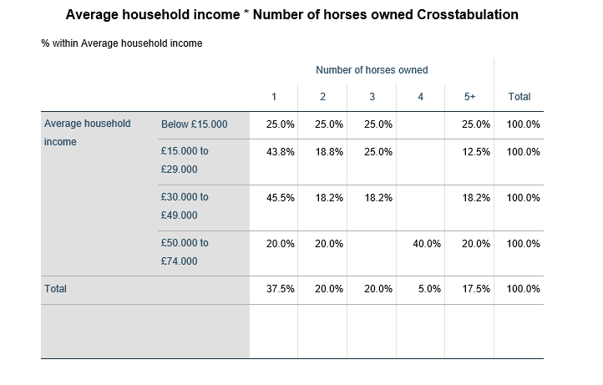

People who earning under £15,000 are the largest percentage who own more than five horses at 25%. Although horse ownership is often related to wealth this is not the case here. This shows a correlation between lowest income and most amount of horses.
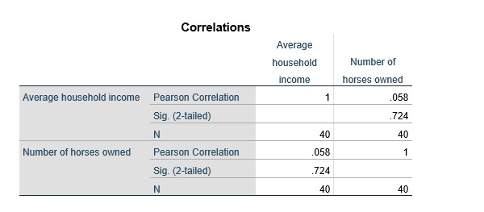
Pearson’s R correlation shows the relationship between two variables. -1.00 and +1.00. Correlation of 0 means no relationship. The closer the correlation is to -1.00 or +1.00 the stronger the relationship.

2:

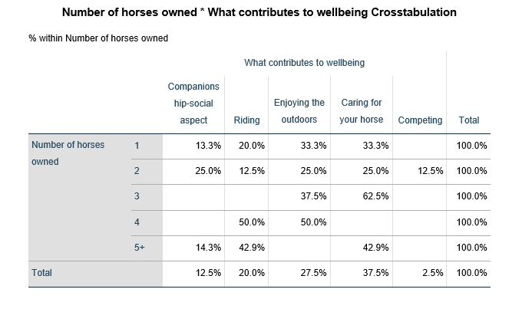

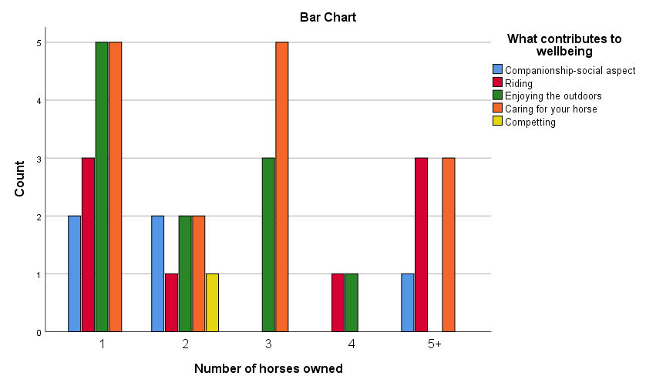

Those with 5 or more horses did not prioritise the importance of enjoying the outdoors. In comparison, those who owned 1 horse selected this as one of the most important aspects, along with caring for their horse. This could suggest those with over 5 horses may not have time to enjoy the outdoors, or do not consider it important.
3:

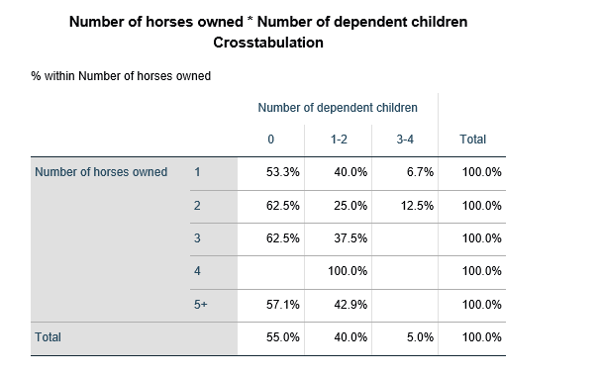

100% of the participants who owned 4 horses had between 1 and 2 children. Those participants who had 3 to 4 children displayed the lowest percentage owning no more than 2 horses. Those with no children had consistent percentages in the number of horses owned.

4.

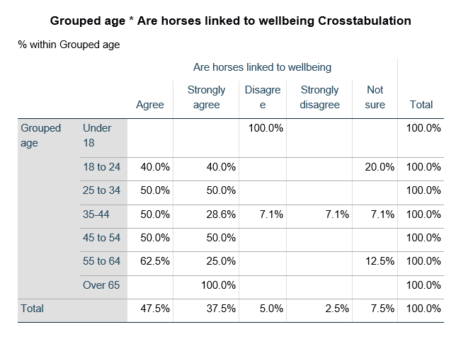
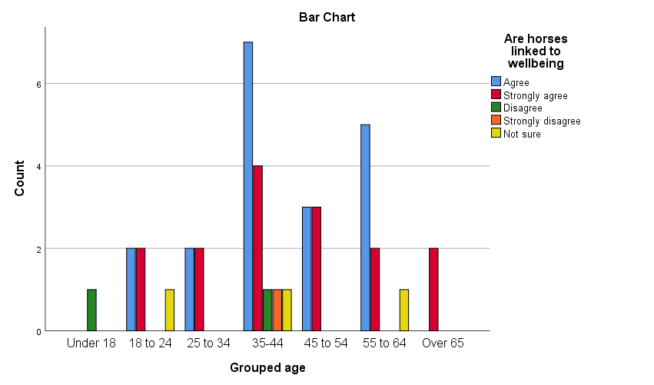

The over 60’s age group strongly agreed their horses linked to their wellbeing, with under 18-year olds disagreeing. A possible correlation that as age increases, the number of participants strongly agree their horse is linked to wellbeing. There could be other factors for the under 18’s such of pressures of schooling and exams.

5.
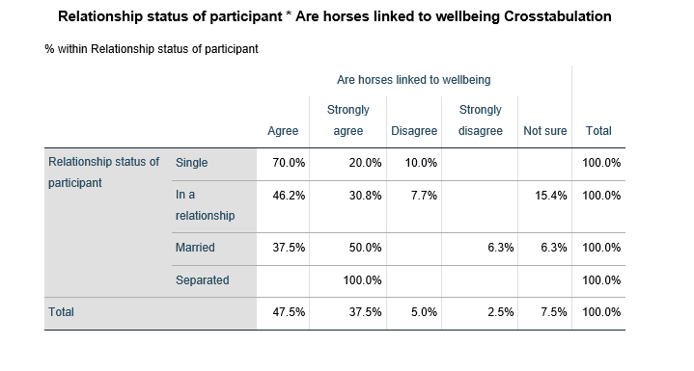
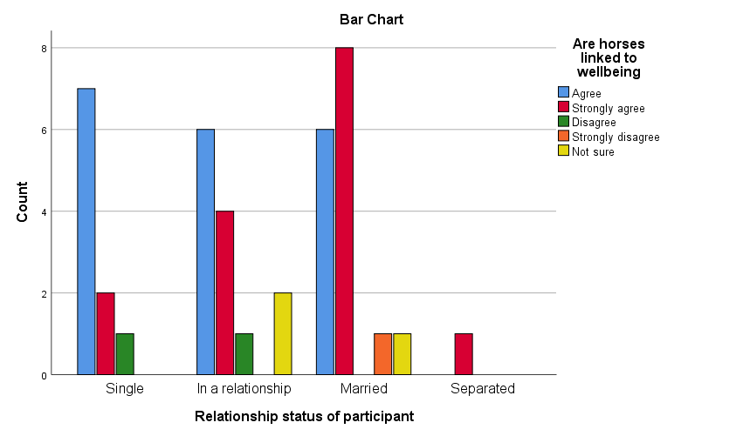

70% of single participants agreed that their horses were linked to their wellbeing. However, 50% of married Participants strongly agreed that their horse is linked to wellbeing. In this case it does not appear to show, that relationships have an adverse effect on the wellbeing of owners and their horses.

6.
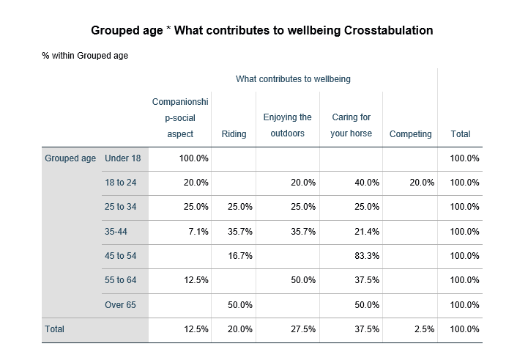

100% of under 18’s selected companionship and social aspect as contributing to wellbeing. However, previously in table 5 participants under 18, disagreed that their horse was linked to well-being, this is conflicting data.

7.
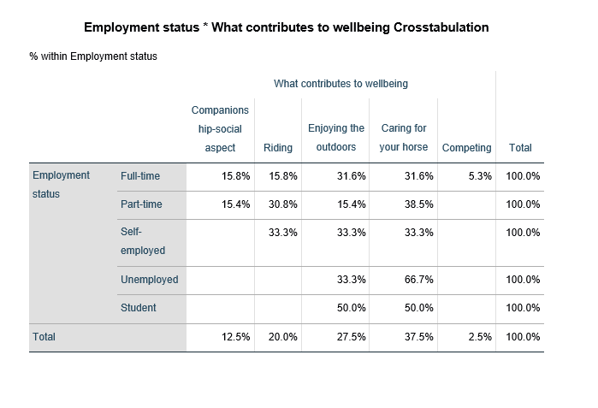
The largest sample of fulltime workers enjoyed the caring their horse most as contributing to their wellbeing, Self employed people equally enjoyed 3 categories ( displayed at 33.3%) riding, the outdoors and caring for their horse , Unemployed people had the highest percentage at 66.7% that caring for their horse contributed to wellbeing. A strong correlation that the routine and welfare of their horse is important, at a time where there is no present employment. Competing at shows or events was the lowest scored category, perhaps due to expense, transport and time.

Critical reflection/ Conclusion

There are a number of areas that could have been conducted differently. It would possibly have been advantageous to gather more scale variables in order to analyse the data further. Gender was certainly and issue and could have produced more conclusive findings, if there was more balance between the genders. Using survey monkey limited my responses to 40, had I used to google docs I may have been able to gather a larger male sample. For future studies research would need to be undertaken to find combat this issue. Smith, ( 2008) study into response behaviour on the online environment, shows that males and female occupy different areas of the internet. This has been shown to influence response rate. I feel this was a weekness in the data, Although,it did give almost a complete female perspective, something not expected.
There was a good response rate and all answered each question, in this respect the survey was sucessful. It would be beneficial to gain an insight into the participants location to insure a wide geographical area had been covered. The information does not expand on whether the horses are owned but for the participants children which would give a different perspective. Exercise and outdoors are also linked to wellbeing not only owning horses, so it is difficult to be definitive. Asking a specific household income may gained more data, however, people often do not like specific questions and are more likely to answer generalised questions (Gathering demographic information from surveys, 2020)“Many people are sensitive about offering their personal information. Demographic information examples where this can ring true, include income level, employment status, race, and ethnicity”. The survey if replicated could yield further interesting insights.

Only one man participated in the survey. Gender could be considered a representative sample in this topic, perhaps there are few men who are active in the equestrian world. The data did display some links to well-being and horse ownership. However, it is difficult to determine if the outside element or exercise elements of horse ownership is part of the overall feeling of wellbeing, this could be gained from other outdoor activities. This is certainly an interesting topic requiring further research. SPSS is a valuable tool in the interpretation of qualitative data. Providing rich insights into many topics. There is an age-old adage, that you get out what you put in. To conclude, the results that are generated are dependent on asking definitive and useful questions from the survey and data set.

References

Smith, G. (2008). Does gender influence online survey participation?: A record-linkage analysis of university faculty online survey response behavior. San Jose : SJSU ScholarWorks.
Verdinelli, S., & Scagnoli, N. I. (2013). Data Display in Qualitative Research. International Journal of Qualitative methods, 359-381.
Bryman, A., & Cramer, D. (2011). QUANTITATIVE DATA ANALYSIS WITH SPSS. London: Routledge.
Gathering demographic information from surveys. (2020, April 29th). Retrieved from Survey Monkey: https://www.surveymonkey.com/mp/gathering-demographic-information-from-surveys/
Kern-Godal, et al;, A. (2015). Substance use disorder treatment retention and completion: a prospective study of horse-assisted therapy (HAT) for young adults. Additional science and clinical practice. Retrieved from https://ascpjournal.biomedcentral.com/articles/10.1186/s13722-015-0043-4
Mandolesi, etal;, L. (2018). Effects of Physical Exercise on Cognitive Functioning and Wellbeing: Biological and Psychological Benefits. Psychol.

