Individual Business Model Canvas with entrepreneurial reflection using appropriate academic models
Name: Dominik Csaba David
Lecturer: Chris Wilkin
Student NO.: 2208146
Module: Entrepreneurship BMIH5001

Part 1
Entrepreneurship is the ability to create, manage uncertainties and grow a business. It is also the readiness to develop and run an enterprise (Barringer & Ireland, 2018). My business venture is “Cuddlecafe”. It is an animal-themed café that shall house exotic animals. It shall serve excellent beverages to the customers and provide the opportunity to pet exotic animals at no cost. It is better to venture into a business space that is expected to grow (Williams, 2021). The demand for unique cafes is always increasing. The need to interact with animals and adopt pets is also increasing among humans. There is a growing awareness of sustainability and the need for the co-existence of all species. Apart from offering excellent drinks and edibles, this café shall uniquely provide an opportunity for the growth of the love for animals and the resulting growth of humanity. It shall help promote the business and the sale of animals as pets and increase awareness towards animal welfare.
A Business Model Canvas has been created for this business and shared in Appendix 1. The value proposition offers five values to customers. First, a unique and fun experience is offered to customers who can enjoy food and beverages while interacting with rare and adorable animals. A study shows that over seventy percent of British citizens consider animal protection and care to reflect their values (Humane Society International, 2023). This shows that animal love can be a significant driving force for consumers in the UK. CuddleCafe shall attempt to tap into this emotion of the customer market segment and build a business that offers the consumption of excellent food and beverages along with animal care. Second, this enterprise offers pet adoption opportunities to customers. There is a huge demand for adoption of pets among customers in the UK. Over a million pets are adopted in the UK every year. Adoption provides economic benefits for the customer. It has been estimated that over three hundred fifty pounds can be saved if a customer chooses to adopt a dog as compared to a purchase from a breeder (Cosgrove, 2024). This business shall attempt to tap into this benefit and rising demand for pet adoption among customers. Third, the business offers to improve community engagement by promoting pet ownership and supporting animal welfare. This business shall increase focus on animal welfare in the community. It shall result in an improved sense of trust, and understanding, among all stakeholders and consequently create a long-lasting positive change in the community towards animals. Fourth, the business shall promote responsible animal keeping. Laws such as the Animal Welfare Act 2006 place certain responsibilities on pet owners (Blue Cross UK, 2023). An information board shall be used to educate customers about all aspects of handling an animal for each adoption. Trained staff shall educate customers about the do’s and don’ts of each animal. Becoming a customer of CuddleCafe, therefore, provides customers with the benefits of improved knowledge about handling the animals they adore and like to spend time with. The biggest offering for the customer is that all this learning can be acquired over a cup of their favourite beverage and a plate of their favourite food. Fifth, the business shall offer customers informative educational materials. The e-learning market in the UK is expected to grow by over fifteen percent by 2026 (Technavio, 2022). This clearly shows an increase in cultural preference towards digital learning. Awareness about animals and pets should also adopt this platform to improve awareness among customers. Apart from the traditional brochures and signages, CuddleCafe shall use extensive digital resources to promote understanding and awareness of animals. Customers of CuddleCafe can benefit by accessing these educational materials using digital platforms and grow into better animal adopters and caregivers.
Partners must be selected carefully so that the gaps in individual businesses may be bridged due to the collaboration (Leonard & Bottorff, 2022). The partners for CuddleCafe shall be local animal breeders, local animal shelters for adoption and events, local farmers for food ingredients and local veterinarians for ensuring the sound health of all animals. Using these ‘Key partners’, the ‘Key Activities” that shall be organised are serving food and beverages, animal care and handling, event planning and coordination, marketing and social media management. All activities related to serving food and care for animals are “Key Activities”. A good entrepreneur needs to find and allocate resources effectively to achieve success (Townsend, 2023). The “Key Resources” required for carrying out these activities are trained pet handlers and baristas. An animal-friendly venue is also required for CuddleCafe. Marketing and promotional platforms and online tools are the other resources required. Animal cafes are on the rise in the UK, especially in Bristol, Nottingham and London (Ferreira, 2016). To gain and maintain a competitive edge, ‘Customer Relationship’ shall be a priority for CuddleCafe. Personalised interactions using friendly and knowledgeable staff shall be used. Customers shall be engaged on social media and regularly updated about upcoming events, new customer offerings and loyalty programs. The ‘Customer Segments’ to be targeted are animal lovers who wish to gain new experiences of spending time with animals, pet adopters, and pet owners. Coffee enthusiasts, families and couples who want a unique outing experience are another target segment. School groups interested in educational trips and animal interaction sessions are the third target segment. The specific ‘Channels’ to be used are Instagram, TikTok and Facebook. Local community events, fairs, and pet shows shall be an important channel for attracting customers. Email marketing shall also be used to update subscribers about new additions to the menu and animal-list additions. The ‘Cost Structure’ includes staff salaries and training costs, animal care and health expenses, cost of food ingredients, renting and utilities, marketing and promotions costs, and insurance. It includes all expenses that shall be incurred through our operations. Identification of ‘Revenue Streams’ is important for risk management and growth prediction (Babelquest UK, 2024). So, multiple sources have been identified for revenue generation. The revenue streams identified for CuddleCafe are the sale of food and beverages, fees from events and workshops, pet adoptions, the sale of animal-themed merchandise, and the sale of photo packages.
The driving factors for the success of CuddleCafe can be discussed using Porter’s theory of competitive advantage, the business model innovation theory, and the use of green supply chain as part of the marketing mix. According to Porter, competitive advantage can be achieved by an enterprise by using cost leadership, differentiation and focus (University of Cambridge, 2024). CuddleCafe shall use the differentiation focus strategy to gain a competitive advantage. There are multiple cat-cafes and dog-cafes in the UK. But CuddleCafe shall offer differentiated service by including exotic animals in the list of pets in the café. CuddleCafe is aware that the market segment has customers with unique needs and different customers are uniquely attracted to different animals. So, a large choice of animals provides CuddleCafe with a distinct competitive advantage in the market. The overall delivery system of CuddleCafe is also distinctly different with add-ons such as awareness materials, information on handling a wide variety of animals and digital education. CuddleCafe also has a competitive advantage if assessed based on the business model innovation theory. According to a study, business model innovation can result in a continuous competitive edge for an enterprise (Bashir & Verma, 2017). CuddleCafe has a stronger business logic as compared to its competitors. Unlike its competitors which provide a single service such as the adoption of cats only, CuddleCafe offers a bundle of services to its customers. CuddleCafe also provides multiple education offerings about the care of animals through traditional and digital mediums. The competition does not provide this. So, the business model of CuddleCafe presents higher value creation than its competitors. CuddleCafe also provides unique subscriptions and has multiple revenue streams including photo packages and merchandise sales. This shall help CuddleCafe to gain higher value capture from the market and generate higher revenue than its competition. The supply chain management of CuddleCafe shall promote sustainability and environmental friendliness. The green initiatives in the supply chain shall be used in the marketing mix to attract customers who are looking to patronize green businesses. Studies show that merging of supply chain management with marketing management offers benefits to businesses (Wacker & Samson, 2021). So, CuddleCafe shall use a strategy that merges marketing-view and resource-view of business management. As depicted in the Mind Map given in Appendix 2, CuddleCafe shall promote eco-friendly operations. Recycled materials such as ceramics shall be rewashed and used. Cutlery shall be recycled. It shall buy ingredients from local farmers. The list of suppliers is given in Appendix 4. CuddleCafe is confident that its approach will attract the appropriate age and gender-based target market. For comparison, a study of Starbucks and Costa Coffee has been carried out to understand the demographic market segments that constitute the market segment of cafes.

It can be concluded that CuddleCafe is a unique and promising business idea. All ideas and information about CuddleCafe have also been captured and organised using the Mind Map. Using the Business Model Canvas, the model for the business has been carefully developed and documented. The value proposition of CuddleCafe offers five attractive values to customers. It offers the unique opportunity to adore exotic animals over food and beverages, and adoption of pets. For the community, the business improves engagement by supporting animal welfare and promoting responsible animal keeping. Value is offered through informative offline and online materials on responsible keeping of animals. CuddleCafe shall position itself as a tech-savvy and digitally active organisation that uses the best of technology for the promotion of the business and providing service to customers. Using differentiation focus, business model innovation, and the merger of supply chain management and the marketing mix, CuddleCafe shall target the appropriate target audience to gain business and competitive advantage.

Part 2
The Gibb’s six-step model provides an excellent cyclical framework for reflection (University of Edinburgh, 2024). It can be extremely useful for reflection by entrepreneurs. In the context of this coursework and assignment, the six stages in Gibb’s model: description, feelings, evaluation, analysis, conclusion and action plan has been discussed below:
Description: The assignment was part of the course to develop theoretical and practical knowledge of entrepreneurship. It required a study of prevailing and emerging entrepreneurship theories, approaches, models, frameworks, and trends to develop a business plan. A Business Model Canvas and Mind Map were developed to document the strategies for the proposed business, CuddleCafe. Test for managerial and entrepreneurial attributes was administered using a questionnaire. A General Measure of Enterprising Tendency test was also administered.
Feelings: I felt a high level of anxiety while answering the questionnaire. It is attached in Appendix 5. The anxiousness was related to the outcome of the test. I was worried that the test may infer a lack of entrepreneurial qualities in me. However, the result came as a relief and boosted my confidence in my abilities and way of approaching challenges related to entrepreneurship. The other exercises such as the development of BMC and Mind Map were exciting as they helped me explore many aspects of my business plan.
Evaluation: The development of the Mind Map was an engaging experience. It ensured an in-depth analysis of the business. It also helped to unleash additional ideas and explore deeper potential for the business idea. The development of the BMC also helped to connect the dots between the value proposition, the customer segment, and the revenue structure. I faced challenges during the documentation of the cost structure. A final list could only be developed after multiple iterations of brainstorming and analysis.
Analysis: The challenges faced during the documentation of the cost structure were due to the limitation of cost-related information. Similar organisations such as CuddleCafe do not give out details of the cost structure on public platforms. The uniqueness of the business idea also presented challenges to the development of cost structure. This course helped me to get information from various sources that consequently helped me understand the various driving factors that can make my business idea successful. Discussion with teachers, and peers, and reading multiple academic papers helped me understand the concepts and benefits of business model innovation, supply chain management, and marketing management.
Conclusion: It can be concluded that CuddleCafe has a strong potential to be a strong business. The entrepreneurship tests revealed that I have certain qualities that are desirable in entrepreneurship. The questionnaire-based test showed that I have the quality to endure and ignore pressure and criticism from peers, society, friends and family and carry out a single-minded pursuit of entrepreneurial endeavour. However, weaknesses exist in the devising of alternative plans in case of failure of the primary plans.
Action plan: The action plan is based on the findings from the questionnaire-based test and overall experience during this exercise. SMART goals need to be set up to ensure continuous effort and achievement for this business plan. Wider study and research need to be carried out to develop alternative plans in case of failure of primary plans. For example, if the bank rejects loans for the business, alternate investors or other sources of finance must be sought.

References
Babelquest UK, 2024. Babelquest UK. [Online]
Available at: https://www.babelquest.co.uk/revenue-forecasting
[Accessed 30 January 2024].
Barringer, B. & Ireland, R., 2018. Entrepreneurship: Successfully Launching New Ventures. 4th ed. New Jersey: Prentice Hall.
Bashir, M. & Verma, R., 2017. Why business model innovation is the new competitive advantage. IUP Journal of Business Strategy, 14(1), p. 7.
Blackwell, E., 2011). How to Prepare a Business Plan: Planning for Successful Start-up and Expansion. 5th Ed ed. s.l.:Sunday Times Business Enterprise Series: Kogan Page.
Blue Cross UK, 2023. Blue Cross UK. [Online]
Available at: https://www.bluecross.org.uk/advice/pets/wellbeing-and-care/did-you-know-owners-must-make-sure-their-pets-are-happy-by-law
[Accessed 31 January 2024].
Burns, P., 2022. Entrepreneurship and Small Business. 5th Ed. ed. Basingstoke: Palgrave Macmillan.
Cosgrove, N., 2024. 10 UK Pet Adoption Statistics & Facts in 2024. [Online]
Available at: https://petkeen.com/pet-adoption-statistics-uk/
[Accessed 31 January 2023].
Ferreira, J., 2016. Coffee and a furball: the rise of animal cafes. [Online]
Available at: https://cafespaces.wordpress.com/2016/11/30/coffee-and-a-furball-the-rise-of-animal-cafes/
[Accessed 30 January 2024].
Hisrich, R., Peters, .. & Shepherd, D., 2008. Entrepreneurship. 7th Ed. ed. New York: McGraw Hill.
Humane Society International, 2023. Humane Society International. [Online]
Available at: https://www.hsi.org/news-resources/polling-reveals-millions-of-brits-put-protecting-animals-from-cruelty-amongst-top-three-most-important-policies-that-will-influence-their-votes/
[Accessed 30 January 2024].
Leonard, K. & Bottorff, C., 2022. 7 Partnership Advantages In 2024. [Online]
Available at: https://www.forbes.com/advisor/business/partnership-advantages/
[Accessed 30 January 2024].
Mariotti, S. & Glackin, C., 2012. Entrepreneurship: Starting and Operating a Small Business. London: Prentice Hall.
Nelson, O., 2013. Enterprise development in SMEs and entrepreneurial firms dynamic processes. s.l.:IGI Global.
Rickman, C. & Roddick, D., 2013. The Small Business Start-Up Workbook: A step-by-step guide to starting the business you’ve dreamed of. London: How To Books.
Technavio, 2022. E-learning Market in the UK Growth, Size, Trends, Analysis Report by Type, Application, Region and Segment Forecast 2022-2026. [Online]
Available at: https://www.technavio.com/report/e-learning-market-in-uk-industry-analysis
[Accessed 31 January 2024].
Townsend, S., 2023. WHAT IS RESOURCE MANAGEMENT AND WHY IS IT IMPORTANT?. [Online]
Available at: https://www.planview.com/resources/guide/resource-management-software/resource-management-leverage-people-budgets/
[Accessed 30 January 2024].
University of Cambridge, 2024. Porter's Generic Competitive Strategies (ways of competing). [Online]
Available at: https://www.ifm.eng.cam.ac.uk/research/dstools/porters-generic-competitive-strategies/
[Accessed 31 January 2024].
University of Edinburgh, 2024. Gibbs' Reflective Cycle. [Online]
Available at: https://www.ed.ac.uk/reflection/reflectors-toolkit/reflecting-on-experience/gibbs-reflective-cycle
[Accessed 31 January 2024].
Wacker, J. & Samson, D., 2021. Beyond supply chain management: jointly optimising operations/ supply and the marketing mix. Operations Management Research, 14(1), pp. 451-466.
Williams, S., 2021. FT Guide to Business Start Up: The most comprehensive guide for entrepreneurs. 32nd Ed. ed. Harlow: Financial Times Press.

Appendix 1

BMC

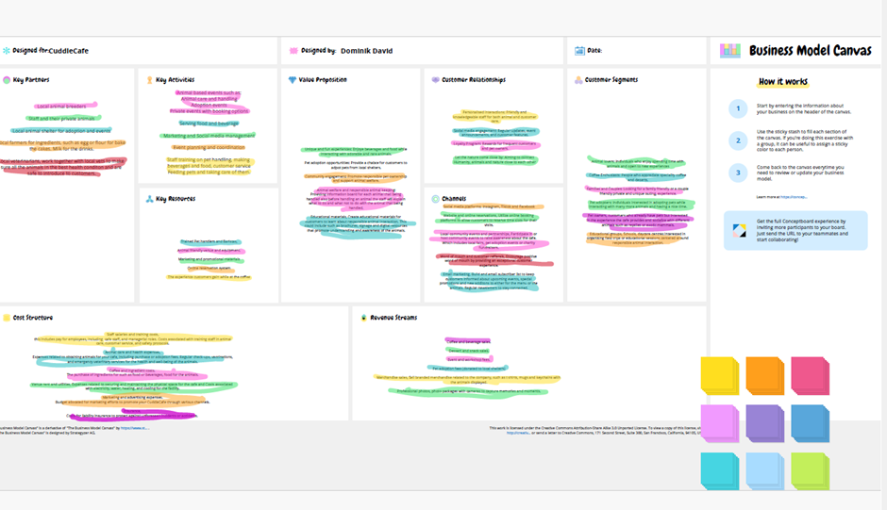
Appendix 2 – Mind Map
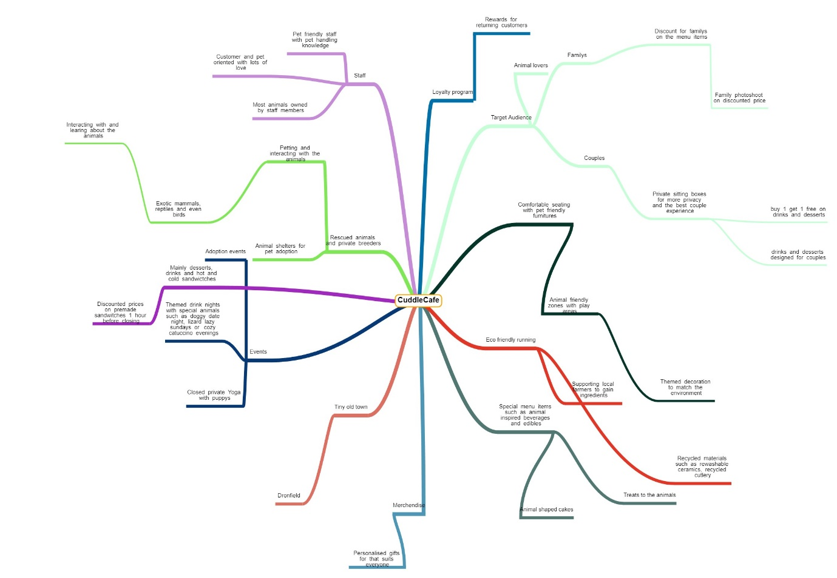

Appendix 3
Trend Analysis
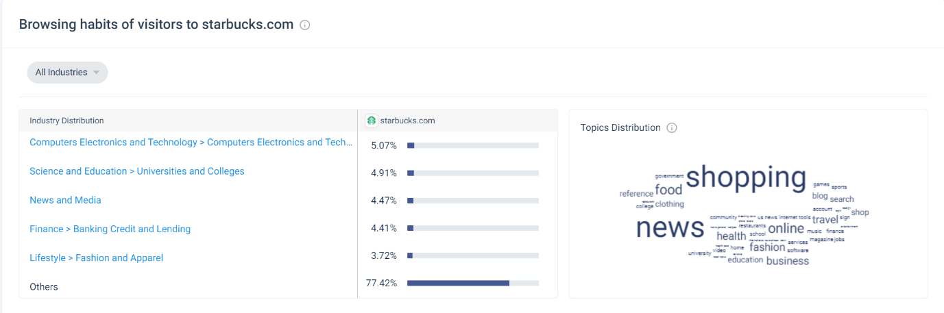

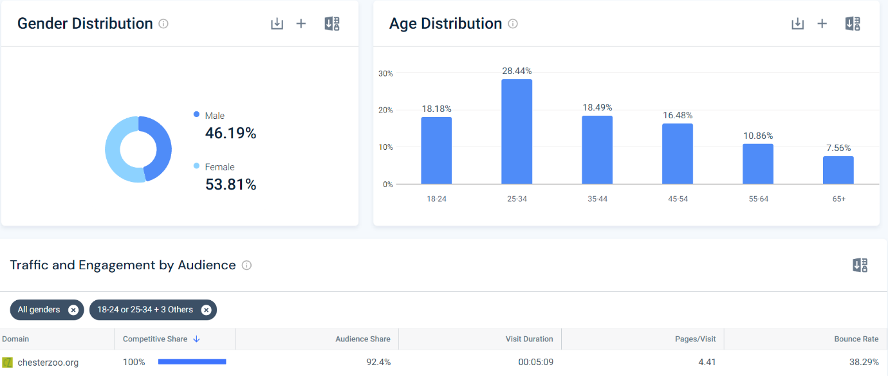

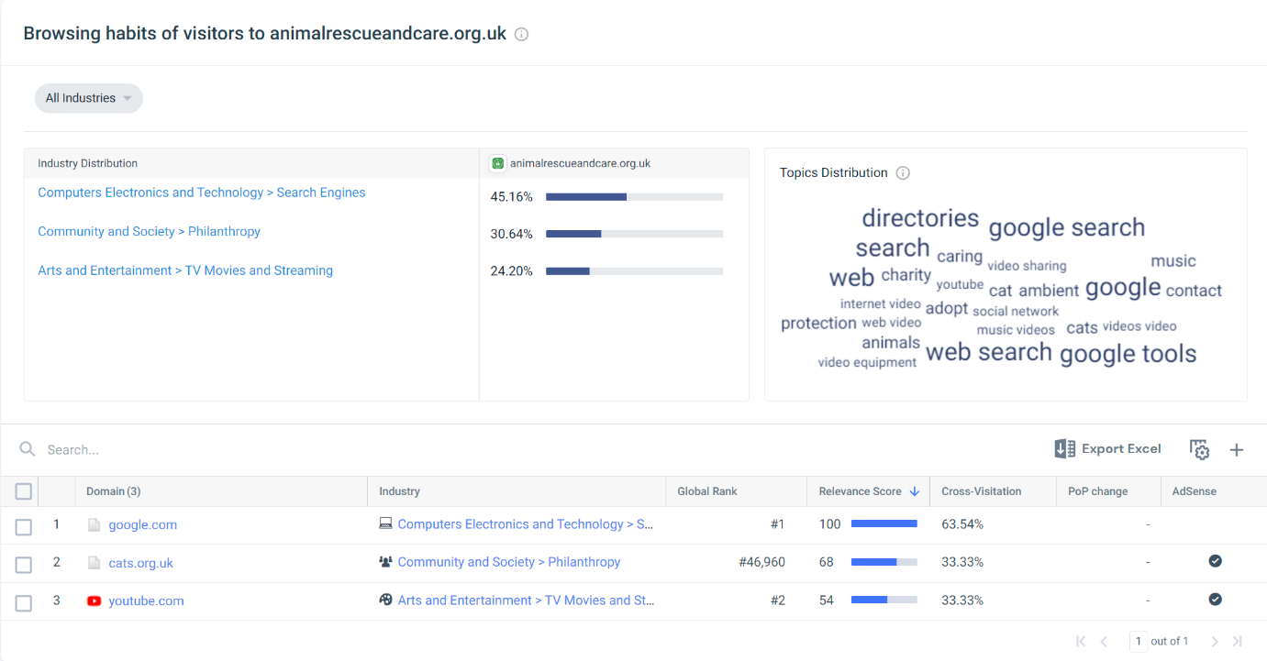

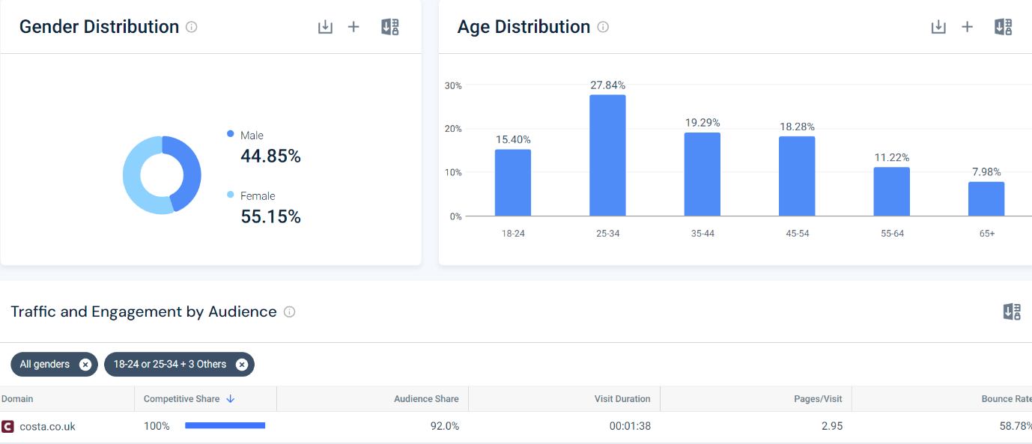

Appendix 4 : List of Suppliers
ARK VETS in Dronfield: https://www.arkvetsheffield.co.uk/?gad_source=1&gclid=Cj0KCQiAn-2tBhDVARIsAGmStVmBRxkqOEY1PPhhPPNEdSzNbvVCXCt80hswQyv20O4CSEKs5szC4RkaAn8eEALw_wcB
Food wholesale, Costco: https://www.costco.co.uk/store-finder/Sheffield
Pets at home Dronfield: https://community.petsathome.com/store/dronfield/
Snakes and adders Sheffield: https://snakesnaddersonline.co.uk/
Dronfield cooked meats: https://dronfieldcookedmea.wixsite.com/dronfield-cooked-mea
Ikea Sheffield: https://www.ikea.com/gb/en/stores/sheffield/
Apollo appliances Dronfield: https://www.apollo4appliances.co.uk/
Border View farm Dronfield: https://www.borderview-farm.co.uk/
Chesterfield Animal rescue Chesterfield: https://www.chesterfieldanimalrescue.org.uk/
Pet Samaritans Animal Sanctuary Chesterfield: https://www.petsamaritans.co.uk/

Appendix 5 - Questionnaire
Where do you want to be in 10 years time?
1. You are leaving University tomorrow. Do you want:
- To do as little as possible?
- A job for life with no stress?
- Responsibility and challenge?
- Money straight away?

2. You are working a job that you do not enjoy, but the money is good. Do you:
- Work hard and get promoted within the company? You still don’t enjoy the work, but you get more money now.
- Resign and start a rival company, eventually taking the first one over?
- Stay where you are and just try to enjoy the bits of your life when you are not at work?
- Resign and sit at home?

3. You are trying to decide whether to start up in business by yourself. All your friends and family tell you that you are crazy and that you will become bankrupt. Do you?
- Listen to them, cancel your plans and apply for a job instead?
- Listen to them, forget about your idea and stay at home watching the television?
- Take no notice and do it anyway?
- Listen to them and put less money into your new business so it is not so risky? This might mean your business will not earn as much money.

4. You want to start up your own business, but you are not sure if people in your area want to buy what you are offering. Do you:
- Do nothing?
- Set up in business straight away without doing any research at all?
- Take your time and do lots of careful research before carrying out your plans?
- Apply for a job with another company doing a similar kind of thing?

5. You are working for a computer software company and you have a really good idea. However, your boss will not all you to test your idea. Do you:
- Have an argument with your boss and resign?
- Resign, start up your own company and try to make your idea work?
- Stay where you are and decide maybe to ask the boss again about it some time in the future?
- Stay in your current job so you keep getting paid, but try to develop your idea in your spare time?
6. You go to the bank to ask for a loan to set up a company, the bank manager says “No”. Do you:
- Stick to your original idea, borrow the money from someone else and do it anyway?
- Scale down your original plans and try and do it on the cheap without borrowing any money?
- Give up the idea completely and stay in the house all day?
- Forgot about your company and apply for a well-paid job with another company?

7. Which of the following do you think is the most important (choose one only)
- Money?
- Security?
- Leisure?
- Challenge?

8. Which of the following do you fear most:
- Boredom?
- Poverty?
- Unemployment?
- Hard Work?

9. Your company is doing well, but a competitor has set up opposite you. Do you:
- Bring out new products and offer special deals to meet the challenge?
- Sell the business and apply for a job with the company across the road?
- Close down the business?
- Carry on with the business and hope for the best?

10. Your company has been doing really well in the last year and the accountant says it has made record profits, partly because of your good management and partly because the employees have worked so hard. Do you:
- Not give yourself or your workers a pay rise, but put the spare money in the bank just in case you have problems in the future?
- Give yourself a huge pay rise; but keep paying the workers the same amount and put the spare money in the bank for yourself in the future?
- Take a pay cut yourself, give the workers a rise and put the rest of the money back into the business to buy new equipment?
- Sell the business, fire the workers and retire to the Bahamas on the profits?

11. At the end of your life would you like to be remembered as:
- Someone who took no risks and did not achieve very much, but always had a steady job and paid the bills on time?
- Someone who did their best, achieved a lot and contributed a lot?
- Someone who had a big house and a new car every year?
- Someone who did not do anything in particular?

12. You are 65 and you run your own successful company. Most people are thinking of retiring at your age. Do you:
- Sell the company and work for the new owners part-time at reduced pay?
- Sell the company, retire and spend the money on a classic car and a mansion?
- Retire and sit at home, watching television and reading a newspaper?
- Carry on working as long as you can because you enjoy working and want to seek new challenges?

Have you got what it takes to start and run your own business?
Check your answers and add up your score!
Your score:
1. a= 1, b= 3, c= 4, d= 2
C

2. a= 2, b= 4, c= 3, d= 1
B

3. a= 2, b= 1, c= 4, d= 3
C

4. a= 1, b= 2, c= 4, d= 3
C

5. a= 1, b= 4, c= 3, d= 2
D

6. a= 4, b= 3, c= 1, d= 2
B

7. a= 2, b= 3, c= 1, d= 4
A

8. a= 4, b= 2, c= 3, d= 1
A

9. a= 4, b= 2, c= 1, d= 4
A

10. a= 3, b= 2, c= 4, d= 1
C

11. a= 3, b= 4, c= 2, d= 1
B

12. a= 3, b= 2, c= 1, d= 4
D

TOTAL
43

Now look up your result from the list below and answer the questions:
0 – 12 points: You do not seem interested in running your own business, but this does not mean you cannot be enterprising!
12 – 24 points: You may have the qualities to be an entrepreneur but you seem to want to make too much money too quickly!
24 - 36 points: You appear to have the potential to run your own business, but some times you may be too cautious.
48 – 36 points: You appear to have all of the qualities needed to be an entrepreneur

