Financial Management for the Hotel Industry

Executive summary
The zero-based budgeting system is a budgeting system or strategy that assists an organization in allocating funds to costs. This budgeting system's goal is to develop and construct a budget from the ground up. This paper begins with an explanation of the zero-based budgeting approach, followed by a description of the procedure and math calculations. This study also discusses some of the benefits of a zero-based budgeting system over a standard budgeting system, as well as how to implement it in an organization, the conclusion, and references.
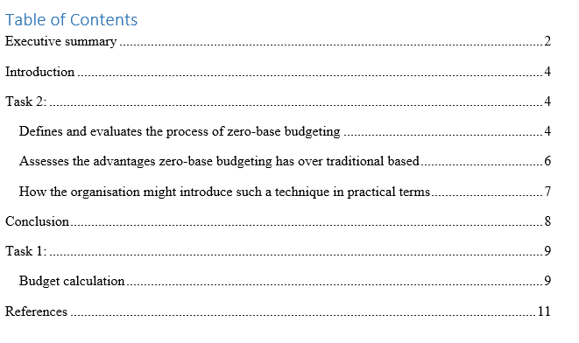

Introduction
The budgeting system or method that helps an organization to allocate the money into the expenses that system is known as the zero-based budgeting system. Aim of this budgeting system is to plan and prepare the budget from the scratch (Beredugo, 2019). In this report first describes zero based budgeting system’s definition with its process and math calculation. In this report also describes some advantages that are found for zero based budgeting system over the traditional budgeting system, ways of applying this system in an organization, conclusion and references.
Zero based budgeting system budgeting mainly starts from the zero. All types of expenses are properly justified in zero based budgeting system. To reduce unnecessary cost from an organization and develops revenue streams zero based budgeting system is used in an organization. More number of employees are required for preparing this budgeting system (Hitz, 2018). All types of activities are property re-evaluated in the zero-based budgeting system. This budgeting system is focused on an effective and new economic proposal. To set the budgets this system is used. Justifies are required in zero based budgeting system. For building clarity and responsiveness, zero based budgeting plays the most important part (Podrez, 2019). It is one of the most effective straightforward approach in the budgeting system. Another aim for building up the zero-based budgeting system is to make both income and expense into zero. This budgeting system helps to develop a new budget. To achieve the strategic goal of an organization zero based budgeting system plays the most important part. To build up annual budget zero based budgeting system is used in every organization (Al-Attara, 2020). For improving the resource planning zero based budgeting system is used in an organization. It helps to build up proper forecasting and assumption.
Process of zero-based budgeting system:
Zero based budgeting system is developed by maintaining the five important steps. In here first part is start. In this part the management of an organization creates a new budget from stretch. This time the management does not use last year actuals as baseline (Ibrahim, 2019). Next part is evaluated. In the part of evaluation, the management of an organization focuses on evaluating each and every cost area. The management also eliminates the necessary activities and expenses in this time for increasing the productivity of the organization. The management also evaluates the budgeting theme in this part. Next part is justify in the zero based budgeting system. In this tike the management tries to identify the cost effective and cost savings areas for justifying the costs. In this stage the management also focuses on relevant cost areas for creating the budget (Salem, 2020). Next part in this system is streamline. In part of streamline, the management determines what activities and which types of activities are properly performed. The management also determines how the activities are properly performed. The management uses standardize and automate process where it is required (Anantha Ramu, 2018). Last process is execute. In this part the management develops comprehensive planning and creates execution process. In this time, management develops clear communication plan. Management also creates plan for roles and responsibilities of the employees in the part of execution.
Example:
Here total monthly income is 50000. In this time rent expense occurs 4000 euros. In this time salaries expense occurs 12000 euros. In this time groceries expense occurs 3000 euros. In this time utilities expense occurs 3000 euros. In this time marketing expense occurs 3000 euros. In this time food expense occurs 2000 euros. In this time entertainment expense occurs 3000 euros. In this time food expense occurs 4000 euros. In this time loan expense occurs 2000 euros. In this time travel expenses occurs 6000 euros. In this time clothing expense occurs 2000 euros. In this time operating expense occurs 4000 euros. In this time phone bill occurs 3000 euros.
Zero based Budgeting system
Account name | £ | £
Total monthly income |  | 50000
Total cash inflow |  | 50000
Less: Total cash outflow
rent expense | 4000
salaries expense | 12000
groceries expense | 3000
utilities expense | 3000
marketing expense | 3000
food expense | 2000
loan expense | 2000
travel expenses | 6000
clothing expense | 2000
operating expense | 4000
Phone bill | 3000
Depreciation expense | 6000
Total cash outflow |  | (50000)
Balance |  | 0

In zero based budgeting systems various types of advantages are noticed. As a result of building up a zero-based budgeting system, it helps to improve additional ways to improve cost. It also helps to cut the unnecessary costs and develops the revenue of an organization. This budgeting system is used for forecasting and assuming the budget (Podrez, 2019). But traditional budgeting system does not help for it. Some cost-effective ways are identified by the manager because of applying the zero-based budgeting system. Level of service is properly identified because of this budgeting system (Podrez, 2019). This system also helps to locate the resources properly. To develop the design, plan as well as execution, zero budgeting system is used in an organization. But traditional budgeting system does not help for it. When an organization when the management focuses on short term thinking, that time management applies zero based budgeting system. To justify the operating expense, management applies zero based budgeting system. To check the expenses, management uses this system (Al-Attara, 2020). It builds up proper cost benefit analysis in an organization. But traditional budgeting system does not help for it.
To promote the business process management, management also uses zero based budgeting system. An organization’s strategic growth is properly noticed due to applying zero based budgeting system. But traditional budgeting system does not help for it. This system creates proper transparency in an organization (Ibrahim, 2019). This system creates proper awareness for developing the cash flow and it plays the important part for customizing budget where it is required. Spending reasons are properly identified by the management as a result of applying zero based budgeting system. To make the quick and important decision for the organization, management also applies zero based budgeting system. But traditional budgeting system does not help for it. Monthly improvement is properly noticed because of zero based budgeting system. To discontinue the obsolete process management uses zero based budgeting system (Hitz, 2018). This system helps to improve the financial condition of an organization. But traditional budgeting system does not help for it. To make the budget quickly, the management uses this budget system. To identify opportunities for the organization this budget system plays the most important part in an organization (Ibrahim, 2019). This budgeting system also encourages responsibility as well as initiatives. To bring innovative operation in an organization this system is used. But traditional budgeting system does not help for it. In order to control the budget, management also applies zero based budgeting system. It focuses on the needs and preferences of the customers. Communication and collaboration system is properly developed in an organization because of zero based budgeting system (Salem, 2020). These things are noticed zero based budgeting system over traditional based budgeting system.
To make the zero based budgeting system, the management of an organization first have to this the month income of an organization. When the monthly income is properly listed by the management of an organization then the management has to focus on listing the expenses. The management has to list experience on the basis of giving terms, extra terms, saving terms, month specific expenses term and other essential terms (Podrez, 2019). After listing expenses, the management has to focus on subtracting the income from the expense of an organization for making the balance zero. When it is done then have to track the expenses. This budget system is the most significant aspect of an organization's ability to recognize opportunities. This budgeting technique also promotes accountability and initiative (Tassew, 2021). This system is utilized to bring new operations into an organization. Because of the zero-based budgeting approach, an organization's communication and cooperation systems are correctly built. Management also utilizes a zero-based budgeting system to boost business process management. The use of a zero-based budgeting method allows an organization's strategic progress to be correctly recognized. Because of this budgeting technique, the level of service is appropriately determined (Salem, 2020). This approach also aids in the correct location of resources. By that an organization can easily develop the zero-based budgeting system for the organization and gets proper benefits from it.

Conclusion
In a zero-based budgeting approach, all forms of costs are fully justified. A zero-based budgeting approach is utilized in an organization to decrease wasteful costs and establish income sources. This budgeting approach will require a larger number of people to prepare. In the zero-based budgeting method, all sorts of activities are property re-evaluated (Hitz, 2018). This budgeting technique is centered on a viable and innovative economic concept. This approach is used to determine budgets. In a zero-based budgeting approach, justifications are necessary. Zero-based budgeting is the most critical aspect of establishing clarity and responsiveness (Ibrahim, 2019). This system is utilized to bring new opportunities into an organization and increases the profit of an organization.

Task 1:

Budget calculation
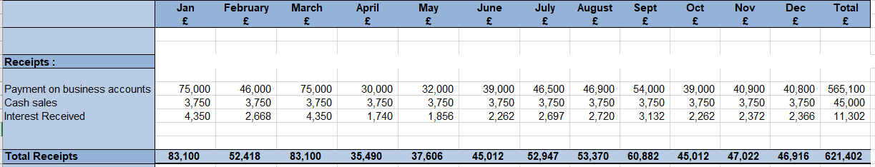
In here it is noticed that, the total cash recipient in the first month that means in January is 83100. The total cash recipient in the second month that means in February is 52418 euros. The total cash recipient in the third month that means in March is 83100 euros. The total cash recipient in the fourth month that means in April is 35490 euros. The total cash recipient in the fifth month that means in May is 37606 euros. The total cash recipient in the sixth month that means in June is 45012 euros. The total cash recipient in the seventh month that means in July is 52947 euros. The total cash recipient in the eighth month that means in August is 53370 euros. The total cash recipient in the ninth month that means in September is 60882 euros. The total cash recipient in the tenth month that means in October is 45012 euros. The total cash recipient in the eleventh month that means in November is 47022 euros. The total cash recipient in the twelfth month that means in December is 46916 euros. In here total 12 month’s total cash recipient are 621402.
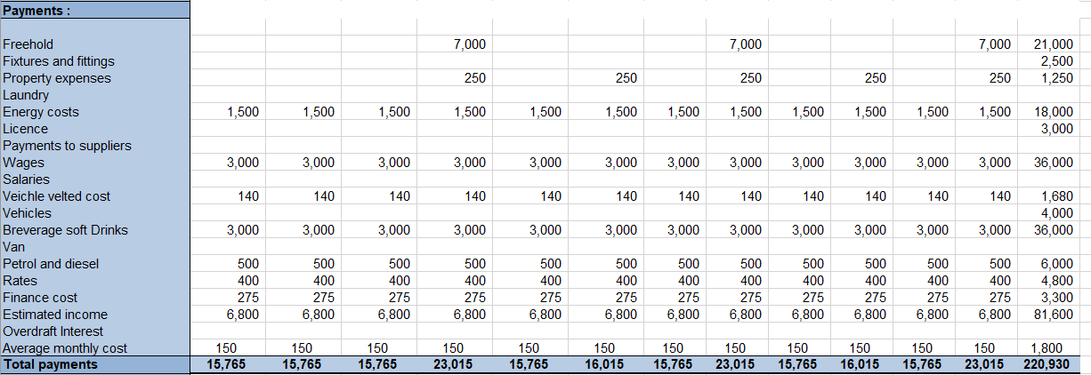
In this second table, it is seen that the total cash payment in the first month that means in January is 15765. The total cash payment in the second month that means in February is 15765 euros. The total cash payment in the third month that means in March is 15765 euros. The total cash payment in the fourth month that means in April is 23015 euros. The total cash payment in the fifth month that means in May is 15765 euros. The total cash payment in the sixth month that means in June is 16015 euros. The total cash payment in the seventh month that means in July is 15765 euros. The total cash payment in the eighth month that means in August is 23015 euros. The total cash payment in the ninth month that means in September is 15765 euros. The total cash payment in the tenth month that means in October is 16015 euros. The total cash payment in the eleventh month that means in November is 15765 euros. The total cash payment in the twelfth month that means in December is 23015 euros. In here total 12 month’s total cash payment are 220930.
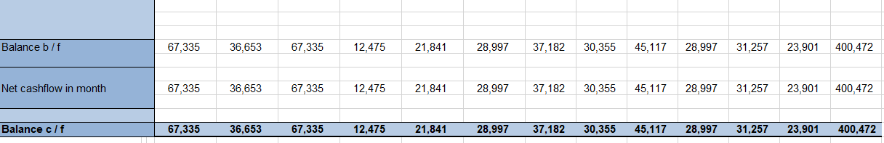
After that, for getting the net cash flow total cash payment have to deduct from the total cash recipient. After deducting it is seen that the total net cash flow in the first month that means in January is 67335. The total net cash flow in the second month that means in February is 36553 euros. The total net cash flow in the third month that means in March is 67335 euros. The total net cash flow in the fourth month that means in April is 12475 euros. The total net cash flow in the fifth month that means in May is 21841 euros. The total net cash flow in the sixth month that means in June is 28997 euros. The total net cash flow in the seventh month that means in July is 37182 euros. The total net cash flow in the eighth month that means in August is 30355 euros. The total net cash flow in the ninth month that means in September is 45117 euros. The total net cash flow in the tenth month that means in October is 28997 euros. The total net cash flow in the eleventh month that means in November is 31257 euros. The total net cash flow in the twelfth month that means in December is 23901 euros. In here total 12 months the total net cash flow are 400472.

References
Beredugo, S.B., Azubike, J.U. And Okon, E.E., 2019. Comparative Analysis Of Zero-Based Budgeting And Incremental Budgeting Techniques Of Government Performance In Nigeria. International Journal Of Research And Innovation In Social Science, 3(6), Pp.238-243.
Al-Attara, H.A., Mashkourb, S.C. And Hassanc, M.G., 2020. Zero-Based Budget System And Its Active Role In Choosing The Best Alternative To Rationalise Government Spending. International Journal Of Innovation, Creativity And Change, 13, Pp.244-265.
Tassew, D., 2021. Towards Program Based Budgeting System In Ethiopian Public Agencies And Its Implications In The Case Of Federal Ministries (Doctoral Dissertation, St. Mary’s University).
Hitz, C., Krey, M., Albath, M., Wyss, R. And Thoma, P., 2018. Zero-Budgeting Processes In Swiss Banks And How They Are Influenced By Rapidly Changing Regulatory Requirements. Journal Of EU Research In Business.-2018, (785563).
Salem, D., Itani, H. And El-Hajj, A., 2020. A Guide For Optimizing Resource Allocation: Link Assessment, Strategic Planning, And Budgeting To Achieve Institutional Effectiveness. Planning For Higher Education, 48(2).
Ibrahim, M.M., 2019. Designing Zero-Based Budgeting For Public Organizations. Problems And Perspectives In Management, 17(2).
O'Shea, J.P., 2018. Viability Of Zero-Based Budgeting Methods In The City Of Albuquerque.
Podrez, O., 2019. Mixed Budgeting As A Tool For Managing Sustainable Industrial Enterprise Management. The Scientific Heritage, (41-3 (41)), Pp.26-31.
Kunnathuvalappil Hariharan, N., 2020. Rethinking Budgeting Process In Times Of Uncertainty.
Habiburrochmana, H. And Rizkib, A., 2020. Zero-Based Budgeting And Its Impact On Control Effectiveness: A Case Study Of The State University Of Indonesia. International Journal Of Innovation, Creativity And Change, 11(11), Pp.366-383.
Husni, N.A., 2018. “Zero-Based” Governance: A New Model For The Future. In Higher Education Governance In The Arab World (Pp. 37-64). Palgrave Macmillan, Cham.
Anantha Ramu, M.R., 2018. Budgeting Techniques Of Rural Local Bodies In Karnataka. In Public Budgeting In India (Pp. 109-118). Springer, New Delhi.

