Independent Project

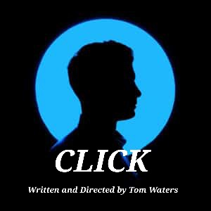

Tom Waters
BA Musical Theatre

Introduction

At the start of this module I was given the task of creating an informative piece about a topic of my choice providing it serves a purpose. The initial process of creating an idea was very difficult for me and it wasn’t until after a few sessions into the project where I had an idea that I felt excited by. The initial idea I had was to represent the dangers of online dating using the issue of Catfishing. The official description of catfishing is “a person who pretends to be somebody else, usually somebody who does not really exist, on social media in order to trick somebody into having a relationship online” (Oxford Learners Dictionaries). I made the decision to explore this topic as I feel the online dating world is at its highest in modern day times with the majority of people now having a dating account online. At the same time, I feel as much as the dating sites are so popular we never hear about the dangers and risks associated with them and meeting people online. Catfishing is something that everyone is aware of but not to the point where people know how to identify them. Personally, it was only when I began watching the now popular TV show Catfish that I actually began to identify the common warning signs and the traits of a catfish. Therefore, I decided that a performance raising awareness of the signs and dangers of catfishing would be both educational and important for an audience of all ages.
Fortunately, myself and close friends have been lucky enough not to ever experience anything like catfishing . It was eye-opening that when I first pitched the idea of basing my performance on someone who gets catfished then every person in the room had experienced or knew of someone who had experienced catfishing when dating online. I found this shocking and this really assured me that this is a real issue that people simply do not know enough about.
As much as I wanted to show the dangers of catfishing I also didn’t want to do the classic scenario of a girl being catfished by an older man, as I wanted my piece to stand out and highlight the fact that this could happen to anyone. This led me to base my piece off a man who gets catfished by a younger girl who’s pretending to be older. Even though this could have been seen as controversial with it being an older man and a younger girl, I feel it is a scenario that will be much more common in the near future with the ever increasing use of mobile phones and technology in younger generations. I decided not to make the age gap too extreme so that the controversy was not too apparent but enough that it still made an impact.
I heavily relied on my research to help make the important decisions for my piece, especially with the method it was to be delivered. Originally, I had the idea of doing a live performance with an audience and making it an enjoyable yet informative experience. This changed abruptly, after I carried out a questionnaire with the results being much more informative and persuasive than I expected.
Throughout the entire process I was very set and excited to make the piece a musical. I had not written music or songs before so I decided to make it a Jukebox Musical where I used existing songs from both the pop and musical theatre repertoire. I was however, very indecisive with how to present my piece. As much as I wanted to do a live performance I also had this strong idea to present it in the form of a film. I was actually very last minute making the decision. As much as the live performance would have been more entertaining from an audience perspective, using the media of film helped me to really create the different scenarios I was trying to form. The message came across much clearer through the film compared to our live rehearsals. Additionally, with everyone in my cast also doing live Individual Projects I was concerned my piece would not have the full attention it deserved to create and portray the impact and emotion that unfolds.

Research

In my opinion, there is a common consensus about the topic of Catfishing, however there are key points of information and details that people should know but don’t. This is something I was very sure to investigate and incorporate into my piece. However, as much as my piece is there to inform I wanted a very naturalistic feel with very realistic situations. This meant that I had to be very careful and selective when choosing what to feature in the piece. My mind-set was to portray that in real life the warning signs I learn about in my research are not obvious and can be mistaken for various things. If signs of catfishing were very obvious then catfishing would not be an issue in modern day times.
The key part to my research focussed on learning more about the warning signs of a catfish. I used google as my main source of information and found various websites explaining very different types of indicators that signal you are being catfished. However, there were a select few that all had the same few signs which I found to be very important as these were clearly the most noticeable and ones that people should be most aware of. Some of the most common signs of a catfish pulled from different websites include:
“They're avoiding face-to-face contact, either meeting up or video chats.
They're just a little bit too perfect.
Their stories sometimes conflict with each other, or don't quite add up.” (Age UK, 2021)
“They won't talk on the phone with you.
They refuse to video chat with you.
They always have a reason they can't meet up in person.” (Pomarico, 2018)
“Scammers Avoid Face-To-Face Chatting
Those who catfish often refuse to give out a personal phone number or use a camera. They also avoid Skype and software programs that can require video, such as Zoom.
They Are Messaging You a Lot
The conversation is moving really fast, and they are eager to move to any potential next level as soon as possible. This is one of the biggest signs of catfishing.
Pressuring You to Share More Personal Information
Scammers are known to ask you a lot of questions about yourself while sharing little about themselves.” (Tolt, 2022)
This research is very important to my piece as it’s purpose is to educate the audience about the warning signs. I ensured to incorporate as many of these signs as possible throughout my piece.
Whenever you hear about people who get catfished it is always focused on the reveal of the catfish rather than the most important part of the situation which is the aftermath for the victim. This is something I decided very early on that I wanted to feature in my performance. Therefore I made sure to carry out research into how exactly someone who gets catfished could feel and react. From research I have found various thoughts that someone could feel which such as:
“shocked – the extent of which is dependent on your prior suspicions
hurt – for the loss of your relationship
depressed – empty and hopeless (see my depression test)
embarrassed – you may have talked endlessly to your friends about how lucky you are to have found this great catch. It can be even worse if the other person was of a different gender than they pretended to be!
ashamed – you never thought anything like that could happen to you (and just in case you too often feel ashamed, see my article on toxic shame)
anxious and irritable – ‘normal’ things seem a burden
you can’t sleep and you can’t eat.” (Prior, 2021)
The last contextual information I felt I needed to look into was the important question of why someone would catfish? I find this a really interesting part of the problem as there could be so many random reasons and exploring and learning more about this would help my cast put their role into context. When writing the script I debated greatly how much focus I wanted to have on the character who is the catfish, as I wanted to fulfil the educational purpose of my piece and answer the project title of What are the dangers and warning signs of Catfishing. Some reasons I found for why someone would catfish include:
“Why Do People Catfish?
Reasons for catfishing are diverse, including isolation, difficulties with social connection, money schemes, trolling, harassment. and discontent with physical appearances.
Personal Insecurities
Some people may choose to catfish someone due to physical insecurities. They might view themselves as unworthy or not good enough, and feel more comfortable using the identity of a person they consider good-looking or charismatic. These people often use online dating sites as their source for fake photos. So, you should visit background check sites for dating to check if the person is truly who he/she says it is.
Money Schemes
In this situation, the person usually makes a request for a small amount of money, and then slowly tries to make more money and profit from naivety. Asking for money that appears to be for your benefit is one of the major catfishing signs, such as asking for money for transportation to come to visit.
Hiding Identity
Some people are unwilling to show who they really are and use fake profiles to hide their identities when searching through social media networks. This is mainly done by adopting another person’s images or persona. Check out some of the impressive identity theft protection companies to help protect yourself from this.
Harassment
Is a common reason for people to catfish. One of the most popular catfishing methods is setting up various accounts to harass someone online. These people often set up several social media accounts, such as WhatsApp or Instagram, as a result of the target of this online deception blocking the initial account. When this happens, you know that you are being catfished.
Unusually Romantic
Intimate recognition can feel good, but sometimes it can overwhelm you with passionate texts to side-track you from asking questions about their identity. If you want to be sure not to fall prey to romantic catfishing, check out the best background check sites for dating.” (Tolt, 2022)

Questionnaire

After completing my research learning about my chosen topic I decided to create a questionnaire asking people of all ages about Catfishing and insightful details about the delivery and entertainment side to my piece. The questionnaire I created is as follows:
- Have you ever been Catfished?
- Do you know of someone who has been Catfished?
- Who is most likely to be Catfished, Men or Women?
- Have you ever been on a Dating Site?
- Would you prefer to watch a Musical or Play?
- Do you feel like a performance about Catfishing would best be shown as a Live theatre Performance or a recorded Short Film?
- Do you think it is important to see the effects being catfished can have on someone?
- Do you feel a Support System of someone who has been catfished is an important thing to have in a piece about Catfishing?

Questionnaire Analysis

I found this questionnaire extremely helpful for my project as it really helped me make decisions and choices that I may not have done without evidence from my target audience. Below is an analysis of some of the results I have gathered from my Questionnaire.
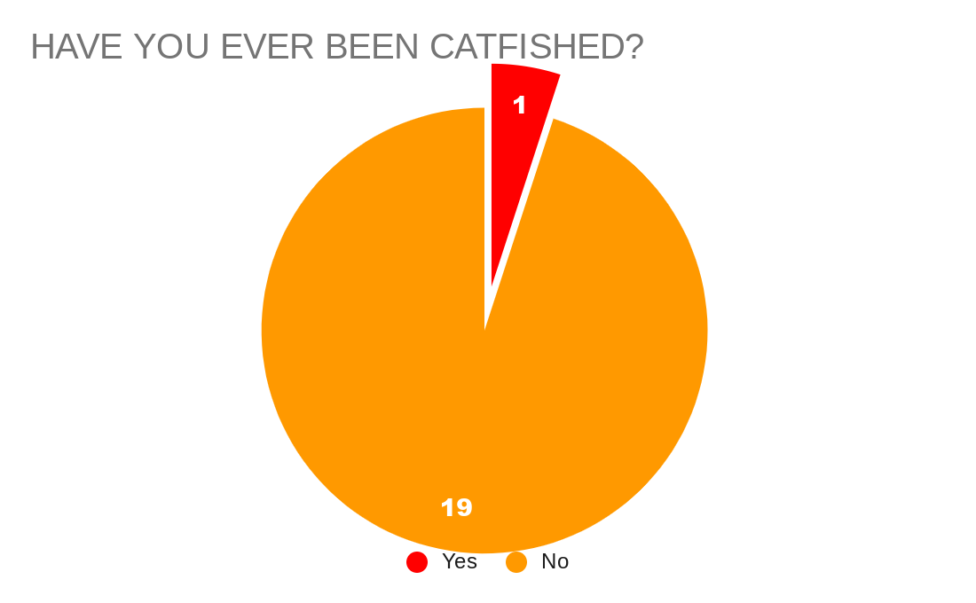

From the results of the questionnaire, it is very clear that the majority of people asked have never been victim of Catfishing. As I have previously stated I do not know of anyone who has been catfished so I was not surprised by this result. However, it is known that people will only be Catfished for a specific reason and will have intent behind it.
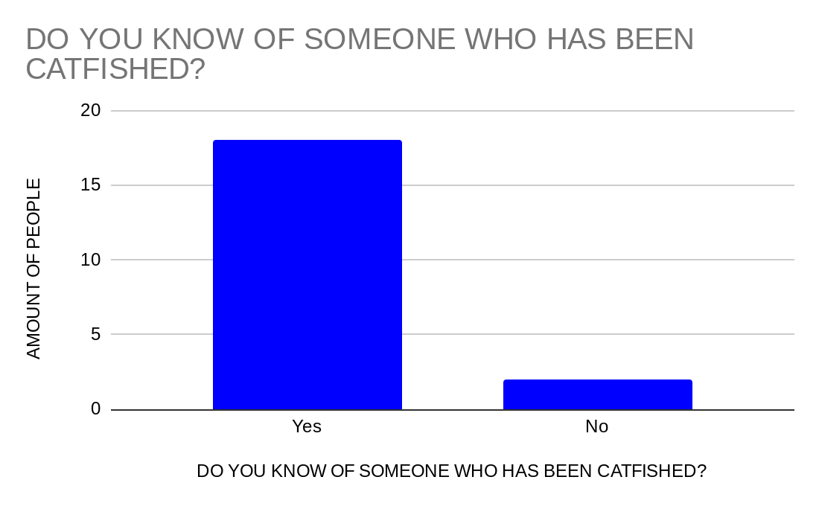
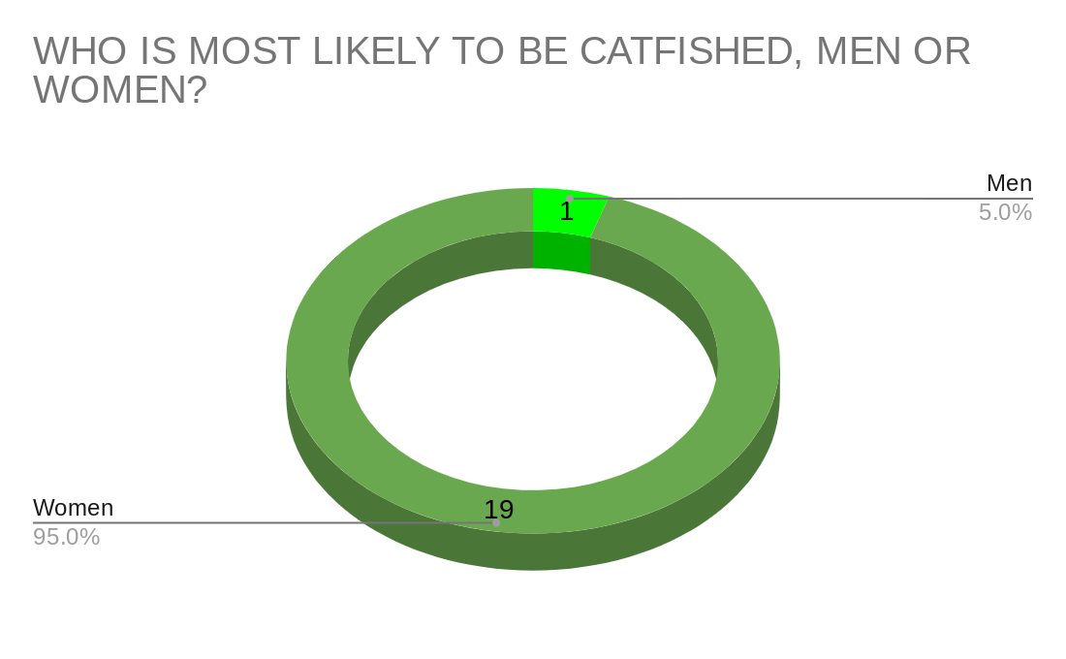
From these findings, I was shocked and surprised to see how many people actually knew of someone who had been Catfished. This amplified to me that this is actually a serious issue in modern day times and something that needs to be addressed. I was pleased with this confirmation that I have chosen a gripping relevant topic that needs to be shared.
From the results I can infer that nearly everyone asked believes that women are more likely to get catfished than men. I feel this is mainly due to the fact that with all the big stories about catfishing we hear about there is a younger girl being catfished by an older man. This was a very big factor in my reasoning that having the catfisher as a young girl would have much more of an impact and will really reiterate the fact that this could happen to anyone no matter of their gender or age.
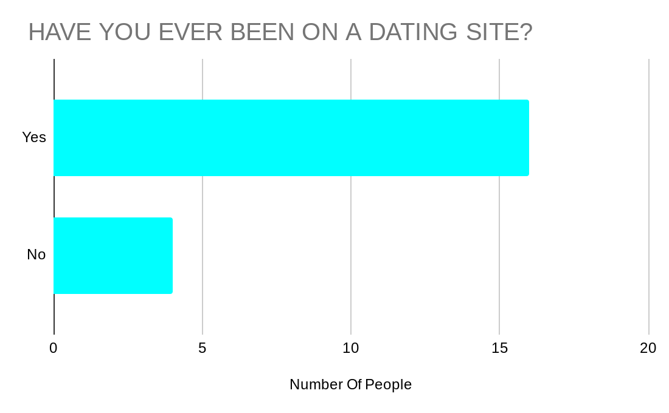

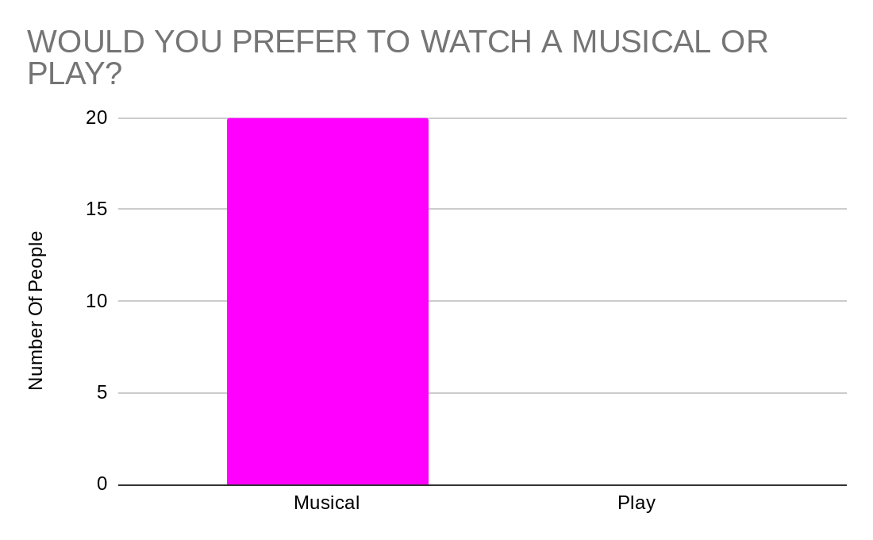
The purpose for asking this question was to prove how big of a platform dating sites are, and that every single person who is on a dating site is at risk of being a victim of catfishing simply because you do not know if the person is being truthful. IN this questionnaire everyone who was under the age of 35 who was asked answered yes to having been on a dating site. This shows how important it is that people are aware of the dangers involved being on these sites.
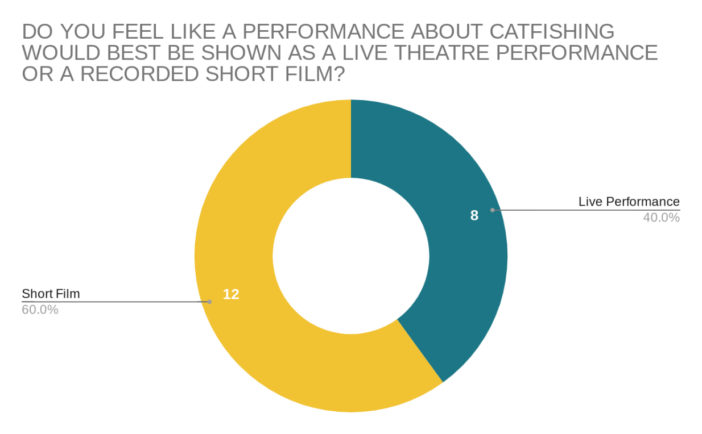
Before starting to carry out my research into the piece I had the idea of my piece being a Jukebox Musical. I believe people are more likely to stay engaged and invested in a musical rather than a play simply due to the entertainment factor the songs and dancing in a musical brings. However, I did understand that due to this being a very current and serious topic in terms of its importance that people may have preferred to see the piece in a more serious setting, with it being all about the message rather than the performance. As shown by the graph above it was clear that everyone would prefer a musical and those I spoke to explained that they need something memorable so that it sticks in their mind like a musical. Therefore I made the decision to include all the relevant information and still show the seriousness of the topic but present it in a way that was still fun and entertaining.

I needed to ask this question as I was very undecided as to how to present this project due to both ways being good options and having different opportunities. After seeing the feedback from the questionnaire, there was really not much difference, however a recorded short film version of the piece had a larger vote. I was unable to decide until the very end of the project so I ensured the staging and blocking would be suitable for either form of delivery but in the end I made the decision to do a recorded version of my piece and I am very happy with the end result.

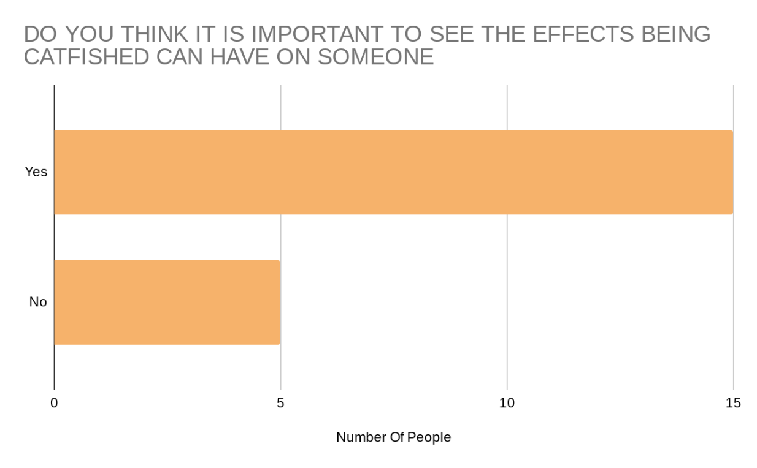

When beginning to think of the general outline of the show I found that I had two options as to how to conclude my piece. I could either make the reveal of the catfish as the climax at the ending or I could carry on and show the aftereffects, and the repercussions to that person who has been catfished. After these results and the research I found on this subject, I made the decision to keep the climax and the reveal towards the middle of the play and then proceed to show the emotions and mind-set of the victim. I included this as my final question of the survey as I felt that this would be a good point to highlight, to show the support system needed for someone who has gone through this.
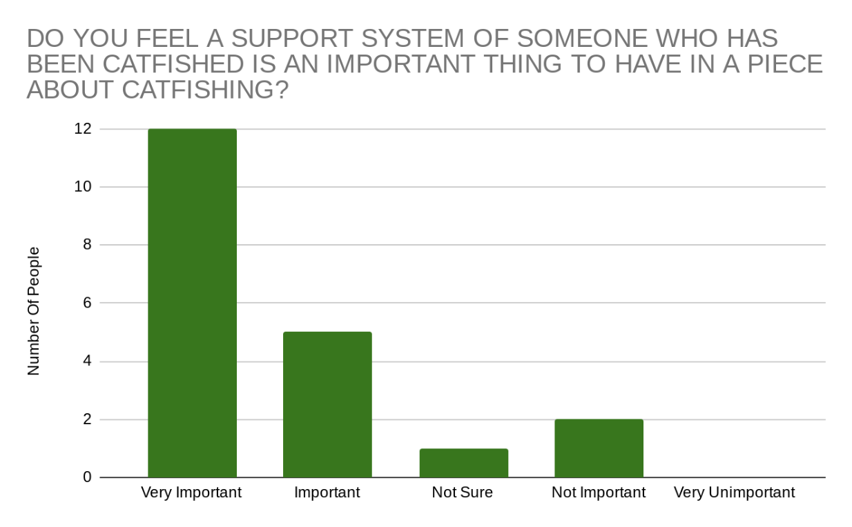

I always feel that some of best moments in a performance is when you have an intimate emotional moment between friends or family where they just express their support for one another. By adding in the sister character and her friends, then I had much more opportunity to create these moments as well as representing another important factor to the issue of catfishing which is how someone recovers from it. Therefore I am extremely pleased to see that a very large number of people asked also agree that this support system would be a good addition to the plot and overall performance.

Process

The script writing process I found to be very simple and straight forward. I had a very clear idea for plot and characters before starting. I began by writing a brief summary or what happens in each scene in which I could then expand into a full script of dialogue. I found this strategy of writing very helpful as I knew exactly where I was heading in each scene and exactly what it was I needed to include. After completing the final script I then decided where would be the most suitable places for the songs to appear throughout the performance. I then spent most of my time searching for songs and musical numbers that I thought best suited my piece. I made sure that the songs I chose were there for a reason and I actually found myself deleting chunks of dialogue as the songs meaning and content were the same. The final list of songs I used in the performance was:
- You Matter To Me – Waitress
- Material Girl – Idina Menzel
- Running Home To You – The Flash/Grant Austin
- You Have More Friends Than You Know – Glee
- A Thousand Years – Christina Perri
- Shake It Out – Glee/Florence and The Machine
- Outcast – Glee
During the editing stages of the piece I then used various other tracks as backing music to play under dialogue or the credits. Music tracks I also featured in the piece were:
- Let Me Love You (Until You Learn To Love Yourself) – Glee/Ne Yo
- Human Nature – Glee/Michael Jackson
- For Once In My Life – Glee/Stevie Wonder
I found that I used a lot of the glee versions of songs simply due to them having a different sound and arrangement of music which suited my piece much more than the original tracks. However I made sure all lyrics were kept the same and were adapted to suit the arrangements and backing tracks of the glee versions.
Once the songs were finalised I then spoke to various people within my year to arrange a cast. I had previously seen them all act and sing before matching them and asking them to feature as specific roles within my show .Along this journey, I had created a connection to the main character so I changed my plan and decided to take on the role myself alongside my fellow classmates. The final cast list is as follows:
Josh – Tom Waters
Ella – Ebony-Rio Rees
Zoe – Georgia Hicks
Mia – Catrin Lewis
Catfish Chloe – Tegan Llio
Chloe – Freya Bussy
Waiter – Gwion Tudur
The rehearsal process was difficult to begin with as the cast was quite large and it was very difficult to get everyone in the room at the same time. Therefore, I decided to split the rehearsals working with specific people at certain times so that once everything had been learnt in pieces we could just piece it all together. I found this format of doing the rehearsals actually benefited the performance as I had written each scene to be in a different moment in time so there didn’t need to be a constant flow as there wasn’t a flow in the timeline. For example there was a three week time gap between Scene 4 and Scene 5.
I was very lucky that everyone in the cast were very professional when it came to rehearsals and commitment so we were able to achieve a great deal. Everyone arrived timely and keen to work and so the rehearsal process could not have gone better in my opinion.
In terms of set and costumes, everything was very naturalistic and didn’t require that much thought. For the costumes, I took inspiration from Heathers where each character would have their significant colour that they would always wear throughout the piece. For example, the character Josh was always wearing green, Ella was in Yellow, Catfish Chloe was in Brown etc. I had slight costume changes amongst the characters just to clarify the time difference however in the end I found that the text and set up of scenes were significant enough so there was no need to have as much of a change as originally expected. The settings for the piece were a living room, a cafe and an area to represent a world of messaging. I really wanted a change of setting between the world of messaging and the real world so I decided to do this by basing the cafe and living room in a white room with a wide shot, and the messaging world was up against a blue, orange and white painted background with a much closer camera shot and the use of phones to symbolise that we are messaging. The final result was very effective in my opinion and the transitions between the two worlds were so clear that people knew exactly what was happening even from the first time watching the performance.
The final stage of my process was the filming and editing of my piece. The filming process was very relaxed and fun. We took our time with each scene and made sure everyone was happy with each recording. We experimented with where to stop filming and whether to film the scenes as one or to record each song and scene individually. I made the decision to record each song and scene separately as it gave the performers more chance to evaluate what we weren’t happy with. Whenever I was happy with the scene I wanted to redo the singing elements so it was a time effective decision to record everything separately and to experiment with transitions when editing.
To edit my recordings I used an app on my phone called INSHOT. I had already had experience using this app in previous modules in university so I was very comfortable with the programming and how to use all the necessary tools. On the app I was able to merge videos together, add transitions, add music, edit audio and much more. This software helped me create a really high level video of my completed performance including an introduction and credits scene ending which really finished it off producing a professional style film .

Script

Here is a copy of my final script. I gave the direction to all the cast that due to wanting a very naturalistic feel to the piece, they were not to stick to the script exactly but ensure the key elements of each line were present. I wanted each actor to make their characters persona their own, which explains why in the video there are slight differences. Overall I am very happy with the finished piece.

TOM INDIVIDUAL PROJECT

Cast:

Josh - Male Lead – Tom
Chloe - Love Interest (Catfish) – Tegan
Ella - Sister – Ebony
Zoe - Sisters Friend 1 - Georgia
Mia - Sisters Friend 2 – Catrin
Chloe (R) - Love Interest (Real) – Freya
Waiter - Gwion

Scenes:

Scene 1 - Josh, Ella
Scene 2 - Josh, Chloe
Scene 3 - Josh, Ella, Zoe, Mia
Scene 4 - Josh, Chloe
Scene 5 - Josh, Ella
Scene 6 - Josh, Chloe ( R), Waiter
Scene 7 - Josh, Ella, Zoe, Mia

Songs:

#1 – Human Nature Underscore Music – Josh
#2 - You Matter To Me - Josh, Chloe
#3 - Material Girl - Ella, Zoe, Mia
#4 - Running Home To You - Josh
#5 - You Have More Friends Than You Know - Ella
#6 - A Thousand Years - Chloe ( R)
#7 - Shake it Out - Ella, Zoe, Mia
#8 - Outcast - Josh, Ella, Zoe, Mia

Script

Scene 1

SONG _ *Human Nature* _

(Josh improvised video message to Chloe declaring his love)

(Ella enters scene)

Ella – Someone’s in a good mood
Josh – Ella… what are you.. (Stumbling) How long have you…?
Ella – Long enough to realise that something or someone is making my little bro very happy. So which one is it?
Josh – Look just because your my sister does not mean I have to tell you every little thing that’s going on in my life
Ella – Okay who is she?
Josh – What? I never said anything..
Ella – Oh come on! Do I know her?
Josh – No you don’t
Ella – Are you sure? Because I know a lot of people
Josh – Believe me, you don’t know her
Ella – Okay do you have a photo? (Josh looks at her) At least tell me what she looks like?
Josh – I don’t know
Ella – Sorry?
Josh – I don’t know what she looks like
Ella – Hang on rewind. You are telling me that you are doing a whole one man show, beaming from ear to ear about someone you’ve never seen?
Josh – Yeah that’s how it works
Ella – Please don’t tell me your on that new dating site
Josh – Click? Yeah I am. It's not that bad
Ella – You do know that like 60% of people who are on that aren't actually who they say they are?
Josh – Yeah like I've spent the last 8 months talking to someone pretending to be someone else. I’m sure I would know
Ella – Eight months? So this is serious then? (Josh nods) How can you feel so strongly for someone that you’ve never met? What happens if you don’t like the way they look?
Josh – But that’s not the point. The point is that you get to know someone for who they really are and you fall in love with THEM, not the way they look. You're telling me that you would never date someone that wasn’t attractive?
Ella – NO! I mean looks aren’t everything but you have to be attracted to them josh. It worries me that you don’t even have a photo of her
Josh – I don’t need one, we’ve spoken about it and we agree that falling for someone for their personality is much more important. And yeah the day will come where we will have to see each other. And you know, it has been 8 months now so I’m sure it will be soon
Ella – Well as long as your careful and happy then I’ll support you like big sisters should do
Josh – Thank you

(Ella goes to leave)

Josh – Oh and please don’t tell anyone about Chloe. I don’t want anyone to know yet
Ella – Chloe huh? (Josh sighs) See I find out everything. And remember the girls are coming over tomorrow
Josh – Yeah yeah I remember
Ella – Okayyy enjoy texty time with Chloe
Josh – (Sarcastically) Bye Ella
Ella – You love me

Scene 2

(Scene changes to messaging world between Josh and Chloe)

Josh – Hey I've just been with Ella and she may have found out about us!
Chloe – Oh really? I thought we decided we weren't going to tell anyone?
Josh – I mean yeah but it was bound to happen at some point! But it's not like she knows who you are so I don’t think it will matter too much. Right?
Chloe – Of course, I just really don’t want anything to mess this up because you do mean a lot to me and I almost feel like one wrong move and everything could change and I REALLY don’t want that to happen
Josh – What could go wrong? My sister is a nice person, she's not as scary as she might make out.
Chloe – I mean she looks nice enough but you know looks can be deceiving..
Josh – Wait.. how do you know what she looks like?
Chloe – Oh… you know…. From that insta photo you posted last week! That was your sister Ella right?
Josh – Yeahh I completely forgot about that! That’s Ella yeah! Honestly, you’ll love her! Your insta is still broken. I still can't see any photos or anything.
Chloe – Oh yeah it's still broken, it's meant to have been fixed a while ago but I guess it hasn’t.
Josh – You know my dad is really good with technology. I can ask him for advice if you want me too?
Chloe – No…. Its okay I’ll sort it thank you. On other terms I have something I wanted to say to you! You are one of the nicest people I think I have ever spoken to and I'm so happy to be able to have you in my life.
Josh – I have never felt this way about anyone before and you mean so much to me and I cannot wait for the day I finally get to meet you.

SONG _ *YOU MATTER TO ME* _

Josh:
I could find the whole meaning of life in those sad eyes
They've seen things that you never quite say, but I hear
Come out of hiding, I'm right here beside you
And I'll stay there as long as you let me

Because you matter to me
Simple and plain and not much to ask from somebody
You matter to me
I promise you do, you, you matter too
I promise you do, you'll see
You matter to me

Chloe:
It's addictive the minute you let yourself think
The things that I say just might matter to someone
All of this time, I've been keeping my mind on the running away
And for the first time, I think I'd consider the stay

Because you matter to me
Simple and plain and not much to ask from somebody
You matter to me
I promise you do, you, you matter too
I promise you do, you'll see
You matter to me

Both:
And you matter to me
Simple and plain and not much to ask from somebody
You matter to me
Chloe:
I promise you do, you
Josh:
I'm out of hiding, I'm right here beside you
Chloe:
You matter too
Josh:
As long as you have me
Chloe:
I promise you do, you, you matter too
Josh:
I'm out of hiding, I'm right here beside you
Chloe:
I promise you do, you, you matter too
Josh:
I do, I promise you do, you matter to me
Both:
I promise you do, you'll see
You matter to me

Scene 3

(Josh is sitting on the sofa on his phone. Ella, Zoe and Mia enter)

Zoe and Mia – (Girls Calling and laughing hugging and jumping on Josh) Joshh, josh, josh
Josh – Hello yes okay, okay.
Ella – Girls leave him alone
Zoe – Josh serious talk time. (Sarcastically) How’s Chloe?

(Girls Laugh)

Ella – Zoe!
Josh – Ella what did I tell you?
Ella – Not to tell anyone! (Josh looks in anger) What do you expect! They're my girls! If my little bro has got himself a girl I have to tell them!
Mia – Even if she is made up
Josh – What?
Mia – I'm joking! She is just probably a married 50 year old guy with two kids who's getting bored of normal boring life.
Josh – Look I’ve told you, Chloe is real and…… I was actually meant to meet her today so if she wasn’t real then why would she agree to meet up?
Ella – What have you actually met her?
Zoe – Oh my god is she pretty? Did she kiss? What did you say? What did she say? Is she tall? Short? Blonde?
Josh – She actually didn’t come
Mia – She stood you up?
Josh – Something came up
Ella, Zoe and Mia – (Sassy) Catfish!
Josh – She is not a Catfish!
Ella – Oh come on it’s a little odd
Mia – Yeah Josh this is literally exactly what happened to my cousin last year.
Zoe – Oh yeah I heard about that! Didn’t this guy she was talking to just completely lie about who he was?
Mia – Yeah, that’s what catfishing is Zoe! This guy used his son's photos to pretend to be a younger guy and it was just lucky that when they met she had people with her! Otherwise who knows what would’ve happened
Ella – There are so many dangerous people in this world and I’m afraid that something bad will happen if this Chloe girl isn’t who she says she is!
Josh – Look what happened to your cousin is awful! But Chloe is real! I just know she is!
Mia – I hope so.
Zoe – SO anyways what present did you buy her for today?
Josh – Present?
Zoe – You did buy her a present didn’t you?
Josh – No
Mia – Amateur
Ella – Josh you always buy a gift for the first date
Josh – Really?
Zoe – Of course you do! You have to have like flowers or chocolates or wine or a little necklace with a heart on
Ella – Look, the dating game nowadays is hard and people have options now
Mia – You have to make her remember you!
Zoe – A PUPPY!!! You should DEFINITELY get her a puppy
Mia – (Sarcastically) Talk about high maintenance!
Zoe – Mia!!!!
Josh – Come on. A puppy? Bit much isn't it?
Ella – Mmmhmmm
Zoe – Hey you know I’m a very wanted woman!

SONG _ *MATERIAL GIRL* _

Zoe:
Some boys kiss me, some boys hug me
I think they're okay
If they don't give me proper credit, I just walk away

Mia:
They can beg and they can plead
But they can't see the light
Ella:
(That's right)

Zoe:
'Cause the boy with the cold hard cash is always Mister Right

Mia:
'Cause we are living in a material world
And I am a material girl

Zoe:
You know that we are living in a material world
And I am a material girl

Josh - But what about romance?

Zoe - Oh please

Ella:
Some boys romance, some boys slow dance
That's all right with me
If they can't raise my interest, then I have to let them be

Zoe: Ella and Mia:
Some boys try, and some boys lie Oooooooooo
But I don't let them play
Ella:
(No way)

Mia:
Only boys who save their pennies make my rainy day

[Chorus]
'Cause they are living in a material world
And I am a material girl (Get it? Yes)

Ella, Zoe and Mia:
We are living in a material world
And I am a material girl
You know that we are living in a material world
And I am a material girl

Zoe:
'Cause everybody's living in a material world
And I am a material girl

Ella and Mia:
'Cause we are living in a material world
And I am a material girl
And I am a material girl

Zoe and Mia: Ella:
Living in a material world (Living in oh)
Living in a material world (oh oh)
Living in a material world (Living in oh)

Ella, Zoe and Mia:
Living in a ma-material world

Scene 4

(Scene change to Josh and Chloe messaging)

Chloe – Hey how are you?
Josh – I'm good thank you! I've just been with my sister and her friends
Chloe – You didn’t tell them did you? What has your sister said?
Josh – Yeah Ella has mentioned it to them but that doesn’t matter they don’t care.

(No reply)

Josh – Chloe?
Chloe – You shouldn’t have told anyone. It makes things complicated.
Josh – Look I'm sorry that people know but it's only three people! Is it really that bad?
Chloe – I'm sorry.
Josh – Your sorry? What are you sorry about? Chloe, is there something you're not telling me? This whole situation with me telling my sister about us, you’ve been acting really strange. Look, they all want to meet you and I feel like the past eight months has been leading up to now! I love you Chloe and I want to be with you
Chloe – I'm sorry.

(Chloe Exits)

Josh – What have I done wrong?

SONG _ *RUNNING HOME TO YOU* _

Josh:
Can't say how the days will unfold,
Can't change what the future may hold
But, I want you in it
Every hour, every minute
This world can race by far too fast
Hard to see while it's all flying past
But, it's clear now,
When you're standing here now
I am meant to be wherever you are next to me
All I want to do
Is come running home to you
Come running home to you
And all my life I promise to
Keep running home to you
Keep running home
To you
And I could see it
Right from the start
Right from the start
That you would be
Be my light in the dark
Light in the dark
Oh, you gave me no other choice
But to love you
All I want to do
Is come running home to you
Come running home to you
And all my life I promise to
Keep running home to you
Keep running home
Home to you
Can't say how the days will unfold
Can't change what the future may hold
But, I want you in it
Every hour, every minute

Scene 5

(Ella is on the sofa and Josh enters looking very glum)

Ella – Hello stranger, where have you been? I've barely seen you!
Josh – Nowhere
Ella – You okay?
Josh – Yeah I’m fine
Ella – I haven't heard you mention Chloe in a while. Everything okay between the two of you?
Josh – Yeah we're fine
Ella – Right what's going on?

(No answer)

Ella – Josh I can tell when your lying, you can talk to me
Josh – So I told Chloe that you and Zoe and Mia all know about us… and she just went really weird and I haven’t heard from her since. I've been messaging her every day and it's nearly been 3 weeks now! I just don’t understand what I’ve done.
Ella – You haven't done anything! Look I know you two had this little agreement of not telling anyone but it's been eight months now. If telling your sister and two friends about her is such an issue for her to stop talking to you for three weeks then is she really worth it?
Josh – She told me she loved me Ella.
Ella – If she loved you that much then she wouldn’t ghost you for three weeks Josh.
Josh – Yeah I guess
Ella – Look even if she does message you tomorrow or not at all you shouldn’t lock yourself away! The girls haven't stopped asking about you and I’m sure all your friends from school miss hanging out with you
Josh – You don’t understand. She was everything I thought about for eight months! And now I literally cannot stop thinking about her because I don’t know what’s going on. Besides, I doubt I'm that much fun to be around right now. So people won't miss me that much.
Ella – Josh you are an amazing person and you shouldn’t let some girl on a computer screen make you feel like this. You are loved by so many people. Probably more than they tell you!

SONG _ *YOU HAVE MORE FRIENDS THAN YOU KNOW* _

Ella:
Mmm... oh
We feel
We hear
Your pain
Your fear
But we're here
To say
Who you are
Is okay

And you don't have to go through this on your own
You're not alone

You have more friends than you know
Some who surround you
Some you are destined to meet
You'll have more love in your life

Don't let go, give it time

Take it slow
Those who love you the most, may need more time to grow

It's gonna be okay
You have more friends than you know

Be brave
Be strong
You are loved
You belong

Some day soon
You will see
You're exactly
Who you're supposed to be
And you don't have to go through this on your own
You're not
Alone

You have more friends than you know
Some who surround you
Some you are destined to meet
You'll have more love in your life
Don't let go

Give it time
Take it slow
Those who love you the most
May need more time to grow
It's gonna be okay
You have more friends than you know

Be who you are
Learn to forgive
It's not about who you love
But how, how you live!
Ooooh!

You have more! friends than you know
Some who surround you
Some you are destined
You'll have more love in your life

Don't let go, give it time

Take it slow

Those who love you the most May need more time to grow

It's gonna be okay

You have more friends than you
Know (Ooh)
It's gonna be okay

Josh – Thank you
Ella – Anytime little bro

(Phone alert)

Josh – It's Chloe. She wants to meet.

Scene 6

(Scene changes to Josh sitting in a café on the phone to his sister)

Josh – (On the phone) Yes I’m still here. No she's not here yet! Look, I told you I’ll be fine! I just hope she actually turns up this time. Yes I understand okay I’ve got to go I’ll ring you later. Yes I will okay bye!
Waiter – Regular latte, three sugars?
Josh – Yes thank you! Sisters eh!
Waiter – I know the feeling (Laughs and exits)

(Chloe (R) sits on table next to Josh listening to his conversation)

Chloe (R) – My sisters are the same too. Sometimes you just need a break don’t you?
Josh – Yeah I think so! (Both laugh) I'm quite lucky though really, I actually get on with my sister really well so it could be worse
Chloe – I barely get to see my sister because of school and her working and that but we still text and call so like you said it could be worse.
Josh – Talking of school shouldn’t you be there right now?
Chloe – Free Period. I come here quite a lot actually, it's really quiet so it’s a good place to do work.
Josh – Yeah it’s a nice little place. I'm actually meeting someone and she told me to meet her here so… Here I am. It's our first time actually meeting so she said this would be a nice quiet place to meet.
Chloe – First time? You must be nervous?
Josh – Yeah a little bit!
Chloe – You got her a gift as well!
Josh – Yeah my sister and her friends were adamant I needed a gift to bring so my sister picked it out
Chloe – Ella’s got good taste (Continues to read/work)
Josh – Sorry do I know you?
Chloe – No don’t think so
Josh – (Confused) It's just that you called my sister Ella. But I haven't said her name since being here
Chloe – Did I? I must've heard you say it to the waiter
Josh – No I definitely haven't said her name! How did you know my sister's name was Ella?

(Josh notices Chloe's name badge on her shirt)

Josh – Your name is Chloe? Please tell me it's not you
Chloe (R) – Josh I am sorry I don’t know what you're talking about!
Josh – I haven’t said my name either! It's you isn't it? Your Chloe!

Chloe (R) – I wanted to tell you…
Josh – Oh my god…
Chloe (R) – I am so sorry Josh, I didn’t want to hurt you I really didn’t…
Josh – So that’s why you never wanted to call or meet? Because you were afraid of me seeing how old you were. I was so sure you were real!
Chloe (R) – I am real! I'm still me
Josh – (Angry) NO! You are not the person I fell in…. Do you have any idea how dangerous this is! You are a little girl! I could have been in so much trouble
Chloe (R) – No you wouldn’t! We love each other! I love you!
Josh – (Shouting) You are not her!! You are not my Chloe! You need to stay away from me and don’t you ever do anything like this to anyone again!
Chloe (R) – Josh please…
Josh – Are you serious? You pretended to be 21 and you're 16, 17?
Chloe (R) – I’m 15
Josh – Oh my god. I'm done. Don’t ever contact me again.

(Josh exits)

SONG _ *A THOUSAND YEARS* _

Chloe (R):
Heart
Beats fast
Colours and promises
How to be brave?
How can I love when I'm afraid to fall
But watching you stand alone?
All of my doubt suddenly goes away somehow
One step closer
I have died everyday waiting for you
Darling don't be afraid I have loved you
For a thousand years
I'll love you for a thousand more
Time stands still
Beauty in all she is
I will be brave
I will not let anything take away
What's standing in front of me
Every breath
Every hour has come to this
One step closer
I have died everyday waiting for you
Darling don't be afraid I have loved you
For a thousand years
I'll love you for a thousand more
And all along I believed I would find you
Time has brought your heart to me
I have loved you for a thousand years
I'll love you for a thousand more
One Step Closer
One step closer
I have died everyday waiting for you
Darling don't be afraid I have loved you
For a thousand years
I'll love you for a thousand more
And all along I believed I would find you
Time has brought your heart to me
I have loved you for a thousand years
I'll love you for a thousand more

Scene 7

(Scene change to Ella, Zoe and Mia consolidating Josh)

Ella – Josh it's not your fault. How were you to know?
Josh – You all knew! You all saw the signs. How didn’t I?
Zoe – You were in love joshy
Mia – Look you may think you’re the stupidest person on the planet right now but you're really not.
Ella – Yeah, there are so many people in your situation right now
Zoe – You're just like Mia's cousin! And she's fine isn't she?
Mia – Yes Zoe she's fine! What has happened to you is awful Josh and I'm so sorry for what this kid has done to you!
Ella – Josh I know it's hard to think but you will get through this. You know teenagers these days are so insecure and under so much pressure to be a certain way and look a certain way, I bet she just felt bad about herself so to have an older guy actually like her for who she is. I bet that’s all she wanted.
Zoe – I would. (Everyone looks) No but seriously josh! None of this is your fault and what she did could have had so many consequences it's just so dangerous
Mia – Count yourself lucky! It could have been much worse
Josh – Yeah it could. Guys thank you so much for being here. I'm just struggling because I still feel like the person I have been talking to for the past eight, nine months and the person I met today….. It just doesn’t feel real. It's gonna take me some time because the Chloe I know was everything to me and to know that this was all just fake, it's hard.
Ella – I know it's hard Josh and were all here for you
Zoe – Of course we are
Mia – Anytime
Ella – And this is just something that you’ll have to put behind you and move on.

SONG _ *SHAKE IT OUT* _

Ella:
Regrets collect like old friends
Here to relive your darkest moments
I can see no way, I can see no way
And all of the ghouls come out to play

Mia:
Every demon wants his pound of flesh
But I like to keep some things to myself
I like to keep my issues drawn
It's always darkest before the dawn

Ella:
And I've been a fool and I've been blind
I can never leave the past behind
I can see no way, I can see no way

Zoe and Mia:
I'm always dragging that horse around
Our love is pastured, such a mournful sound

Ella:
Tonight I'm gonna bury that horse in the ground

Zoe:
So I like to keep my issues drawn
But it's always darkest before the dawnnnn
Ella and Mia:
Shake it out, shake it out
Shake it out, shake it out, oh whoa

Ella, Zoe and Mia:
Shake it out, shake it out
Shake it out, shake it out, oh whoa

And it's hard to dance with a devil on your back
So shake him off, oh whoa

Zoe:
And it's hard to dance with a devil on your back

Ella:
And given half the chance, would I take any of it back?

Mia:
It's a fine romance but it's left me so undone

Ella, Zoe and Mia:
It's always darkest before the dawn

Ella:
Looking for heaven
Ella and Zoe:
Found the devil in me
Looking for heaven

Ella:
Found the devil in me
But what the hell

Ella, Zoe and Mia:
I'm gonna let it happen to me, yeah

Shake it out, shake it out
Shake it out, shake it out, oh whoa (Oah, oh)
Shake it out, shake it out
Shake it out, shake it out, oh woah (Shake it out)

And it's hard to dance (When it's hard to dance)
With a devil on your back
{So shake him off} oh whoa
(Ouh, shake it off)

Shake it out, shake it out (Yeah)
Shake it out, shake it out, oh woah (Shake it out)
Shake it out, shake it out (Shake it out)
Shake it out, shake it out, oh whoa (Eeey)

And it's hard to dance with a devil on your back
{So shake him off} oh woah

(Oh-oh, ooh-whoa, oh-oh)

Ella – We are here for you Josh. We love you
Zoe – Look, forget about Chloe, Linda, Betty whatever her name is! You are an amazing person who deserves so much better! And you know when your over your little heartbreak
Ella and Mia – Zoe!
Zoe – I’m only joking
Mia – Josh I've known you for a long time now! So if my cousin can get through it you definitely can! We got your back
Josh – I know I’ll be okay its just gonna take time but in the meantime I’m going to surround myself with people who really care for me.

SONG _ *OUTCAST* _

Mia:
Who's to say
Who's not okay?
The breakaways
Will outlast, will outlast

Josh:
Sticks and stones
Won't break these bones
They're just some drones
To get past, I'll get past

Josh and Ella:
Feeling downcast
Like an outcast
Underdogs, it's time to bite back!

All:
We are, we are, we are
Stronger from every scar
Brighter than any star!

We're the outcast! O-o-outcast!
There's nothing you can say
To blow our dreams away!
We rise above the fray!
We're the outcast! Ooo

Josh and Zoe:
I'd rather be outrageous than

Josh and Ella:
Just another dull cliché again!

Josh and Mia:
I'd rather be a rainbow than

All:
Just some shade of grey!

Josh: Ella, Zoe and Mia:
We are, we are, we are Ah, ah, ah, ah, ah, ah
Stronger from every scar, Ah, ah, ah, ah, ah, ah {Yeah}
Brighter than any star Ah, ah, ah, ah, ah, ah {Yeah}
The outcast Ah, ah, ah, ah, ah, ah

Josh:
The outcast...

Ella, Zoe and Mia:
Oh, whoa, whoa!
Oh, whoa, whoa!

All:
Stronger from every scar!
Josh, Zoe and Mia: Ella:
The outcast! Outcast!
O-o-outcast! Outcast!

All:
Oh, whoa, whoa!
Oh, whoa, whoa!

Josh, Zoe and Mia: Ella:
Brighter than any star! Oooh! Oooh!
The outcast!

Ella, Zoe and Mia: Josh:
O-o-outcast! The outcast

Oh, whoa, whoa!
Oh, whoa, whoa!

Josh, Zoe and Mia: Ella:
We are, we are, we are Yes, we are!

All:
The outcast! O-o-outcast!

BOWS - SONG _ *GLORIA* _

THE END

Conclusion

Overall, I am very happy with the finished piece. I was able to create a very entertaining yet educational piece of performance that had a very talented cast portraying a thorough storyline showing the warning signs and struggles of catfishing and those who get hurt by it. I initially set myself the task to show that the warning signs and dangers of catfishing were highlighted which I met to a very high standard. I featured multiple factual indicators of people catfishing as well as gave an insight into the aftermath and emotion involved for the victim, which is something I especially wanted to touch upon especially after the interest shown in the questionnaire.
I feel I chose relevant, interesting songs to be featured within the piece that not only served its purpose of entertainment but also helped move the story forward with the lyrics and overall atmosphere created by each number. I chose a cast of very confident singers who were very comfortable learning new material and executing it to a very high standard, in particular the group numbers, where harmonies were crucial elements in some numbers. The musical numbers helped keep the piece bright and hopeful rather than sad and quite drowsy which would have been the standard choice for a topic of this importance and seriousness. The mixture of pop, musical theatre and TV show covers worked really well as each of them had been adapted to suit their required audiences and when pieced together in the context of my project created this feel good soundtrack. Every song was as important as the last and the emotions created from each song contrasted so much that the music in this performance took the audience on an emotional rollercoaster. This actually proved a good reflection and insight into the feelings of the lead character Josh, as he too is also forced to tackle a different issue and emotion in every scene. I was particularly pleased how this is apparent throughout the show.
The script was very well spread throughout the scenes and there was a clear beginning, middle and end to the plot which is always a good structure to have when writing. I feel there possibly could have been a moment between the three friends Ella, Zoe and Mia that would have been a very good insight into the support system element to the piece which shows their importance after the catfish is revealed. However, going into this piece I was very determined to have the focus about the victim and any other characters would be there to support his storyline.
Following on from this, the character Josh was featured throughout the whole piece and was only ever off screen for one song which was performed by the character Chloe just after the reveal. For me this was a very key moment in the show as for the audience this is the only true time we see it from the perspective of the real Chloe rather from Josh’s’. This was important to show as behind every story about catfishing there is always a question of why they did it in the first place. As much as I wanted the entire piece to be about Josh, it was important to show that amongst the wave feeling being portrayed by Josh there was also another side that had reasoning and emotions tied to it. However, for my project I decided to minimise that element for this scenario as the focus needed to be on Josh to make the ending work. Much of the external research I did was watching the programme Catfish which features various stories of people who get catfished. It very much focus’ on the catfishes motives for lying and the investigation in finding their identities. The aftermath however, is only lightly looked into with a quick one minute conversation shown through a zoom call. Watching this programme gave me the idea of showing an insight into the aftereffects of someone who gets catfished as that is never really spoken about. Personally, I feel I created a really nice, loving moment in the show where I showed the feelings and emotions of the character Josh as well as how someone who has been through something of this calibre needs a strong sense of support provided by family and friends. During filming I found this scene to be quite forced in terms of everyone reciting their lines perfectly and we were struggling to get that honest, safe connections between the characters. I decided to give the direction to not stick to the script completely but to instead make sure all the main elements of each line were included but to make it personal to each actor. Immediately we all felt a shift in emotion and connection and a bond was created between the actors and we just felt the truthfulness immediately. For me, this contributed to making this scene one of the best moments in the whole project.
I am very happy with the set and costumes for the show. Personally, I feel the costumes could have been made much more contrasting in terms of styles between characters, however I was very mindful when selecting costumes that the possibility of a live performance was still present so I had to keep in the back of mind whether or not the costumes would have worked on stage and the practicality of quick changes etc.. The assigning of colours for each character was very effective as it was very easy to keep up with the introduction of new characters and I feel the colours made moments memorable for the audience so that even after the film finished, audiences were still commenting on the sister who was wearing yellow etc.. Additionally I found myself to be very limited for set ideas, as my initial idea relied heavily on lighting to distinguish different settings especially the messaging world. I was creative and worked with what I had to the best of my ability, which resulted in a clear contrast in settings. The staging would have been enhanced with the assistance of lights but overall I am delighted with the complete aesthetic of the performance.
If I were to do this project again I would like to experiment with performing the piece as a theatre show as I am very intrigued as to whether the message would have had the same effect as on film. Live to an audience, I would defiantly spend more time building up the relationships between each character and portray how one another felt about each person. As the cast already knew each other really well and were close friends those natural relationships were already present so enhanced the piece. It would be very interesting to see how far we could push those relationships as in a theatre piece, there is much more opportunity to play and experiment in characteristics and feelings. A filmed piece in comparison, has it’s main goal being to have the emotion portrayed in the correct way to the camera which I feel I very much achieved.
The technical filming of the performance was simply filmed using my phone with a clamp to keep it in place. As I did not have any experience filming, in terms of camera angles and professional editing I did not know if I was capable of producing a quality item. In my opinion, my experience showed in a lack of professional camera quality. I could have captured specific moments in the play and given the whole piece a better quality and finish. I am disappointed that the great performances given by the cast was not matched by the equivalent excellent filming quality. This said, I am very happy with the way it has turned out and feel extremely proud that I managed to create something of that level with the little resources I had.
The most important element to this whole project was that my piece was educational and informative for the audience. I very strongly believe that my piece had a very strong message and included vital important information regarding warning signs of someone your dating online, emotional implications of being catfished, how having a strong support system is crucial when going through a hard struggle as well as a brief insight into reasoning why catfishing happens. Most of these were found during the research element to this project where I found interesting information about catfishing and portrayed this in a naturalistic manner which I strongly believe I achieved. Furthermore, not at any point did I feel that information and facts were being forced onto the audience in order to provide the educational content. instead I feel if you weren’t really focusing on what the characters were saying then you wooden even realise they were there which I found to be very effective as this piece would still work and have the same effect even if its purpose wasn’t to inform. On the other hand, even though there is a lot people don’t know about catfishing, there is also a lot they do know and for the people watching this piece acted none other than a reminder of what to look for and at least they were able to connect with the piece and recognise exactly how aware thy themselves were being.
In conclusion, I am very happy with the end result of my overall project and performance. I feel I utilised my research into making my performance the most effective and suitable type of performance needed to satisfy my audience. It was amazingly cast, with the performances of both song and scenes being of a very high standard, displaying true representations of each persons talent as singers and actors. The rehearsal process was very fast paced and had a constant positive attitude throughout its entirety which clearly showed in the final result. If I were to complete this project again, I would invest in better recording facilities and explore the possibility of producing a theatre version instead. Overall, I am extremely proud of the piece I created. I succeeded to produce the appropriate platform to explore some of the dangers of catfishing in the modern day world, whilst providing great entertainment,

Link To Performance

https://youtu.be/yjXGFKfLW1Y

Bibliography

Oxford Learners Dictionaries
Available at: https://www.oxfordlearnersdictionaries.com/definition/english/catfish_1#:~:text=%E2%80%8B(US%20English%2C%20informal),into%20having%20a%20relationship%20online
(Accessed on: 9th March 2022)

Age UK (April 20 2021) How to spot a catfish
Available at: https://www.ageuk.org.uk/information-advice/money-legal/scams-fraud/how-to-spot-a-catfish/
(Accessed on: 9th March 2022)

Pomarico, N. (Sep 12 2018) 10 signs you're being catfished — even if you think you aren't. Insider
Available at: https://www.insider.com/signs-being-catfished-2018-9#they-always-have-a-reason-they-cant-meet-up-in-person-4
(Accessed on: 9th March 2022)

Tolt, M (March 22 2022) How to Tell if You’re Being Catfished [Guide for 2022], Review 42
Available at: https://review42.com/resources/how-to-tell-if-youre-being-catfished/
(Accessed on: 9th March 2022)

Prior, E. (28 June 2021) WHAT TO DO WHEN YOU’VE BEEN CATFISHED ONLINE, Professional-Counseling.com
Available at: https://www.professional-counselling.com/being-catfished-by-a-catfish.html
(Accessed on: 9th March 2022)

