Financial comparison of two organisations
Marriott International and
Accor International

-REPORT-

Financial Management BMIH5007
Belu Roxana Elena (2120013)
Tutor: Dale Clarke

Executive summary

Circumstances over the past few years have triggered a transformation within the hospitality industry. Many firms failed, while others quickly adjusted and persevered. Some emerged from the ensuing upheaval with creative innovations catered to the new demands. In todays globalized world competition has no borders and is difficult to manage the business development. This report will examine the financial position on the market of Marriott International and Accor international, two of the biggest organisations in the hospitality sector. The report will compare the total revenue, market position, growth potential and financial commitment to CPR of the two organisations and will critically analyse the difference between them.

Table of content

Introduction………….......………………………………………………...…4

- Financial Comparison………………………………………………….4
- Total Revenue…...……………………………………………….….....5
- Market Position…………………………………………………………6
- Growth Potential………………………………………………………..7
- Financial commitment to corporate social responsibility (CSR)…………………………….……………………………………...8

Recommendations…..……..,……..………………………………………..9

Conclusions……..…………………………...……………………….....….10

References……...…………………………………………………………...11

Appendix A…………………………………………………………………...15
Appendix B……………………………………………………………………15
Appendix C…………………………………………………………………...16
Appendix D…………………………………………………………………...16

Introduction:

Financial management is the department within an organisation responsible for allocating the available financial resources to maximise business success and return on investment. Effective financial management is necessary for a company's entire existence, even when it is sold or shut down. At every stage of the business lifecycle, finances need to be managed, regulated according to regulations, and monitored.
Financial Management draws extensively on the accounting information recorder, classify, and reported by the financial accounting department (Guilding, 2002, p.9).
- Financial comparison:

Marriott International is the organisation with the most powerful portfolio in the industry. It is an American company that owns 31 brands in over 138 countries worldwide and more than 8500 properties. Was founded in 1927 by Willard and Alice Marriott and grow over the years in name and reputation to become today the biggest company in the tourism industry (Marriott International, 2023).
On the other side, Accor International is the biggest hospitality organisation in Europe. It was founded in 1967 by Gerard Pellisson and Paul Dubrule and ranks sixth worldwide in the Hospitality industry (Accor, 2023).
 | Accor International | Marriott International
Established in | 1967 | 1927
Total assets | 9,6 B € | 54,76 B $
Proprieties | 5.100 | 8.500
Brands | 30 | 40
Employees no | 140.00 | 84.190
Figure 1.1
Accor owns 30 brands and more than 5100 properties around the globe. As is easy to see in Figure 1.1. the total asset of Accor is 9.6 billion € (Accor Group, 2023) The number is noticeably much smaller than the one owned by Marriot International which sums to 54,76 billion $.
Accor﮺s employee number is 84,190, also smaller than Marriott International As can be seen in appendix A Marriott had 140.000 employees in 2022, but there was a significant decrease in employment of approximately 50,000 from 2016 to 2017(Statistica, 2023).

- Total Revenue

One of the various sectors that uses revenue management to increase revenue potential is the hotel sector. Revenue is the result of the price of the rooms multiplied by quantity (Sturman et al, 2011, p.177). Hospitality organisations have started to implement tactics based on revenue management, which appears to be moving towards total revenue management (Zheng and Forgacs, 2017, p. 238). Total revenue is the income received by a company during a period of time from the sale of accommodation to guests (Hsmay Academy, 2023). Total Revenue can be obtained by maximising the profitability of every source of income at every point where a guest interacts with a hotel or resort's asset (Wang, X.L. et al., 2015). Is determined by maximising the hotel's largely unrealized revenue and profit potential from its non-room revenue-generating areas. The most likely non-room revenue centres to be included in TRM were mentioned as function space, dining establishments, spas, and shopping.
In 2022 Marriott International revenue (Appendix B) was 20,77 B $ reached the highest figure registered in revenue from 2001 to 2022. On the other hand, Accor International revenue (Appendix C) in 2021 was 2,49 B $ registering a change of 25.19%, smaller than the one registered by Marriott International in the same year which registered a change of 31.09% which grow in 2022 at 49,91%. The company reported Q1 2023 revenue of $1,255.6 million, an increase of 54% like-for-like of €1,139 million. This growth translates into an activity increase of 71% for management and franchise, 60% for services to owners, and 37% for hotel assets and others (Kathakali, 2023). Both organisations﮺ revenue recorded a decline in 2020 because of the Covid-19 Pandemic. Marriott International revenue was 10.57 B $ in 2020 registering a decrease of -49.59% compared with Accor International revenue of 1.99 B $ for 2020 with a change of -56,04%.

- Market Position

According to the Corporate Finance Institute Market position is the capacity to shape consumers' perceptions of a brand or product in comparison to rivals (Corporate Finance Institute, 2023). Establishing a brand's or product's image or identity with the intention of influencing how consumers view it is the goal of market positioning.
Accor International and Marriott International are using a multi-brand tactic offering various parallel products in the same market under different brand names. Accor Group is one of the leading corporations in the hospitality industry, which operates hotels, casinos, restaurants, and travel agencies in over 100 countries. With 40+ hotel brands (Figure 3.1.) spanning all market segments, from luxury to economy Accor offers the most comprehensive brand portfolio in the sector. It is seen more as an economy brand probably because the first brand launched by Accor in 1974 was an Ibis Hotel Brand that today owns 2.043 proprieties and is the pipeline brand owned by the company.
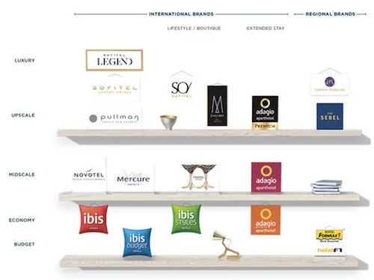Figure 3.1.

Compared with Accor International, Marriott International, the biggest organisation in the tourism industry in the world is seen as an innovative leader in luxury hospitality. The portfolio owned by Marriott is not as diverse as in Accor. The company brands are from moderate upper midscale to luxury or exquisite luxury (Figure 3.2) with no economy or budget brands.
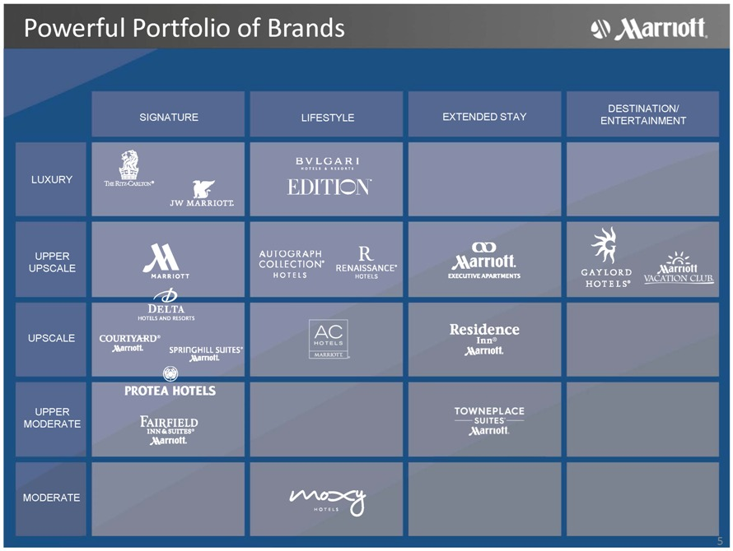
Figure 3.2.

- Growth Potential

Technology breakthroughs, productivity gains, capital investments, infrastructure upgrades, government policies that support entrepreneurship and innovation, and other factors all have an impact on economic growth (Tamplin, 2023). An organisation﮺s ability to increase profits and production in the future is defined as growth potential. By developing innovative products and services and by entering a new market an organisation can expand its growth potential. Revenue and profit are good indicators of the growth potential of a company.
Marriott had almost 8,300 properties by the end of 2022, which is around 1,000 more hotels than its hotel portfolio did before the pandemic. By adding more than 65,000 rooms on a gross basis, Marriott increased the number of rooms by 3.1 per cent in 2022 (Marriott International Annual Report, 2022, p.3). The company's continued priority is to increase the variety of travel options offered to its clients that’s why with an agreement to purchase the highly praised City Express brand portfolio, which consists of roughly 17,000 rooms in Mexico and three other Latin American nations, Marriot announced its plan to enter the popular inexpensive midscale category (Koumelis, 2023).
On the other hand, Accor International expansion is also progressing (Appendix D). The Middle East, Europe, and China all had excellent performances in 2021. With 153 new hotels signed in Europe, which represents a 20% increase over 2020, Accor's largest market over that period. With the biggest percentage growth (+39% vs. 2020), China came in second in terms of signings, while the area of India, the Middle East, Africa, and Turkey improved their strategic positions over the year (Cougot, 2022). The company added 299 hotels in 2022, totalling 43,000 rooms. This is a 3.2% annual net organic increase in the network (Nicholls,2023).
Both organisations target to increase the hotel numbers also in India which is a potential market where is a lot of space for growth because there aren't many branded hotel chains in the market and domestic leisure demand is increasing (Kulshrestha, 2016).

- Financial commitment to corporate social responsibility (CSR)

The notion that a corporation should play a positive role in the community and think about how its decisions may affect the environment and society is something very important in our days management strategies. CSR is a wide corporate idea that applies to many different companies practises it is very closely linked to sustainability and typically refers to a company's dedication to conducting business ethically by managing their commercial operations while considering the human rights, social, economic, and environmental impacts. CSR (Homer and Gill, 2022).
In the long run, it is believed that corporate social responsibility initiatives would give businesses a competitive edge, especially in a sector like the lodging industry where labour turnover and demand flexibility are prevalent. CSR initiatives have favourable implications on the performance of the business, staff attitudes and behaviours, consumer perceptions of service quality, brand image, and demand for higher compensation (Bagdadi, 2023).
With more than 5100 hotels, The Accor Hotels Group is engaged in numerous CSR activities to promote sustainable development. The Accor Group's Planet 21 Sustainable Development Programme has established a framework with seven fundamental steps, each of which is broken into three parts and incorporates the components of dialogue, local, employment, innovation, health, nature, and carbon. According to the Accor International progress report, the company removed 71,577,414 plastic products and packaging from its restrooms between January 2019 and December 2020, totalling 430 metric tonnes of plastic. (Global Tourism Plastic Initiative, 2020).
Marriott International also adopted ambitious goals for 2025 and demonstrated a strong commitment to addressing the world's environmental and social concerns throw its CSR program Serve 360: Doing Good in Every Direction” which includes four coordinates that are in line with the 2030 Sustainable Development Goals of the United Nations: ensure ethical business practises, provide opportunities for everyone, welcome everyone, and advance human rights (Ertuna and Yu,2022).

Recommendations

Accor has always been a highly acquisitive company, quickly acquiring brands and related companies. With the $2.7 billion purchase of FRHI in 2016, the business gained the Fairmont, Raffles, and Swissôtel brands, which served as the catalyst for its entry into the United States and Canada. But although Accor has a presence in the United States, notably through its luxury brands Fairmont, Sofitel, and SLS, it is negligible in comparison to the rest of the world (Eisen, 2022). It will be interesting to see that the company put aside the concerns about its downscale brands extending to the US market and try to grow more and strengthen its position in that area which has a strong economic potential.
Marriott International has also good possibilities to increase its portfolio and expand in different areas like Middle East or Africa where the company owns just 130 properties in around 20 countries. Marriott announced a expansion plan in the area with the opening of 30 more sites by end of 2024. This will consolidate its position as a hospitality leader in the African continent to (Brandler, 2022). The

Conclusions

The hotel sector is constantly growing, which requires expert financial management. Organizations can achieve amazing triumphs if they use the right concepts and put real emphasis on values. Marriott International an American organization and Accor International Group a French organization are two of the leading companies in the hospitality industry and two good examples of successful organizations with outstanding portfolios and global reach, both organizations have achieved increased revenue in recent years. Organizations' strategies for multi-branding, rebranding and asset management have helped them increase profitability and remain competitive in the industry over the years.

Reference:
Accor (2023) ﮺Our History – ﮺Reaching of the impossible﮺. Available at: hhtps://group.accor.com/en/group/who-we-are/our-history (accessed: 05.05.2023)

Accor Group (2023) Discover our brands. Available at: htt[ps://all.accor.com/brands/index.en.shtml#:~:text=Discover%20our%20brands,for%20the%20most%20unforgettable%20stays. (accessed: 05.05.2023)

Bagdadi, A. (2023) ‘Corporate social responsibility practices within the scope of sustainable tourism: A research at Accor Hotels’, Prosperitas, 10(In press), pp. 1–10. Available at: https://doi.org/10.31570/prosp_2022_0022. (accessed: 09.05.2023)

Brandler, H. (2022) Marriot to open 30 hotels across Africa by end of 2024. Business Traveller – 5th Nov. Available at: https://www.businesstraveller.com/business-travel/2022/11/05/marriott-to-open-30-hotels-across-africa-by-end-of-2024/ (accessed: 09.05.2023)

Companies Market Cap (2023) ﮺Revenue for Accor﮺. Available at: https://companiesmarketcap.com/accor/revenue/ (accessed: 06.05.2023)

Companies Market Cap (2023) ﮺Revenue for Marriott International﮺. Available at: https://companiesmarketcap.com/marriott-international/revenue/ (accessed: 06.05.2023)

Corporate Finance Institute (2023) ᾽Market Positioning﮺. 19th Apr. Available at: https:// corporatefinanceinstitute.com/resources/management/market-positioning/ (accessed: 09.05.2023)

Cougor, H. (2022)﮺ Accor confirm its growth prospects thanks to very good result in 2021﮺, Luxus Plus – 16th March. Available at: https:// luxus-plus.com/en/accor-confirms-its-growth-prospects-thanks-to-very-good-results-in-2021/ (accessed: 09.05.2023)

Eisen, D.(2022) ﮺Accor is a global hotel giant. Why isn’t its US footprint bigger and broader?﮺. Hospitality Investors, 12th June. Available at: https:/ www.hospitalityinvestor.com/brands/accor-global-hotel-giant-why-isnt-its-us-footprint-bigger-and-broader/ (accessed: 09.05.2023)

Ertuna, B., Gu, H. and Yu, L. (2022) ‘“A thread connects all beads”: Aligning global CSR strategy by hotel MNCs’, Tourism management (1982), 91, p. 104520–. Available at: https://doi.org/10.1016/j.tourman.2022.104520. (accessed: 09.05.2023)

Global Tourism Plastic Initiative (2020) Accor Progress Report business signatory accommodation provider﮺. One Planet Network. Available at: https:/www.oneplanetnetwork.org/sites/default/files/from-crm/GTPI_Report2021_ACCOR.pdf/ (accessed: 09.05.2023)

Guilding, C (2002) Financial Management for Hospitality Decision Maker. Butterworth Heinemann – Oxford, United Kingdom

Homer, S.T. and Gill, C.M.H.D. (2022) ‘How Corporate Social Responsibility Is Described in Keywords: An Analysis of 144 CSR Definitions Across Seven Decades’, Global business review, p. 97215092211011–. Available at: https://doi.org/10.1177/09721509221101141 (accessed: 06.05.2023).

Hsmay Academy (2023) ﮺Revenue﮺. Available at: https://hsmaiacademy.org/glossary/revenue/#:~:text=In%20hotels%2C%20revenue%20is%20the,sale%20of%20accommodation%20to%20guests. (accessed: 05.05.2023)

Kathakali, N. (2023) ﮺Opened China unlocks optimism for Accor﮺ Hotels Passion for Hospitality Magazine, 27th Apr. Available at: https://hotelsmag.com/news/accor-expects-double-digit-revpar-growth-target-in-2023/ (accessed: 05.05.2023)

Koumelis, K (2023) ﮺Marriott International expends into affordable midscale segment with acquisition of City express brand portfolio﮺, Travel Daily News - 5th May. Available at: https:// www.traveldailynews.com/hotels-lodging/marriott-international-expands-into-affordable-midscale-segment-with-acquisition-of-the-city-express-brand-portfolio/ (accessed: 09.05.2023)

Kulshrestha, A. (2016) ﮺International hotels set to step up in India expansion, investment﮺, The Economic Times – 19th Dec. Available at: https://economictimes.indiatimes.com/industry/services/hotels-/-restaurants/international-hotels-set-to-step-up-india-expansion-investment/articleshow/56059440.cms?from=mdr (accessed: 09.05.2023)

Marriott International (2023) ﮺We are Marriott International﮺. Available at: https://www.marriott.com/marriott/aboutmarriott.mi (accessed: 05.05.2023)

Marriott International Annual Report (2022) ﮺Global growth trends﮺. Available at: https:// marriott.gcs-web.com/static-files/b82978a6-9d28-4e38-9855-fc4ae2cebe11 (accessed:09.05.2023)

Nicholls, C. (2023) ﮺Accor continues consistent global network growth﮺ Top Hotel News - 3th March. Available at: https:// tophotel.news/accor-continues-consistent-global-network
growth/#:~:text=Accor%27s%20continual%20hotel%20expansion%20is,over%20the%2012-month%20period.(accessed: 06.05.2023)

Statistica (2023) ﮺Number of Marriott International employee number worldwide from 2016 – 2017﮺. Available at: Https://www.statista.com/statistics/297269/number-of-marriott-international-employees-worldwide/ (accessed: 05.05.2023)

Sturman, M.C. et al. (2011) The Cornell School of Hotel Administration on hospitality: cutting edge thinking and practice. Hoboken, N.J: Wileyk

Tamplin, T. (2023) ﮺Economic growth﮺, Finance strategies – 29th March. Available at: https://www.financestrategists.com/wealth-management/macroeconomics/economic-growth/ (accessed: 08.05.2023)

Zheng, C. and Forgacs, G. (2017) ‘The emerging trend of hotel total revenue management’, Journal of revenue and pricing management, 16(3), pp. 238–245. Available at: https://doi.org/10.1057/s41272-016-0057-x. (accessed: 08.05.2023)

Wang, X.L. et al. (2015) ‘Revenue Management: Progress, Challenges, and Research Prospects’, Journal of travel & tourism marketing, 32(7), pp. 797–811. Available at: https://doi.org/10.1080/10548408.2015.1063798 (accessed: 09.05.2023)

Appendix A
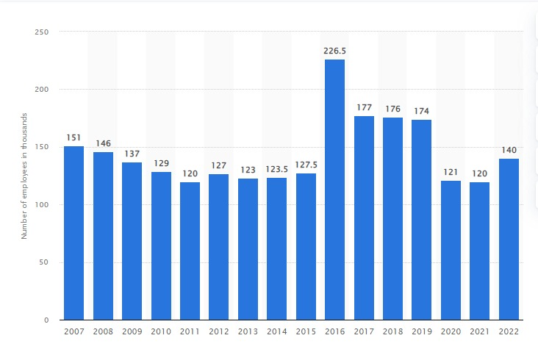
Marriott Employee Number (Statistica, 2023).

Appendix B
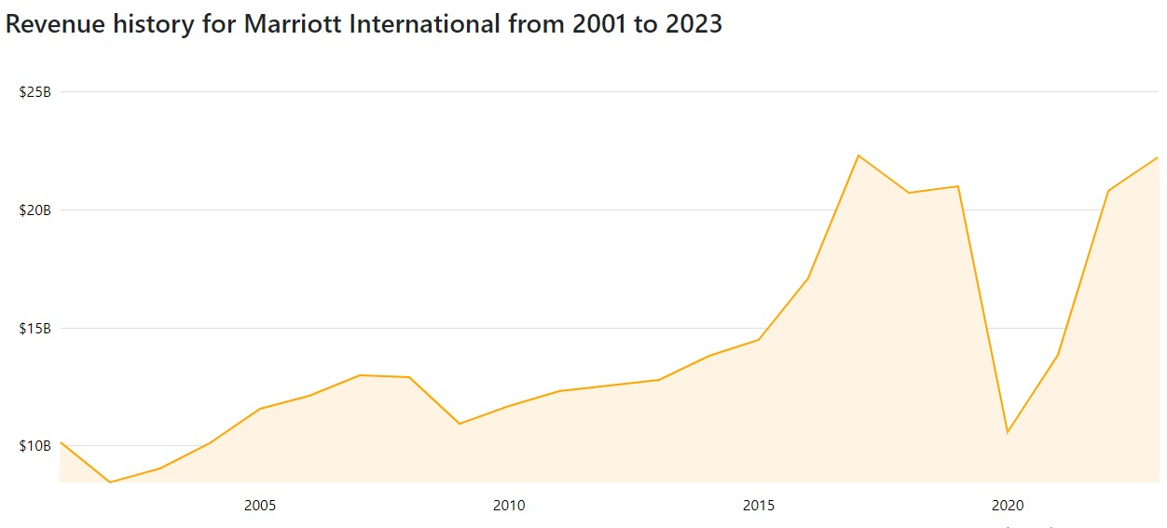
(Companies Market Cap, 2023)

Appendix C
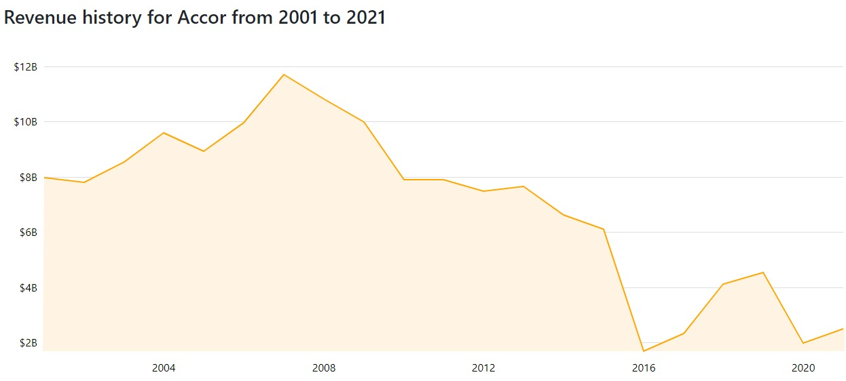
(Companies Market Cap, 2023)

Appendix D
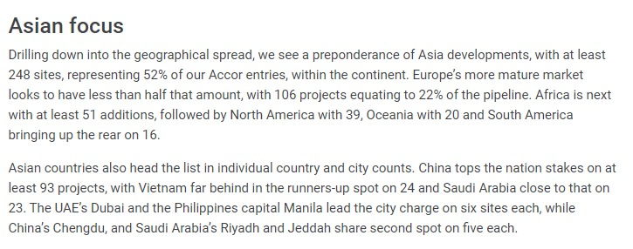
(Nicholls, 2023)

