
University of Wales Trinity Saint David
School of Engineering
22nd March 2019

Stephen Hutchings – P148299

GD&T and drafting

Abstract

A fully dimensioned and tolerance drawing of Honda CRF 450 triple clamps was produced from a 3D model using SolidWorks 2018. In order to complete this project and produce an accompanying report, individual components of the triple clamps were mated together and basic and angle dimensions were applied to all features of the part. Following this, tolerances were calculated to determine types of fit. ASME Y14.5-2009 Tolerance standards were used in the drawing as these are the standards that Solidworks 2018 conform to, they are also most commonly used in industry. As well as this, ISO standards were applied when calculating tolerances as these were simplistic to use. A hole basis system was deployed as would allow for a more simplistic manufacturing process. In addition, hole and shaft tolerances were H6/H7 meaning that a locational clearance fit needed to be utilised; this was chosen as it provided the location for stationary parts on the drawing. It was decided that stainless steel would be used for the bolts and aluminium for the triple clamp; this reason being that aluminium is commonly used for triple clamps and stainless steel is strong, these choices conformed with the compatibility of tolerances and the manufacturing processes.

Contents Page

1.0 Introduction …………………..Page 3
1.1 Aim……………………………..Page 3
2.0 Research………………………Page 3
3.0 Methodology………………….Page 6
4.0 Results and Discussion……Page 7
4.1 Limits and fits…………….….Page 7
4.2 Maximum and minimum material condition….Page 8
4.3 Materials Choice…………...Page 9
5.0 Conclusion……………….…Page 10
6.0 Reference list ……………….Page 12
7.0 Appendices………………….Page 14
7.1 Exploded view of drawing..Page 14
7.2 ISO Tolerance tables……..Page 15
7.3 ISO IT class of work………Page 18
7.4 ISO standard class of grades..Page 19

1.0 Introduction

Geometric dimensioning and tolerancing (GD & T) is a method used to express the geometry requirements of a component (Krulikowski, 2012). Thus, by communicating these design specifications during the manufacturing process it is more likely that design accuracy will be improved. GD & T relates to the size, shape and features of mechanical parts (Wilson, 2010). In addition, certain dimensioning and tolerancing standards are used to ensure consistency in design and promote the understanding of drawing specifications, these include ASME and ISO standards (Henzold, 2006). Symbols are applied during the GD & T process, the objective of these symbols is to convey the purpose of the part (Cogorno, 2011). Avoiding the use of the GD & T system could mean that tolerances are inconsistent and issues could occur during the assembly process. In support of this, Meadows (2017) states that the use of GD & T symbols and rules reduce manufacturing cost and improve the functionality of parts because dimensioning is interpreted the same by all individuals. Therefore, this suggests that GD & T improves the overall manufacturing process and enhances that quality of all designs. During this report, research on GD & T techniques and their applications will be carried out, a review of dimensioning and tolerancing standards will also be undertaken. Following this, the assembly of triple clamps for a Honda CRF 450 will be modified in accordance with calculated tolerances. A set of drawings will be created to demonstrate all the dimensions and tolerances needed to make the components of the assembly. An explanation of materials used, how the tolerances were derived and analysis of chosen tolerances will be included in this report.

1.1 Aim: The aim of this report is to produce a fully dimensioned and toleranced drawing of triple clamps (Honda CRF 450) following the analysis of tolerances required to make the part function correctly.

2.0 Research

GD & T refers to the investigation of relationships between mating parts during the design process (Krulikowski, 2012), by completing this process before the part is produced this ensures that the part is fully functional before it is manufactured. From research, it can be seen that there are many reasons as to why GD & T should be used, these include to reduce cost, improve part assembly processes and design analysis (Umaras and Tszuki, 2007; Murari et al 2010; McGee, 2012). Thus, suggesting that GD & T improves overall efficiency of design and manufacturing processes. Furthermore, it is apparent that there are many benefits of using geometric dimensioning and tolerancing. According to Krulikowski (2012) the main benefits of using GD & T includes communication improvement through uniformed drawing specifications and making tolerance analysis easier to understand. Therefore, suggesting that the whole design process is simplified. To add to this further, it has been recognised that GD & T is the only design instrument that completely accomplishes machine part geometry (Tandler, 2017). However, Tandler’s study found that several concepts and rules of GD & T were confusing. Therefore, possibly meaning that errors could be made whilst using this method. Also, a study conducted by Lemu (2014) found that several complications occur when GD & T is linked with computer aided design, they discovered that “implementing the standards in the seamless linking of CAD and manufacturing (CAD/CAM) system has not been straightforward”. Difficulties were mainly due to the frequent revision of standards. Thus, suggesting many challenges may be faced when using GD & T and CAD in collaboration. In addition, programmes such as Solidworks conform to particular standards (SolidWorks, 2018). Therefore, if an engineer wanted to use different standard to the one used in this software the process may be complicated.
As mentioned previously, there are two main types of dimensioning and tolerancing drawing standards, these being ASME and ISO, which are both used globally. However, corporate standards which conform to elements of the global standards may be published by large companies should they wish to “add on any tolerancing concepts not included in the original standards” (Krulikowski, 2012). These standards are said to be necessary in manufacturing industries because they provide a unified approach to drawings (Henzold, 2006) thus, making drawings easier to understand throughout the whole design and manufacturing process. Also, if set standards were not in place then design specifications would not be adhered to. According to ASME (2009) geometric tolerances are used to “describe the allowable variation in the parts geometry”, thus, geometric tolerances link to the design specifications and individual features of a component.
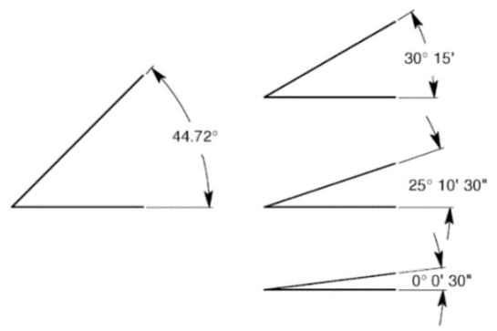
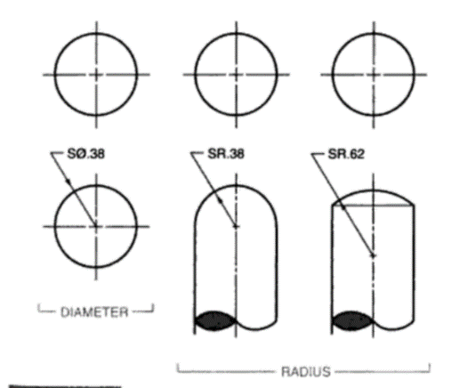
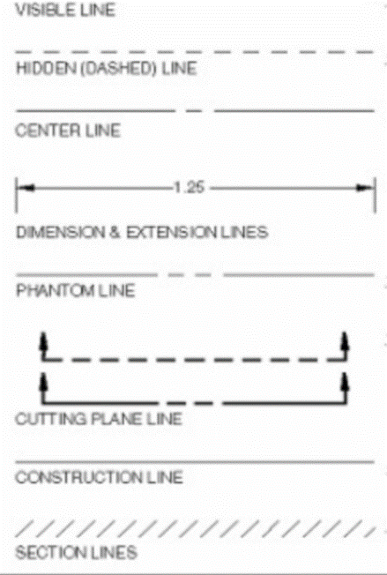
It can be established that there are several different types of dimensioning needed in technical drawing (Meadows, 2017), in addition to this, it also appears that various sectional views and lines are needed in order to provide clarity on certain features of the part (ElMaraghy, 2017). This suggests that the application of these techniques will allow for clear interpretation of the part. Angles and holes play a key role in dimensioning. According to Olivio (2004) the correct size of the angle is important as angles are used in countersunk holes and enable a flush finish to be provided when accommodating the heads of screws and rivets. Angles are shown on drawings in degrees using linear or angular dimensions (Timings, 2014). See figure 1 for illustration of angle dimensioning. Holes are dimensioned as circles and include leaders pointing towards the middle of the hole which illustrates the hole diameter (Goetsch, 2005), thus making the hole size and its properties easily readable. The method for illustrating hole diameter is shown in figure 2. There are several types of lines included in technical drawings, these include continuous narrow lines, dashed lines and dotted lines (see figure 3), the purpose of these is to display the distancing and placing of features (Madsen, 2002) therefore, these outline any features of the part and make the drawing more readable. Sectional views are also included in drawings in order to display the shape of the part (Planchard, 2014). However, it is apparent that outside sectional views are only needed for certain parts that have complex features (Oskacue , 2018). This suggest that several views are needed in order to clearly demonstrate the features of a component.
Figure 1: Angular measurement (Corgono, 2011)
Figure 2: Hole dimensioning (Goetsch, 2005)
There are three main types of tolerances used in GD and T, these are; form, orientation and location, these relate to the shape, tile and position of the tolerances (Fischer, 2011). Furthermore, these tolerances are represented by symbols during the drafting stage of design (Koura et al, 2002). Thus, possibly making drawing specifications easier to read. Additionally, the symbolic language highlights the functional requirements of a part and this is principle is uniformed using the GD and T standards. Therefore, if all the dimensions of the design drawing has tolerances and these are defined by the same set of symbols this means that the draft will be easily readable throughout the design process (see figure 4 for symbols).
Figure 3: Dimensioning lines (Madsen, 2002)
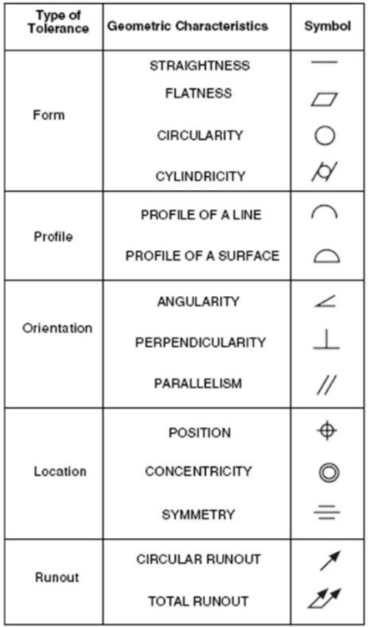
According to Simmons and McGuire (2012) the datum reference is an important feature when considering GD & T applications, datum’s relate to the dimensions of a part. Furthermore datum references refer to the characteristics of part features in particular the functions and fit (Corgono, 2011) this suggests that datum’s are associated with the mating features of a part. This implies that not all features will have datum’s as not all features are related together. Another important element to consider when discussing GD & T applications is the feature control frame (FCF), this is used to link a geometric tolerances and highlight basic dimensions, as well as providing information about material conditions (Wu, 2017). Therefore, this implies that the purpose of the feature control frame is to highlight certain conditions. This is supported by Britton(2002, pg2) who states that the main principle of the FCF is to justify “the conditions and tolerances of a geometric control on a part’s feature”. This suggests that this concept enables the correct manufacturing of parts.
Figure 4: Tolerancing symbols (Krulikowski, 2012

3.0 Methodology
Prior to the task, the standards used in the GD &T process needed to be determined. As SolidWorks software supports the ASME Y14.5-2009 standards (SolidWorks, 2018), it was decided that these standards would be used as the symbols on SolidWorks would conform to these standards. In addition, these standards provide many more features than others which include datum references and concept of feature size (Wilson, 2010). Therefore, using these standard would allow the dimensioned and toleranced drawing of the triple clamp to be more detailed and easier to interpret. Also, this standard is most commonly used currently in industry (Kumar, 2018). However, the limits and fits table and IT class used conformed to ISO standards, therefore, drafting has a mixed standards approach.
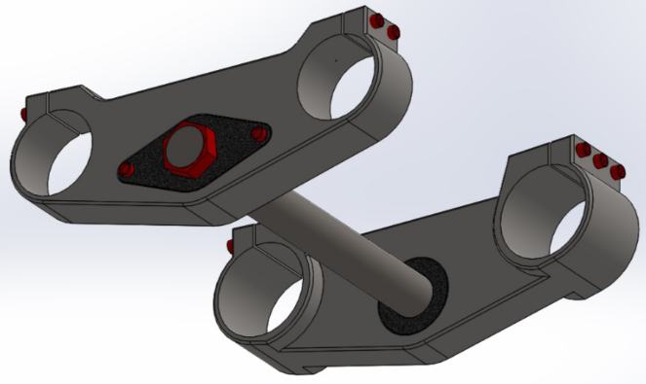
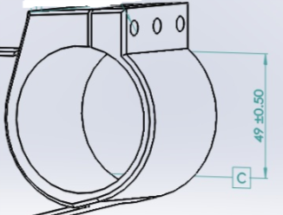
In order to produce a fully dimensioned and toleranced drawing of the triple clamps the assembly model files were downloaded and opened with SolidWorks assembly. These parts included top and bottom yoke, stem, upper and bottom insert and a full assembly image of the bike. After this, all parts were imported and mated. Firstly, the top yoke was mated to the upper insert by using a concentric mate, this type of mate is used to mate two concentric features and aligns the central axis of each component together (Tickoo, 2013). The outer of the insert was mated to the inside face of the top yoke centre hole. The bolt hole of insert was then selected and was concentric mated to the upper yoke bolt hole. The two faces were then mated together. This step was repeated with the bottom insert and bottom york. A concentric mate was also used on the outer face of the stem and the inner face of the bottom insert. The lower face of the stem head and top face on bottom insert were mated together using the same process, as was the upper insert face and the outer face of the stem. Following this a parallel mate was used on the lower and upper york; a parallel mate is used to keep two components away from each other at a constant distance (Tran, 2016), thus this was necessary to ensure the part functioned properly (see figure 5 for fully assembled part).. Basic dimensions and angle dimensions of all features were applied to the 3D model, this was done by selecting smart dimension in sketch on SolidWorks. As dimensioning on SolidWorks is linked directly with the 3D model of the triple clamps the drawings will reflect the 3D model (SolidWorks, 2018) See figure 6 for example of an added dimension. Following this, three datum points were chosen, these being primary, secondary and tertiary. The datum points should be relevant to points of contact; the primary should have 3 contact points, secondary should have 2 and tertiary should have one (Wu, 2017). See figure 7 for illustration of datums. The datum reference is an significant part of the datum reference frame so it was important that these were chosen correctly.
Figure 5: Full assembly of triple clamps and bolts
Figure 6: Added dimension example
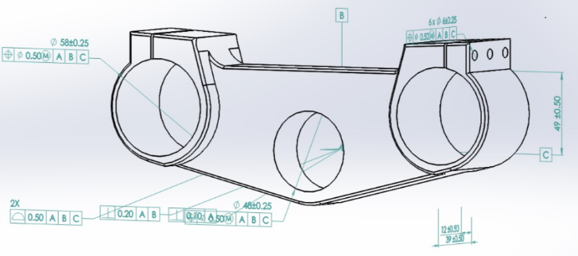
After this, the tolerances were calculated and limits and fits were determined; a detailed analysis of this will be provided in the results section. 10 bolts for the yokes, 2 bolts for upper insert, 2 bolts for lower insert and one nut for the stem was created and mated with screw mating. Before bolts were created the evaluate button was used on SolidWorks to determine the depth of the hole, measurements of bolts and nut can be found can be seen on the SolidWorks drawing, this linked with the calculation of tolerances. An exploded view of the part is included in appendix A to highlight the positioning of the bolts. The materials of the triple clamp and bolts were then chosen. After this a bill of materials was created, this was created by using the bill of materials tab on SolidWorks. this will be explained in more detail in the results section; the next section will provide an analysis of the model and types of tolerances derived at.
Figure 7: Illustration of datums

4.0 Results and discussion
4.1 Limits and fits
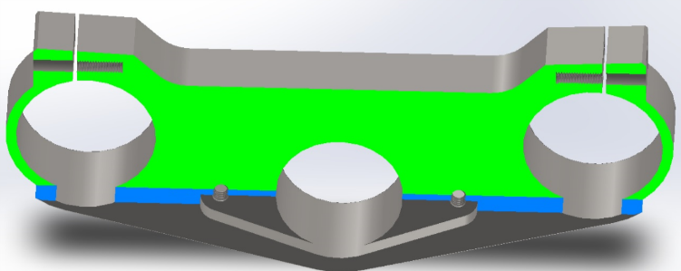
After all dimensions were inserted into the 3D model, the model was made into a 2D drawing in order for tolerancing to be applied. Bolts were also created as these were needed to calculate the diameter of the shaft, this was needed for clearance calculations (Singh, 2011). Limit tolerancing was used on the holes of the triple clamps and this is when the high and low limits are stated in a dimension (Corgono, 2011). This was applied to determine the hole’s size and feature. To work out the hole tolerances the nominal size of the holes were taken from the drawing, the nominal size is defined by the size of which the hole is already known (Krulikowski, 2012), this was already available on the 3D model, bolt hole sizes were 6mm and the stem hole size was 25.900mm (see figure 8 for sectional view of bolts). Following this, the basic size of the hole needed to be calculated by converting the hole size into mm (Olivio, 2004). However, as the nominal hole sizes were already worked out using mm this did not need to be calculated. After this, the limits of size needed to be obtained for each hole. Fischer (2011, pg 412) states that the “limits of size are defined by the combination of the basic size and specified tolerance class”. The tolerance classes were taken from a bearings website as the limits and fits table was simplistic to use, it is important to note that micrometres are used in this table (see appendix B for tolerance tables). This table was utilised to determine the upper and lower limits of size and the difference between the two was calculate for each hole and shaft. A locational clearance fit was chosen, reasons for choice will be analysed during this section. An example of this for a hole on the drawing is provided below:
Figure 8: Sectional view of bolts
Hole diameter: 6mm
Upper limit (+12) = 6.00mm + 0.012mm = 6.012mm
Lower limit (- 0) = 6.00mm + 0.00mm = 6.00mm
Shaft diameter: 6mm
Upper limit (-0) = 6.00mm – 0.00mm = 6.00mm
Lower limit (-0.08) = 6.00mm – 0.008mm = 5.992mm
The tolerance for the shaft and hole were calculated by subtracting the upper limit from the lower limit. An example from the drawing is provided below. All hole tolerances were between h7 and shaft tolerances were H6. According to Bhandri (2010), this type of tolerance is very common to use and it provides a fit that is tight, the example below demonstrates that the tolerance is tight as the deviation between the upper and lower limit is relatively small.
Hole tolerance = 6.01 mm – 6.00mm = 0.01mm
Shaft tolerance = 6.00 – 5.99mm = 0.01mm

4.2 Maximum and minimum metal condition
The maximum is the calculation between the largest hole and the smallest shaft and the minimum clearance is worked out by subtracting the largest shaft from the smallest hole (Jack, 2013). See an example of this calculation below:
Maximum clearance: 6.01mm – 5.99mm = 0.02mm
Minimum clearance: 6.00mm – 6.00mm = 0.00mm
However, it has been established that the minimum clearance may be more important than maximum clearance as this clearance is used to work out a correctly functioning tightest fit (Corgono, 2011). The minimum metal condition was also linked to the classes of fit; minimum metal condition gives a clearance fit whereas maximum metal condition gives interference fit (Timings, 2014). On the drawing of the triple clamps a clearance fit was used on all holes, these holes all had a diameter of 6mm. It is also important to note that the hole used were a constant size because it was easier to redesign the shaft than redesign the triple clamps. This is known as a hole basis system (Bawa, 2004). In addition this type of system is most commonly used in industry as several standard hole sizes are used during the manufacturing process when drilling holes (Babu and Sindra, 2010). Therefore, this would make the manufacturing process a more simplistic one. In addition, using a clearance fit allowed the upper limit and lower limit to be rounded and this would be more cost effective in the manufacturing process(Timings, 2014). The type of clearance fit chosen was a locational clearance fit as it matched up with h6/h7 hole and shaft basis (See figure 8 for table of fits). This fit was chosen as it provides the location for the parts that are stationary, this is relevant to the shaft and holes included on the drawing (Madsen, 2002).

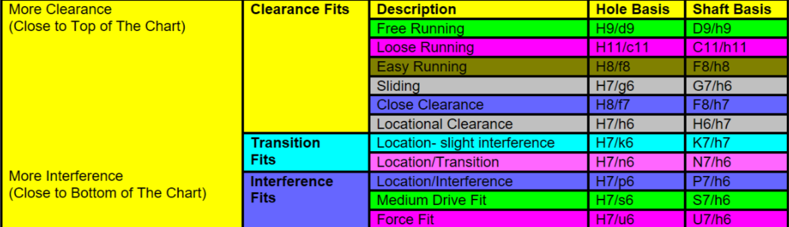
Figure 8: hole and shaft basis and fits (Coban Engineering, 2012)
Following the calculations of all tolerances, datum reference frames were added to the drawing in order to illustrate the functional requirements of each part (Wu, 2017). This provided a clearer definition of the drawing and increased the reliability of results (see figure 9 for datum reference frame taken from the drawing).

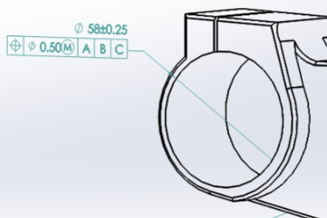
4.3 Materials choice
The materials chosen to use on the bolts were stainless steel and aluminium for the triple clamps. This was influenced by compatibility of tolerances and the manufacturing process; this was worked out using the ISO class of work chart (see appendix C) As the shaft had a diameter of 6.00mm and a tolerance of 0.01mm it was worked out that the standard tolerance grade between IT6 and IT7 would be used (See Appendix C for chart). The manufacturing processes best suited include superfinishing, cylindrical gliding, diamond turning, plan grinding, broaching, reaming, boring and turning. Therefore, these processes would provide appropriate accuracy (Timings, 2014). It was also established that 316 stainless steel is most commonly used for bolts and fasteners in manufacturing (Barker, 2017). It is apparent that stainless steel has high strength and does not corrode easily (Barret, 2012), therefore, this would be the ideal material to use on the component. Aluminium was chosen for the triple clamp as many triple clamps manufacturers prefer the choice of aluminium because it is lightweight (Hibbeler, 2016). In addition, aluminium does not corrode easily (Dwight, 2002) and therefore should provide a long life time to the parts.
Figure 9: Datum reference frame
Following this, a bill of materials was created using Solidworks, this provided information on all of the parts required to assemble the triple clamp. According to Solidworks (2018) a BOM informs the manufacturers of all components that need to be purchased prior to assemble. Therefore, a BOM could improve efficiency during the manufacturing process. However, Anbuvelan (2005) notes that a BOM does not inform the manufacturer of the process used to make the components. Thus, it is imperative that the notes on the drawing are accurate to make this process easier. Another way that this could be improved is by providing routing information (Swift and Booker, 2013).

5.0 Conclusion
From producing a fully dimensioned and toleranced drawing of a 3D model it was discovered that tolerances are important to the correct functioning of a part. In addition, it was determined that limit tolerancing allows hole features such as size and position to be defined; this also ensures that parts will be produced correctly. It was also found that GD & T standards ensure a uniformed approach to drawings. However, as Solidworks 2018 conforms with ASME standards and ISO standards were also used in the drawing this could have affected the reliability of the drawing; nevertheless, it was determined that this was acceptable practice as some companies use mixed standards. Following an analysis of tolerance decisions made in the drawing, it was realised that many of the decisions conformed to those made in industry; a hole basis system used was most common in manufacturing and a locational clearance fit was commonly used to determine the location of statutory parts. It was also discovered that shaft tolerances influence the manufacturing process. Overall, it has been established in this report that GD & T improves accuracy during the manufacturing process and the precision of parts.

Link for file on one drive:
https://uowtsd-my.sharepoint.com/:f:/g/personal/shutchings_148299_student_uwtsd_ac_uk/EuSraiS2dA9Htv32TxQ1S5oBGeAP1XSeKKTHIMj9m1Wnnw?e=9XbiXh

6.0 Reference list
Babu, L. and Sindra K. (2010) Design of machine elements. London: McGraw Hill
Barker, B. (2017) Codes and Standards. China: Cool Spinning Press
Barret, R. (2012) Fastener design manual. London: Createspace.
Bawa, H. (2004) Manufactuing Processes. London: McGraw Hill
Bhandri, V. (2010) Design of machine elements. London: McGraw Hill
Bramble. K (2007) Geometric Boundaries: The Engineers Edge. London: McGraw Hill
Britton, A. (2002) Geometric Dimensioning and Tolerancing. (online) available from: https://synthetica.eng.uci.edu/mechanicaldesign101/GDandT.pdf [last accessed 26/02/2019]
Coban Engineering (2011) ISO Hole and Shaft Basis Limits. (online) available at: https://www.cobanengineering.com/Tolerances/ISOHoleandShaftBAsisLimitsAndFits.asp [last accessed 15/03/2019]
Cogorno, G. (2011) Geometric dimensions and tolerancing: For mechanical design. USA: Cogorno LTD
Dwight, J. (2002) Aluminium design and construction. London: Routledge
ElMaraghy, H. (2017) Geometric design tolerancing: Theories and Applications. London: Springer Science
Henzold, G. (2006) Geometrical Dimensioning and Tolerancing for Design, Manufacturing and Inspection: A Handbook for Geometrical Product Specification using ISO and ASME standards.
Hibeler, R. (2016) Mechanics of materials. London: Pearson education
Jack, H. (2013) Engineering design, planning and management. Oxford: Elsevier
Krulikowski, A. (2012) Fundamentals of geometric dimensioning and tolerancing (3rd eds). Clifton Park: Delmar
Koura, M., Elewa, I., Gadh, P. and Prabhu, M. (2002) Feature based geometric dimension and tolerance modelling system. University International Conference on Mechanical Engineering. Advanced Technology for Industry Production. December 24-26 (2002)
Lemu. H. (2014) Current status and challenges of using geometric tolerance information in intelligent manufacturing systems. Advances in Manufacturing. Vol 2(1). PP13-21
Madsen, D. (2002) Engineering Drawing and Design. Albany: Delmar
McGee, W. (2012) The Accuracy of CAD/CAM Parts - A Critical Analysis. SAE Technical Paper 2012-01-0557.
Meadows, J. (2017) Geometric Dimensioning and Tolerancing: Applications and Techniques for Use in Design: Manufacturing, and Inspection. London: Routledge
Murari, T., Ungaretti, P., Silva, D., Nascimento, F (2018) Challenges to develop a robust dimensional tolerancing management process in the automotive industry. SAE Technical Paper 2018-36-0158,
Olivio, T. (2004) Basic Blueprint and Sketching. Clifton Park: Thompson Learning
Oskacue, E. (2018) Introductory Engineering Graphics. New York: Momentum Press
Planchard, D. (2014) Drawing and Detailing with SolidWorks 2014. Mission: SDC Publications
Solidworks (2018) BOM (online) available from: http://help.solidworks.com/2018/english/SolidWorks/sldworks/c_Bill_of_Materials1.htm [last accessed 18/03/2019]
Simmons, C. and McGuire, D. (2012) Manual of Engineering Drawings. Oxford: Elsevier
Simply Bearings (No, date) ISO tolerance fits (online) available from: https://simplybearings.co.uk/shop/Info-Pages-ISO-Limits/c4746_4779.php/index.html?page=1 [last accessed 20/03/2019]
Singh, R. (2011) Machine Drawings. London: McGraw Hill Publishing
Swift, K. and Booker, J. (2013) Manufacturing process selection handbook. Oxford: Elsevier
Tandler, B. (2017) Empowering GD and T. Quality magazine june 2017
Timings, R. (2014) Basic Engineering Technology. Cornwall: Butterworth-Heinnmann
Tickoo, S. (2013) SolidWorks 2013 for Designers. Indiana: CADCIM Technologies
Tran, P. (2016) Solidworks 2017: Basic Tools. Mission: SDC Publications
Tubing China (No date) ISO Tolerance chart. (online) available from: https://tubingchina.com/ISO-Tolerance-Chart.htm [last accessed 20/03/2019
Umaras, E. and de Sales Guerra Tsuzuki, M. (2007) Design Considerations on Optimum Application of Geometric Dimensioning and Tolerancing. SAE Technical Paper 2007-01-2594
Wilson, B. (2010) GD and T: Application and interpretation. Tinley Park: Good Heart Wilcox Company. London: Elsevier
Wu, Y. (2017) The composition principle of the datum reference frame. Procedia CIRP. Vol 43. PP 226-331

7.0 Appendices

7.1 Appendix A – Exploded view of part

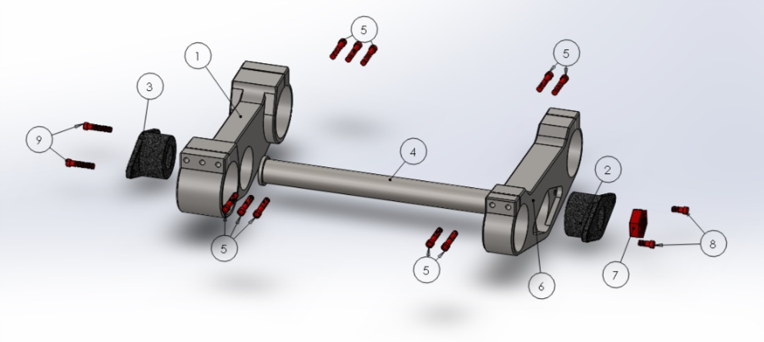

7.2 Appendix B – Tolerance table –hole (Simply Bearings, no date)
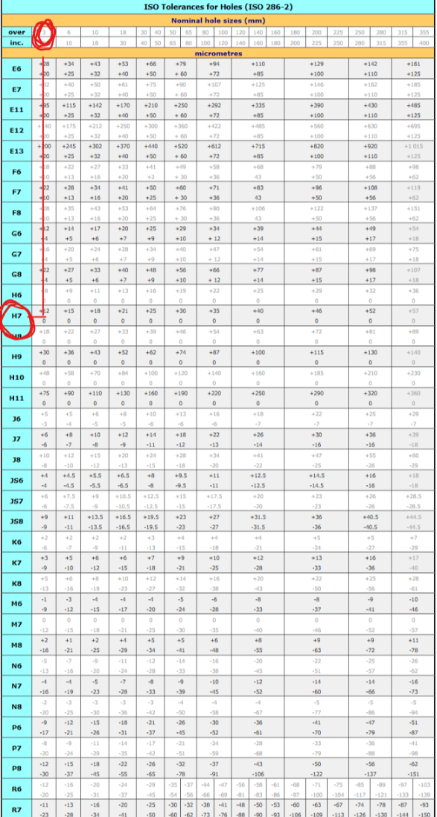
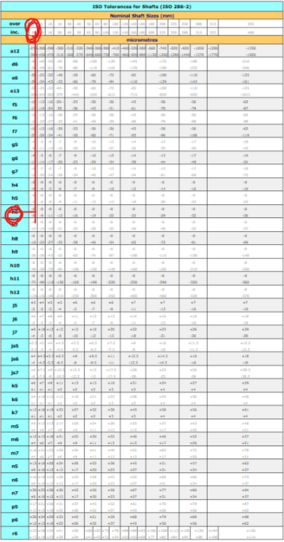
ISO Shaft tolerances (Simply bearings, no date)

Clearance descriptions (Simply Bearings, no date)

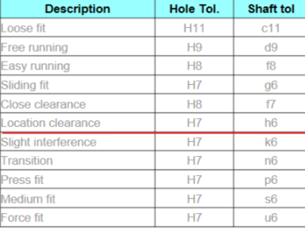

Appendix C- ISO tolerance class of work (IT class) – Tubing China (No date)

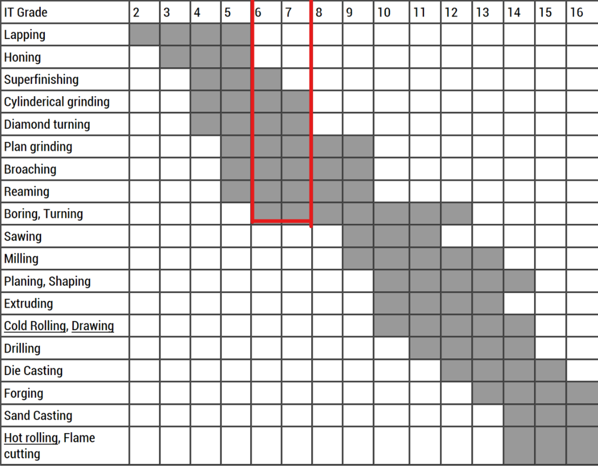

Appendix D – ISO tolerances class of work (Engineerings Edge, no date)



