Cameron Rees

Database Design (The Book Store)

Table of Contents
Introduction 2
The Database 2
ERD 2
User Guide for Microsoft Access 3

Introduction
In this essay I will be talking about how I designed and developed a database for a bookstore and how it works with Microsoft Access. The tables I have used was Customer, Books, Publisher, Purchase and I used varchar no most of the fields/tables and I used integer on the quantity of the purchase and I chose to do the date as date because I just thought that would make sense.

The Database
I made a database suitable for a bookstore and I did this by making the titles and the columns in each table revenant to the bookstore for example I had book id so every book has a three digit id and book title so you know what book it was and I thought having book id would be a faster way to search and find the information you need to know about the book you are looking for. I also had the customers information so you can look at any customer that bought a book form the store and every customer has a unique id that is also three digits and when you search the three digits then the customer information will appear. If I had to improve the database, I made I would have a supplier and a stock level so you could have the supplier information and you could see the stock level on a book.

ERD
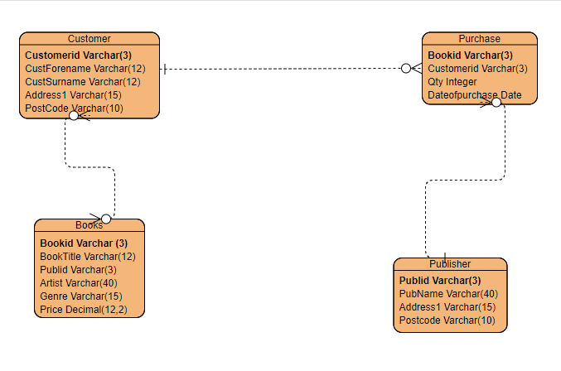
this is my ERD and I have chosen to have the CustomerID, BookId and the Publid as primary keys

User Guide for Microsoft Access
This is my user guide for my database in Microsoft Office
First, I connected my SQL database to a database in Microsoft access so I could make the database on access and when you load up the database the switchboard will appear with three buttons, one button to open the Books form another to open customer report and one to close the application. When you open the books form you can click the next and previous buttons to look at all the forms and when you look open the customer form there will be all the customers information.



