

Knowledge of, and attitudes towards traditional and non-traditional treatments for anxiety and depression.

Dissertation in Psychology
P150743
21/04/2020
University of Wales Trinity St David

Dissertation in partial fulfilment of the requirements for the degree of Bachelor of Arts (hons) in Counselling Studies and Psychology

DECLARATION
This work has not previously been accepted in substance for any degrees and is not being concurrently submitted in candidature for any degrees.
Signed D.Schell………………………………………………………………. (candidate)
Date 21/04/2020………………………………………………………………….

This dissertation is being submitted in partial fulfilment of the requirements for the degree of Bachelor of Arts (hons) in Counselling Studies and Psychology …………………………………………………………………………………… (insert degree title)
Signed D.Schell………………………………………………………………. (candidate)
Date 21/04/2020………………………………………………………………….

This dissertation is the result of my own independent work/investigation, except where otherwise stated. Other sources are acknowledged by giving explicit references. A reference list is appended.
Signed D.Schell………………………………………………………………. (candidate)
Date 21/04/2020………………………………………………………………….

I hereby give consent for my dissertation, if accepted, to be available for photocopying and for inter-library loan, and for the title and summary to be made available to outside organisations.
Signed D.Schell………………………………………………………………. (candidate)
Date 21/04/2020………………………………………………………………….

Acknowledgments

After several months of hard work and dedication, leading to the completion of this dissertation, I deem it necessary to show my respect and apparition to all of those who have given me their 100% support. The first of these being the Psychology & Counselling team. With their combined experience and support, I have been able to progress in an effective and successful manor over my three years at the University of Wales Trinity St David.

My dissertation supervisor, I would like to thank you for all of the support and hard work you have shown me. I have felt a significant improvement in my confidence, motivation and overall working skills. I would also like to show my appreciation for the outstanding level of feedback I received throughout the course of completing this dissertation.

Finally, I would like to take this opportunity to express my appreciation to my peers. It has been a pleasure to share this experience with you all. This has been an incredible journey and one I am sure neither of us will ever forget. I would also like to say a massive thank you to my family who have supported my on a daily basis, reassuring me that I am capable of achieving my goals.

Table of Contents
Declaration………………………………………………………..1
Acknowledgements……………………………………………….2
Abstract…………………………………………………………...4
Chapter 1 - Literature review…………………………………….5
Chapter 2 – Method……………………………………………...19
2a – Participants………………………………………….19
2b – Design……………………………………………..19-21
2c – Materials…………………………………………...22
Chapter 2b – Procedure………………………………………….23
2d – Pilot Study…………………………………………..23
2e - Ethical considerations………………………………23-25
2f - Study Procedure……………………………………..25-26
Chapter 3 – Results………………………………………………27
3a - Attitudes Questionnaire Results……………………..27
3b - Knowledge Questionnaire Results…………………..28
3c – Therapy & Medication Data………………...............29
3d – SPSS Data (Mean Score)……………………………30
3e – Inferential Statistics…………………………………31
Chapter 4 – Discussion……………………………………………32-37
Chapter 5 – Reference List & Appendices.………………………..38-90

Abstract
The objective of this study was to explore the correlation between the participants attitudes and knowledge in relation the traditional , (medication) and non-traditional, (therapeutic) treatment methods for depression and anxiety, with the main sources being antidepressant medication for the medical form of treatment and controlled behavioural therapy (CBT) for the therapeutic form of treatment. This study was quantitative by design and was aided by two questionnaires that attempted to explore whether there was a correlation between the level of undergraduate students knowledge of both medical and therapeutic treatments for depression and anxiety and their attitudes towards each type of treatment for these illnesses. The study included 30 participants, comprising of 22 males and 8 females. The study consists of two Likert-scale questionnaires, the first of these questionnaires was measured by the ‘Correlation between drug treatment adherence and lithium treatment attitudes and knowledge by bipolar patients’, (Rosa et al., 2007) and the second questionnaire was measured by the ‘Barriers to treatment seeking for anxiety disorders: initial data on the role of mental health literacy’, (Coles & Coleman, 2010). The first questionnaire attempted to identify each of the participants attitudes towards medical and therapeutic treatments for anxiety and depression. The second of questionnaires then attempted to identify each of the participants knowledge towards medical and therapeutic treatments for anxiety and depression. The results for each of the participants was divided into two sections which were labelled as a ‘low knowledge group’ and a ‘high knowledge group’. Each of these groups had been determined by calculating a median score of the results the participants scored within knowledge questionnaire, (M= 10.6). It had been hypothesised that traditional medication was the most common theme and there would be a significant correlation between the attitudes of and knowledge towards traditional (medical) and non-traditional (therapeutic) forms of treatment for anxiety and depression.
Chapter 1 - Literature Review
According to Haslam et al (2004), the prevalence of anxiety and depression has significantly increased in recent years, resulting in a major increase in the use of the relevant medication. This statement was supported by Nicos Middleton et al (2001) who published his own work regarding the trends in antidepressant prescribing in the UK during 1975 to 1988. In addition to this, Middleton (2001) claimed that the amount of prescribed medication increased to 23.4 million in just one year, (Middleton et al, 2001 pp 262-267). Furthermore, this is a clear indication that suggests to us that the use and need for prescribed medication for treating anxiety and depression has risen over previous years and may continue to do so. In support of this, a survey was conducted by McManus et al (2016) which attempted to explore how many individuals suffer from different mental health problems. The results of this survey suggested that during this time period, 1 in 6 individuals had reported experiencing symptoms of anxiety and depression each week, (McManus et al, 2016).
Koen Demyttenaere, (2001) argues that the poor conformity with medication such as antidepressants is a major widely spread concern, equally as much with the newly improved antidepressants available, (Koen Demyttenaere, 2001 pp 21-35). This may become a severe consequence to the individuals who are taking these antidepressants and are still committing to their daily workplace life. Despite evidence suggesting that psychotropic medicines such as antidepressants effecting an individual’s in ways such as their memory, alertness, motor coordination and problem solving, it is yet to be clear how these effects may have a negative impact on an individual’s workplace performance, which is in accordance with (Potter, 1990 pp 355-361). However, despite this, it is clear to understand as to why anxiety and depression can impair their workplace performance.
Anxiety is considered to be where the individual shows signs of worry, poor concentration, fatigue, lack of sleep and irritability, whereas depression is considered to be where the individual shows signs of low mood, poor decision making and poor thought processing. Furthermore, according to Ladder et al (1994), both anxiety and depression do often co-exist with each other, and each of the effects included within both can have an impact on an individual’s workplace environment, (Ladder, 1994 pp 321-324).
According to Stahl (1990), the advancements made in the medication used to treat individuals with anxiety and depression in the past decade, (Stahl, 1990 pp 213-214). Stahl 1990 also believed that there are still a significant number of patients who are responding to their medication but may be continuously treated in an insufficient manner. This suggests that despite Stahl firmly implying that antidepressants continuing to advance and are effective among patients, the medical professionals supplying the medication are possibly relying far too much on the medication alone to allow a full recovery for the patient. In other words, medical professionals should aim to recover the patient of all their symptoms in order for them to have complete recovery process. In addition to this, the medical professionals prescribing the medication may not be treating the patients as assertively as they perhaps should. Furthermore, a potential result of this may be that the patient suffers a relapse, due to the medical professional not fully understanding whether the patient had made a complete recovery. A relevant example to support this claim may come from Keller et al (1992) who previously suggested that individuals with mental illnesses such as schizophrenia and Alzheimer’s are only able to alleviate their symptoms not completely recover from them, whereas it is possible for individuals with anxiety and/or depression to achieve a complete recovery. (Keller et al, 1992 pp 809-816).

Despite this claim that patients suffering from anxiety and depression may face severe consequences due the medical professionals possible lack of awareness and understanding shown towards them. There is a suggestion that there may be a lack of adherence displayed by the patients towards their medication. According to Julius et al (2009), adherence can be best defined as the degree to which the patient’s behavioural traits can connect with the advice given to them by a medical professional. In this instance, adherence is the preferred term rather than ‘compliance’ for example, which is due to that term portraying a negative meaning and possibly suggesting the full blame of not adhering is being directed at the patient, (Julius et al, 2009 pp 33-44). Furthermore, according to Gabriel & Violato (2010), a lack of adherence could be as a result of forgetfulness, carelessness, stopping the treatment when the patient begins to feel worse and stopping the treatment when they begin to feel better, (Gabriel & Violato, 2010 pp 388-394). As previously mentioned, if these actions do take place, the patient may still also be at risk of a potential relapse.
The impact that the professional relationship a doctor and patient share can have a significant bearing on the patient’s future health and well-being, it can be equally negative or positive depending the effectiveness of the relationship between the doctor and patient. In 2011, a qualitative design-based study was conducted by Modig et al 2012 which attempted to explore the experiences that elderly individuals have based on the information they receive regarding prescription medication from medical professionals (Modig et al, 2012). Some may consider the elderly to have a limited level of knowledge regarding their personal medication which may be caused by either a lack information provided by the medical professional or as previously mentioned, a poor level of adherence. According to (Hovstadius et al 2008), this is a major concern especially as many elderly individuals often receive daily intakes of a number of different medications. It has been made clear from a governmental basis that patients of all ages are to receive the appropriate and correct amount of information on their specific medication, allowing them to have the ability to manage it correctly, this is supported by (Patients Safety Act, 2010). Furthermore, a lack of the appropriate information provided to the patients may result in them having insufficient medical knowledge to facilitate their daily needs which could in turn lead to poor adherence.
With regards to cases where individuals have shown high levels of adherence to their medication, a study had previously been conducted by Razali et al (2014), which was based on the topic of schizophrenia. This study has much relevance to the researchers work, including a number of features that can contribute to the researcher’s literature and study. This study attempted to compare medication adherence between both outpatients and individuals who were faced with relapse circumstances. There were 35 of each participant group and according to the source, the researches utilised a medication adherence rating scale and identified each of the participants ratings by using the appropriate tools to assess their social support, insight and their mental illness, which in this instance would be schizophrenia. The results of the study suggested that medication adherence among outpatients was far greater than those of relapse cases, which suggests in this circumstance that individuals who do adhere to the professional medical advice they receive can display a major positive impact on their own schizophrenia, (Razali et al, 2014). In addition to this, the information can also be applied effectively towards an individual suffering from a number of various mental illness, such as anxiety and depression. Furthermore, it seems fairly evident that by adhering to your medication you have a significantly better chance of relieving yourself of your symptoms. However, there are a number of elements to also consider from this study. By delving deeper into the study, it may be clear to some to notice some obvious limitations of its accuracy such as the overwhelming differences between the two groups of participants. The outpatients for example, whom all of which will have already received some form of support may have only recently displayed their symptoms whereas the participants in the relapse group may potentially be in a more advanced state of schizophrenia. In a different context, if an outpatient was suffering from a fairly high level of schizophrenia equally as much as the relapse patient, they may still be at an advantage in some ways as they may be more receptive all forms of medication and advice offered to aid them, whereas the relapse patient may become much more sceptical of any treatment due to their past experiences.
Moving on from these points, the main focus of the forms of medication available to treat anxiety and depression is based on their overall effectiveness. Antidepressants may be seen as a clear and accessible form of medication available to the public via a prescription for the effective treatment of anxiety and depression and can play a critical role in the long-term management of symptoms. The aim of antidepressants is to relieve the current symptoms the patient has encountered and prevent them from ever returning. This claim is fully supported by the NHS who have stated themselves that antidepressants are in fact a form of medication used to treat anxiety and depression, among a number of other conditions, (NHS, 2020). The opinions others may have about antidepressants can vary greatly based on their effectiveness. Some believe antidepressants have a critical role in relieving the relevant symptoms of anxiety and depression. Some other individuals may display a significant amount of doubt and scepticism that they help as effectively as other forms of treatment. However, what is relevant for many other forms of medication as well as antidepressants is the fact that they may help a certain individual in certain situations, but perhaps not all of them.
In terms of the statistical information regarding the effectiveness of the medical professionals prescribing the antidepressants, an analysis conducted between 2001 to 2003 by Stettin et al (2006) in north-eastern US examined over 85,000 patients who had been prescribed the medication. The study discovered that the number of visits from outpatients 12 weeks prior to their first initial visit was 4.45%. However, the analysis also indicated that only 0.97% of the patients were specifically seen by a mental health professional, (Stettin et al, 2006 pp 453-463). It seems clear to suggest that the first percentage indicating that a high number of individuals may have felt an improvement with their symptoms and therefore deemed it unnecessary to return for further treatment. However, following the second percentage from the analysis, with such a small number of patients being seen by mental health professionals it may possibly suggest that the patients may have received a lack of specialist information and been possibly misdiagnosed. Furthermore, this may result in as mentioned previously a potential relapse for the patient, meaning that their medical treatment would have been ineffective and only exacerbated their situation.
With regards to the effectiveness of the antidepressants themselves there have been a number of studies which have previously attempted to explore the effectiveness of antidepressants. According to McCormack (2018), a specific analysis by Cipriani et al (2018) has provided a well-balanced summary with regards to high number of tests of 21 different forms of antidepressants in over 100,000 participants, (McCormack, 2018). After a long period of testing, the results of this study indicated that each of the forms of antidepressants used in the study were effective in the treatment process. In addition, the researchers listed each of the forms of medication and stated the effectiveness of each based on the fewer number of individuals abandoning their antidepressant, such as fluoxetine in this instance, (Cipriani et al, 2018 pp 420-429). The researcher’s results suggested that each of the antidepressants included can have a positive impact on an individual, it all very much depends on the individual themselves and how they react to their medication. Furthermore, as the study is exploring the efficiency of antidepressants among severely depressed adults, some may believe that each participant would react identically to one another with each of the antidepressants possibly due to their rate of depression being considered as severe. However, according to Cohn 1990, there are a number of elements to consider whilst prescribing an individual antidepressants and it is of the utmost importance in choosing the correct one as they all can differ in their ability to relieve an individual of their symptoms, (Cohn, 1990 pp 88-102). In some ways only testing these antidepressants on severely depressed participants may leave them with a limitation as perhaps the results of each antidepressant may have had a different outcome if tested on all stages of depression. In addition, many of the forms of antidepressants used would very unlikely be offered to an individual with a moderate case of depression, therefore this study is proven to highly relevant.
Some may believe that therapies are also a useful and effective form of treatment for anxiety and depression, often deemed as life changing experiences. Cognitive behavioural therapy, also known as CBT, is a common and well-grounded form of treatment used for anxiety and depression. According to Clak & Beck 1999, CBT has grown in status significantly over the past three decades and was developed upon by psychologist Aaron Beck. In addition to this there are a number of suggestions as to why psychotherapy alone is a much more effective form of treatment than antidepressants. Before exploring these suggestion’s it is important to note that this book states that depression rates are not decreasing and have never once began to do so, (Beck et al, 1996 pp 490-498).
This is an eye-catching statement and offers the reader a sense of urgency and suggests that despite the widespread use and variety of antidepressants available to an individual there is still no indication of an overall improvement. Therefore, this may be implying that something needs to change. One of these many suggestions are concluding that not all individuals will respond positively to their antidepressants, also claiming that based on previous literature regarding controlled based studies on chemotherapy that only a maximum of 65% of patients respond positively to their antidepressants, (Beck et al, 1996 pp 490-498). In other words, the book is implying that as a result of this, further measures must be put in place, such as alternative methods including CBT.
CBT can be best defined as a directive and time-limited structured method that can be utilised to treat a number of mental disorders including depression and anxiety. It is based on the rationale that an individual’s behaviour is highly determined by the ways in which they structure the world, more specifically the environment around them, (Beck et al, 1996 pp 490-498). In terms of the advancements in CBT, there are now a number of computerised advanced systems according to Foroushani et al, (2011) that are available for individuals. This form of therapy may divide opinions among many, which has been considered and researched previously, (Foroushani et al, 2011). With much relevance, research had been conducted regarding the attitudes towards advanced computerised CBT for anxiety and depression among university students, 122 to be precise, which is in accordance with Mitchell & Gordon (2007). The researchers claimed that a number of studies based on computerized cognitive behaviour therapy have offered significant evidence of its efficiency and effectiveness. However, a number have reported low uptake and a high number of non-completion rates and as a result of this, the researchers wanted to examine whether or not this information is true, (Mitchell & Gordon, 2007 pp 421-430).
The results of the researcher’s study indicated that the credibility and expectancy of use were all originally fairly low, despite a small minority of the student participants stated that they preferred the form of computerised CBT over other alternative interventions. However according to Mitchell & Gordon, 2007, despite the majority of student participants firstly disregarding computerised CBT, many altered their opinions after viewing a demonstration of the method, (Mitchell & Gordon, 2007 pp 421-430). This study has suggested that the advancement in CBT with regards to a computerised format has had previous negative remarks.
The results have shown that at first glance, computerised CBT had been dismissed by the participants for reasons we cannot be certain of. Perhaps this is due to its lack of status and popularity in such a highly demanding field, being the treatment of anxiety and depression. It was clear to note that once the students had viewed the computerised CBT the majority were then intrigued and approving of this particular method. However, a key limitation to this study was its participant group, which in this instance was a standard group of university students. Despite the number of participants being at a reasonable level the participants themselves were not in a state of depression or anxiety so therefore couldn’t provide an evaluation as to whether the computerised CBT was effective for its patients. However, the students were able to claim that they were compelled to adopt the method after viewing the process.
However, despite the limitation to this computerised CBT study there have been previous studies eliminating it. Another controlled pilot study had been previously conducted by Walls et al (2013) in search of comparing the use of a computerised CBT method in the form of a mobile phone application, (Watts et al, 2013). This study included 35 participants all of whom were considered to have severe depression and were all randomly allocated to use the new computerized CBT format via their mobile device. The results of this study indicated that the use of CBT can be used in both a computerized system and also a mobile device, with each having equally significant positive impacts on individuals relieving them of their symptoms. Furthermore, the key feature to note in this study was the simple fact that it was experimented on individuals with depression, suggesting that these formats of CBT must be effective in some ways if deemed so by individuals with depression.
Another element of CBT with regards to treating anxiety and depression can come in the form of a group-based environment. According to Tucker & Oei (2007), group-based CBT for treating anxiety and depression can be equally as useful and effective as standard CBT and many may suggest that it is a cost-effective alternative, (Tucker & Oei, 2007 pp 77-91). Furthermore, another advantage to group-based CBT is that individuals may deem group cohesion and learning from others experiences beneficial. However , according to Whitefield (2010), it had been suggested that group-based CBT involves less time for the individual to engage primarily the counsellor and may suffer with feelings of discomfort whilst surrounded by other individuals, which may be viewed as a common factor amongst individuals with depression, (Whitfield, 2010 pp 219-227). Furthermore, despite the overwhelming elements suggesting that group-based CBT can be extremely effective there are still elements that have still yet to be researched.
According to Thimm & Antonsen (2014), previous research has indicated that group-based CBT has been known to be an effective form of treatment for anxiety and depression, however both have significant concerns over the lack of research with regards to routine care, such as a psychiatric outpatients for example, (Thimm & Antonsen, 2014). Both Thimm and Antonsen (2014) examined the results of patients who have received group-based CBT whilst within a routine care unit. This was achieved by viewing the records of patients which had previously been registered for receiving group-based CBT for depression between the years of 2002 and 2013. In addition to this they both claimed that the purpose of their study was to explore the patient dropouts and the differences between individuals who benefited from the group-based CBT treatment and those who did not. A total number of 143 patients participated in the study, all of which had used this form of CBT for their treatment whilst in routine care. The results concluded that the dropout rate was at a low 17% and that during post treatment 45% of participants showed significant signs of relieving their symptoms with 30% completely recovering. Furthermore, the results of this study have indicated that group-based CBT has been recorded to be effective with very few dropouts within this specific routine care unit. In addition, given the timescale of the study it may be viewed as a positive factor suggesting that CBT may be becoming a stronger force in aiding individuals with anxiety and depression year on year.
Concluding the research regarding CBT it seems clear that it is a powerful and effective form of treatment coming in various forms which are all unique and beneficial in their own way. According to Safren (2007), over 30 years of thorough and endless research had continued to accept CBT as an effective form of therapy in treating individuals with anxiety and depression, also indicating that much of this research has similar if not greater effects than those of a specific form of medication such as antidepressants, (Safren, 2007) (Robinson et al, 1990). In addition to this, CBT treatment for depression has lower rates of relapse than those of medications according to, (Blackburn et al, 1986 pp 67-75). Furthermore, in accordance with Fava et al (1986), the protection and guidance available to relapse patients even extends to those who attempted to improve upon their current state through the use of antidepressants, (Fava et al, 1986 pp 816-820).
In terms of a comparison between the traditional (antidepressants) and non-traditional (CBT) forms of treatment for treating anxiety and depression a journal article had previously been published by Robert DeRubeis et al (2005). His study attempted to explore cognitive therapy versus medications in the treatment of moderate and severe depression.He claimed that there was a significant amount of evidence suggesting that antidepressants can effectively treat moderate and severe depression. However, the study also suggested that there is less data supporting the effectiveness of cognitive behavioural therapy (CBT) for treating moderate and severe depression, which is in accordance with DeRubeis et al (2005). The study had hypothesised that the cognitive behavioural therapy can be equally as effective as the different forms of medications (antidepressants) which are primarily used for the initial treatment of moderate to severe major depression.
In order to compare and contrast the two forms of treatments, the study recruited up to 240 participants, who were all currently suffering from levels of depression ranging from moderate to severe. Each of these participants were randomly assigned to either 16 weeks of medication or 16 weeks of CBT, with the number of treatments spilt evenly among participants. The results of this study suggested that at 16 weeks of either medication or CBT the response rates of the participant were all at 58% according to DeRubeis et al (2005). Furthermore, this indicated that both medication and therapies are both a useful and effective source of treatment for individuals suffering from moderate to severe depression, therefore the overall result of this study does support the original hypotheses.
Something to consider in this study which may be viewed by many as a positive is the fact that the researchers recruited participants ranging from both moderate and the severely depressed. This strengthens the researcher’s study as it suggests that both forms of treatment being antidepressants and CBT can be equally as effective at many stages of anxiety and depression. However, what may be considered a potential limitation to the overall study is that to gain an even firmer and stronger group of results the study could have asked each participant what form of treatment they wanted to choose rather than allocating them randomly. As a result of this the participants choosing the therapeutic approach may have had significantly better results than the medical approach. In addition this would have been due to the participants potentially engaging much more with therapist and possibly gaining much more from the experience as opposed to being randomly allocated the therapeutic approach and may have personally opted for a different approach such as a medically based treatment.
Furthermore, another study was conducted by Coles & Coleman (2010) which related to both medication and therapeutic forms of treatment and was conducted at a university in the United States. This study used approximately 284 of the undergraduate psychology students. These students were required to view a number of video clips of individuals suffering from a variety of mental disorders. The study included them viewing these clips and labelling which mental disorder they believed the patients had, the cause of the disorder based on a sufficient amount of background information on them and finally which treatment they would recommend if deemed necessary, (Coles & Coleman, 2010 pp 63-71).
Without delving too deeply into the results of this study a major factor relating to this particular study is that the results were calculated only using information supplied by university undergraduate psychology students. The findings of this study are also primarily based on the attitudes and limited knowledge of the participants involved. Furthermore, in order for the 284 participants to allocate each of the digital individuals with the correct disorder, identify the cause and provide them with appropriate treatment they would require the accurate knowledge of the subject matter and this level knowledge may be subject to a limited understanding or perhaps driven by their personal attitudes.
Also, with regards to the correlation between both attitudes of and knowledge towards traditional and non-traditional treatments for anxiety and depression there is an article which attempted to explore the correlation between drug treatment adherence and lithium treatment attitudes and knowledge by bipolar patients and this does in fact have major significance. This study had been conducted by Rosa et al (2007) and had hypothesised that there would be a positive correlation between the attitudes and knowledge aspects of the study. On the topic of individuals not adhering to medication that has previously been mentioned throughout this literature review this study claims that non-adherence should always be tested once a failure in bipolar treatments becomes apparent. In order to explore this claim the researchers recruited approximately 106 bipolar patients under the lithium treatment program which is a form of medication used to treat individuals with bipolar and was conducted at the hospital de Clínicas, (Rosa et al., 2007 pp 217-224).
Each of these participants were required to complete both a lithium attitudes questionnaire and a lithium knowledge test. The medication adherence rating scale used plasma and red blood cells to measure the lithium content in their blood and to subsequently assess their medication adherence. The results of this study indicated that the level of knowledge of the participants has a significant correlation to their attitudes. Furthermore, this piece of literature is significant support as its primary objective is to precisely identify the correlation between attitudes of and knowledge towards the lithium treatments for the bipolar disorder patients. However, despite this a key limiting factor to this study is that it is only considering one treatment for bipolar disorder rather than identifying and exploring a number of them. Although the study shows a great emphasis on the lithium treatment and has explored this in great detail the study’s results may have been strengthened if they had been able to include more potential forms of treatment within their study.

Chapter 2 - Methods
2a – Participants
This study recruited first, second and third-year students at the University of Wales Trinity St David (UWTSD), aged 18 and above. Each of the participants were recruited by the researcher at the UWTSD’s university campus and were approached directly for the recruitment process, (Note that this was the only recruitment process available to the participants as the researcher was unable to use the EMS system). The participants were each allocated a consent form briefly mentioning what the study would be attempting to explore and a debrief form to be completed once the study had been concluded. As a brief reminder the participants were advised of main focus of the the study. All participants were also advised that if they had any further questions or concerns they were able to chat with the researcher either in person or via email and also the researcher’s supervisor via email if they deemed it necessary. See appendix A and B. Each of the participants were allocated a unique identification code by the researcher allowing their specific questionnaires to be easily identified for the data collection process.
A total number of 30 participants responded to the study and all of their data was analysed. This consisted of 8 females (27%) and 22 males (73%).

2b - Design
The design was a quantitative correlation-based study subject in the form of hard-copy questionnaires which collected continuous data. In this instance the continuous data would be recognised as the attitudes of and knowledge towards medication and therapeutic methods for treating anxiety and depression offered by each of the participants.
The questionnaires aimed to measure the participants attitudes and knowledge by giving them a range of 10 questions per questionnaire. A 5-point-likert-scale was used in the attitude’s questionnaire which allowed the researcher to have a clear understanding of the participants attitudes on medication and therapeutic methods for treating anxiety and depression. Additionally, the knowledge questionnaire would gauge the amount of knowledge each participant expressed on the therapeutic and medication interventions for treating anxiety and depression, see appendix C and appendix D.
The attitudes-based questionnaire explored the participant’s attitudes towards medical and non-medical treatments for anxiety and depression. This questionnaire containing 10 questions included a combination of both positive and negative questions reflecting on both the medical and therapeutic treatments. In order to score each participant the researcher reversed the likert-scale scoring process between the positive and negative questions. For example, a positive question reflecting the therapeutic approach (CBT) would range from (strongly agree = 5 points) and (strongly disagree = 1 point). When a negative question reflecting a therapeutic approach (CBT), it would then range from (strongly agree = 1) and (strongly disagree = 5). This Likert-scale was constructed based on the readings of ‘Attitudes and beliefs of patients with chronic depression toward antidepressants and depression’, (Jacob, Hassali & Ab Rahman, 2015). This process was introduced so that the researcher could establish as clearly as possible which form of treatment was more commonly chosen among participants. For example, if a participant scores highly on a positive question reflecting a therapeutic approach (CBT) (strongly agree = 5), they should then score highly on a negative question reflecting the medication approach (Antidepressants) (strongly disagree = 5).
This questionnaire was constructed based on the readings of ‘Correlation between drug treatment adherence and lithium treatment attitudes and knowledge by bipolar patients’ (Rosa et al., 2007) and the Cognitive Therapy vs Medications in the Treatment of Moderate to Severe Depression, (DeRubeis et al., 2005). Both of these pieces of literature support the researcher’s study as they explore both the attitudes towards treatments for anxiety and depression and the exploration of medication vs cognitive therapy (CBT).
The second questionnaire aimed to identify the knowledge each participant had on the medical and non-medical treatments available for those suffering from anxiety and depression. Each participant was scored on their knowledge of the topic ranging from (correct = 2) and (incorrect = 0). If a participant didn’t know a particular answer, they were then notified by the researcher to write that down on the desired question and would be scored (don’t know = 1 point). This was done to limit the possibility of participants guessing any of the questions so the results of each participant can be as accurate as possible. This questionnaire was constructed based on the readings of ‘Barriers to treatment seeking for anxiety disorders: initial data on the role of mental health literacy’, (Coles & Coleman, 2010) which represent elements of the knowledge of participants through various statements, (Greenberg et al., 1999.), (Henderson et al., 2002) and also through the conduct of their study via a questionnaire, which required the knowledge of the participants.
One of the variables used within this study was the mean (M) score of the participants results through the attitudes questionnaire. This was achieved by dividing the total number of participants by the total score of the results on the attitudes questionnaire. This method enabled the researcher to establish the average number of participants score which as a result, allowed the researcher to categorise the participants into low knowledge and high knowledge groups.

2c - Materials
This was an analysed quantitative correlation-based study between subjects study which took the form of hard copy questionnaires. There were two questionnaires within the study which were all hard-paper copies. The first of these questionnaires included an attitudes-based questionnaire, followed by a knowledge-based questionnaire.
The first of the questionnaires used a 5-point-likert-scale scoring system which ranged from 5 (strongly disagree) to 1 (strongly agree). This Likert scale was supported and adapted by the ‘Attitudes and beliefs of patients with chronic depression toward antidepressants and depression’, (Jacob, Hassali & Ab Rahman, 2015). The 10 questions included in this questionnaire were divided equally into 5 question for therapies (CBT) and 5 for medications (Antidepressants). Each of the questions expressed themselves via a positive/negative theme based on the topic areas, being therapies (CBT) and medication (Antidepressants).
The second of these questionnaires used a right/wrong method in order for the researcher to gain a firm understanding of how much knowledge the participant had on the subject. This could then be analysed further where the two questionnaires would be compared and contrasted with regards to the data provided.
The attitudes-based questionnaire was supported and adapted from the ‘Correlation between drug treatment adherence and lithium treatment attitudes and knowledge by bipolar patients’ (Rosa et al., 2007) and the ‘Cognitive Therapy vs Medications in the Treatment of Moderate to Severe Depression’, (DeRubeis et al., 2005). See Apendix E
The knowledge-based questionnaire was supported and adapted from the ‘Barriers to treatment seeking for anxiety disorders: initial data on the role of mental health literacy’, (Coles & Coleman, 2010), (Greenberg et al., 1999.). See Apendix F
Chapter 2b - Procedure
2d – Pilot Study
This correlation-based questionnaire study was first piloted the week of the 23/02/2020. There was a total of 5 responding participants all of which were level 6 students studying Counselling studies and Psychology at the UWTSD campus. This study was piloted primarily to indicate the reliability of the questionnaires included. Due to the positive feedback the researcher was able to begin the official data collection process commencing from the 4/03/2020 until the 5/03/2020.

2e - Ethical Considerations
The researcher had completed both a dissertation proposal form and an ethics form before any type of data collection could begin, see Appendix C and Appendix D. This was to ensure the wellbeing of the researcher and also the participants taking part in the study. This study was granted approval by the School Research Ethics Committee.
In relation to the ethical considerations for each of the participants the first of these was the emotionally distressing effect that my study may have on the participants which may be due to their own personal experience. This ethical consideration has the potential to occur at any stage of the study, so every effort was made to prevent this from becoming a major issue. Participants were informed at the recruitment stage that if participating in this topic is likely to cause distress they are advised not to participate. During the consent stage it had been emphasised that if at any point the questions make them feel uncomfortable, they were able to immediately withdraw their participation and have their data deleted from the study.
Another ethical consideration within the study was the participants right to anonymity. Participants were informed at the consent stage that all data collected will be anonymised and categorised with only a unique number for the purpose of the data collection process. All collected data was stored securely and separately from the signed consent forms.
Due to the possible sensitive nature of the study the researcher had a specific procedure in place to deal with any issues that may occur. Initially the investigator will deal with any distress caused to the participant. Any future issues that the participant may find distressing can be dealt with by the researcher or supervisor as previously communicated. Support links will also be provided at the end of each debrief form for the benefit of the participant if such a need should occur.
Regarding the ethical considerations for the researcher a potential risk to the investigator within this study may have been a complaint made against them by one of their participants. The investigator will address any complaints in accordance with the BPS code of ethical conduct. They will adhere to these guidelines closely to limit any risk of an accusation of improper research conduct. If a complaint is made towards the researcher, they will highlight the situation to their supervisor and take note of all of their guidance.
With regards to the ethical considerations relating to the university (UWTSD), the university may have potentially faced negative publicity if one of my participants endures emotional distress from my questionnaire-based study. This could become a major issue if the appropriate precautions were not taken and affect not only the study itself, but the university’s reputation. This will be avoided by ensuring the participant is comfortable within the study at all times and attending to their every individual enquiry and subsequent needs when required. This will be made clear through the consent form provided to the participants. Each participant will have the opportunity to visit the NHS helpline if they deem it necessary. This will be made clear through the debrief form given to each participant once the study has been completed. Any potential risk to the participant will all be dealt with in accordance with the BPS guidelines and the investigator will always ensure the participant is happy when leaving the researcher`s premises. The supervisor will make sure they remind the participants of all these factors throughout the study.
Data protection could potentially become an issue to the university. This may be due to the researcher collecting their data in an unprofessional manner, such as listing any personal data of the participants for example. All paper questionnaires and consent form will be kept securely (consent forms separate from questionnaires). Data from the questionnaires will be input into SPSS on a password protected laptop. The backup memory stick will be secured in a locked drawer at the researcher’s home.

2f- Study Procedure
Each participant was approached and greeted by the researcher in a professional manner, asking if they were able to spare 10 minutes of their time to complete the two questionnaires. Each of the questionnaires took place on the university campus, primarily in the university library and the university common room. Each participant was presented with a consent form providing them with vital information regarding what the study involves and their rights within the study, such as their rights to withdraw themselves or their data at any time during the study process.
The study would take approximately 10 minutes to complete and each participant was required to answer the attitudes questionnaire firstly by circling the appropriate answer with a pen provided to them by the researcher. This was completed before the knowledge questionnaire. This was to ensure that the participants could express their attitudes towards the subject prior to expressing their levels of knowledge on the subject. The attitudes questionnaire contained 10 questions, listing 5 available answers which ranged from (Strongly agree, Agree, Neither, Disagree, Strongly Disagree). Once this questionnaire had been completed, the participant then moved onto the second questionnaire.
The knowledge questionnaire also contained 10 questions involving a range of information regarding each topic area. The minimum amount of answers available to the questions was 2 and the maximum was 3. All participants were notified that if they did not know answers to any of the questions, they were able to clearly label this as an indicator for the researcher.
Once both of the questionnaires had been completed in the order specified by the researcher each participant was thanked for their time and efforts and were also asked for their thoughts and opinions on the questionnaires if any. Each piece of data was stored securely into a folder which only the researcher had access too. Once all of the data had been gathered the researcher imported it onto their laptop using the Microsoft excel app. This was achieved in order to allow the researcher to not only calculate the data in a professional manner but also to present it in a similar manner. This would help facilitate an accurate reflection of all the data and would enhance the appearance of the results and aid the clear labelling of each feature.

Chapter 3 – Results
3a – Descriptive Statistics
Once the researcher had gathered all of the required data from all the participants they were then able to construct it into data spreadsheet on their laptop. Please note this laptop was password protected and only the researcher alone has access to this. The spreadsheet below is the data scored by the researcher with an overall score at the end of each participant`s scoring. This same process was used for each of the questionnaires. Please note that n/a listed on the spreadsheet is an indication that the participant left the question unanswered. This will be discussed further within the discussion section. See spreadsheet’s below.

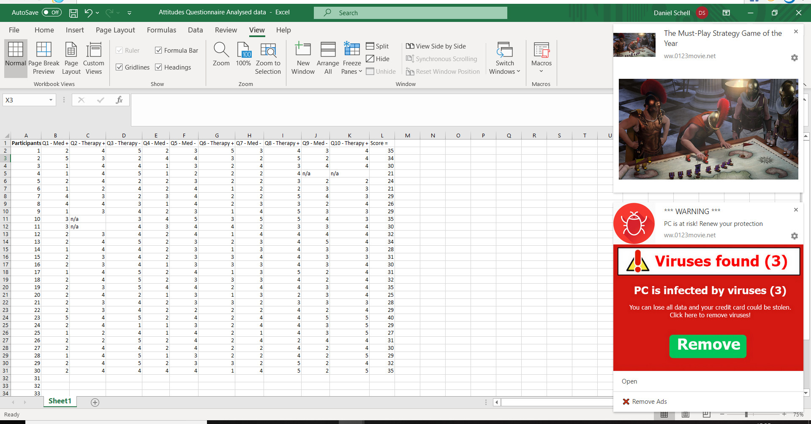
Image 1 – Attitudes Questionnaire
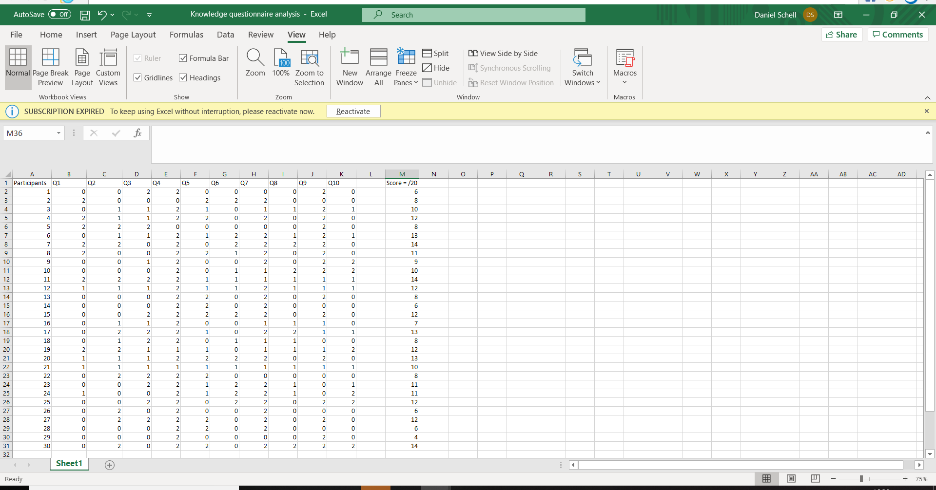
Image 2 – Knowledge Questionnaire

In order for the researcher to establish some common themes within the data they had gathered they separated the data between the therapy and medication aspects of the attitudes questionnaire. This allowed the researcher to identify which form of treatment was most common, which allows for a further consideration within the discussion. See spreadsheets below.

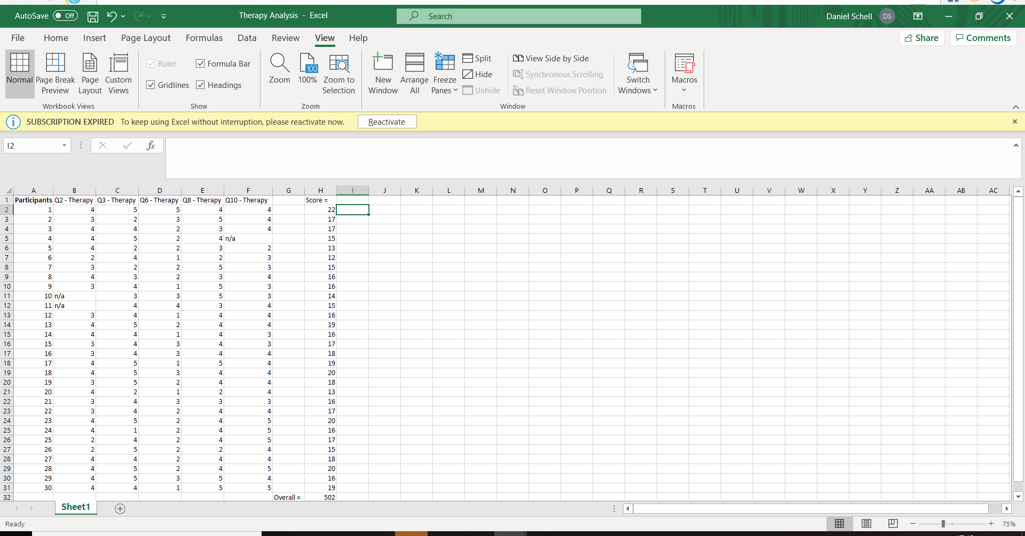
Image 1 – Therapy Data

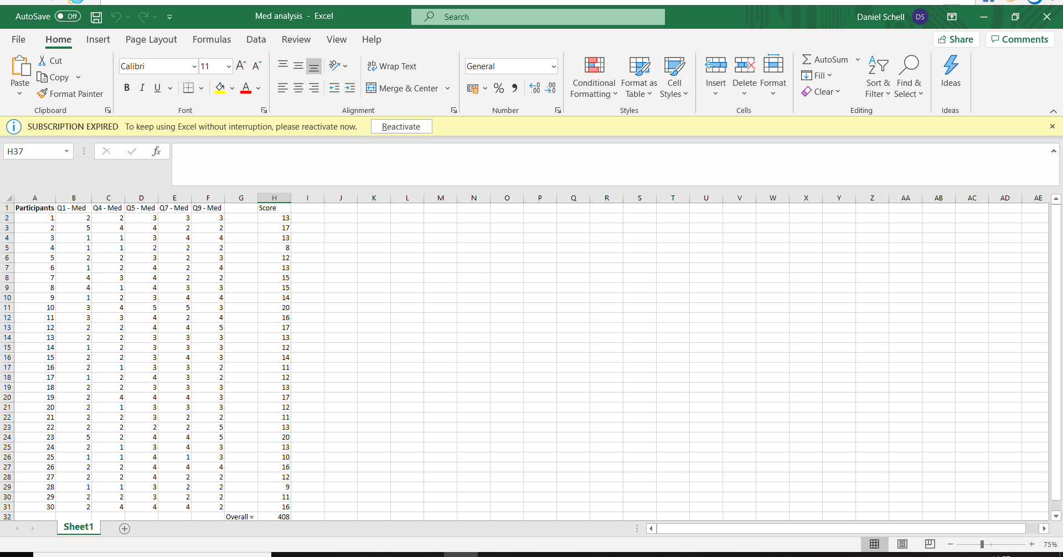
Image 2 – Medication Data

As illustrated in the two spreadsheets of data above the most common choice of treatment among participants was therapy (55%) compared to medication (45%). From the results of this data gathered by the researcher they were able to determine that the therapeutic approach had a higher overall score of 502 among participants than the medication approach which had an overall score 408.
The table of data below is a report of the mean and standard deviation of both the attitudes and knowledge scores of the 30 participants. This had been calculated via the SPSS system.
Attitudes  Questionnaire | Knowledge  Questionnaire
Mean (M)  = 29.80000 | Mean (M)  = 10.6667
Std Deviation (SD)  = 4.01205 | Std Deviation (SD)  = 3.61351
N = 30 | N = 30

With this information being provided by the SPSS software it provided the researcher with the relevant information they required to gain prior to the study’s conclusion.
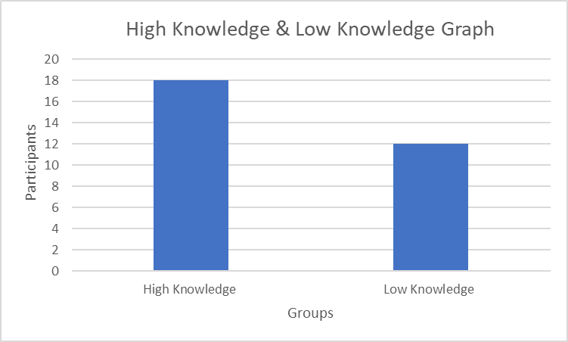
The main variable to take into consideration here is the mean (M) of the knowledge questionnaire data. With the mean score being (M=10.6), the researcher rounded the calculation to (M=11). This indicates that the researcher could now identify which participants belong to the high knowledge and low knowledge groups, which was achieved by calculating the number of participants which had a score of 11 or more on the knowledge questionnaire. See graph below for results.
3B – Inferential Statistics
Attitudes Questionnaire | Knowledge Questionnaire
Spearman’s Rho | Spearman’s Rho
Correlation Coefficient = 1.000 | Correlation Coefficient = 1.000
Sig (two tailed)  = .604 | Sig (two tailed)  = .604
N = 30 | N = 30

It had firstly been hypothesised (DeRubeis et al, 2005) that a therapeutic approach can be viewed equally as effective as medication among individuals with regards to the treatment of anxiety and depression. This does not support the researcher’s findings and is rejected as it had been suggested from the results of their study that in fact a therapeutic approach (55%) was more desirable among participants than medication (45%).
It had secondly been hypothesised (Rosa et al, 2007) that there would be a significant correlation between the attitudes of and knowledge towards medical and therapeutic treatments for anxiety and depression among the participants. A correlation test was conducted to identify this and there is a positive correlation between the two elements (1.000) therefore this hypothesis does support the researcher’s findings.

Chapter 4 - Discussion
Key Findings
This study attempted to identify whether or not there is a significant or non-significant correlation between the attitudes of and knowledge towards (medication) and non-traditional (therapies) methods of treatment for anxiety and depression. In order to achieve the overall findings of the study, the researcher developed an attitudes and knowledge questionnaire containing 10 questions reflecting the traditional and non-traditional forms of treatment. Haslam et al (2004) had previously suggested that both anxiety and depression had become much more common in recent years, therefore the need for various forms of medication were becoming increasingly popular among the healthcare community. This raised a significant amount of awareness for the researcher to identify which form of treatment is viewed mostly effective and how reliable are the opinions of those claiming which treatment is most effective.
There were a number of findings within this study, the first of these being which form of treatment (traditional or non-traditional) would be considered most effective among the participants. DeRubeis et al (2005) had concluded within their study that the route of non-traditional methods of treatment (therapy) can be viewed equally as effective as the standard traditional route of treatment (medication). This conclusion had also been based on the attitudes each of the participants who had were currently undergoing moderate too severe cases of depression and were all equally allocated 16 week prescription of medication or therapy which in this instance was controlled behavioural therapy, also referred to as CBT. This study hypothesised that a non-traditional approach could be equally as effective as a traditional approach with regards to treating individuals with cases of anxiety and depression, which was therefore included within this dissertation as one of the researcher’s hypotheses.
The researcher had concluded that this hypothesis was rejected due to an influx in participants deeming a therapeutic approach more effective/applicable to treating anxiety and depression. This hypothesis may have been rejected due to a number of reasons, the first of these being that the study participant groups were diverse. Alternatively, with DeRubeis et al (2005) study it included a group of participants who were seeking a form of traditional or non-traditional treatment to aid their moderate to severe cases of depression. On the other hand, the researcher used a group of participants who were simply offering the attitudes they had on both a traditional and non-traditional form of treatment for anxiety and depression. Perhaps the attitudes of the participants may change if they were to experience both methods of treatment in the same circumstances as DeRubeis participants. However, the process of the researcher’s study had not included whether or not each of the participants included had previous or current experiences of suffering from anxiety and depression. This suggests that it is unknown to the researcher if the any of the results from their study could be viewed in any similar way to Rebueis et al (2005), therefore this could be viewed as a potential implication and will be discussed further on during the further research suggestions of this discussion.
With regards to poor conformity to traditional and non-traditional methods included within the literature review, despite it not being tested due to the nature of the researcher’s study, it could however be addressed and dealt with as effectively as possible, Koen Demyttenaere, (2001). Such as DeRubeis et al (2005) and the researcher’s study, we were able to create studies that indicate the treatment method that are viewed as most effective and applicable among patients and in the researchers instance the student university community. Furthermore, these types of study can alert medical authorities of the potentially increasing or decreasing the demand for specific methods of treatment based on the findings these studies provide.
Another key finding within this study was there was a significant correlation between the attitudes of and knowledge towards traditional and non-traditional methods of treatment for anxiety and depression, which supports the original hypotheses, Rosa et al (2007). The supported hypotheses study consisted of bipolar 106 patients and 2 questionnaires attempting to identify their attitudes and knowledge on lithium treatments, which as mentioned is a form of treatment for individuals with bipolar. It is clear to suggest that this study had a clear similarity to the researcher’s study which was that they both included an attitudes and knowledge questionnaire. Perhaps this is why both studies resulted in a significant correlation in relation to their results. It was interesting to note that Rosa et al (2007) study included far more participants (106) than the researchers (30), yet both correlations still stand as significant.
Furthermore, this provides much strength to the researcher’s study as it suggests that despite the highly differing number of participants between the two studies, the overall results still remained similar in relation to the correlation aspect. In addition to this the significant correlation may have been facilitated by the format of the scoring system adopted within the attitudes questionnaire of the researcher’s study. As previously mentioned this format suggested that if a participant scored highly on a positive question regarding the traditional method they would likely score highly on a negative question regarding the non-traditional method.

Further Research Suggestions
Prior to the commencement date of the study the researcher and their supervisor thoroughly identified what needed to be accomplished in order for the study to be a success and what requirements needed to be met if presented with ethical criteria such as distress caused to a participant for example. The study was viewed as a success by both the researcher and their supervisor as the data was gathered efficiently and participants were fully satisfied with the study as whole, to the knowledge of the researcher. However, after a thorough and clear inspection of the study there are some aspects which could have been altered or added in order to enhance the study.
The first of these suggestions would be to increase the number of participants allocated to the study if possible. By having a high intake of participant’s the probability is that the results will be far more accurate compared to having a low intake in participants. In addition to this it would be in the researcher’s best interest to suggest that a study of this nature may benefit from being conducted with a variety of groups including medical professionals or the general public for example. Furthermore, despite this study indicating which form of treatment was most applicable among university students the overall data provided may have potentially benefitted from both an increase in participant numbers and also an increase in more diverse participant groups.
The second of these suggestions would be to increase the number of questions allocated within both questionnaires. Despite the attitudes questionnaire displaying a clear indication that the non-traditional method was most applicable and chosen among participants the number of participants deemed as ‘high knowledge’ may have increased if there were more questions available. In addition to this the questions included within in the knowledge questionnaire were fairly specific in terms of the answers available. However, it had been considered by the researcher that if a participant felt strongly about either of the traditional or non-traditional methods, they would perhaps have a fairy standard level of knowledge.
Thirdly, another suggestion for future research may be to adopt a different scoring system for the knowledge questionnaire. It had come to the researcher’s attention that if a participant indicated they didn’t know a question they had a score of 1 point, whereas if they answered a question incorrectly, they had a score of 0 points. This may divide opinion among many as it suggests that if a participant does not know a question they still score a point and may have been placed into the high knowledge group over another participant who attempted to answer all of the questions and may have been only 1 point from being placed into the high knowledge group. Therefore, for future research perhaps the participants who answer don’t know could be scored in a different manner.

Conclusion
In conclusion, the researcher identified through a number of previous studies and within their own study some key features arose. The previous research set itself as a benchmark for the researcher and allowed them to truly understand the nature of what their study aimed to accomplish and how this could be achieved. Furthermore, the previous research allowed the researcher to establish why they had chosen their study method and why they felt it was the best available. By critically reviewing previous literature the researcher would be able to adopt this once they had completed their study allowing themselves and others to establish what was done well, what may have potentially been done better and also what could have been included or excluded from their study.
Based on the conversations the researcher had with the participants it seemed evident that the study flourished due to each of the participants being open and honest in expressing their opinions not only to via the questionnaires but also directly to the researcher. Despite the location of the study (university library) having the potential to disrupt participants this did not actually occur and the participants were able to complete each of the questionnaires to the best of their ability. The data itself took a total of 2 days to gather which left the researcher with a sufficient amount time to carefully prepare it effectively.
The data analysis was achieved via the SPSS system and was produced appropriately and the researcher presented these findings through their own meaningful image whilst still presenting the SPSS output data through the appendix list as evidence of the process. The results of the data indicated that the non-traditional approach (55%) was most applicable among participants as oppose to the traditional method of treatment of anxiety and depression (45%). This indicated that the original hypothesis was rejected which claimed that the non-traditional method of treatment would be equally as applicable and effective as the traditional method, (DeRubeis et al, 2005). In terms of the correlation aspect of the study, it had been suggested from the data provided that there was a significant correlation between the attitudes of and knowledge towards traditional and non-traditional methods of treatment for anxiety and depression among the participants. It had originally been hypothesised that there would in fact be a significant correlation, therefore this hypothesis was accepted based on the data results provided by the researcher’s findings, (Rosa et al, 2007). In essence, my study was unique in it`s precise format but included proven methods of calculation from previous works. I maintain that the findings are accurate, objective and reflect positively regarding the influences of previous researcher`s studies and subsequent conclusions.

Chapter 5 – Reference List & Appendices

Antidepressants. (2020). Retrieved 18 March 2020, from https://www.nhs.uk/conditions/antidepressants/
Blackburn, I. M., Eunson, K. M., & Bishop, S. (1986). A two-year naturalistic follow-up of depressed patients treated with cognitive therapy, pharmacotherapy and a combination of both. Journal of Affective disorders, 10(1), 67-75.
Beck, A. T., Steer, R. A., & Brown, G. K. (1996). Beck depression inventory-II. San Antonio, 78(2), 490-498.
Coles, M., & Coleman, S. (2010). Barriers to treatment seeking for anxiety disorders: initial data on the role of mental health literacy. Depression And Anxiety, 27(1), 63-71. doi: 10.1002/da.20620
Cipriani, A., Furukawa, T. A., Salanti, G., Chaimani, A., Atkinson, L. Z., Ogawa, Y., ... & Egger, M. (2018). Comparative efficacy and acceptability of 21 antidepressant drugs for the acute treatment of adults with major depressive disorder: a systematic review and network meta-analysis. Focus, 16(4), 420-429.
Cohn, J., Katon, W., & Richelson, E. (1990). Choosing the right antidepressant. Patient Care, 24(12), 88-102.
Clak, D. A., & Beck, A. T. (1999). Scientific foundations of cognitive theory and therapy of depression. John Wiley & Sons.
Demyttenaere, K. (2001). Compliance and acceptance in antidepressant treatment. International Journal of Psychiatry in Clinical Practice, 5(1), 29-35.
DeRubeis, R. J., Hollon, S. D., Amsterdam, J. D., Shelton, R. C., Young, P. R., Salomon, R. M., ... & Gallop, R. (2005). Cognitive therapy vs medications in the treatment of moderate to severe depression. Archives of general psychiatry, 62(4), 409-416.
Foroushani, P. S., Schneider, J., & Assareh, N. (2011). Meta-review of the effectiveness of computerised CBT in treating depression. BMC psychiatry, 11(1), 131.
Fava, G. A., Rafanelli, C., Grandi, S., Conti, S., & Belluardo, P. (1998). Prevention of recurrent depression with cognitive behavioral therapy: preliminary findings. Archives of general psychiatry, 55(9), 816-820.
Gabriel, A., & Violato, C. (2010). Knowledge of and attitudes towards depression and adherence to treatment: The Antidepressant Adherence Scale (AAS). Journal of affective disorders, 126(3), 388-394.
Hovstadius, B., Hovstadius, K., Åstrand, B., & Petersson, G. (2010). Increasing polypharmacy-an individual-based study of the Swedish population 2005-2008. BMC clinical pharmacology, 10(1), 16.
Haslam, C., Brown, S., Atkinson, S., & Haslam, R. (2004). Patients' experiences of medication for anxiety and depression: effects on working life. Family Practice, 21(2), 204-212.
Julius, R. J., Novitsky Jr, M. A., & Dubin, W. R. (2009). Medication adherence: a review of the literature and implications for clinical practice. Journal of Psychiatric Practice®, 15(1), 34-44.
Keller, M. B., Lavori, P. W., Mueller, T. I., Endicott, J., Coryell, W., Hirschfeld, R. M., & Shea, T. (1992). Time to recovery, chronicity, and levels of psychopathology in major depression: a 5-year prospective follow-up of 431 subjects. Archives of general psychiatry, 49(10), 809-816.
Lader, M. (1994). Fortnightly review: treatment of anxiety. Bmj, 309(6950), 321-324.
Middleton, N., Gunnell, D., Whitley, E., Dorling, D., & Frankel, S. (2001). Secular trends in antidepressant prescribing in the UK, 1975–1998. Journal of Public Health, 23(4), 262-267.
McManus, S., Bebbington, P., Jenkins, R., & Brugha, T. (2016). Mental health and wellbeing in England: Adult Psychiatric Morbidity Survey 2014. A survey carried out for NHS Digital by NatCen Social Research and the Department of Health Sciences, University of Leicester.
McCormack, J., & Korownyk, C. (2018). Effectiveness of antidepressants.
Mitchell, N., & Gordon, P. K. (2007). Attitudes towards computerized CBT for depression amongst a student population. Behavioural and Cognitive Psychotherapy, 35(4), 421-430.
Modig, S., Kristensson, J., Troein, M., Brorsson, A., & Midlöv, P. (2012). Frail elderly patients’ experiences of information on medication. A qualitative study. BMC geriatrics, 12(1), 46.
Potter, W. Z. (1990). Psychotropic medications and work performance. Journal of occupational medicine.: official publication of the Industrial Medical Association, 32(4), 355-361.
Robinson, L. A., Berman, J. S., & Neimeyer, R. A. (1990). Psychotherapy for the treatment of depression: a comprehensive review of controlled outcome research. Psychological bulletin, 108(1), 30.
Rosa, A., Marco, M., Fachel, J., Kapczinski, F., Stein, A., & Barros, H. (2007). Correlation between drug treatment adherence and lithium treatment attitudes and knowledge by bipolar patients. Progress In Neuro-Psychopharmacology And Biological Psychiatry, 31(1), 217-224. doi: 10.1016/j.pnpbp.2006.08.007
Razali, S. M., & Yusoff, M. Z. A. M. (2014). Medication adherence in schizophrenia: a comparison between outpatients and relapse cases. East Asian Archives of Psychiatry, 24(2), 68.
Stahl, S. M. (1999). Why settle for silver, when you can go for gold? Response vs. recovery as the goal of antidepressant therapy. The Journal of clinical psychiatry, 60(4), 213-214.
SLS 2010:659 Ch 6, §6. Patient Safety Act. 2010, Government Offices of Sweden
Stettin, G. D., Yao, J., Verbrugge, R. R., & Aubert, R. E. (2006). Frequency of follow-up care for adult and pediatric patients during initiation of antidepressant therapy. American Journal of Managed Care, 12(8), 453-463.
Safren, S., Gonzalez, J., & Soroudi, N. (2007). CBT for Depression and Adherence in Individuals with Chronic Illness. Oxford University Press.

Thimm, J. C., & Antonsen, L. (2014). Effectiveness of cognitive behavioral group therapy for depression in routine practice. BMC psychiatry, 14(1), 292.
Tucker, M., & Oei, T. P. (2007). Is group more cost effective than individual cognitive behaviour therapy? The evidence is not solid yet. Behavioural and Cognitive Psychotherapy, 35(1), 77-91.
Watts, S., Mackenzie, A., Thomas, C., Griskaitis, A., Mewton, L., Williams, A., & Andrews, G. (2013). CBT for depression: a pilot RCT comparing mobile phone vs. computer. BMC psychiatry, 13(1), 49.
Whitfield, G. (2010). Group cognitive–behavioural therapy for anxiety and depression. Advances in psychiatric treatment, 16(3), 219-227.

Listed below are the consent and debrief form which were allocated to all of the participants.

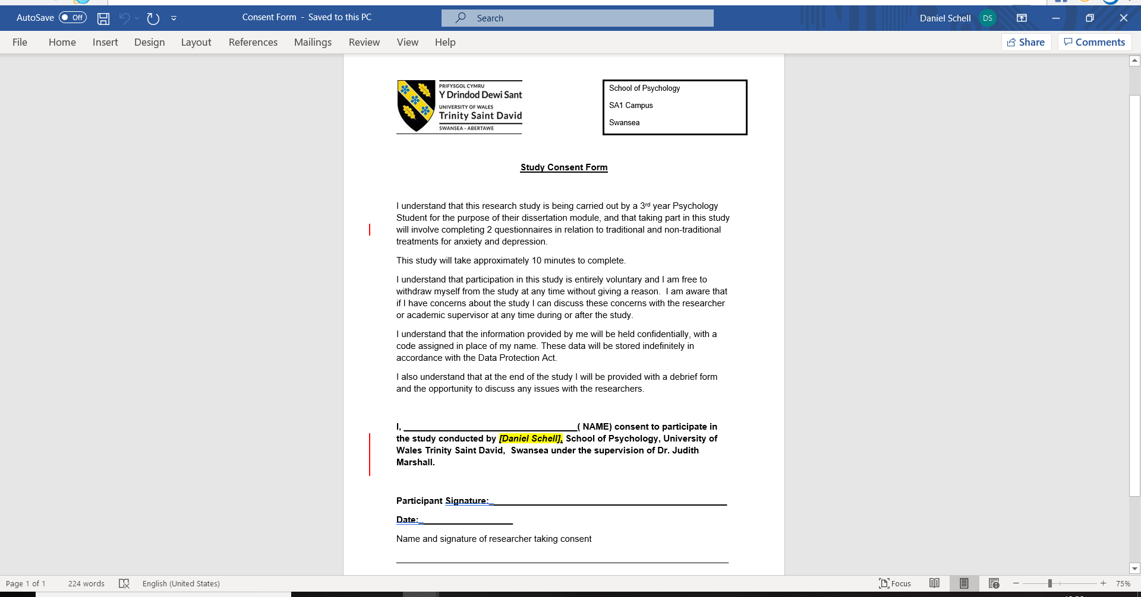
Appendix A – Consent Form

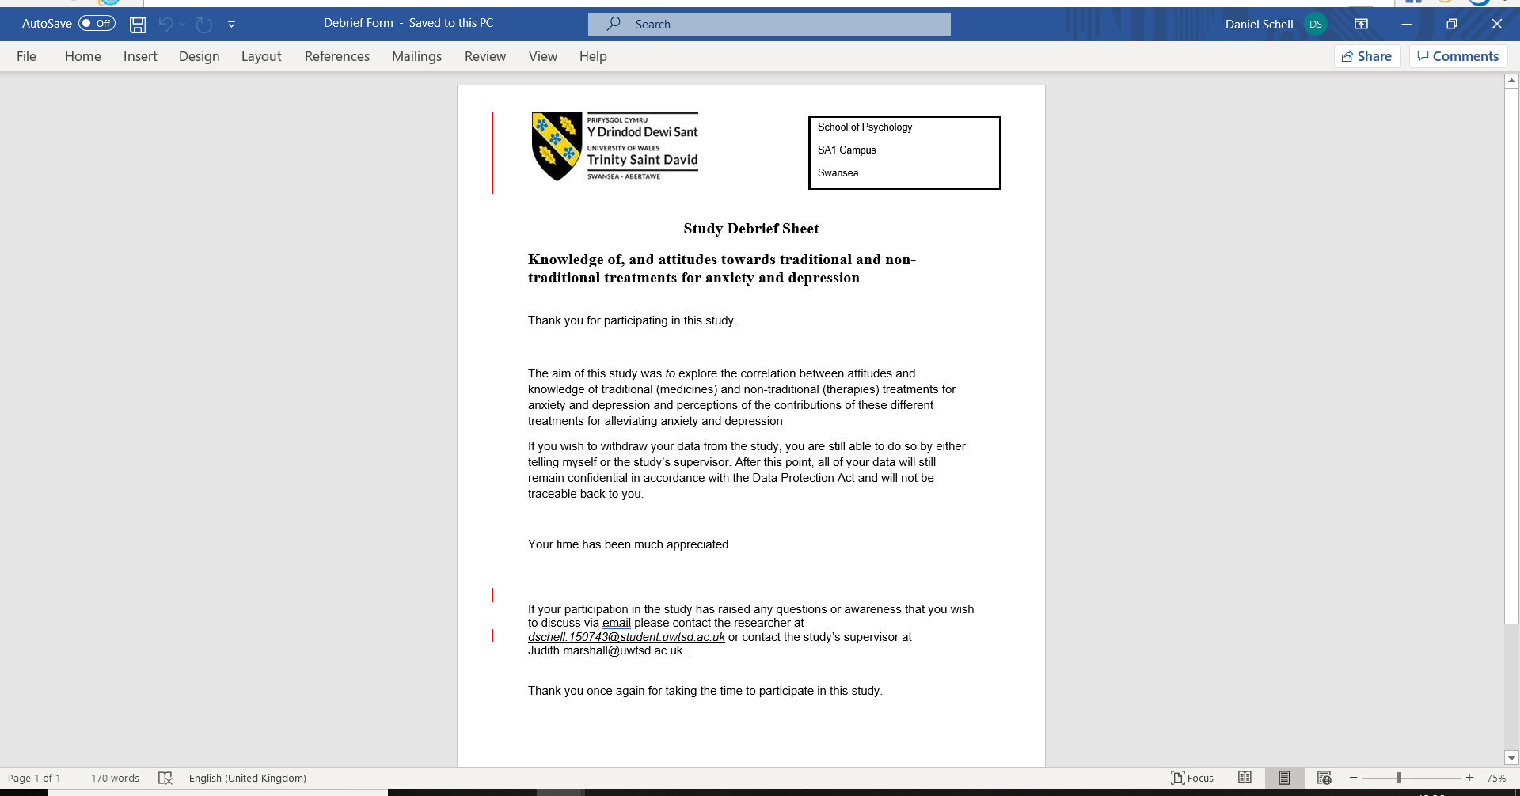
Appendix B – Debrief Form
This attitudes questionnaire was based on the readings of (Rosa et al., 2007) & (DeRubeis et al, 2005).

Appendix C – Attitudes Questionnaire

Positive Question Scale Negative Question Scale
Strongly Agree – 5 Strongly Agree – 1
Agree – 4 Agree – 2
Neither – 3 Neither – 3
Disagree – 2 Disagree – 4
Strongly Agree – 1 Strongly Disagree – 5

1. Prescribed medication should be the first alternative for treating anxiety and depression.
2. Therapeutic interventions such as Cognitive Behavioural Therapy (CBT) for example, are the most effective forms of treatment for anxiety and depression.
3. Those suffering from anxiety and depression should not seek a therapeutic intervention in the first instance.
4. Prolonged usage of medication such as antidepressants, will lead to a dependency on the medication.
5. Antidepressants do not actually help with depression and anxiety
6. People who believe more in non-medical treatments than in medications are fooling themselves
7. Prescribed medication is bound to cause harm, as it causes changes in the brain
8. Non-medicinal Therapies should be the first offer from medical professionals for treating an individual’s depression and anxiety
9. The negative side effects to taking medication for treating anxiety and depression outweigh the positive aspects.
10. Therapeutic practitioners are as professional as medical practitioners. with anxiety and depression.

This knowledge questionnaire was based on the readings of (Coles & Coleman, 2010), (Greenberg et al., 1999) & (Henderson et al., 2002)

Appendix D – Knowledge Questionnaire

Scale
Correct – 2
Don’t Know – 1
Incorrect – 0

1. Antidepressants cure mental disorders, E.G. anxiety and depression? (Huang et al., 2013)
2. Newer medications for anxiety and depression are more effective than older medications (Huang et al., 2013)
3. The use of medical treatments speeds up the recovery of mental disorders? (Huang et al., 2013)
4. An individual could become addictive to medical treatments for anxiety and/or depression, E.G Prozac.
5. The percentage of young people suffering from a mental disorder and receiving the correct support is. ("Statistics | Mental Health Foundation", 2020) =
6. Over the past decade, the cost of antidepressants for the NHS have become cheaper to purchase?
7. Cognitive behavioural therapy is the most common and highly recommended form of talking therapy
8. The percentage of people living with psychotic disorders receiving therapeutic treatment is.
9. Medications, such as antidepressants are more effective than therapies, such as CBT, as they are better at protecting us from depression/anxiety relapse.
10. In Wales and England, how many adults suffering from depression and anxiety are receiving treatment for their mental condition.

The two spreadsheets of data below are in relation to the results of the attitudes and knowledge questionnaire of each of the participants.

Appendix F - Attitudes Data
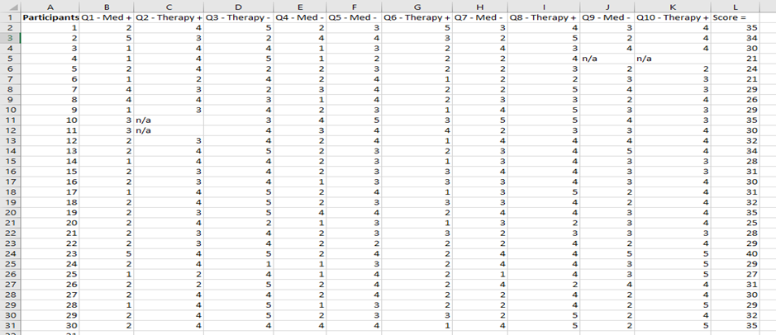

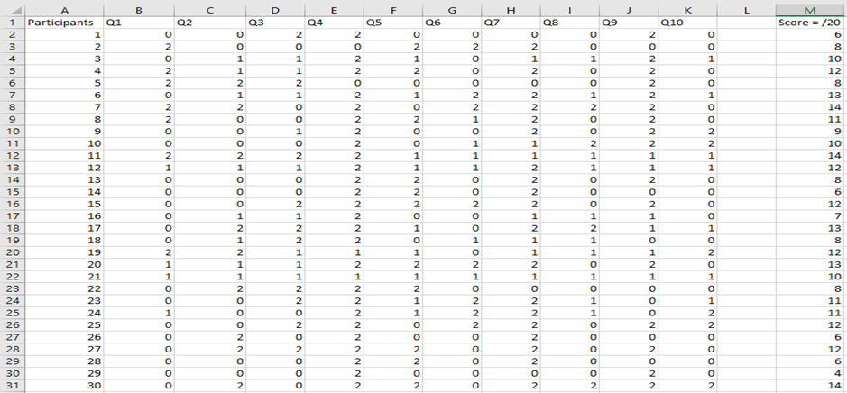
Appendix G – Knowledge Data

The spreadsheets below are the scores for the therapeutic and medication approach of each of the participant’s with regards to the attitude’s questionnaire.

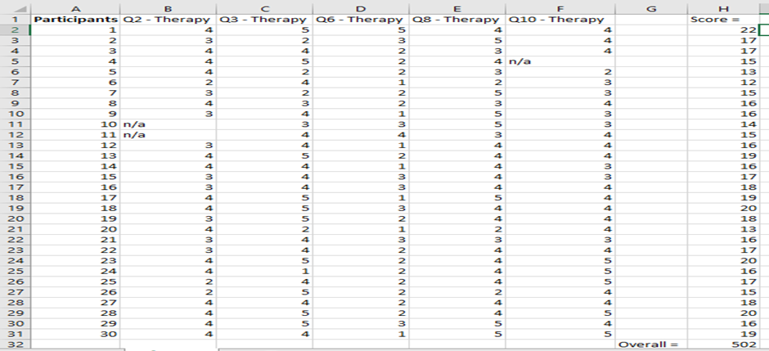
Appendix H – Attitudes Therapy Data

Appendix I – Attitudes Medication Data
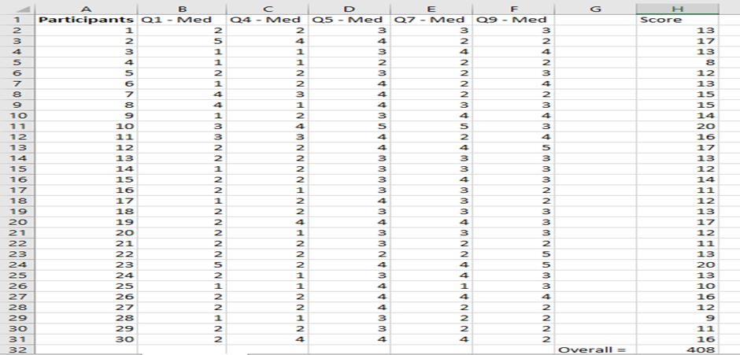

Below is the Descriptive statistics which as mentioned, were professionally calculated via the SPSS system. The graph below is the overall result of how many of the participants were categorised low knowledge and high knwo

Appendix J – SPSS Output

Descriptive Statistics
 | N | Mean | Std. Deviation
Attitudes | 30 | 29.8000 | 4.01205
Knowledge | 30 | 10.6667 | 3.61351
Valid N (listwise) | 30

Appendix K – High Knowledge & Low Knowledge Groups (Graph)

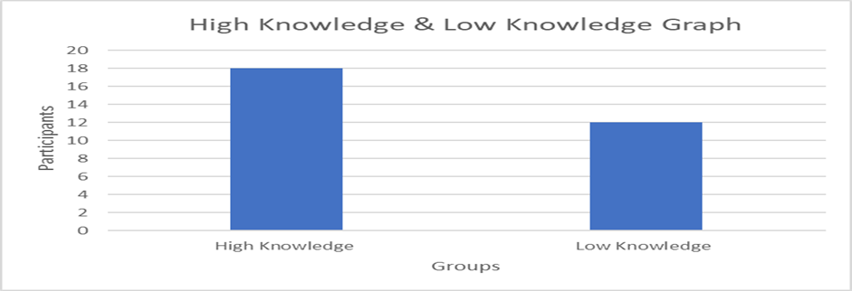

Appendix L – Inferential Statistics (Correlation)

Below is the correlation test which was calculated via the SPSS system.
Correlations
 |  |  | Attitudes | Knowledge
Spearman's rho | Attitudes | Correlation Coefficient | 1.000 | .099
Spearman's rho | Attitudes | Sig. (2-tailed) | . | .604
Spearman's rho | Attitudes | N | 30 | 30
Spearman's rho | Knowledge | Correlation Coefficient | .099 | 1.000
Spearman's rho | Knowledge | Sig. (2-tailed) | .604 | .
Spearman's rho | Knowledge | N | 30 | 30

Below is the Proposal form which had been completed by the researcher and accepted by the dissertation supervisor prior to the ethics form.

Appendix M – Proposal Approval Form

Dissertation proposal 2019-2020

Student Name | Daniel Schell
Dissertation Supervisor | Judith Marshall
Date submitted | 11/10/2019

Title of Research (this must reflect the essence of your proposed research question, study design and study population and should be more specific than the broad topic area provided in the dissertation topics selection book).

Knowledge of, and attitudes towards traditional and non-traditional treatments for anxiety and depression

Please state your main research question(s) and hypothesis/hypotheses

To determine the correlation between attitudes and knowledge of traditional (medicines) and non-traditional (therapies) treatments for anxiety and depression and perceptions of the contributions of these different treatments for alleviating anxiety and depression

Based on previous literature, in accordance with (DeRubeis et al., 2005) and (Rosa et al., 2007), it has been hypothesised that there will be a significant association between, both the traditional and non-traditional treatment methods.

What empirical evidence supports your research question? (Please provide a 1500 word review of relevant psychological literature and theory and a minimum of eight references). If you have already drafted a review of literature please attach it to the end of this document – you do not need to complete this section if so).

The topic under consideration in this literature review is Knowledge of, and attitudes towards traditional and non-traditional treatments for anxiety and depression. In order to identify this, the researcher will need to identify the correlation between attitudes and knowledge of traditional and non-traditional treatments for anxiety and depression and perceptions of the contributions of these different treatments for alleviating anxiety and depression. The literature that will be investigated within this review will cover a variety of areas in relation to the question the researcher is attempting to explore. These areas will include, anxiety and depression articles, traditional and non-traditional treatment methods, attitudes and knowledge articles (theories, models and research) and articles regarding the correlation between attitudes and knowledge in relation to the traditional and non-traditional treatments. Statistical information will also be provided throughout to give further support to the researcher’s study.

In comparison to the traditional (medication) and non-traditional (therapy’s) aspect of the study, a journal article based on a study conducted on cognitive therapy vs medications in the treatment of moderate and severe depression. The study claims that there is a significant amount of evidence antidepressants can effectively treat moderate and severe depression, yet there is less data supporting the effectiveness of CBT for treating moderate and severe depression, (DeRubeis et al., 2005). It had been hypothesised that Cognitive therapy can be as effective as medications for the initial treatment of moderate to severe major depression. In order to compare and contrast the two alternatives, the study held up to 240 participants, who all suffered from moderate to severe depression. Each of these participants were randomly assigned to either 16 weeks of medication, or 16 weeks of CBT. The results of this study suggested that at 16 weeks of either medication or CBT, the response rates of the participant were all at 58%, (DeRubeis et al., 2005). Therefore, the overall result of this study does support the original hypotheses. One main area of consideration within this study may be the potential limitation of this study, which is testing both moderate and severely depressed patients. This is due to the fact of these two forms of depression may be viewed as opposites in some ways. Those who are suffering from moderate depression may find that the CBT may have been extremely effective as the root cause of the patient’s moderate depression may have been recognised and supported at a much higher rate than of those patients suffering from severe depression who may take much more time. This is also apparent within the medication element of this study as those suffering with moderate depression may not require the medication provided and feel the full effectiveness whereas someone with the severe depression may do so.
Also, in relation to traditional and non-traditional treatments towards anxiety and depression, an online based survey study regarding traditional and non-traditional
treatments for autism spectrum disorder with seizures was conducted, (Frye, Sreenivasula and Adams, 2011). It had been stated within the study that ‘there is little information regarding the relative effectiveness of treatments for seizures in the ASD population’(Frye, Sreenivasula and Adams, 2011). In some ways, this statement is relatable as it is attempting to identify the ‘effectiveness of treatments’ which relates to the main researcher as part of their study is attempting to identify and understand an individual’s knowledge of traditional and non-traditional. This is relatable to the main researcher’s study as for the individual to have the appropriate and correct understanding of the ‘effectiveness of treatments for seizures in the ASD population’ (Frye, Sreenivasula and Adams, 2011), they would be required to have the correct knowledge of the matter.

A piece of background literacy on anxiety and depression which is an important focus of the researcher would be an article published in 2009 titled, ‘Barriers to treatment seeking for anxiety disorders: initial data on the role of mental health literacy’, (Coles & Coleman, 2010). As the title suggests, this journal article covers the limitations of an individual seeking to find the correct treatment for their anxiety disorder. The journal article states that ‘Anxiety disorders represent the single largest mental health problem in the United States’ (Greenberg et al., 1999.) This statistical information relates to the researcher’s study as it could be useful in relation to the knowledge-based questionnaire and not only this, but it creates a relative discussion topic around the researcher’s study. A possible discussion topic may be how these barriers limiting the chances of an individual seeking the appropriate treatment for their anxiety disorder can be prevented and also why these barriers even exist.
Another statement from this journal article claims that ‘most individuals with anxiety disorders never seek treatment’ (Henderson et al., 2002). This again compares to the main researchers study as it is seeking to explore which form of treatment being traditional or non-traditional is most applicable according to their findings and also can contribute towards the knowledge based questionnaire providing the appropriate statistical information, giving each individual participant a clear insight into the matter. This may or may not expand their current knowledge of depression and anxiety further and therefore may potentially manipulate their attitudes on either the traditional methods or the non-traditional methods. Furthermore, if this outcome did present itself, it would support and add further relevance to the researcher’s discussion.
Coles and Coleman conducted their study at a university in the United States, using 284 of the undergraduate psychology students, (Coles & Coleman, 2010). These students were required to view a number of video clips of individuals suffering from a variety of mental disorders and then label the appropriate disorder, the cause of the disorder and what treatment they would recommend if deemed necessary. (Coles & Coleman, 2010). A major relatable factor with this particular study with the main researcher’s study is that they are both calculating their study’s finding based off of undergraduate psychology students. The findings of Coles and Colemans study are also primarily based on the attitudes and knowledge of the participants involved, despite this not being stated at any point through out their literature. In order for the 284 participants to allocate each of the digital individuals with the correct disorder, identify the cause and provide them with appropriate treatment, they would require the accurate knowledge on the matter. This knowledge may be factual or driven by their attitudes, which in some cases may be bias and inaccurate.

In relation to the correlation between both attitudes of and knowledge towards traditional and non-traditional treatments for anxiety and depression, an article regarding the ‘Correlation between drug treatment adherence and lithium treatment attitudes and knowledge by bipolar patients’ does in fact have major significance to the correlation aspect of the researchers study, (Rosa et al., 2007). This study claims that non-adherence should always be tested when a failure in bipolar treatments. To test this claim, the study included 106 bipolar patients under the lithium treatment at the hospital de Clínicas. Each of these participants were required to complete both a lithium attitudes questionnaire, lithium knowledge test, medication adherence rating scale and used plasma red blood cells lithium measurements to assess their medication adherence, (Rosa et al., 2007). The results of this study indicated that the level of knowledge of the participants has a direct correlation to the participants attitudes. This piece of literature supports the researcher’s study as its main objective is to identify the correlation between attitudes of and knowledge towards the lithium treatments for the bipolar disorder, also supporting the researcher’s hypotheses. However, despite this, a key limiting factor to this study is that it is only considering one treatment for bipolar, rather than identifying and exploring a number of them. Although the study shows a great emphases on the lithium treatment and has explore this in great detail, the study’s results may have been strengthened as they would have been able to allocate more potential forms of treatment to their study.

Please describe your participant group (including anticipated number of participants required) and any specific inclusion/exclusion criteria.

It has been anticipated that the study will include 40 participants. Each of the participants will come from first- and second-year students studying BSc Psychology at the UWTSD university at the SA1 campus. This participant group choice is supported in accordance with (Coles & Coleman, 2010)

The participants will be identified 1st and 2nd year university students aged 18+ which will be retrieved at the SA1 UWTSD campus. Each student will also have their own unique EMS number to identify themselves by. The participants will be included in the study as between-subjects and will be a part of a one group- based study. This is due to each of the participants being tested on the same condition, being the correlation between attitudes and knowledge of depression, anxiety and the traditional and non-traditional treatments available.

Each participant will be targeted via the EMS sign up portal where they will be able to locate an overview of the study. No participant will be targeted directly for the recruitment process and the researcher will not be involved in the signing up process.

Each participant will be provided with a thorough and detailed debrief form once the two questionnaires have been completed, explaining to them the study’s purpose and why it was originally conducted. Each of them will also be given an opportunity to contact either the study’s instructor or the study’s supervisor for any further quires in relation to the study, with both email addresses linked into the debrief form. A helpline website will also be noted within the debrief form for those who may have suffered emotional distress from the study.

Participants will have access to a hard-copy consent-sheet before taking part in the study, containing the relevant information in regard to the study. The consent-sheet will allow the participants to explore the purpose and aims of the study and the option to withdraw themselves at any point of the study. Each of the participants results will remain anonymous at all times, and their data can be removed at any time of the study and they are not required to answer every question if they deem it necessary. They will also be made aware that upon completion of the study, their results will not be traceable as each participants study will be labelled with a unique code so there was no way to access their data to the questionnaire.

All of the participant’s data collected through the questionnaires will be collected and made anonymous, ensuring that the participants data is maintained in a confidential manor. The hard-copy questionnaire results will be stored within the university grounds and secured, all identified with their own unique code, linking them to the study’s data collection

Once the data of the participants results from the study has been collected, the study will convert the participants from a one group-based to a two-group based study. This is as a result of the participants data being calculated and segregated into two groups, with the first group being labelled ‘low knowledge’ and the second being labelled as ‘high knowledge’. By achieving the segregation of the participants, A calculation of each of the results will be conducted and then physically divided into 2 by finding the mid-way point of the overall.

Please provide brief details of the anticipated design (e.g., between, within, mixed, regression, focus groups, interviews, experimental, questionnaires) and main procedure for your study (it should be clear from this how you are actually planning to carry out your study, and what will be happening to your participants).

In order to for the researcher to identify the correlation between traditional and non-traditional treatments for anxiety and depression, this study will implement a between subject questionnaire-based study.

This will consist of two different questionnaires. The first of these being an attitudes-based questionnaire exploring each element of the participant’s attitudes towards traditional and non-traditional treatments. This questionnaire will be based on the ‘Correlation between drug treatment adherence and lithium treatment attitudes and knowledge by bipolar patients’ (Rosa et al., 2007) and the Cognitive Therapy vs Medications in the Treatment of Moderate to Severe Depression, (DeRubeis et al., 2005). Both these pieces of literature support the researcher’s study as they explore both the attitudes towards treatments for anxiety and depression and exploration of medication vs cognitive therapy (CBT).

The second questionnaire will aim to identify the knowledge each participant has on the traditional and non-traditional treatments for anxiety and depression. This questionnaire will be based on ‘Barriers to treatment seeking for anxiety disorders: initial data on the role of mental health literacy’, (Coles & Coleman, 2010) which represent elements of the knowledge of participants through various statements, (Greenberg et al., 1999.), (Henderson et al., 2002) and also through the conduction of their study, requiring the knowledge of the participants.

Each of the questions will aim to measure the participants attitudes towards the matter by giving them a range of 15 questions using a 5-point-likert-scale. This likert-scale is supported by (Jacob, Hassali & Ab Rahman, 2015), ‘Attitudes and beliefs of patients with chronic depression toward antidepressants and depression’. See example below;

The study will be conducted within the university premises, where the participants will be provided with all of the necessary information and equipment. Each participant will be required to sign up for my study through the EMS system, where they will be provided with the title of the study, the expected duration and also a brief overview of the study, including the main topic areas surrounding the study, allowing the participant to have a clear understanding of what to expect from the study. Prior to beginning the study, each participant will be required to carefully read through and sign a consent form provided to them. After the study has been completed, each participant will be thanked for their time and effort and urged if they have any remaining questions please feel free to express their questions/concerns.

After completing both questionnaires, each participant will be provided with a text box indicating that if they wish to add any further queries or relevant information towards the study to please include it. This would allow the researcher to expand upon their discussion and make reference to future researchers.

What measures are you planning to use for data collection and how will this data be used in the analysis in order to answer your research question? (Be as specific as possible here – what type of data will you be obtaining, what specific topics/measures/scales/instruments will you be using and what will you do with this data?)

The measures that the study will be using to collect my data will consist of 40 participants which will all take part in a questionnaire-based study, (2 questionnaires). These questionnaires will be paper-based and within the university premises where each of the participants will complete this individually. The measures that the researcher will be taking with both the first and second questionnaire will be to calculate and identify each of the participants attitudes and knowledge results from the two questionnaires. The researcher will then calculate this data by finding a ‘median’ score between both of the participants questionnaires results and combining them. This calculated median score will then determine the participants specific group, being either low knowledge or high knowledge. As a result of this, it will be able to identify the correlation between attitudes and knowledge of traditional (medicines) and non-traditional (therapies) treatments for anxiety and depression and perceptions of the contributions of these different treatments for alleviating anxiety and depression.

The objectives of this study is to identify all of the provided data results through both of the questionnaires from the participants and be able to determine whether there is a correlation between the participant group, in relation to depression/anxiety and the available prescription and complementary treatments.

1. To collect data on the attitudes and knowledge of traditional and non-traditional methods of treating depression/anxiety

2. To calculate the results by finding the ‘median’ score

3. Categorising the participants into ‘low knowledge’ and ‘high knowledge’ groups

The overall result of this study will determine the attitudes and knowledge of traditional and non-traditional treatment methods towards depression/anxiety and also the correlation between the participants between the ‘low knowledge’ and ‘high knowledge’ groups.

What are the main ethical issues that you will need to address in this study? (Please note all students will need to complete the full ethics form prior to final approval for data collection being given).

One ethical consideration that will need to be aware of is firstly the emotionally distressing effect that my study may have on my participants, which may be due to personal experience for example. This ethical consideration has the potential to occur at any stage of my study, may it be through reading the brief overview of my study through EMS too specific questions within either of my questionnaires which my trigger the participant. To prevent this from becoming a major issue, the study’s instructor will be providing a network link to the end of each debrief form, so the participants are aware of the support available to them. In addition to this, the study’s instructor will be ensuring that there is a 10-minute gap between each participant slot, allowing themselves and the participant time to evaluate their situation and will then be of aid to them until they feel well enough and ready to leave my study.

An ethical consideration that will need to be aware of is participants rights to confidentiality. By not following to correct confidentiality procedures, the participants information provided to the study’s instructor in confidence is disclosed, which as a result, would be in breach of my study’s ethical proposal. The result of this could be fatal. To prevent this from happening within the study, the study’s instructor will be ensuring that all the participants data they collect will be stored appropriately, informing each participant of the process. The appropriate lawful information will also be put into effect and each participant will be made aware of this specific federal law.

Another ethical consideration that will also need to be aware of is the non-biased wording of the questions within my questionnaire. Many study leaders may feel extremely passionate about the topic of interest within their study. However, to achieve accurate results of what they’re trying to identify, it is extremely important to keep their own personal beliefs out of the study. To prevent this from occurring within the study, I will be ensuring that each of the questions my participant will answer will be non-biased. This will not allow any participant to feel swayed towards a specific answer due to the wording of my questions. Note, this would only apply within the attitudes questionnaire as the knowledge questionnaire is strictly factual answering.

Student Name (Please print clearly) Daniel Schell__________________________________________

Student Signature D.schell________________________________________Date_11/10/19______________

Proposal Outcome |  | Supervisor to tick one only
Satisfactory proposal (all final materials have been approved by the supervisor; proceed to submitting the ethics form to the discipline research ethics committee).

Minor revisions (some areas require clarification before submitting ethics to the discipline research ethics committee - see below for required actions)

Unsatisfactory (proposal lacks significant detail and must be resubmitted to supervisor within seven days following feedback - see below for required actions)

Unsatisfactory - proposal is considered unethical/unworkable in practice. New proposal to be developed following feedback from supervisor (see below)

Proposal is satisfactory but requires full consideration by the Faculty research ethics committee due to the nature of the study

Supervisory team additional comments/feedback:

Action required:

Date of comments/feedback :

Supervisor’s Signature: ___________________________ Date: _______________

<+

Appendix N – Ethical Approval Form

Below is the ethics form which had to be completed by the researcher and also accepted by the ethical team of approval before the commencement of the study.

APPLICATION FOR ETHICAL APPROVAL

In order for research to result in benefit and minimise risk of harm, it must be conducted ethically. A researcher may not be covered by the University’s insurance if ethical approval has not been obtained prior to commencement.

The University follows the OECD Frascati manual definition of research activity: “creative work undertaken on a systematic basis in order to increase the stock of knowledge, including knowledge of man, culture and society, and the use of this stock of knowledge to devise new applications”. As such this covers activities undertaken by members of staff, postgraduate research students, and both taught postgraduate and undergraduate students working on dissertations/projects.

The individual undertaking the research activity is known as the “principal researcher”.

Ethical approval is not required for routine audits, performance reviews, quality assurance studies, testing within normal educational requirements, and literary or artistic criticism.

Please read the notes for guidance before completing ALL sections of the form.

This form must be completed and approved prior to undertaking any research activity. Please see Checklist for details of process for different categories of application.

Delete the Guidance Notes at the end of the form BEFORE submitting your application

SECTION A: About You (Principal Researcher)
Full Name: |  | Daniel Schell
Tick all boxes which apply: |  | Member of staff: | ☐ | Honorary research fellow: | ☐
Undergraduate Student | ☒ | Taught Postgraduate Student | ☐ | Postgraduate Research Student | ☐

Faculty/School/Centre: | Yr Athrofa - Education and Communities, Academic Discipline of Psychology and Counselling.
Campus: | SA1
E-mail address: | dschell.150743@uwtsd.ac.uk
Contact Telephone Number: | 07578381519
For students:
Student Number: | 150743
Programme of Study: | BA Counselling Studies and Psychology
Director of Studies/Supervisor: | Dr Judith Marshall

SECTION B: Approval for Research Activity
Has the research activity received approval in principle?  (please check the Guidance Notes as to the appropriate approval process for different levels of research by different categories of individual) |  | YES | ☒ | NO | ☐
 |  |  |  | Date
If Yes, please indicate source of approval (and date where known): Approval in principle must be obtained from the relevant source prior to seeking ethical approval | Research Degrees Committee |  | ☐
 | Faculty Research Committee |  | ☐
 | Dr Judith Marshall |  | ☒ | 22/01/2020

SECTION C: Internal and External Ethical Guidance Materials
Please list the core ethical guidance documents that have been referred to during the completion of this form (including any discipline-specific codes of research ethics, and also any specific ethical guidance relating to the proposed methodology). Please tick to confirm that your research proposal adheres to these codes and guidelines.
UWTSD Research Ethics & Integrity Code of Practice (2017) | ☒
UWTSD Research Data Management Policy (2016) | ☒
BPS code of ethics and conduct (2018) | ☒

SECTION D: External Collaborative Research Activity
Does the research activity involve collaborators outside of the University? |  | YES | ☐ | NO | ☒
If Yes, please provide the name of the external organisation and name and contact details for the main contact person and confirmation this person has consented to their personal data being shared.as part of this collaboration.
Institution
Contact person name
Contact person e-mail address

Has this individual consented to sharing their details on this form? |  | YES | ☐ | NO |  |  | ☐
Are you in receipt of a KESS scholarship? |  | YES | ☐ | NO |  |  | ☐
Is your research externally funded |  | YES | ☐ | NO |  |  | ☐
Are you specifically employed to undertake this research in either a paid or voluntary capacity? | Voluntary | YES | ☐ | NO |  | ☐
 | Employed | YES | ☐ | NO |  | ☐
Is the research being undertaken within an existing UWTSD Athrofa Professional Learning Partnership (APLP) | If YES then the permission question below does not need to be answered. | YES | ☐ | NO |  |  | ☐
Permission to undertake the research has been provided by the partner organisation | (If YES attach copy)  If NO the application cannot continue | YES | ☐ | NO |  |  | ☐

Where research activity is carried out in collaboration with an external organisation
Does this organisation have its own ethics approval system? | YES | ☐ | NO | ☐
If Yes, please attach a copy of any final approval (or interim approval) from the organisation

SECTION E: Details of Research Activity
Indicative title: | Knowledge of, and attitudes towards traditional and non-traditional treatments for anxiety and depression
Proposed start date: | 22/02/2020 | Proposed end date: | 18/05/2020
Introduction to the Research (maximum 300 words)
Ensure that you write for a Non-Specialist Audience when outlining your response to the three points below:
- Purpose of Research Activity
- Proposed Research Question
- Aims of Research Activity
- Objectives of Research Activity
Demonstrate, briefly, how Existing Research has informed the proposed activity and explain
- What the research activity will add to the body of knowledge
- How it addresses an area of importance.
Purpose of Research Activity

According to psychologist Serge Moscovici, social representation theory is a set of values, beliefs and practices, mostly shared among groups and is an identified theory within social psychology. The social representation theory attempts to explore how scientific knowledge becomes ‘socialised’ into everyday common sense. (Jodelet, 1991) conducted a study based upon social representation of madness within a small community in rural France. She found that the mentally ill individuals living as lodgers within the community were identified as ‘tramps’ or ‘idiots’. This allowed the community to classify a set of characteristics to these mentally ill lodgers. This may have been due to the knowledge majority making this claim among the lodgers, resulting in the specific characteristics ‘tramps’ and ‘idiots’. This theory relates to the researcher’s study as it also aims to explore the socialised (attitudes) and knowledge aspects of a group of individuals.

In relation to the correlation between both attitudes of and knowledge towards traditional and non-traditional treatments for anxiety and depression, an article regarding the ‘Correlation between drug treatment adherence and lithium treatment attitudes and knowledge by bipolar patients’ does in fact have major significance to the correlation aspect of the researchers study, (Rosa et al., 2007). Rosa’s study claims that non-adherence should always be tested when a failure in bipolar treatments. To test this claim, the study included 106 bipolar patients under the lithium treatment at the hospital de Clínicas. Each of these participants were required to complete both a lithium attitudes questionnaire, lithium knowledge test, medication adherence rating scale and used plasma red blood cells lithium measurements to assess their medication adherence, (Rosa et al., 2007). The results of this study indicated that the level of knowledge of the participants has a direct correlation to the participants attitudes.

The main objective of Rosa’s study main objective was to identify the correlation between attitudes of and knowledge towards the lithium treatments for the bipolar disorder, also supporting the researcher’s hypotheses. However, despite this, a key limiting factor to this study is that it is only considering one treatment for bipolar, rather than identifying and exploring a number of them. Although the study has a great emphasis on the lithium treatment and has explore this in great detail, the study’s results may have been strengthened as they would have been able to allocate more potential forms of treatment to their study.
A wider focus was taken by Stone and Merlo (2011), who researched the link between college students’ attitudes towards mental illness and use of psychiatric medication. They found that less-stigmatized beliefs, e.g. treatability, were linked to the likelihood of misusing such medication, while those with more stigmatized attitudes were less likely to believe in the efficacy of psychiatric medication were less likely to abuse such medication.

Anxiety and depression are commonly diagnosed within student populations (e.g. Beiter etal, 2015; Eisenberg et al, 2007). Therefore the purpose of this research study is to identify and explore the correlation between university students’ knowledge of, and attitudes towards traditional (medication) and non-traditional (therapies) treatment methods for depression and anxiety.

References

Beiter R., Nash, R. McCrady, M., Rhoades, D., Linscomb, M., Clarahan, M., Sammut S. (2015). The prevalence and correlates of depression, anxiety, and stress in a sample of college students. Journal of Affective Disorders 173 (2015) 90–96

Eisenberg, D, Sarah E. Gollust, S.E., Golberstein, E, and Hefner, J. L. (2007). Prevalence and Correlates of Depression, Anxiety, and Suicidality Among University Students. American Journal of Orthopsychiatry Vol. 77, No. 4, 534 –542

Jodelet, D. (1991). Madness and social representations: Living with the mad in one French community Vol. 5. Univ of California Press.

Stone, A.M., Merlo, L., J. (2011). Attitudes of college students toward mental illness stigma and the misuse of psychiatric medications. Journal of Clinical Psychiatry, 72(2), 134-139.

Wenzig, E. M., Widowitz, U., Kunert, O., Chrubasik, S., Bucar, F., Knauder, E., & Bauer, R. (2008). Phytochemical composition and in vitro pharmacological activity of two rose hip (Rosa canina L.) preparations. Phytomedicine, 15(10), 826-835.

(this box should expand as you type)
Research Question

Is there a correlation between the level of undergraduate students’ knowledge of both medical and non-medical treatments for depression and anxiety and their attitudes towards different types of treatments for these illnesses

(this box should expand as you type)
Aims of Research Activity

The aim of this research study is to collect data from conducting 2 questionnaires. These will determine university students’ direction and strength of attitudes towards different types of medical/non-medical treatments, e.g talking therapies. The main aim is to determine any correlation between attitudes and knowledge towards different treatments.

The first questionnaire will consist of a variety of questions (10) exploring each participants attitude towards traditional and non-traditional treatments for depression and anxiety.

The second questionnaire will consist of another variety of questions (10) testing each participants knowledge on medical and non-medical treatments for depression and anxiety

The first questionnaires are supported by, (Rosa et al., 2007) & (DeRubeis et al., 2005).

The second questionnaire is supported by, (Coles & Coleman, 2010), (Greenberg et al., 1999.) & (Henderson et al., 2002)

See examples below;

Attitudes questionnaire

1. Prescribed medication should be the first alternative for treating anxiety and depression.

Strongly agree Agree Neither Disagree Strongly disagree

2. Therapeutic interventions such as Cognitive Behavioural Therapy (CBT) for example, are the most effective forms of treatment for anxiety and depression.

Strongly agree Agree Neither Disagree Strongly disagree

3. Those suffering from anxiety and depression should not seek a therapeutic intervention in the first instance.

Strongly agree Agree Neither Disagree Strongly disagree

4. Prolonged usage of medication such as antidepressants, will lead to a dependency on the medication.

Strongly agree Agree Neither Disagree Strongly disagree

5. Antidepressants do not actually help with depression and anxiety

Strongly agree Agree Neither Disagree Strongly disagree

6. People who believe more in non-medical treatments than in medications are fooling themselves

Strongly agree Agree Neither Disagree Strongly disagree

7. Prescribed medication is bound to cause harm, as it causes changes in the brain
Strongly agree Agree Neither Disagree Strongly disagree

8. Non-medicinal Therapies should be the first offer from medical professionals for treating an individual’s depression and anxiety

Strongly agree Agree Neither Disagree Strongly disagree

9. The negative side effects to taking medication for treating anxiety and depression outweigh the positive aspects.

Strongly agree Agree Neither Disagree Strongly disagree

10. Therapeutic practitioners are as professional as medical practitioners. with anxiety and depression.

Strongly agree Agree Neither Disagree Strongly disagree

Rosa, A. R., Marco, M., Fachel, J. M., Kapczinski, F., Stein, A. T., & Barros, H. M. (2007). Correlation between drug treatment adherence and lithium treatment attitudes and knowledge by bipolar patients. Progress in Neuro-Psychopharmacology and Biological Psychiatry, 31(1), 217-224.

DeRubeis, R. J., Hollon, S. D., Amsterdam, J. D., Shelton, R. C., Young, P. R., Salomon, R. M., ... & Gallop, R. (2005). Cognitive therapy vs medications in the treatment of moderate to severe depression. Archives of general psychiatry, 62(4), 409-416.

Knowledge questionnaire

1. Antidepressants cure mental disorders, E.G. anxiety and depression? (Huang et al., 2013)

Yes No

2. Newer medications for anxiety and depression are more effective than older medications (Huang et al., 2013)

Yes No

3. The use of medical treatments speed up the recovery of mental disorders? (Huang et al., 2013)

Yes No

4. An individual could become addictive to medical treatments for anxiety and/or depression, E.G Prozac.

Yes No

5. The percentage of young people suffering from a mental disorder and receiving the correct support is. ("Statistics | Mental Health Foundation", 2020) =

40% 70% 20%

6. Over the past decade, the cost of antidepressants for the NHS have become cheaper to purchase?

Yes No

7. Cognitive behavioural therapy is the most common and highly recommended form of talking therapy

Yes No

8. The percentage of people living with psychotic disorders receiving therapeutic treatment is.

65% 45%

9. Medications, such as antidepressants are more effective than therapies, such as CBT, as they are better at protecting us from depression/anxiety relapse.

Yes No

10. In Wales and England, how many adults suffering from depression and anxiety are receiving treatment for their mental condition.

1 in 8 or 1 in 4

Coles, M. E., & Coleman, S. L. (2010). Barriers to treatment seeking for anxiety disorders: initial data on the role of mental health literacy. Depression and anxiety, 27(1), 63-71.

Huang, Y., Gu, J., Zhang, M., Ren, Z., Yang, W., & Chen, Y. et al. (2013). Knowledge, attitude and practice of antibiotics: a questionnaire study among 2500 Chinese students. BMC Medical Education, 13(1). doi: 10.1186/1472-6920-13-163

Counselling Facts & Figures - Counselling Directory. (2019). Retrieved 21 November 2019, from https://www.counselling-directory.org.uk/stats.html (1,4)

Mental health statistics: depression. (2019). Retrieved 21 November 2019, from https://www.mentalhealth.org.uk/statistics/mental-health-statistics-depression (2&3)

(this box should expand as you type)
Objectives of Research Activity

The objectives of this study are to identify all of the provided data results through both of the questionnaires from the participants and be able to determine whether there is a correlation between the level of participants’ knowledge of medical and non-medical methods of treating depression/anxiety and their attitudes towards different methods of treatment.

(this box should expand as you type)
Proposed methods (maximum 600 words)
Provide a brief summary of all the methods that may be used in the research activity, making it clear what specific techniques may be used. If methods other than those listed in this section are deemed appropriate later, additional ethical approval for those methods will be needed.
This study is an analysed quantitative correlation-based questionnaire design. The study will be conducted within the university premises, where the participants will be provided with all of the necessary information and equipment. Each participant will be required to sign up for the study through the EMS system, where they will be provided with the title of the study, the expected duration and also a brief overview of the study, including the main topic areas surrounding the study. This will allow the participant to have a clear understanding of what to expect from the study. Prior to the study, each participant will be required to carefully read through and sign a consent form provided to them. The participant will then be formally introduced by the researcher expressing again what the study will include and also if they have any concerns or feelings of distress at any time during the study to report to the researcher at any given moment, or the study’s supervisor if they deem it necessary. After the study has been completed, each participant will be thanked for their time and effort by the researcher and urged if they have any remaining questions or further comments please feel free to express them to the researcher or if necessary, the supervisor. If in the event of any of the participants showing signs of distress or discomfort once the study has been completed, a 15-minute interval has been put into place at the end of each study. The researcher will ensure they aid the participant to the best of their ability, to adhere to BPS guidelines regarding duty of care, (2018). The supervisor will also be available for the participant if either/or the participant or researcher deem it necessary. If the supervisor is not available, the researcher will email them immediately informing them of the situation, providing them with the participants appropriate details.

The study will consist of 2 questionnaires. The first of these questionnaires will attempt to identify each of the participants attitudes towards traditional and non-traditional treatments for anxiety and depression. The results of the participants attitudes can play have a major factor in the second questionnaire based on the knowledge of traditional and non-traditional treatments for anxiety and depression and will create much further discussion.

The second questionnaire will then be able to identify each participants knowledge towards traditional and non-traditional treatments for anxiety and depression. This questionnaire will determine the specific type of knowledge the participants have on the topic.

After completing both questionnaires, each participant will be provided with a text box indicating that if they wish to add any further queries or relevant information towards the study to please include it. This would allow the researcher to expand upon their discussion and make reference to future researchers.

(this box should expand as you type)

Location of research activity
Identify all locations where research activity will take place.
Data collection will take place at the SA1 university campus. In more specific terms, the study will be conducted within the university Psychology labs.

(this box should expand as you type)
Research activity outside of the UK
If research activity will take place overseas, you are responsible for ensuring that local ethical considerations are complied with and that the relevant permissions are sought. Specify any local guidelines (e.g. from local professional associations/learned societies/universities) that exist and whether these involve any ethical stipulations beyond those usual in the UK (provide details of any licenses or permissions required). Also specify whether there are any specific ethical issues raised by the local context in which the research activity is taking place, for example, particular cultural and/or legal sensitivities or vulnerabilities of participants.
N/A

(this box should expand as you type)
Use of documentation not in the public domain: Are any documents NOT publicly available? | NO | ☒
 | YES | ☐
If Yes, please provide details here of how you will gain access to specific documentation that is not in the public domain and that this is in accordance with prevailing data protection law of the country in question and England and Wales.

N/A

(this box should expand as you type)

SECTION F: Scope of Research Activity
Will the research activity include: | YES | NO
Use of a questionnaire or similar research instrument? | ☒ | ☐
Use of interviews? | ☐ | ☒
Use of diaries? | ☐ | ☒
Participant observation with their knowledge? | ☐ | ☒
Participant observation without their knowledge? | ☐ | ☒
Use of video or audio recording? | ☐ | ☒
Access to personal or confidential information without the participants’ specific consent? | ☐ | ☒
Administration of any questions, test stimuli, presentation that may be experienced as physically, mentally or emotionally harmful / offensive? | ☒ | ☐
Performance of any acts which may cause embarrassment or affect self-esteem? | ☐ | ☒
Investigation of participants involved in illegal activities? | ☐ | ☒
Use of procedures that involve deception? | ☐ | ☒
Administration of any substance, agent or placebo? | ☐ | ☒
Working with live vertebrate animals? | ☐ | ☒
Other primary data collection methods, please explain in this box  For example, ‘focus groups’. Please indicate the type of data collection method(s) in this box and tick the accompany box. | ☐ | ☒
Details of any other primary data collection method:  (this box should expand as you type) | ☐ | ☒
If NO to every question, then the research activity is (ethically) low risk and may be exempt from some of the following sections (please refer to Guidance Notes).

If YES to any question, then no research activity should be undertaken until full ethical approval has been obtained.

SECTION G: Intended Participants
Who are the intended participants: | YES | NO
Students or staff at the University? | ☒ | ☐
Adults (over the age of 18 and competent to give consent)? | ☒ | ☐
Vulnerable adults? | ☐ | ☒
Children and Young People under the age of 8? (Consent from Parent, Carer or Guardian will be required) | ☐ | ☒
Prisoners? | ☐ | ☒
Young offenders? | ☐ | ☒
Those who could be considered to have a particularly dependent relationship with the investigator or a gatekeeper? | ☐ | ☒
People engaged in illegal activities? | ☐ | ☒
Others (please identify specifically any group who may be unable to give consent) please indicate here and tick the appropriate box. | ☐ | ☒
Other – please indicate here:  (this box should expand as you type) | ☐ | ☒

Participant numbers and source
Provide an estimate of the expected number of participants. How will you identify participants and how will they be recruited?
How many participants are expected? | 40 participants  (this box should expand as you type)
Who will the participants be? | It is expected that the participants will be 1st and 2nd year students at the SA1 UWTSD campus  (this box should expand as you type)
How will you identify the participants? | The participants will be recruited through the EMS system and will be identified through their own unique EMS number  (this box should expand as you type)

Information for participants: | YES | NO | N/A
Will you describe the main research procedures to participants in advance, so that they are informed about what to expect? | ☒ | ☐ | ☐
Will you tell participants that their participation is voluntary? | ☒ | ☐ | ☐
Will you obtain written consent for participation? | ☒ | ☐ | ☐
Will you explain to participants that refusal to participate in the research will not affect their treatment or education (if relevant)? | ☒ | ☐ | ☐
If the research is observational, will you ask participants for their consent to being observed? | ☐ | ☐ | ☒
Will you tell participants that they may withdraw from the research at any time and for any reason? | ☒ | ☐ | ☐
With questionnaires, will you give participants the option of omitting questions they do not want to answer? | ☒ | ☐ | ☐
Will you tell participants that their data will be treated with full confidentiality and that, if published, it will not be identifiable as theirs? | ☒ | ☐ | ☐
Will you debrief participants at the end of their participation, in a way appropriate to the type of research undertaken? | ☒ | ☐ | ☐
If NO to any of above questions, please give an explanation
(this box should expand as you type)

Information for participants: | YES | NO | N/A
Will participants be paid? | ☐ | ☒ | ☐
Is specialist electrical or other equipment to be used with participants? | ☐ | ☒ | ☐
Are there any financial or other interests to the investigator or University arising from this study? | ☐ | ☒ | ☐
Will the research activity involve deliberately misleading participants in any way, or the partial or full concealment of the specific study aims? | ☐ | ☒ | ☐
If YES to any question, please provide full details
(this box should expand as you type)

SECTION H: Anticipated Risks

Outline any anticipated risks that may adversely affect any of the participants, the researchers and/or the University, and the steps that will be taken to address them.

If you have completed a full risk assessment (for example as required by a laboratory, or external research collaborator) you may append that to this form.
Full risk assessment completed and appended? |  | Yes | ☐
 |  | No | ☒
Risks to participants
For example: emotional distress, financial disclosure, physical harm, transfer of personal data, sensitive organisational information
Risk to Participant:  One ethical consideration that will need to be aware of is firstly the emotionally distressing effect that my study may have on the participants, which may be due to personal experience for example. This ethical consideration has the potential to occur at any stage of the study.  Another ethical consideration is the participants rights to anonymity.  (this box should expand as you type) | How will you mitigate the Risk to Participant  Every effort will be made to prevent this from becoming a major issue. Participants will be informed on EMS at the recruitment stage that if participating in this topic is likely to cause distress, they are advised not to participate. During the consent stage, it will be emphasised that if at any point the questions make them feel uncomfortable, they are able to immediately withdraw their participation and/or their data.  Participants will be informed at the consent stage that all data collected will be anonymised and categorised with only a number. All collected data will be stored securely and separately from the signed consent forms.  (this box should expand as you type)
If research activity may include sensitive, embarrassing or upsetting topics (e.g. sexual activity, drug use) or issues likely to disclose information requiring further action (e.g. criminal activity), give details of the procedures to deal with these issues, including any support/advice (e.g. helpline numbers) to be offered to participants. Note that where applicable, consent procedures should make it clear that if something potentially or actually illegal is discovered in the course of a project, it may need to be disclosed to the proper authorities
Initially, the investigator will deal with any distress caused to the participant. Any Later distress that is still causing the participant distress, they will already be aware that they are able to contact researcher/supervisor or make their own decision to seek help elsewhere

(this box should expand as you type)
Risks to investigator
For example: personal safety, physical harm, emotional distress, risk of accusation of harm/impropriety, conflict of interest
Risk to Investigator:  A potential risk to the investigator within this study for the investigator would be a complaint made against them  (this box should expand as you type) | How will you mitigate the Risk to Investigator:  The investigator will address any complaints in accordance with the BPS code of ethical conduct. They will adhere to these guidelines closely to limit any risk of an accusation of improper research conduct. If a complaint is made towards the researcher, they will address the situation to their supervisor and take note on all of their guidance.  (this box should expand as you type)
University/institutional risks
For example: adverse publicity, financial loss, data protection
Risk to University:  Also relating to a participant’s risk, the university my face negative publicity if one of my participants/students faces emotional distress from my questionnaire-based study. This could become a major issue if the appropriate precautions were not taken and affect not only the study itself, but the university’s reputation.  Data protection could potentially become an issue to the university. This may be due to the researcher collecting their data in an unprofessional manner, such as listing any personal data of the participants for example.  (this box should expand as you type) | How will you mitigate the Risk to University:  This will be avoided by ensuring the participant is comfortable within the study at all times and attending to their every need’s when required. This will be made clear through the consent form provided to the participants. Each participant will have the opportunity to visit the NHS helpline if they deem it necessary. This will be made clear through the debrief form given to each participant once the study has been completed. Any potential risk towards will all be dealt with in accordance with the BPS guidelines and the investigator will be ensuring the participant is happy when leaving the study’s premises. The supervisor will make sure they remind the participants of all these factors throughout the study.  All paper questionnaires and consent form will be kept securely (consent forms separate from questionnaires). Data from the questionnaires will be input into SPSS on a password protected laptop. The backup memory stick will be secured in a locked drawer at the researcher’s home.  (this box should expand as you type)

Disclosure and Barring Service
If the research activity involves children or vulnerable adults, a Disclosure and Barring Service (DBS) certificate must be obtained before any contact with such participants. | YES | NO | N/A
Does your research require you to hold a current DBS Certificate? | ☐ | ☒ | ☐

SECTION I: Feedback, Consent and Confidentiality
Feedback
What de-briefing and feedback will be provided to participants, how will this be done and when?
Each participant will be provided with a thorough and detailed debrief form once the two questionnaires have been completed, explaining to them the study’s purpose and why it was originally conducted. This will accompany a verbal explanation and time allowed for questions before they leave the study. Each of them will also be given an opportunity to contact either the researcher or the supervisor for any further quires in relation to the study, with both email addresses linked into the debrief form.

(this box should expand as you type)
Informed consent
Describe the arrangements to inform potential participants, before providing consent, of what is involved in participating. Describe the arrangements for participants to provide full consent before data collection begins. If gaining consent in this way is inappropriate, explain how consent will be obtained and recorded in accordance with prevailing data protection legislation.
Participants will have access to a hard-copy consent-form before taking part in the study, containing the relevant information in regard to the study. The consent-sheet will allow the participants to understand the focus of the study and will inform them of the option to withdraw themselves during or immediately after data collection. After this time, the data will be anonymised and will not be traceable. Each of the participants results will remain anonymous at all times, and their data can be removed at any time of the study and they are not required to answer every question if they deem it necessary. They will also be made aware that upon completion of the study, their results will not be traceable as each participants study will be labelled with a unique code so there was no way to access their data to the questionnaire.

(this box should expand as you type)
Confidentiality / Anonymity
Set out how anonymity of participants and confidentiality will be ensured in any outputs. If anonymity is not being offered, explain why this is the case.
All of the participant’s data collected through the questionnaires will be collected and made anonymous. This will be achieved by all of the participants being identified with their own unique code, linking them to the study’s data collection process. This will ensure that the participants data is maintained appropriately. The data from each of the participants will all be secured in a labelled envelope. The researcher will input the data into the SPSS system at the end of each day after the data collection process, (within 24 hours). The researcher will then arrange to hand over the results to the supervisor for secure storage.

(this box should expand as you type)

SECTION J: Data Protection and Storage
In completing this section refer to the University’s Research Data Management Policy and the extensive resources on the University’s Research Data Management web pages (http://uwtsd.ac.uk/library/research-data-management/).
Does the research activity involve personal data (as defined by the General Data Protection Regulation 2016 “GDPR” and the Data Protection Act 2018 “DPA”)? | YES | NO
“Personal data” means any information relating to an identified or identifiable natural person (‘data subject’). An identifiable natural person is one who can be identified, directly or indirectly, in particular by reference to an identifier such as a name, an identification number, location data, an online identifier or to one or more factors specific to the physical, physiological, genetic, mental, economic, cultural or social identity of that natural person. | / | []
If YES, provide a description of the data and explain why this data needs to be collected:
The consent form will require each participants name and email address. The attitudes questionnaire will contain the participants age and gender

(this box should expand as you type)
Does it involve special category data (as defined by the GDPR)? | YES | NO
“Special category data” means sensitive personal data consisting of information as to the data subjects’ –  (a) racial or ethnic origin,  (b) political opinions,  (c ) religious beliefs or other beliefs of a similar nature,  (d) membership of a trade union (within the meaning of the Trade Union and Labour Relations (Consolidation) Act 1992),  (e) physical or mental health or condition,  (f) sexual life,  (g) genetics,  (h) biometric data (as used for ID purposes), | ☐ | /
If YES, provide a description of the special category data and explain why this data needs to be collected:
(this box should expand as you type)
Will the research activity involve storing personal data and/or special category data on one of the following: | YES | NO
Manual files (i.e. in paper form)? | ☒ | ☐
University computers? | ☒ | ☐
Private company computers? | ☐ | ☒
Home or other personal computers? | ☒ | ☐
Laptop computers/ CDs/ Portable disk-drives/ memory sticks? | ☒ | ☐
“Cloud” storage or websites? | ☒ | ☐
Other – specify: | ☐ | ☒
For all stored data, explain the measures in place to ensure the security of the data collected, data confidentiality, including details of password protection, encryption, anonymisation and pseudonymisation:
All of the data collected in this study will be in hard-copy form. This data will remain anonymous and each of the participants results will contain a unique code, linking them to the study’s findings and preventing the participants results being traced back to themselves. This hard-copy data will be securely stored within the university grounds, as well as the signed consent forms.
(this box should expand as you type)
All Data Storage
Will the research activity involve any of the following activities: | YES | NO
Electronic transfer of data in any form? | ☒ | ☐
Sharing of data with others at the University? | ☒ | ☐
Sharing of data with other organisations? | ☐ | ☒
Export of data outside the European Union or importing of data from outside the UK? | ☐ | ☒
Use of personal addresses, postcodes, faxes, emails or telephone numbers? | ☐ | ☒
Publication of data that might allow identification of individuals? | ☐ | ☒
Use of data management system? | ☐ | ☒
Data archiving? | ☒ | ☐
If YES to any question, please provide full details, explaining how this will be conducted in accordance with the GDPR and DPA (and/or any international equivalent):
All of the data provided from the investigator’s study will be stored in a secure filing cabinet and also password protected via the investigator’s electronic memory stick. This memory stick will also remain in this filing cabinet and the date will remain completely anonymous and also untraceable back to the participants. Those available to view this data will be the investigator and study supervisor only. The study’s supervisor will use the memory stick as a backup as a precaution which will be kept in a locked cabinet draw.

(this box should expand as you type)
List all who will have access to the data generated by the research activity:
Investigator - Daniel Schell and study’s supervisor - Dr Judith Marshall

(this box should expand as you type)
List who will have control of, and act as custodian(s) for, data generated by the research activity:
Investigator – Daniel Schell and study’s supervisor – Dr Judith Marshall

(this box should expand as you type)
Give details of data storage arrangements, including security measures in place to protect the data, where data will be stored, how long for, and in what form. Will data be archived – if so how and if not why not.
Temporary storage of consent forms, debrief forms and questionnaires, stored separately, will be located within a locked filling cabinet within the psychology and counselling laboratories, located in the SA1 IQ building. Each of these hard copies will be destroyed following the examination boards confirmation of the investigator’s dissertation grade.

(this box should expand as you type)
Please indicate if your data will be stored in the UWTSD Research Data Repository (see https://researchdata.uwtsd.ac.uk/ ). If so please explain. (Most relevant to academic staff)
(this box should expand as you type)
Confirm that you have read the UWTSD guidance on data management (see https://www.uwtsd.ac.uk/library/research-data-management/) | YES | ☒
 | NO | ☐
Confirm that you are aware that you need to keep all data until after your research has completed or the end of your funding | YES | ☒
 | NO | ☐

SECTION K: Declaration
The information which I have provided is correct and complete to the best of my knowledge. I have attempted to identify any risks and issues related to the research activity and acknowledge my obligations and the rights of the participants.

In submitting this application I hereby confirm that I undertake to ensure that the above named research activity will meet the University’s Research Ethics and Integrity Code of Practice
Signature of applicant: | D.Schell | Date: 27/01/2020

For STUDENT Submissions:
Director of Studies/Supervisor: | Dr Judith Marshall | Date: 27/01/2020
Signature: | 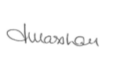 | Date: 27/01/2020

For STAFF Submissions:
Head of School/Assistant Dean: |  | Date:
Signature: |  | Date:

Checklist: Please complete the checklist below to ensure that you have completed the form according to the guidelines and attached any required documentation:
☒ | I have read the guidance notes supplied before completing the form.
☒ | I have completed ALL RELEVANT sections of the form in full.
☒ | I confirm that the research activity has received approval in principle
☐ | I have attached a copy of final/interim approval from external organisation (where appropriate)
☐ | I have attached a full risk assessment (and have NOT completed Section H of this form) (where appropriate) ONLY TICK IF YOU HAVE ATTACHED A FULL RISK ASSESSMENT
☒ | I understand that it is my responsibility to ensure that the above named research activity will meet the University’s Research Ethics and Integrity Code of Practice.
☒ | I understand that before commencing data collection all documents aimed at respondents (including information sheets, consent forms, questionnaires, interview schedules etc.) must be confirmed by the DoS/Supervisor, module tutor or Head of School.
☒ | I have deleted the guidance notes before submitting the PG2 for consideration

RESEARCH STUDENTS AND STAFF ONLY
All communications relating to this application during its processing must be in writing and emailed to pgresearch@uwtsd.ac.uk , with the title ‘Ethical Approval’ followed by your name.
You will be informed of the outcome of your claim by email; therefore it is important that you check your University and personal email accounts regularly.

STUDENTS ON UNDERGRADUATE OR TAUGHT MASTERS PROGRAMMES should submit this form (and receive the outcome) via systems explained to you by the supervisor/module leader.

This form is available electronically from the Academic Office web pages: http://www.uwtsd.ac.uk/academic-office/

Application Process

All staff research projects and all research students must submit the Ethical Approval Form to the University Ethics Committee via the Academic Office (pgresearch@uwtsd.ac.uk). Staff research directly in relation to personal study for taught undergraduate or Masters programmes should be submitted via the Faculty procedures explained below.

Taught masters and taught undergraduate research Ethical Approval Forms are considered within Faculties. Faculties will provide details of the specific processes for this. Where the Ethical issues within any single ethical application are of particular concern the Faculty will refer these to the University Ethics Committee. Any student activity that involves the collection of primary data needs to undergo Ethical approval, this includes assignment work as well as dissertations.

Notes for guidance in completion of this form

Section A: About You
Please complete all relevant sections

Section B: Approval for research activity
Research proposals must be approved in principle before applying for Ethical Approval. The proposal approval only becomes final when the ethical approval is received.

The process for proposal approval varies according the individual and programme of study:
- Research students, by application on form PG1 to the Research Degrees Committee
- Taught students by review of research proposal within Faculties (Faculties provide specific details of these processes)
- Staff, by agreement by the Head of School/Assistant Dean

Section C: External Ethical Guidance materials
Many discipline areas are required to operate with the discipline specific codes of research ethics (for example health, psychology, education etc.), any such codes must be listed and you must tick to confirm that you have consulted with these.

Section D: External Collaborative Research Activity
Provide details of the external collaborative partners, where appropriate you might want to submit a copy of the external collaboration agreement with the Ethical Approval Form. If the partner requires the research to be subject to its own internal Ethical approval process then please provide details of that process and a copy of any final (or interim) approvals received from the organisation.

Section E: Details of Research Activity
Remember that the individuals reviewing this Ethical Approval Form may not have seen your research proposal, and also may not be experts in the specific area of your research. The information provided should therefore be jargon free and clearly stated.
Indicative Title: please use the same title as used on the research proposal.
Purpose: the Ethical approval process will want to ensure that the methods you propose are adequate and appropriate to address the research aims and objectives. Excessive additional data collection can be seen as unethical.
Proposed Methods: the Ethical approval process seeks to ensure that you understand the methods that are intended, and that the implementation of those methods will be appropriate and without unnecessary impact on respondents. This section must explain how the methods described will lead to the collection of necessary and sufficient data, but not excessive data. Please be specific.
Location: this needs to mention geographical location and also local situation (for example, within Local Authority Offices in Cardiff, using a private room but close to other individuals). If you are collecting data within an organisational setting then you need to explain the permissions that you have obtained to do this.
Research Activity outside of the UK: please complete this section in detail, and note any guidance you have received. Also describe your own familiarity (or not) with the location that you will be utilising.

Section F: Scope of Research Activity
Please tick ALL of the research activities that might be undertaken. If any additional types of activity are intended then please add an extra box and describe these.
If you have answered no to all questions in F then sections G and J do not need to be completed. Section H should be considered, and may be completed. Signatures are still required in section K.

Section G: Intended Participants
Please tick all categories that might apply.
Numbers & Source: if you are using a series of different methods or research activities please list numbers for each stage/phase. Be clear about how you will find respondents. Will you use intermediaries, and if so how? How will you ensure compliance with your sampling strategy?
Information for participants: all participants should be appropriately informed about the research, what is expected of them and what will happen to the information that they provide. The Ethical review process does not ask to see this documentation, but requires this to be reviewed and approved by the Director of Studies in the case of research students, the supervisor/module tutor in relation to students on taught programmes and the Head of School/Assistant Dean in relation to staff research.

Section H: Anticipate Risks
All research carries some level of risk. The answers you provide to questions in this section will be reviewed to ensure that you have an appropriate understanding of the type of risks involved and how you can mitigate against these risks. If you have completed a full risk assessment, as required for example for laboratory work, field work, clinical tests, diving operations, or by a collaborative partner, you may append that to this form. In that case, please tick the box indicating this has been provided. You will not then be required to complete Section H.
Risk to participants Think very carefully about how your actions/questions/discussions might affect the people you are involving as participants. You might identify the risk as small but it would still be a risk. Many types of question have the potential to make respondents less content with their life / job; you need to recognise and try to ameliorate any such effects
If these are business owners, time with you may reduce profit.
In some locations physical risk is very real to both participants and yourself, please consider this.
Risk to you, the researcher Think about where you will meet people, if there are any dangers involved in the location. If you are meeting people as individuals think about using a public place. In general do not visit people in their own homes or remote locations. If you are talking to individuals about certain issues think about how their responses might affect you emotionally. What about the risk of collecting insufficient data?
Risk to the University When undertaking your research, you are acting as a member of the University (student or staff). Professionalism is important, so it is important to be well organised and well prepared. Punctuality, clarity etc. are all part of this. What will you do to ensure this? You must ensure you do not harm the good name of the University in any way and do nothing to undermine the reputation of the research it conducts and sponsors. Upholding high standards of conduct and integrity are vital in this regard. You must also conduct the research in such a way to minimise the potential for claims of negligence made against the University, its researchers and any collaborating individual or organisation. In this respect you should always comply with ethical, legal and professional frameworks, obligations and standards as required by statutory and regulatory authorities, as well as the university’s Research Integrity and Ethics Code of Practice. Research misconduct in this respect can take many forms, including:
- fabrication: making up results or other outputs (eg, artefacts) and presenting them as if they were real
- falsification: manipulating research processes or changing or omitting data without good cause
- plagiarism: using other people’s material without giving proper credit
- failure to meet ethical, legal and professional obligations: for example failure to declare competing interests; misrepresentation of involvement or authorship; misrepresentation of interests; breach of confidentiality; lack of informed consent; misuse of personal data; and abuse of research subjects or material
- improper dealing with allegations of misconduct: failing to address possible infringements such as attempts to cover up misconduct and reprisals against whistle-blowers

Adverse Outcomes. Think carefully about the possibilities, and cover here

Section I: Feedback, Consent and Confidentiality
Feedback to participants: outline your approach. Will interview transcripts be shared with respondents to check accuracy? Will summaries of questionnaire analysis be made available to respondents in some way? Will an overview report be provided? How and when?
Informed consent: Draft letter / e-mail / or heading (or footer) section of questionnaire must be approved by DoS/supervisor (if research student), supervisor/module tutor if taught student, or Head of School / Assistant Dean if a member of staff.
Confidentiality/Anonymity. Explain clearly how you will ensure confidentiality and anonymity.

Section J: Data Protection and Storage
Before completing this section it is necessary to read the University’s Research Data Management information. The questions that follow are designed to ensure compliance with the Data Protection Act as well as established research protocols.

Many research activities will involve electronic transfer of data and use of data management systems in the summarisation and analysis of data. You will need to explain these in relation to compliance with the Data Protection Act.
Think carefully about who will have access to your data, this will include supervisors and examiners. Also that a thesis will be made available via the University library and the British Library system. If you are seeking an access bar for a period of time after completion then mention it here. If you will provide a copy of your findings, or intend to give a presentation, to a facilitating/ supporting/accessing organisation then explain that in this section. But also think about the general principle of data sharing, as explained in the Research Data Management information.
In terms of storage of data please ensure security, and also mitigate against loss of data.

Section K: Declaration
Ensure the appropriate countersignatures have been provided
Look carefully at the checklist and ensure that you comply with and tick all that are relevant to your research.

