Digital Surveying and highway Design
Assignment 1
JAck bailey
2026

Contents
Introduction 2
Planning the Survey 2
Purpose of the Survey 2
Survey Area Definition 3
The Survey Area 3
Methods to be Used and Detail required 3
Site Assessment 4
Access Points & Scanning Positions 4
Lighting Conditions 4
Safety Considerations 4
Executing the survey plan 5
Survey Execution Summary 5
Problems Encountered 5
Comparison of methods 6
The Traditional Method – Manual Measurement v The Modern Method 6
Conclusion 6
Appendix 7
Appendix A – Site Risk Assessment 7
Overall Risk Rating 7
Appendix B – Photos Taken from the Scanning Locations 8

Figure 1- Rough Drawing of Floor Layout 3
Figure 2- Accurate Drawing with Manually Recorded Dimensions 4
Figure 3 - Pictures Taken from Scanning Locations 7
Figure 4 - modelled floor plan using recorded measurements 8

Introduction
This assignment will discuss the practical application of digital surveying technologies within the built environment, including the use of technology such as 3D laser scanning and more traditional manual methods.
The assignment is divided into three structured stages, a detailed survey plan, considering the purpose, safety, methodology, and site requirements necessary to achieve accurate results. The second stage involves carrying out the survey on site using 3D laser scanning technology to collect high-quality spatial data. Finally, the processed point cloud data will be analysed and interpreted to extract accurate building measurements and generate meaningful information about the surveyed structure.

Planning the Survey

Purpose of the Survey
The purpose of this survey is to capture accurate information relating to:
- The internal layout of the building or area being surveyed
- The existing structural elements of the building
- Locations of items, e.g. doors, pillars, stairs

This survey can then be used for future expansions or projects, such as design development, space planning, building documentation, BIM modelling or any future refurbishment. Due to the vast uses of this survey, it is imperative that the data is accurate and collected properly.

Survey Area Definition

The Survey Area
The area being surveyed is on the first floor of the IQ building in UWTSD, the area required extends from the northeast corridor and staircase down to the southern staircase including the open seating area and linking around to the bridge joining the two sides of the building.
The required level of detail included wall positions, door openings, staircases and columns. Furniture and temporary objects were not recorded with the manual methods but are included within the scanners rendered model, as well as this no high-level measurements were taken, observations were taken from ground level, and all areas were accessible by normal means.
This survey of the floor plan from the first floor excluded several areas. The doors for rooms have been marked out and recorded accurately but the rooms themselves are not recorded. Other areas that have been left out are the bottom hallways; these can be seen in figure 2 and are denoted with black squares as well as these the height of the rooms and corridors was not recorded as the survey focused on the footprint of the floor.

Methods to be Used and Detail required
This survey will be completed using multiple methods. Firstly, a rough drawing was completed by walking around and taking note of corners pillars and doors (Fig 1). Next a 2D drawing was completed using manual methods, taking measurements via tape and a laser distance measurer and has been imported onto an accurate drawing of the floor layout (Fig 2). A laser scanner was also used to create a digital drawing of the floor plan; this scanner is simpler to use and creates more accurate and reliable results, these results can be stored online but will also help to clarify if all areas are accurately recorded.
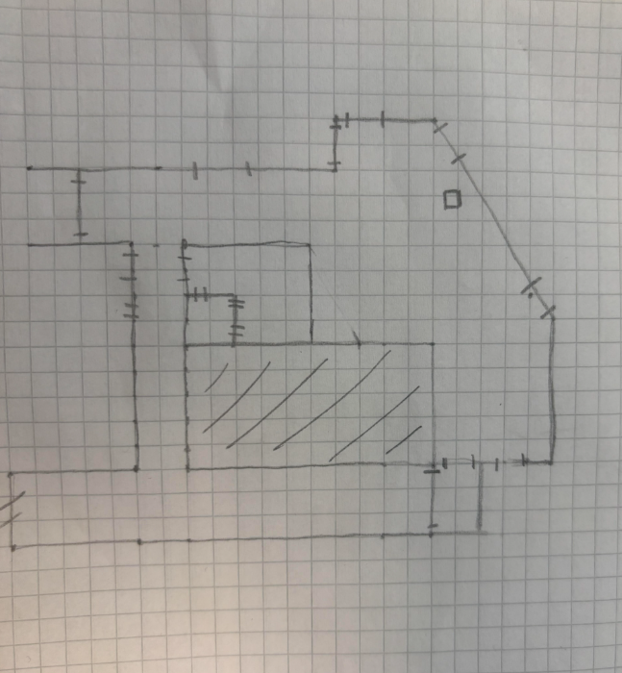
Figure 1- Rough Drawing of Floor Layout
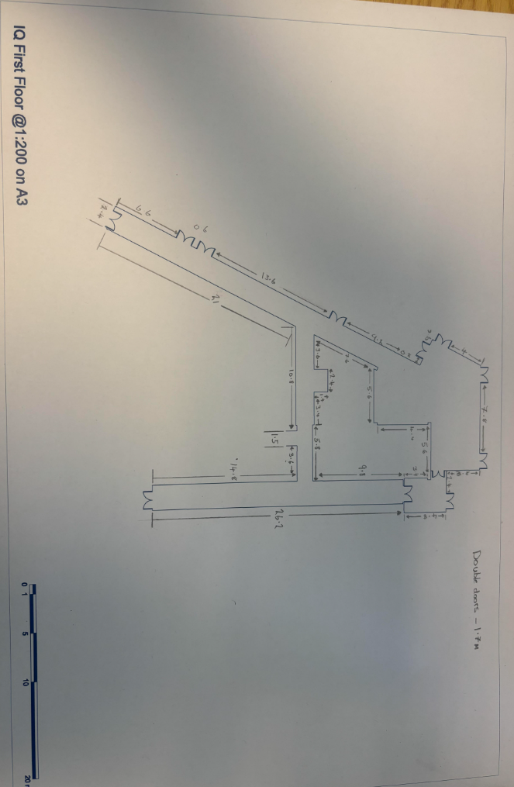
Figure 2- Accurate Drawing with Manually Recorded Dimensions

Site Assessment

Access Points & Scanning Positions
The area being surveyed has multiple access points including 4 staircases and 2 elevators. When setting up scanning positions for the laser scanner we selected positions that would give the best lines of sight for corridors in intervals of 5-10m; when approaching doors to get the best results the scanner was set on either side with the doors wide open, this helped to stitch the areas together after. For the main large open plan room multiple scans were taken from various positions to reduce shadows from objects blocking the scans. When using the scanner, it is important to consider the following:
- Blind spots in the scanners view
- There is adequate overlap from scans
- Doorways and access routes are scanned effectively
- The use of the area, if the area has constant flow of people or movement the scans will be inaccurate
- Reflective materials in the area causing inaccurate scans

with access to the scans on site data quality can be checked before leaving, areas affected by shadowing, obstruction or insufficient overlap can be rescanned immediately. These quality control checks reduce the risk of missing data and minimise the risk for repeat visits.

Lighting Conditions

Lighting conditions of the area are an important factor to consider for both health and safety but also the effectiveness of the scanner, the floor being surveyed has constant lighting from both artificial but also natural sunlight in given areas making it well lit during the survey. It is important to consider this when planning the survey as while low light may not affect the scanner, it will reduce the survey team’s ability to identify hazards, monitor and manage the equipment, as well as this any reflective or highly glazed surfaces should be covered, if possible, these surfaces can throw off data collection from the scanner by redirecting the light from the scanner.

Safety Considerations

There are many safety considerations to make and prepare for with most sites, such as the PPE needed, possible site inductions and security clearance as well as visitor passes.

When on-site the following considerations should be considered: -
- Follow site safety procedures
- Attend inductions and meetings, if the areas being surveyed are affected by an issue
- Maintain clear emergency routes and ensure all personnel are aware of routes and assembly points
- Keep pathways clear from obstructions e.g. work equipment, plant
- Be aware of equipment blocking access or causing hazards
- Theft or movement of equipment if left unattended
- Potentially restricted access

As this survey has been undertaken in a completed and operational university building with no ongoing works and was completed during normal working hours with access to light, the requirement for PPE is minimal.

A site risk assessment was done, seen in appendix A. It covers the most likely injuries to occur and steps to mitigate.

Executing the survey plan

Survey Execution Summary
  - What went as planned
- The Arrival for site was on time – Had adequate time to complete survey
- Equipment was set up ready and calibrated – No issues recording or capturing the data
- Completed overlap and stitching scans successfully due to sufficient overlaps – Stitched scans were accurately reassembled
- Survey was completed to the required level of detail with no shadows – The scans were accurate and captured all relevant information
- Data was successfully collected and uploaded with backups – The data was saved successfully; no return visits and the information is there for anyone who needs it

  - What had to change
- When checking after scan shadows were found requiring another scan from a different angle – shadows leave gaps in the information, another scan fixed that issue
- The location was changed due to a heatwave – the location selected as backup was better suited to work in during the heat
- The time of the survey was changed to avoid high temperatures – avoiding high temperatures let us complete the survey in more comfortable situations

  - Run-down of the survey
To start the survey a rough sketch was completed, this was to identify the area that needed to be surveyed, once the areas required were confirmed we could begin manually measuring the areas using a laser distance measurer and tape. We recorded these results on a rough drawing and then later transferred them onto a more accurate copy, seen in Fig 2. Once the manual measurements were completed, we used the scanner to create an accurate version, this included moving the scanner to multiple locations, seen in Fig 3 and setting up the height and levelling the scanner. The scan took about 2 minutes and then the scans were checked for quality and stitched together to slowly build the profile.

Problems Encountered
Before the survey was completed the location was originally designated as the Dylan Thomas centre of UWTSD. The dates arranged for the survey to be completed collided with a heatwave with temperatures reaching 35 degrees, it was deemed that given the heat and the amenities of the building such as lower air flow, that the conditions were unsuitable to complete the survey. The survey was moved to the IQ building earlier in the day to avoid some of the heat. As this scan was taken during a time where pedestrian traffic was expected, we checked areas before and the scans after in case someone did walk through the area as to avoid errors from the obstruction which would have thrown off the model.
Picture of the area can be seen in appendix B; the photos were taken from the scanning locations.

Comparison of methods

The Traditional Method – Manual Measurement v The Modern Method

The traditional method of gathering measurements is a slow process and involves a laser measuring device to record lengths of every wall, door and window. This leaves a lot of room for human error, it also becomes an issue when working in buildings with corners that aren’t 90°, this is due to not having an accurate wall to measure off from.
This process of collecting every length can be slow and inaccurate especially if the building is complex, this method could also potentially require another person to help with recording measurements in some situations. Due to these factors the chances to miss measurements or small details becomes more likely which could result in return visits.

The modern method of using a scanner is much more effective at gathering data and saves time, the data gathered can be put straight into a model on site as the scanner works. The scanner can collect different depths of data depending on the timer set, for our survey just under 2 minutes was set. This enabled the scanner ample time to gather the data at the depth required. Moving and choosing new scanner locations is a simple task and once levelled given the survey is indoors, it should be level for the rest of the survey. Once the scanner is set the everything else can be controlled from a linked tablet; the scanned portion of the area appears on the tablet and is then checked for quality such as obstructions or potentially reflective objects creating inaccuracies within the model. After the data is checked, we look to stitch the partial area with others already collected, this continues till the job is complete. This method greatly reduces the likelihood of human error, producing a quicker and more accurate collection of data compared to the traditional method.

When comparing the two methods, the models produced by scanning are significantly more detailed and the accuracy is of a much higher grade. The speed of both methods depends on the building shape and complexity, while small areas are easier to manually measure, the scanner may only need 1-2 scans to fully scan and develop a more accurate and precise model, more complex areas make the job harder for both methods. Multiple doors or obstructions mean more scans to complete to eliminate shadows, and this can extend time to complete the job, this method is still quicker and more effective than manually collecting the measurements.

Below is a comparison of the methods to clearly show the effectiveness of these methods: -
Factor | Manual Survey | Laser Scan Survey
Accuracy | Moderate | High
Speed of Data Collection | Slow | Fast
Costs | Low | High
Data Capture | Only select measurements | Complete 3D Record
Revisiting likelihood | More likely | Less Likely
Complexity | Difficult | Less difficult once set up

Conclusion

This survey helped to demonstrate the practical differences between manually measuring and modern scanning. Through planning, a risk assessment and careful execution both methods were able to yield accurate results and give a comprehensive representation of the IQ building. While the manual method was able to produce an accurate floor plan this took considerably more time and concentration to achieve without making mistakes. On the other hand, the scan was much quicker to set up and complete, had a greater level of detail and significantly reduced the chances of human error, it also resulted in an online copy that could be used in design, BIM or future refurbishments without requiring any more work to be done.

Appendix

Appendix A – Site Risk Assessment

Overall Risk Rating
For this standard visual building survey in an occupied university building during regular working hours, the overall risks that a surveyor would be exposed to are generally low, provided that normal health and safety procedures are followed and no intrusive investigations are conducted during the survey. Given this, there are still some risks that a person might be exposed to such as slips trips and falls, fire alarm or evacuation and manual handling injuries.
Hazards | Potential Harm / Severity | Who / What is at risk | Likelihood | Severity | Mitigation
Slips, trips and falls | Minor to serious injuries | Surveyors, General Public | Medium | Minor to serious | Follow designated walkways, good housekeeping awareness and wear suitable footwear
Staircase and level changes | Minor to serious injuries | Surveyors, General Public | Medium | Minor to serious | Use handrails, take care when carrying equipment or use elevators where possible, avoid rushing
Occupied work and teaching areas | Collision with students / staff, disruptions with scans | Surveyors, General Public | Medium | Minor | Have situational awareness, communicate operation with the people when needed
Manual handling of survey equipment | Strains and sprains | Surveyors | Low | Minor | Use correct lifting form, keep loads manageable, take rests if needed
Fire alarm or emergency evacuation | Injury during evacuation | Surveyors, General Public | Low | Serious | Familiarise with fire exits and evacuation procedures before conducting survey
Lone working | Delayed assistance in emergency | Surveyors | Low | Minor to serious | Maintain communication with colleagues, have check ins, follow lone working procedures

Appendix B – Photos Taken from the Scanning Locations

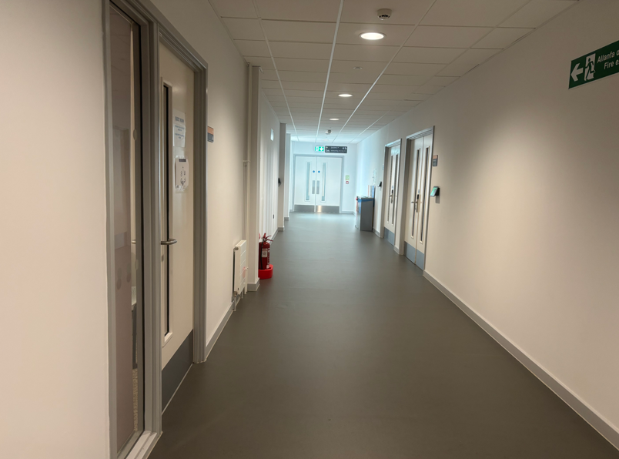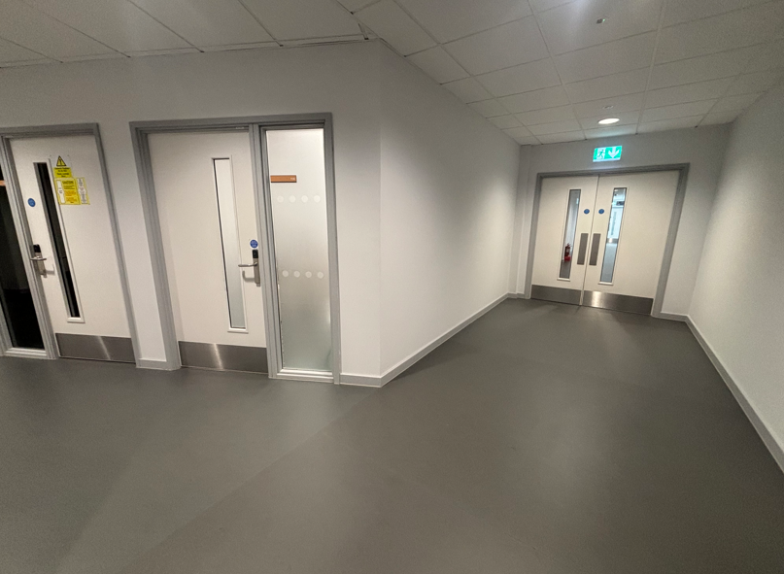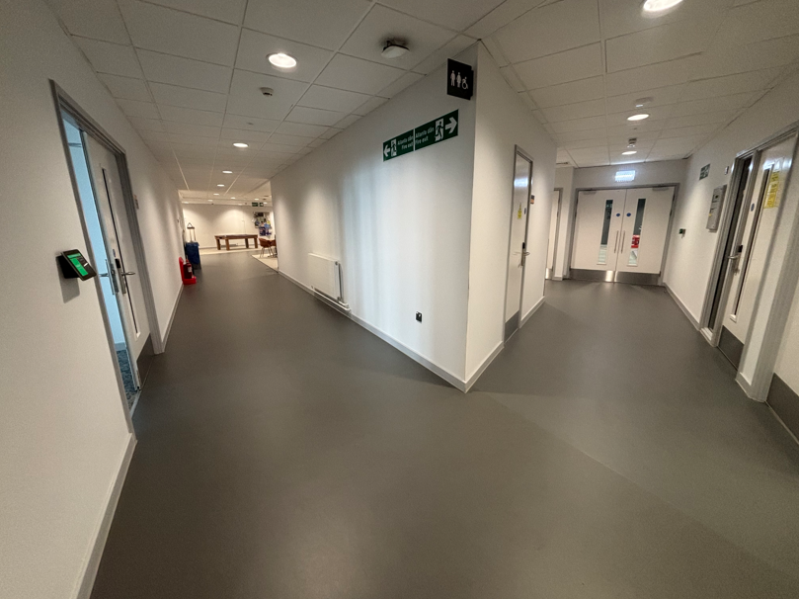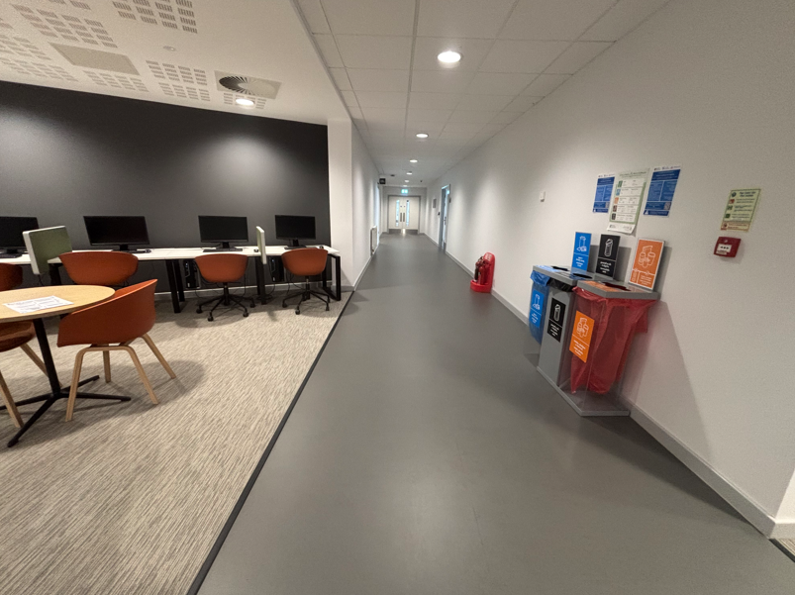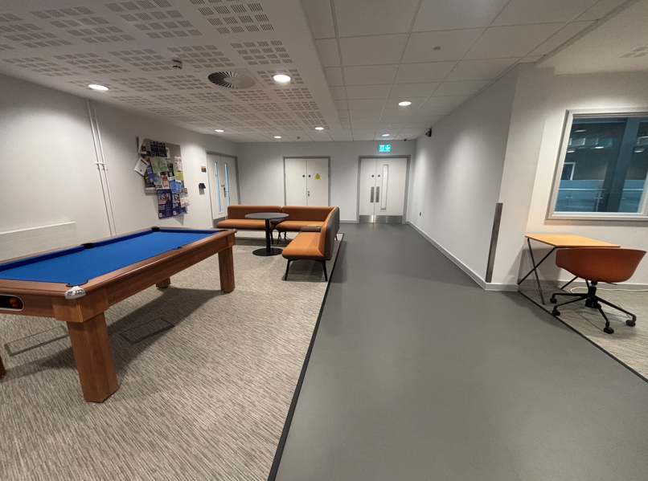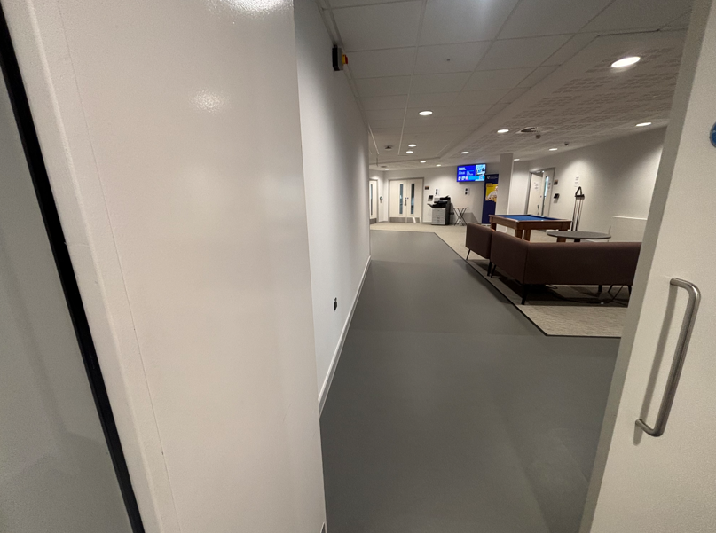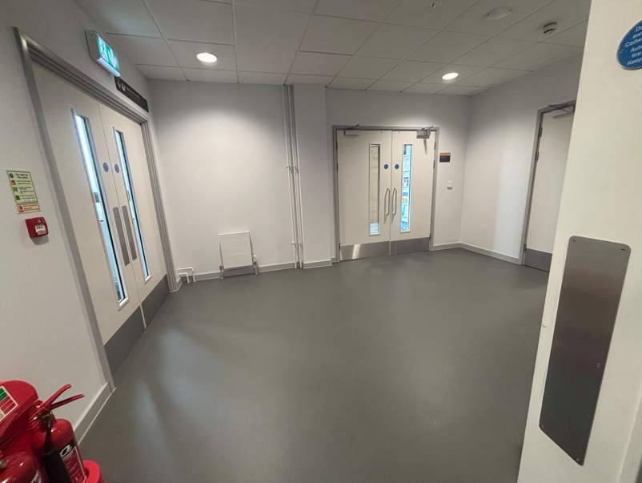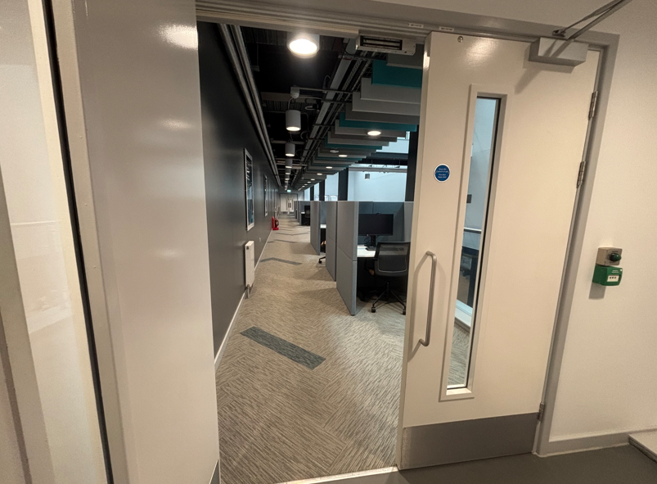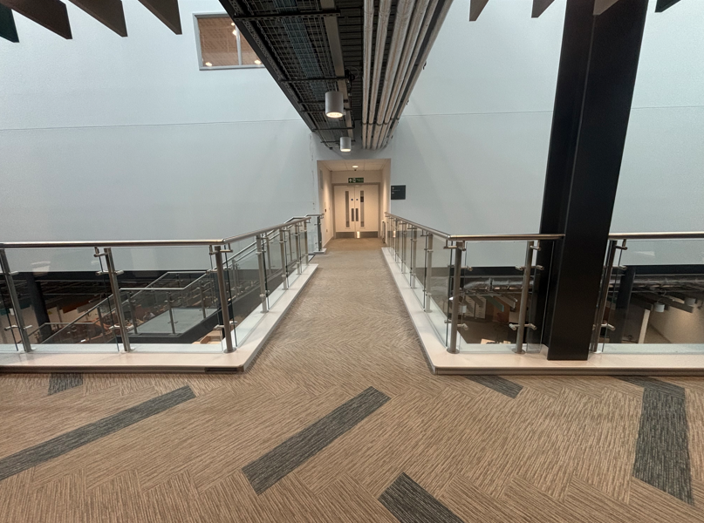
Figure 3 - Pictures Taken from Scanning Locations
Appendix C – Externally Modelled Floor Plan
The manually gathered measurements were used in combination with the 2D scan to calculate the approximate Net internal Area (NIA) I used a website to remodel the floor using the gathered measurements, seen in figure 4. I double checked the manually gathered distances against the 2D scan using a scale rule, using the scale rule I lost some of the smaller details to rounding but overall, from the survey, we had managed to gather all the necessary measurements with a great deal of accuracy. Given the dimensions from both methods and a take-off of the 2D render using a scale rule the approximate overall area is 286m².
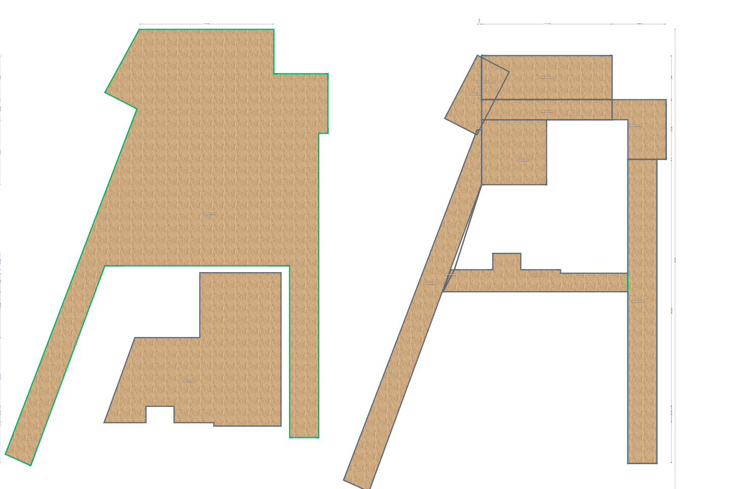
Figure 4 - modelled floor plan using recorded measurements

