Martin White (2218704)

Learning in the digital era(ACCA4025)
BENG2-PT Embedded Electronic Systems

Assesment 1

Contents
E-Portfolio 1
Task 1 2
Task 2 3
Task 3 4
Task 4 7

E-Portfolio



https://sites.google.com/view/martins-study-skills-uwtsd/home

Task 1

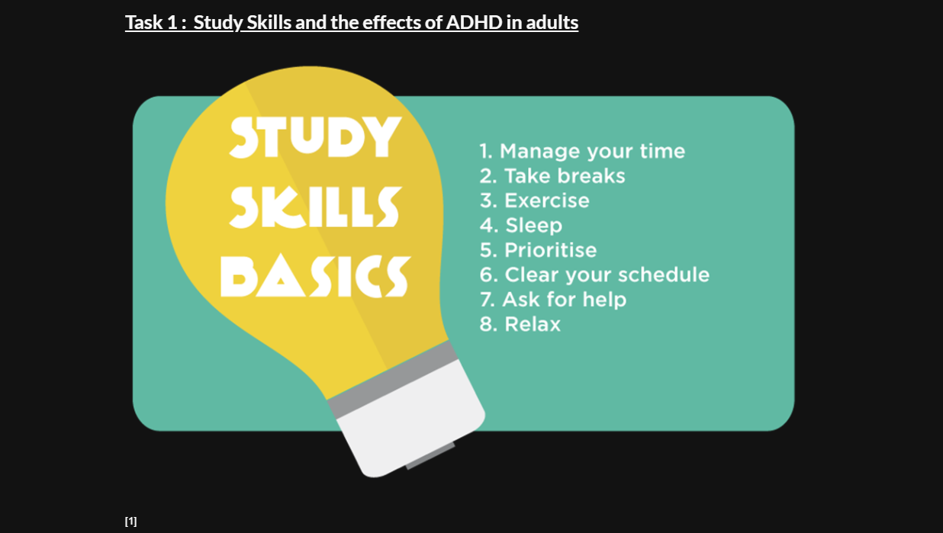
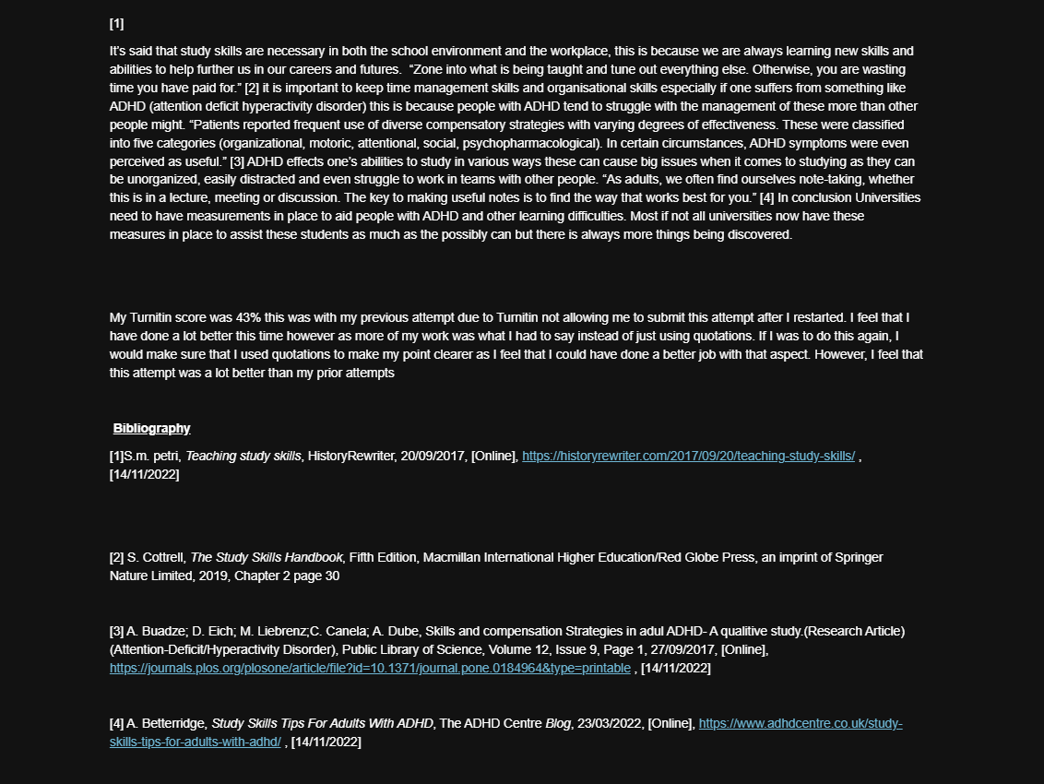

Task 2

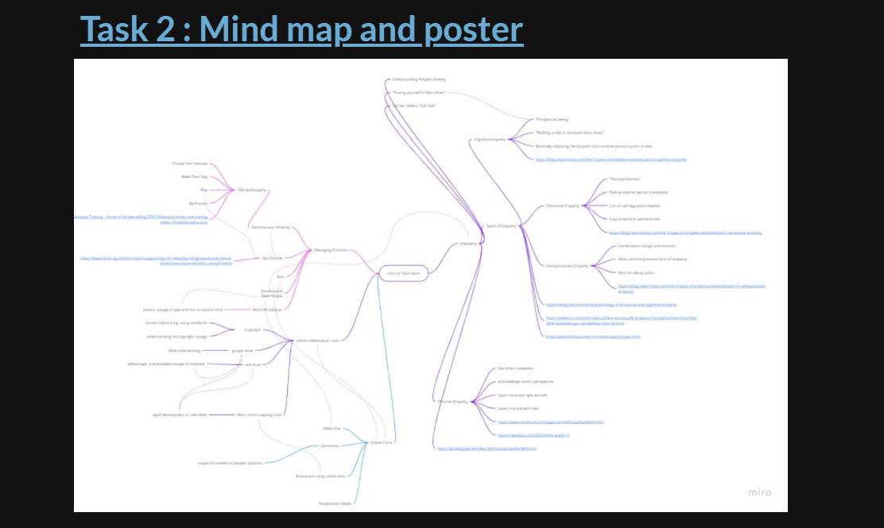
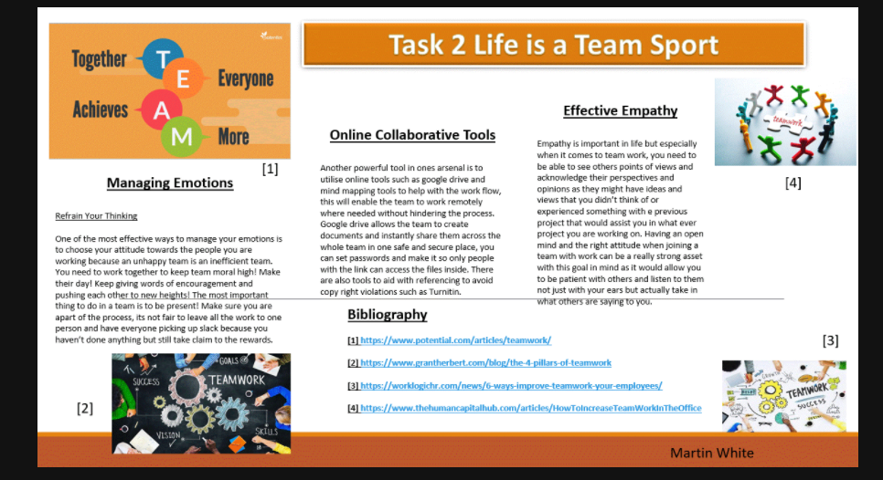
https://www.mediafire.com/file/ct86qi7td0ohp39/Team_work_poster.pptx/file

Task 3

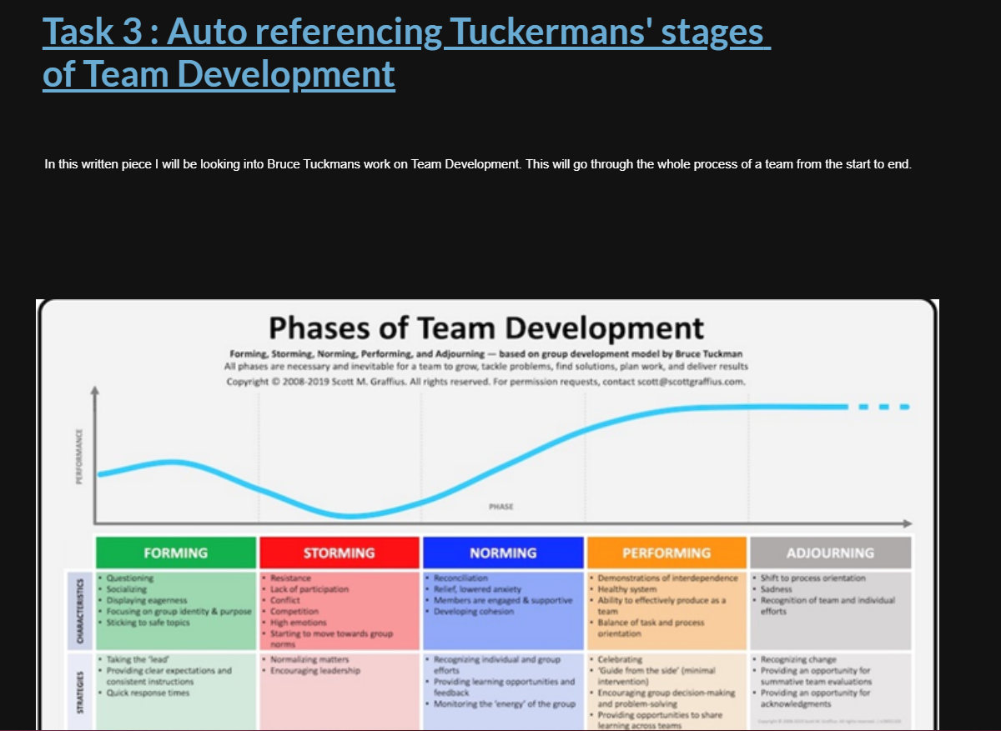

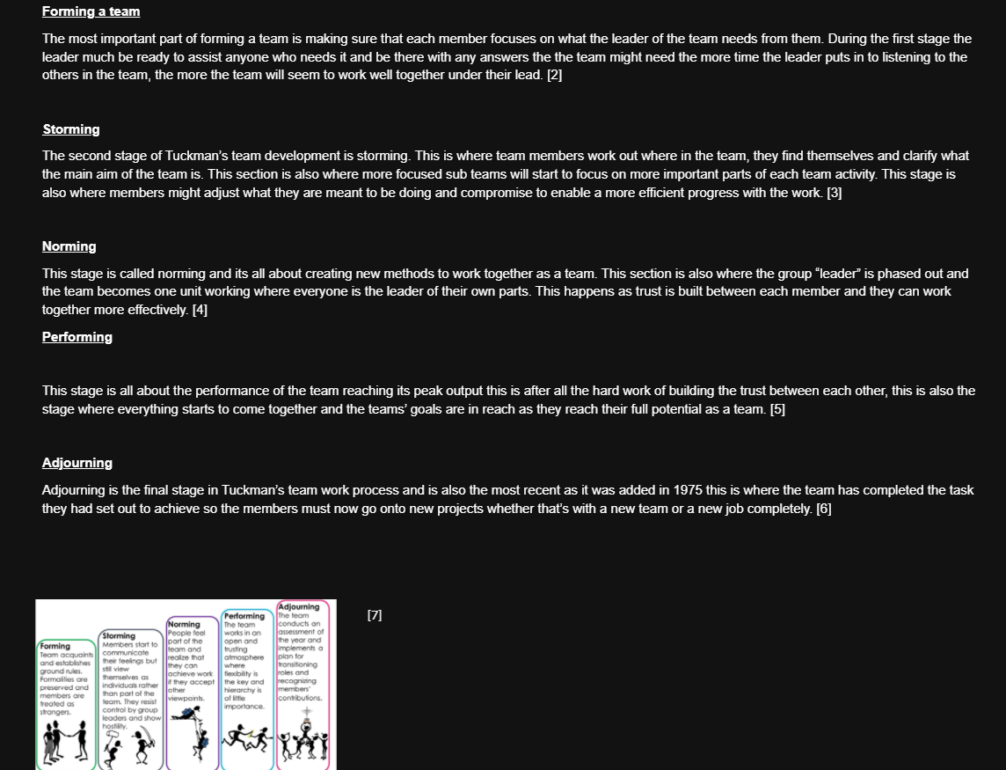
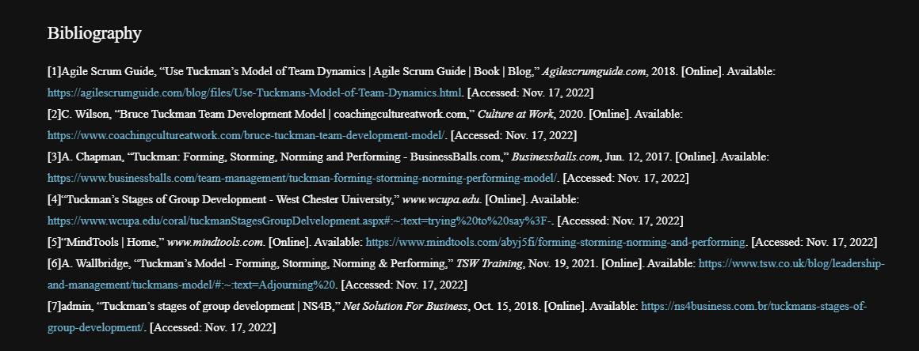

Task 4 A

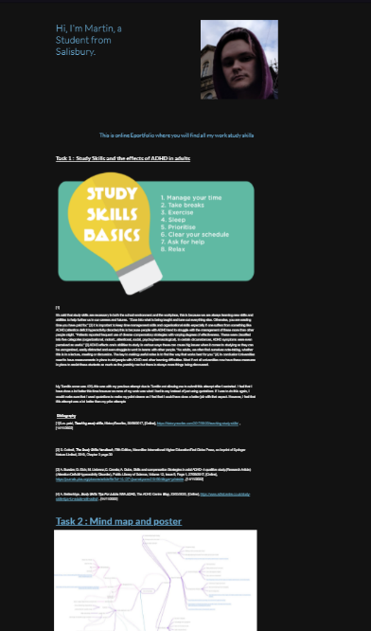

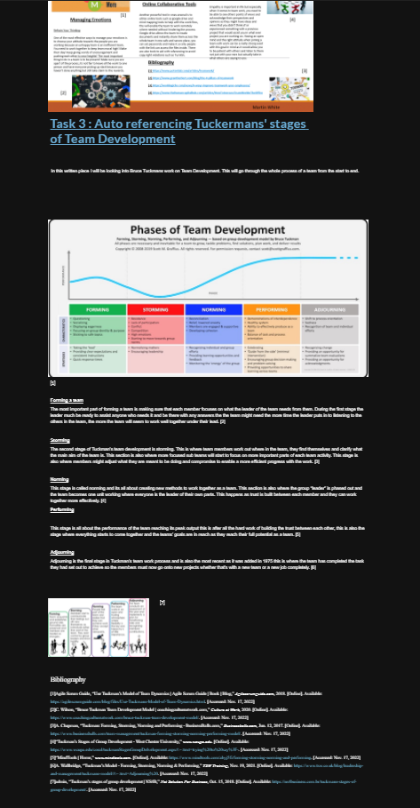

Task 4 B



