Wonderland Ltd
Website page
Digital skill and retail methods BMSK4003
Musarat Bibi 1805973
Email: 1805973@gmail.com password: uwtsdchris
Team members: Mohammed Nazamul Ahmed, Hayath Hareed Deen, Sadia Ahmed, Rahima Khanom.
In our team I started to create to first page then I got taken off to make it easier for one of my fellow team members. So throughout the course I have showed a lot of compassion towards this business plan in fair honesty I believe in this concept and do see viability. So I choose to create the service page as I was the one with the vision of the final product. So I choose to have a sensory room in the background as I wanted the customer to have the gloomy illuminated feel and that it was our ultimate USP besides many others. My tutor suggested to darker the background to make the writing standout
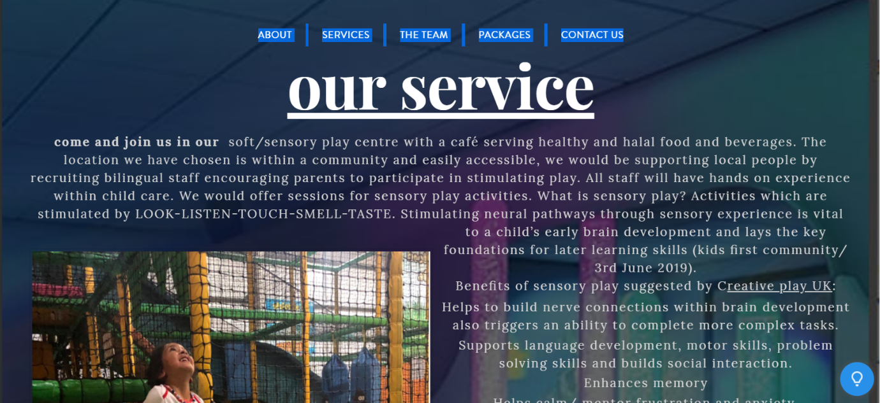
I choose to put a brighter image of a fellow peers child playing in a ball pit and it really brings emotion to the page.
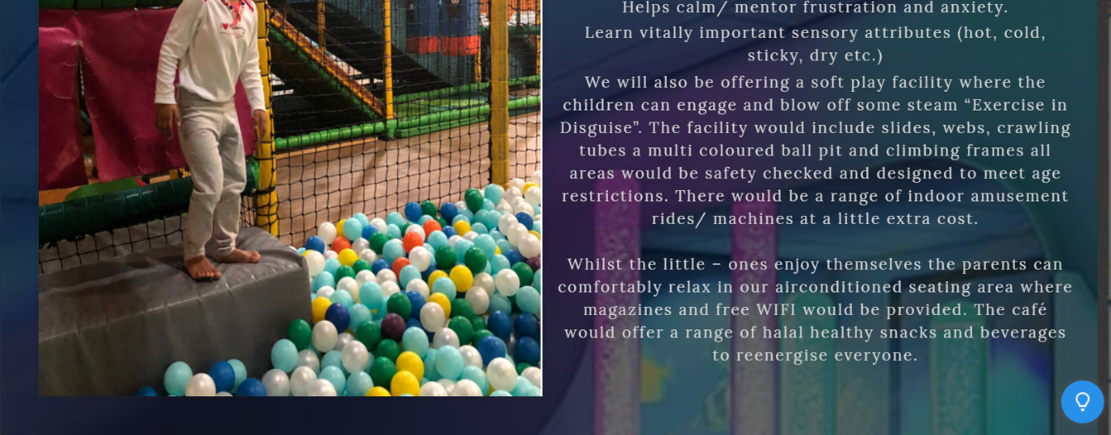
Within my writing I have shared akmost everything we will be offering to the customer for there payment. I have gone into the benefits and equipment offered to create a imaginative vision of our playcentre.
I also decided to include the menu I designed for the business, to reflect the 2nd USP in the business. I was aiming to bring life into website and get people druling.
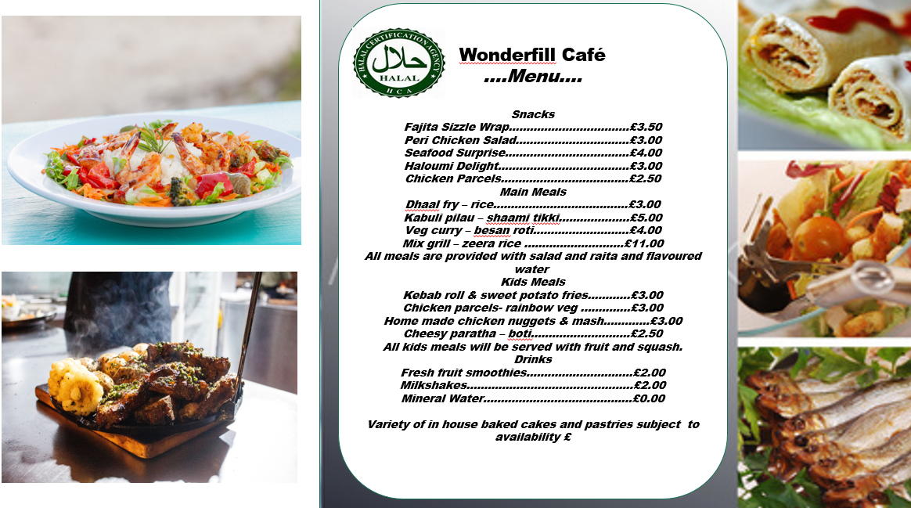

The book button was inserted for the customer to be directed to the payment page.


