

Managing Enterprise in the 21st Century
Business Plan: CAR PARTS EXPORTS FROM UK TO NAMIBIA


Submission Date:
Lecturer:
BIRMINGHAM: DR CHUNG LAI JOHNNY WAN
LONDON: DR CHARLES OHAM
Table of Contents
Executive Summary 3
Business Concept 4
Business Description 4
Product Description 5
Business Objectives (SMART Objectives) 5
Short-Term Objectives (less than a year) 5
Long-Term Objectives (More than a year) 6
Market Analysis and Marketing Plan 7
Market Analysis (Competitors, Customers, Target Groups) 7
PESTEL Analysis 8
SWOT Analysis 9
Marketing Mix (4Ps) 9
Management Team 10
Management Team and Their Background 10
Organisational Chart 10
Key Milestones 11
Financial Plan (One Year) 12
Sources of Finance 12
Cash Flow Forecast 12
Sales Forecast 13
Cost of Production Forecast 14
Break Even Analysis 14
Operations and Management Plan 15
Production of Good and Service 15
Technology Plan 15
Human Resource Plan 15
Expansion Plan 15
Business Model Canvas 16
Reference List 17
Appendices: 19

Executive Summary
BritLink Auto Parts Exports Ltd. will be a UK-based company focussing on exporting better quality car parts to Namibia. The business will aim to provide affordable, reliable automotive components by excellent customer service and efficient supply chain management. Further, through leveraging strategic partnerships and trusted suppliers, the firm can seek sustainable growth, long-term success and profitability in the Southern African market.

Business Concept

Business Description
Figure 1: Logo of BritLink Auto Parts Exports Ltd.
(Source: Self-Created)
BritLink Auto Parts Exports Ltd. will be a UK based private limited company. The organisation will be established for exporting high-quality certified and new aftermarket car parts from the UK to Namibia. Apart from this, the business will also focus on supplying essential automotive components, incorporating braking systems, engine parts, electrical parts, suspension components, accessories and filters to the wholesalers, vehicle repair workshops and retailers. Besides this, BritLink Auto Parts Exports Ltd. will also operate under the functional management structure that would be led by the Managing Director along with supported by the departments which are responsible for logistics, procurement, finance, customer service and sales. The legal format of BritLink Auto Parts Exports Ltd. will be “Private Limited Company (Ltd.)”. The use of “Private Limited Company (Ltd.)” can be helpful as it assists in providing limited liability, ensuring perpetual succession and establishing separate legal identity (Dudycz, 2025). Furthermore, the organisation will provide reliable, timely and cost-effective export services with supporting and building long-term partnerships with Namibia's growing automotive aftermarket.

Product Description
BritLink Auto Parts Exports Ltd. will focus on supplying high-quality genuine, certified, OEM aftermarket car parts that are sourced from the reputable UK distributors and manufacturers. Besides this, the product range incorporates engine braking systems, components, suspension parts, filters, batteries, tyres, electrical components and vehicle accessories that will be exported to wholesalers, retailers, along with automotive repair workshops across Namibia.

Business Objectives (SMART Objectives)
Objective: To be a leading UK exporter of high quality car parts to Namibia through building long-term customer relationships and achieving sustainable sales growth within the first year of operation.
Specific | Exporting high-quality UK car parts to Namibia
Measurable | Achieving 75% in sales revenue and securing 10 regular business customers
Achievable | Building reliable logistics and supplier partnerships
Relevant | Ability to meet Namibia's increasing demand for quality automotive parts
Time-bound | Achieve within the first 12 months of the business operation
Table 1: SMART Objectives
(Source: Self-Created)

Short-Term Objectives (less than a year)
- Obtain all export licences and register the business
- Securing at least 5 customers in Namibia
- Establishing partnerships with the UK car parts suppliers
- Developing a digital marketing strategy and e-commerce website
- Achieving consistent positive customer feedback and monthly export shipments

Long-Term Objectives (More than a year)
- Expanding exports across the Southern African markets
- Building long-term partnerships with the major Namibian distributors
- Increasing product range to incorporate commercial vehicle parts
- Achieving profitability and sustainable revenue growth
- Establishing BritLink Auto Parts Exports Ltd. as one of the trusted automotive export brands

Market Analysis and Marketing Plan

Market Analysis (Competitors, Customers, Target Groups)
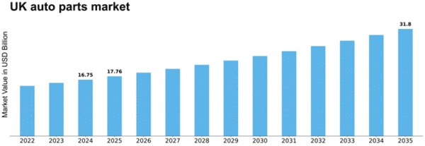
Figure 2: Auto parts market in the UK
(Source: Market Research Future, 2026)
BritLink Auto Parts Exports Ltd. will compete with the UK’s automotive regional and export suppliers serving Namibia. The auto parts market is forecasted to increase to “31.8 USD Billion” by 2035 reflected in above figure (Market Research Future, 2026). However, in Namibia demand for automotive parts has increased extensively. For instance, Trentyre Namibia has generated $8.5M in revenue (Zoominfo, 2026). The target customers incorporate spare parts retailers, automotive wholesalers, fleet operators, vehicle repair workshops and dealerships. The organisation will differentiate itself by competitive reliable product quality, pricing, excellent customer service and efficient logistics.
Segmentation | Targeting | Positioning
- Wholesalers, garages, retailers, fleet operators | - B2B automotive businesses in Namibia | - Reliable UK exporter of affordable and quality car parts
Table 2: “Segmentation, Targeting, Positioning (STP)” Framework
(Source: Self-Created)

PESTEL Analysis
Factors | UK Description and Impact | Namibia Description and Impact
Political | - Trade relations with United States, Germany, Ireland and others (Gov.uk, 2026)  - Positive | - Trade relations with South Africa, Botswana, China and others (World Integrated Trade Solution, 2026)  - Positive
Economic | - Inflation increased by 2.8% (Office for National Statistics, 2026)  - Negative | - Inflation 3.5% (Worldbank, 2026)  - Negative
Social | - 0.84% of global population (Worldometers, 2026) | - 0.04% of global population (Worldometers, 2026)
Technological | - 36.2% investment in R&D (Office for National Statistics, 2025) | - Only 11% in R&D (Research Professional News, 2026)
Environmental | - Strict polluter penalties (Azo Cleantech, 2025) | - A fine of fine of N$10 000 penalties for pollution (Namibian, 2026)
Legal | - “Companies Act 2006” (Legislation.gov.uk, 2026) | - “Import and Export Control Act (Act 30 of 1994)” (Namibia Trade Portal, 2026)
Table 3: PESTEL Analysis of the UK and Namibia
(Source: Self-Created)

SWOT Analysis
Strengths | Weaknesses
- Reliable supplier network  - High quality UK car parts  - Competitive pricing | - High shipping costs  - Limited brand recognition  - Increased dependence on export regulations
Opportunities | Threats
- E-commerce and B2B partnerships  - Expansion into Southern Africa  - Increasing demand in Namibia | - Robust market competition  - Exchange rate fluctuations  - Supply chain disruptions
Table 4: SWOT Analysis of BritLink Auto Parts Exports Ltd.
(Source: Self-Created)

Marketing Mix (4Ps)
Factors | Description
Product | Genuine, certified aftermarket UK car parts and OEM
Price | Value-based and competitive pricing with bulk purchase discounts
Place | Exported from the UK to retailers, wholesalers and garages in Namibia by maintaining efficient logistics
Promotion | Digital marketing, trade exhibitions, B2B sales, distributor partnerships and email marketing
Table 5: Marketing Mix (4Ps) for BritLink Auto Parts Exports Ltd.
(Source: Self-Created)

Management Team

Management Team and Their Background
BritLink Auto Parts Exports Ltd. will be led by a Managing Director. Additionally, experienced in business management and international trade. The management team incorporates a Logistics Manager, Procurement Manager, Finance Manager and Sales and Marketing Manager. Further each will bring expertise in customer relations, supply chain operations, export compliance and financial management.

Organisational Chart
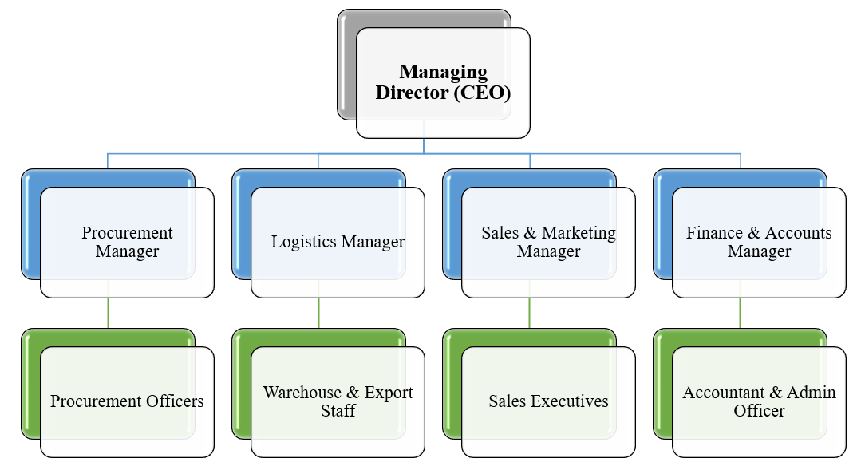
Figure 3: Organisational Chart
(Source: Self-Created)

Key Milestones
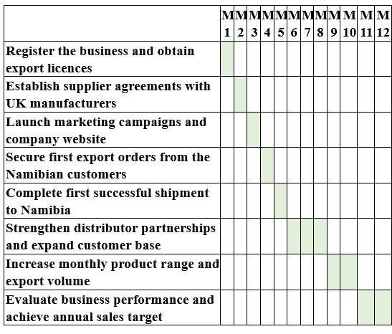
Figure 4: Key Milestones
(Source: Self-Created)

Financial Plan (One Year)

Sources of Finance
- Bank business loan
- Trade credit from UK suppliers
- Owner's personal investment
- Government export support grants or schemes
- Retained earnings from initial sales
- Business overdraft facility
- Private investor funding or angel investor
- Invoice financing or trade finance

Cash Flow Forecast
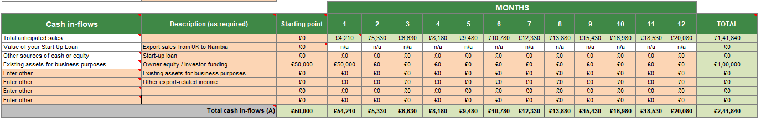
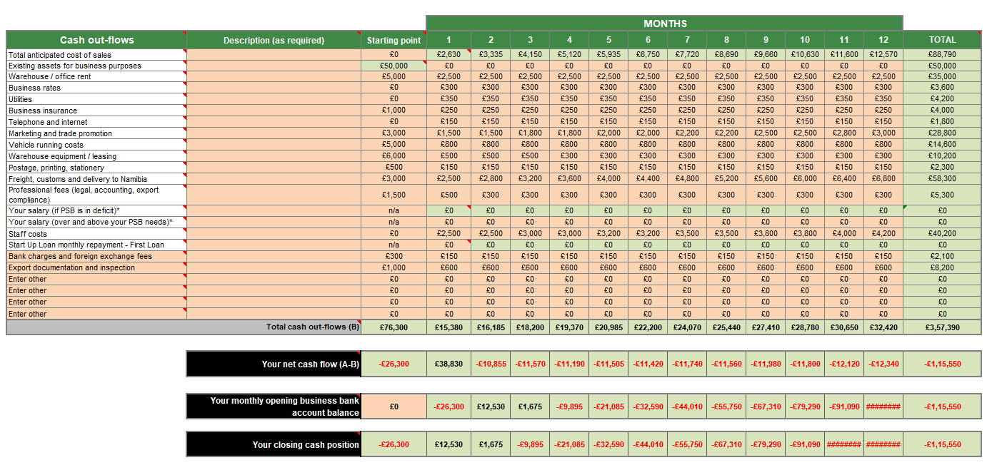
Figure 5: Cash in-flows and Cash out-flows of BritLink Auto Parts Exports Ltd.
(Source: Self-Created)
The Cash Flow Forecast assists in indicating that the car parts export business needs to maintain positive cash flow as there is increase in sales. Besides this, initial funding also aids to support early operating and setup costs, whereas gradually export revenue can strengthen liquidity. Further, careful control of freight, purchasing, operating and customs expenses will be significant to maintain sufficient support growth and cash reserves.

Sales Forecast
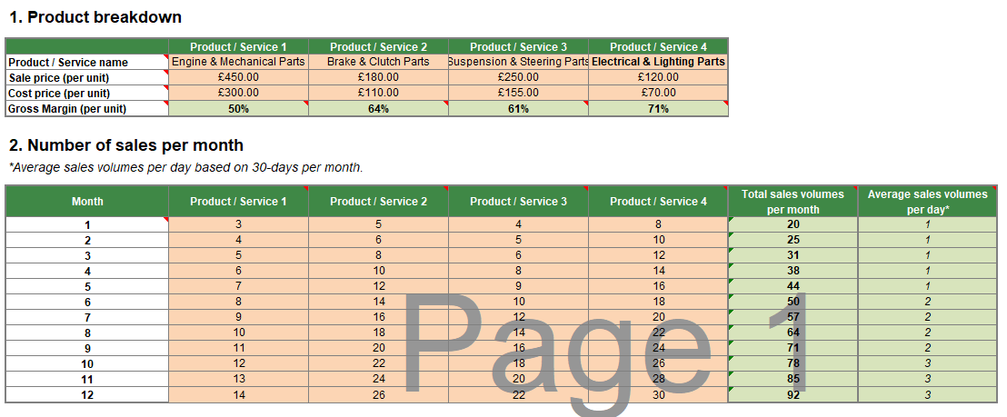
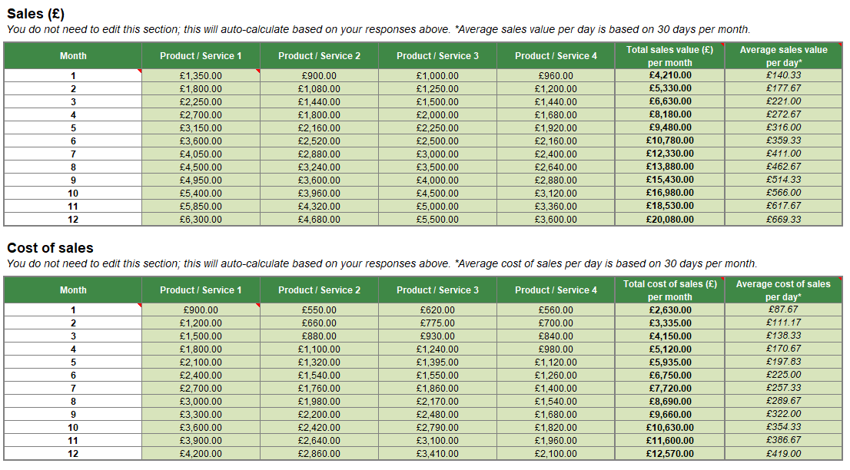
Figure 6: Sales Forecast of BritLink Auto Parts Exports Ltd.
(Source: Self-Created)
The sales forecast mirrors gradual growth in the car-parts exports from the UK to Namibia. Additionally, supported by repeat orders and increasing customer demand. Required cost for the organisation for startup funding can be £50,000 approximately. The funding can be sourced primarily from small business loan as well as an owner investment, in the initial operations.

Cost of Production Forecast
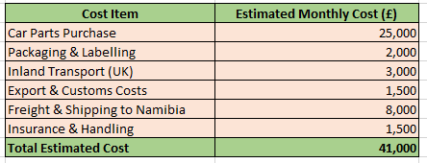
Figure 7: Cost of Production Forecast
(Source: Self-Created)
The costs are forecasted to elevate as the export volumes increases, and cost control can be significant for ensuring sustainability in the business operations along with maintaining higher margins in profit. The above figure reflects Cost of Production Forecast that highlights the expenses for purchasing car parts, UK transportation, shipping to the country (Namibia), packaging, export customs, insurance as well as handling.

Break Even Analysis
The respective business named BritLink Auto Parts Exports Ltd. is projected to reach the break-even at 60–65% approximately considering the planned sales capacity. Apart from this, the sales revenue can also cover the variable along with the fixed costs. Grasping more than 70% sales capacity can be fruitful to provide a stronger financial position followed by generating a positive operating margin.

Operations and Management Plan

Production of Good and Service
The respective organisation will focus on sourcing genuine, certified, OEM aftermarket car parts from the reliable UK suppliers. However, the products will be packaged securely, undergo through multiple paths such as quality checks, inventory management, customs documentation followed by efficient shipping. Additionally, this pathway is followed before exporting to the retailers, wholesalers as well as automotive workshops in Namibia along with ensuring reliable and timely deliveries to enhance customer satisfaction.

Technology Plan
The respective organisation will focus on incorporating and effectively using inventory management software, “Customer Relationship Management (CRM)”, cloud-based accounting systems followed by shipment tracking technology. Apart from this, digital communication tools followed by a professional e-commerce website will be helpful to provide support in customer service, order processing, real-time monitoring as well as supplier coordination for exporting to improvise accuracy and efficiency.

Human Resource Plan
The concerned organisation will focus on recruiting qualified professionals for procurement, sales, administration, logistics and finance. Regular training on customer service, export regulations, workplace safety and inventory management will also be provided to staff. Apart from training, performance-based incentives followed by continuous professional development initiatives can aid to improvise employee motivation, productivity along with long-term organisational performance.

Expansion Plan
Considering the above factors BritLink Auto Parts Exports Ltd. in Namibia can focus on expanding into the neighbouring Southern African markets, incorporating Botswana, Angola and Zambia. Moreover, the organisation can also strengthen supplier partnerships in future, increase warehouse capacity, diversify the product portfolio as well as invest in digital marketing for enhancing support for sustainable business growth and increasing more profits.

Business Model Canvas
Key partners  Logistics firms  UK suppliers  Customs agents | Key Activities  Exporting  Sourcing Marketing customer service | Value Proposition  Quality UK car parts at very competitive prices | Customer Relationships  Long-term partnerships  Personal support | Customer Segments  Wholesalers  fleet operators  Retailers  Garages
Key partners  Logistics firms  UK suppliers  Customs agents | Key Resources  Inventory  Staff  Warehouse  Technology |  | Channels  Website  Distributors  B2B sales
Cost Structure  Inventory  Shipping  Salaries  Marketing |  |  | Revenue Streams  Bulk export contracts  Car parts sales
Table 6: Business Model Canvas for BritLink Auto Parts Exports Ltd.
(Source: Self-Created)

Reference List
Azo Cleantech, (2025). “United Kingdom: Environmental Issues, Policies and Clean Technology”. Available at: https://www.azocleantech.com/article.aspx?ArticleID=535 [Accessed on: 26th July 2026]
Dudycz, T., 2025. Legal form affects the performance of a company. European Journal of Law and Economics, 60(1), pp.81-143. https://link.springer.com/content/pdf/10.1007/s10657-025-09852-0.pdf
Gov.uk, (2026). “Trade and investment core statistics book”. Available at: https://www.gov.uk/government/statistics/trade-and-investment-core-statistics-book/trade-and-investment-core-statistics-book#:~:text=Top%20UK%20export%20markets,%3A%20October%20to%20December%202025). [Accessed on: 26th July 2026]
Legislation.gov.uk, (2026). “Companies Act 2006”. Available at: http://legislation.gov.uk/ukpga/2006/46/contents [Accessed on: 26th July 2026]
Market Research Future, (2026). “UK Auto Parts Market”. Available at: https://www.marketresearchfuture.com/reports/uk-auto-parts-market-47090 [Accessed on: 26th July 2026]
Namibia Trade Portal, (2026). “General Export, Import and Transit Procedures”. Available at: https://namibiatradeportal.gov.na/general-trade-information/general-export-import-and-transit-procedures [Accessed on: 26th July 2026]
Namibian, (2026). “Govt to impose heavier penalties for sea pollution”. Available at: https://www.namibian.com.na/govt-to-impose-heavier-penalties-for-sea-pollution/ [Accessed on: 26th July 2026]
Office for National Statistics, (2025). “Research and development expenditure by the UK government: 2023”. Available at: https://www.ons.gov.uk/economy/governmentpublicsectorandtaxes/researchanddevelopmentexpenditure/bulletins/ukgovernmentexpenditureonscienceengineeringandtechnology/2023 [Accessed on: 26th July 2026]
Office for National Statistics, (2026). “Inflation and price indices”. Available at: https://www.ons.gov.uk/economy/inflationandpriceindices [Accessed on: 26th July 2026]
Research Professional News, (2026). “Namibia’s R&D intensity exceeds national goal”. Available at: https://www.researchprofessionalnews.com/rr-news-africa-south-2017-3-namibia-s-r-d-intensity-doubles-in-a-few-years/ [Accessed on: 26th July 2026]
World Integrated Trade Solution, (2026). “Namibia trade balance, exports and imports by country 2021”. Available at: https://wits.worldbank.org/CountryProfile/en/Country/NAM/Year/2021/TradeFlow/EXPIMP/Partner/by-country [Accessed on: 26th July 2026]
Worldbank, (2026). “Inflation, consumer prices (annual %) - Namibia”. Available at: https://data.worldbank.org/indicator/FP.CPI.TOTL.ZG?locations=NA [Accessed on: 26th July 2026]
Worldometers, (2026). “Namibia Population”. Available at: https://www.worldometers.info/world-population/namibia-population/ [Accessed on: 26th July 2026]
Worldometers, (2026). “U.K. Population”. Available at: https://www.worldometers.info/world-population/uk-population/ [Accessed on: 26th July 2026]
Zoominfo, (2026). “Top Small Automobile Parts Stores companies in Namibia - July, 2026”. Available at: https://www.zoominfo.com/top-lists/top-retail-auto-parts-companies-in-NA-size-small [Accessed on: 26th July 2026]

Appendices:

