A report on Marketing management of Golf shoes

Abstract
Golf shoes are a smart idea because they are made to prevent the feet from moving about while the player plays. Golf shoes that fit properly will stop the feet of the player from slipping within the shoes as well as the shoes from slipping out from beneath the player while he/she is swinging. The report undertakes the Customer journey and touchpoints of the golf shoes with the description of the total engagement model.

Contents
1. Introduction 2
1.1 Background 3
2. Communication 3
2.1 Communication Model 3
3. Integrated marketing communication 4
4. Promotional stratagies 4
5. Branding 5
6. Brand Equity 5
6.1 Aaker’s brand equity model 6
7. Customer Journey 7
8. Customer Touchpoints 8
9. Total engagement model 9
Conclusion 10
References 11

1. Introduction
Golf shoes are a smart idea because they are made to prevent the feet from moving about while the player plays. Golf shoes that fit properly will stop the feet of the player from slipping within the shoes as well as the shoes from slipping out from beneath the player while he/she is swinging. The midline foot portion, which is typically more elastic in athletic shoes, is kept stabilized and solid while the player swing thanks to characteristics built expressly with the golf game in consideration. Golf shoe bottoms are designed to prevent lateral displacement (Drashti,2020).
Many widely known companies produce golf shoes such as Skechers, Nike, PUMA, Adidas and others. Setting objectives is essential when looking for the best golf shoes. The three most crucial factors are convenience, fit, and swinging stability for the majority of golfers. Along with stability, ventilation, lightweight, how they handle on slopes and in wet circumstances, and whether or not they retain the dry, there are also, obviously, aesthetic considerations (Drashti,2020).

1.1 Background
The Golfer's Guidelines 1857 edition has one of the aforesaid factors of spiked golf shoes. According to the Scottish journal, inexperienced golfers should wear sturdy shoes "whacked with little screws or sprigs" to navigate slick terrain securely. In 1906, Spalding unveiled the "saddle oxford" kind of shoe, which had an additional saddle-shaped segment of leather wrapped around the strings. Although it was initially intended for racquet sports, it wasn't particularly well-liked there (Drashti,2020). It did establish itself as the norm for golf shoes and continued into the twenty-first century. To enhance the golf shoes into more comfortable and much less harmful to greens and clubhouse floors, shoemakers began using non-metallic spurs in the 1990s. The benchmark for studded golf shoes has now been established by these tiny plastic spikes (Gokalgandhi et al.,2020).
Spike-less shoes, a style that goes back to the first golfers, became popular by 2010. There has been an upsurge in demand for more relaxed golf shoes as a result of the small number of Professional golfers who have been spotted using spike-less shoes (Gokalgandhi et al.,2020). The newest generation of spike-less shoes offers improved relaxation despite giving up part of the traction of spiked shoes. Golfers frequently choose between wearing spike-less or spiked shoes based on the course of the play and the conditions of the clubhouse. The mission statement of golf shoes is to “Increase the performance of the golf players and to create more relaxed and comfortable golf shoes” (Gokalgandhi et al.,2020).

2. Communication
Information exchange in the company and with external parties is known as business communication. To achieve organisation objectives, management and staff must interact effectively in the workplace (Coffelt,2020). Its goal is to make system components better and cut down on mistakes. To accomplish effective business communication, it's critical to improve both communication abilities and procedures. Effective communication and communication strategy are the cornerstones of every structured action in an organization (Coffelt,2020).
This could involve everything from technological supplier interaction to administrative communication. One indicator of a high-performance environment at work is communication. Professional communication is the process of transferring knowledge and ideas inside a company (Coffelt,2020). However, successful communication can be done when information is sent and interpreted appropriately. Communication is essential to achievement and enjoyment in all facets of one's life (both professionally and personally). For all corporate objectives, positive workplace communication is critical (Coffelt,2020).

2.1 Communication Model
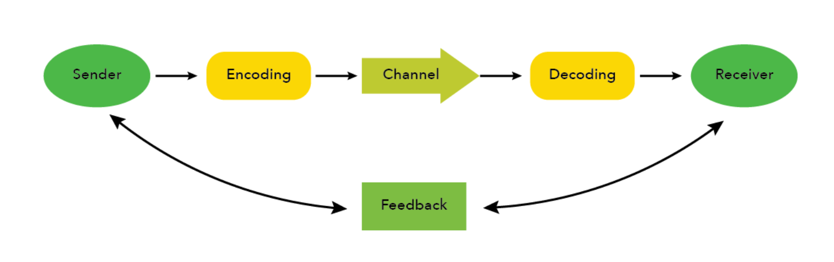
Fig.1. Communication model
Source: (Tawafak et al.,2020)
In effective workplace communication, the sender shares the information with the receiver. Before the information is shared it is encoded into a form of transmission. The form of transmission can be spoken words to the receiver or it can be in form of texts, tables, graphs and charts. It is the channel of the medium into which the information is exchanged from the sender to the receiver. The channels of communication include air conveying methods through sound waves, paper conveying methods such as texts, emails and images, electronic signals and others (Tawafak et al.,2020).
In two-way communication, the receivers perform the same process in communicating with the sender. The receiver receives the encoded messages and then decodes them to comprehend the information shared. After decoding the message and understating the information the receiver sends feedback to the sender indicating that the message has been received and interpreted. It encourages a conversation between the sender and the receiver and leads to effective communication in the organisation (Tawafak et al.,2020).
For instance, A customer wants to purchase golf shoes, The customer visits the outlet of the company and sends the information to the manager through the medium of spoken words. The manager decodes the information and comprehends the requirements of the customer regarding the golf shoes. Effective communication helps the manager to meet the demands of the customer and to make a profit (Tawafak et al.,2020).

3. Integrated marketing communication
The practice of marketing communication that includes various aspects, such as brand management, social networking sites, market analytics, business growth concepts, and promotion, into a brand recognition that is constant across various media channels is known as integrated marketing communication (IMC). It enables both private and public entities and corporations to provide enjoyable and smooth customer satisfaction for a good or service, as well as to enhance a company's effectiveness and connections with stakeholders (Tanjung,2021).
A multifunctional subject called integrated marketing communication includes the use of both traditional and digital media. As the name implies, integrated marketing communications is a robust marketing plan that takes into account the greater context of an organization’s goals as well as the necessities for business growth and upkeep (Tanjung,2021). The integrated marketing communication tools include advertising, sales promotion, personal selling, Public relations, direct and indirect marketing channels, events and others. The golf shoe companies undertake the process of integrated marketing communication to increase the market reach of the products and inform potential customers regarding the shoes. Integrated marketing communication helps the golf shoe companies to send a unified message to the wider customer market (Tanjung,2021).

4. Promotional stratagies
4.1 Social media marketing
The promotional strategies that companies can undertake to promote golf shoes include social media marketing of golf shoes. Companies can advertise their products and offerings on social media platforms like Facebook and Google+ in a more informal setting. The best kind of marketing and advertising is this (Ciesla,2019). Through social media, golf shoe companies can reach a global audience of prospective customers who may have a unique viewpoint on the organisations and the product. For instance, Nike skillfully uses social media to connect with its millions of consumers and draw in new potential customers throughout the world. This business broadened its internet presence by setting up various accounts on various social media sites, including Fb and Twitter, Twitter, Instagram, and LinkedIn (Ciesla,2019).
4.2 Public Relations
The Other promotional strategy that companies can undertake tis o promote golf shoes is Public relations. Public relations generally referred to as the process of improving a brand's reputation in the minds of the public, has long been acknowledged as among the most successful forms of advertising (Ciesla,2019). Corporations participate in public relations activities including hosting media interviews, sending out press statements, and doing media appearances. Organizations frequently employ endorsements as a form of public relations tactic to build a positive reputation for their company (Anunobi,2018).
For example, Nike has improved its global visibility by sponsoring several athletic activities and professional athletes. Huge athletic events were financed by Nike as a direct way to reach its intended audience. It sponsored numerous football clubs in Africa, Asia, Europe, and South America as well as every NFL league's jersey. Additionally, it supported numerous international football teams (Anunobi,2018).
4.3 Charity
Another promotional strategy that golf shoe companies undertake includes charity. The target market of the company is upper-middle-class golfers. Donations and tying up with a Ngo will help the companies in creating brand awareness and penetrating the target market. Individuals are drawn to businesses that offer top-notch services while also providing back to society (Anunobi,2018). As a result, both influential and small businesses alike employ this tactic to expand their clientele. The businesses should collaborate with a charitable foundation or an NGO, and then promote the relationship and campaign on their websites, social media accounts, and in-store displays to raise awareness and encourage consumers to purchase golf shoes to contribute to society (Sackey,2022).
4.4 Direct marketing
Direct marketing is another type of promotional strategy that companies can undertake. Direct marketing is a type of promotion that directly targets an individual or organization in an effort to increase sales, bring attention to a brand or product, or bring in new clients. Prevalent forms of direct marketing include sales promotion, online marketing, and newsletters (Sackey,2022). The most valuable sales advantage of all is used by direct marketing: the chance to interact personally and immediately with the buyer. It enables businesses to communicate directly with their market segment without resorting to old-fashioned, expensive promotional methods like TV, news outlet, and radio commercials (Sackey,2022).
For instance, Nike uses a direct marketing method to reach more customer groups with its advertising. The business uses its additional features to stand out from the competition, draw in more buyers, and have an increased market effect. Through a direct marketing scheme, this business fosters brand engagement and raises consumer awareness of Nike (Sackey,2022).

5. Branding
By using components like a logo, layout, vision and mission, and a constant theme across all the marketing and communications, branding aims to give consumers a clear, favourable impression of a business, its services or goods. Efficient branding enables businesses to stand out from the competition and develop a devoted consumer base (Hao et al.,2019). By building and defining a brand in clients' perceptions, branding is the method of imparting meaning to a certain organization, company, product, or service (Hao et al.,2019). By defining what this specific brand is and is not, businesses can help people immediately recognize and appreciate their brand and offer them a reason to pick their services over those of the opposition. By consistently providing a product that is in line with everything the brand claims, the goal is to draw in and keep the support of devoted clients as well as other constituencies (Hao et al.,2019).
The golf shoe companies undertake the prices of branding to increase brand awareness and brand recognition in the target market. The golf shoe companies aim to provide comfortable and lightweight shoes to the golfers, undertake to the brand to aware the customer about the products and increase brand loyalty among customers (Hao et al.,2019).

6. Brand Equity
Brand equity is the worth of having a recognisable and well-recognized business as well as the extent of influence a brand name has over buyers' minds. Companies build brand equity by offering customers satisfying experiences that motivate them to stick with them instead of switching to rivals who provide comparable goods (Keller,2019). Brand equity is often developed by awareness-raising initiatives that appeal to the values of the potential consumers, fulfilling commitments and requirements when customers use the goods, and engagement and retention initiatives (Keller,2019).
The impacts it can have on Profitability are a significant advantage of building strong brand equity. Businesses that effectively use branding frequently outperform their rivals in terms of revenue while investing less overall, whether on marketing, manufacturing, or other expenses. For instance, solid brand equity helps companies to demand higher prices (Keller,2019). Customers will pay more to buy from a brand when they respect the principles it upholds and the calibre of the goods it produces (Shariq,2018). Additionally, promoting brand-new products within the same brand name will accelerate the growth of the new offering because credibility has already been built. The golf shoe companies such as Adidas, Nike, and PUMA have strong brand equity and brand loyalty of the customers (Shariq,2018).

6.1 Aaker’s brand equity model
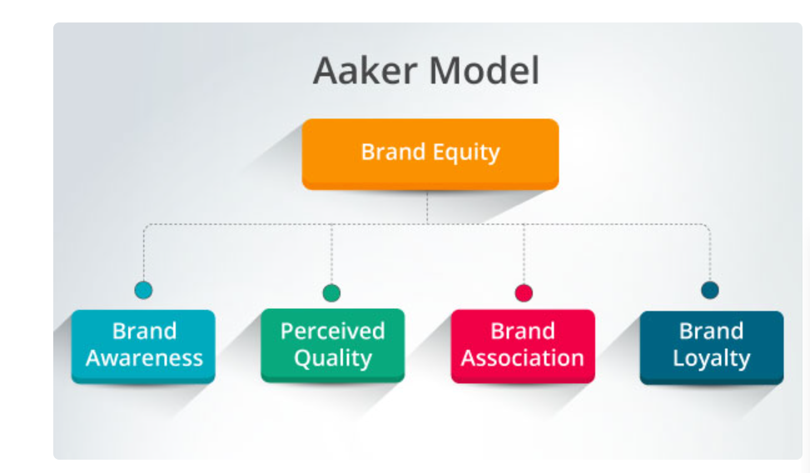
Fig.2. Aaker’s brand equity model
Source: (Amoako,2022)
Brand awareness
The brand awareness of golf shoes is increasing through various promotional methods. The companies undertake various marketing and promotional strategies such as advertisement, use of social media marketing, and endorsing famous golf players. Partnership with the golf teams and others helps the companies in increasing brand awareness (Amoako,2022).
Perceived quality
The company manufactures and produces high-quality golf shoes to meet the requirements of the customers. The companies aim to provide a high-quality experience to golfers. They provide comfortable, relaxed, lightweight products to increase the overall quality of golf shoes. It will increase customer satisfaction of the customers while playing golf (Amoako,2022).
Brand Association
The golf shoe companies undertake various methods to create a positive brand association in the market. The companies undertake various ways to create positive brand association such as brand identity, use of brand assets including logos and colours, advertisements, presence on social media platforms and others. For instance, the brand association of Nike is comfortable, luxurious, and sportswear (Tsordia,2018).
Brand loyalty
The golf shoe companies undertake various methods to increase the brand loyalty of the target customers. The methods include engaging with the golfers and understanding the requirements, focusing on providing a quality experience to the customer, focusing on attractive logo design and endorsing popular athletes to gain consumer attraction. For instance, PUMA endorses Usain Bolt and Rihanna to promote its brand image (Amoako,2022).
Advantages of Aaker’s brand equity model
1. Helps in analysing the brand equity of the company
Aaker’s brand equity helps the company in analysing the brand equity of the company. It also helps in analysing the awareness of the brand and brand association in the market. It also helps in evaluating the quality of the products that the company is providing to its customers. The company can analyse its competitive advantage over its competitors and the differentiation of the products from its competitors (Tsordia,2018).
2. Helps in analysing the negotiation power of the company
The model also helps the companies in analysing the negotiation power. After analysing the customer loyalty and brand association, the organisations get an idea regarding their brand equity that further helps them in identifying the company’s negotiation power (Tsordia,2018).
3. Analyse the credibility of the products
The model also helps the companies in evaluating the credibility of their products in the market. Through analysing the quality of the products and customer experiences, it becomes easier for the company to identify the credibility of their brand and the products under the brand name (Tasci,2020).
Disadvantages of Aaker’s brand equity model
1. Less flexible
Aaker’s brand equity model outlines the guideline of brand equity but it is less flexible. It does not consider other factors. The approaches and guidelines of the model are more rigid and cannot be modified according to unusual situations (Tasci,2020).

7. Customer Journey
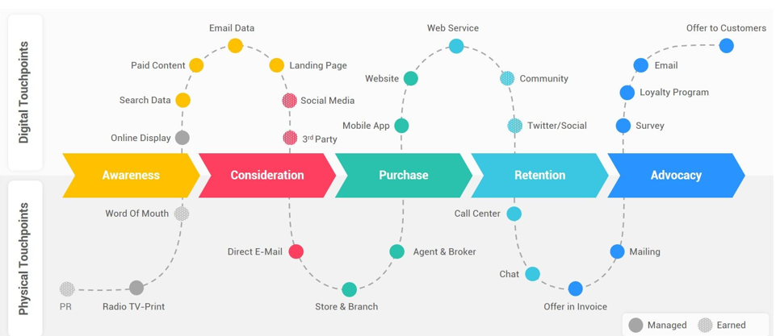
Fig.3. Customer journey Map
Source: (Gao,2020)
7.1 Awareness
It is the first phase of the customer journey where the customer realises the problem or the needs of a specific product or service. It is the phase where golfers realise the golf shoes are needed to enhance their performance in golf. It is the point where customers seek content regarding the product that could meet their needs. Marketing teams of the companies help the customers to meet their requirements by offering the appropriate products (Grewal,2020).
7.2 Consideration
In this phase, the customers compare the products of different products in terms of price, brand, features and others. The teams of the companies help the customers in understanding the features of the golf shoes (Grewal,2020).
7.3 Purchase
Individuals in this stage frequently have a narrow list of businesses they might buy from, so a business has an advantage over its rivals if it has a strong sales strategy and compelling case studies. Such as the customer might have an alist of the popular golf shoe companies and might buy from the one that appeals to them the most and meets their requirements (Gao,2020).
7.4 Retention
It Is the post-sale phase of the customer journey. Companies might develop a customer loyalty program or knowledge base FAQ during the retention phase. They can also routinely update clients on business or product advancements (Gao,2020). Additionally, businesses might arrange frequent product training sessions or extend their campaigns throughout the service lifecycle. Greater consumer involvement, consumer satisfaction, and knowledge can all result from constant communication (Grewal,2020).
7.5 Advocacy
Word-of-mouth promotion, which can draw prospective users to a brand, can result from customer endorsement. Many people base their consumer choices on peer-to-peer positive stories and case studies (Gao,2020). If properly tracked, businesses may link the influence of a single referral to subsequent increases in revenue. The customer who bought golf shoes from Adidas can advocate about his/her experience that will increase the brand image and sales of Adidas (Gao,2020).

8. Customer Touchpoints
8.1 Before purchase
Official website
The official website of the golf shoe company is an important touchpoint for the customer journey. The customers would come across the official website to get knowledge regarding golf shoes. It is possible that the customer might purchase the shoes online if the website meets the requirements of the customers (Brann et al.,2020).
Partnerships
Another important customer touchpoint in the customer journey is the partnerships and endorsements of the golf shoe companies with popular brands and famous celebrities. The influencers will help the customers to get knowledge regarding golf shoes (Bascur,2018).
8.2 During Purchase
Brochures
Whether they are physical copies or online soft versions, product catalogues or pamphlets are excellent tools for showcasing golf shoes. Customers may gather all the details required to make a transaction with the aid of product information and images (Barann et al.,2020).
Customer reviews
Numerous websites allow users to publish product reviews, where they can rate the item and provide details or criticisms of particular features. It's crucial to keep in mind that prospective buyers are consulting these evaluations while deciding whether or not to acquire the golf shoes (Bascur,2018).
8.3 After Purchase
Feedback
The feedback is an important touchpoint in the customer journey. The feedback surveys help the companies evaluate the experiences of the customers through the purchase of golf shoes. It includes the evaluation of the reasons behind the good or bad feedback of the experience of the customers (Barann et al.,2020).

9. Total engagement model
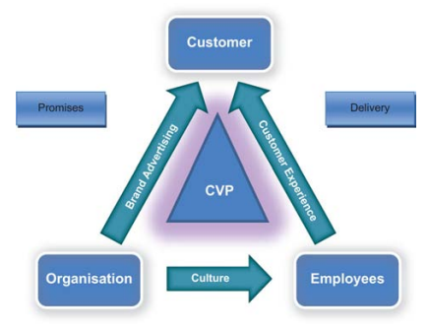
Fig.4. Total engagement model
Source: (Roberts,2018)
9.1 Customer Value proposition
The golf shoe companies provide high-quality and comfortable golf shoes to the customers to create value. The companies aim to meet the demands of the customers, For instance, the customer value proposition of Adidas is fast fashion, innovation and customization. It includes a quick reaction to the market trends and ensuring the quality of the products. It gives Adidas a competitive advantage over its competitors (Grover,2020).
9.2 Brand advertising
The golf shoe companies undertake various advertising methods such as digital marketing, social media marketing, email marketing and others to reach the target customers and increase the brand awareness of the golf shoes (Grover,2020). For instance, Tim Clarke, the president of Wilson Golf, started using reality TV in 2016 to promote the company. Wilson and The Golf Channel collaborated to create "Driver vs. Driver," a Shark-Tank counterfeit where regular people were asked to provide ideas for a "groundbreaking new driver” (Sun,2018)
9.3 Customer Experience
The golf shoe companies aim to provide a high-quality experience to the golfers to retain the customer and gain new ones. The companies aim to fulfil their commitments to the customer and deliver high-quality experiences to the customers (Sun,2018). The role of employees plays an important role in providing a high-quality experience to the customers. A clear understanding of roles and responsibilities in golf shoe companies helps the organisation in enhancing the customer experience. It shows the culture of the organisation that takes place within the management of the company (Sun,2018).
9.4 Culture
The organisational culture of the golf shoe companies is to increase the overall profitability of the company by providing high-quality, comfortable shoes to the golfers to enhance their performance and satisfy their needs. Playing golf is considered a luxury and the golf shoes culture aims to enhance the customer’s experience and to deliver comfortable golf shoes to the golfers (Grover,2020).

Conclusion
The golf shoes has been evolved through the times in order to help the golfers in improving their performance. The report undertakes the background of the golf shoes and its journey from the past year. The report also describes the definition of communication and integrated marketing communications. The communication models helps in facilitating the two way communication in the golf shoe companies. The report undertakes the definition of branding and brand equity. The report undertakes the customer journey and customer touchpoints of the customers.
The customer touchpoint includes three phases that are before the purchase, during the purchase and after the purchase. It also describes the total engagement model of the golf shoe companies including customer value proposition, customer experience, brand awareness and culture of the companies. The report undertakes Aaker’s brand equity model related to the golf shoe companies. It also details the advantages and disadvantages of the brand equity model.

References
Amoako, K. and Boateng, E., 2022. Analysis of the effectiveness of Corporate Social Responsibility in brand marketing with AAKER Brand Equity and Daisy Wheel Models. Technium Soc. Sci. J., 30, p.484.
Anunobi, C.V. and Ape, R., 2018. Promotional Strategies for Open Access Resources Discovery and Access. Webology, 15(1).
Barann, B., Hermann, A., Heuchert, M. and Becker, J., 2020. Can't touch this? Conceptualizing the customer touchpoint in the context of omni-channel retailing. Journal of Retailing and Consumer Services, p.102269.
Bascur, C., Rusu, C. and Quiñones, D., 2018, October. User as customer: touchpoints and journey map. In International Conference on Human Systems Engineering and Design: Future Trends and Applications (pp. 117-122). Springer, Cham.
Ciesla, R., 2019. Promotional Strategies. In Game Development with Ren'Py (pp. 325-337). Apress, Berkeley, CA.
Drashti, G., Laxit, K., Shah, N. and Ninad, M., 2020. A Review of Smart Technologies Embedded in Shoes. Journal of Medical Systems, 44(9).
Gao, L., Melero, I. and Sese, F.J., 2020. Multichannel integration along the customer journey: a systematic review and research agenda. The Service Industries Journal, 40(15-16), pp.1087-1118.
Gokalgandhi, D., Kamdar, L., Shah, N. and Mehendale, N., 2020. A review of smart technologies embedded in shoes. Journal of Medical Systems, 44(9), pp.1-9.
Grewal, D. and Roggeveen, A.L., 2020. Understanding retail experiences and customer journey management. Journal of Retailing, 96(1), pp.3-8.
Grover, P. and Kar, A.K., 2020. User engagement for mobile payment service providers–introducing the social media engagement model. Journal of Retailing and Consumer Services, 53, p.101718.
Hao, A.W., Paul, J., Trott, S., Guo, C. and Wu, H.H., 2019. Two decades of research on nation branding: A review and future research agenda. International Marketing Review.
Keller, K.L. and Brexendorf, T.O., 2019. Measuring brand equity. Handbuch Markenführung, pp.1409-1439.
Sackey, M.E., Markey, K. and Grealish, A., 2022. Healthcare professional’s promotional strategies in improving Human papillomavirus (HPV) vaccination uptake in adolescents: A systematic review. Vaccine.
Shariq, M., 2018. Brand equity dimensions-a literature review. International Research Journal of Management and Commerce, 5(3), p.312.
Sun, G. and Bin, S., 2018. Construction of learning behavioral engagement model for MOOCs platform based on data analysis. Educational Sciences: Theory & Practice, 18(5).
Tanjung, I.S., Tanjung, H. and Wibowo, Y.S., 2021. Development of Tourism Communication Model Based on Local Wisdom in Padangsidimpuan. Budapest International Research and Critics Institute (BIRCI-Journal): Humanities and Social Sciences, 4(4), pp.9877-9885.
Tasci, A.D., 2020. A critical review and reconstruction of perceptual brand equity. International Journal of Contemporary Hospitality Management.
Tawafak, R.M., Romli, A.B., Arshah, R.B.A. and Malik, S.I., 2020. Framework design of university communication model (UCOM) to enhance continuous intentions in teaching and e-learning process. Education and Information Technologies, 25(2), pp.817-843.
Tsordia, C., Papadimitriou, D. and Parganas, P., 2018. The influence of sport sponsorship on brand equity and purchase behavior. Journal of Strategic Marketing, 26(1), pp.85-105.
Roberts, Christopher & Alpert, Frank. (2010). Total customer engagement: Designing and aligning key strategic elements to achieve growth. Journal of Product & Brand Management. 19. 10.1108/10610421011046175.

