Focus on Facilitation

Facilitation comes from the latin word ‘facilis’, meaning easy. Does that mean that facilitation is easy? As the facilitator… no not at all, as the participant in the group… yes, one would want participants to feel at ease. In your applied drama learning and practice and throughout this book you will hear much about the facilitator – the person who runs the applied drama sessions. However, when we start to explore what this role looks like and the intentionality behind facilitating it can open up a world of complexities.

As a student of applied drama you will be prompted to ask questions of yourself in relation to this role: What is a facilitator? Is the facilitator just another word for teacher or leader? What’s the difference between a facilitator and a teacher or a facilitator and director? What kind of facilitator am I? As we start to develop our practice we may consider questions like: what is the status of the facilitator? How much control should the facilitator have? How can the facilitator actually keep the group ‘safe’?

In applied drama the facilitator is the person who manages the process of the participants. This process is often multi-faceted and complex but it is usually working towards a shared goal of some sort. Managing this process requires the facilitator to work on a number of levels at the same time. A great way to start to break this down is with the Iceberg Model below.

Here you can see that that there are different layers that we have as facilitators that go beyond what the participants can explicitly see.

Layer 1 The tip of the iceberg

This is the most explicit level of the facilitator, what everyone in the room can see. This part consists of what is happening in the room. The facilitator will have a clear plan that they are following with an intended outcome or outcomes. This could involve drama exercises, games and techniques, discussion, creation and group reflection. This is where we see time and space managed effectively and the journey of the participants move from A to B through the process of the workshop or event. The facilitator is likely to appear as the group leader at this point.

At the tip of the iceberg we may thinking about the real practicalities of being in the space with a group of people, what that looks like and where we are going. The activities and the action of the facilitator in relation to the participants are what this part of facilitation is about. It is here we would make decisions around co-facilitation, strategies and what applied drama approaches we will be using.

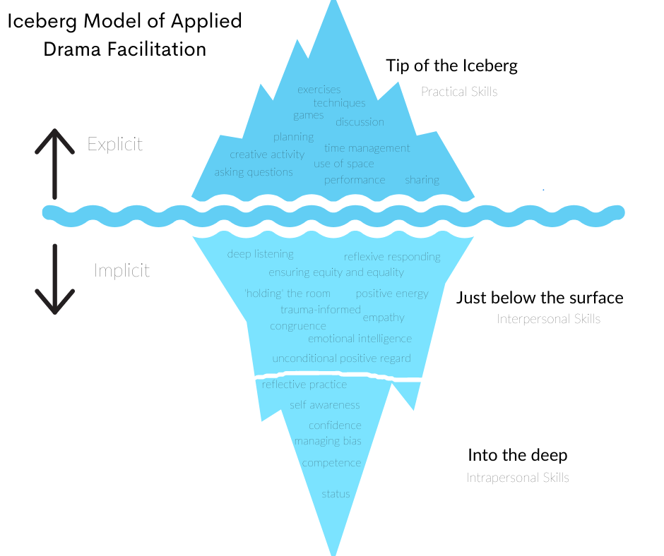

Layer 2 - Below the surface

This layer is about the interpersonal skills of the facilitator. This part of the facilitators work is less explicit – we cannot always see it clearly, (depending on how rough the sea is), however it is always going on. This part is concerned with the facilitator’s relationship with the participants. Primarily interpersonal skills involve communication. As the facilitator, your interpersonal skills here set the tone and expectations for the group and start to build the stable foundation for the rest of the work to happen.

Specifically in applied drama facilitation this means deep listening, meaningful reflection, emotional intelligence, ensuring equity amongst group members, responding reflexively to the needs in the room. It is here that we might consider Carl Rogers’ Core Conditions as being helpful to the facilitator: empathy, congruence and unconditional positive regard (see box 1).

Communication here is more than you explicitly see on the surface it is about the deeper communication skills that the facilitator utilises to create a productive, brave and intentional space. It is where we utilise our emotional intelligence and negotiate our energy levels; it is where we ensure our work is trauma-sensitive and informed.

Layer 3 - Into the deep

This layer of the iceberg is much deeper and will go unseen by participants. This layer concerns the intrapersonal skills of the facilitator. This is about the facilitator’s relationship with themselves: their confidence and competence, their biases and prejudices and their awareness of their intended status in the room. Depending on what environment or context we are working in we need to make sure that we are competent and resilient enough to working with potentially vulnerable people and in fragile spaces. This is at the very roots of our facilitation work. How can we create spaces that are brave, foster trust and allow people to explore their voice and themselves through the drama if we are not exploring ourselves.

This part of the iceberg can be strengthened and developed through reflective practice and ongoing personal growth and self-awareness work.

Box 1
Carl Rogers. Core Conditions of a Person-Centred Approach

Carl Rogers (1902-1987)
Humanistic Psychologist and founder of the Person-Centred Approach.

At the heart of a Person-Centred approach is the belief that all humans are whole, resourceful and creative. Therefore given the right conditions human beings can flourish, grow, develop and change in a way that is unique and authentic to them.

Rogers outlined what he believed were the core conditions for this environment in which people can grow and that these were routed in relationship. Within this relationship there needs to be:

Congruence: being genuine, be yourself, be real and present
Unconditional Positive Regard: having an accepting and positive regard to whoever you are working with in the moment that you are working with them, regardless of what has gone before.
Empathy: sensing the feelings and personal experience of whoever you are working with from their frame of reference and communicating this.

For further reading see Rogers, C. (1995) A Way of Being. London: Harper Collins

Using this model, we can start to understand that we need to working on every layer in order to be effective and dynamic applied drama facilitators. In fact, if we just concentrate on the tip of the iceberg then we will soon discover that we are unstable and ineffective as we will have nothing holding us up from underneath. Great facilitators make their role look easy but there is always much more going on to make it appear that way. Much of the work that goes on underneath the surface can be developed and strengthened through robust and critical reflective practice. When we are new at facilitation we will likely start with the tip of the iceberg, but very soon we can delve deeper to reflect upon what happened in the room, why it happened, what our role was in that and how we can show up in more effective ways to really create a dynamic and hopefully transformative space. The best way to get started as a facilitator is to plan a workshop and just do it. It is not until we are in that role that we start to learn about ourselves as facilitators and develop our facilitator persona.

Facilitation Tasks
- Think about some of the facilitators you have worked with. List the qualities that made them effective.

- Write a list of your core values as an applied drama practitioner, what are the values that underpin your work or the work you wish to do?

- Look at the Iceberg Model. Where are your strengths and where do you need to develop?

- Write a list of reflective practice questions that will be useful for you to answer after facilitating? Keep these somewhere safe as a resource to support your own development.

Throughout this book there will Focus on… Facilitation boxes to help you to consider the role of the facilitator in relation to specific contexts and approaches.

Useful resources for facilitation:

Preston, S. (2016) Applied Theatre: Facilitation: Pedagogies, Practices, Resilience. London: Bloomsbury

