Student Name: Prisca Kiongo

Student Number : 1908199

Institution: UWTSD

Module Title: Marketing Management A2 (LCMB7001)

Instructor : Hossein Shokri

Submission Date: 10/09/2020

Executive Summary
The purpose of this report is to analyse and critically appraise Coca-Cola’smarketing operations by applying several standard models: PESTLE, Five Forces and SWOT analysis. The current marketing strategy and then evaluated in order to make recommendations for future marketing strategies that would sustain its competitive advantage. The main conclusions is that the company had made substantial progress in repositioning its brand as a total beverage company and made some strategic changes to protect revenues and profits in the anticipated, damaging continuation of Coronavirus pandemic. The weaknesses that were more evident were its poor reputation for sustainable practice, association with obesity, and insufficient exploitation of technologies. Therefore the major recommendations included continuing to increase product diversity with strongest brands, investments in acquisition/alliance with sustainable brands, and new consumer preferences to protect profits and reputation and to innovate with new technologies to develop synthetic ingredients that would mitigate possible future ingredient shortages and enhance reputation as a sustainable company.

Table of Contents
Executive Summary 1
Introduction 3
Marketing Analysis 3
Company Overview 3
Macroeconomic Analysis 3
Political/Legal 4
Economic 4
Social 5
Technological 5
Ethical/Environmental 6
Five Forces Analysis 6
SWOT Analysis 8
Coca-Cola Marketing 9
Conclusion 10
REFERENCES 12

Introduction
This marketing analysis was commissioned by Coca-Cola to inform appropriate future marketing strategies and sustainable competitive advantage. The report comprises: company overview; macro analysis using the Political, Environmental, Social, Technological, Legal, Ethical/Environmental (PESTLE) model (Whittington, Regner, Angwin, Johnson. and Scholes,2019); sector position indicated by Five Forces model (Porter,2008); Strengths, Weaknesses, Opportunities, Threats (SWOT) analysis appraising internal strengths and weaknesses determining strategy to exploit external opportunities and minimise threats(Whittington et al.,2019). The current marketing strategy is appraised so that conclusions can be drawn and recommendations made.

Marketing Analysis

Company Overview
The Coca-Cola Company founded in 1886 in Atlanta, Georgia is a global company, operating as six divisions; four regional networks, North America, Latin America, Asia Pacific, Europe, the Middle East and Africa, Global Ventures and Bottling Investments (Marketline,2020;CC,2020a). Its global reach extends to more than 200 countries, offering 4,700+ products in 30 million retail outlets (CC,2020b) served by 225 bottling partners and 700,000 people (CC,2020a). The company had 86,200 direct employees in 2019, in contrast to 100,000 in 2015 (Macrotrends,2020), reflecting its falling revenues (Marketwatch,2020). Coca-Cola’s mission is “to refresh the world” (Coca-Cola,2020a,p.1) and to make a difference. Its associated vision it to produce a balanced range of beverage brands to match consumer preferences, at the same time increasing their energy levels and sense of well-being (CC,2020c). The company aims for profitable but sustainable business, and to respect people, profit and planet (CC,2020a).

Macroeconomic Analysis
A PESTLE analysis determines the major opportunities and threats acting on the non-alcoholic beverage sector owing to changes in the external environmental. These opportunities/threats are relevant to Coca-Cola and its competitors, because how it employs its internal organisational strengths to exploit the opportunities and minimise the threats determines the extent of competitive advantage. Coca-Cola’s internal weaknesses may also limit its capability to manage the macroenvironmental changes (Whittington et al.,2019). The internal forces are appraised later in this report. Since each environmental factor is often relevant to multiple categories, the most common ones are combined to reduce repetition.

Political/Legal
This sector has recently been subject to inspection by global health institutions and governments owing to the link between carbonated drink consumption and obesity. Increase in obesity is associated with life-threatening diseases, for instance diabetes and heart disease. Consequently governments have taken various measures from imposing sugar tax, which increases the price of sugar-sweetened drinks, limiting advertising, and banning sale to certain groups (Arthur,2019). The increasing concern regarding sugar is a serious threat to businesses in this sector (CC,2020a). However, developing sugar-free,healthier options beverages is an opportunity to gain market share (AMR,2020).
Government legislation also varies regarding which ingredients are unhealthy or harmful. This variation is a threat to profits for two reasons: using standard ingredients may limit the countries where specific beverages can be sold, and changing ingredients to comply with each country raises costs. Loss of reputation if the manufacturer is fined for adding banned ingredients is another threat. However, companies can label the packaging carefully and accurately, which is an opportunity to gain consumer confidence and government approval (Prvast and Kusar,2020;TMR,2020).
Economic
The most recent economic threat is the Coronavirus pandemic, but Fortune Insights (FI,2020) suggest that producers of non-alcoholic beverages are likely to experience a significant opportunity to increase growth at a rate higher than forecast, owing to the increased consumer concern for fitness and health. An average annual increase in sales of 8.2% is forecast until 2027, when the market value will reach$US1,257.77 billion (FI,2020) compared with 4.7% growth previously suggested (AMR,2020). However, a potentially serious threat is volatility in raw material prices for several years (FI,2020), particularly seasonal fruits. Euromonitor (2020) reports that production and distribution networks have been impacted by the pandemic, some firms experiencing temporary closures and others remaining cautious of employee and customer safety; uncertainty of supply being a potential threat to revenues/profits. Whilst customers stockpiled beverages during the pandemic, continuing closures of restaurants and bars are also a serious threat to revenues.

Social
In addition to continually increasing concern about health, the non-alcoholic beverage industry will benefit from consumer interest in innovative flavours forecast to increase volumes consumed (FI,2020). This trend was evident in the16 to 24 yearsand Millennialage groups, who favoured non-alcoholic beverages. It is a particular opportunity for manufacturers to widen current customer segmentsand to gain market share by introducing new products regularly (Burrellon,2019;AMR,2020). The Coronavirus lockdown reinforced this trend, and new products such as non-alcoholic cocktails and grape infused water became extremely popular, Food-Bev (2020) highlighted this as a substantial growth opportunity. Teas and coffees are also significant growth opportunities owing to their high anti-oxidant levels (AMR,2020), and Mintel (2020) found that teas which improve mood by integrating natural ingredients, for instance valerian root, were very popular. Exclusive coffee brands and premium mixers were popular and attracted premium prices and profits (Colberg, 2019).A range of other natural ingredients infused into non-alcoholic beverages were increasingly demanded as consumers linked health with environmental sustainability (Mintel,2020). Cannabidiol, an active ingredient in cannabis, infused into beverages to reduce pain and stress is also increasingly demanded (Burrellon,2019).
The online channel is gaining popularity for purchasing non-alcoholic beverages, and subscription boxes (Colbert,2019); these direct sales are an additional sales opportunity for manufacturers and enhance consumer value/loyalty.

Technological
Advances in technology, particularly e-commerce platform development and leaner manufacturing techniques, are an opportunity for non-alcoholic beverage firms to obtain significant market growth, including more online sales (FI,2020;Colbert,2019). They will also facilitate new packaging initiatives to improve environmental sustainability and enhance consumer loyalty (Ardnt,2019). The advances in data gathering and analysis are an opportunity for high customisation of products aimed at enhancing mental, physical and emotional health (Mintel,2020).

Ethical/Environmental
Packaging is a major concern, particularly single-use plastic and its effect on ecosystems such as oceans (Ardnt,2019). The threat is that consumers will reject companies, which fail to use ecologically friendly packaging, leading to decline in sales, whilst use of aluminium cans and paper boxes are approved. The consumer expects firms to continuously increase sustainability throughout the supply chain so that every activity is traceable. Laboratory grown synthetic ingredients are also being developed. All potential opportunities for competitive advantage (Mintel,2020).

Five Forces Analysis
This model indicates how the company can optimise profitability by assessing how the five forcesimpact on costs and revenues, figure 1.
Figure 1: Five Forces Model
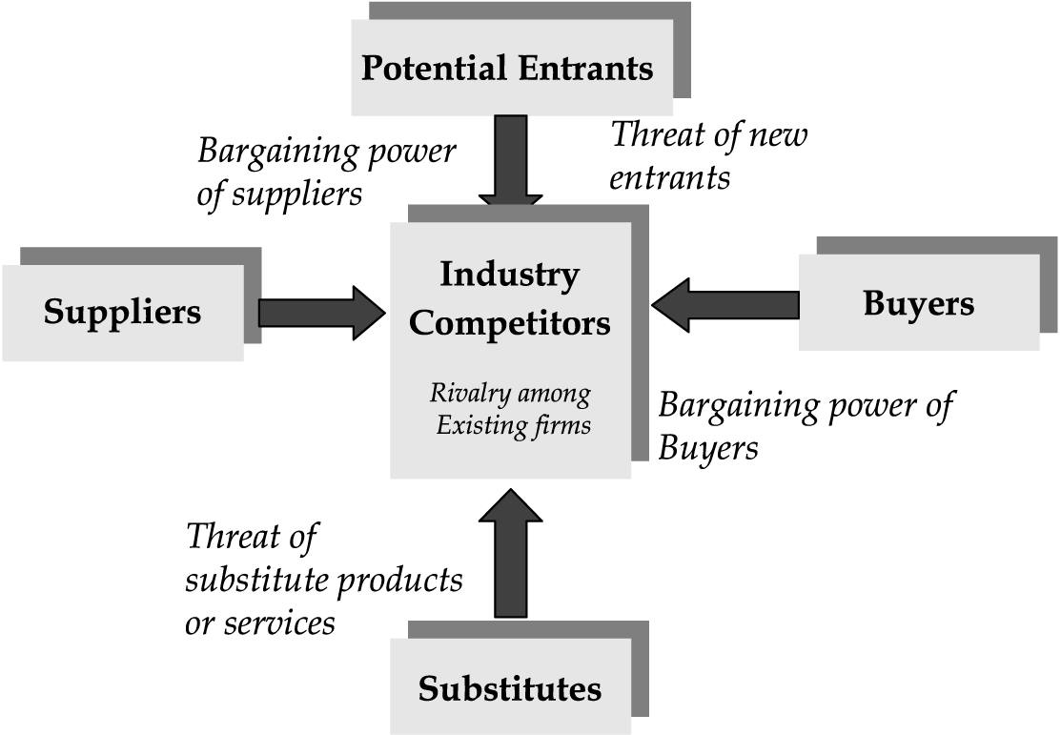
Source: Porter (2008,p.4)
Industry competition is represented by the market share of the top ten non-alcoholic brands, demonstrates high market competition and Coca-Cola’ssector domination.

Table 1: Non-Alcoholic Beverage Market Share 2013-2017
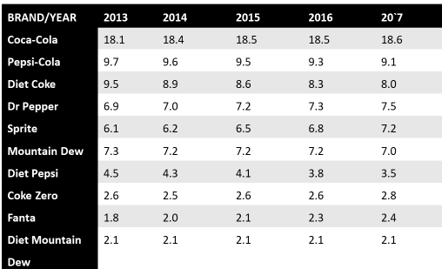
Source: Jacobsen (2019,p.1)

The sector is highly competitive because it is attractive to firms, owing to forecast revenues of $US1,257.77 billion by 2027 (FI,2020). The major companies are Coca-Cola, Pepsico and Dr Pepper but Coca-Cola has the highest market share, 17.8% compared with Pepsico’s 8.4% (CNN,2018). Small companies with niche operations are able to profit in this market (TMR,2020). The threat of new entrants is high owing to attractiveness of high profits, but also because there are substantial barriers to entry, such as high set-up costs, the marketing strength and customer loyalty of the major companies and restrictive regulation (Arthur,2019). Small companies able to differentiate their products can enter and be successful so that overall threat is moderate/low (Porter,2008). The Bargaining Power of Buyers is moderate because although large buying groups can force manufacturers to reduce prices, their customers demand certain brands, which they must purchase to retain them (Porter, 2008). Similarly suppliers have substantial bargaining power because manufactures require sustainability-produced, quality ingredients. However, suppliers need security of on-going purchase of their products and tend to agree long term contracts which lowers their negotiating position (Mintel,2020;Porter,2008).
Threat of Substitutes comes predominantly from home-made drinks including fruit and vegetable smoothies and tap water, but their threat is low owing to small volumes produced and relatively low prices of commercial beverages (Mintel,2020;Porter, 2008). Therefore the market is attractive, relatively profitable with moderate forces. The main criticism of these models is that they consider historic facts, and the impact of forces varies (Grundy,2006).

SWOT Analysis
Coca-Cola’s major internal strengths include substantial product and geographical diversification supported by the 225 bottler distribution network, with quality control by Bottling Investments, and identification and development of new opportunities by Global Ventures division (Thompson,2017;CC,2020a). Coca-Cola brand strength/customer loyalty isvalued at $US 64 million (Forbes,2020) and it owns other valuable top brands including Sprite, Fanta and Powerade (Marketline,2020;Keller and Swaminathan,2019). Financial strength represented by market capitalisation is $US 202,329 billion (TMR,2020), and considerable innovation and marketing expertise is exemplified by development of plant-based bottles and beverages (Coca-Cola,2020d, p.4). Recent agility to quickly adapt to changes in market post-Covid reinforces strong competences, new focus on: investment in extension of biggest strongest, most profitable brands; recognition that 50% brands sold returned just 2% total revenues; adjustment of distribution network to concentrate on highest demand and supply, and greater collaboration with all distribution levels; innovation in distribution, for example contactless fountain dispensers with disposable cupsand pre-order from mobile phones; bundling beverages and meal items to suit different tastes and budgets; strengthening digitalisation competence; acquisitions for diversification including Costa Coffee Chain, kombucha manufacturer and Organic & Raw Trading Co for production of alcoholic and energy drinks (Quincy,2020;BF,2019).
Major weakness include continued dependence on original Coca-Cola as cash cow for investment in innovation (Lussier,2008:Kotler et.al.,2012) and brand association with obesity. Hence revenues continue to be threatened by declining demand for sugary beverages (PMR,2019) despite recovering recently (TMR,2020), figure 2, especially considering post-Covid recession(Quincy,2020).
Figure 3: Revenues 2015-2019

Source: Marketwatch(2020)
Other weaknesses include; poor transparency in supply chain sustainability especially accurate water consumption (Arev,2016); high cost of smaller portion traditional products associated with higher profits (Soundarya,2019); involvement in costly legal battles, which impact on reputation (Marketline,2020).
The major opportunities/threats were identified in the PESTLE analysis. Vital opportunities to be exploited: diversifying products and satisfying forecast demand for innovative non-alcoholic beverages; increasing demand for healthy lifestyles and premium-priced drinks; enhancing sustainable practice, for instance laboratory created ingredients; optimising technology in distribution/production; customisation; online/direct sales. Substantial threats are: declining demand owing to continuing coronavirus restrictions, and impact on manufacturing/distribution; ingredient shortages; declining demand for traditional beverage products; poor reputation associated with sustainable practice.

Coca-Cola Marketing
The market analysis includes substantial information on Coca-Cola’s marketing strategy,therefore, this section of the report focuses on supplementing these facts with specific reference to positioning, segmenting and marketing mix.
Coca-Cola overall marketing strategy is brand repositioning (Keller and Swaminathan, 2019) as a total beverage company (CC,2020a) to mitigate association with obesity, An integrated marketing strategy, devised to generate a total customer journey comprising all touchpoints, creating awareness across all channels, satisfaction throughout all segments, enabling decision making facilitated by consumer capacity to receive and to make product recommendations, constantly enhancing brand loyalty (Maechler, Neher, and Park,2016). It employs multiple segmentation approaches including geographical location, catering for global/local tastes, psychographic and demographic age/lifestyle/income preferences (Kotler et al,2012).
The 7P marketing mix has also been adapted to demonstrate product diversification with distinctive teas, coffees, dairy products, innovative premium products, waters and meal deals, and partnerships with premium brands such as Illycaffe. Price strategy is adjusted to the needs of all consumers, for instance through smaller portions, local pricing, diverse meal deals for different tastes/global locations. Promotion comprises consistent message reflecting Coca-Cola’s mission to refresh the world, incorporating all media, including print advertising, website, social media, mobile marketing plus special offers. Distribution is generated directly and indirectly by means of Coca-Cola owned and franchised bottlers, wholesalers and retailers, intelligent automatic dispensing machines and online, with delivery included and voice ordering of further products at delivery points. Hence, it generates sales by combining push and pull strategies (CC,202bd;Quincy,2020;Doerling,2017;Keller and Swaminathan,2019). These indicate integration of three soft Ps: physical evidence through visible global company presence, co-creation facilitated by constantdata feedback; process indications include self-service and delivery technologies; people because consumer-to-consumer-company link is seamless (Kotler et al.,2012).

Conclusion
This report critically appraised Coca-Cola’s operations in the context of its external environmental, industry sector andinternal capabilities so that recommendations could be made for future marketing strategies to provide sustainable competitive advantage. The main conclusions are that the company has made substantial progress in repositioning its brand as a total beverage company, and was extremely agile in response to the Coronavirus pandemic and its on-going impact. Coca-Cola has substantive innovative, marketing, financial and people capabilities to sustain its market leadership and competitive advantage. However, weaknesses remain such as its poor reputation for sustainable practice, brand association with obesity, and insufficient exploitation of technologies. Therefore the major recommendations are to:
- Continue increasing product diversity with strongest brands, investments in acquisition/alliance with sustainable brands, and new consumer preferences to diminish sugar image and protect profits
- Instigate synthetic ingredient development to mitigate possible future ingredient shortages concurrently enhancing visible commitment to sustainable supply chain
- Increase reporting transparency especially regarding water consumption to reduce accusation of greenwashing
- Further exploit new consumer preferences for innovative premium non-alcoholic beverages such as cocktails, wines and plant-based drinks to diminish profit uncertainty
- Instigate higher value strategies on small portions of consumer preferred products
- Expand direct marketing capacityusing new technologies and distribution channels to manage demand and supply, exploiting strength of bottler network

REFERENCES
Arev, J., 2016. Coca-Cola and Water Scarcity: substantial progress or just another drop in the bucket? Harvard Business School [online] Available at: <https://digital.hbs.edu/platform-rctom/submission/coca-cola-and-water-scarcity-substantial-progress-or-just-another-drop-in-the-bucket/>[Accessed 10 September 2020].
AMR., 2020. Non Alcoholic Beverages Market by Product Type 2014 to 2022. Available at:<https://www.alliedmarketresearch.com/non-alcoholic-drinks-market>[Accessed 9 September 2020].
Ardnt, F., 2019 Trends: The non-alcoholic beverage industry in 2038.DrinkTec [online]Available at: <https://blog.drinktec.com/non-alcoholic-beverages/trends-in-the-non-alcoholic-beverage-industry/> [Accessed 9 September 2020].
Arthur, R., 2019. UK bans sale of energy drinks to U16s. Beverage Daily [online]Available at <https://investors.coca-colacompany.com/strategy>[Accessed 9 September 2020].
BF.2019 Always Coca-Cola: World’s Favourite SodaTops Brand Ranking. Brand Finance [online]Available at: <https://brandfinance.com/news/press-releases/always-coca-cola-worlds-favourite-soda-tops-brand-ranking/>[Accessed 10 September 2020].
Burrellon, H., 2019 Five major trends for the non-alcoholic beverage industry in 2019.FoodBev [online]Available at: https://www.foodbev.com/news/five-major-trends-for-the-non-alcoholic-beverage-industry-in-2019/>[Accessed 9 September 2020].
CC., 2020a. 2019 Business & Sustainability Report. Atlanta, GA: The Coca-Cola Company.
CC., 2020b. About Us. Coca-Cola [online]Available at:< https://investors.coca-colacompany.com/about>[Accessed 9 September, 2020].
CC., 2020c. Strategy.Coca-Cola [online]Available at:<https://investors.coca-colacompany.com/strategy>[Accessed 9 September 2020].
CC. 2020d.Form 10K. Atlanta, GA: The Coca-Cola Company.
CNN, 2018Thinking outside the can. CNN [online]Available at: <https://money.cnn.com/2018/02/20/news/companies/cola-wars-coke-pepsi/index.html> [Accessed 9 September 2020].
Colbert, R., 2019.5 trends transforming the beverage industry. KPMG [online]Available at:<https://home.kpmg/xx/en/blogs/home/posts/2019/08/five-trends-transforming-the-beverage-industry.html>[Accessed 9 September 2020].
Doerling, C. 2017. Coca-Cola embraces a digital future as consumers move online. Food Dive [online] Available at <https://www.fooddive.com/news/coca-cola-embraces-a-digital-future-as-consumers-move-online/511494/> [Accessed 10 September 2020].
Euromonitor, 2020. The Impact of Coronavirus on Soft Drinks. Euromonitor International [online]Available at <https://www.euromonitor.com/the-impact-of-coronavirus-on-soft-drinks/report>[Accessed 9 September 2020].
FI., 2020. Non-alcoholic Beverages Market Size to Reach USD 1,257.77 Billion by 2027: Current Trend of Maintaining Health and Fitness to Boost Growth, says Fortune Business Insights. Fortune Business Insights [online]Available at: <https://www.globenewswire.com/news-release/2020/08/11/2076635/0/en/Non-alcoholic-Beverages-Market-Size-to-Reach-USD-1-257-77-Billion-by-2027-Current-Trend-of-Maintaining-Health-and-Fitness-to-Boost-Growth-says-Fortune-Business-Insights.html>Accessed 9 September 2020].

FoodBev, 2020 Top three no- and low-alcohol beverage trends for 2020. FoodBev [online] Available at: https://www.foodbev.com/news/five-major-trends-for-the-non-alcoholic-beverage-industry-in-2019/> [Accessed 9 September 2020].
Forbes, 2020.The World’s Most Valuable Brands. Forbes [online]Available at: <https://www.forbes.com/the-worlds-most-valuable-brands/#4fefe17d119c>Accessed 9 September 2020].

Grundy,T., 2006. Rethinking and Reinventing Michael Porter's Five Forces Model. Strategic Change,15(5), pp. 213-229.
Jacobsen, J., 2019. 2019 Soft Drink Report: Occasional consumer offers potential for market. Beverage Industry [online] Available at: <bevindustry.com/articles/92021-2019-soft-drink-report-occasional-consumer-offers-potential-for-market> [Accessed 9 September, 2020
Keller, K. and Swaminathan, V.,2019. Strategic Brand Management. 5th ed. Harlow: Pearson.
Kotler, P., Keller, K., Brady, M., Goodman, M. and Hansen, T., 2012. Marketing Management. 2nd. Ed. Harlow: Pearson.
Lussier, R., 2008. Management Fundamentals: Concepts, Applications, Skill Development.4thed. Mason, OH: Cengage Learning.
Maechler, N., Neher, K. and Park, P., 2016.From touchpoints to journeys: Seeing the world as customers do. McKinsey & Co,
Macrotrends. (2020) Coca-Cola: Number of Employees 2006-2019 | KO. Macrotrends
Marketline, 2020. Company Profile: The Coca-Cola Company. Informa Inc.
Marketwatch., 2020. Coca-Cola Co. NYS: KO.Coca-Cola [Online] Available at https://www.marketwatch.com/investing/stock/ko/financials> [Accessed 9 September 2020].
Mintel, 2020. Global Food and Drinks Trends 2030. London: Mintel.
PMR, 2019Global Market Study on Non-Alcoholic Beverages. Persistence Market Research[online]Available at: https://www.persistencemarketresearch.com/market-research/non-alcoholic-beverages-market.asp> [Accessed 23 January 2020].
Porter, M.E., 2008. On Competition, Boston, MA: Harvard Business Press.
Pravst, I. and Kušar, A., 2020. Labeling of Nonalcoholic Beverages. In: C Galanakis, ed. Trends in Non-alcoholic Beverages. Amsterdam: Elsevier. pp. 263-307
Quincy, J., 2020. Pandemic Prompting Coca-Cola to ‘Move Even Faster,’ CEO Tells Analysts. Coca-Cola [online] Available at: <https://www.coca-colacompany.com/news/pandemic-prompting-coca-cola-to-move-even-faster-ceo-tells-analysts>[Accessed 9 September 2020].
Soundarya, J., 2019. Zero-sugar sodas, smaller soft drink cans drive Coca-Cola revenue beat. Available at: <https://www.reuters.com/article/us-coca-cola-results/zero-sugar-sodas-smaller-soft-drink-cans-drive-coca-cola-revenue-beat-idUSKBN1WX1B7>[Accessed 10 September 2020].
Thompson, L., 2017. The Coca-Cola Company Completes Refranchising of Company-Owned Bottling Operations in the United States. Business Wire [online]Available at: <https://www.businesswire.com/news/home/20171030005384/en/Coca-Cola-Company-Completes-Refranchising-Company-Owned-Bottling-Operations> [Accessed 9 September 2020].

TMR., 2020.Non-Alcoholic Beverage Market - Global Industry Analysis, Size, Share, Growth, Trends, and Forecast 2017 – 2025.Transparency Market Research [online]Available at:<https://www.transparencymarketresearch.com/nonalcoholic-beverage-market.html>[Accessed 9 September 2020].
Whittington, R., Regner, P., Angwin, D., Johnson, G. and Scholes, K., 2019. Exploring Corporate Strategy: Text and Cases. 12th ed. Harlow: Pearson.

