Module: Marketing Fundamentals
Module Code: LCBB4004
Assessment 2: Marketing Fundamentals Analysis and Evaluation
Name:Didina-Stefania Turai
Student ID:2028048

Table of Contents
Introduction 1
Process of marketing 2
Macro Environmental analysis 3
SWOT analysis 6
Segmentation, Targeting, Positioning 8
Marketing Mix 9
Recommendations 11
Conclusion 12
References 13

Figure 1: PESTEL analysis for Sainsbury’s in the UK 3
Figure 2: SWOT analysis of Sainsbury’s 6
Figure 3: Segmentation, Targeting and positioning of Sainsbury’s in UK 8
Figure 4: Marketing Mix of Sainsbury’s in UK 9

Introduction
Marketing is a process in which a business organisation creates value for its customers through a market offering to create a good relationship with customers to get value in return. Marketing is important for the modern business to have customer satisfaction, competitive advantage, corporate image, brand loyalty, brand equity, brand equity, optimum uses of resources, expansion of business and so on. Sainsbury’s is the second-largest Super chain organisation in the UK and this company aims at prioritising building strong brand heritage as well as a reputation for the quality, range and innovation having lower prices and consistent value in the offering. Sainsbury’s have some renowned brands like Argos, Habitat, Tu, Simsbury’s bank, nectar and so on through which they serve customers (sainsbury’s.com, 2021). This report is aiming to screen out the internal and external environment of Sainsbury’s through PESTEL analysis, SWOT analysis. This report also aims at finding the segmentation, targeting and positioning strategy of Sainsbury’s and finding the marketing mix and their changes due to covid-19. Finally, recommends how to take strategic decisions and bring changes to operate a successful business over time.

Process of marketing
Marketing is a set of processes of creating, communicating as well as delivering value to the customers to create a relationship with customers to get the value in return through profits (Kotler and Armstrong, 2011). In addition, the marketing concepts refer to satisfying customers considering the needs and wants of customers while the organisation’s goal is to achieve the profit goal. The process of marketing includes four stages such as situation analysis, setting long and short-term objectives, developing marketing strategy and finally marketing implementation and control. Situation analysis in the marketing process refers to analysing the activities of competitors and various things that are happening in the marketplace in which an organisation operates its business over time such as analysing trends and insights. Situation analysis has some effectiveness like having a clear definition regarding target audience and target market, understanding competitors’ insights, operations, strategy, weakness and strength and then the organisation can identify its market offerings opportunities and threats. The marketing objective is the goals that are set by a business to promote the products and services to the existing and potential customers which a business is bound to achieve within a specific time framework (Parola et al., 2018). Marketing objectives are set following the SMART objective techniques. Marketing strategy is a path of achieving the predetermined marketing objectives and in the strategy, a marketer may go through the existing marketing plan, perform marketing research, develop the value proposition, set marketing goals, define marketing strategies, define the way of the marketing mix, create a final marketing plan and then review and assess. The final stage of the marketing process is to implement the marketing strategy and have control over the marketing activities. Marketers execute marketing plans and take necessary marketing actions and then incessantly monitor the performance of the marketing to get the best ROI (Return on Investment).

Macro Environmental analysis
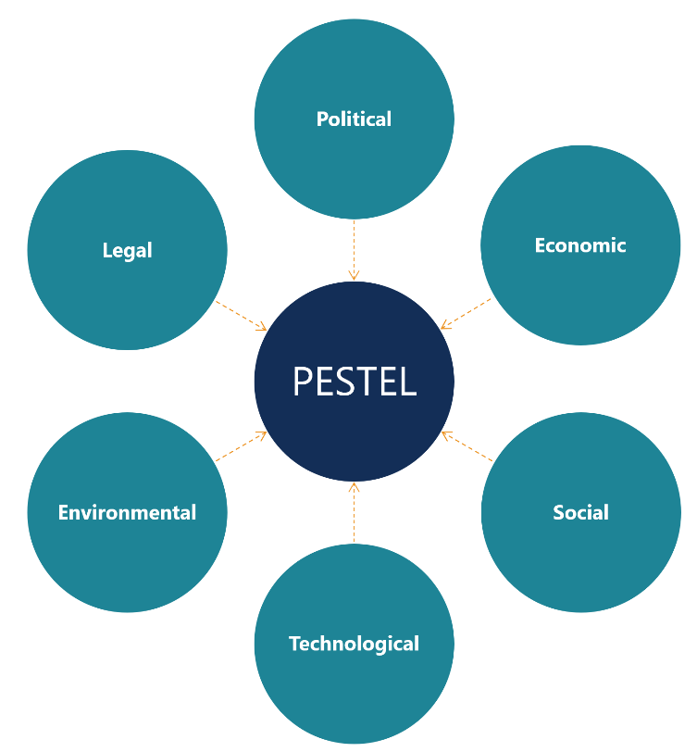
A PESTEL analysis is nothing but a strategic framework that is used to evaluate and understand the big picture and the external macro environment of a business in which the business operates over time, A PESTEL analysis is an acronym of political, economic, social, technological, environmental, legal factors. PESTEL analysis has some benefits including having facilitation on perceiving the wider business environment, getting encouragement on the development of the strategic and critical thinking, having anticipation on the future business situation and taking actions predicting the impending threats and risk of the business, enabling business into taking the full opportunity that has a positive impact on the business (Çitilci and Akbalık, 2020). Analysing PESTEL a business can make strategic decisions to adapt to the changing external environment of the business over time. Below the PESTEL analysis is shown to screen the external macro environment of Sainsbury’s:
Figure 1: PESTEL analysis for Sainsbury’s in the UK
Source: (Yusop, 2018)

Political Factors
Political factors usually refer to the impact of government policy and actions. Political factors include tax policy, trade restrictions, tariffs, bureaucracy, political stability, industry safety legislation, Environmental and consumer protection legislation, regulation and de-regulations trends and so on (Prabhu, 2019). Brexit uncertainties have had a great impact on the business of Sainsbury’s as this company have to import different types of products from other European countries and Sainsbury have to buy products from other countries spending high cost while they will have low-profit margin for this Brexit issues. The government decision in the covid-19 pandemic has also had a great impact on Sainsbury’s business like a large base of customers didn’t able to come to the physical shop for lockdown and there was the limitation in the movement of the people due to pandemic spread. But right now, Sainsbury’s can operate their business following government rules and regulations regarding the covid-19 hygiene. So, Political factors are slightly favourable to the business and Sainsbury’s have to be cautious about every policy and decision, rule and regulation of the government.
Economic Factors
The second influential factor that has an impact on a business like Sainsbury’s and the economic condition in the pandemic period have slowed down greatly. In the pandemic, many businesses have shut down due to the continuous lockdown and loss, many employees have to leave jobs for the organisation's loss (Altig et al., 2020). The economic impact was severe in the pandemic time and GDP have declined 9.8% in 2020. To grow and to surpass the hurdles that have been faced in the pandemic time, Sainsbury’s get help from the government like having loans from banks with lower interest rates. Economic factors include the current and project economic growth, inflation and interest rate, unemployment and labour supply, labour cost, level of disposable income as well as income distribution and so on. Every element of the economic environment harm the business of Sainsbury’s over the pandemic period but now the economic environment steeping forward. So, this economic factor is now favourable to businesses like Sainsbury’s.
Social Factors
The social factors have a direct and indirect influence on the business operating in the UK. The social factors include population employment pattern, job market freedom as well as attitudes, values and ethics of the people, lifestyle choices and perceptions towards super chin business, consumption pattern, buying behaviour, socio-cultural changes, populations health, education, social mobility and so on. In the UK, the inequality and gender gaps have increased due to covid-19, new poor raised substantially, the consumption pattern has changed, the online purchase has increased, expenditure on health have increased, education has been disrupted, life-styles choices have been impacted due to economic crises and job market freedom have lessened over the pandemic as people continuously losses jobs. The social life pattern has drastically changed after the pandemic, the social distancing has made distance among people. However, people have started going digitalised in their buying pattern and for that people prefer online as more friendly, better, online give more freedom while buying, more options to choose, home delivery and so on. This factor is unfavourable to some extent and Sainsbury’s have to adapt to the socio-cultural changes.
Technological Factors
With the changes in the technological environment in the UK, a business-like Sainsbury’s has to change its technological landscape over time. The more a business is flexible and able to adapt to the technology, the more possibility to get success in business operations. In the UK, technology like automation, internet connectivity, uses of artificial intelligence, big data, machine learning, uses of IoT (Internet of Things), cloud accounting, blockchain technology, augmented reality (AR) and so on. Sainsbury has to change the technological trends and they need to go for digitalisation in every aspect of the business. Due to covid-19, the consumer prefers e-commerce, thus Sainsbury's have to initiate the online sale and ensure the E-service quality (Flynn et al., 2020). The technological factors are in a favourable situation but Sainsbury’s have to be more proactive to the changes of technological factors over time.
Environmental factors
To the sustainability issues, business-like Sainsbury’s need to consider environmental factors more closely and strictly. Environmental factors like chemical safety, pollution, carbon emission, climate change, global environmental issues, scarcity of natural resources are now of high concern that a business should consider for their sustainability. At COP-26, the government of the UK pledged to the business to go one step greener and business organisations should become more energy-efficient, make landfill-free and provide the commitment to zero carbon emissions (Aines et al., 2021). Sainsbury’s have to follow the environmental regulations, guidelines, restrictions, rules and laws to sustain. Sainsbury’s can follow the triple bottom line to sustain the business for the long term.
Legal Factors
The laws and regulations have effects on Sainsbury’s business. Sainsbury’s have to follow business law, intellectual property act, consumer data protection law, consumer rights and so on. To operate the business in the UK, Sainsbury’s needs to maintain the legal system in their business operation and follow the common business law while there needs any disputation. The legal environment of the UK is favourable in terms of business.

SWOT analysis
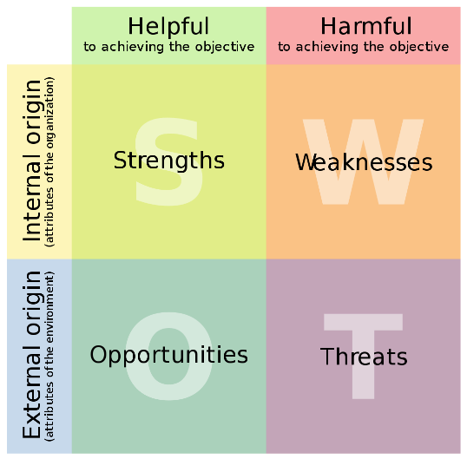
Sainsbury’s is a retail super chain in the United Kingdom. Moreover, Sainsbury deals with grocery, food and other merchandise, financial services, property investments as well. SWOT analysis is a tool that identifies a business organisation’s internal business environments such as strengths, weaknesses, opportunities, threats. There are some advantages of SWOT such as exploring new solutions to internal organisational problems, identifying the barrier that will create hurdles on the achievement of objectives or goals, revealing the possibilities and limitations for change, facilitating planning, helping in innovation, ensuring the survival of the business (Teoli et al., 2019). There are some of the disadvantages too of SWOT such as SWOT emphasise the single dimension strategy. The SWOT analysis of Sainsbury’s is given below:
Figure 2: SWOT analysis of Sainsbury’s
Source: (Soegoto, 2021)

Strengths: The strength of the Sainsbury’s is right expansion moves like convenience stores to the supermarket that deals with a large number of merchandise categories. Moreover, Business philosophy is another strength that ensures the business low-cost product, quality service and creating strong brand loyalty. Having the opportunity to serve all types of customers and having wholesale and retail banking is another strength that Sainsbury’s holds. Sainsbury’s have innovative promotion strategies and coupons. Sainsbury’s have 800 convenience store and 600 supermarkets across the UK (Ekwulugo, 2020). Having a strong network, excellent marketing strategy and implementing digital marketing, creating strong leadership and brand value is the strongest strength that Sainsbury’s have over its competitor.
Weaknesses: Over competition is a weakness for Sainsbury’s because belonging to different categories Sainsbury’s have to face competition over the different company which are niche focus. The niche focus competitor has a high market share in the different category which harm Sainsbury’s. Increasing prices of the product is another weakness that Sainsbury’s faces because the Covid-19 pandemic situation has created uncertainty in the economy and have created a shortage of the supply of the product (Bai et al., 2021). Thus, Sainsbury’s have to face over price while buying products.
Opportunities: Sainsbury’s have established a very large network in the UK but there is a high opportunity to expand business outside of the country like other European country or Asian country and this company can have online sales globally. Sainsbury’s is the largest consumer market worldwide and this company have high potential to grow through digitalisation. Sainsbury’s can have a merger with the competitor to lessen the level of competition and they can also avail of 24-hour service.
Threats: The threats of Sainsbury’s are pandemic and globalisation. In the pandemic, many stores of Sainsbury’s in the UK have to shut down because of the continuous loss and economic crisis which happened because of the loss of customers over time. The pandemic period has dropped the annual income and net income by 3.2% and 32.78% as well as the recession after the pandemic has lessened the buying power of lower-income people. Due to globalisation, Sainsbury’s lose their sales because e-commerce has started globally with different companies. Global multinational brands have reached international countries which harm Sainsbury’s.

Segmentation, Targeting, Positioning
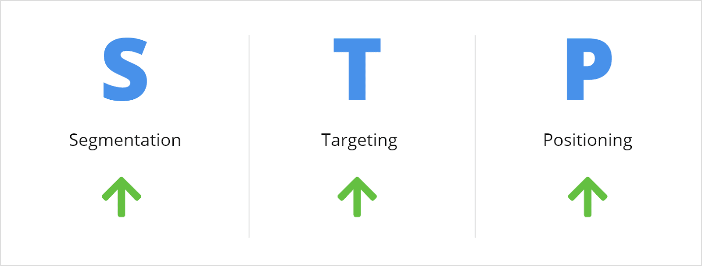
Segmentation, targeting and positioning is a model of marketing that examines the product or service a company offers to its specific customer base and the way of communication to provide the market offering. Below is the STP model in marketing discussed in terms of Sainsbury’s:
Segmentation: Marketing segmentation is nothing but a process of dividing the target market into smaller as well as more defined categories and depending on the different characteristics like demographics, interests, needs or geographical locations, Sainsbury’s segments the whole target market. Segmentation helps Sainsbury’s create stronger marketing messages, identify the most effective marketing strategy or tactics, define targeted ads and attract quality leads, differentiate brands from the competitors in the industry and so on (Islam, 2020). Sainsbury has especially location-based segmentation through it consider other three types of segmentation bases such as demographic, psychographic, behavioural while segmenting the market for specific brands.
Figure 3: Segmentation, Targeting and positioning of Sainsbury’s in UK
Source: (Ing et al., 2020)
Targeting: Targeting is concentrating on a specific group of customers among the total market. Targeting is necessary for making strategy directly for delivering to a defined audience, attracting and converting high-quality leads, building deeper brand loyalty, staying focused. Sainsbury’s needs to more focus on the target market that is not only focused on quality but also conscious about value.
Positioning: Positioning in marketing refers to a process of differentiating the products or services of any company from the competitors and determining which market niche the company is filling (Camilleri, 2018). Different companies position themselves based on price, quality, differentiation, convenience, customer service. Positioning helps Sainsbury’s through creating a strong competitive position in the market, improving sales, defining a clear target market, making more effective decisions, connecting with customer needs. Sainsbury’s have positioned itself at the mid-tier of the market and from the price point of view, this company compete with the lower end.

Marketing Mix
The marketing mix is a set of actions or tactics that are controlled by an individual company and this model is used to promote as well as influence the customer to purchase its products or the product of any company in the marketplace (Sudari et al., 2019). Moreover, the marketing mix element includes 4Ps (Product, Price, Place, Promotion). The marketing mix helps to develop a new product, increasing product portfolio, guides properly to improve business, differentiation and finally, marketing mix helps in taking strategic decisions towards to change and adapts with the new trends of marketing.
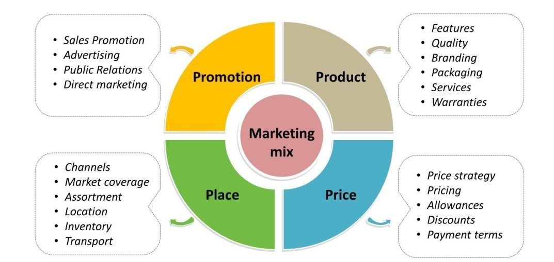
Product: The product in the marketing mix refers to features, quality, branding, packaging, services and warranties. In the pandemic time, people need the availability of the product and Sainsbury’s have 30,000 product lines with a good depth and breadth but among them, 20% are their label product. Sainsbury’s have diversified product level such as fruits and vegetables, fish and meat, chilled, dairy, bakery, beer, wine and spirits, health and beauty, personal care, baby, household, pet care and so on (Grimmer, 2019). People want now e-services that must maintain e-service quality and Sainsbury’s must ensure the proper value of their market offering which must ensure through the product.
Figure 4: Marketing Mix of Sainsbury’s in UK
Source: (Thabit and Raewf, 2018)
Price: Sainsbury’s always believed the value for money is ensured by setting the prices for a different product in different categories. Besides, Sainsbury’s wants to keep their customers for the long term and for that they ensure the quality and service. To keep a balance, between low price and quality, Sainsbury’s have a competitive pricing policy. Sainsbury always keeps track of competitors who use EDLP pricing strategy and considering EDLP, Sainsbury’s maintain pricing over time. For the new normal time, People are facing economic recession, thus need to adjust the price that means having lower profits on the low-income geographic areas or locations.
Promotion: Sainsbury’s have different promotional strategies and this company is focusing on digital marketing. Sainsbury’s have a strategy to take multi-channel and omnichannel strategy in terms of product promotion over the market. As amid the pestilence, people were more engaged with the online and more people were using the internet who are late adopters of technology, Sainsbury’s have increased digital marketing strategy (Khosiev et al., 2019).
Place: The place of Sainsbury is across the UK and they have convenience stores as well as supermarkets. Sainsbury’s is focusing on online sales through their websites but they can avail their products more online to have a seamless experience for customers. Because of the pandemic, people prefer online purchases, home-delivery (Ансере et al., 2020).

Recommendations
The covid-19 pandemic has had a great impact on all types of business and the marketing landscape have also changed over this period. Sainsbury’s have faced a crisis period in the pandemic time; thus, this company have to shut down many of its stores across the UK. I have some recommendations for Sainsbury’s to step forward in this time. Sainsbury’s needs to
- Adapt with the changing environment like maintaining government rules and regulations and following covid-19 protocols.
- Follow the socio-cultural factors while developing a marketing mix and another promotional strategy to have the best marketing offer according to customer need and want.
- Be flexible to adapt to the technological changes incessantly and increase the digital marketing budget.
- Have more specific segmentation, targeting and look back its positioning strategy for the new normal situation considering the economic condition of the customers.
- Reshaping marketing mix with the changes in the market and implementing the new product development, setting pricing strategies, going more for online promotion.

Conclusion
In brief, every business organization in any industry have a profound effect on the pandemic. Pandemic time brings more possibilities for the business-like Sainsbury’s but this company must need to adapt the changes with the findings of macro-environmental screening and internal analysis of SWOT. In this report, the segmentation, targeting and positioning strategy has been discussed and there need to change the positioning strategy of the company to some extent. After the pandemic period, Sainsbury’s have to cope up with the new normal situation and have to step forward with the economic growth but for this Sainsbury’s needs to have a strong marketing strategy. Finally, Sainsbury’s have to adopt new technology, go for digitalisation and E-commerce, take omnichannel strategy and so on.

References
Aines, E., Clulow, Z., Neilson, A., Shuckburgh, E. and Evans, S. (2021). COP26 Futures We Want-UK Country Profile.
Altig, D., Baker, S., Barrero, J.M., Bloom, N., Bunn, P., Chen, S., Davis, S.J., Leather, J., Meyer, B., Mihaylov, E. and Mizen, P. (2020). Economic uncertainty before and during the COVID-19 pandemic. Journal of Public Economics, 191, p.104274.
Bai, L., Guo, H., Guo, S., Han, X., Yue, N.J. and Li, Q. (2021). SWOT analysis and preliminary study on prevention and control management of temporary integrated isolation ward during COVID-19 Outbreak. Frontiers in Public Health, 9, p.86.
Camilleri, M.A. (2018). Market segmentation, targeting and positioning. In Travel marketing, tourism economics and the airline product (pp. 69-83). Springer, Cham.
Çitilci, T. and Akbalık, M. (2020). The Importance of PESTEL Analysis for Environmental Scanning Process. In Handbook of Research on Decision-Making Techniques in Financial Marketing (pp. 336-357). IGI Global.#
Ekwulugo, F. (2020). Marketing planning in small businesses. In Entrepreneurship Marketing (pp. 324-336). Routledge.
Flynn, D., Moloney, E., Bhattarai, N., Scott, J., Breckons, M., Avery, L. and Moy, N. (2020). COVID-19 pandemic in the United Kingdom. Health Policy and Technology, 9(4), pp.673-691.
Grimmer, E.L. (2019). The power of private labels drives Coles’ deal with Sainsbury’s: Interview with Isabelle Lane.
Ing, P., Osman, Z. and Tze-Yin, L. (2020). Marketing Mix and STP Strategies: An Exploratory Study into Grocery Retailers in Malaysia. Asian Journal of Entrepreneurship, 1(4), pp.129-143.
Islam, M.M. (2020). Segmenting, targeting and positioning in Islamic marketing. Journal of Islamic Marketing.
Khosiev, B.N., Ostaev, G.Y., Kontsevoy, G.R., Suetin, A.N., Sokolov, V.A., Antonov, P.V. and Suetin, S.N. (2019). Development of a brand promotion strategy: management accounting and comprehensive analysis. Indo American Journal of Pharmaceutical Sciences, 6(5), pp.10060-10068.
Kotler, P. and Armstrong, G. (2011). Principle of marketing 16th Ed. In Library of Congress Catalogingin-Publication Data. Pg1-8.
Parola, F., Pallis, A.A., Risitano, M. and Ferretti, M. (2018). Marketing strategies of Port Authorities: A multi-dimensional theorisation. Transportation Research Part A: Policy and Practice, 111, pp.199-212.
Prabhu, P.R. (2019). A study on the political & government policy related challenges faced by startups in the UK (Doctoral dissertation, Dublin Business School).
Sainsburys.co.uk. (2021). About us. [online] Available at: <https://www.about.sainsburys.co.uk/about-us> [Accessed 5 November 2021].
Soegoto, F.A. (2021). Product Development using SWOT Analysis. International Journal of Entrepreneurship & Technopreneur (INJETECH), 1(1), pp.1-10.
Sudari, S., Tarofder, A., Khatibi, A. and Tham, J. (2019). Measuring the critical effect of marketing mix on customer loyalty through customer satisfaction in food and beverage products. Management Science Letters, 9(9), pp.1385-1396.
Thabit, T. and Raewf, M. (2018). The evaluation of marketing mix elements: A case study. International Journal of Social Sciences & Educational Studies, 4(4).
Yusop, Z.B.M. (2018). PESTEL analysis. COMRAP 2018, p.34.
Ансере, Д.К.О. and Ухова, А.И. (2020). EFFECT OF CORONAVIRUS (COVID-19) PANDEMIC ON MARKETING MIX (4Ps). Вестник Южно-Уральского государственного университета. Серия: Экономика и менеджмент, 14(3), pp.180-187.

