BA Leadership and Management
Module: Developing Workplace Critical Thinking

Module code: BMSW5101_BIRM
Developing Workplace Critical Thinking portfolio of assignment

Kamil Lenczowski
Student number:
2120445

Lecturer:
Zahra Mohammadnazari

Contents
Introduction 3
Overview of McDonald's products 4
Management theory 7
Internal Conflicts and Resolution Strategies 13
Conclusion 16
References 17
Appendix 20

Introduction

This report examines how a large UK-based food retailer executes its management theory and resolves conflicts among employees regarding organizational priorities. For this purpose, McDonald's has been chosen as the subject of this analysis. McDonald's is a well-known fast-food chain that has been operating in the UK for over 70 years, with over 1,200 restaurants across the country. The introduction provides a brief overview of McDonald's products, its main operation, and its background. The report will investigate the McDonald's System, the management theory, the company follows and evaluate its advantages and disadvantages. Additionally, the report will discuss the nature of conflicts that may arise within the company and strategies that are used to overcome them. This report aims to provide insight into the management practices of a large UK-based food retailer, offering critical analysis and evaluation of its management theory and conflict resolution strategies.

Overview of McDonald's products

McDonald's is a global fast-food restaurant chain that specializes in burgers, fries, and other fast food items. Founded in 1940 by Richard and Maurice McDonald, the first McDonald's restaurant was a small drive-in located in San Bernardino, California. Today, McDonald's is one of the largest and most recognizable fast-food chains in the world, with over 38,000 restaurants in more than 100 countries.
McDonald's menu includes a variety of fast food items such as
- hamburgers,
- cheeseburgers,
- chicken sandwiches,
- french fries,
- salads, milkshakes,
- soft drinks.
McDonald's is renowned for its standard menu options, but it also provides regional and seasonal items that cater to local tastes and preferences. In terms of operations, the fast food chain operates using a franchising model, where independent franchisees own and run individual restaurants, while the company provides support and guidance to ensure consistency in branding, operations, and menu offerings. Furthermore, McDonald's places a strong emphasis on sustainability, ethical sourcing, and responsible marketing practices.
Overall, McDonald's has had a significant impact on the fast-food industry and has become a household name around the world.
This work will also demonstrate the available app and menu delivered by this company but also how this brand awards their customers with special programs.
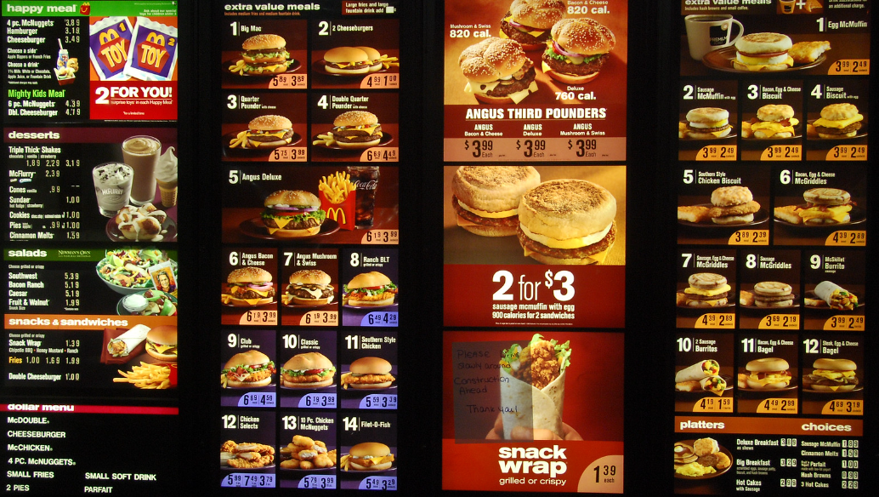
Figure 1. (available menu McDonald’s sourced from : https://www.flickr.com/photos/dougalug2005/3176399858/in/photostream/)


Figure 2. (source: https://www.mcdonalds.com/gb/en-gb/good-to-know/in-our-restaurants/my-mcdonalds-app/rewards.html?cid=RF:Kochava:GWS::McD-rewards-GWS:not-mobile)

The company overall is performing well in the market. The achievements are visible, as customers recognize this company and its services as a brand. The name of McDonald's is recognized as a brand in every country where the company launches its restaurants. The established company applies well-performing plans and targets the market in appreciable ways. It should be pointed out that their targeting plan is wide and targets a few sectors.

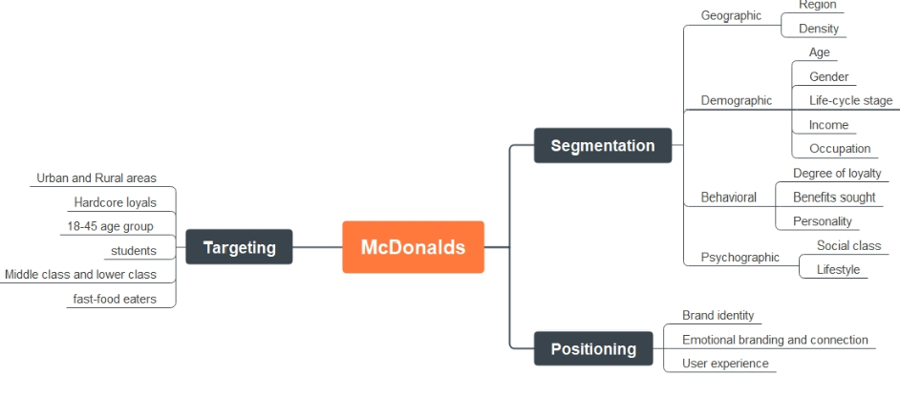
Figure 3. ( sourced from: BUSINESS ANALYSIS
McDonald's Market Segmentation, Targeting, and Positioning)

The above graph explains McDonald's targeting groups and segmentation and also focuses on an important aspect of positioning. The direction they are looking to position themselves is highly important for business settings to explore brand identity, emotional branding, connection and also significant user experience.
The position of marketing strategy according to WondershareEdrawMind (2023), article McDonald's Segmentation, Targeting and Positioning.’’ It has been proven that McDonald's employed four distinct ways to develop its marketing segmentation. Even though each of them has a limited influence, combining them well might result in ineffective marketing tactics. However, these four marketing segmentation techniques might be used for a wide range of consumer items. As a conclusion and for better understanding, consumers can aid any organization in developing a better business strategy, and these tactics are the important parts.’’
To sum up, McDonald's uses four different marketing segmentation techniques to understand its target audience and create effective marketing campaigns. While each technique may not have a big impact on its own, it can be powerful when combined. These techniques are not just for fast food but can be used for many different products. Understanding customers' needs and preferences is crucial for a successful business strategy, and using segmentation techniques is an important way to achieve this.

Management theory

According to different sources regardless management theories, this report reviews UKessays article "The Importance of Rapidly Changing Market Needs" (May 2017) and other author Gianpiero Petriglieri's article "Are Our Management Theories Outdated?" (June 18, 2020) in the Harvard Business Review both discuss how quickly markets change and the effect it has on how businesses are managed. These articles show that it's important to keep updating how we manage businesses to keep up with the changing world.

“In the past, a strategic principle was nice to have but was hardly required, unless a company found itself in a trying business situation. Today, many companies simultaneously face four situations that make a strategic principle crucial for success: decentralization, rapid growth, technological change, and institutional turmoil.” (Orit Gadiesh,James Gilbart 2001).
To deal with changes and meet what customers want, businesses need good plans for how they work. Strategic management helps with this. It means making and doing big-picture plans that use a company's strengths to meet what the market needs. Orit Gadiesh and James Gilbart (2001) said that strategic management is about finding and doing the right plan by matching what a company can do with what the market wants.
This helps businesses stay flexible and able to handle changes in their industries.

This article discusses basic management theories and their potential applicability to McDonald's Restaurant. When faced with the challenge of decentralization or other disruption, McDonald's is exploring a range of approaches to address the issue. By considering various methods and making assumptions, the company seeks to effectively manage its business in a difficult-to-control environment.
One of these approaches, created by Henri Fayol, has been with managers for a long time. This theory consists of fourteen principles, and to better understand them, the following pictures provide a review.
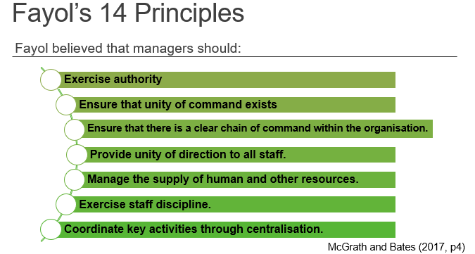
Figure 4. Fayol’s 14 principles (sourced from UWTSD)
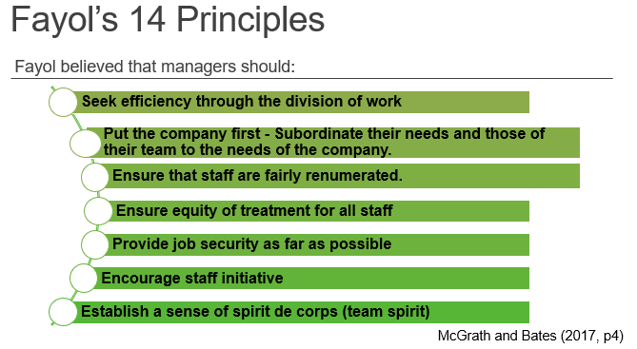
Figure 5. Fayol’s 14 principles (sourced from UWTSD)
His theory is based on the idea that there are five basic functions of management: planning, organizing, commanding, coordinating, and controlling. According to Fayol, these functions are universal and can be applied to any organization, regardless of its size or industry. Henri Fayol was a management theorist who believed that there are five key things that managers need to do to run a successful organization. These five functions are planning, organizing, commanding, coordinating, and controlling.
According to an article McDonald's Knows It's Losing the Burger Battle—Can It Come Back?( Julie Jargon 2016). McDonald's is an example of a company that follows several of these principles. The company plans its operations, menus, and marketing strategies, uses technology to make informed decisions, and has a hierarchical management system where managers delegate tasks and oversee employees. McDonald's also emphasizes teamwork and coordination between different departments to ensure that everything runs smoothly. Additionally, the company closely monitors its financial performance, employee productivity, and customer satisfaction levels to identify areas for improvement. By following these principles, McDonald's has become a successful and profitable business.
This work also aims to explain another theory. Taylor’s scientific management theory can be linked to McDonald’s by examining how the company optimizes its work processes and procedures for efficiency. This can be seen in the standardization of its menu items and operations across all franchise locations, as well as the use of technology to streamline decision-making processes. However, applying scientific management principles to employee management may also lead to conflicts between management and employees.
For example, the emphasis on efficiency and productivity may result in employees feeling overworked or undervalued, which can lead to low morale and high turnover rates. It is important for McDonald's to balance the benefits of standardization and efficiency with the needs and well-being of its employees. In contrast, Fayol's management theory focuses on broader organizational functions such as planning, organizing, and controlling. This theory can be linked to McDonald's through its hierarchical management structure and emphasis on teamwork and coordination between different departments.
By applying these principles, McDonald's has become a successful and profitable business. Overall, both Fayol's and Taylor's management theories have contributed to McDonald's success in different ways, but it is important for the company to carefully evaluate the potential benefits and disadvantages of applying these theories to its specific organizational structure and employee management practices.
Gathered data leads to highlighting the advantages and disadvantages of these theories.

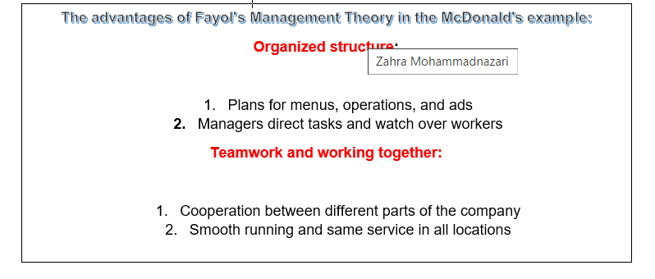
Figure 6. the advantages of Fayol’s Management Theory in McDonald case

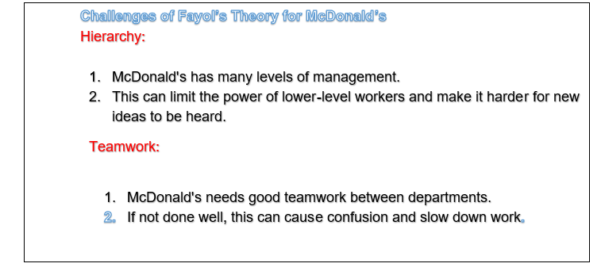
Figure 7. challenges of Fayol’s theory in McDonald’s case ( brainstorming)

In addition to Taylor’s theory, the following picture will demonstrate the importance of each step and the way how Taylor understood the process.

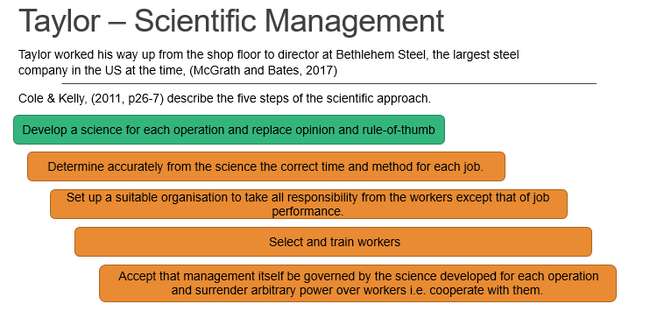
Figure 8. Taylor scientific management (Photo sourced from UWTSD)
The book written by McGrath and Bates "The Little Book of Big Management Theories" (2013), discuss Frederick Taylor's management theory, which is known as Scientific Management.
Assuming the important aspects, Taylor's theory focuses on making work processes more efficient by studying and improving them.
To be clearer, it is highly recommended to understand the first step well. In Taylor's first step, the manager looks at a job and finds the best way to do it. They break the job into smaller parts and see how to make it faster and better. This helps save time and make work easier.
By examining the significant structure of this theory, it is not difficult to see how it could be applied to McDonald's approach.
The way of approaching Taylor’s Theory by McDonald’s can bring advantages and challenges.
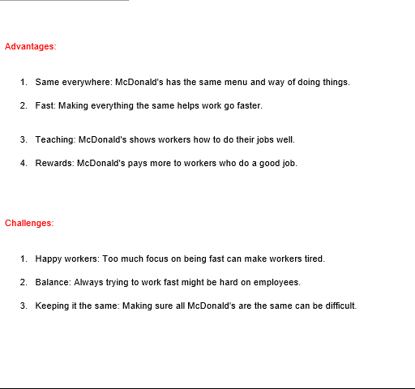

Figure 9. advantages and challenges of Taylor’s theory in McDonald’s ( author’s thoughts)

Internal Conflicts and Resolution Strategies

According to Richard Rumelt’s book ‘’Good Strategy/Bad Strategy: The Difference and Why It Matters’’ (2011), there are elements within companies that are difficult to see and define objectively, such as customer service quality or employee satisfaction. However, this can be compared to McDonald's, as the company takes action to measure these unobservable phenomena, for example, by conducting customer and employee satisfaction surveys and monitoring performance and quality indicator. We can use this idea to examine McDonald's and see how it addresses these challenges and what it does to succeed. For example, McDonald's has a strong organizational culture that consists of values such as customer service, cleanliness, quality, and value.
The company consistently invests in training their employees and encourages positive behaviors and attitudes. McDonald's also has a strong reputation as a fast-food industry leader, attracting customers from around the world. The company strives to maintain its reputation by introducing innovations in products and services and maintaining quality and food safety.

In conclusion, the ideas presented in Richard Rumelt’s book are fundamentally consistent with McDonald's approach to management.
McDonald's believes that managing unobservable phenomena in the fast-food industry is key to achieving success.
As a result, the company focuses on investing in organizational culture, reputation, and managerial skills, as well as studying and monitoring these phenomena to measure their impact on the company's performance.
"Because the key factors that determine firm success are not readily observable, this creates significant problems for the development and testing of strategic theory. Many of the phenomena central to strategy – such as reputations, intangible resources, or dynamic capabilities – are difficult to observe and define in a way that can be made operational for research purposes." Rumelt, R. (2011).
.
This chapter emphasizes how challenging it is for businesses to manage things that are not easy to see, such as reputation or employee satisfaction.

McDonald's is an example of a company that deals with these challenges well. They train their employees and adhere to good values, such as maintaining cleanliness and ensuring customer satisfaction.
People from all over the world enjoy McDonald's because it is a leader in fast food. The company works hard to maintain its good reputation by coming up with new ideas and ensuring food safety. They also solicit feedback from customers and employees to evaluate their performance.

Although McDonald's has an excellent overall reputation, the company's focus on quality and efficiency can sometimes result in conflicts.
To overcome this, McDonald's places great importance on training programs to help break down problems and prevent them from occurring.
Taylor's theory helps the organization understand the value of training staff and instilling a sense of responsibility for their assigned tasks, regardless of how insignificant they may seem.
Specifically, each team member should be assigned tasks that are equally important in building the entire service in the best possible way.
McDonald’s overall does a well-organized job and applies good techniques to balance facing the company with challenges.
The following bullet points will show some of the tactics being used by this organization.

- McDonald's provides rewards to workers who perform well, such as increased pay. This aligns with Taylor's idea of offering workers more money when they work more efficiently.

- McDonald's trains their workers in the best way to do their job. This corresponds to the idea of selecting the right workers for each job and providing them with proper training.

- McDonald's has the single best method for performing each job. This is like Taylor's concept of determining the most efficient way to do a job through careful study.

This work highlights significant facts about management theories and how two different approaches can be used in McDonald's business. While both theories have been adopted, one of them is more visibly used when it comes to problem-solving. As mentioned in Taylor's theory, there are stages and steps that can create issues in operational aspects.

McDonald's is a large company that employs many people and supports numerous jobs in the UK, serving millions of customers every day. However, this can lead to conflicts in areas such as wages, working conditions, environmental concerns, and health. To address these issues, McDonald's strives to be open and transparent with everyone involved and to listen to their concerns.

The company also focuses on creating a positive work culture, training its employees, and checking performance through surveys. All of this is part of McDonald's Corporate Social Responsibility (CSR) program, which aims to make decisions that benefit the environment, employees, and communities they serve.

There is evidence that McDonald's is making progress in these areas, such as reducing their carbon footprint by recycling their cooking oil to make biodiesel that fuels their lorries and switching from plastic straws to recyclable paper ones. These efforts demonstrate McDonald's commitment to their CSR goals and to making a positive impact on society and the environment.

Conclusion
McDonald's is a leading UK-based food retailer that uses various management theories to ensure its smooth operations. Its main management approaches include Fayol's administrative theory, which focuses on coordination, planning, and control, and Taylor's scientific management theory, which emphasizes efficiency and productivity. While these approaches have their advantages, they also have limitations that affect their effectiveness. Conflicts may arise when employees disagree on organizational priorities, but McDonald's resolves these conflicts through communication, collaboration, and conflict resolution strategies. Overall, McDonald's management theories and conflict resolution strategies have been successful in ensuring its continued success in the food retail industry.

References

Anonymous (2018) Strategic Management Approaches of McDonalds, UK Essays, available at: https://kw.ukessays.com/essays/business/strategic-management-approaches-of-mcdonalds-business-essay.php?vref=1
Anonymous (2018) What is McDonald's corporate social responsibility (CSR) policy?, McDonald’s, available at: https://www.mcdonalds.com/gb/en-gb/help/faq/what-is-mcdonald-s-corporate-social-responsibility--csr--policy.html
Anonymous (2018). Leadership And Change Management At Mcdonalds Business Essay, UKEssays, available at: https://www.ukessays.com/essays/business/leadership-and-change-management-at-mcdonalds-business-essay.php?vref=1
Anonymous (2018). Strategic Management And Leadership Within McDonalds, UKEssays. Available at: https://www.ukessays.com/essays/business/strategic-management-and-leadership-within-mcdonalds-business-essay.php?vref=1
Anonymous (2023) Efficient, bold and sustainable: McDonald's supply chain secrets, Wondershare EdrawMind, available at: https://www.edrawmind.com/article/mcdonalds-segmentation-targeting-and-positioning.html
Anonymous (2023) McDonald's Corporation, Reference for Business, available at: https://www.referenceforbusiness.com/businesses/M-Z/McDonald-s-Corporation.html
Anonymous (2023) McDonalds Organisational Structure, StudySmarter, available at: https://www.studysmarter.co.uk/explanations/business-studies/business-case-studies/mcdonalds-organisational-structure/
Anonymous (2023) Our Plan for Change, McDonald’s, available at: https://www.mcdonalds.com/gb/en-gb/our-plan-for-change.html
Anonymous (2023) The financials, How the business works, McDonald’s, available at: https://www.mcdonalds.com/gb/en-gb/franchising/the-financials.html
Anonymous (2023) Valuing and Respecting our People, McDonald’s, available at: https://www.mcdonalds.com/content/dam/uk/nfl/pdf/reports/Valuing-and-Respecting-our-People.pdf
Cole, G.A., Gerald A., Kelly, P. and Kelly, P. (2011) Management theory and practice. 7th edition. Andover, U.K: Cengage Learning.
Ganti, A., Brown R J, Kvilhaug S (2022) How McDonald's Makes Money, Investopedia, available at: https://www.investopedia.com/articles/markets/032015/how-mcdonalds-makes-its-money-mcd.asp
Ganti, A. (2022) How McDonald's Makes Money, Investopedia, available at: https://www.investopedia.com/articles/markets/032015/how-mcdonalds-makes-its-money-mcd.asp
Godfrey, P.C. and Hill, C.W.L. (1995) The problem of unobservables in strategic management research, Strategic management journal, 16(7), pp. 519–533. Available online: https://www-jstor-org.ezproxy.uwtsd.ac.uk/stable/pdf/2486973

Jacobs K. (2018) Efficient, bold and sustainable: McDonald's supply chain secrets, Supply Management, Cips, available at: https://www.cips.org/supply-management/analysis/2018/march/mcdonalds-supply-chain-secrets/
Jargon J. (2016) McDonald’s Knows It’s Losing the Burger Battle - Can It Come Back?, The Wall Street Journal, available at: https://www.wsj.com/articles/mcdonalds-knows-its-losing-the-burger-battlecan-it-come-back-1475769684
Kelso A. (2021) How McDonald’s New Chief Global Impact Officer Plans To Execute The Company’s ‘Refreshed Purpose’, Forbes, available at: https://www.forbes.com/sites/aliciakelso/2021/03/01/how-mcdonalds-new-chief-global-impact-officer-plans-to-execute-the-companys-refreshed-purpose/?sh=1c74be4a125a
Lutz A. (2014) McDonald's Is Cutting A Ton Of Menu Items, Business Insider, available at: https://www.businessinsider.com/mcdonalds-is-cutting-menu-items-2014-12?r=US&IR=T
McGrath, J. and Bates, B., (2017) The Little Book of Big Management Theories, 2nd edition, Harlow: Pearson Education available at: https://issuu.com/pearsonprofessional/docs/little_book_manage_theories_echapte
Meyer P. (2022) McDonald’s Mission Statement & Vision Statement (An Analysis), Panmore Institute, available at: https://panmore.com/mcdonalds-vision-statement-mission-statement-analysis
Morgan P. (2017) The business student’s guide to study and employability, Sage, page: 222-322.
Owen, J (2021) The Leadership Skills Handbook, Fifth Edition, KoganPage, page: 97-106.
Peek S. (2023) Management Theory of Henri Fayol, Business.com, available at: https://www.business.com/articles/management-theory-of-henri-fayol/
Petriglieri G. (2020) Are Our Management Theories Outdated?, Harvard Business Review, available:
https://hbr.org/2020/06/are-our-management-theories-outdated?autocomplete=true
Purdy C. (2017) McDonald’s isn’t just a fast-food chain—it’s a brilliant $30 billion real-estate company, Quartz, available at: https://qz.com/965779/mcdonalds-isnt-really-a-fast-food-chain-its-a-brilliant-30-billion-real-estate-company
Rumelt, R.P. (2012) Good Strategy/Bad Strategy: The Difference and Why It Matters, Strategic Direction, Vol. 28 No. 8. https://doi.org/10.1108/sd.2012.05628haa.002
Thompson A. (2022) McDonald’s Organizational Structure & Its Characteristics – An Analysis, Panmore Institute, available at: https://panmore.com/mcdonalds-organizational-structure-analysis
Tikkanen A., Anonymous (2023), McDonald’s, American corporation, Encyclopaedia Britannica, available at: https://www.britannica.com/topic/McDonalds
Trainer, D. (2022) McDonald’s: A Golden Stock Worth A Premium, Forbes, available at: https://www.forbes.com/sites/greatspeculations/2022/05/18/mcdonalds-a-golden-stock-worth-a-premium/?sh=189d0fd25a56
Gadiesh, O. and Gilbert, J. L. (2001) Transforming Corner-Office Strategy into Frontline Action, Harvard Business Review, available at:
https://hbr.org/2001/05/transforming-corner-office-strategy-into-frontline-action
Taylor, F. W. (2022) The Principles of Scientific Management , BEW Learning, available online: https://www.google.co.uk/books/edition/The_Principles_of_Scientific_Management/89tbEAAAQBAJ?hl=en&gbpv=1

Appendix

Anonymous (2023). Scientific Management Theory, Sourced from UWTSD available online : https://moodle.uwtsd.ac.uk/pluginfile.php/687553/mod_resource/content/1/McDonalds%20-%20Scientific%20Management%20Theory.pdf
Anonymous (2023) Managing Change in the Workplace: 10 Best Practices for Change Management, Indeed, available at: https://www.indeed.com/hire/c/info/best-practices-for-managing-change-in-the-workplace?hl=en&cc=US
Ardley D. (2018) Business Studies Year 13 revision Day 4 - PESTLE analysis part 1, EZY Education, video available at: https://www.ezyeducation.co.uk/ezybusinessdetails/ezybusiness-news/entry/business-studies-year-13-revision-day-4-pestle-analysis-part-1.html
Anonymous (2020) McDonald’s Annual Report, McDonalds, available at: https://corporate.mcdonalds.com/content/dam/sites/corp/nfl/pdf/2020%20Annual%20Report.pdf
Anonymous (2023) Biodiesel Initiative, McDonald’s, available at: https://www.mcdonalds.com/ae/en-ae/biodiesel-initiative.html
Anonymous (2019) McDonald's paper straws 'fully recyclable' makers say, BBC, available at: https://www.bbc.co.uk/news/uk-wales-49247049

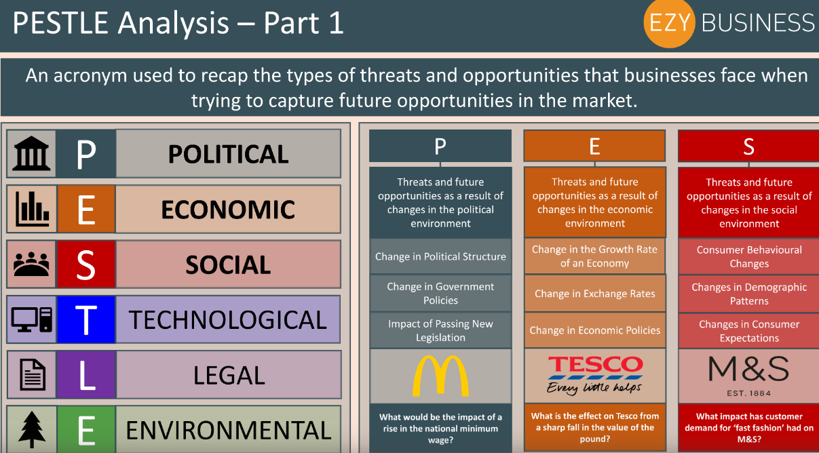
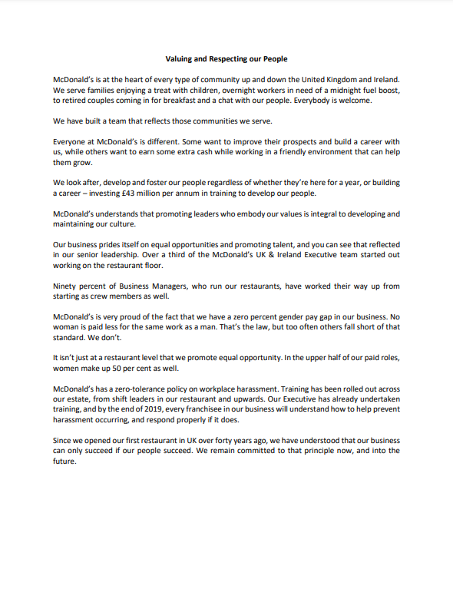
(Document is no longer available on the website of McDonald’s)

