Week 5: Computer Architecture Tutorial
Task 1: Creating and ‘Fine tuning’ a Virtual Machine.
A virtual Machine (VM) is a software emulation of a full working computer system. It runs as a piece of software, upon a specific platform/environment referred to as a Hypervisor.
A hypervisor is software that facilitates virtualisation and makes it possible to run virtual machines upon host hardware. It does this by pooling resources from the physical hardware, such as Memory, Processing and Storage, and managing/dispensing them to virtual machines that run on the host. This allows for multiple different Virtual machines, of various specifications and types to run on a host system. The role of the hypervisor is critical within Virtualisation. It requires the use of some ‘core operating system level’ components to perform this role. These include input/output stacks, memory management, CPU/processor scheduling and networking stacks (e.g. TCP/IP protocol stack), amongst others. The hypervisor has to manage scheduling each virtual machines resource requirements against the physical resources. Since the physical hardware still does the task that the virtual systems require (e.g. CPU instructions, memory access), the Hypervisor is responsible for managing the schedule.
There are two main types of Hypervisors, Type 1: Bare metal Hypervisors and Type 2 Hosted Hypervisors.
Type 1 Hypervisors are referred to as bare metal as it runs on the host hardware as the actual Operating system. It replaces the host OS and manages access to the hosts resources directly for the Virtual Machines running on the host. Since there is no broker between hardware and the VMs, these types of Hypervisors are more powerful providing higher performance for Virtual Machines. Example of Type 1 Hypervisor software include Microsoft Hyper-V, Citrix Xen and VMWare vSphere.
Type 2 Hosted-hypervisor software is installed as a self-contained application on the Hosts operating system. It functions by having several abstract operating systems installed on VMs. These resources are scheduled within the host operating system, which is then executed against the host hardware. Since the Hypervisor does not have direct hardware access, these systems generally are not as powerful as their type 1 variants. They are ideal though for efficiently running and testing various flavours of Operating systems on a host PC. The most common examples of Type 2 Hypervisor software include VMWare Workstation and Oracle VirtualBox.
The type 2 hypervisor software utilised here is a software application called Oracle VirtualBox.
The download link and Installation steps for VirtualBox and the VirtualBox Extension Pack, can be found here:
https://www.virtualbox.org/wiki/Downloads
https://download.virtualbox.org/virtualbox/7.2.6/UserManual.pdf
Download the Ubuntu Operating System.
- Download Ubuntu 24.04.4LTS (Long Term Support)
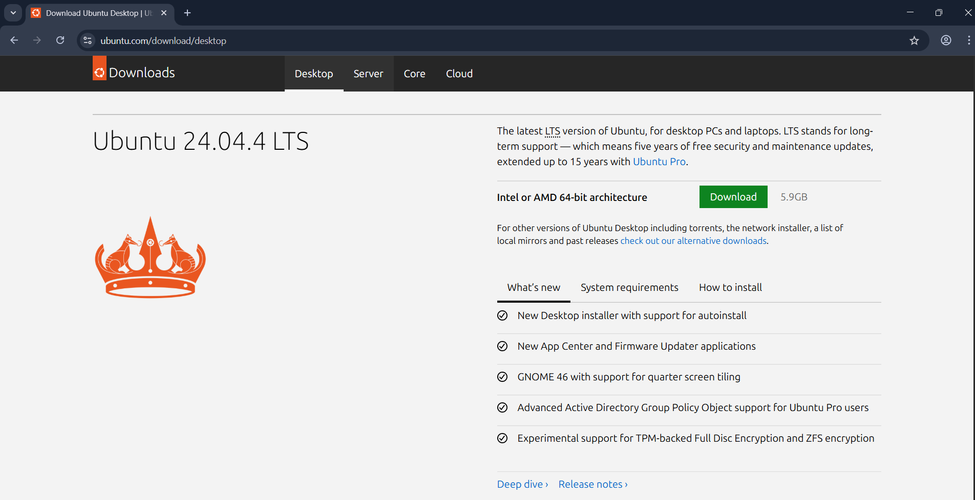

Creating a Virtual Machine in VirtualBox.
When installed Start > Oracle VirtualBox
Creating a Virtual Machine in VirtualBox.
- In VirtualBox – Choose Expert View > from the main menu select New – you will see the following dialogue window.
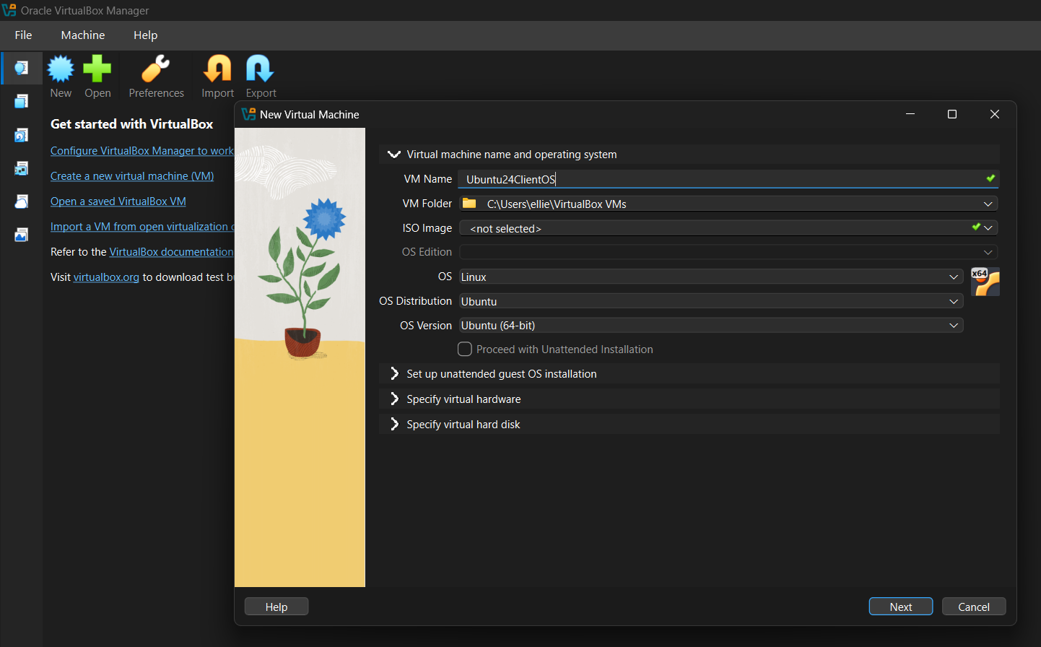
- Set the following values:
  - VM Name: Ubuntu24ClientOS
  - VM Folder [Accept Default]
  - ISO Image [Click drop down menu arrow > click Other > select the ISO file downloaded for Ubuntu (shown below)
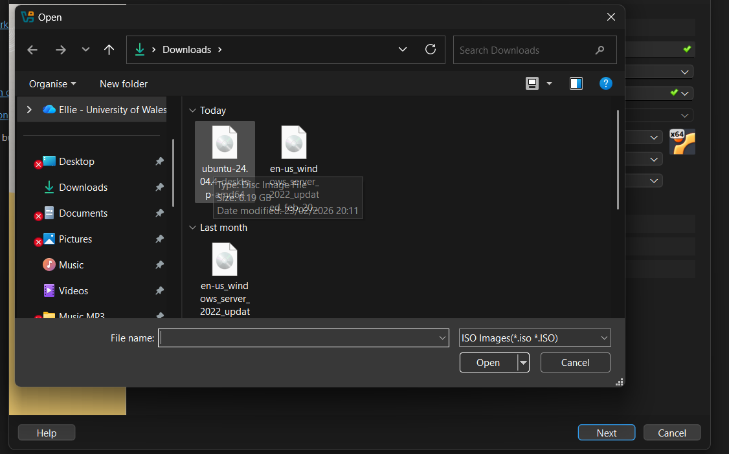
  - Unattended Installation: [Check off]
  - Expand Specify Hardware:
  - Base Memory: 4096MB (4GB RAM)
  - Number of vCPUs: 2
  - Use EFI: [Check on]
  - Expand Specify Virtual Hard Disk:
  - Disk Size: 25GB
  - Click Finish.
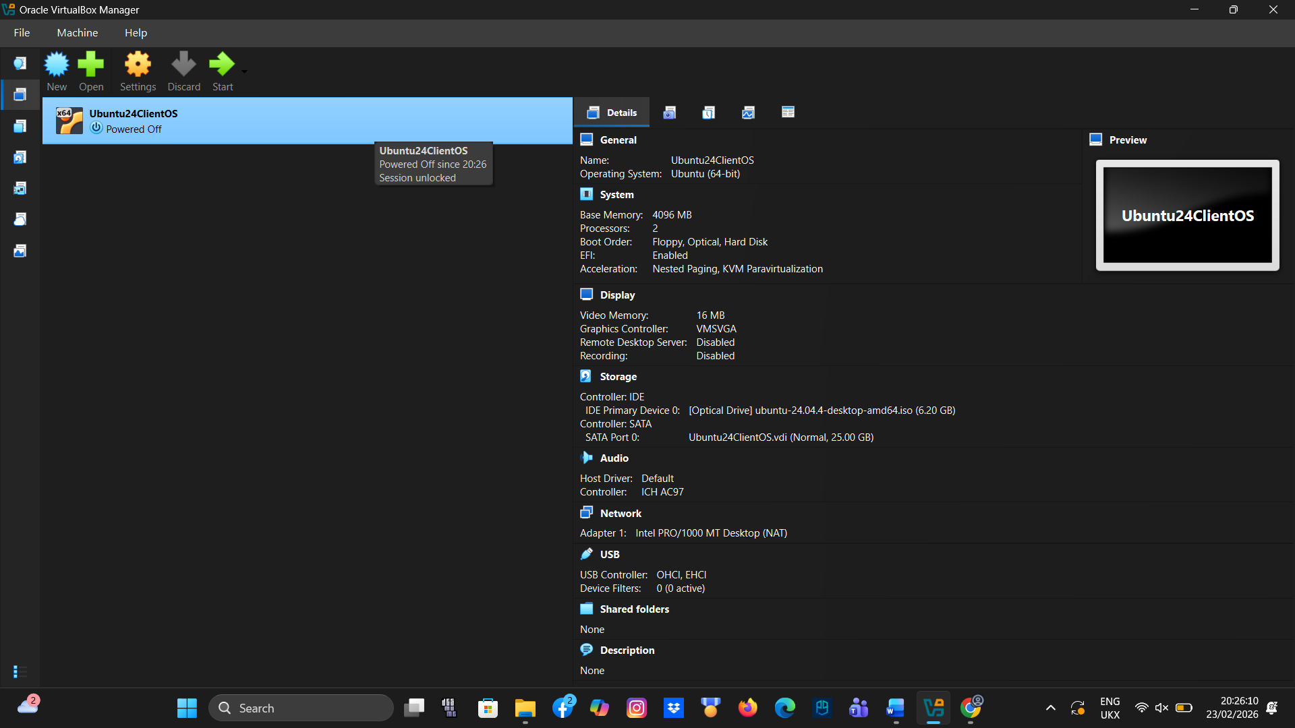
- To fine ‘tune’ VM settings for optimised performance:
  - Right click on the VM in the left hand side of the console window > Settings.
  - Display > Video Memory: Maximize to 128 MB.
  - Display > Graphics Controller: Select VMSVGA.
  - Display > Acceleration: Enable 3D Acceleration for smoother graphics.
  - Storage: Choose NVMe for the controller type to improve I/O throughput.

- Add in additional hard disks:
  - It is good practice to have an additional hard drive for backing up files with most operating systems. An effective strategy is to use a high performance SSD (using NVMe) over PCIe 4.0/5.0 technology for Operating systems and high performance requirement applications. To backup data, a less expensive legacy drive could be used. In the result of Operating system failure, this drive can keep important files archived. To add in an additional disk to the VM in VirtualBox:
Right click the VM and choose Settings
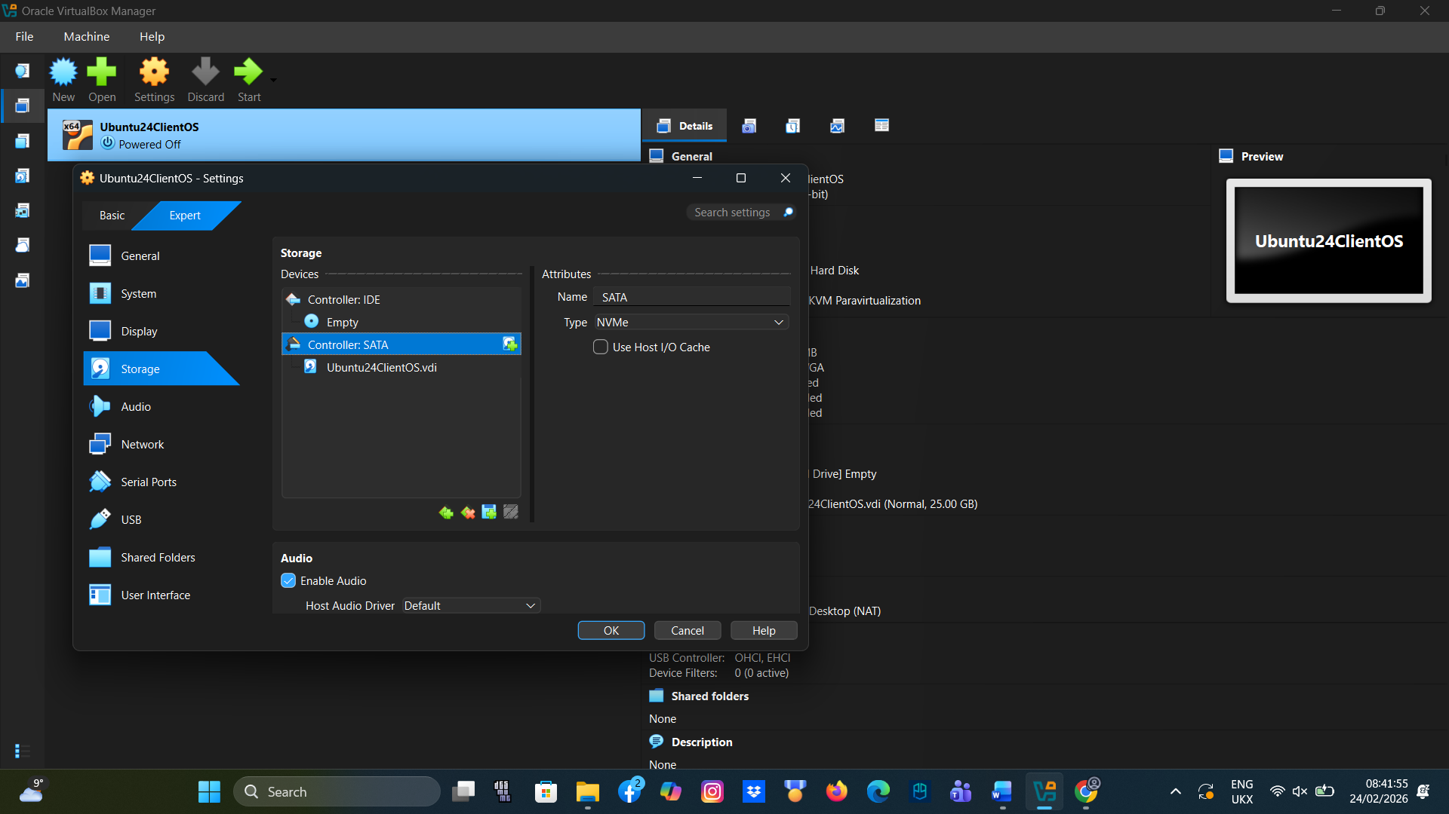
  - Choose Storage then click on the Controller SATA > choose the Add Disk button
  - Click Create, set the Disk Size to 25GB and then click Finish

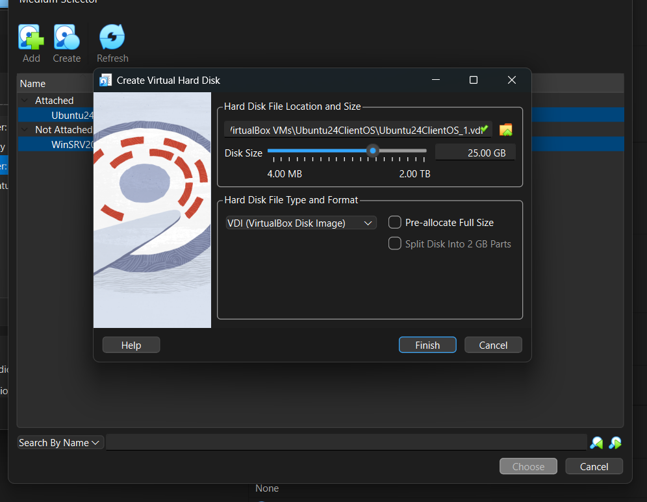
  - Now the newly installed disk needs to be added/attached to the VM
  - To do this click to select the new disk and then click the Choose button.
You will now see the disk available under the SATA Controller
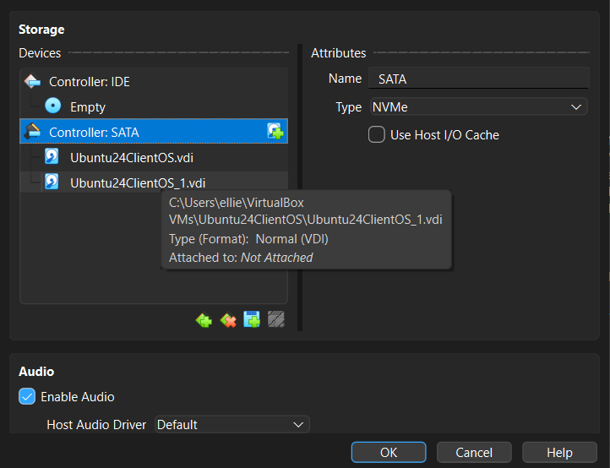

- To install Ubuntu 24.04.4LTS on the VM
  - Click Start – The console window will show the VirtualBox logo and Linux pre-installation screen
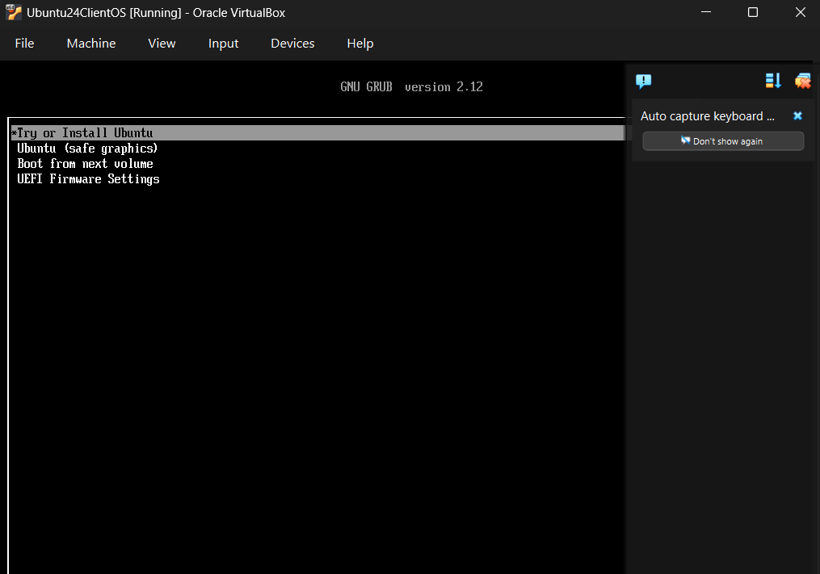
  - Click Enter on Try or Install Ubuntu
  - Wait for Ubuntu to load

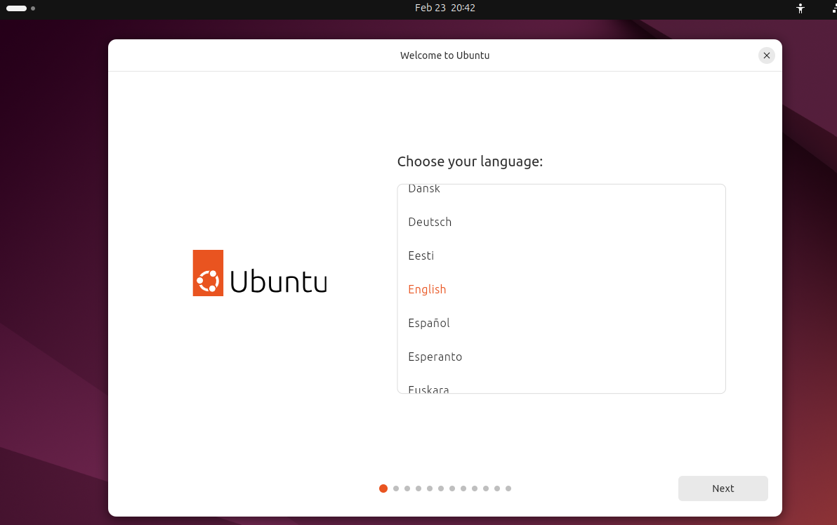
  - Choose English – Click Next
  - Accesibility in Ubuntu > Unless you have any special requirements > Next
  - Select your Keyboard layout > English United Kingdom
  - Connect to the Internet > Use Wired Connection > Next
  - What do you want to do with Ubuntu > Install Ubuntu > Next
  - How would you like to install Ubuntu > Interactive Installation
  - What apps would you like to install to start with > Default selection
  - Install Recommended Proprietary software > Check on third-party software support and Download and install support for additional media formats
  - How do you want to install Ubuntu > To follow good practice when install linux, click > Manual Installation and then set the following options:
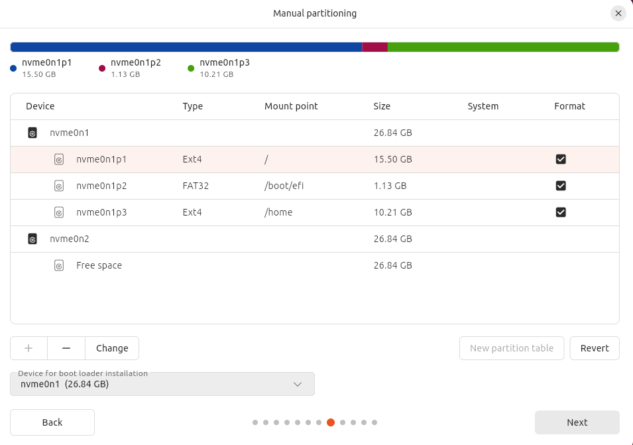
This disk/partition setup comprises:
- / (The root partition, set to roughly 15GB for running the OS
- /EFI (A boot partition set to around 1GB (created automatically) that stores the boot loader files for quick read access when starting up the OS
- /home (creates a partition on the disk that will occupy the remaining space. In the result the OS files become corrup and OS requires rebuilding or repair, having a /home partition separate, keeps your data files safe/sandboxed away from the OS. This partition can then be copied restored when O/S is rebuilt.

Once done click on the Root partition to install the OS and click Next.
- Now setup your user to login:
  - Username: [your name]
  - Computer Name (e.g. [your initials]Ubuntu24Client)
  - Password: Use a strong minimum 12 character password, good practice (e.g. The first letter in each word that makes up an easily memorable sentence]. NB use Caps in some words and letter/symbols to make things more complex for any potential hackers.
  - Require my password to login > Check on
  - Use Active Directory > Leave checked OFF
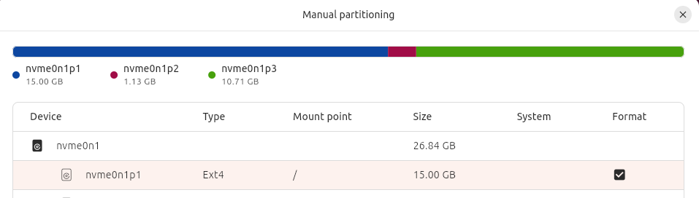
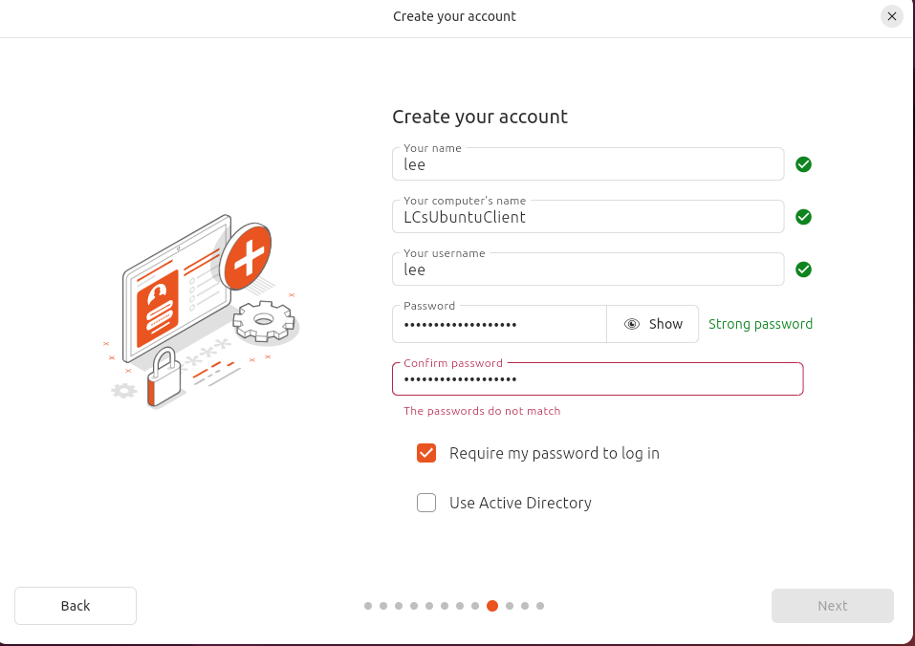

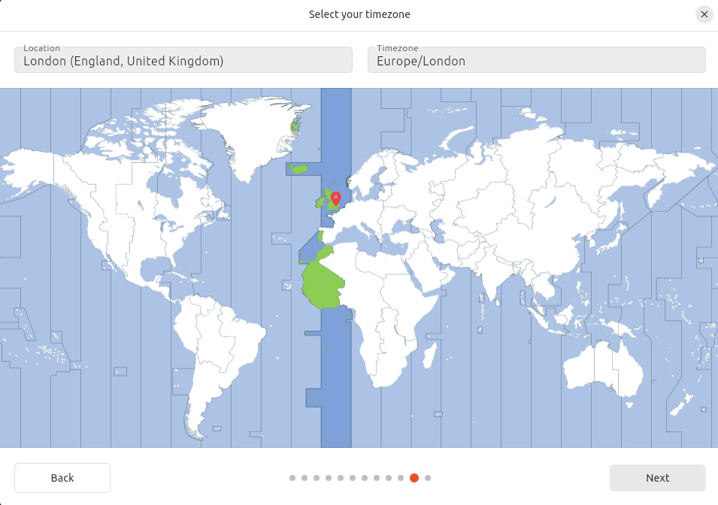
- Choose Next
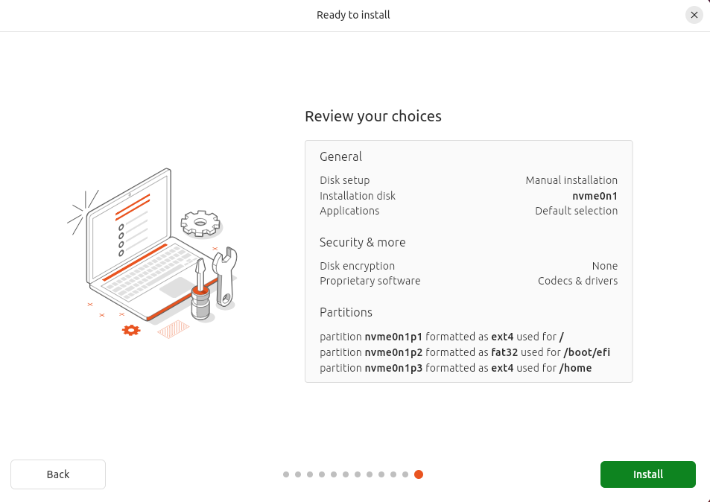

- Review summary selections and click Install.
Login to the Ubuntu OS with your username and password:
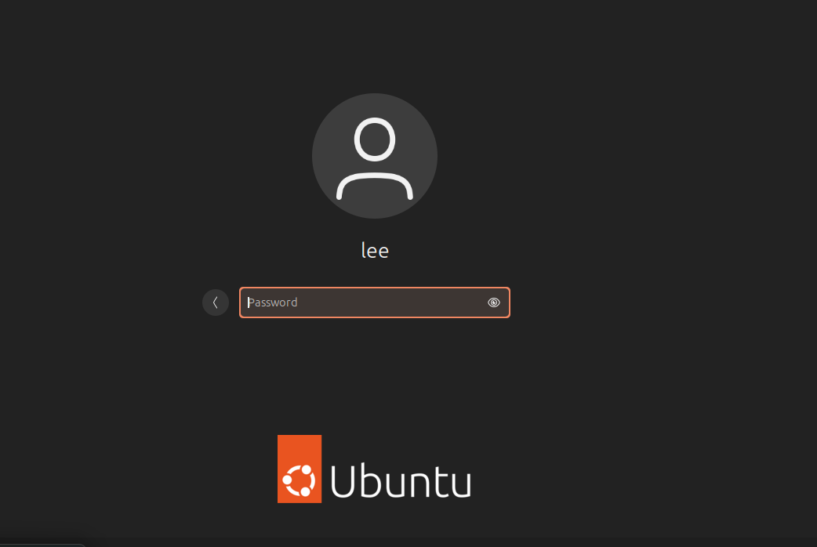

You can skip the first few screens, e.g. Collecting data for Ubuntu, you will find the App Center a useful OS utility/application
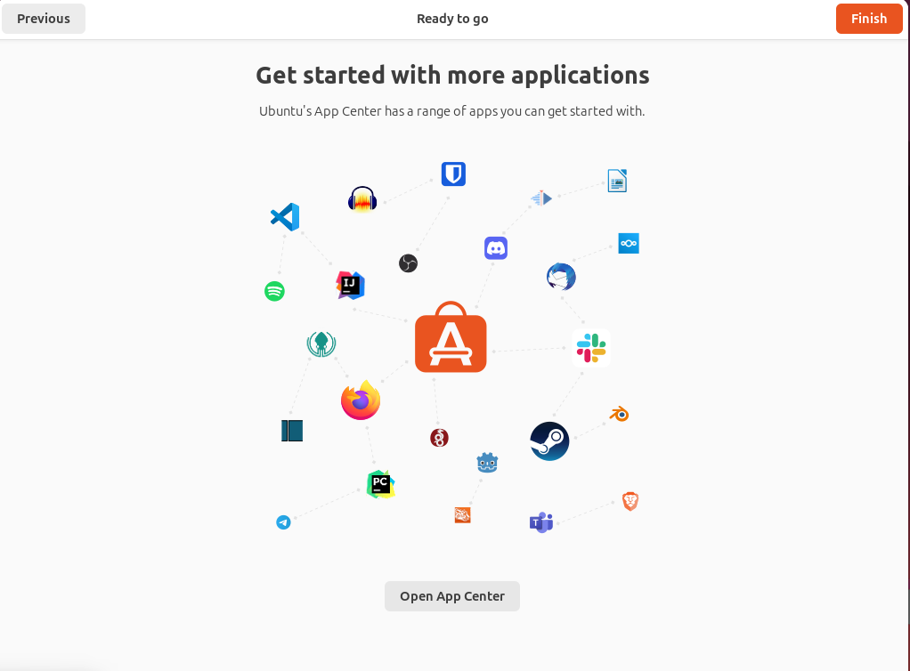
App Center categorises apps and utilities that can be used ranging from Productivity, Creativity and Design, Development, System Utlities, Communication, Entertainment and Gaming.
Applications of note, that can be used within Linux (Ubuntu):
- LibreOffice Suite – Default open source alternative in Ubuntu and other Linux distributions to Microsoft Office. It includes Writer (Word), Calc(Excel) and Impress(Powerpoint).
- Mozilla Thunderbird – Open source email client application
- Mozilla Firefox – The default web browser
- VLC media player – Media player for playing video/movie/audio files.
- Krita – Professional grade digital art/paint software
- GIMP – An open source alternative to Adobe Photoshop
- Timeshift – Very useful piece of system software for taking system snapshots for backup and restore purposes.
- Stacer – An all in one system monitor, can monitor performance and optimise the system.
- VirtualBox – Type 2 Hypervisor software for building VirtualMachines in a controlled environment.
- Docker - The tool for implementing/learning serverless/container technology.
- Remimina – A remote desktop client (similar to Remote Desktop Connection in Windows) that allows Linux to remotely connect to/be connected to with other machines over a network/internetwork.
- Telegram – A native client for secure messaging within the Linux OS
- Slack – An alternative work/team communication platform similar to Zoom/MS Teams.
- Steam – The principal gaming Platform for Linux systems.
Arguably the most critical system utility in Linux systems is the Terminal.
The Linux terminal is a text based terminal emulator (similar to the Command prompt in Windows). It provides users with a more efficient and powerful means of sending commands to interact with the operating system.
The Terminal utilises 3 key components in order to achieve this
- A command prompt – this allows you to enter commands and view the results
- A shell – Bash is one flavour of shell, it is the ‘interpreter’ that allows text based commands to be understood by the OS, so that the OS can complete its actions and tasks.
- Command syntax/arguments – When using the terminal, users will use a number of keywords that are conventions to the Linux Kernel. These tell the OS to perform its tasks. Examples include ls (List contents of a folder/directory), cd (Change directories in the OS file system) mv (move a file) and rm (Remove a file).
Terminal is used for a host of tasks in the OS including:
- System Administration
- System Controls
- File Management
- Automation of complex tasks, via shell scripts. Shell scripts are files containing a batch/sequence of commands).
Using the Terminal.
- Click on the Ubuntu start button > Terminal
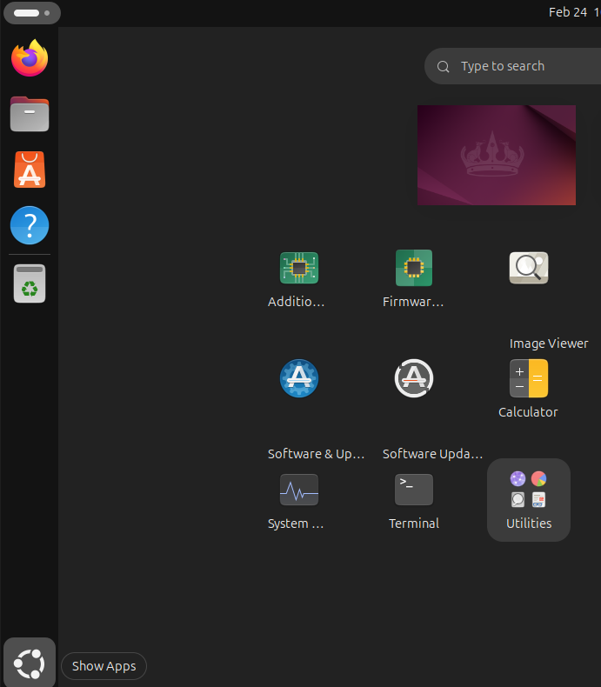
- Before entering any commands into the Terminal command prompt, it is important to take note of the command sudo. sudo (stands for Super user do or substitute user do). It is the command required for executing ‘system admin/root level commands within the OS. You will need to enter this command in order to elevate privileges to perform many root level system changes. apt (Advanced package tool) is an advanced package management tool used by derivatives of the Debian Linux system (such as Ubuntu). It allows us to make changes to the application inventory on the OS as well as perform system level changes such as OS updates/upgrades. A package is a collection of files that make up a program.
- In terminal type the following command
  - sudo apt update -y
Here we use commands and their arguments to install the updates that we find for our Linux distribution from the Repositories (Servers) that host these updates on the Internet.
Using Terminal to run useful commands:
- OS navigation and File management commands
- pwd
  - pwd prints the working directory of the user, without the sudo command we should be in the /home directory
- ls -lh
  - This command lists files available in the current working directory along with the file sizes in human readable format
- cd \etc
  - An example of using the cd command to change directory with the argument /etc (takes us to the /etc) in the file system
Fig A: The Linux File system (an abstract, top-down view where the Penguin represents root!! /
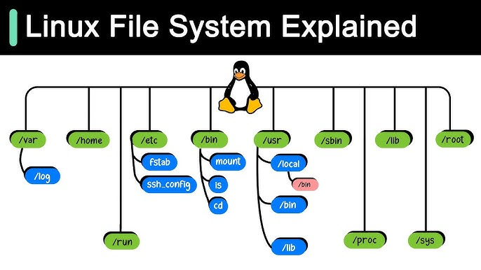
Task: Investigate what each of these branches in the Linux File System Tree is for?

- In terminal test the following types of System Maintenance, Monitoring and Troubleshooting commands.
  - top
  - htop

[The commands above present resource usage statistics in real time for system resources such as CPU, RAM and running processes, the latter are identifiable by their PID process ID].

  - df -h
  - du -sh *
[These commands firstly show available disk space on all mounted file systems in readable form and secondly a summary of file and directories within your current working directory].
  - kill -9 [PID]

NOTE: DO NOT USE the kill -9 command on PIDs at this stage as it will destroy your Linux system if used incorrectly.

  - neofetch

This command will display your system information

  - cmatrix

You will likely need to acquire this app
In terminal sudo apt install cmatrix

For fans of the matrix movie, that one should be self-explanatory!!

  - sudo !!

Will re-run whatever the last command was with sudo/root level access

  - clear

Clears all commands in the terminal window.

Task:
Install some useful applications, either from the above list, or for your own preferences using terminal and appropriate commands and arguments. Resolve any dependencies you may require, by carefully observing instructions provided in the terminal window.

