

ASSIGNMENT 1

NAME: IVAYLO DOSEV
NUMBER: 1909471
SUBJECT: (BMSW4002)
TOPIC: EFFECTIVE TEAMWORKING AND COMMUNICATION
LECTURER: AFZAL MUNNA

CONTENT
- Introduction 3
2. Importance of Communication in Management 3
3. Communication Theories 3
Berlo’s SMCR Model of Communication 3
Schramm Communication Model 4
Shannon-Weaver Mathematical Model 4
4. Importance of Effective Communication 5
Critical Reflections on Workplace Communication 5
Communication Disruption 5
Nonverbal Communication 6
Encoding and Decoding 6
5. Conclusion 7
References 8

Table of Figures
1.Figure 2: Berlo's Model of Communication (Source: Businesstopia.net) 3
2.Figure 2: Schramm's Communication Model (Source: Communicationtheory.org) 4
3.Figure 3: Shannon-Weaver Model of (Communication Source:CommunicationTheory.org)…………………………………………………...…..5

INTRODUCTION
The purpose of this report is to explore the concept of effective communication from both the theoretical and practical perspectives. This report will explore three prominent theories on the communications field; (1.) Shannon and Weaver Model of Communication, (2.) Wilber Schramm’s Model of Communication, and (3.) Berlo’s Model of Communication. The theoretical insights will then be applied to practical evidences of both the author’s in-class activities, and experience with communication in the workplace. This report will examine three distinct examples of my personal workplace experience to evaluate how well the communication worked in our scenario, and what we could have done to further improve it.

IMPORTANCE OF COMMUNICATION IN MANAGMENT
Success in an organisational environment depends on how well organised the involved people are. The effectiveness and efficacy of their communication can make a strong influence on their performance. Studies note that better communication flow in the workplace is linked to increased workout/performance, productivity, and employee engagement (Femi, 2014; Bucata & Rizescu, 2017).
The components of creating an effective communications environment arguably includes the availability of proper interpersonal skills (i.e. a unified social system, communication skills, cultural competency), availability of appropriate mediums (i.e. electronic, radio, physical), and an appropriate communications environment. Insights into creating effective communication are explored through theories in the following section.

COMMUNICATION THEORIES

Berlo’s SMCR Model of Communication
Berlo’s model of communication is constituted by four processes over which communication takes place; (i) Source, (ii) Message, (iii) Channel, and (iv) Receiver. In this model, when a communication takes place, the sender encodes a message based on their communication skills, attitude, culture, knowledge, and other interpersonal factors (First stage). This ‘message’ can be of any content or code (Second stage), sent through an appropriate channel (hearing, touching, tasting, etc.) (Third stage). The ‘receiver’ then takes the message and ‘decodes’ it as per their own communication skills, attitude, culture, knowledge, and other interpersonal factors (Fourth Stage) (Turaga, 2016).
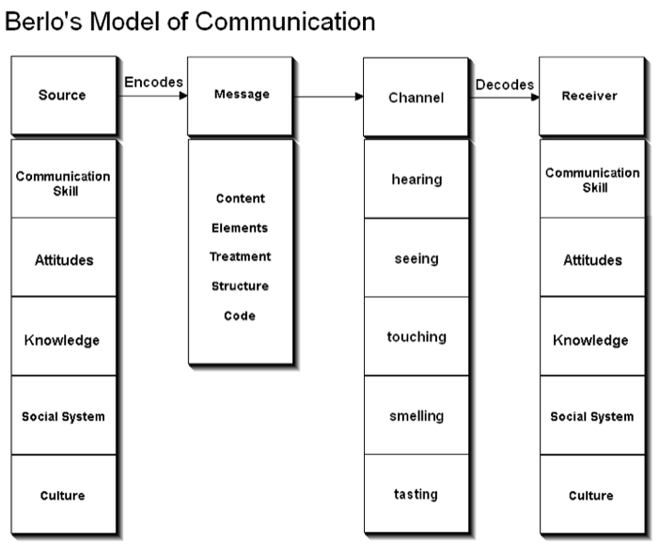
Figure 2: Berlo's Model of Communication (Source: Businesstopia.net)
Berlo’s theory of communication is modelled around encoding and decoding of communication – the theory asserts that both the encoder and decoder have a different method of interpretation for the communication. This means that if two people do not share similar interpersonal skills, their communication might be misunderstood or confused. The channels of communication are also important; the channel used by the encoder will be interpreted differently by the decoder, which makes it important to choose a channel that can be used by all the communicating parties.
However, it is can argued that the linearity of this communication model means that it does not account for other elements of a communication, i.e. noise and disturbance. It also does not appear to have any mechanism for feedback from the decoder using two different communication models at the same time (i.e. physical sarcasm).

Schramm Communication Model
Schramm’s model of communication asserts that effective communication is possible only in a loop; a continuous exchange of messages that originate from an encoder and are then interpreted for their context and meaning. Unlike other models of communication that take into account the influence of interpersonal skills, cultural competency, and even environmental noise and disruption, the Schramm model focuses on a simplistic loop of communication (Schramm, 1954; Croft, 2004). This indicates that the theory assumes that all communication contexts happen in a strictly local sense where the communicating parties have no difficulty understand each other (i.e. language barrier, distance barrier).
Although this theory provides a simpler approach to communication, the applicability of it to measure effective workplace communication is important because modern workplaces often have several layers of disruptions and interpretations that hinder effective understanding and communication, which means communication is often not loop-able. It is arguable that the scope of the message would be vulnerable to disruption, or convenience, when comparing different forms of communication medium.

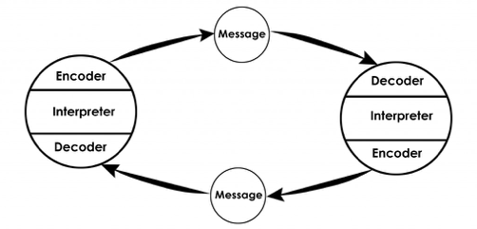
Figure 2: Schramm's Communication Model (Source: Communicationtheory.org)

Shannon-Weaver Mathematical Model
Shannon-Weaver’s communication model provides a more ‘broader’ view of communication. In this model, the ‘sender’ of the message transmits the message through an encoder (i.e. converting the message into signals), which is then relayed through an appropriate channel. However, unlike Berlo’s model of communication, the Shannon-Weaver model accounts for potential disturbances in the channel, which can disrupt or modify the message, and thus can be cause of miscommunication that stops effective communication.
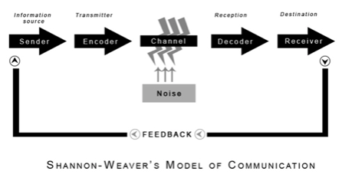
Figure 3: Shannon-Weaver Model of Communication (Source: CommunicationTheory.org)
The channel, modified or otherwise static, delivers the message through an appropriate decoder to the receiver. The receiver decodes the message, interprets the content, and then provides feedback to the original sender. This feedback loop (the return of the feedback is arguably also subject to disturbance by noise or other disruptors) completes a communication loop. In this perspective, effective communication is the process where all these systems work with complete efficiency – the message is encoded correctly, delivered through an appropriate channel without noise or disruption, and is returned in the same manner (Maras, 2000). Compared the Berlo’s model, however, this theory does not appear to account for interpersonal encoding that might disrupt the meaning of the message, rather the Shannon-Weaver model appears to focus more on encoding and disruption.

IMPORTAMCE OF EFFECTIVE COMMUNICATION

Critical Reflections on Workplace Communication

Communication Disruption
There is one prominent example in my mind where my team in the workplace suffered from poor communication. We run a cleaning business, and experience substantially spiked demand during Winter times, particularly before Christmas time. To cope with this demand, we came up with the strategy to split into two teams so that we can at minimum meet the demand, even though the service speed would be impacted. Because we had no prior experience of splitting into different teams, we did not have the foresight to anticipate what equipment each team would require. The first night of splitting into separate teams, both our teams realised that we did not have the correct equipment to work.
Although this was a fixable mistake, we had no means of communication, particularly due to the bad weather. It took us several minutes of calling to contact the other team to deliver the required equipment to us. However, we could not communicate effectively because the medium of communication was not working – we could barely exchange single words before losing the phone connection. I think Shannon-Weaver’s model is an effective theory to describe our communication in this context; although both teams possessed the correct skills to encode and decode messages (we had our own nicknames for our cleaning equipment), the channel we used was experiencing considerable noise/disruption (Bauer, 2009). As such, we could not communicate properly and both sides were misunderstanding the message.
The receiver decoded our noisy message, misunderstood it, and then gave us a response that we could not properly decode as well. The result of this miscommunication was that the other team sent us equipment that we did not ask for. Because the weather was worsening and work was stalled entirely, we lost an entire work night and our clients were dissatisfied with the slowness of our service as we took an additional day to complete the contracted work.
This example demonstrates the importance of effective communication in the workplace. We needed to have the foresight to obtain the correct infrastructure that would allow for more stable communication between us. At that moment, we could have set up an online chatting system on our smartphones (i.e. WhatsApp). This communication medium could have worked better in giving a clearer message to the other team. Free from disruption, the message would have been decoded properly, allowing to us complete our work on-time and with reasonable satisfaction. No communication method is perfect however, and this method could also have been slow, which would also disrupt effective communication as the messages would be delivered late.

Nonverbal Communication
Continuing the reflection on the same employment, we also tend to rely on a lot of nonverbal communication whilst working. This is because the environment we work in are often very loud due to the heavy machinery working around us – this makes it impossible to communicate from a distance and walking to each other for a quick message is highly inefficient and non-effective, particularly where communication efficacy is concerned. It is arguable that effective workplace communication is one where messages are transmitted as efficiently as possible. As also discussed in the in-class activities, we employ the use of nonverbal communication when conventional communication is not possible.
This communication often takes form of communicating through hand and head gestures. Team members often point to the next task to be completed, with guidance from their hands or head on what sort of work is to be done. However, even this communication method is vulnerable to noise and disruption – often smoke and poor field of visibility means that we cannot understand the gestures given to us. This is also applicable to Shannon-Weaver’s model, the communication medium we choose is vulnerable to disruption, which discredits effective two-way communication (Gillespie & Schiffman, 2018). If the disruption is high enough, we have to walk towards each other for instruction and guidance, leading to slower work overall.

Encoding and Decoding
We have our own specific workplace lingo (as discussed in different forms of encoding and decoding messages in the class). Berlo’s model of communication is useful for interpreting the meaning here – the source of the message is influenced by the communication skills and culture (amongst other factors). We had our own lingo for what we call our equipment, vehicles, and methods of working. This lingo allows us to communicate faster than we would, as compared to using the traditional terms. This lingo persists regardless of the communication method we use (i.e. verbal, nonverbal, digital) and the intended receiver is able to properly understand the message (Kurien, 2010; Rodríguez, 2006).
Because of how our workplace team is constituted, only the people we work with are able to understand our lingo. The continuity of this communication is essential, which is why it is important for us to maintain a consistent workforce. If any member of the team has to be replaced, they also have to learn about our own specific lingo, which makes it harder for us to communicate effectively as a team.

CONCLUSION
This report has examined effective communication from three theoretical frameworks; Berlo’s communication theory, Schramm’s communication model, and the Shannon-Weaver communication model. Examining these theoretical perspectives with real-life reflections of the workplace, this report has explored that communication is a perpetual process. Disruptions in communication is an ever-persistent threat to effective communication, regardless of the method (this report examined conventional, digital, and nonverbal communication methods).
Culture also plays a critical role in enabling effective communication – we have our own workplace lingo that allows to us work better. This is a culture that we have developed over a long time of working together, which makes it difficult for us to adapt new employees to communicate effectively with us. The insights gained through these models, however, have helped me gain a more refined picture of how workplace communication works.

References
1.Asgedom, A., (1999). The S-E-M-D-R model of Schramm: description and application to mass communication in different social systems. I.E.R. Flambeau, , 6(2), pp. 61-72.
2.Bauer, T. L., (2009). Information and meaning revisiting Shannon's theory of communication and extending it to address todays technical problems.. [Online]
Available at: https://www.osti.gov/biblio/993634
(Accessed 13.12.2019)
3.Bucata, G. & Rizescu, A. M., (2017). The Role of Communication in Enhancing Work Effectiveness of an Organization. Land Forces Academy Review.
4.Chandler, D., (1994). The Transmission Model of Communication. ed. (): University of Western Australia.
5.Croft, R. S., (2004). Communication theory. [Online]
Available at: https://cs.eou.edu/rcroft/MM350/CommunicationModels.pdf
(Accessed 05.12.2019)
6.Femi, F., (2014). The Impact of Communication on Workers’ Performance in Selected Organisations in Lagos State, Nigeria. IOSR Journal Of Humanities And Social Science, 19(8).
7.Gillespie, D. J. & Schiffman, R., (2018). A Critique of the Shannon-Weaver Theory of Communication and Its Implications for Nursing. Research and Theory for Nursing Practice, , 32(2), pp. 216-225.
8.Kurien, D. N., (2010). Body Language: Silent Communicator at the Workplace. [Online]
Available at: https://papers.ssrn.com/sol3/papers.cfm?abstract_id=1610020
(Accessed 13.12.2019)
9.Maras, S., (2000). Beyond the transmission model: Shannon, Weaver, and the critique of sender/message/receiver. The Australian Journal of Communication, , 27(3), p. 123.
10.MSG, n.d. Schramm’s Model of Communication. [Online]
Available at: https://www.managementstudyguide.com/schramm-model-of-communication.htm
(Accessed 28.11.2019)
Rodríguez, C. M., (2006). Language Diversity in the Workplace. Northwestern University Law Review, , 100(4), p. 1689.
Schramm, W., (1954). The process and effects of mass communication. Urbana, IL: University of Illinois Press.
Turaga, R., (2016). Organizational Models of Effective Communication. The IUP Journal of Soft Skills, , 10(2), p. 56.



