Max Smith (1810364)
1810364@student.uwtsd.ac.uk
True Word Count: 2495
Systems engineering
Development and Evaluation of a Test, Trial Project using Systems Engineering Approaches

Table of Contents
1 Introduction 2
2 Statement of Need 3
2.1 Needs Analysis 3
2.2 Stakeholder Engagement 4
3 Requirements 5
3.1 Key Requisites 5
3.2 QFD Analysis 5
3.3 Possible Options 6
4 Design 9
4.1 Concept Designs 9
4.2 Chosen design 10
5 Identifying Constraints 11
5.1 Resources 11
5.2 FMEA 11
6 Conclusion 12
6.1 Summary 12
6.2 Recommendations 12
7 Bibliography 13

Table of Figures
Figure 1 - Explosive Production Statistics 2
Figure 2 - A3 Analysis 3
Figure 3 - Stakeholder Engagement Mind Map 5
Figure 4 – QFD Analysis 7
Figure 5 - Modern 3D-Printer 8
Figure 6 - Die Pressing Process 9
Figure 7 - Pressing Bag Process 9
Figure 8 - Design 1 11
Figure 9 - Design 2 11
Figure 10 – Design 3 11
Figure 11 - Design 4 11
Figure 12 - Design Feature Rating Table 12
Figure 13 - FMEA 14
Figure 14 - Process Flow for FMEA 17
Figure 15 - V Model Diagram 18

Introduction
The purpose of this report is to investigate potential opportunities and solutions to reducing the amount of explosive material the company currently goes through, identifying the main area of waste of material and applying systems engineering tools to work towards the best solution with minimal impact on the current production programme. A holistic approach will be implemented identifying the needs requirements. This will include the potential constraints on the current process, looking at alternate methods and opting for the best one. An FMEA will be carried out on the chosen option, assessing the potential risk and managing the actions required. Through this process the options considered and investigated further will be those deemed most ALARP.
A Quality, Function Deployment model will be used to identify those areas which are most critical to the area identified in the need’s analysis [1]. Typically applied in conjunction with a Failure Modes Effect Analysis, which looks at the ways in which a process or product may fail and the effect it will have on key stakeholders from customer to consumer [2].
The process for manufacturing powder and pressing into shaped charges is currently very wasteful [3], leading to an approximate loss of 66% overall explosive material. There is a countrywide shortage of base explosive material, meaning the financial cost is high [4]. The figure below demonstrates how the trends in the Explosive Manufacturing industry since 2010. It is expected to decline further over the next 4-5 years. [5]
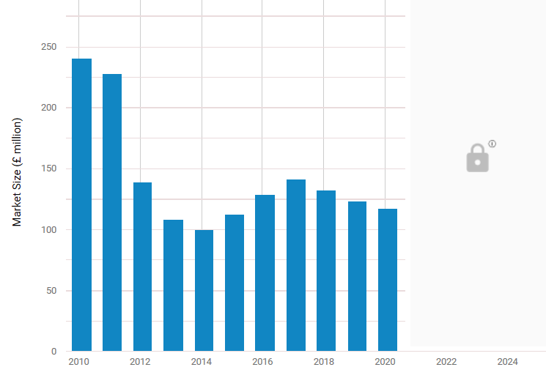
Figure 1 - Explosive Production Statistics
The aim of this report is to investigate alternate methods of pressing as to reduce the overall waste of explosive material, thus reducing the amount of financial resource spent on material. See below, an A3 analysis of the process using a work template based on Six Sigma workings. [6]
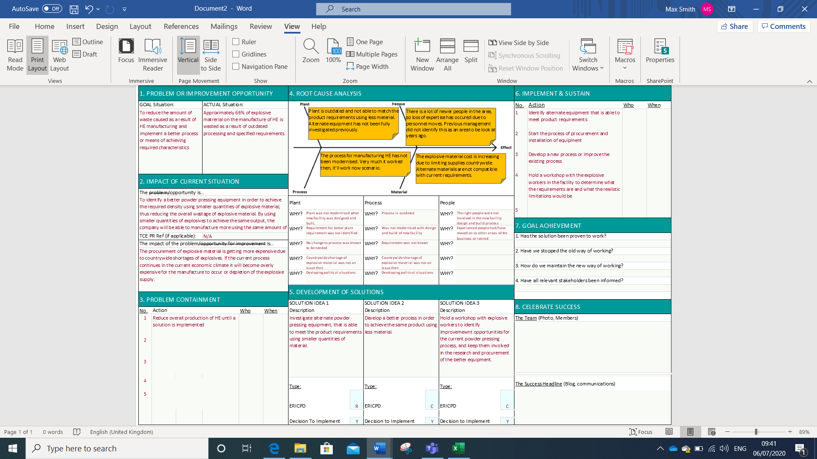
Figure 2 - A3 Analysis
For classification reasons, the quantities and type of material used in this process have been changed for the purpose of this assignment. Quantifiable units will be represented by Alphabetical values.

Statement of Need

Needs Analysis
One of the best methods to fully understanding the needs requirements is to carry out root cause analysis (RCA). There are many methods of carrying out route cause analysis, such as Six Sigma, Fishbone Diagrams and the Five Why’s. RCA can be broken down into five main sections. [7]
- Define the Problem – An amount of explosive material is brought into the company. It is manufactured into powder form and dried in an oven. This is then poured into a pressing bag, tampered down and vacuum sealed. Once requirements have been met, the bag is placed into a hydrostatic press. This process is causing the waste of approximately 66% of material, which is then sent off as explosive waste.
- Collect/Analyse the data – This is a problem that has existed for the past 20 years in the company. Whilst facilities and equipment has been modernised to a degree over the years, the process remains largely the same, because it produces the product required. Approximately 66% of all explosive material is being sent off for waste disposal. Systems and processes need to be updated and followed each time which can take up to 6 hours. Four people required for explosive transportation. The overall cost considering material, people hours, storage and transportation, and disposal cost is very high.
- Identify possible causal factors – Using the process of the five why’s to identify the sequence of events that led to this problem.
Why’s | Reason’s
Why are we wasting so much material? | The current process is wasteful.
Why is the current process wasteful? | The excess material is required for the process in order to achieve the required density.
Why can’t the required density be achieved through means of changing the process? | Alternate methods have not been tested on the current equipment.
Why is the current equipment not capable of doing this? | The equipment is outdated and due to the current process, it has not been tested
Why is the equipment outdated? | From the time of design concept to in service, the timescales were so long that older equipment was purchased
- Identify the route cause – The root cause is that the equipment for the current process is not and has not be optimised or replaced in order to achieve the same product utilising less material.
- Recommend and Implement solutions – Identify alternate methods of carrying out the process to achieve the required product. Once the product has been manufactured, using a new test method, it will be required to go through mechanical properties testing and velocity of detonation testing to ensure it is not varied from the product made under the current method.

Stakeholder Engagement
Conversations were had with the appropriate stakeholders that the change in process would affect. The information in the below mind-map are the key points made as a result of the conversations, see below [8].
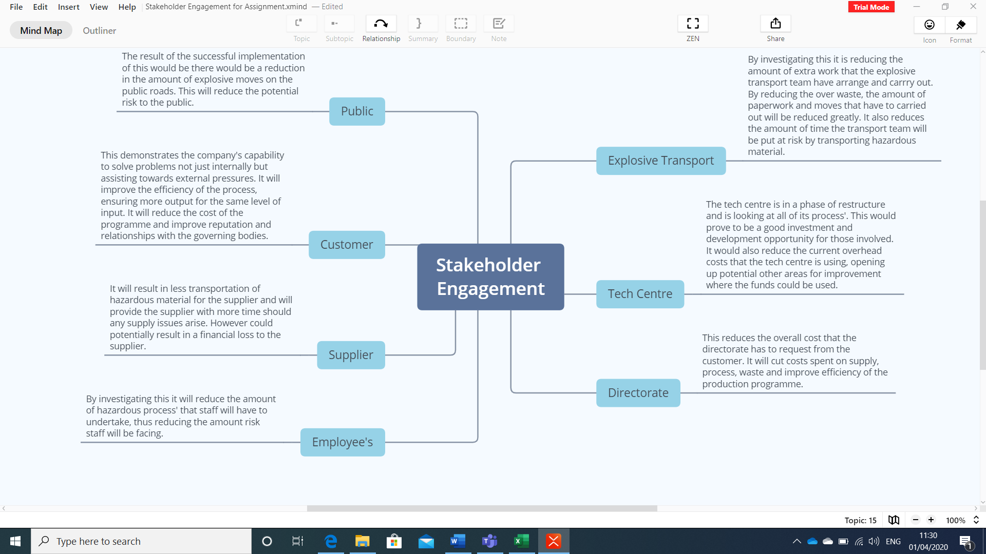
Figure 3 - Stakeholder Engagement Mind Map

Requirements

Key Requisites
The shape must remain the same in order to be incorporated into the current system. The dimensional requirements are very precise with little tolerance room.
The correct weight must be achieved for the system to reach equilibrium and that the current container, transit and tooling mechanisms remain viable.
The density requirements are crucial to design, due to the nature of the material, the proposed method must be reliable as not include voids or inclusions into the product.
The materials that are used for the proposed methods must not have any adverse effects, such as reacting in a hazardous manner or bonding with the explosive material.
The methods proposed must reduce the total amount of material used for this process, thus reducing the overall waste.

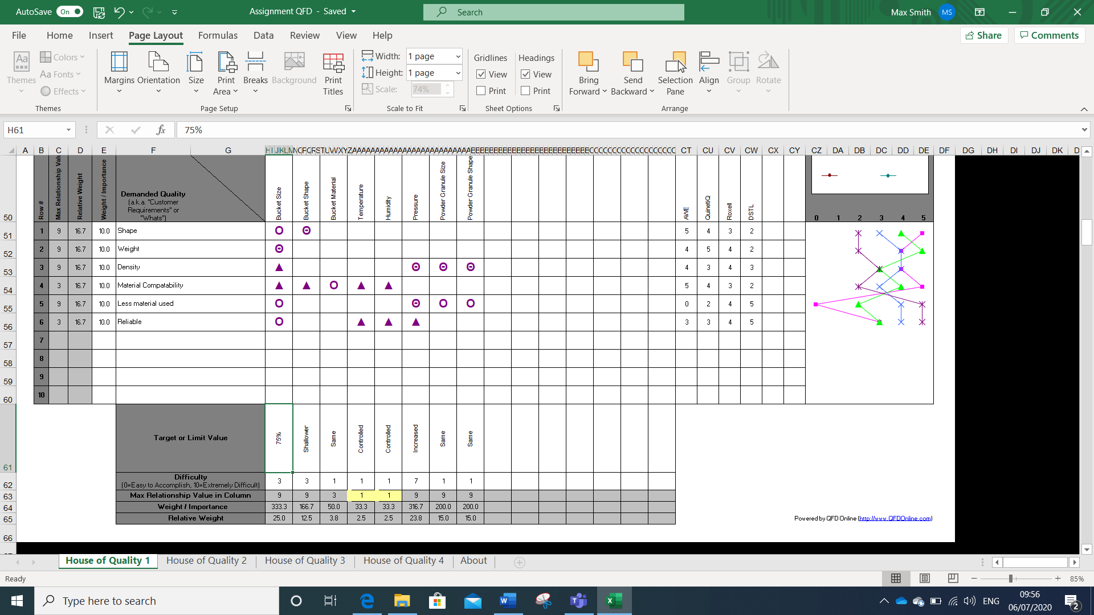
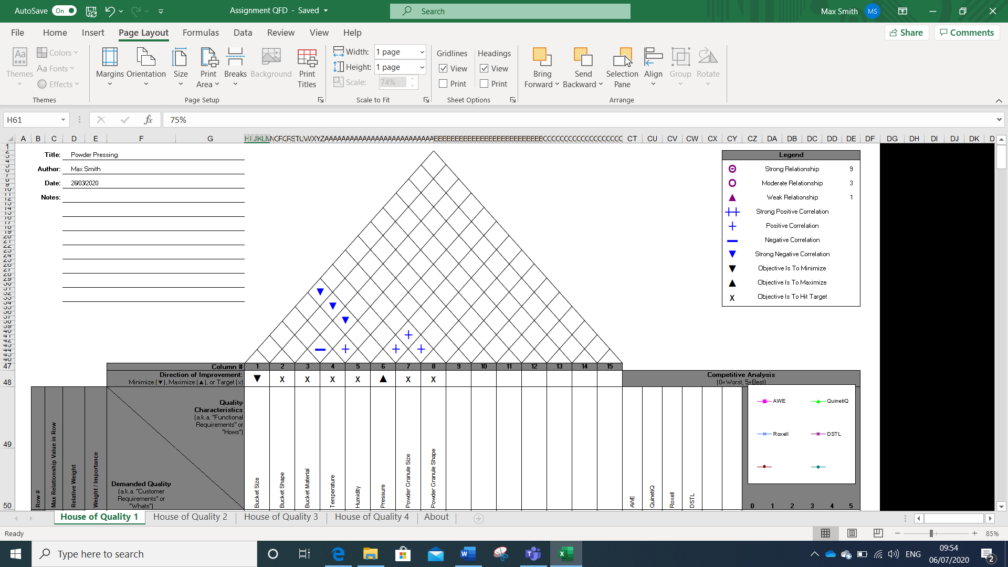
QFD Analysis
Figure 4 – QFD Analysis
[9]. The customer requirement for use of less material has a strong relationship with the bucket size, if the bucket is smaller less material will be used. There is a strong relationship between density and pressure; particle size and particle shape. These will be the key areas to determine success or failure. Equally the relationship between less material used and pressure; particle size and particle shape are strong/moderate and will also be key to success or failure.
The key areas where conflict may occur are the bucket size; shape and material against pressure (g psf). The selected material may not be able to achieve the required density (f kg/m³) or in granular form the material could be insufficiently insensitive, the bucket size too small or shape of the bucket slightly off, the pressure is likely to damage or destroy the bucket.
To meet the engineering specification the pressure is to increase, and the bucket size is to decrease, with the rest staying the same as are developed in processes prior to this.
The importance and importance weights as determined by the QFD are shown at the bottom. Referring to the importance weights shows that the most important specifications to focus on the bucket size and the pressure increase.
The comparative assessment on the right shows where in terms of the same process and production the company is at in the current market. The comparative assessments of the other companies are purely fictional, they were used as an indicator to show where the writer of this report believes the company stands. [10]
The information in the QFD was completed based on discussion and input from a couple of sources [11] [12].

Alternate Methods
Changing the current process so that the required density can be achieved, reducing the overall amount of explosive material used and without introducing new risks to process, plant or people.
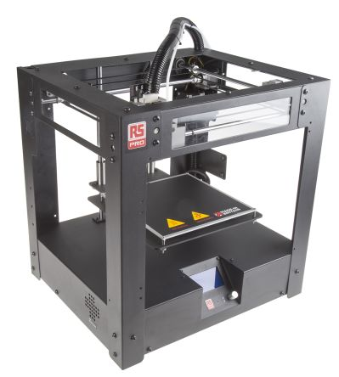
3D printing, this is an advancing technology with the possibilities increasing all the time, though it is currently not able to process the material the company uses. 3D printing can be used for complex shapes and designs and those with specific requirements. It can be used for rapid prototyping and vastly decreasing manufacture time and process. It can print on demand and removes any human factor errors. It drastically minimises waste reducing cost of waste and amount of material used. However, currently the 3D printing process is limited to specific plastics and metals, but this range is increasing. Items retrieved from 3D printing are required to undergo cleaning/treatment to remove the support material, so whilst the overall manufacturing is sped up, it can be slowed down by this post processing requirement. Equally the use of this process could result in the loss of some personnel jobs, though this would not be the case in the company currently. [13] [14]
Figure 5 - Modern 3D-Printer
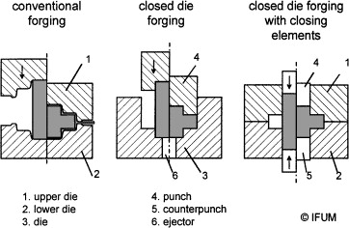
Die Pressing would require the installation of new machinery and would have a high initial cost. Floating die has been proven to be a useful approach when pressing powder, which the combined movements of the punch and the floating die by use of interface friction negates the need for a double action press. The density of powder achieved is like that of double action press and has increased uniformity. This method does not require as a high a compaction load as is currently used, and the use of lubricant reduces the required ejection force for excess material. [15]. This method can produce at a higher rate and with greater accuracy, with the speed, pressure and travel of the die being automatically controlled. The operation would be completed in a single squeezing motion. Nevertheless, the initial cost would be substantially high with the process being suitable if the equipment is efficiently utilised. The process would have to be adapted in order to greatly reduce or eliminate the friction generated as this would be introducing an additional high hazard of which the risk would be significant [16] [17].
Figure 6 - Die Pressing Process

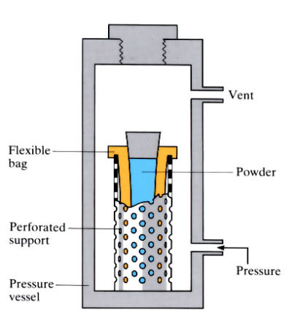
The current pressing bag used is made of a bonded plastic-rubber polymer that is non-reactive with the explosive material and does not result in inclusions of the bag material into the final product. The volume capacity is significantly higher than the material required. Using a shallower pressing bag would be the most cost-effective method to reduce the waste, and adjustments to existing equipment would have minimal impact on the production process. Figure 6 depicts an example of the pressing bag whilst being pressed [18].
Figure 7 - Pressing Bag Process

A SWOT analysis of the three options has been carried out, see the table below. These options were discussed with those who work in the area and have knowledge of the process [19] [20].
 | 3-D Printing | Die Pressing | Pressing Bag
Strengths | - Quicker manufacture times  - Reduces process time  - Removes human error factors  - Reduces waste significantly  - Reduces material used | - Does not require as high compaction loads  - Decreases production time  - Increased accuracy  - Reduces waste generated  - Automated process, reducing human error factors | - Low cost  - Adjustments to existing plant as opposed to purchasing new plant  - Minimal impact to production programme  - Reduced testing required for validation
Weakness | - Technology is not yet able to print explosive material  - Adds additional steps into the process as products would be required to undergo treatment to remove any support material  - Potential loss of personnel jobs  - Initial high cost | - Very high initial cost  - Modification of the plant would be required to reduce friction  - Moving parts could cause explosive material to be displaced in the machine, creating potential hazard to maintenance workers  - Massive impact on production programme | - Potentially cause the product not to meet specified requirements
Opportunities | - Once the technology is available, this would be the desired approach  - Reduced material cost over time | - This method could be better applied to alternate process’ within the company  - Reduced material cost over time | - Reduced material cost over time
Threats | - Limited knowledge on technology  - Depletion of explosive material | - After market solution  - Depletion of explosive material | - Keeping the process the same preventing or slowing any potential modernisation  - Depletion of explosive material
[21]

Design

Concept Designs
For classification purposes the dimensions have been given letters as opposed to the actual figures.
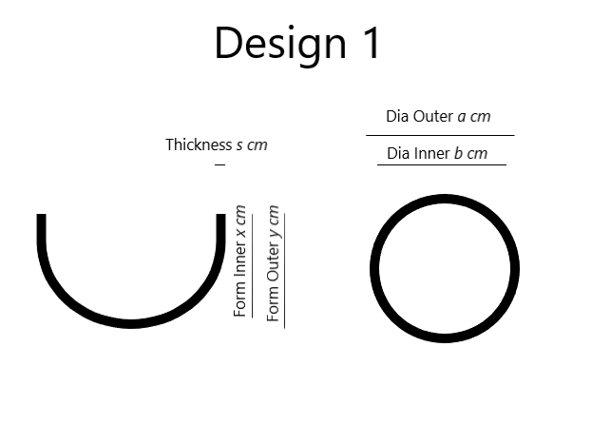 | Design 1 – This design uses the same material as the original pressing bag. The bag has been designed so that it is the same size as the final product with a 10% positive tolerance. This would vastly reduce the amount of material require per run. The diameter of the outer and inner form has remained the same, the thickness of the bag is uniform and the depths matching the product requirements.  Figure 8 - Design 1
Design 2 – This design, has higher sides allowing for a 20-30% positive tolerance as more material is required for the pressing density to be achieved. The thickness of the bag increases from the top to the base of the bag, with the thickest section being the base, this was to increase the structural integrity of the bag to cope with the increased pressure.  Figure 9 - Design 2 | 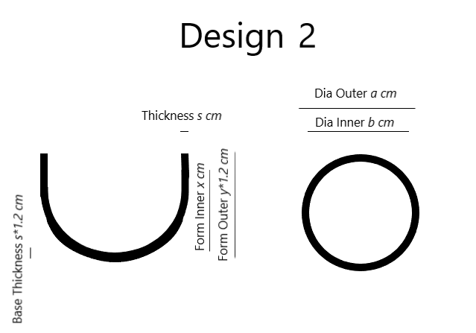
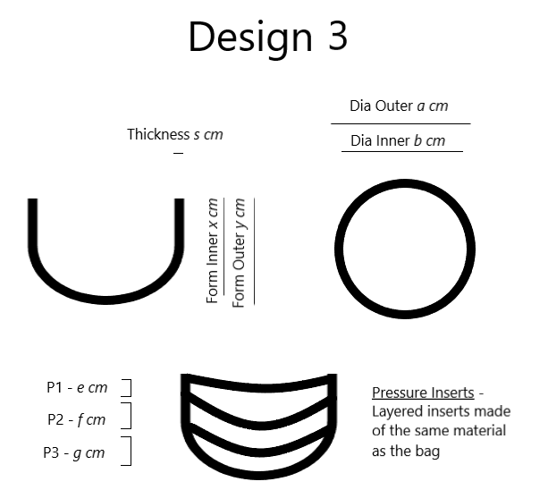 | Design 3 – This design incorporates additional parts to the pressing bag, so that to achieve a high level of density and reduce the overall use of material, there are pressing inserts which can be put in a few times throughout the process to have each section pressed separately. The bag thickness and diameters remain the same as that of Design 1.  Figure 10 – Design 3
Design 4 – This design incorporates a reinforced steel wire mesh into the pressing bag, increasing the strength of the bag and enabling a uniform application when being pressed. The thickness of the bag has been doubled to accommodate for the increased pressure. The inner diameter and depth of the bag are the same as that of Design 1.  Figure 11 - Design 4 | 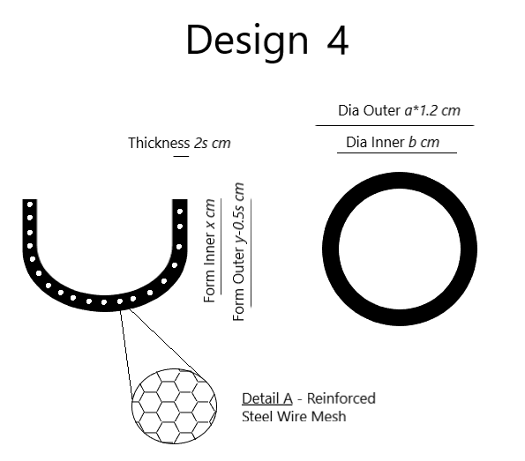

Chosen design
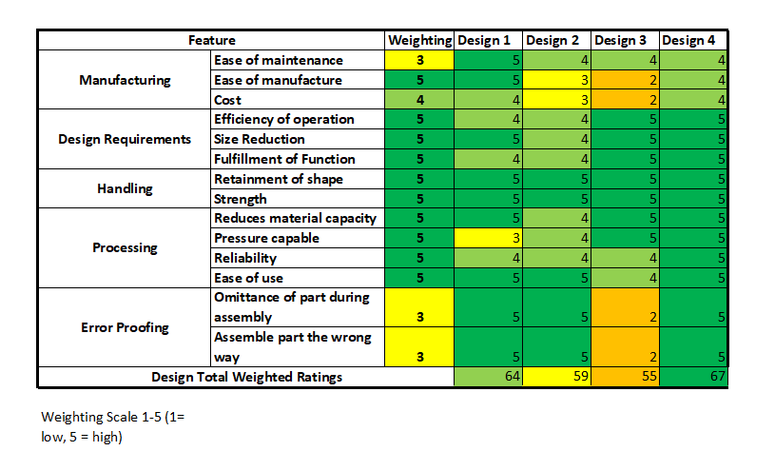
Figure 12 - Design Feature Rating Table
A Design Feature Rating assessment was carried out for all the potential designs, table above [22]. The criteria were based on the use of the design during the current process. Of which the ease of maintenance, and error proofing sections have the lowest importance weighting. Along the bottom of the table the overall weighting for each design is stated. Design 3 has the lowest weighting score, introducing additional parts to the process is introducing more potential issues. The addition of the extra pressing pads indicates that the process would be longer and raises the issue of, if pressed in layers would the layers then join and what would be the effect of multiple pressing of the same areas. Design 4 shows the highest potential, scoring predominately top score against the criteria. All component parts of the design would go through the Production Part Approval Process, which is an important step in developing confident in the parts. [23]

Identifying Constraints

Resources
The chosen design will introduce additional material for the process but will not react with the product as the steel mesh will be covered the plastic-rubber polymer material as comes into contact already. The cost as a result will increase due to it being a more complex design. The increase in cost in this phase will be heavily outweighed by the increased product output that will be as a result of the new tooling and adjustments to process. The manufacture and drying process for the powder does not change so the particle size and shape would remain the same. By reducing the bag capacity and strengthening the structure, the increase of pressure should not be an issue. [24]
A variety of pressure tests will need to be undertaken to ensure the design meets the requirements and is able to withstand the increased pressure, equally using inert material to determine whether the required density can be achieved and is repeatable.

FMEA
The FMEA below demonstrates the current process and its implications against the process using the new design. [25]
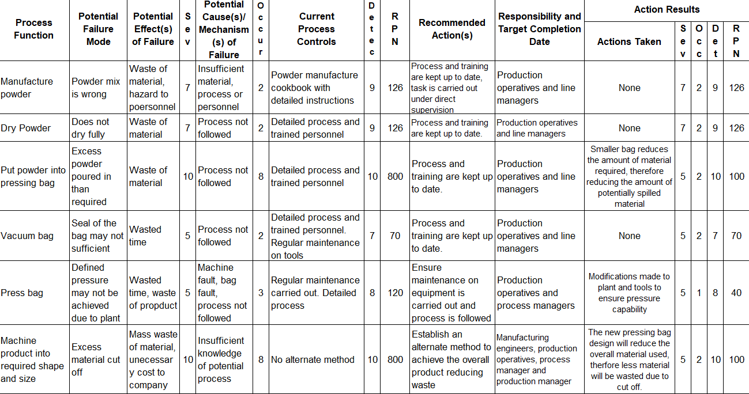
Figure 13 - FMEA
The FMEA demonstrates that the priority areas of concern were the amount of waste generated through pouring the powder into the pressing bag and the amount of waste material cut off as a result of the machining process. This was based on the existing process and tooling available. The greatest risks being that the existing equipment does not provide the best efficiency for the process nor for reducing material waste.
By implementing the new design for the pressing bag and reducing the capacity of it, the outcome of the FMEA drastically reduced in severity and occurrence for the two prioritised areas. With the RPN values going from 800 down to 100. The highest risks now lie around the powder manufacture and drying processes which cannot be changed due to customer requirements and specific process instructions.

Conclusion

Summary
Through this report, the waste of explosive material through processing has been investigated. The key area identified was in the powder pressing process where vast amounts of excess material was being wasted. Various alternate methods or new ways of working were identified in the optioneering process, of which some the cost would be too high and others, the technology is currently not quite ready for the desired use.
Through a multitude of systems engineering tools, it was determined that the most ALARP method of reducing this was to address the design of the key tool used in the process as well as adjusting existing pressing equipment to facilitate this. The process was determined that it would need to be updated to account for the changes in design.
The design was rated against others using a design feature rating assessment and through application of FMEA to determine the potential risk factors. The main high-risk areas that were addressed were reduced significantly resulting in a huge potential reduction in waste of explosive material.

Validation
A process walk down was carried out using the new pressing bag design and adjustments to the existing plant carried out, as is in accordance with HSE legislation [26]. During the process of filling the pressing bag, it was observed that approximately 50% less explosive material was used to fill the bag. Concerns around the integrity of the bag when undergoing higher pressure conditions were negated as the bag’s integrity held with no issue. Post pressing, for analysis purposes, the product underwent mass spectrometry and radiography which is crucial to determine if there are any abnormalities with the article [27]. There were no inclusions or voids found to be in the product, most importantly the density achieved met the density requirements. The product also underwent velocity of detonation testing of which it met the requirements [28].

Recommendations
This report is predominantly based on information and views from a limited number of people. To achieve a full system engineering approach more personnel would have been involved and information captured had they and the time been available in the current situation [19] [29]. In short, the process diagram below would have been followed and implemented, selecting a team of personnel with a variety of disciplines and experience to produce, more than likely a better solution [30].
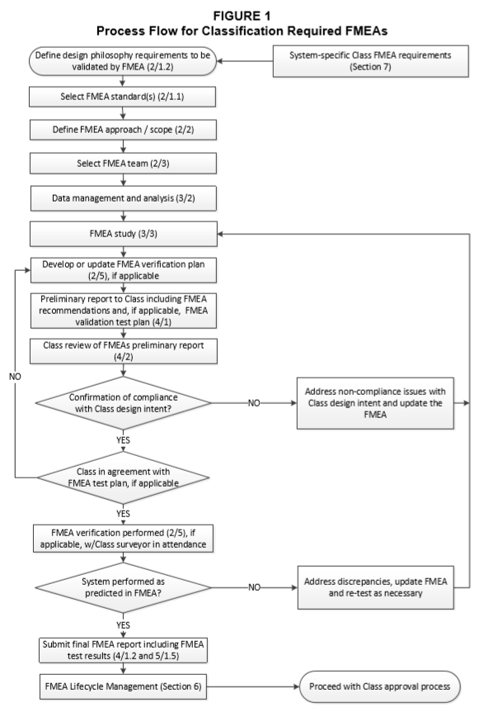
Figure 14 - Process Flow for FMEA
The option chosen was determined as ALARP for the current company situation, in practice this should have been identified and acted on years ago.
Other tools could have been applied such as the V-Model, which considers the whole lifecycle of the product and process. The left-hand side of the V-model represents the breakdown of requirements and development of system specifications. The right-hand side of the V-model represents the implementation of parts and their verification. Simply put, the requirements must be defined, designs must be tuned prior to build, be fully build before testing and testing before validation [31].
Figure 15 - V Model Diagram
[31]

Bibliography

[1] | Q.-O. Team, “Quality Function Deployment,” Quality-One, 2020. [Online]. Available: https://quality-one.com/qfd/. [Accessed 12th June 2020].
[2] | O. E. Consulting, “Training Presentation: Failure Mode & Effects Analysis (FMEA),” in Operational Excellence Consulting, 2020.
[3] | AWE, Process Document, Reading: AWE.
[4] | IBISWorld, “Explosive Manufacturing in the UK Market Research Report,” IBISWorld Database, London, 2019.
[5] | IBISWorld, “Explosives Manufacturing in the UK,” IBISWorld Database, London, 2020.
[6] | M. Smith, 8-Step Improvement A3, Basingstoke: University of Wales Trinity Saint Davids, 2020.
[7] | EduPristine, “Root Cause Analysis,” Edu Pristine, 3rd August 2018. [Online]. Available: https://www.edupristine.com/blog/root-cause-analysis. [Accessed 26th March 2020].
[8] | S. M, Stakeholder Engagement MindMap, Reading: Max Smith, 2020.
[9] | R. Morgan, “QFD Analysis Template,” Richard Morgan, Swansea, 2019.
[10] | A. Kossiakoff, W. N. Sweet, S. J. Seymour and S. M. Biemer, Systems Engineering Principles and Practice, Hoboken: Wiley, 2011.
[11] | Z. S. O. E. Specialist, Interviewee, Systems Engineering Approach to Work Based Project. [Interview]. 26th February 2020.
[12] | M. L. E. T. Specialist, Interviewee, Systems Engineering Approach Work Based Project. [Interview]. 12th March 2020.
[13] | T. Ltd, “What are the advantages and disadvantages of 3D printing?,” TWI, 2020. [Online]. Available: https://www.twi-global.com/technical-knowledge/faqs/what-is-3d-printing/pros-and-cons. [Accessed 26th March 2020].
[14] | R. Pro, “RS PRO iTX PC 3D Printer,” [Online]. Available: https://uk.rs-online.com/web/p/3d-printers/1734711/. [Accessed 26th March 2020].
[15] | H. Homayoun, M. Shahbaz and R. Ebrahimi, “Investigation of Floating and Single-Action Dies in Producing Dense Compacts with High Aspect Ratio,” Shiraz University, Shiraz, Iran, 2019.
[16] | S. Editor, “Press Forging: Process, Advantages and Disadvantages,” 15th January 2019. [Online]. Available: https://www.harsle.com/Press-Forging-Process-Advantages-and-Disadvantages-id3209375.html. [Accessed 26th March 2020].
[17] | E.Doege and R.Bohnsack, “Closed die technologies for hot forging,” Journal of Materials Processing Technology, vol. 98, no. 2, pp. 165-170, 2000.
[18] | O. University, “Cold Isostatic Pressing,” [Online]. Available: https://www.open.edu/openlearn/science-maths-technology/engineering-technology/manupedia/cold-isostatic-pressing. [Accessed 26th March 2020].
[19] | S. O. M. Dooley, Interviewee, Systems Engineering Approach Work Based Project. [Interview]. 10th March 2020.
[20] | P. P.-W. T. Engineer, Interviewee, Systems Enginerring Approach Work Based Project. [Interview]. 20th March 2020.
[21] | T. Bush, “SWOT Analysis Opportunities: Definition & Examples,” Pestle Analysis, 2016.
[22] | D. Stienstra and Rose-Hulman, “Introduction to Design for (Cost Effective) Assembly and Manufacturing,” [Online]. Available: http://me.gatech.edu/files/capstone/L071ME4182DFA. [Accessed 30th March 2020].
[23] | Q.-O. Team, “PPAP,” Quality-One, 2020. [Online]. Available: https://quality-one.com/ppap/. [Accessed 12th June 2020].
[24] | B. W. Wah, “Population-based learning: a method for learning from examples under resource constraints,” IEEE Transactions on Knowledge and Data Engineering, vol. 4, no. 5, pp. 454 - 474, 1992.
[25] | R. Morgan, “FMEA Template,” Richard Morgan, Swansea, 2019.
[26] | HSE, “Inspections of the Workplace,” HSE, 2017. [Online]. Available: https://www.hse.gov.uk/involvement/inspections.htm. [Accessed 13th June 2020].
[27] | N. S. Imaging, “Explosives,” North Star Imaging, 2020. [Online]. Available: https://4nsi.com/application-studies/explosives. [Accessed 13th June 2020].
[28] | R. Cornell, E. Wrobel and P. E.Anderson, “Research and Development of High-performance Explosives,” Journal of Visualised Experiments, 2016.
[29] | GOV.UK, “Coronavirus (COVID-19),” GOV.UK, April 2020. [Online]. Available: https://www.gov.uk/coronavirus. [Accessed 18th April 2020].
[30] | A. B. o. Shipping, “FAILURE MODE AND EFFECTS ANALYSIS (FMEA) FOR CLASSIFICATION,” ABS, Houston, 2018.
[31] | W. C. Elm, J. S. Tittle and J. Gualtieri, “Integrating Cognitive Systems Engineering Throughout the Systems Engineering Process,” Journal of Cognitive Engineering and Decision Making, vol. 10, no. 1518, pp. 252-255, 2008.

