Synthesize a solution to a potential real-life scenario
INTERNET TECHNOLOGY AND SECURITY
Correy Heard (1901709)
2020
Contents
BYOD (Bring your own devices) 2
What is BYOD? 2
Advantages 2
Disadvantages 2
Policies 3
Password Policy 3
Security Policy 1
Diagrams 1
Hierarchy diagram 1
Packet Tracer 2
MDM (Mobile Device Management) 3
Conclusion 3
References 5

BYOD (Bring your own devices)

What is BYOD?
BYOD known as Bring your own devices is a way for companies to utilize the employer's devices to be productive within their role, this allows for employers to be able to access the network to complete tasks on their own devices instead of needing to access via the companies computers systems, this allows for the employers to always have access for the data so if they needed to fill in reports or do the task that needs to be done before a deadline they can access this data from their home and be able to upload them for the companies use without the employer needing to wait for a computer system to be free for her/he to be able to access the data [1]

Advantages
Cost Reductions, Due to the use of employers own devices it allows for the company to have reduced numbers of systems within the workspace allowing for more money to be saved because the company doesn’t need to spend money on computer systems, hardware, licensing and system maintenance.
Comfort, because the employers will be using their own devices to work from it allows for them to have more comfort because they’d be using a system that they know how to use and run, some employers could find it hard adapting to new systems so using your own devices allows for the employers to be comfortable with the system they’d be using. [2]
Increased mobility, BYOD allows for more mobility of the job because the user wouldn’t need to be in a set location to be able to do work they can work on the move which allows for the increase of how the work can be done in the company with good mobility, this allows for users to access and update data on the companies systems. [3]

Disadvantages
Security Measures, Since the company will be allowing for users to be able to use their own devices thief or loss of their own devices can cause issues within the security of the company due to the authorization on the device, companies will need to apply a high level of security measure to allow for secure data if a user/employer was to lose their device it would need to be reported to the network administrators to be able to revoke access to the users/employers accounts this will stop any potential risks but the network administrators need to implement a two-step verification with a code to generate every time you log into the account this will also stop any potential breaches if a device from a user/employer was to get lost or stolen. [2]
Ranges of operating systems, Allowing BYOD gives the companies staff the ability to use their own devices and doesn’t restrict the employers on what devices they allowed to use so it can cause security issues with the many of operating systems that the company needs to restrict or allow on the network, to deal with different types of operating systems that the employer can use they could restrict access on specific operating systems to only allow devices that can be managed easier by the company, for example, only allowing devices to connect to the network that runs Windows, IOS and latest Android operating systems will help the company keep a handle on the operating systems/devices that could connect to the network.
Applications and Tools, Due to the company allow the employers use their own devices it restricts the employer on the number of tools and applications they can use on their own devices since the company will have many applications that it will have on the companies computer systems that they pay for licencing but these applications aren’t given to the employers for their own devices, this can make the employers lack in their field of work because they won't have the correct applications or tools to be able to finish or complete their task, to deal with the potential risk of people using different applications on their devices we can limit the amount of access we give to the employers we can restrict access so they can’t use applications while connected to the companies network they’d need to complete their tasks and upload the data to the network, this will make sure that the employers can’t use applications that could potentially affect the company or its network. [4]

Policies

Password Policy
1. All users will need to input a password with at least 1 uppercase and lowercase character, 1 special character and at least 1 number character, all passwords must contain over 8 characters.

2. Users will be required and prompted to change their passwords every 90 days.

3. Users previous passwords will be deemed invalid and no longer be valid to use in the future.

4. Users can only be able to change their passwords once in 24 hours.

5. Users will be prompted to change their passwords before the 90-day requirement.

6. After 3 failed login attempts the user's account will be temporally locked and a security alert sent to the network administration.

7. If a user’s account was to be inactive for over 30 days, the account will be temporally locked out of the account. [5]

Security Policy
- User data should be stored on an off-site system that will be managed and controlled by the company, other data can be stored on staff’s systems, USB, phones, etc and needs to be password locked.

- Sensitive data shouldn’t be stored on staffs devices or systems and will be required to be kept on an on-site system to access this data staff users ID will be required and they’d be limited on how long they could access the data to keep sensitive data secure. [6]

- Users must log on with a valid User ID and Password once verification of these credentials is successful the user will be granted access the networks systems.

- All users actions and login attempts are logged in a log server system where all the user's actions can be retrieved if an incidence was to occur, all of the log data will be stored in a different system to the other off-site or on-site systems. [7]

- All users will not be allowed access to install any software to the company’s computer systems and USB devices will be not allowed to be added to the systems that are connected to the company’s systems.

- Removable USB be devices that have been granted permission to be connected to the company’s computer systems will be encrypted and will need to be verified with IT administrators. [8]

- Users cannot leave their user accounts unattended while the account is active when moving away from the computer system the computer must be locked and have an auto-lock for 30 seconds.

- Users cannot share data from the company’s computer systems to any person.

- Anti-virus software will be added to all devices connected to the network, the users are not allowed to remove or disable the anti-virus and not allowed to interrupt any scan processes. [9]

Diagrams

Hierarchy diagram
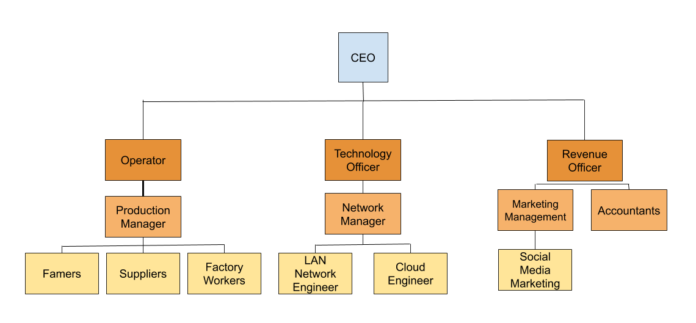
I have created a Hierarchy diagram to show the roles within the company and shows the levels of access/privileges they’d get within the system of the company this diagram have been made for the CoffeeCapulus and its to make sure that product of the coffee will run while using BYOD within the company to deal with all the tasks the employers need to do, there are 3 levels to the hierarchy diagram which will represent the 3 levels of authentication within the network the Yellow shows level 1 authentication, light orange represents level 2 of the hierarchy and finally we have the dark orange which represents level 3 the highest level these are granted most highest permissions / authentication on the network and system the CEO is been granted with full access to the computer systems and network, he/she will have the highest credentials that could access the full system so if their was a breach the CEO could be the first person to help within locking the system if they was to lockout all accounts.

Packet Tracer
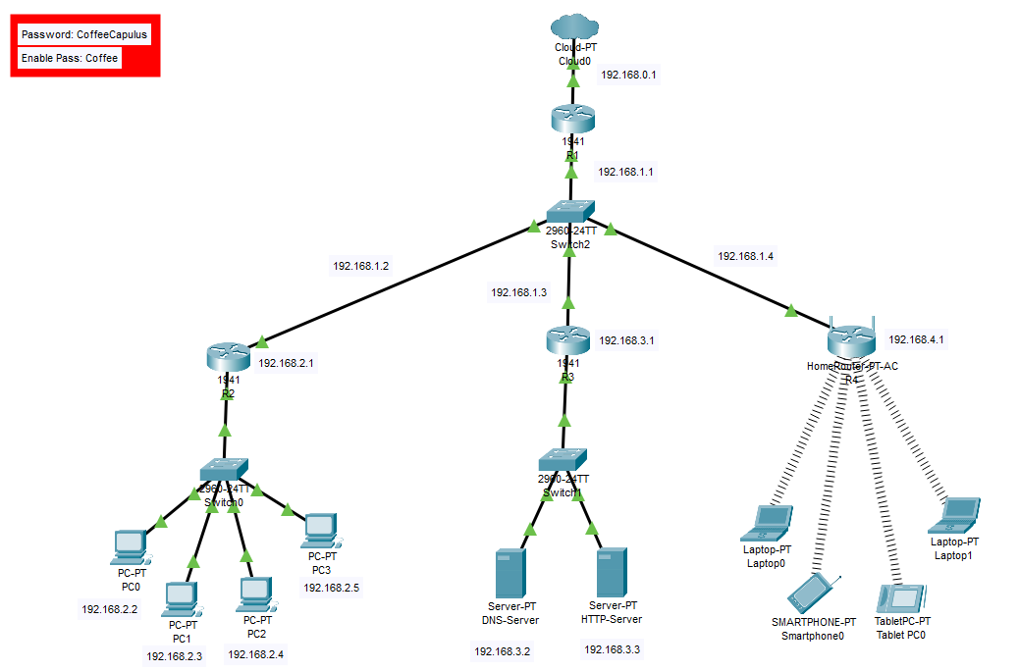
This image represents the CoffeeCapulus network, I have designed the network to be able to hold multiple users to connect through office computers and home devices, all devices will be able to be connected to our main systems and all computer systems will be connected to our DNS server, the system also supports for an HTTP server which allows for a webpage for the advertisement of the company CoffeeCapulus this page is useful for our shops to get some research into the company before we supply them with our resources.

MDM (Mobile Device Management)
MDM also is known as Mobile device management is software that companies use to be able to manage the companies workers devices, for example, if a worker in a company needed to access data from the company while working at home then they would log into the companies systems and get the data from the company system, the MDM allows for the users to be granted access to the data they’re allowed to access and will restrict the users from accessing or editing data that they don’t have privileges to do so.
Cisco has an MDM called Meraki, Meraki has many advantages it allows for centralized management, this allows for the administrations to be able to see information about the devices that are connected to the companies network, which also allows the administration to be able to remotely revoke or grant access to the users without accessing the device.
Meraki allows the administration to be able to update policies and apply new policies to groups or devices on the network for example, if a user with an IOS device wasn’t allowed to download any applications from the app store while on the network then the administration can update or apply a new policy to the device to revoke access to app store downloads. [10]
Meraki offers automatic firmware updates this allows for up to date management tools and security for all the Meraki systems these updates will be set for Saturday 3:00 AM this will update all improvements to the system and updates security certificates so allow for updates on the security of the system.
Meraki allows for control over company devices if you set a company device on Meraki you can manage what applications are installed on the device and can push configurations to the devices remotely if a device was stolen the administration can push for the devices to be remotely wiped.
Meraki will generate an automatic topology for the devices connected to the network which allows for a visualisation of the network, this can be used to gather information about the devices and locations of the device. [11]
Meraki allows for a VPN client to be installed remotely from the Meraki applications allowing for administrators to give users/staff access to a VPN remotely this could be used to access the company’s data using a VPN as a security procedure.
Meraki secures its own devices so it can not have any data interference this goes with all devices it would encrypt all the data that is getting sent through the network making sure that the data can not be intercepted and to make sure that the network is secure at all times. [12]

Conclusion
BYOD and MDM’s can improve CoffeeCapulus’s systems to be able to hold the employers and the workers that need to connect to the network to be able to do tasks and access data that needs to be accessed to proceed with production, BYOD allows for the users such as Famers to get information from the higher authority within the company such as delivery times, etc to be able to keep to its deadlines to allow the fast production of its products, BYOD allows for staff to run the company while being at home instead of having many offices they need to pay for which helps within reducing cost and improving profits for the company. To be able to control and manage the CoffeeCapulus BYOD systems they will need to have an MDM to be able to control the network and systems, I would suggest Meraki because while researching it I found that it is the most reliable and has many features that the company could use to proceed to help within the company, MDM will allow for the company to keep control and security of the systems and network without needing to be active 24/7 on the network it allows for administrators to access the network and work remotely and allows for quick enhancements to policies and restrictions remotely that can be deployed to all devices connected so using BYOD and implementing an MDM application/system to the Company CoffeeCapulus would help its production.

References

[1] | R. Siddiqui, “Bring your own devices (BYOD),” 2014.
[2] | D. Evans, “What is BYOD and why is it important?,” 2013.
[3] | R. MAHINDRU, “BRING YOUR OWN DEVICE (BYOD): AN EMPIRICAL STUDY ACROSS INDUSTRIES.,” CLEAR International Journal of Research in Commerce & Management.
[4] | J. M. King, “Identifying Best practices for a BYOD Policy,” 2016.
[5] | D. W. C. S. a. D. E. Bosworth, “Password Policy: The Good, The Bad, and The Ugly,” Trinity College Dublin, 2004.
[6] | University of Huddersfield, “I.T. Security Policy,” [Online]. Available: https://www.hud.ac.uk/media/policydocuments/IT-Security-Policy.pdf. [Accessed 5 4 2020].
[7] | G. C. S. V. Sherlock, “System and method security policy,” Securify Inc , US, 2001.
[8] | NHS England, “Information Security Policy,” NHS, [Online]. Available: https://www.england.nhs.uk/wp-content/uploads/2016/12/information-security-policy-v4.0.pdf. [Accessed 5 4 2020].
[9] | “Sample of usage policy,” [Online]. Available: https://www.getsafeonline.org/themes/site_themes/getsafeonline/download_centre/Sample_Acceptable_Usage_Policy.pdf. [Accessed 5 4 2020].
[10] | “Meraki,” Cisco, [Online]. Available: https://meraki.cisco.com/solutions/mobile-device-management. [Accessed 29 3 2020].
[11] | Cisco, “10 Things You Need To Know About Cisco Meraki,” Cisco, 14 2 2020. [Online]. Available: https://gblogs.cisco.com/uki/10-things-you-need-to-know-about-cisco-meraki/. [Accessed 5 4 2020].
[12] | Cisco, “Cloud-Based Mobile Device Management (MDM),” Cisco, [Online]. Available: https://meraki.cisco.com/products/systems-manager. [Accessed 5 4 2020].

marking criteria and Student FEEDBACK

This section details the assessment criteria. The extent to which these are demonstrated by you determines your mark. The marks available for each criterion are shown. Lecturers will use the space provided to comment on the achievement of the task(s), including those areas in which you have performed well and areas that would benefit from development/improvement.

Common Assessment Criteria Applied (Assignment 1) | Marks available | Marks  awarded
1. Engagement with Literature Skills
Extent of research and/or own reading, selection of credible sources, application of appropriate referencing conventions.
You have used mainly websites for your referencing and did not engaged with any academic peer review article to make your work credible. Websites require careful consideration. Key concept considered. Try to utilise the University online resources and journals. (Grade mark: 50.00%) | 15 | 7.5
2. Knowledge and Understanding Skills
Extent of knowledge and understanding of concepts and underlying principles associated with the discipline.
You have demonstrated knowledge and understanding. However, see comment above which is lacking in this report. You have not used the IEEE report formatting. (Grade mark: 50.00%) | 15 | 7.5
3. Cognitive and Intellectual Skills
Analysis, evaluation and synthesis; logic, argument and judgement; analytical reflection; organisation of ideas and evidence
Your report explain the relevant areas for this assignment; policy, DFD, network design, etc. and a written conclusion. Number, name and refer to your figures within the report. You could have included an introduction, see comment in report. (Grade mark: 57.50%) | 40 | 23
4. Practical Application Skills
Deployment of methods, materials, tools and techniques; application of concepts; formulation of innovative and creative solutions to solve problems.
Your practical design considered security measures within the core devices (routers). All host in the same LAN can communicate but cannot access devices outside its LAN such as the servers. Proper labelling/naming of LANs and host could be done rather than the default names. You could consider redundancy but not mandatory at this level. (Grade mark: 60.00%) | 20 | 12
5. Transferable Skills for Life and Professional Practice
Attributes in professional practice: individual and collaborative working; deployment of appropriate media; presentation and organisation.
Your report could be aligned justified. Writing can be improved. Avoid writing in first person tense. See report for more comments. (Grade mark: 58.00%) | 10 | 5.8

Assignment Mark (Assessment marks are subject to ratification at the Exam Board. These comments and marks are to give feedback on module work and are for guidance only until they are confirmed. ) | Late Submission Penalties (tick if appropriate) |  | 56%
 | Up to four weeks late |  | 56%
 | First Attempt? |  | 56%

