

Programme: Master of Business Administration
Module: International Business Concepts
Module code: LCMB7034
Lecturer: Ejike Udeogu
Student Name: Sabbir Ahmed
Student ID: 2438312

Assessment Tittle: Global Competitiveness of Vietnam’s Consumer Electronics Industry: A Strategic Analysis Using Porter’s Diamond and Samsung Electronics.

Word Count: 5069.
Contents
Introduction 4
Industry and Country Overview 4
Vietnam Consumer Electronics Industry 4
Economic Importance, Scope and Size 5
Large Domestic and Multinational Companies and Relative Placing 6
Diamond Model of National Advantage 8
Factor Conditions 8
Demand Conditions 9
Associated and Supporting industries. 9
Strategy, Structure, and Competition. 10
Role of Government 10
Role of Chance 11
Major Foreign MNC Analysis: Samsung Electronics in Vietnam 12
PESTLE Analysis 12
SWOT Analysis 18
Strategic Analysis Using OLI and CAGE Frameworks 19
OLI Model 19
CAGE Model 20
Conclusion 21
Reflective Account Using Gibbs’ Reflective Cycle 22
Description 22
Feelings 23
Evaluation 23
Analysis 24
Conclusion 25
Action Plan 25
References 27

Introduction
This report aims at critically discussing the consumer electronics industry in Vietnam, its strategic relevance both in the global and domestic environment and analyzing factors that contribute to operations of multinational corporations (MNCs) in this environment (Minh, 2024). Vietnam has become one of the largest electronics manufacturing centers due to the low cost of labor and some of their policies, which have propelled them to become part of the global value chain. The size, scope, and economic contribution of the consumer electronics business are areas that will be explored in this report with the identification of major domestic and international players. The global competitiveness of the industry shall be reviewed using Diamond Model of National Advantage developed by Michael Porter. Moreover, the report will provide a critical evaluation of the operational environment of a major foreign MNC based on the political, economic, legal, and cultural environments. The reason behind the analysis is to give an insight into the strategic opportunities as well as the challenges that firms in the fast-growing electronics industry in Vietnam can face.

Industry and Country Overview

Vietnam Consumer Electronics Industry
The consumer electronics sector in Vietnam has been growing fast in the last two decades and it has made the nation become an important participant in the international electronics manufacturing. The industry has a broad product portfolio characterized by smart phones, televisions, computers, home appliances and semiconductor components (OECD, 2025). The competitive advantage of Vietnam is low-cost yet steadily skilled labor that is combined with the strategic geographic position in the Southeast of Asia and with the economic conditions favorable to the foreign investors both in terms of their direct investment (FDI) and in export-oriented development (Nguyen and Le, 2021). There are many industrial parks and technology zones created by the government, aimed at attracting MNCs and help local companies in improving their production capacity and technological potential. These efforts, including the fact that Vietnam is a member of free trade agreements (Comprehensive and Progressive Agreement for Trans-Pacific Partnership (CPTPP) and EU-Vietnam Free Trade Agreement (EVFTA)) have further boosted the country as a manufacturing destination of electronic products.

Economic Importance, Scope and Size
Consumer electronics is among the greatest contributors of the industrial output and export earnings that Vietnam has attained. As General Statistics Office of Vietnam (GSO, 2024) indicates, electronics occupied the first position in exports from the country in 2023, with a share of about 35 percent of the entire exports being electronic-based.
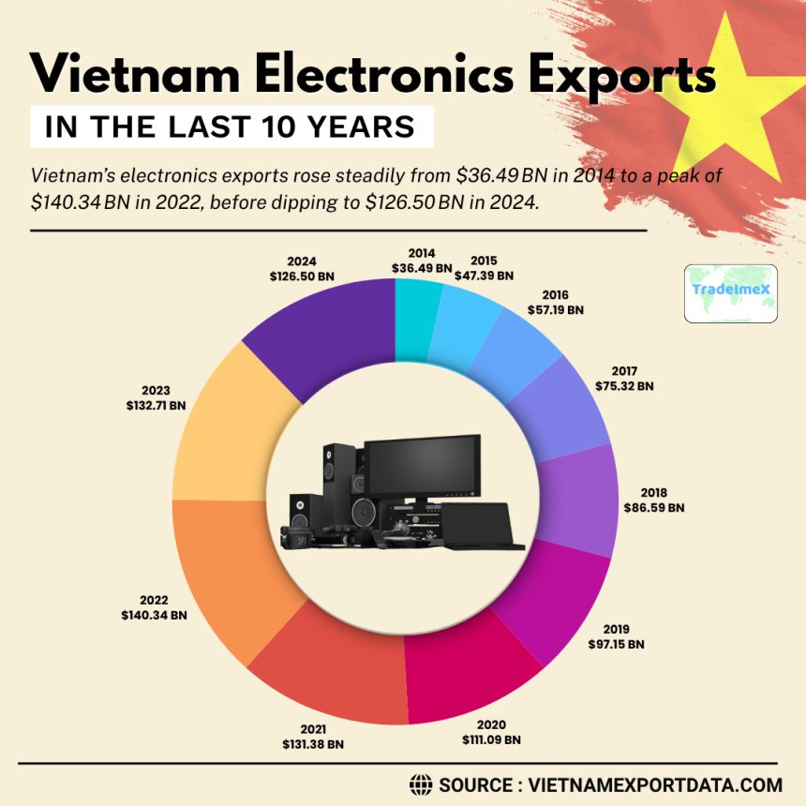
Figure 1: Vietnam Electronics Exports
Source: World Bank (2023)
The electronics and electrical equipment sector is a major pillar of Vietnam’s export-led growth, accounting for approximately 30–35% of total merchandise exports, largely driven by foreign-invested firms such as Samsung (World Bank, 2023; GSO, 2024). However, it is important to distinguish between consumer electronics (e.g. smartphones, TVs) and the broader electronics and ICT manufacturing sector, which also includes components, semiconductors, and intermediate goods. While the broader sector contributes significantly to industrial output, its direct contribution to GDP is lower when measured as value-added, reflecting Vietnam’s continued reliance on imported high-value components (UNCTAD, 2023).

Large Domestic and Multinational Companies and Relative Placing
The consumer electronics market of Vietnam is characterized by both the presence of foreign MNCs dominating the market and the presence of new domestic contenders. Samsung Electronics is a South Korean MNC and the biggest foreign investor and employer of electronic industry in Vietnam with huge smartphone and television assembly factories in Bac Ninh and Thai Nguyen. The strategy of Samsung is focused on large volumes of export production, playing on the advantages of using Vietnam as a low cost manufacturing location and maintaining global quality issues (Pham & Vu, 2024). Other companies that have significant production plants in Vietnam include LG Electronics and Intel, which produce TVs, home appliances and semiconductor assembly respectively. These MNCs have positioned Vietnam as a major hub in their global supply chains, which have taken advantage of the country through its good labor cost, government subsidization, and location advantage in exporting to Asia, Europe, and North America (UNCTAD, 2023).

Table 1: Relative Positioning
Company | Origin | Main Role in Vietnam | Segment Focus | Localisation Depth | Export Intensity
Samsung Electronics | South Korea | Large-scale device assembly and manufacturing | Smartphones, TVs, consumer electronics | Medium | Very high
LG Electronics | South Korea | Electronics manufacturing and appliance production | TVs, home appliances | Medium | High
Intel | United States | Semiconductor assembly and testing | Integrated circuits | Low | Very high
Vingroup (VinSmart) | Vietnam | Consumer electronics manufacturing | Smartphones, smart TVs | Medium–High | Low–Medium
Viettel | Vietnam | Telecommunications and electronics development | Telecom equipment, smart devices | High | Low

The relative positioning of firms in Vietnam’s electronics industry reflects a clear segmentation of roles within global value chains. Foreign MNCs such as Samsung and Intel occupy high-volume export-oriented assembly and component roles, benefiting from economies of scale and integration into global production networks. In contrast, domestic firms such as Viettel and Vingroup demonstrate higher localization depth but lower export intensity, focusing on domestic markets and selective regional expansion (Nguyen et al., 2022; UNCTAD, 2023).

Critically, this division highlights a structural imbalance: while Vietnam is highly competitive in assembly and manufacturing, it remains dependent on foreign firms for technology, design, and high-value components, limiting domestic upgrading and long-term value capture.
At domestic level, Vingroup and Viettel are entering the market as competitive forces, creating smartphones, smart TV and other consumer electronics. A differentiation strategy implemented by Vingroup, such as localized products and technological innovations, and targeted at the domestic market and regional exports is Vingroup VinSmart. Although the domestic companies have made significant technological progress, they are still smaller and do not have sufficient international market coverage as the existing MNCs (Le & Bui, 2024). The competitive nature is hence typified by a high level of competition between high volume export-based MNCs and domestic firms that aim at innovation based differentiation.
These strategic differences are reflected in the relative positioning in the market. MNCs such as Samsung are superior in terms of scale of production, exporting, and brand awareness globally with the domestic firms concentrating on market niches, technological tailoring and price-sensitive consumers within the country. The obscure and apparent yet complementary roles of these players in the Vietnam electronics ecosystem can be mentioned through performance indicators, including revenue growth, production output, and market share (Hoang & Dao, 2025).

Diamond Model of National Advantage
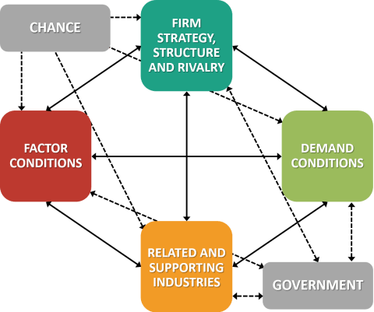
Figure 2: Porters Diamond Model
Source: Porters (1990)

Factor Conditions
The factor conditions include the endowment of factors of production in the country together with labor, capital, infrastructure, and technological capability. The major competitive edge of Vietnam is its high number of young and skilled labor force. Electronics industry enjoys the benefits of having a workforce with a mix of technical education and cost effectiveness enabling MNCs like Samsung and Intel to produce in large volumes at low costs compared to local competitors (Nguyen & Le, 2021). This is a key cause of foreign direct investment in production of electronics. The sustainability of this benefit is however becoming contested as salaries in Vietnam keep on increasing and rival economies like Indonesia and India seek to lure in the same manufacturing sector. This will then mean that the long term competitiveness of Vietnam will not be limited to the advantages of labour cost alone but also the potential enhancement of technological capability, productivity and innovation capacity (Minh, 2024).
This suggests that Vietnam’s advantage is primarily efficiency-driven rather than innovation-driven, limiting its ability to sustain long-term competitive advantage without structural upgrading.

Demand Conditions
Demand conditions entail the refinement and size of the domestic consumer demand. The domestic electronics market in Vietnam is steadily increasing due to increasing disposable income, urbanization, and the use of smartphones, smart televisions and other personal computing devices (World Bank, 2023). Although the domestic market in itself is important, the global competitiveness of Vietnam is mostly determined by the demand through exports. Large volume exports to the United States, Europe and Japan, have forced the firms internationally to adhere to the quality standards and keep innovating. This openness to challenging global markets promotes constant improvement of products, efficiency of operations and compliance with international certification requirements. Consequently, companies in Vietnam can become more integrated into the global production networks and compete in high volumes of export markets. Nevertheless, the high reliance on export business also poses a weakness to the shocks experienced in international consumer electronics markets especially during economic declines or discontinuities in the trade (Tran, 2022).

Associated and Supporting industries.
Related and supporting industries are important to continuing to retain a competitive advantage. The electronics ecosystem of Vietnam consists of suppliers of components, software development companies, logistics firms and packaging companies. These supportive industries being concentrated in and around industrial areas make transactions cheaper and quicker, lead times shorter and coordination along the entire supply chain improved (UNCTAD, 2023). However, even with these advances, a significant percentage of high value electronic parts, such as semiconductors and sophisticated chipsets, is still imported into the country by other nations like China, South Korea and Japan (Bui and Nguyen, 2025). Such dependency on imported elements shows that Vietnam now occupies a middle-to-lower position in the global electronic values chain with assembly and manufacturing being the dominant features with higher value design and component production by more advanced economies. The supplier base in Vietnam is still somewhat fragmented, and the high-end component supply mostly depends on imports in China, South Korea, or Japan.
This dependence on imported components constrains Vietnam’s bargaining power within global value chains, as domestic firms capture limited value compared to upstream technology producers. As a result, the country’s competitive advantage remains structurally fragile and heavily reliant on external inputs rather than internally developed capabilities.

Strategy, Structure, and Competition.
Strategy, structure and domestic competition have firm effects on the firm competition and innovation. Vietnam consumer electronics market is typified by both local and strong foreign MNCs. Efficiency, global integration, and high-volume production are the focus of MNCs like Samsung, LG, and Intel, who take advantage of the cost advantage in Vietnam but reject any compromise in global standards (Nguyen et al., 2022). The domestic companies such as Vingroup Vinsmart and Viettel use differentiation strategies which include product customization, innovation and niche domestic markets. Extreme domestic competition, along with the existence of international competitors, brings about innovation, promotion of cost efficiencies, and promotion of continuous improvement. The presence of large multinational companies and domestic producers that are on the rise poses competition which can stimulate the factor of upgrading the technology and development of the workforce and enhancement of operational efficiency within the industry (Hoang and Dao, 2025).

Role of Government
Government policy is also not a component of the initial Diamond Model, but it plays a crucial role in determining the success of consumer electronics in Vietnam. FDI policies, development of industrial parks, incentive policies to encourage export and to develop vocational training have reinforced all the aspects of the Porters Diamond. Vietnam has become more competitive in the eyes of multinational electronics companies due to tax incentives to foreign investors, facilitated licensing, and getting involved in trade agreements like CPTPP and EVFTA (Tran et al., 2023). Meanwhile, regulatory challenges, weaknesses in the effectiveness of the intellectual property protection and trade-related irregular local governance have been the obstacles which need to be navigated. Though these policies have been able to bring huge inflows of foreign investment, there is a school of thought that the electronics industry in Vietnam is still largely reliant on government incentive and favors which cast doubt on the sustainability of the investment model should the policy environment change (Le and Bui, 2024).

Role of Chance
The competitive position in Vietnam has been determined by chance events, including global supply chain disruptions, the COVID-19 pandemic, and geopolitical tensions. Interestingly, the China+1 approach used by most electronics MNCs has made investment in Vietnam to be made, which offers unanticipated avenues of fast industrial growth (Vu & Phan, 2025). On the other hand, external shocks would create vulnerability especially among export-based companies and therefore it is important that operation strategies and risk management mechanisms should be flexible. These are the external developments that have been further boosting the shift in electronics manufacturing operations to Vietnam, which is strengthening the country position in the global supply chain diversification plan.
In general, the competitive advantages that Vietnam has in consumer electronics are now cost-efficient, favourable to its policy and well-integrated into global supply chains, but eventually, the competitiveness of the country will rely increasingly on technological modernisation and the establishment of a domestic industrial capacity (Nguyen and Do, 2025).
Overall, Vietnam’s competitive position can be characterised as conditionally strong but structurally constrained, requiring a transition from cost-based to innovation-driven competitiveness.

Major Foreign MNC Analysis: Samsung Electronics in Vietnam
Vietnam has emerged as one of the fastest growing centres of consumer electronics manufacturing in the Southeast Asia which has attracted a lot of foreign direct investment (FDI) by multinational companies (MNCs). Among them, Samsung Electronics is the most prominent among the investors of the electronics industry in Vietnam, a South Korean technology and electronic giant. Since its entry in the middle of the 2000s, Samsung already established huge production facilities on the territory of the provinces Bac Ninh and Thai Nguyen with a workforce of over 160,000 officials and its contribution to the export-oriented economy of the country (UNCTAD, 2023). The company produces a broad variety of consumer electronics including mobile phones, tablets, television and other electronic components. The example of Samsung investment in the country of Vietnam may serve as an example of the strategic fit between global aims of the company on the one hand and the comparative advantage of the national country on the other hand including cheap labour force, favourable regulatory systems, and access to global value chain. Opportunities and threats that are associated with the operational environment can however have an impact on long term competitiveness of the company (Bui & Nguyen, 2025).
Samsung’s strategy in Vietnam is reflected in concrete operational decisions, including large-scale greenfield investments, the development of local supplier networks, and the establishment of R&D centres in Hanoi. These decisions demonstrate that Vietnam is not only a low-cost manufacturing location but a strategic production and export hub within Samsung’s global value chain (UNCTAD, 2023; Sheldon and Kwon, 2023).

PESTLE Analysis
Table 2: Key PESTLE Factors Affecting Samsung in Vietnam
Factor | Description | Implications for Samsung
Political | Stable one-party system, FDI incentives, trade agreements (CPTPP, EVFTA) | Long-term operational security, preferential export access
Economic | Rapid GDP growth, low-cost skilled labor, export orientation | Competitive cost base, scalable production, but wage inflation risk
Social/Cultural | Collectivist work culture, labor expectations, language differences | Requires cultural adaptation, employee training, and engagement programs
Technological | Advanced production technology, reliance on imported components | Opportunities for local supplier development, need for supply chain risk management
Legal | FDI-friendly laws, evolving IP protection, labor and environmental regulations | Compliance necessary, risk mitigation through internal legal systems
Environmental | Energy efficiency and sustainability regulations | Investments in green processes enhance compliance and global reputation

Political Factors
Vietnam has enjoyed political stability, which has been very instrumental in attracting foreign investment in the consumer electronics industry. The single-party system of the country which is controlled by the Communist Party of Vietnam offers the country with a stable policy environment and the focus on economic growth, industrialization and foreign investment. Tax exemptions, development of industrial parks, and simplified business licensing processes are active incentives of the government in electronics manufacturing (Pham et al., 2024). Moreover, Vietnam is a signatory to multilateral trade agreements like Comprehensive and Progressive Agreement on Trans-Pacific Partnership (CPTPP) and European Union-Vietnam Free Trade Agreement (EVFTA), which gives Samsung an advantage of favorable access to major global markets, which boosts its export-focused business model. Bac Nhin and Thai Nguyen have become significant production complexes in Samsung, creating one of the largest global manufacturing centers of smartphones of the company (Pham and Vu, 2024). They mainly manufacture gadgets that they export to the world markets, which is a testament to the fact that political stability in Vietnam and trade agreements are in full support of the international supply chain strategies of Samsung.
Foreign companies such as Samsung have to deal cautiously with the local government to ensure that they comply and do not spoil relations with the government (Nguyen & Do, 2025). Also, the government in Vietnam tends to give preference to domestic industrial growth and domestic firms, which may lead to the occurrence of implicit changes in policy that affects the strategy of foreign firms. It is essential to have advanced government relations, proactive involvement, and flexibility to adapt to the changes in regulations in order to navigate such an environment. These risks have been addressed by Samsung in terms of good corporate-government relations, lobbying and in line with the objectives of national development so that the political factors pose more facilitations than limitations to its operations.
Economic Factors
The fast economic development and growing middle income in Vietnam offers a viable consumer electronic production and exports market. It has been experiencing 6–7% yearly GDP growth, with manufacturing and export oriented businesses taking up a bigger part of the economy (World Bank, 2023). Electronics industry, specifically, is a key pillar of the industrial output of the country given that it is exporting about 35% of the total export of the country.
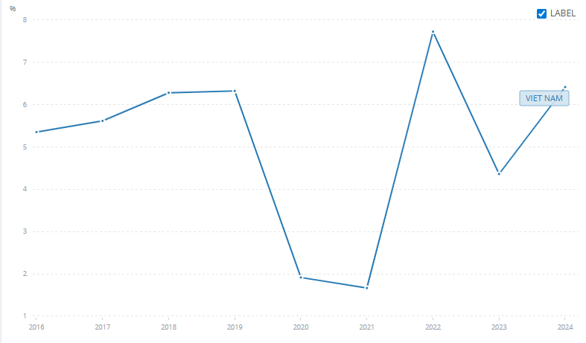
Figure 3: Vietnam GDP Growth
Source: World Bank (2023)
The presence of abundant young and highly skilled labor force with relatively low wages when compared to other neighboring economies like China and South Korea are some of the key economic benefits that Samsung possesses. This is an economy of scale that allows large scale production of smartphones and other electronics at competitive prices in the international market (Sheldon and Kwon, 2023). The industrial areas of Vietnam are well developed and there is also better port and logistics infrastructure which also support the production and export activities. This is enhanced by the availability of the supporting industries (suppliers of components and logistics) which also helps in the low cost of production and lead times.
There are however risks associated with the economy. Consumer electronics are very sensitive to any economic changes and any slow pace in major markets like North America, Europe, or Japan would put downward pressures on the exports and affect the profitability of Samsung. Inflation of wages and skilled labor is increasingly becoming a significant issue in Vietnam that has the potential of undermining the cost advantage in the long run World Bank (2023). Also, revenue and costs of the supply chains can be affected by fluctuations in currency and macroeconomic instability in markets where the export happens. As a strategy to reduce these risks in the economy, Samsung has the capacity to respond flexibly to these changes in production, invest in labor development and hedge the currency and cost prices by financial means.
In response to Vietnam’s cost advantages, Samsung has concentrated a significant proportion of its global smartphone production in the country, enabling it to achieve cost leadership while maintaining global scale efficiency. However, this concentration also exposes Samsung to risk, as heavy reliance on Vietnam increases vulnerability to labour cost inflation, regulatory changes, and geopolitical disruptions.
Legal Factors
Vietnam has also developed its legal environment to facilitate FDI and this has been advantageous to foreign electronics manufacturers such as Samsung. Corporate and investment laws help in foreign ownership, protection of foreign investors and give dispute resolution frameworks. Samsung is further improved in its operational efficiency by tax incentives including lower rates of corporate income tax on high tech investments and projects that have export orientation (Minh, 2024). The environmental laws have gone tougher and this indicates that the government is dedicated to sustainable industrial growth, which motivates them to abide by international production standards. Samsung in turn has adopted more stringent environmental management and sustainability policies in its Vietnamese production operations in order to meet the local regulations as well as its corporate governance policies on a global scale.
Regardless of such legal improvements, there are still challenges. The enforcement of intellectual property (IP) is not entirely enforced in practice despite being legally recognized, and foreign MNCs must have strong internal IP protection. The litigation and enforcement of contracts may involve a lot of time, which is dangerous in contracting with suppliers and partners (OECD, 2025). The adherence to labor regulations, that are becoming stricter in relation to working hours, safety norms, and rights of employees, has to be constantly supervised and the human resources management investment is needed. Samsung uses internal audits, compliance training teams and specialized legal teams to overcome these challenges and make sure that it is in line with the local regulations and global corporate standards (Smith and Katz, 2023).
Social and Cultural Factors
The management and labor relations in Vietnam are affected by the cultural differences at Samsung. The culture of Vietnamese society is based on collectivism, respectfulness to the hierarchy and making decisions based on consensus, unlike the top-down, hierarchical management prevalent in South Korean-based firms (Tran, 2022).
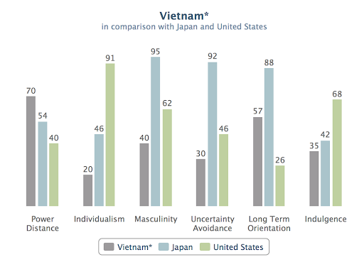
Figure 4: Vietnam Hofstede Cultural Dimensions
Source: Hofstede Insights (2023)
It is important to understand these cultural subtlety to ensure that employees remain engaged, productive and that there is harmony at the workplace. Bilingual management teams and cultural training programs are also mandatory in language barriers to fill the communication gap between expatriate managers and the local employees.
Samsung has remedied this by investing in workforce development programmes, TSuch activities are useful in aligning local labour practices to global standards of operations of Samsung and also enhance productivity and retention of employees (Pham et al., 2024).

SWOT Analysis

Figure 5: Vietnam SWOT Analysis
Source: (Pham, et al. 2024)
The SWOT analysis suggests that the technological capabilities, large-scale production capacity, and global supply chains integration are the main sources of the competitive advantage of Samsung in Vietnam. Nonetheless, it has weaknesses including reliance on imported high-value components which portray structural constraints in the domestic electronics ecosystem in Vietnam. Such external risks as geopolitical tensions, trade policy changes, and increasing labour prices might demand Samsung to constantly change the production strategy, and diversify the supply chain risks (Nguyen & Phan, 2025).

Strategic Analysis Using OLI and CAGE Frameworks
While PESTLE analysis identifies the external environment, the OLI and CAGE frameworks provide a deeper explanation of Samsung’s strategic response, showing how firm-specific advantages interact with location-specific conditions.

OLI Model
Table 4: Samsung OLI Advantages Table
OLI Component | Description | Implications for Samsung in Vietnam
Ownership (O) | Samsung’s strong global brand, technological expertise, proprietary production processes | Provides competitive edge in product quality, innovation, and global market integration; allows Samsung to leverage brand recognition and R&D capabilities in Vietnam.
Location (L) | Vietnam’s low-cost, skilled labor, FDI-friendly policies, industrial infrastructure, and export-oriented market | Reduces production costs, ensures efficient logistics and access to global markets, and supports high-volume manufacturing.
Internalization (I) | Wholly-owned greenfield investments in industrial parks | Enables Samsung to control operations fully, protect intellectual property, maintain quality standards, and efficiently manage the supply chain.

The activities of Samsung in Vietnam can be used as an example of the OLI paradigm of Dunning. The benefits of ownership are the brand name, technology, and own production technology. The benefits of location are realized in the low cost of labor in Vietnam, positive FDI policy, and export oriented infrastructure. Wholly-owned greenfield investments are beneficial in terms of internalization, which allows Samsung to have control over their rigorousness, IP safeguards, and efficiency of the supply chain (Dunning, 2001).
These merits justify the reason why Samsung has been using wholly owned manufacturing business instead of joint venture in Vietnam (GSO, 2024). The internalization of the production activities will allow the company to exercise a high quality control over the product, safeguard the proprietary technologies and to synchronize its global supply chain more effectively.

CAGE Model
The CAGE model also puts emphasis on operation factors. The South Korean and Vietnam cultural differences require cross-cultural management techniques. Vietnam has FDI friendly regulations that reduce administrative distance but needs local involvement (Le & Bui, 2024). The geographic proximity to the markets in Asia-Pacific supports logistics and export efficiency whereas the economic distance focuses on the cheap labor and the increasing domestic demand as the strategic benefits.
Table 5: The CAGE framework Table
Dimension | Analysis | Implications for Samsung
Cultural | South Korean and Vietnamese work cultures differ; collectivism prevalent in Vietnam. | Requires cultural adaptation programs, local HR training.
Administrative | One-party political system, stable policies, FDI-friendly regulations. | Predictable regulatory environment but requires local engagement.
Geographic | Proximity to Asia-Pacific markets; port infrastructure for exports. | Enables efficient supply chain and regional distribution.
Economic | Low-cost labor, growing domestic demand, export orientation. | Competitive cost advantage, scalable production.

The activities of Samsung in Vietnam indicates how the foreign MNC can exploit the host-country benefits, and it can meet intricate external threats. Enabling factors are political stability, economic growth, labour availability, and government incentives, whereas geopolitical risks, labour cost pressures, cultural differences, and dependencies on the supply chain are some of the challenges that should be dealt with through strategic management (Hoang & Dao, 2025). Altogether, the CAGE analysis shows that Vietnam has favourable economic and geographic environment in which Samsung can run its manufacturing activities. Despite the cultural and administrative differences that will need adaptation in the management practices and active involvement of the regulation, the economic distance, especially in terms of labour expenses and potential market expansion, is relatively low, which makes Vietnam a strategically desirable production site in the global network of Samsung (Pham et al., 2024).

Conclusion
Through this report the consumer electronics sector in Vietnam has been critically analyzed and has gained to be one of the most important sectors in the country in terms of economic growth and export performances. Strategic advantages that Vietnam holds, which include young and skilled workforce, favorable government policies, and good integration in the global trade networks has gone a long way in enhancing its capacity to attract foreign investment in the manufacturing of the electronic gadgets (Le and Bui, 2024). Through the Porters Diamond Model, the analysis has shown that favourable conditions of factors, export-oriented demand, developing supporting industries, and high rates of firm competition all are contributing factors to global competitiveness of the Vietnam electronics industry. Nevertheless, the competitive presence of Vietnam is still much focused on the manufacturing and assembly processes with still little value added operations like advanced component production and research and development.
Overall, Vietnam demonstrates strong competitiveness in electronics manufacturing; however, its binding constraint lies in limited domestic technological capability and reliance on imported high-value components. This suggests that its current advantage is efficiency-driven rather than innovation-driven, raising concerns about long-term sustainability.

For Samsung, Vietnam represents a strong strategic fit, combining cost efficiency with export accessibility. However, the firm’s key risk lies in overdependence on a single production location, which may expose it to future economic and geopolitical uncertainty.

Looking forward, Vietnam’s competitiveness over the next 3–5 years will depend on its ability to upgrade into higher value-added activities, particularly through domestic supplier development, R&D investment, and technological capability building. Without this transition, the country risks remaining a mid-tier assembly hub rather than an innovation-driven electronics leader.

Section 2: Reflective Account Using Gibbs’ Reflective Cycle

Figure 02: Gibbs’ Reflective Cycle
Source: Gibbs (1988)

Description
The assignment involved a preparation of international business report analyzing the consumer electronics industry of Vietnam, with special interest in the foreign multinational that has operated in the country, Samsung Electronics. I have started with researching appropriate sources of openly available data, such as scholarly publications, industry reports, state statistics and company publications. I was intending to combine theoretical concepts like the Diamond Model by Michael Porter, PESTLE analysis, CAGE framework, and the OLI paradigm by Dunning to critically assess the competitiveness of the industry and influence on the operations of Samsung.
The study entailed the compilation of both the quantitative and qualitative information of the size, scope, and economic contribution of consumer electronics industry in Vietnam. I also examined the competition environment, including key local and international companies and their performance, market strategies and positioning comparing them. Thereafter, I used the tactical models to evaluate the national benefits of Vietnam and the internal capabilities and weaknesses of Samsung. Lastly, I was able to generalize the results into a unifying story, which connected theory with practice, which led to the conclusion and recommendations.

Feelings
I was excited and had some apprehension at the beginning. This was an interesting intellectual experience to study a dynamic industry within an emerging market, and I was aware of the challenge of applying various theoretical frameworks. Initial accredited and recent data collection appeared to be a difficult task because of the discrepancies between the sources, particularly when it comes to the firm-specific data and export statistics. As I went forward, I gained belief in my navigation skills in databases, government reports, and scholarly articles, and I was pleased to see how the theoretical models can successfully and effectively explain the dynamics of business in the real world. The review of Samsung operations provided a feeling of achievement especially in the connection of national competitiveness to firm level strategy.

Evaluation
The strengths and limitations of the research process and writing have been mentioned. One of the strengths is the fact that there was a strong use of literature and this allowed the analysis to be supported and based on evidence. The combination of frameworks also enabled me to analyze the consumer electronics industry of Vietnam through prism of many dimensions, namely, national competitiveness, external environment, and multinational operational strategy. PESTLE and OLI analyses and SWOT analyses were provided in the table format, which made the analysis more understandable and provided the opportunity to cross-reference information. Moreover, the critical evaluation of the work of Samsung allowed seeing the practical side of how theoretical concepts can be applied to management decisions.
Nevertheless, this was not without difficulties. There were occasional irregularities in data availability especially when it comes to financial performance or even production quantities of domestic firms. There was a need to carefully decide to reconcile the conflicting information and cross-validation which was time consuming. It was also difficult to strike the balance between the descriptive information and critical analysis, however, it was necessary that each framework should not be only described but also applied to the analysis of the strategic implications. Another limitation was time, which meant that it was necessary to revise the synthesis of complex information into a coherent story several times.

Analysis
Reflectively, the assignment has improved my focus on the interdependence of the global business environments. The use of the Diamond Model as set out by Porter demonstrated the interaction of the conditions of factors, domestic demand, industry-related and the firm strategy in generating a national competitive advantage. On the same note, both the PESTLE and CAGE analyses depicted the multidimensional influences on multinational operations, with reference to political stability, economic growth, adherence to the law, cultural adaptation, and technological preparedness. The OLI paradigm by Dunning also highlighted the potential of Samsung to leverage global ownership benefits and combine them with location-specific benefits of Vietnam and internalize them with fully controlled operations.
The integration of various theoretical points of view proved to be worthwhile in this process. As an example, the study of wages and labor supply by means of the Diamond Model and PESTLE analysis allowed gaining a clearer picture of the efficiencies in the work and some limitations. Similarly, the management of cultural and administrative aspects via CAGE framework was used to explain managerial issues and the significance of human resource policies. On the whole, these discussions supported the idea that successful performance in emerging markets involves integrated strategic thinking, which involves the potential of the host environment as well as the limitations of the firm and its capabilities.

Conclusion
The reflective process revealed the importance of an organized research, critical analysis, and systematic research in preparing an advanced level of international business report. Key learning points include:
The relevance of triangulating information and substantiating claims using credible and varied sources.
It is important to note that the theoretical frameworks that are reviewed like Porters Diamond model, PESTLE, CAGE and OLI are not independent tools but rather complementary lenses that give a comprehensive view of industry and firm dynamics.
Learning how to take complex information and show coherent arguments without losing critical thinking of phenomena instead of being able to describe phenomena.
Valuing the reality of the practical issues of multinational corporations, including coping with regulatory diversity, cultural and supply chain risks.
This reflection shows that the undertaking of the assessment has not only enhanced my skill in research but it has also enhanced my analytical skills in strategy making to make decisions focused on the international business environment.

Action Plan
Considering this experience, a number of measures will improve my performance in the future:
Enhance Time Management: Allocate specific time on literature review, data validation, as well as critical synthesis in order to avoid the last minute rush.
Improve Data Verification Skills: Find a systematic method of checking any conflicting data sources, especially when it comes to emerging market settings.
Expand Theoretical Understanding: Learn about other international business models like the Eclectic Paradigm, the Institutional Theory, and the Global Value Chain analysis in order to enhance the flexibility of analytical tools.
Enhance Integration and Writing: Train to combine tables, figures, and narrative text into one fluid and clear written product.
Reflect Continuously: Engage in the continuous reflection throughout the research and analysis processes to discover strengths, limitations, and areas of improvement on a real-time basis.
These strategies will enable me to build more competencies of high-quality research and effective strategic analysis in academic and professional contexts of international business.

References
Bui, T.N. and Nguyen, K.L. (2025) ‘Consumer Electronics Export Performance: The Role of Innovation and FDI in Vietnam’, Journal of World Business, 60(3), 101480.
Dunning, J.H. (2001) The Eclectic (OLI) Paradigm of International Production: Past, Present and Future. International Journal of the Economics of Business, 8(2), pp.173–190.
GSO (2024) Statistical Yearbook of Vietnam 2023. Hanoi: General Statistics Office of Vietnam.
Hoang, A.N. and Dao, P.T. (2025) ‘Location Determinants of Electronics FDI in Vietnam’, Transnational Corporations Review, 17(2), pp.120–138.
Le, H. and Bui, T.Q. (2024) ‘Trade Policies and Technology Diffusion in Southeast Asia’s Electronics Sector’, International Trade Journal, 38(5), pp.457–478.
Minh, C.T. (2024) ‘Vietnam’s Participation in the Global Value Chain of the Electronics Industry in the Context of Digital Transformation’, International Journal of Advanced Research and Publications.
Nguyen, D. and Phan, L. (2025) ‘Electronics Manufacturing and Industrial Upgrading in Vietnam’, Journal of Asian Economics, 78, pp.1–15.
Nguyen, M.A. and Do, T.H. (2025) ‘Skills Shortages and Workforce Development in Vietnam’s High-Tech Manufacturing’, Human Resource Management Review, 35(1),100829.
Nguyen, P., Tran, D. and Pham, L. (2022) ‘Domestic Firms in Vietnam’s Consumer Electronics Industry: Competitive Strategies and Market Positioning’, Journal of International Business Studies, 53(5), pp.789–805.
Nguyen, T. and Le, H. (2021) ‘The Development of Electronics Manufacturing in Vietnam: Opportunities and Challenges’, Asia Pacific Business Review, 27(3), pp.345–362.
OECD (2025) OECD Economic Surveys: Viet Nam 2025. Paris: OECD Publishing.
Pham, L. et al. (2024) ‘Multinational Enterprise Strategy in Southeast Asia’s Electronics Sector’, International Business Review, 33(1), 102612.
Pham, T.L. and Vu, H.T. (2024) ‘Global Value Chain Embeddedness and Technological Capabilities in Vietnam’, Asia Pacific Journal of Management.
Porter, M.E. (1990) The Competitive Advantage of Nations. New York: Free Press.
Sheldon, P. and Kwon, S.-H. (2023) ‘Samsung in Vietnam: FDI, Business–Government Relations, Industrial Parks, and Skills Shortages’, The Economic and Labour Relations Review.
Smith, G. and Katz, J. (2023) ‘Global Production Networks and Emerging Economy Integration: A Comparative Analysis of Vietnam and Malaysia’, Journal of Comparative Economics, 51(1), pp.1–23.
Tran, D. (2022) ‘Managing Multinational Operations in Emerging Markets: The Case of Samsung in Vietnam’, International Business Review, 31(4), pp.102–118.
Tran, T.M. et al. (2023) ‘Vietnam’s Industrial Policy and FDI Attraction Strategy’, Journal of International Economic Policy, 10(4), pp.295–312.
UNCTAD (2023) World Investment Report 2023: FDI in Electronics Manufacturing. Geneva: United Nations Conference on Trade and Development.
Vu, Q. and Phan, D. (2025) ‘Foreign Direct Investment and Domestic Firm Productivity in Vietnam’, Economic Modelling, 110, pp.205–220.
World Bank (2023) Vietnam Economic Monitor 2023: Manufacturing and Exports. Washington DC: World Bank.
Zhang, Y. and Xie, Y. (2024) ‘Electronics Global Value Chains in ASEAN: The Case of Vietnam’, Global Networks, 24(2), pp.90–110.

