.
Applied Leadership and Management in the Workplace
Module Assignment Submission
Student Name: | Jean Ellis
Student Number: | 2309700
Module No: | BMSK4013
Module Title: | Management communication

Statement of Confirmation of Authenticity
By the act of making this submission, the student declares that this is the work of the student named above. The work has not, in whole or in part, been knowingly presented elsewhere for assessment, or where assessment has been built on a previous assessment, this has been identified. Where materials have been used from other sources it has been properly acknowledged. If this statement is untrue, the student acknowledges that an assessment offence has been committed.
Attention is drawn to the plagiarism and unfair practice policies of both the University and of ILM.

Contents
Introduction 3
Communication 3
Explanation of communication cycles 3
Importance of verbal and non verbal 3
Workplace communication methods 3
Motivation 3
overview of different theories of motivation 3
Factors that impact motivation in the workplace 3
Application of motivational theories 3
Self evaluation 3
Conclusion 3

Introduction
This report will explore the concept of communication and motivation. It will research and explain about the different communication cycles used in a workplace and look at how someone’s communication style can impact or influence other people. This report will then go on to learn about the communication theories and the researcher will apply these theories to their own workplace. And it will then do a self-evaluation of everything it has learned and what the researcher can do to improve their own communication style.

Communication

Explanation of communication cycles
(Study.com, 2023) describes how communication is an essential part of our lives. We communicate every day with our family, friends, colleagues, and even strangers. Whether it be verbal or non-verbal, we are constantly using our words or body language to communicate and express ourselves. And we often communicate accordingly to the receiver. A communication cycle is the process of sending and receiving information. It begins with the source of information and the sender must then determine how they will pass on the information to the receiver. When the sender has information that the need to send to the receiver, they must send it in a way that is appropriate to their audience. If sending information via email it is important that they sender uses the appropriate wording and punctuation because a message sent over email may not be received accordingly and can often be misunderstood or even taken the wrong way. Whereas a message sent over text between friends in an informal manner can be received correctly.
An example of a communication cycle is Schramm’s Model of communication (1954)
This model was developed by Wilbur Schramm (1954) and is based on the concept of a two-way communication process. Schramm claimed that communication is a circular where both sender and receiver are active in the exchange of information. The model comprises of 3 steps, The sender, the message, and the receiver. This model includes a feedback loop so sender and the receiver can continue to communicate equally.
According to Schramm (1954) it is the recipient’s responsibility to decode the information they have been sent by the sender and if they are unsure of anything then they must be clear about it with the sender. After understanding this information then it
has completed the circle of communication.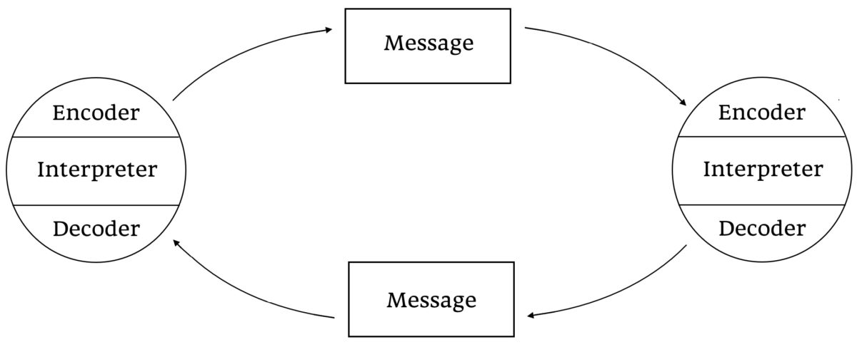

The Shannon-Weaver Mathematical Model, 1949
Warren Weaver and Claude Shannon (1948) developed this theory to describe how communication occurs between sender and receiver. The model finds factors that may obstruct information reaching the sender such as noise or technical issues. It deals with various concepts which include the information source, the sender/transmitter, noise, destination, encode and decode. An example of the Shannon-Weaver model is a phone call. A person makes a call and uses the telephone as the encoder to send the message/information to the recipient which can be relayed through wires. Noise may arise when the phone call is being made so the receiver can relay this back to the caller. This model was originally a one-way system. Below is a visual graph on how this would look.

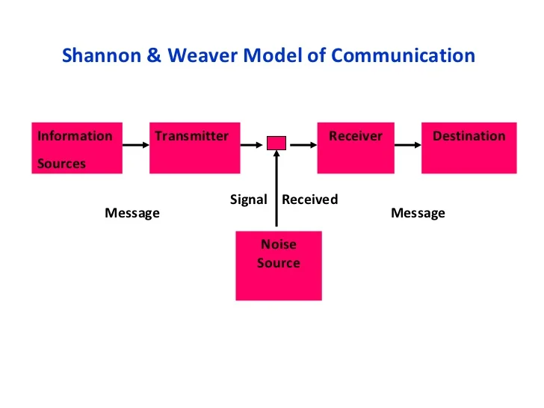

Berlo’s Model of Communication (1960)
David Berlo was the founder of this model, and it is used in things like newspapers, advertising etc. It is a one-way method of communication to send information, or statements and the recipient must decode it themselves. An example of this could be a news article (source) which includes information. The reader will take in this information and use it as they wish. Another example is a news show. The watcher will see and hear what is happening and decode this information as they wish. The source and senders' communication skills and knowledge are crucial in this delivery of information and the message will include tone of voice, body language and emotion which will get the message across more efficiently. The channel in which the message will be delivered could be verbal, non-verbal, written, or visual and the receiver must use their own communication skills and experience to take in and understand the message/information they have listened to or read.
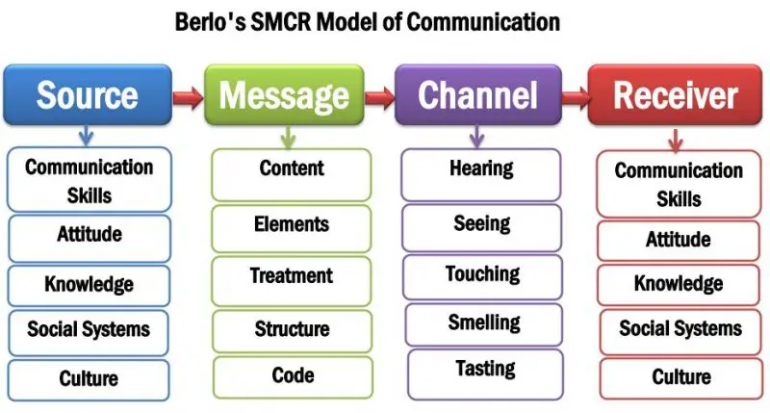

Importance of verbal and non-verbal

Verbal communication is the delivery of words we use to send messages and information to other people. According to (Caprese, 2023) Verbal communication is the most used form of communication. We use it every day to exchange information to everyone who crosses our path. By using verbal communication, we can deliver a message to a person or group with more efficiency and the feedback loop is faster. While communicating verbally we are also using our body language and tone of voice to get our message across appropriately to our chosen audience. The most effective form of verbal communication is face to face. It allows us to convey our message authentically and is a good strategy for managing work conflicts and difficult conversations.
Other forms of verbal communication are over the phone, whether it be phone call or videocall. This method can have its disadvantage though due to possible technical issues. It can obstruct a message being delivered fully or the recipient misunderstanding the message.
(Caprese, 2023) Also believes that possessing good verbal communication skills can help us to improve our personal and professional relationships. And it can help us to build trust when working with others and avoid conflict.
When we use verbal communication, it is important that we think before we speak and be clear and concise with our message. It is also important to be aware of our audience. We would not relay a message to our boss as we would to a friend or family member. There are various levels of formality that we use when verbally communicating with people.
Nonverbal communication is when we convey messages without using words. This can be done through eye contact, facial expressions, body language and hand gestures.
(Calero, 2005) claims that it is not just the words we use that are important. In fact, it is our nonverbal cues that speak the loudest. Without our expressions, body language and eye contact then words are just empty words with no real meaning. Our messages are conveyed with more meaning when we can express ourselves whilst speaking. Verbal and nonverbal communication combined allows us to fully understand a message being conveyed to us and we can notice others’ emotions and adapt ourselves accordingly to respond.
Barriers of communication
- Language barriers (when two people do not speak the same language it can be difficult to get their messages across)
- Knowledge of understanding. (when the message being conveyed is difficult for the receiver to understand)
- Distrust (our lack of trust in someone)
- Distorted perception (how we perceive or make assumptions about people)
- Emotional barriers (our psychological state impacts how we communicate)
- Belief systems (people of diverse cultures and beliefs have their own ways of communication)
- Noise (too much noise can disrupt communication)
- Disabilities (not being able to see or hear nonverbal cues)
Mehrabian (1967) conducted a study on communication. He claims that only three elements account for our perception of people. These are our words, our tone of voice and body language. In his findings it suggests that we use only 7% of words, 38% in our tone of voice and 55% in our body language. So, this could confirm that nonverbal is just as important than using words alone.
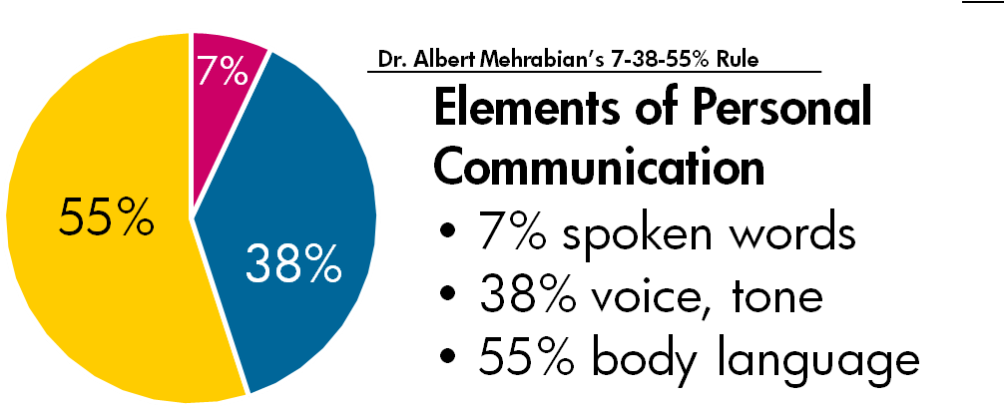

Workplace communication methods
(Vain, 2021) explains that establishing clear communication in the workplace can improve the company culture and prevent misunderstandings between management and employees. Effective communication can also boost morale and encourage productivity. Every workplace will have their own methods of communication that they will use to deliver information or to converse with colleagues.
- Written communication- (documentation, letters, or emails)
- Formal communication- (company policies, official information, conferences)
- Visual communication- (posters, graphs, presentations)
- Informal communication- (casual chats in an unofficial manner)
- Active listening- (actively listen to employees and colleagues)
The tools which are used in the workplace to help with communication could be;
- Telephone
- Videocall
- Text message
- Group chats.
- Walkie talkies
- Emails
- Notice boards.
- Posters
- Meetings
- Training
- Pager
- Tannoy
- Notes
- Letters
- Presentations
The methods used in the researcher’s workplace are all the above apart from walkie talkie, pager and Tannoy.

Motivation

overview of different theories of motivation
(Carol Sansone, 2000) Explains that motivation is specific to each individual and is what drives us to achieve our goals and needs. Motivation could be Extrinsic which means to be motivated by outside sources such as a promotion at work. Motivation could also be Intrinsic which means to be motivated by personal desires such as buying a house or starting a business. Motivation leads to action with the three motivators being need, values and goals.
Maslow (1943) believed that the human needs are built up in a hierarchy. There are five levels to the hierarchy. From the bottom upwards these are survival, safety, love, self-esteem, and the top being self-actualisation. Maslow argued that survival needs must be met before one can satisfy their higher needs or goals. he believed that once we fulfil each level then we can progress onto the next level.
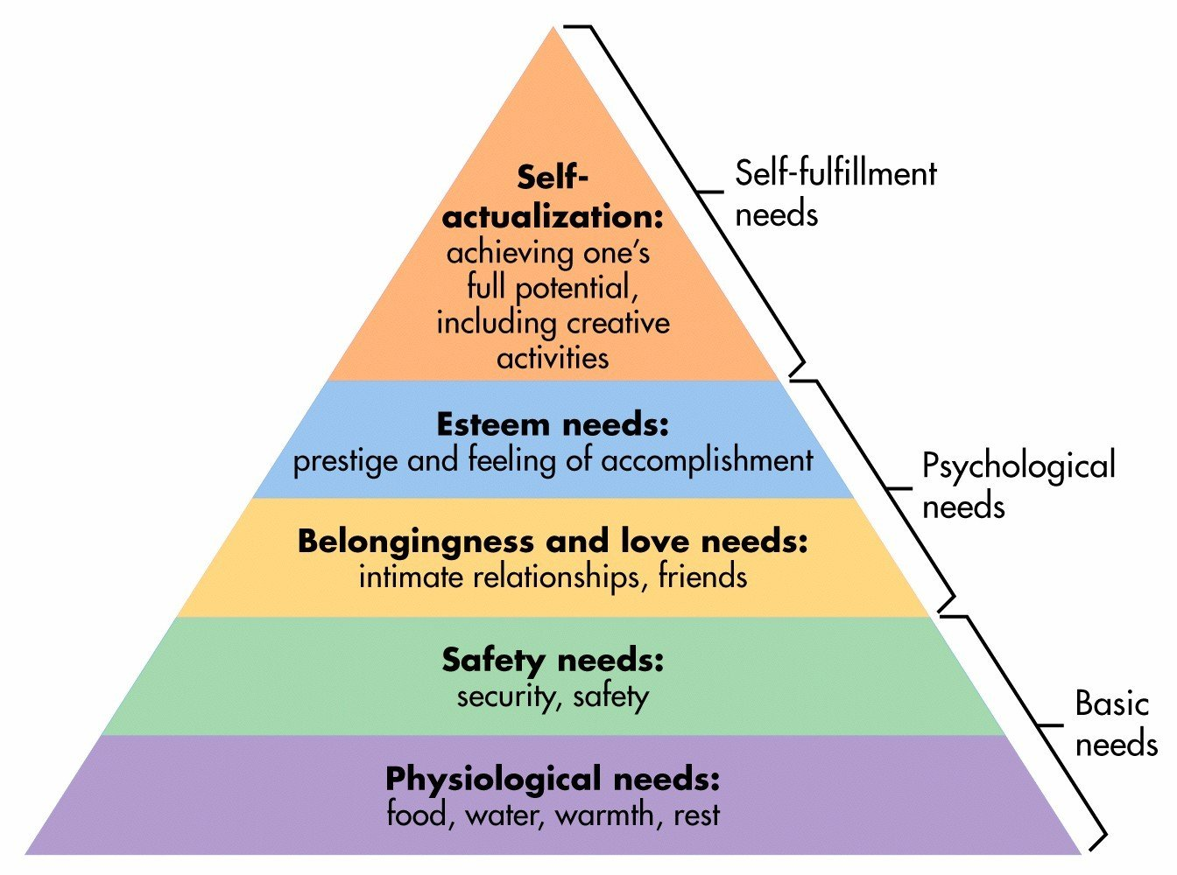

Another theory of motivation is that of McClelland (1961). He suggests that motivation is made up of three needs. The need for power, for achievement and for affiliation. He claims that these desires come in no order and that every human has a blend of each need but there is usual one that outweighs the others and drives us the most. According to McClelland (1961) the urge so these needs can heavily influence their behaviour and these needs can be developed through life experiences and our environment. 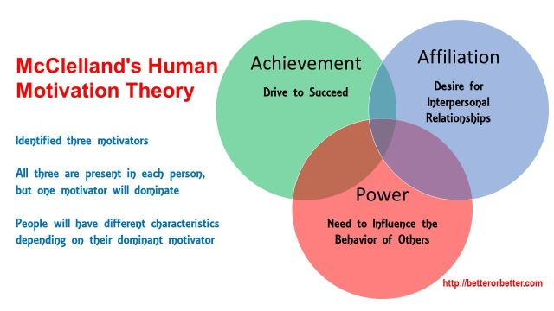

Factors that impact motivation in the workplace

According to (Marmara, 2018) there are factors that impact motivation in the workplace.
- Management – The way a workplace is managed can have a significant impact on an employee’s motivation.
- Reward system- The lack of recognition and reward for demanding work can make employees feel unmotivated.
- Communication- The lack of communication can have serious implications.
- Job security- If an employee does not have this it can impact their productivity.
- Workplace culture- This can impact the performance and behaviour of employees.

Application of motivational theories
With the application of motivational theories in the workplace, employees can feel appreciated and motivated to be productive in their work. Motivation theories are a way of learning about what drives an employee and how this can be used within management to help them achieve their goals and benefit the company.
In the researcher’s workplace the management team are approachable and always talk in an informal manner. This makes her feel more at ease when carrying out her work. She often feels appreciated for the work that she does, and management always thank her at the end of the day when she clocks out. Praise and gratitude are their main approach. The researcher perceives this as good management skills because it is what drives her to be productive. But it is only until recently that her workplace has introduced a reward system in the form of employee of the month. The employee of the month gets a small trophy and bottle of bubbly. The researcher personally does not feel this motivates her to achieve employee of the month. She feels that a bonus or an extra day annual leave would be more of a motivator for herself and most of her colleagues.
The motivational theory most relative to the researchers place of work is that of McClelland (1961). The reason being that there are people in a position of power. There are employees striving to progress further in their career. But there are also people who are happy to stay in their current role with no aspirations to progress higher or have more power.

Self-evaluation
The researcher carried out a communication style questionnaire to have a better understanding of what kind of communicator they are. The questionnaire consists of 20 questions, and they must be answered out of a score of 1 to 4. With 1= disagree strongly, 2= disagree somewhat, 3= agree somewhat and 4= agree strongly. Upon completing the questionnaire, the researcher must then tally up their marks into four column’s which include, Assertive, Passive, Passive aggressive and Aggressive. The column in which they score the highest in the one that gives an indication of what kind of communicator the researcher is.
The researcher learned that she scored the highest for Assertive and second highest for passive aggressive. She was curious to know what others thought of her communication style, so she asked a fellow colleague and her partner to answer a few questions.
Researcher – Am I assertive, passive, passive aggressive or aggressive?
Colleague – You are outspoken and confident but can sometimes be passive aggressive.
Researcher – Am I sarcastic at times?
Colleague – Yes, very!
Researcher – Do I listen well?
Colleague – Yes, you are a great listener.
Researcher – Do I express myself well with my body language?
Colleague – Yes.
Researcher – Do I talk clearly?
Colleague - You clearly talk most of the time. But you can talk too fast at times.

The researcher then asked the same questions to her partner.
Partner
- You are assertive but you can also be passive aggressive depending on your mood.
- Yes, you are sarcastic all the time.
- You are a good listener but can interrupt at times.
- Yes, you express yourself well with body language, but eye roll a lot at times.
- You clearly talk most of the time. But do mumble at times.
Both agree the researcher is assertive but can be passive aggressive at times. and both agree that the researcher is sarcastic. But the last three questions they each have their own views on the researcher. They both think she is a good listener, but the partner thinks she interrupts at times. and they both think she expresses well with her body language, but her partner says she eye rolls a lot. Her partner also thinks she mumbles at times whereas her colleague thinks she talks fast at times. this is due to her colleague being from Thailand and not used to the accent of the researcher.
Upon its findings the researcher’s communication style seems to be assertive and at times stand offish. This may impact her colleagues in a few ways. The assertiveness may influence her colleagues to be more outspoken and confident themselves, it may lead the way for them to feel confident to speak up to management or other colleagues in a way they have never done before. But the researcher’s passive aggression could have an impact on the atmosphere between her team, so she needs to continue to work on her self-awareness.

Strengths
- Assertive – the researcher has no qualms speaking her mind.
- Empathetic – the researcher is receptive of others’ emotions and experiences.
- Expressive – the researcher is expressive in how she can get the message across.
- Listens – the researcher actively listens.
Weaknesses
- Passive aggressive= the researcher can have a negative attitude.
- Outspoken = as good as it can be to be outspoken it can also be negative. It is important to know your audience before speaking.
- Sarcastic – again it is important to know your audience when using sarcasm because not everyone understands.
- Facial expressions- if the researcher does not say it her face will.
- Interrupts – The researcher can interrupt people talking at times.

Pdp
Growth area | Developmental goal | Action plan | Resources needed | Timeframe/evaluation
 | To be a better communicator | To actively communicate in a more positive manner | Mindfulness, feedback off peers, workshops | Evaluate in 6 months’ time.
Passive aggression | Not be so passive aggressive | “ “ | Self-help books, mindfulness, think before speaking, patience | 6 months
Outspokenness | To not be so blunt | “ “ | Mindfulness | 6 months
Sarcasm | To communicate normally | “ “ | Mindfulness, patience | 6 months
Facial expressions | Control facial expressions | “ “ | Self-awareness, mindfulness | 6 months
Interrupts | Listen before responding | “ “ | Self-awareness, patience, mindfulness | 6 months

Conclusion
To conclude this report has investigated the different communication styles people use in everyday life and professional life. It has explored the motivational theories of Maslow and McClelland and discovered that they both agree that people are motivated by need. This report has looked at how these theories match against the researcher’s workplace and what could be done instead to improve motivation. The researcher then carried out their own self-discovery journey of their own communication style and asked close ones to give their honest opinions. The end thought for this report is that clear and concise communication is vital for a workplace to be productive and positive. It is important that management listen to their employees and aid them thrive in their environment.

References

Andrew S. Rancer, T. A. (2010). Arguments, Aggression, and Conflict: New Directions in Theory and ResearchUnited Kingdom. Taylor & Francis.
Berlo, D. (1960). The Process of Communication: An Introduction to Theory and Practice. United States: Holt, Rinehart and Winston.
Calero, H. H. (2005). The Power of Nonverbal Communication: How You Act is More Important Than what You Say. . Silver Lake Publishing.
Caprese, J. ( 2023). Effective Communication Skills: Mastering the Art of Verbal and Nonverbal Communication. . Online Trendy Store.
Carol Sansone, J. M. (2000). Intrinsic and Extrinsic Motivation: The Search for Optimal Motivation and Performance. United States: Elsevier Science.
Marmara, R. (2018). A Study on Motivational Theories and Motivational Factors for the Job Performance. Germany: GRIN Verlag.
McClelland, D. (1988). Human Motivation. United States: Cambridge University Press.
McGuire, K. (2012). . Maslow's Hierarchy of Needs. An Introduction. . Germany: GRIN Verlag.
Mehrabian, A. (2017). Nonverbal communication. United Kingdom: Taylor & Francis.
Schramm, W. (1997). The beginnings of communication study in America : a personal memoir. . India: SAGE Publications.
Severin, W. (1988). Communication theories: origins, methods, uses. . United Kingdom: Longman.
Shannon, C. (2015). The Mathematical Theory of Communication. United States: University of Illinois Press.
Study.com. (2023, 11 21). Communication Cycle | Definition, Stages & Example. Retrieved from Communication Cycle | Definition, Stages & Example
Vain, C. (2021). Different methods of communication. Cpd online college.

