

How police uniform standards can affect public perception

Dominic Richards
2117850

UWTSD Swansea
Degree: BSc Hons. Professional Policing Practice
Word Count: 7116

Declaration
This work has not previously been accepted in substance for any degree and is not being concurrently submitted in candidature for any degree.
Signed: Dominic Richards
Date: 06/07/2024
STATEMENT 1
This dissertation is being submitted in partial fulfilment of the requirements for the degree of BA.
Signed: Dominic Richards
Date: 06/07/2024
STATEMENT 2
This dissertation is the result of my own independent work/investigation, except where otherwise stated.
Other sources are acknowledged by footnotes giving explicit references. A bibliography is appended.
Signed: Dominic Richards
Date: 06/07/2024
STATEMENT 3
I hereby give consent for my dissertation, if accepted, to be available for photocopying and for interlibrary loan, and for the title and summary to be made available to outside organisations.
Signed: Dominic Richards
Date: 06/07/2024
STATEMENT 4
I hereby give consent for my dissertation, if accepted, to be available on the university’s IT system to those who have consent to use the system.
Signed: Dominic Richards
Date: 06/07/2024
Abstract

The uniform of police officers extends beyond mere clothing, symbolizing authority, professionalism, and trustworthiness. This dissertation explores the multifaceted impact of police uniform standards on public perception, focusing on elements such as tattoos, makeup, and piercings. By examining historical evolution, design elements, and the role of specialized units like firearms teams, this study provides a comprehensive analysis of how visual presentation influences public attitudes towards police officers. Through a detailed literature review, this research highlights the correlation between police appearance and public trust, professionalism, and effectiveness in the police force. The findings underscore the importance of developing inclusive uniform policies that balance professionalism with individuality, addressing the evolving societal attitudes towards personal expression. This study aims to enhance understanding and inform policy development, contributing to more effective and positive community-police relations.

Index

Chapter 1: Introduction ……………………………………………………………………. 9

1.1 Research background ………………………………………………………………. 9

1.2 Research rationale ………………………………………………………………….. 10

1.3 Aims and objectives ………………………………………………………………… 11

1.4 Structure ……………………………………………………………………………. 11

1.5 Conclusion ………………………………………………………………………….. 12

Chapter 2: Literature review ……………………………………………………………….. 13

2.1 Introduction ………………………………………………………………………… 10

2.2 The history of police uniforms ……………………………………………………… 14

2.3 Police uniforms. Why are they needed? ……………………………………………. 14

2.4 How changes in police uniform standards influence public perceptions
of police professionalism, authority, and trustworthiness …………………………. 15

2.5 The impact of different police uniforms on public perceptions across
various policing roles, including response teams, neighbourhood police
teams, the Criminal Investigation Department (CID), and firearms units …………… 15

2.6 The role of specific uniform elements, such as body armour,
high-visibility clothing, and cosmetic regulations, in shaping public
opinion and officer effectiveness …………………………………………………….. 18

2.7 Conclusion ……………………………………………………………………………. 21

Chapter 3. Research methodology …………………………………………………………… 22

3.1 Introduction ………………………………………………………………………….. 22

3.2 Ethical practice ……………………………………………………………………….. 22

3.3 Independance and impartiality ………………………………………………………. 23

3.4 Ethical research and participant confidentiality ……………………………………… 23

3.5 Research methods ……………………………………………………………………. 24

3.6 Longitudinal research …………………………………………………………………. 24

3.7 Qualitative vs. quantitative research ………………………………………………….. 24

3.8 Research tools …………………………………………………………………………. 25

3.9 Sampling technique …………………………………………………………………… 26

Chapter 4. Analysis of results ………………………………………………………………….. 27

4.1 Introduction ……………………………………………………………………………. 27

4.2 Theme 1. Trust, confidence, and approachability ……………………………………… 28

4.3 Theme 2. Body modifications: piercings, tattoos, and cosmetics ……………………… 33

4.4 Theme 3. Body-worn video …………………………………………………………….. 37

4.5 Theme 4. Weapons, firearm officers, and body armour ……………………………….. 40

Chapter 5. Conclusion and recommendations …………………………………………………. 44

5.1 Introduction ……………………………………………………………………………. 44

5.2 Summary of primary findings ………………………………………………………….. 45

5.3 How differences in police uniforms influence
public trust and perceptions of the police …………………………………………….. 45

5.4 Do body modifications such as tattoos, piercings, and cosmetics affect
the public perceptions of police professionalism? …………………………………….. 45

5.5 Analysis of the effect that the overt display of weapons and police
equipment on police uniforms has on the public perception of police ………………. 47

5.6 Recommendations ……………………………………………………………………. 49

References …………………………………………………………………………….. 50

Appendix A. Summary of survey responses …………………………………………… 58

List of figures and tables

4.2.1 Both groups agree that police uniform design affects public trust,
with serving officers slightly more so …………………………………………………………28
4.2.2 Officers are more inclined to assume that uniformed officers and
plain-clothed investigators are trusted differently by the public …………………………….. 29
4.2.3 Both groups feel less confident in police if uniforms seem more like
normal attire, with serving officers more so …………………………………………………. 30
4.2.4 Neither group found the PCSO uniform more approachable ………………………………… 31
4.2.5 Serving officers prefer conventional PCSO uniforms to casual ones ………………………… 32
4.3.1 Most members of both categories think tattoos affect an officer's
professionalism, but non-serving members more so ………………………………………… 33
4.3.2 Both groups feel tattoo placement (e.g., hands, neck, face) does not
affect officer confidence ……………………………………………………………………… 34
4.3.3 Serving officers are slightly more likely than others to believe that officer
makeup does not effect confidence …………………………………………………………… 35
4.3.4 Most people in both groups think piercings don't alter their impression
of officers, but some disagree ………………………………………………………………… 36
4.4.1 Most of both groups feel body cameras make police officers more
accountable, with non-serving members agreeing significantly more ……………………….. 37
4.4.2 Both groups feel body cameras improve public impressions, with the
public showing a slightly stronger belief ……………………………………………………… 38
4.4.3 Both groups believe body cameras have improved police behavior, but
officers show a stronger belief ………………………………………………………………… 39
4.5.1 Police officers are in favour, while the public is divided ………………………………………. 40
4.5.2 Both groups dispute that equipment lowers police friendliness ……………………………… 41
4.5.3 Both groups are evenly split on feeling more or less intimidated …………………………….. 42
4.5.4 The public believes firearms officers' uniforms increase compliance ………………………… 43
Chapter 1. Introduction

This study investigates whether police uniforms affect public opinion. This chapter will summarize the study and explain its purpose. Additionally, it will provide a concise summary of its objectives.

1.1 Research background

A police officer's uniform is more than just their clothing; it is a potent representation of their professionalism, authority, and trustworthiness. According to research conducted by Sergeant and Simpson (2023), public attitudes towards police indicate that the uniform's presence, as well as its color and style, can impact how the public perceives the police.

Since the early 19th century, police uniforms have undergone substantial change in response to societal demands and expectations. The public's perception of police forces has been greatly influenced by their uniforms ever since the London Metropolitan Police Service was founded in 1829. These uniforms' look and style have been carefully thought out to strike a balance between practicality and the symbolic portrayal of protective power and community involvement (Quill P, 2016)

The original police uniforms, with their leather top hats and dark blue tailcoats, were intended to set police officers apart from military forces and convey a sense of civil authority. This distinction was critical to building public cooperation and trust, which were necessary for the newly formed police forces to function effectively (Emsley, 2009). Body armor and high-visibility clothing are examples of components that have been added to uniform requirements over time as the role of the police has grown and changed, improving officer safety and operational effectiveness (Shernock, 1992).

1.2 Research rationale

Despite several studies on police clothing and public opinion, the author found gaps in the literature. Few longitudinal studies have examined public opinion on factors that affect police uniform perceptions. Furthermore, little is known about how particular uniform components affect police officers' and the general public's psychological well-being. The effect of uniform standards on public perception is still a crucial subject of research in modern policing.

The needs of response teams, neighbourhood police, the Criminal Investigation Department (CID), and firearms units are considered when designing current police uniforms. Each unit's uniforms reflect its functions and operational needs, influencing public opinion of police. Firearms units have body armor and specialised weaponry. This equipment is vital for officer safety in difficult situations, yet it may appear militarised, which may affect public opinion. In less risky situations, armed officers can alarm individuals, but they can also comfort them in emergencies. In contrast, Skogan (2006) claims that local police units dress informally in polo trousers and shirts to appear friendlier and improve community relations.

Police cosmetics, piercings, and tattoo regulations also affect public perception of police. Visible tattoos, long considered unprofessional, are now increasingly accepted in police forces due to societal trends (Lloyd, 2018). Similarly, modest cosmetics can promote a professional appearance, while heavy makeup is prohibited (Bain, 2013). Piercings—especially facial ones—are limited to maintaining a professional appearance (Guy & Newman, 2013).

1.3 Aims and objectives

This dissertation aims to explore the following research objectives:

1. Investigate how changes in police uniform standards influence public perceptions of police professionalism, authority, and trustworthiness.

2. Analyse the impact of different police uniforms on public perceptions across various policing roles, including response teams, neighbourhood police teams, the Criminal Investigation Department (CID), and firearms units.

3. Examine the role of specific uniform elements, such as body armour, high-visibility clothing, and cosmetic regulations, in shaping public opinion and officer effectiveness.

1.4 Structure

Each chapter will make a unique and valuable contribution towards achieving the four aims of this dissertation. Chapter Two examines pertinent academic literature. In Chapter Two, themes will be developed from theory, hypotheses, and research questions utilising deductive reasoning. Chapter Three examines study scale, ethical considerations, and time constraints in order to determine the most effective data collection methods for the study. Chapter Four examines the data to identify trends and examines the results and their consequences. In Chapter Five, the dissertation will present the findings of each objective and provide recommendations founded on the research results obtained in the study.

1.5 Conclusion

This chapter has presented the background and rationale for this study. The research is grounded on the four specified aims and objectives, and the justification for further exploration of this subject has been clarified. The forthcoming chapter of this dissertation will undertake a thorough analysis of the current scholarly literature.

Chapter 2. Literature review

2.1 Introduction

This study aims to fill gaps in the literature on police clothing and public image. This study evaluates the psychological impact of uniform looks and tracks public perceptions on how this factor affects trust, approachability, and confidence in police. The study will also examine public opinion on police uniform technological advancements, summarising debates on uniform standards and public perception. Each of the three research objectives will be examined by reviewing the pertinent literature. Thorough research on this topic has revealed that there are few recent studies on the subject of police uniforms affecting public perception of police.

1. Investigate how differences in police uniforms influence public trust and perceptions of the police.

2. Assess if body modifications such as tattoos, piercings, and cosmetics affect public perceptions of police professionalism.

3. Analyse the effect that the overt display of weapons and police equipment on police uniforms has on the public perception of police.

2.2 The history of police uniforms

According to Goldsmith (2002), the Metropolitan Police was founded in 1829 as the first British professional police organization. Cowley (2011) said that police officers, known as 'Bobbies', wore navy blue swallow-tail tunics to match the trend. They chose this color to distinguish themselves from the army's red uniforms. The goal was to show the public and cops that they were a civilian law enforcement entity. This affected public and officer perceptions of the force through their attire. According to Andrews (2023), the uniform gradually changed from colored shirts and tunics to blue shirts. However, the subsequent introduction of white shirts rendered the nickname "boys in blue." inaccurate. Today, all UK police services save the MET wear black t-shirts and trousers, according to the same survey. Tasers and body armor are prevalent among all police forces, giving police an unintended militaristic look.

2.3 Police uniforms—why are they needed?

According to Ross (2024), The manner in which we attire ourselves holds significance as it must effectively communicate a message of collaboration, cohesion, structure, and authority. The police officer's outfit serves as a way of communicating via nonverbal means. Upon the arrival of an officer at an incident, their outfit is designed to immediately capture the attention, demand respect, and exhibit unwavering consistency, strength, and expertise. This aligns with research conducted by Sargeant and Simpson (2023) which provides evidence for the significant influence of officer appearance on influencing police views and conduct. It reinforces previous studies that focus on civilians' opinions of police uniforms and equipment. According to Kepp (2023), uniform also has a significant role in personal safety, stating that law enforcement officers must be safeguarded in situations of disturbance. An officer who has received thorough training and is equipped with appropriate protective measures would possess enhanced capabilities to make crucial judgments in high-pressure scenarios.
2.4 How changes in police uniform standards influence public perceptions of police professionalism, authority, and trustworthiness.
According to research conducted by Emsley, (2009), the evolution of police uniforms is not merely a reflection of changing fashion but a mirror of broader societal shifts and the evolving role of policing. The same study found that in the 19th century, the establishment of the Metropolitan Police Service in London marked a turning point in how law enforcement was perceived by the public. Sir Robert Peel's vision for a professional police force, underscored by uniforms designed to be non-threatening yet authoritative, sought to balance visibility and public reassurance. Critically, the early police uniforms were a deliberate attempt to distance the police from military imagery, a choice reflecting societal fears of an overreaching state power (Critchley, 1978). Reynolds (1998) found that the gradual changes in police uniforms, such as the transition from white to dark trousers and the introduction of the custodian helmet, were driven by practical needs and public perception. According to Rawlings (2002), these changes mirrored a growing acceptance and trust in the police force as it demonstrated its role in maintaining public order. This is supported in research conducted by Stinger and Stinger (1985), a group of students were provided with one set of photographs of police officers wearing civilian clothing and another where they were dressed in police uniform. The photographs depicting the police in their official attire were seen as possessing higher levels of competence, reliability, intelligence, and helpfulness compared to the photographs of the same officers without their uniforms.
In modern times, the perception of police uniforms has continued to evolve. The introduction of high-visibility clothing and body armour reflects not only advancements in technology and a response to increased threats to officer safety but also societal expectations for transparency and accountability (Sleek, 2017). This dual focus on functionality and symbolism highlights the ongoing balance between ensuring officer safety and maintaining public trust. This aligns with Quill (2016) who argues that the use of lighter colors in the standard police uniform can foster a sense of “honesty, truthfulness, trustworthiness, and helpfulness," thus promoting tighter bonds between the public and its police officers.

2.5 The impact of different police uniforms on public perceptions across various policing roles, including response teams, neighbourhood police teams, the Criminal Investigation Department (CID), and firearms units.
Police uniforms must serve practical purposes—such as comfort, durability, and utility—while also carrying significant symbolic weight. Modern uniforms are designed with durable, breathable fabrics to ensure comfort during long shifts, and incorporate multiple pockets and attachments for essential equipment (Muir, 2009). The integration of body armour, although vital for officer safety, also carries symbolic implications, potentially impacting public perception of the police as militarized (Baker, 2015).
The symbolic aspects of police uniforms, including elements like high-visibility clothing and badges, serve to enhance the visibility and recognizability of officers, reinforcing their authority and approachability (Campbell & Campbell, 2010). However, the militarization of police uniforms, particularly the use of tactical gear in firearms units, raises critical questions about the balance between perceived authority and public fear (Balko, 2013). The debate on police militarization is central to understanding the impact of modern police uniforms. Kraska and Kappeler (1997) argue that the use of military-style equipment and uniforms can create a perception of an aggressive, authoritarian police force, which can undermine public trust. In contrast, Johnson et al., (2005) suggest that such gear is essential for the safety and effectiveness of officers in high-risk situations. Simpson and Sergeant (2023) found that police equipment can be used for a wide range of purposes, and occasionally, purpose and perception might clash. For example, essential accoutrements may also create unfavorable public opinions.This debate extends to the different policing roles, where the uniforms of firearms units, CID officers, neighbourhood police teams, and response units each convey distinct messages to the public. According to Bayley (1976) the heavily armed appearance of firearms units can evoke fear, while the professional attire of CID officers projects competence and discretion. The informal uniforms of neighbourhood police teams aim to enhance approachability and trust, reflecting the philosophy of community policing (Skogan, 2006).
The impact of police uniforms on public perception varies significantly across different policing roles. Firearms units, often equipped with tactical gear, present a militarized image that can either reassure or intimidate the public depending on the context (Squires & Kennison, 2010). In contrast, CID officers in plainclothes are perceived as more approachable and less intimidating, facilitating undercover work and building community relationships (Brodeur, 2010). Neighbourhood police teams, wearing more informal uniforms, aim to foster better relationships with the public by appearing less authoritarian. This approach is crucial for community policing, which relies on trust and cooperation from the community (Cordner, 2014). Response units, with their standard uniforms designed for visibility and authority, play a critical role in maintaining order during emergencies, but their appearance must be carefully managed to avoid perceptions of militarization (Muir, 2009). According to De Carmargo (2019), Police Community Support Officers (PCSO’s), uniforms are intentionally meant to resemble those of the police force, while yet being easily distinguishable from actual police personnel.

2.6 The role of specific uniform elements, such as body armour, high-visibility clothing, and cosmetic regulations, in shaping public opinion and officer effectiveness.
According to Simpson (2019), Vests, sometimes known as 'body armor', are primarily worn to mitigate harm caused to a police officer by weapons used by criminals, and in a policing environment, their secondary duties may include enhancing the overall appearance of the dark colored uniform and providing protection for any equipment that would otherwise be carried in this area. Johnson (2005) found that the public had negative perceptions of police if they wore black coloured body armour. Simpson (2019) hypothesised that police officers wearing high-visibility vests will be seen as less hostile and more accessible, amiable, courteous, and responsible compared to when they are not wearing these vests. This aligns with research by Blaskovits et al. (2021) in which it was found that the utilisation of military equipment and weapons had an adverse effect on the public's trust and sense of approachability. Sergeant and Simpson (2023), also found that when police officers wore the high-visibility vest, people thought of them most highly in terms of qualities. However, police personnel who overtly exhibited such equipment were perceived as more robust and better equipped to handle dangerous situations. This is supported by research conducted by Sergeant and Simpson (2023) in which they found that the uniform's color and the high visibility jackets had an impact on how police officers perceived the level of accountability, aggressiveness, approachability, competence, and friendliness of their colleagues. Johnson (2005) posits that uniform colour supports the age old cultural view that white is indicative of ‘good’ and black represents ‘bad’. Couper et al., (2006) agree with this finding, stating that lighter colors are generally perceived as more pleasant and less overpowering compared to dark colors. In opposition to this, Kim and Song (2021) found that police officers may have concerns that their authoritative image could be distorted if they were to wear vibrant, reflective vests. Innovations in fabric technology, such as smart fabrics that monitor vital signs or provide climate control, are less familiar to the public. These advancements are viewed with a mix of curiosity and scepticism. While they hold potential for improving officer safety and comfort, their acceptance hinges on public understanding and trust in their benefits (Perrottet, 2011).
Technological advancements in police uniforms, such as body cameras and smart fabrics, play a significant role in shaping public perception. Research of public opinion in relation to the appointments (equipment) carried by police, found that there was conflicting evidence on the subject. O’Neill et al., (2017) presented images of officers wearing vests both adorned and unadorned with use of force equipment, featuring various attachments such as batons, incapacitant spray, handcuffs and a body-worn camera. Participants ranked vests with more attachments as more militarized and alarming. However, with these attachments, faith in the police remained high among respondents. This is supported by Johnson et al,. (2014) who found that wearing accessories does not seem to have any effect on how the public perceives the police. In contrast, Simpson (2018) found that the presence of a vest had a significant effect on public perception. It increased the likelihood of the depicted police officer being seen as forceful, respectful, and culpable, but diminished the likelihood of them being regarded as approachable. According to Poirier, Charbonneau and Boivin, (2023), police body-worn video (BWV) are praised for their ability to enhance accountability and openness by recording police actions and contacts with the public. In the same study, it was found that the majority of participants were open to being recorded by police, with <6% of respondents being concerned with privacy issues. The integration of body cameras has been widely adopted to promote transparency and accountability in policing (White, 2014). This is supported in research by Goodison and Berger (2024) who discovered that body-worn video did not have any significant impact on the way the public perceives police officers.
Specific elements of police uniforms, such as tattoos, makeup, and piercings, have diverse impacts on public perception. While tattoos have become increasingly mainstream, their visibility on police officers can still elicit mixed reactions. According to Adams (2012), tattoos have a traditional affiliation with particular oppressed groups and environments, typically carrying a negative association. These groups include former convicts, punks, gang members, bikers, seafarers, and military. Visible tattoos, especially on the face, neck, and hands, are often perceived as unprofessional or indicative of nonconformity (DeMello, 1993). Hauke-Forman, Methner and Bruckmüller, (2021) describe the current controversy around the permissibility of police officers displaying tattoos or piercings on exposed areas of their bodies. The concern frequently raised against it is that such physical transformations could elicit negative perceptions of police by the public, which could hinder officers' ability to carry out their responsibilities effectively. However, the same research found that there is a lack of empirical evidence to support this assertion. The research found that officers adorned with tattoos and piercings were regarded as less reliable and less capable, eliciting a somewhat lower level of acceptance and provoking heightened perceptions of fear. Furthermore, individuals evaluated police officers who had tattoos, instead of piercings, as being less amicable and more forceful. Swanger (2006) concurs, suggesting that tattoos can undermine the perceived authority and professionalism of police officers, potentially affecting public trust. This is supported by research conducted by Sergeant and Simpson (2023) who found that in relation to tattoos and piercings, deviation from the conventional uniform in terms of look seems to diminish officers' opinion of their own legitimacy. In contrast, Wyllie (2021) argues that one way to humanise police officers is to allow them to display tattoos and piercings. Public attitudes towards piercings vary widely. While ear piercings are generally accepted, facial and multiple piercings can evoke negative judgments. Such piercings are often associated with nonconformity and unprofessionalism, which can affect how police officers are perceived (DeMello, 1993). Makeup use among police officers, particularly female officers, intersects with gender expectations. Subtle, conservative makeup is generally viewed positively, enhancing a professional appearance (Forbes et al., 2006). However, excessive or flamboyant makeup can detract from the perception of authority and professionalism, highlighting the need for balanced and appropriate grooming standards (Bain, 2013).

2.7 Conclusion

The literature on police uniforms underscores the complex interplay between functionality, symbolism, and public perception. By critically analysing key themes and debates, this review provides a comprehensive understanding of the issues surrounding police uniforms. Addressing identified gaps and pursuing future research directions will enhance the development and implementation of uniform policies, ensuring they meet the needs of contemporary policing while maintaining public trust and confidence.

Chapter 3. Research Methodology

3.1 Introduction

This chapter explains this dissertation's research methods in detail. Effective research requires a deep understanding of research and technique. The Cambridge Dictionary (2019) defines research as “a detailed study of a subject, especially in order to discover (new) information or reach a (new) understanding.” Brown (2006) defines methodology as “the philosophical framework within which the research is conducted or the foundation upon which the research is based.” This dissertation should give empirical data on how police uniform standards effect public perception.

3.2 Ethical Practice

The University of Wales Trinity Saint David (2024) defines ethical research as “To protect the rights and welfare of participants and minimise the risk of physical and mental discomfort, harm and danger from research procedures.” According to the WHO (2024), an ethics council should evaluate human subject research ethics. The USWTSD ethics committee approved the researcher's ethics document which summarised the research objectives, described the data collection techniques, and showed the researcher's rigorous appraisal of participant risks and development of solutions to reduce them. The ethical consent form described data storage, anonymity, and the researchers' commitment to participant rights to minimize harm.

3.3 Independence and impartiality

According to Slotfeldt-Ellingson (2023), neutrality, impartiality, and independence are fundamental principles that help to define the essence of research. In line with these guidelines, the researcher has not established any affiliations, professional or personal, that would conflict with this research.

3.4 Ethical research and participant confidentiality

The Office of Research Integrity (ORI) (2024) emphasizes that high-quality research requires thorough detail. The results of experiments must be properly documented, analysed, and reported. In ethical research, bias detection is essential. According to Pannucci and Wilkins (2011), "bias" is any tendency to prejudge an issue. Open-mindedness is crucial in study and according to Hare (2011), open-mindedness is 'an openness to develop and adjust our beliefs based on a careful study of data and reasoning that tries to reach the challenging standards of objectivity and impartiality.' The researcher aims to approach this study this way to obtain the best findings. To protect individuals involved in data collection, Coffelt (2017) recommends confidentiality and anonymity. Data confidentiality requires removing or altering personal information. Anonymous data collection does not reveal personal information. Quantitative research uses anonymity, but qualitative research values confidentiality. Participants gave informed consent and ethical permission. The study's objective, voluntary nature, and right to withdraw were explained to participants. Anonymity and confidentiality were maintained throughout the research. This ethical approach guarantees that participants understand their rights and the study's goals, generating trust and honest responses.

3.5 Research methods

3.6 Longitudinal research

Longitudinal studies see the same variables throughout time (Bekhor et al., 1995). This method allows researchers to examine public perception and behavior over time, showing how views shift in response to police uniform standards, society norms, and key events. The researcher found no longitudinal research on the topic. Due to the dissertation's brief duration, the researcher decided not to conduct longitudinal research.

3.7 Qualitative vs. quantitative research

Qualitative research uses interviews, focus groups, and case studies to gather non-numerical data. This method yields deep understanding of public perceptions and their contextual variations (Forbes et al., 2006). Qualitative research is useful for difficult topics where numerical data is insufficient. Qualitative research offers context, insight, and flexibility, with Anderson (2010) noting that qualitative research is more sensitive to the researcher's biases and quirks. The amount of data obtained using this method requires a lot of time for analysis and interpretation, and anonymity and secrecy can make study findings difficult to share. It could also be difficult and time-consuming to visually convey the findings.

According to Tracey (2024), quantitative research quantifies conversations, behaviors, news items, and other social or physical activities. Quantitative research builds mathematical models, predicts, and draws causal inferences using measurement and statistical analysis. This method collects vast datasets, making it easier to identify trends and patterns across populations, according to Lloyd (2018). Quantitative studies use organised surveys or questionnaires with preset response possibilities to compare responses and test hypotheses statistically. Qualitative research entails collecting written material through face-to-face or virtual interviews or online surveys and converting it to numerical values, according to Tracey (2024). The researcher has decided to employ a quantitative research method in the form of an online multiple-choice questionnaire to collect the data.

3.8 Research tools

Online surveys are cost-effective and efficient, according to Regmi et al. (2016). They also say online surveys are good for getting data quickly and reaching a wide audience. Surveys can reveal public mood and discover patterns and correlations. In comparison, surveys have major drawbacks. According to Andrade (2020), voluntary participation in online surveys to unknown demographics can bias responders into the sample, making the results uncertain. They collect data at a single moment in time since they are cross-sectional. This limits the capacity to track public perception trends over time. A study may show that a large section of the public regards police uniforms as military, but it cannot establish how this opinion has changed or what events may have influenced it. Surveys also rely significantly on self-reported data, which might be affected by respondents' honesty, memory recall, and question interpretation. A questionnaire was created to obtain quantitative data for the research objectives. A wide range of issues was carefully selected for the questionnaire to fully grasp popular perception. The topics of police uniforms, uniform components, psychological impact and non-uniformed officers were covered. Each component was designed to elicit thorough responses for a multidimensional data analysis. This strategy ensured a wide range of outcomes, captured public opinion nuances, and provided a solid platform for analysis. Microsoft Forms was used for managing the survey online for dissemination, data collection, and preliminary analysis. The capacity to easily reach a wide and diversified audience drives online platform selection. Although in-depth analysis was desired, a protracted survey could deter participants, therefore, the poll mostly used basic, one-answer questions to optimise response rates and capture valuable data. To provide a thorough and engaging survey, detail and brevity were balanced. Advanced data analysis was used to interpret the data. Data trends and patterns were summarised by descriptive statistics. Inferential statistics like regression and correlation analysis identified significant group differences. Data was organised and analysed using Microsoft Forms and Excel to code and categorise replies to find common themes and trends. Data was summarised via descriptive statistics to highlight major findings. Regression and correlation analysis were used to find group differences and correlations. These advanced statistical methods revealed hidden patterns and relationships in the data.

3.9 Sampling technique

A closed group of police officers and civilians was expected to generate 50–100 respondents. The poll was sent to South Wales Police (SWP) officers via the Occupational Support Unit (OSU) and a closed group of members of the public from a sporting organisation (Dragons Academy). Serving police officers were selected because they can remark on how uniform standards affect public perceptions of police. The closed group public sample was used to understand public opinion on the topic. Self-selection and response bias are potential drawbacks, thus multiple recruitment paths were employed to reduce selection bias and provide a varied sample. The study targeted a wide audience through Whatsapp and email invitation, reducing bias and enhancing sample representation. Anonymity enabled individuals to feel more comfortable giving their actual thoughts without fear of judgment or repercussions.
Chapter 4. Analysis of results

4.1 Introduction

This chapter of the study will evaluate the primary findings of the quantitative data in a methodical manner, and it is anticipated that the findings will achieve the dissertation's objectives in full.

1. Investigate how differences in police uniforms influence public trust and
perceptions of the police.

2. Assess if body modifications such as tattoos, piercings, and cosmetics
affect public perceptions of police professionalism.

3. Analyse the effect that the overt display of weapons and police
equipment on police uniforms has on the public perception of police.

The survey answers are condensed and depicted in bar graphs, which can be seen in Appendix A. Fifty people participated in the survey, of whom 17 were police officers and 33 members of the public. The data from each of the survey questions will be catagorised into four distinct themes, to efficiently display the findings.

4.2 Theme 1. Trust, confidence, and approachability

Question 1.
Do you believe that the design of a police uniform can significantly influence public trust?

Participants were asked if the uniform's appearance affected their opinion of a police officer's trustworthiness. Figure 4.2.1 reveals that 65% of police and 58% of the public agreed.

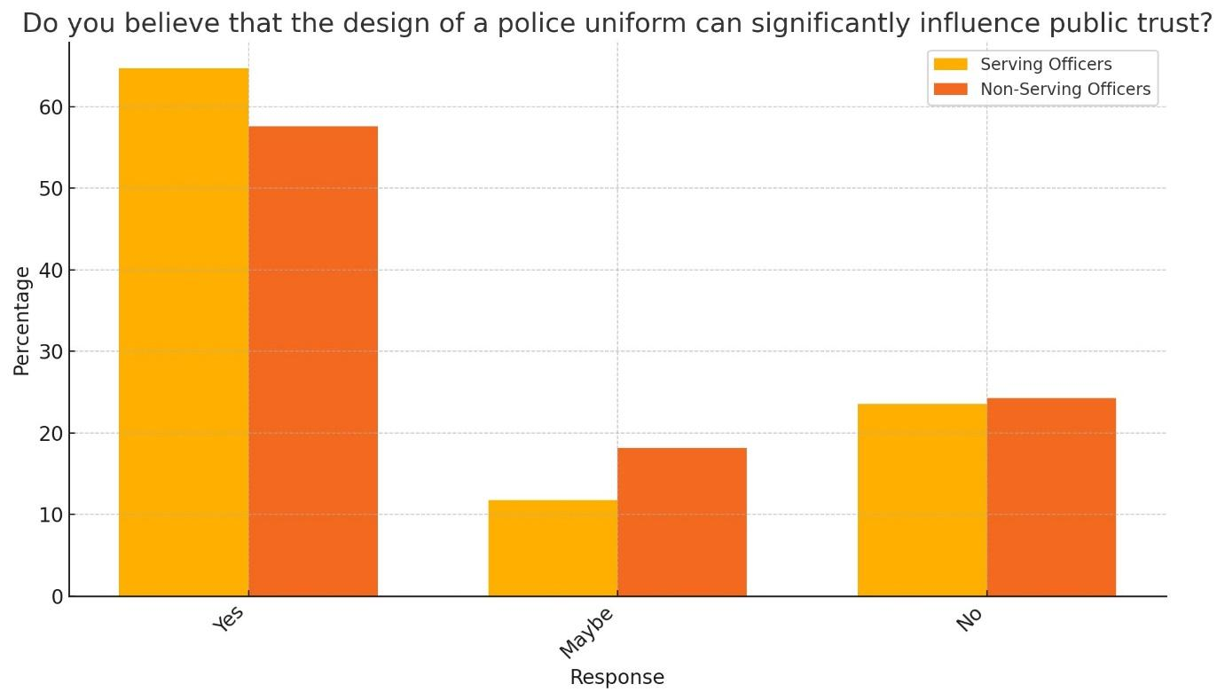
Figure 4.2.1 Both groups agree that police uniform design affects public trust, with serving officers slightly more so.
Question 2.

Do you believe that public trust varies significantly between uniformed police officers and plainclothed detectives?

The study participants were asked if uniforms damaged public trust. Figure 4.2.2 shows 76% of police and 52% of the public agreed.

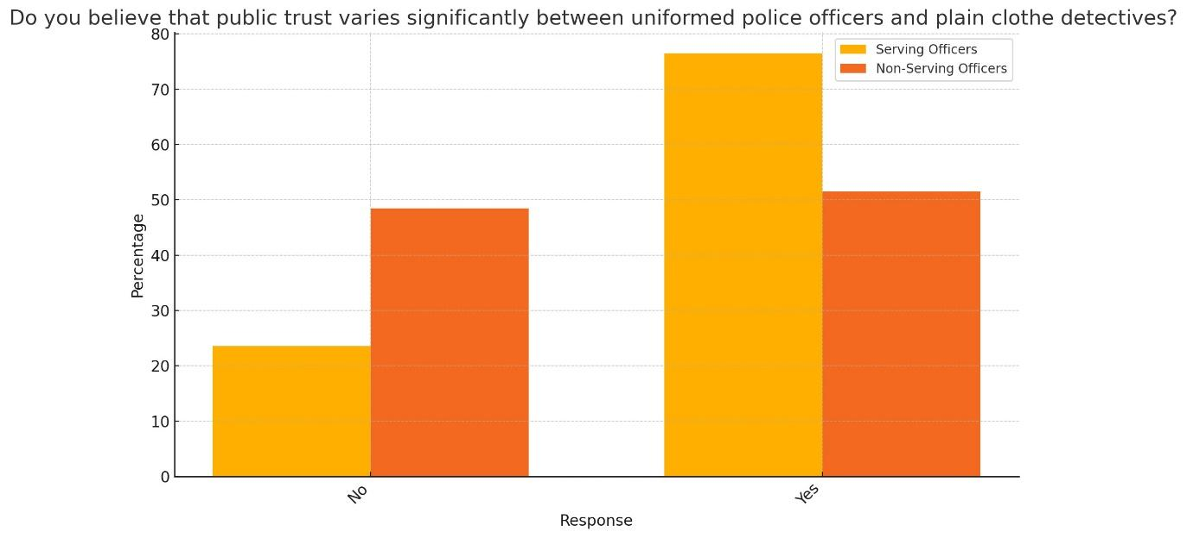

Figure 4.2.2. Officers are more inclined to assume that uniformed officers and plain-clothed investigators are trusted differently by the public.

Question 3.

Would you feel more confident in police if their uniforms looked more like everyday clothing rather than traditional clothing?

This question assessed group confidence. Figure 4.2.3 reveals that 65% of officers and 60% of the public felt less confident in police in casual dress.

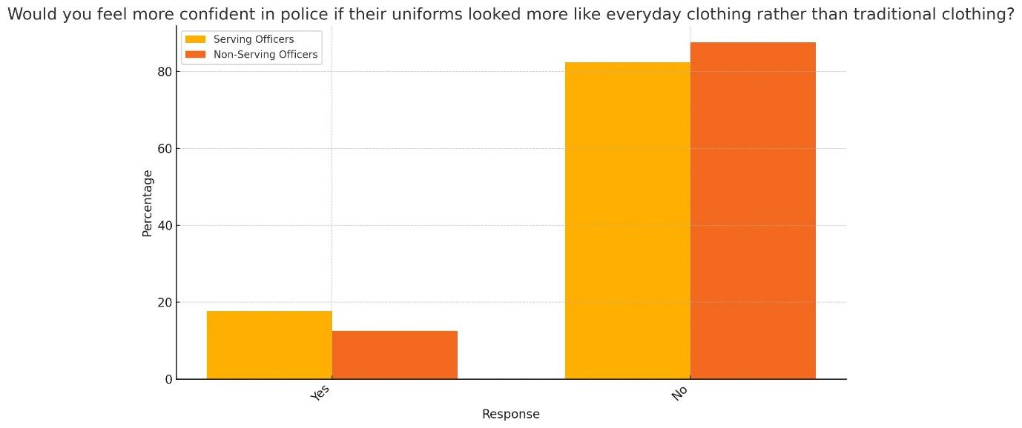

Figure 4.2.3 Both groups feel less confident in police if uniforms seem more like normal attire, with serving officers more so.

Question 12.

Do you think that NPT (Neighbourhood Policing Teams), more specifically PCSO’s uniform, is more approachable than other police units?

Participants were asked if one neighborhood community policing outfit was more approachable than another. The public felt that the PCSO outfit was not more approachable, although 75% of police agreed (figure 4.2.4).

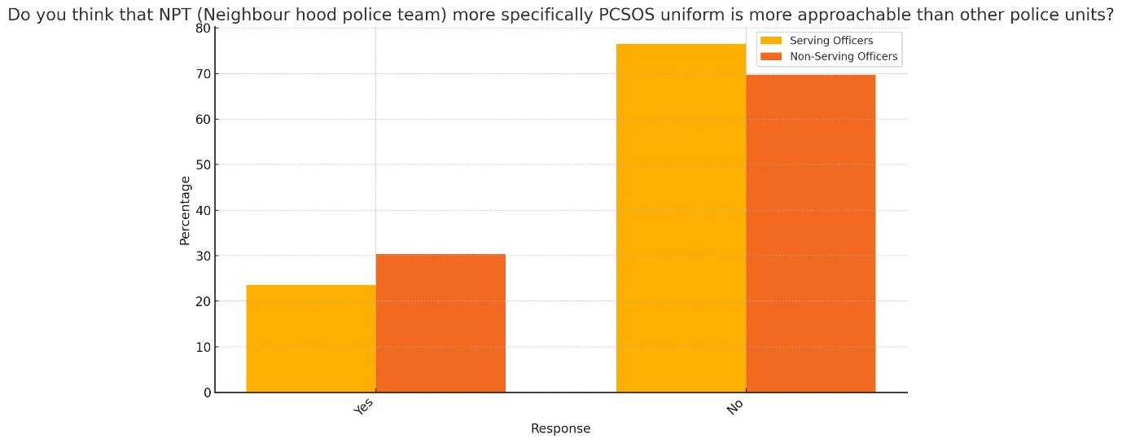

Figure 4.2.4 Neither group found the PCSO uniform more approachable.

Question 13.

Do you think that PCSO’s should wear more casual uniforms to appear more approachable and trustworthy to the public.

The above question was asked to determine if PCSOs should wear different apparel from police and if this would boost approachability. Figure 4.2.5 shows that 60% of the public thinks PCSOs' uniforms are appropriate. It's intriguing that 25% of police officers wanted a PCSO uniform change. This may be because a small minority of police officers don't value PCSOs and want the public to view them differently.

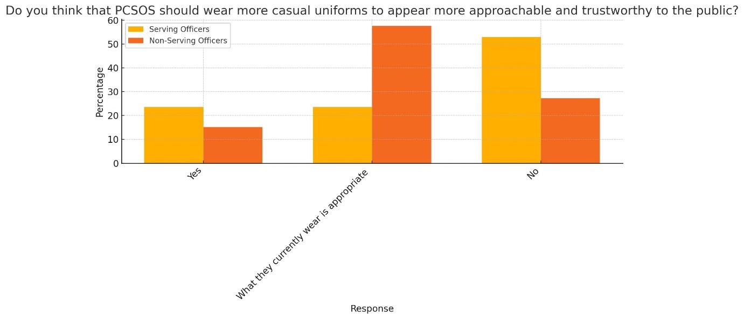

Figure 4.2.5 Serving officers prefer conventional PCSO uniforms to casual ones.

4.3 Theme 2. Body Modifications—piercings, tattoos, and cosmetics.

Question 4.

Does your opinion on the professionalism of an officer change if he or she has tattoos?

This question saw a similar response from both police and the public, with 71% of police feeling that tattoos alter the perception of professionalism, along with 79% of the public.

Figure 4.3.1 Most members of both categories think tattoos affect an officer's professionalism, but non-serving members more so.

Question 5.

Does the placement of a tattoo affect your confidence in the officer?

Would body tattoo placement affect public impressions of the officer's professionalism more than tattoo placement in general? Interestingly, 65% of officers and 70% of the public did not think tattoo placement would damage confidence.

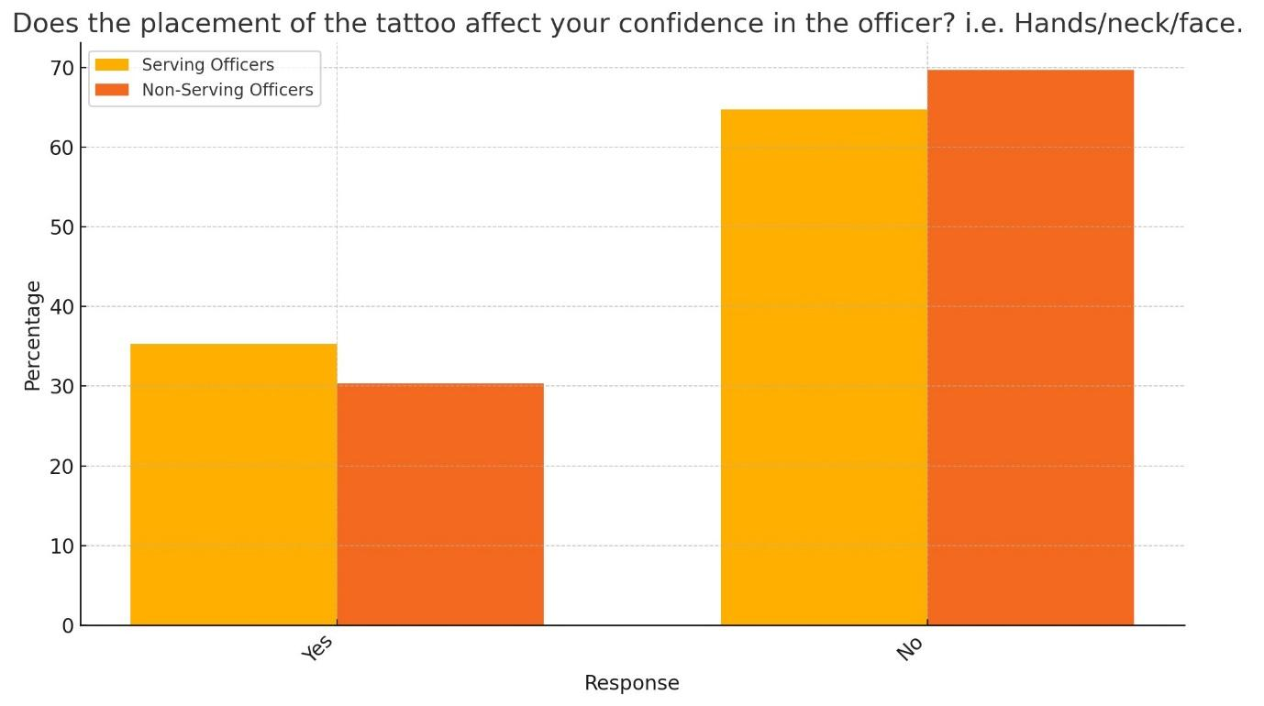

Figure 4.3.2 Both groups feel tattoo placement (e.g., hands, neck, face) does not affect officer confidence.

Question 6.

Does the amount of makeup an officer wears affect your confidence in them?

Cosmetics in frontline policing are controversial. This issue investigated if makeup lowers public confidence. Figure 4.3.3 shows that both parties feel similarly about the topic. 76% of police officers and 67% of the public said it did not damage confidence.

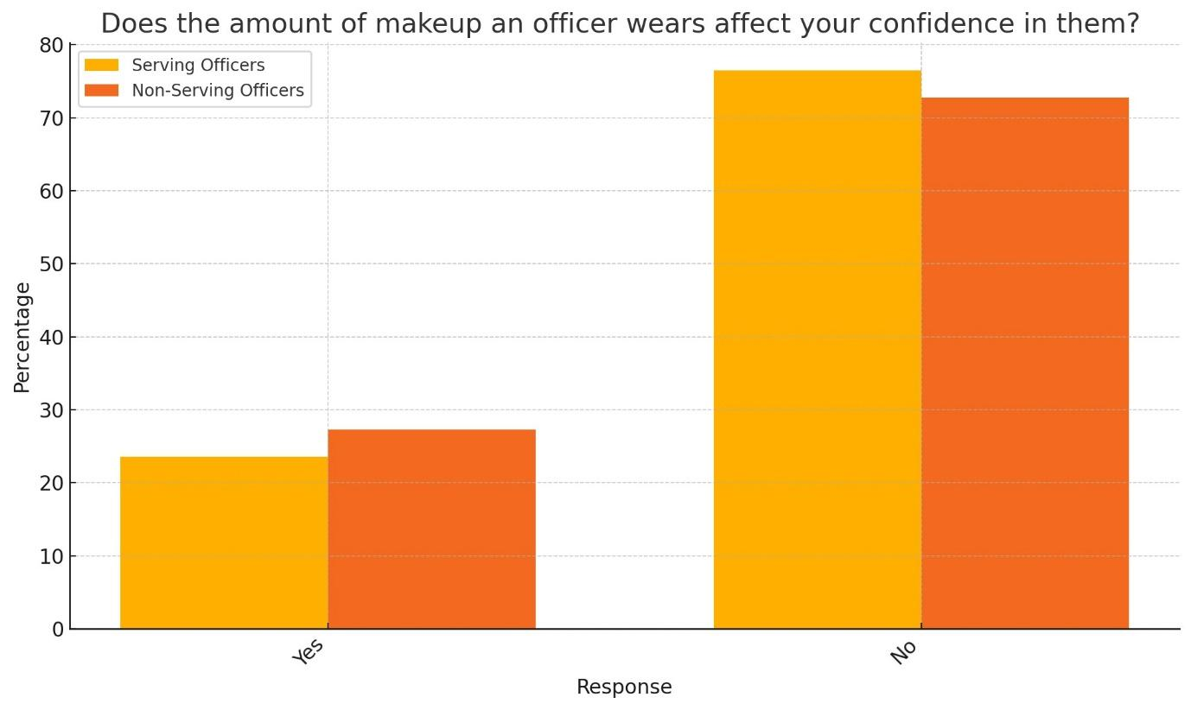

Figure 4.3.3 Serving officers are slightly more likely than others to believe that officer makeup does not effect confidence.

Question 7.

Does the amount of piercings an officer has affect your opinions of them?

Recently, body piercing has become more mainstream, although societal stereotyping persists. This survey examined the popular perception of police personnel with piercings. Figure 4.3.4 reveals that 82% of police and 62% of the public do not think piercings affect officer perceptions. These results may reflect the police attitude that performance, not appearance, should be judged.

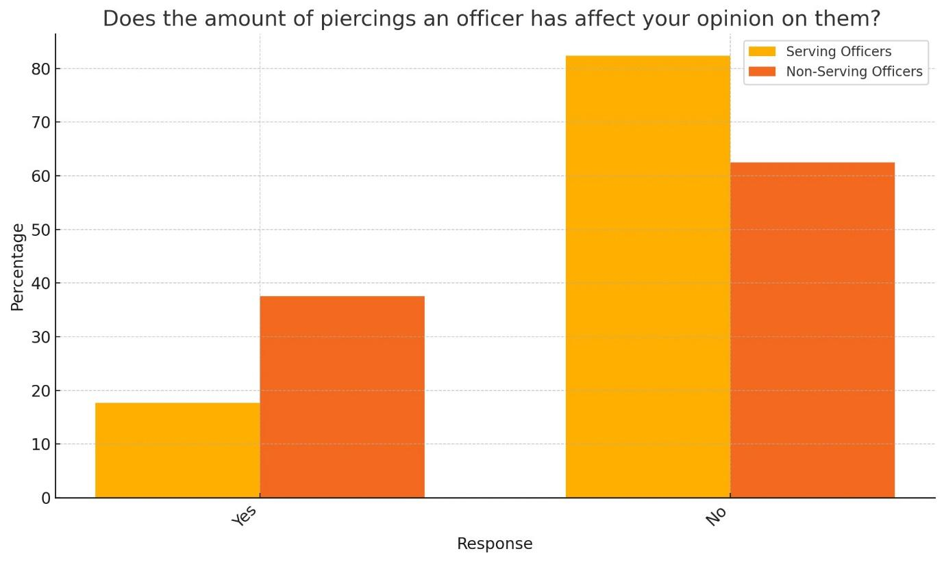
Figure 4.3.4 Most people in both groups think piercings don't alter their impression of officers, but some disagree.

4.4 Theme 3. Body-worn video

Question 9.

Do you believe that the use of body cameras on police uniforms makes police officers more accountable for their actions?

Figure 4.4.1 shows that police and the public majority agree that body-worn cameras promote police accountability. 88% of officers and 94% of the public agreed.

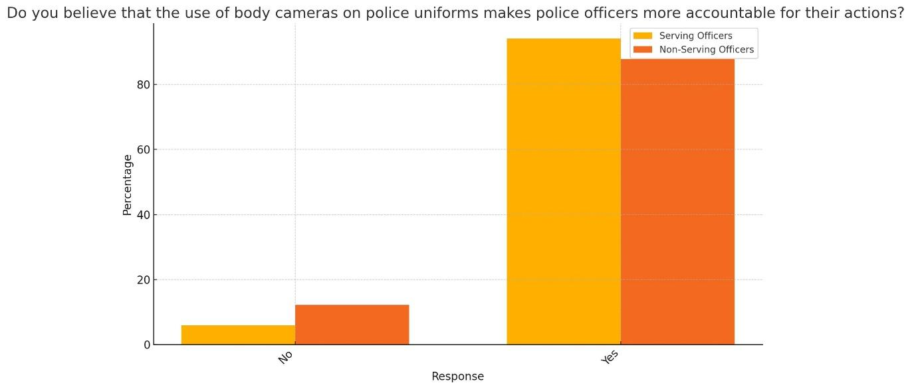

Figure 4.4.1 Most of both groups feel body cams make police officers more accountable, with non-serving members agreeing significantly more.

Question 10.

Are you under the opinion that the presence of body cameras can change public perceptions of the police in a positive way?

This question examined if body cameras improved public opinion of officers. The majority of officers and the public (figure 4.4.2) concurred. 76% of police and 85% of the public said body-worn video helped uniforms.

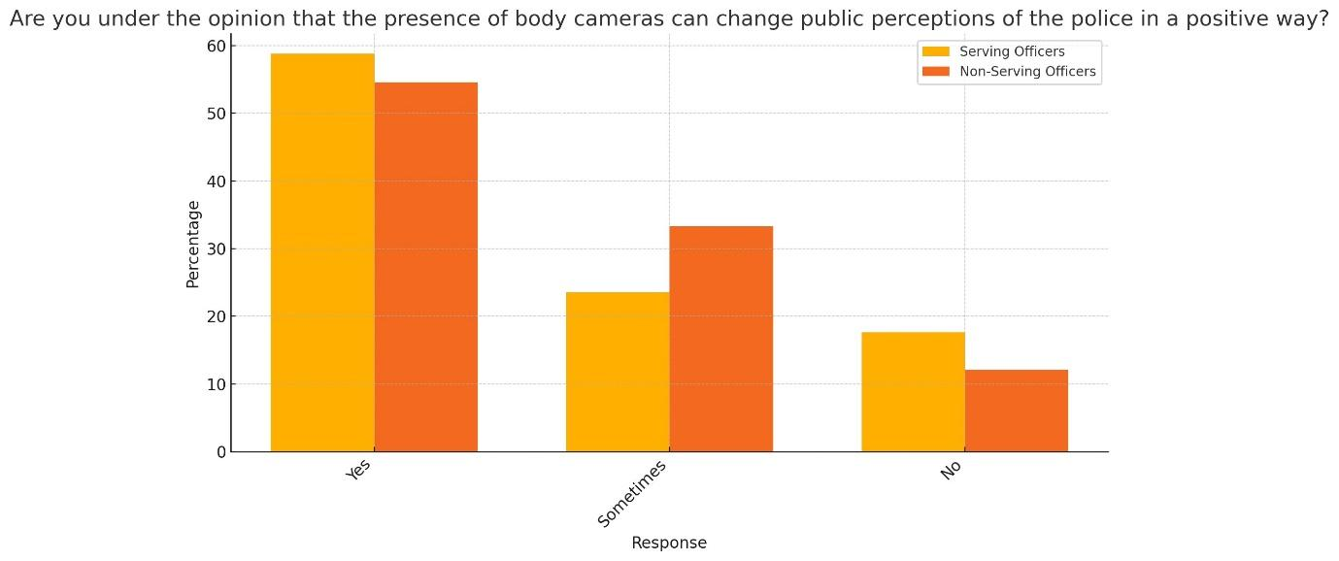
Figure 4.4.2 Both groups feel body cameras improve public impressions, with the public showing a slightly stronger belief.

Question 11.

Do you think the introduction of the body cameras has already improved the behaviour of police officers?

Question 11 addressed officer conduct and whether cameras on uniforms had improved it. Figure 4.4.3 demonstrates that 80% of police officers thought the addition enhanced behavior, but 40% of the population did. Police officers turning off cameras in specific situations, which has been well publicised, may explain the low public agreement, which may have altered public opinion.

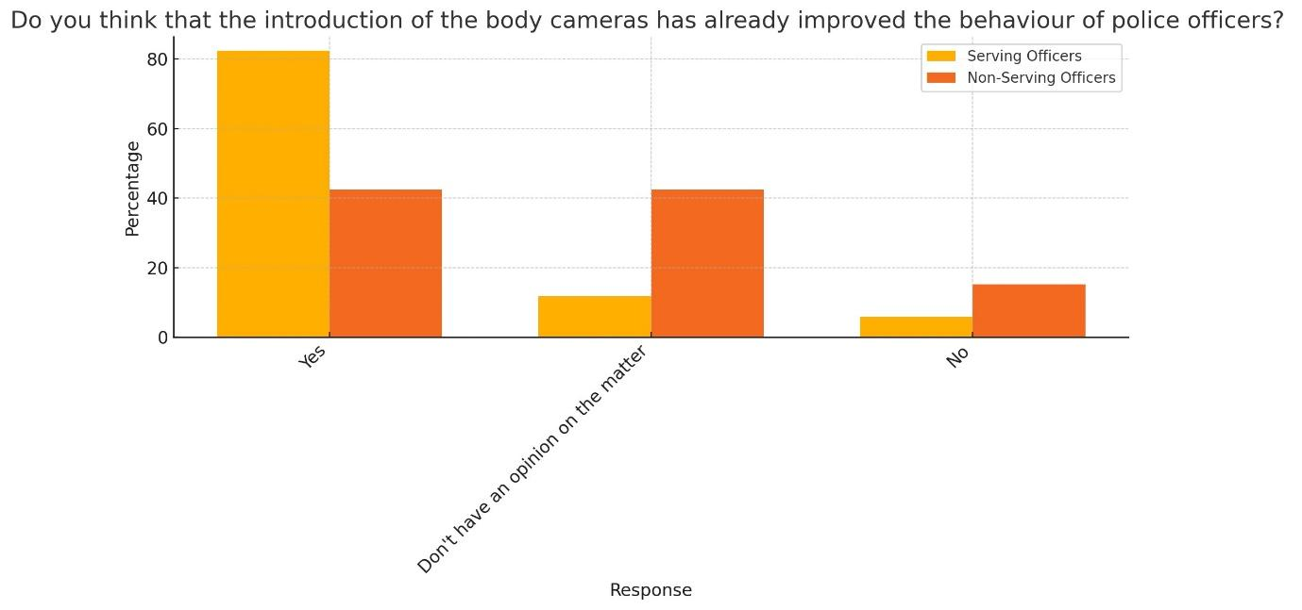
Figure 4.4.3 Both groups believe body cameras have improved police behavior, but officers show a stronger belief.

4.5 Theme 4. Weapons, firearm officers, and body armour.

Question 8. Do you agree that the visibility of weapons and equipment on a police uniform affects your perception of the officers approachability?

This question examined if officers' overt carrying of police-issued equipment, known as ‘appointments’, increased public anxiety and lowered police approachability. Figure 4.5.1 shows that the public has varied feelings about police carrying guns. 51% of people agreed and 49% disagreed. 82% of cops disagreed. The public may view armed officers as more ready to fight crime, which may explain their opinion.

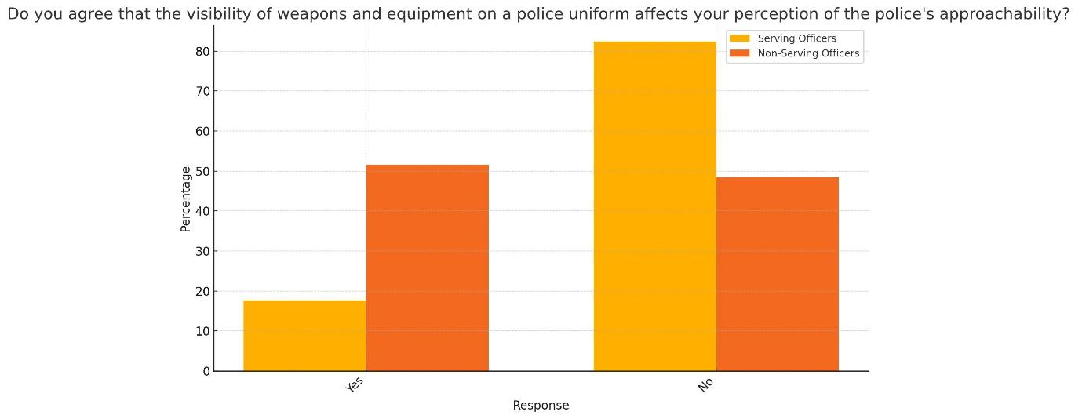

Figure 4.5.1. Police officers are in favour, while the public is divided.

Question 14.

Do you feel that the visibility of body armour and tactical gear on certain police units negatively impacts public perceptions of police friendliness and approachability?

This question was given to determine the public's perception of police friendliness if the officer was heavily equipped. Overall, police and public dispute that equipment impacts public opinion (Figure 4.5.2). 65% of police and 81% of the public disagreed.

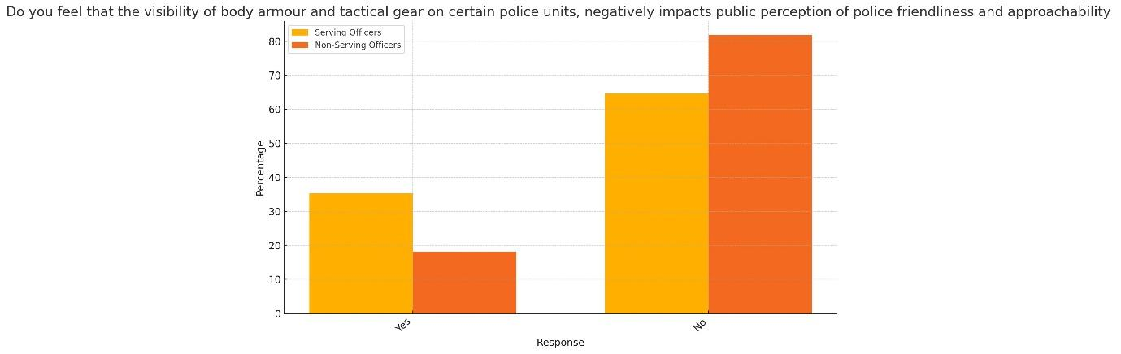

Figure 4.5.2. Both groups dispute that equipment lowers police friendliness.

Question 15.
Would you feel more or less intimidated approaching a firearms officer for assistance rather than a PCSO?

The data in Figure 4.5.3 reveals that both groups are evenly split in their feelings of intimidation. This could be a contextual issue. To a person seeking help after a violent attack, a firearms officer might be less intimidating and more reassuring. Thus, asking a firearms officer for directions may be more intimidating than asking a PCSO.

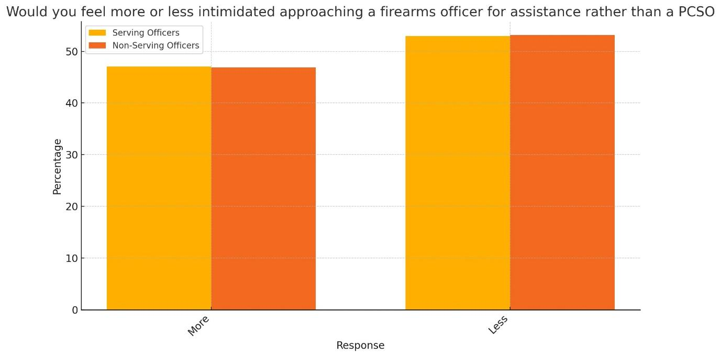

Figure 4.5.3 Both groups are evenly split on feeling more or less intimidated.

Question 16.

Do you believe that a firearms officer's uniform can influence more compliance from members of the public due to the militaristic style?

Figure 4.5.4 demonstrates that 88% of the population and 76% of police believe militarism subtly encourages conformity.

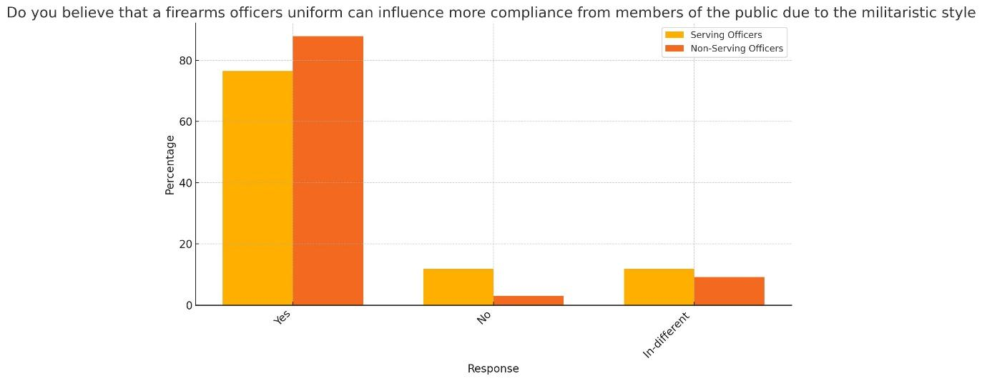

Figure 4.5.4 The public believes firearms officers' uniforms increase compliance.

Chapter 5. Conclusion and recommendations

5.1 Introduction.

This final chapter will provide a summary of the research findings. The objectives stated in the introduction will be reviewed to confirm their achievement and to evaluate if the conclusions discussed in Chapter 2 Literature Review align with or contradict the study results.

1. Investigate how differences in police uniforms influence public trust and perceptions
of the police.

2. Assess if body modifications such as tattoos, piercings, and cosmetics affect public
perceptions of police professionalism.

3. Analyse the effect that the overt display of weapons and police equipment on police
uniforms has on the public perception of police.

5.2 Summary of primary findings

5.3 Investigate how differences in police uniforms influence public trust and perceptions of the police.

Respondents to the poll came from two primary categories: members of the public (33 respondents) and serving police officers (17 respondents). Participants were questioned regarding their opinions on a range of subjects pertaining to police uniforms, such as how they affect public confidence.

According to the survey, 58% of the public and 65% of officers said uniform design affected public trust. This implies that police officers believe that uniform design affects public trust, with a significantly higher degree of agreement among serving officers. Sargeant and Simpson (2023) discovered that officer appearance strongly influences police beliefs and conduct and reinforces civilians' impressions of police. This matches Stinger and Stinger (1985), who found that police in uniform were perceived as more competent, reliable, intelligent, and helpful than those in civilian clothes.

76% of serving officers say there is a major difference in public trust between uniformed police and plain-clothed detectives, compared to 52% of the public. This shows that serving officers are more aware or convinced of the uniform-based public trust gap. If police uniforms looked like everyday clothes, 65% of active police and 60% of the population would distrust them. According to 65% of the population and 59% of current officers, police uniforms that resembled civilian clothes would lower public confidence in the force. This supports Campbell and Campbell (2010), who found that police uniforms, especially high-visibility clothes and badges, make officers more visible and approachable. Both groups choose conventional uniforms over casual ones, highlighting the importance of professional appearance. This complements study by Stinger and Stinger (1985), who found that uniformed police were perceived as more competent, reliable, intelligent, and helpful.
NPT and PCSO outfits are more approachable to 65% of serving police and 70% of the public. Sergeant and Simpson (2023) discovered that people rated police officers most positively when they wore the high-visibility vest. This implies that these clothes make officers more approachable. De Carmargo (2019) stated that Police Community Support Officers (PCSOs) clothes are designed to resemble police uniforms while still distinguishing them from police officers. More than half of serving officers and 60% of the public favor classic PCSO attire. Although slightly different, both groups prefer traditional PCSO uniforms. Sergeant and Simpson (2023) found that the uniform's color and high-visibility jackets affected police officers' perceptions of colleagues' responsibility, aggressiveness, approachability, competency, and friendliness. Nickels (2008) found that a darker uniform was more appealing, while Jenkins et al. (2021) found that officers in dark clothing were seen as more authoritative, even though the public disliked darker uniforms. In contrast, Kim and Song (2021) discovered that police officers may worry that bright, reflective vests will distort their authority. While not explicitly assessing power, the data suggest uniform color and design may alter public perceptions.

5.4 Assess if body modifications such as tattoos, piercings, and cosmetics affect public perceptions of police professionalism.

Tattoos, piercings, and makeup did not alter public impression of officers, according to both research samples. This contradicts Swanger (2006), who found that tattoos can lower police officers' credibility. Sergeant and Simpson (2023) discovered that tattoos and piercings seem to lower officers' authority. This contradicts Wyllie (2021), who suggests that tattoos and piercings might humanise police officers, supporting this study. DeMello (1993) disagrees, saying piercings are connected with nonconformity and unprofessionalism, which might impair police officers' credibility. When asked about police makeup use, respondents reported that public impression was unaffected by makeup amount. Forbes et al. (2006) say modest, conservative cosmetics enhances a professional appearance. The study contradicts Bain (2013), who found that excessive or flashy cosmetics can lower authority and professionalism, emphasising the necessity for balanced and suitable grooming.

5.5 Analyse the effect that the overt display of weapons and police equipment on police uniforms has on the public perception of police.

76% of serving officers and 88% of the public believe firearms officers' uniform enhances compliance, the study found. This widely held view emphasises the importance of militaristic police clothing. This contradicts Blaskovits et al. (2021), who found that military gear and apparel may hinder police community trust. This supports data in this survey that found 71% of active police and 79% of the public felt police uniforms with weapons and equipment make officers less approachable. The findings contrast Johnson et al. (2014), who found no effect of accessories on police perception. Simpson and Sergeant (2023) observed that police equipment can serve many purposes and that perception and intent can contradict. Essential accessories may also be unpopular. This implies that both groups believe cops are less approachable with prominent gear. This supports O'Neill et al. (2018), who found that officers with more tactical vest items are seen negatively by the public. Cooke (2004) observed that officers with visible guns were more aggressive, unsettling, and alarming. Body armour and tactical gear lower police friendliness for 59% of officers and 70% of the public. This supports Simpson (2020), who found that the public disliked firearms officers. Serving officers and the public were equally intimidated by armed officers and PCSOs, with 53% feeling less afraid. According to Squires & Kennison (2010), firearms officers, often armed with tactical gear, portray a militarized image that may reassure or alarm the public.

According to Tregle, Nix, and Pickett (2020), police have universally used body-worn cameras to promote transparency and accountability. This study found that body-worn cameras on police uniforms improve officer behavior, public perceptions of police, transparency, and accountability. Body cams would boost police accountability, according to 94% of the populace and 88% of current police personnel. The majority of police officers (88%), and the public (94%), believed body cams made them more accountable. According to White and Malm (2020), police and the public were open to body-worn cameras as a tool to hold each other accountable. Both groups support body cams for accountability, as seen by this overwhelming support. Poirier, Charbonneau, and Boivin (2023) concluded that police body-worn video (BWV) improves accountability and openness by capturing police actions and public interactions. 88% of the public and 82% of active police believe body cams have improved police behavior. According to Sousa et al. (2018), the public welcomed police wearing body cameras since it held them accountable. Body cams improve public impressions, according to 76% of serving cops and 85% of the public. In contrast, Goodison and Berger (2024) found that body-worn video did not change public perceptions of police personnel.

These insights highlight the importance of considering both internal (serving officers) and external (public) perspectives when discussing police uniforms and their impact on public perception. Understanding these perceptions can help in designing uniforms that foster trust, approachability, and professionalism, ultimately enhancing the relationship between police forces and the community.

5.6 Recommendations

Longitudinal Studies: Future research should prioritize longitudinal studies to track changes in public perception over time. These studies can provide insights into how uniform policies influence public trust and police effectiveness in the long term.
Psychological and Behavioural Impacts: Detailed psychological studies on the impact of specific uniform elements on both officers and the public can inform better uniform design. Experimental research involving variations in uniform elements could provide empirical data on their effects.
Cultural Sensitivity in Uniform Policies: Comparative research on the influence of cultural contexts on uniform perception should be expanded. This can help tailor uniform policies to better fit the cultural norms and expectations of different communities.
Plainclothes Policing: More research is needed on the impact of plainclothes officers on public perception and trust. This includes studying their effectiveness in different contexts and how their presence influences community-police relations.

References

Adams, J. (2012). Cleaning Up the Dirty Work: Professionalization and the Management of Stigma in the Cosmetic Surgery and Tattoo Industries. Deviant Behavior, 33(3), pp.149–167. doi:https://doi.org/10.1080/01639625.2010.548297.
‌Anderson, C. (2010). Presenting and Evaluating Qualitative Research. American Journal of Pharmaceutical Education, [online] 74(8), p.141. doi:https://doi.org/10.5688/aj7408141.
Andrade, C. (2020). The Limitations of Online Surveys. Indian Journal of Psychological Medicine, [online] 42(6), pp.575–576. doi:https://doi.org/10.1177/0253717620957496.

Andrews, T. (2023). The superhero effect: How enclothed cognition can impact on the perceptions and actions of serving UK police officers. The Police Journal. doi:https://doi.org/10.1177/0032258x231184778.
Ashcroft, J., Daniels, D. J., & Hart, V. T. (2003). Preventing school shootings: A summary of a US Secret Service Safe School Initiative report. National Institute of Justice Journal, 248, 11-19.
Bain, A. (2013). ‘Dressing up and looking the part’: Examining the role of appearance in policing. Policing and Society, 23(2), 268-282.
Baker, R. (2015). The future of smart fabrics in law enforcement. Law Enforcement Technology, 42(4), 18-21.
Balko, R. (2013). Rise of the Warrior Cop: The Militarization of America's Police Forces. PublicAffairs.
Bayley, D. H. (1976). Forces of Order: Policing Modern Japan. University of California Press.

‌Blaskovits, B., Bennell, C., Baldwin, S., Ewanation, L., Brown, A. and Korva, N. (2021). The thin blue line between cop and soldier: examining public perceptions of the militarized appearance of police. Police Practice and Research, 23(2), pp.1–24. doi:https://doi.org/10.1080/15614263.2021.1889378.
Brodeur, J. P. (2010). The Policing Web. Oxford University Press.
‌Cambridge Dictionary (2019). RESEARCH | meaning in the Cambridge English Dictionary. [online] Cambridge.org. Available at: https://dictionary.cambridge.org/dictionary/english/research.
Campbell, A., & Campbell, R. (2010). The impact of high-visibility police patrols on public reassurance and crime reduction. Police Quarterly, 13(1), 3-25.
Coffelt, T. (2017). Confidentiality and Anonymity of Participants. [online] Sagepub.com. Available at: https://methods.sagepub.com/reference/the-sage-encyclopedia-of-communication-research-methods/i3126.xml.
‌Cooke, C. A. (2004). Public and private policing: The uniform as mediator of public perception. [ Doctoral dissertation]. University of Teesside.
Cordner, G. (2014). Community policing. The Oxford Handbook of Police and Policing, 148-171.
Couper, M.P., Tourangeau, R., Conrad, F.G. and Singer, E. (2006). Evaluating the Effectiveness of Visual Analog Scales. Social Science Computer Review, 24(2), pp.227–245. doi:https://doi.org/10.1177/0894439305281503.

Cowley, R. (2011). A history of the British police : from its earliest beginnings to the present day. Stroud: History Press.
Critchley, T. A. (1978). A History of Police in England and Wales. Constable.
Dag Slotfeldt-Ellingsen (2023). Professional Ethics for Research and Development Activities. Springer Nature.

De Camargo, C. (2019). ‘They wanna be us’; PCSO performances, uniforms, and struggles for acceptance.. Policing and Society, 30(7), pp.854–869. doi:https://doi.org/10.1080/10439463.2019.1598998.
DeMello, M. (1993). The convict body: Tattooing among male American prisoners. Anthropology Today, 9(6), 10-13.
Emsley, C. (2009). The birth and development of the police. In C. Emsley (Ed.), A Short History of Police and Policing (pp. 15-38). Oxford University Press.
Forbes, G. B., Collinsworth, L. L., Jobe, R. L., Braun, K. C., & Wise, L. M. (2006). Sexism, hostility toward women, and endorsement of beauty ideals and practices: Are beauty ideals associated with oppressive beliefs? Sex Roles, 56(5), 265-273.
‌Goldsmith A (2002) The Development of the City of Glasgow Police c.1800-C. 1939 (PhD Thesis). Strathclyde: Strathclyde University.
Goodison, S. and Berger, E. (2024). Citizen perceptions of body-worn cameras: Results from a randomized controlled trial. Social Science Research Network. [online] doi:https://doi.org/10.2139/ssrn.4743087.
Guy, M. E., & Newman, M. A. (2013). Managing the Hidden Organization: Strategies for Empowering Your Workforce. Praeger.
Hare, W. (2011). Helping Open-mindedness Flourish. Journal of Thought, 46(1-2), p.9. doi:https://doi.org/10.2307/jthought.46.1-2.9.
Harris, D. A. (2017). A City Divided: Race, Fear and the Law in Police Confrontations. Brookings Institution Press.
‌Hauke-Forman, N., Methner, N. and Bruckmüller, S. (2021). Assertive, but Less Competent and Trustworthy? Perception of Police Officers with Tattoos and Piercings. Journal of Police and Criminal Psychology, 36(3), pp.523–536. doi:https://doi.org/10.1007/s11896-021-09447-w.
Jenkins, B., Semple, T., Bennell, C., Carter, E., Baldwin, S. and Blaskovits, B. (2021). Examining the impact of uniform manipulations on perceptions of police officers among Canadian university students. Police Practice and Research, pp.1–24. doi:https://doi.org/10.1080/15614263.2021.1900849.
‌Johnson, R.R. (2005). Police uniform color and citizen impression formation. Journal of Police and Criminal Psychology, 20(2), pp.58–66. doi:https://doi.org/10.1007/bf02852653.
Johnson, R. R., Kuhns, J. B., & Scherer, J. A. (2005). The impact of officer appearance on police-citizen interactions. Journal of Criminal Justice, 33(6), 659-667.
Johnson, R.R., Plecas, D., Anderson, S. and Dolan, H. (2014). No Hat or Tie Required: Examining Minor Changes to the Police Uniform. Journal of Police and Criminal Psychology, 30(3), pp.158–165. doi:https://doi.org/10.1007/s11896-014-9152-3.

Kepp, J.J. (2023). Considerations for Personal Protective Equipment for Public Order Policing. Springer eBooks, pp.487–503. doi:https://doi.org/10.1007/978-3-031-43856-1_23.

Kim, M. and Song, C.S. (2021). Understanding Police Officers’ Usage of High-Visibility Safety Apparel: The Role of Safety Ethics and Professional Appearance. Safety, 7(1), p.15. doi:https://doi.org/10.3390/safety7010015.
Kraska, P. B., & Kappeler, V. E. (1997). Militarizing American police: The rise and normalization of paramilitary units. Social Problems, 44(1), 1-18.
Lloyd, R. (2018). Body art and police work: The case for and against visible tattoos. Police Quarterly, 21(2), 210-232.
Lobban, M. (1996). The Common Law and English Jurisprudence 1760–1850. Clarendon Press.
Mastrofski, S. D. (1999). Policing for people. Ideas in American Policing, 1, 1-15.
Miller, L. (2018). Police Innovation: Contrasting Perspectives. Cambridge University Press.
Miller, L., Forest, K., & Jurik, N. (2020). Diversity in policing: Strategies for change. Journal of Contemporary Criminal Justice, 36(1), 49-65.
Monkkonen, E. H. (1981). Police in Urban America, 1860–1920. Cambridge University Press.
Muir, W. K. (2009). Police: Streetcorner politicians. University of Chicago Press.
Nickels, E. (2008) ‘Good guys wear black: uniform color and citizen impressions of police’, Policing: An International Journal of Police Strategies & Management, 31(1), pp. 77–92. Available at: https://doi.org/10.1108/13639510810852585.

O’Neill, J., Swenson, S.A., Stark, E., O’Neill, D.A. and Lewinski, W.J. (2017). Protective Vests in Law Enforcement: a Pilot Survey of Public Perceptions. Journal of Police and Criminal Psychology, 33(2), pp.100–108. doi:https://doi.org/10.1007/s11896-017-9237-x.

ori.hhs.gov. (2024). Data collection | ORI - The Office of Research Integrity. [online] Available at: https://ori.hhs.gov/content/Chapter-6-Data-Management-Practices-Data-collection.

Pannucci, C.J. and Wilkins, E.G. (2011). Identifying and Avoiding Bias in Research. Plastic and Reconstructive Surgery, [online] 126(2), pp.619–625. doi:https://doi.org/10.1097/PRS.0b013e3181de24bc
Perrottet, T. (2011). The evolution of police communication systems. Police Technology, 30(3), 22-26.
Poirier, B., Charbonneau, É. and Boivin, R. (2023). Police body-worn Cameras and privacy: Views and Concerns of Officers and Citizens. International Journal of Police Science and Management, 26(2). doi:https://doi.org/10.1177/14613557231214383.

Quill, P. (2016). The Bill Blackwood Law Enforcement Management Institute of Texas The Police Uniform and Its Impact on Public Perception A Leadership White Paper Submitted in Partial Fulfillment Required for Graduation from the Leadership Command College. [online] Available at: https://shsu-ir.tdl.org/server/api/core/bitstreams/823ad12e-9cbc-481e-a75b-b3e2fef1fa07/content.
Rawlings, P. (2002). Policing: A Short History. Willan.
Regmi, P.R., Waithaka, E., Paudyal, A., Simkhada, P. and Van Teijlingen, E. (2016). Guide to the Design and Application of Online Questionnaire Surveys. Nepal Journal of Epidemiology, [online] 6(4), pp.640–644. doi:https://doi.org/10.3126/nje.v6i4.17258.
Reiss, A. J. (1971). The Police and the Public. Yale University Press.
Reynolds, D. (1998). The Policeman's Progress: A History of Policing in Metropolitan London, 1829–1978. Routledge.
Ross, M. (2024). The Evolution of the Police Officer’s Uniform and Why It Matters. Available at: https://www.herzing.edu/blog/evolution-police-officers-uniform-and-why-it-matters [Accessed 16 Aug. 2024].
‌Sargeant, E. and Simpson, R. (2023). In the eye of the powerholder: examining the relationship between uniform and accoutrement combinations and police self-legitimacy. Police Practice and Research, pp.1–18. doi:https://doi.org/10.1080/15614263.2023.2246620.
Simpson, R. (2018). Officer Appearance and Perceptions of Police: Accoutrements as Signals of Intent. Policing: A Journal of Policy and Practice, 14(1). doi:https://doi.org/10.1093/police/pay015.

Simpson, R.H. and Sargeant, E. (2023). Situational context and public perceptions of officer appearance: A vignette-based study of police uniforms and accouterments. Criminology & Criminal Justice. doi:https://doi.org/10.1177/17488958231210991.
‌Singer, M.S. and Singer, A.E. (1985). The Effect of Police Uniform on Interpersonal Perception. The Journal of Psychology, 119(2), pp.157–161. doi:https://doi.org/10.1080/00223980.1985.10542882.
Skogan, W. G. (2006). Police and Community in Chicago: A Tale of Three Cities. Oxford University Press.
Sleek, S. (2017). Innovations in body armor: Meeting modern threats. Law Enforcement Technology, 44(2), 24-27.
Smith, R. (2019). Balancing tradition and innovation in police uniform policies. Police Practice and Research, 20(4), 346-360.
‌Sousa, W.H., Miethe, T.D. and Sakiyama, M. (2017). Inconsistencies in Public Opinion of Body-Worn Cameras on Police: Transparency, Trust, and Improved Police–Citizen Relationships. Policing: A Journal of Policy and Practice, 12(1), pp.100–108. doi:https://doi.org/10.1093/police/pax015.
Squires, P., & Kennison, P. (2010). Shooting to Kill?: Policing, Firearms and Armed Response. Wiley-Blackwell.
The University of Wales Trinity Saint David. (n.d.). Research Integrity and Ethics. [online] Available at: https://www.uwtsd.ac.uk/research/research-integrity-and-ethics.
‌Tracy, S.J. (2024). Qualitative Research Methods. Wiley-Blackwell.
Tyler, T. R. (2004). Enhancing police legitimacy. The ANNALS of the American Academy of Political and Social Science, 593(1), 84-99.
White, M. D., & Malm, A. (2020). Cops, cameras, and crisis: The potential and the perils of police body-worn cameras. New York, NY: NYU Press.
‌World Health Organisation (2024). Ensuring ethical standards and procedures for research with human beings. [online] World Health Organisation. Available at: https://www.who.int/activities/ensuring-ethical-standards-and-procedures-for-research-with-human-beings#:~:text=As%20such%2C%20all%20research%20involving,are%20central%20to%20ethical%20review. [Accessed 16 Aug. 2024].
Wyllie, C.J. (2021). The Professional Appearance of Police Officers: Does Visible Body Art Effect Perception? - ProQuest. [online] Available at: https://www.proquest.com/docview/2561921047?pq-origsite=gscholar&fromopenview=true&sourcetype=Dissertations%20&%20Theses [Accessed 16 Aug. 2024].
Yamamoto, T. (2012). The effectiveness of high-visibility clothing for traffic officers. Journal of Safety Research, 43(2), 123-130.

‌

Appendix A. Summary of Survey Responses





