Restaurant Concept: "Flavors of the World"
"Flavors of the World" is an exciting new restaurant concept being introduced to the Hotel Trinity Chain. With a focus on global cuisine, the restaurant aims to take diners on a culinary journey worldwide, offering an immersive dining experience that celebrates the diverse flavors, ingredients, and cooking techniques from various cultures.
Target Audience: The restaurant concept is designed to appeal to many customers, including hotel guests, residents, and tourists. It targets individuals with an adventurous palate and a curiosity for exploring different cuisines. Whether business travelers looking for a unique dining experience, local food enthusiasts seeking new tastes, or tourists wanting to savor global flavors, "Flavors of the World" caters to those who appreciate culinary diversity and crave a memorable dining experience.
Menu Choices: The menu at "Flavours of the World" is carefully crafted to offer a well-balanced selection of dishes representing different regions and cultures while accommodating various dietary preferences and requirements. Here is the reasoning behind the menu choices:
- Appetizers: The starters include a variety of small plates and sharing platters inspired by different culinary traditions. It allows guests to explore a range of flavors and textures, from Japanese sushi rolls to Mediterranean mezze and Indian samosas.
- Main Courses: The main course section showcases signature dishes from different countries, offering a mix of vegetarian, seafood, and meat options. It includes classics such as Italian pasta dishes, Mexican fajitas, Thai curries, and Moroccan tagines. Each dish is prepared with authentic ingredients and techniques, staying true to its cultural origins.
- Specials: To keep the menu exciting and dynamic, "Flavors of the World" offers daily specials highlighting seasonal ingredients or introducing lesser-known dishes from specific regions. This encourages guests to try something new each time they visit and allows the kitchen to showcase its creativity.
- Dietary Accommodations: The menu also considers dietary preferences and restrictions, offering a range of vegetarian, vegan, gluten-free, and dairy-free options. This ensures that guests with specific dietary needs can enjoy a rich and diverse culinary experience.
- Desserts: The dessert selection features a fusion of global influences, combining traditional sweets with innovative twists. Guests can indulge in French pastries, American pies, Middle Eastern baklava, and more, providing a sweet ending to their gastronomic journey.
Overall, the menu choices at "Flavours of the World" are driven by the desire to celebrate the rich tapestry of global cuisine, promote cultural diversity, and create an unforgettable dining experience. The restaurant aims to become a go-to destination for food enthusiasts and curious diners seeking an immersive culinary adventure by offering a wide variety of dishes that cater to different tastes and dietary requirements.
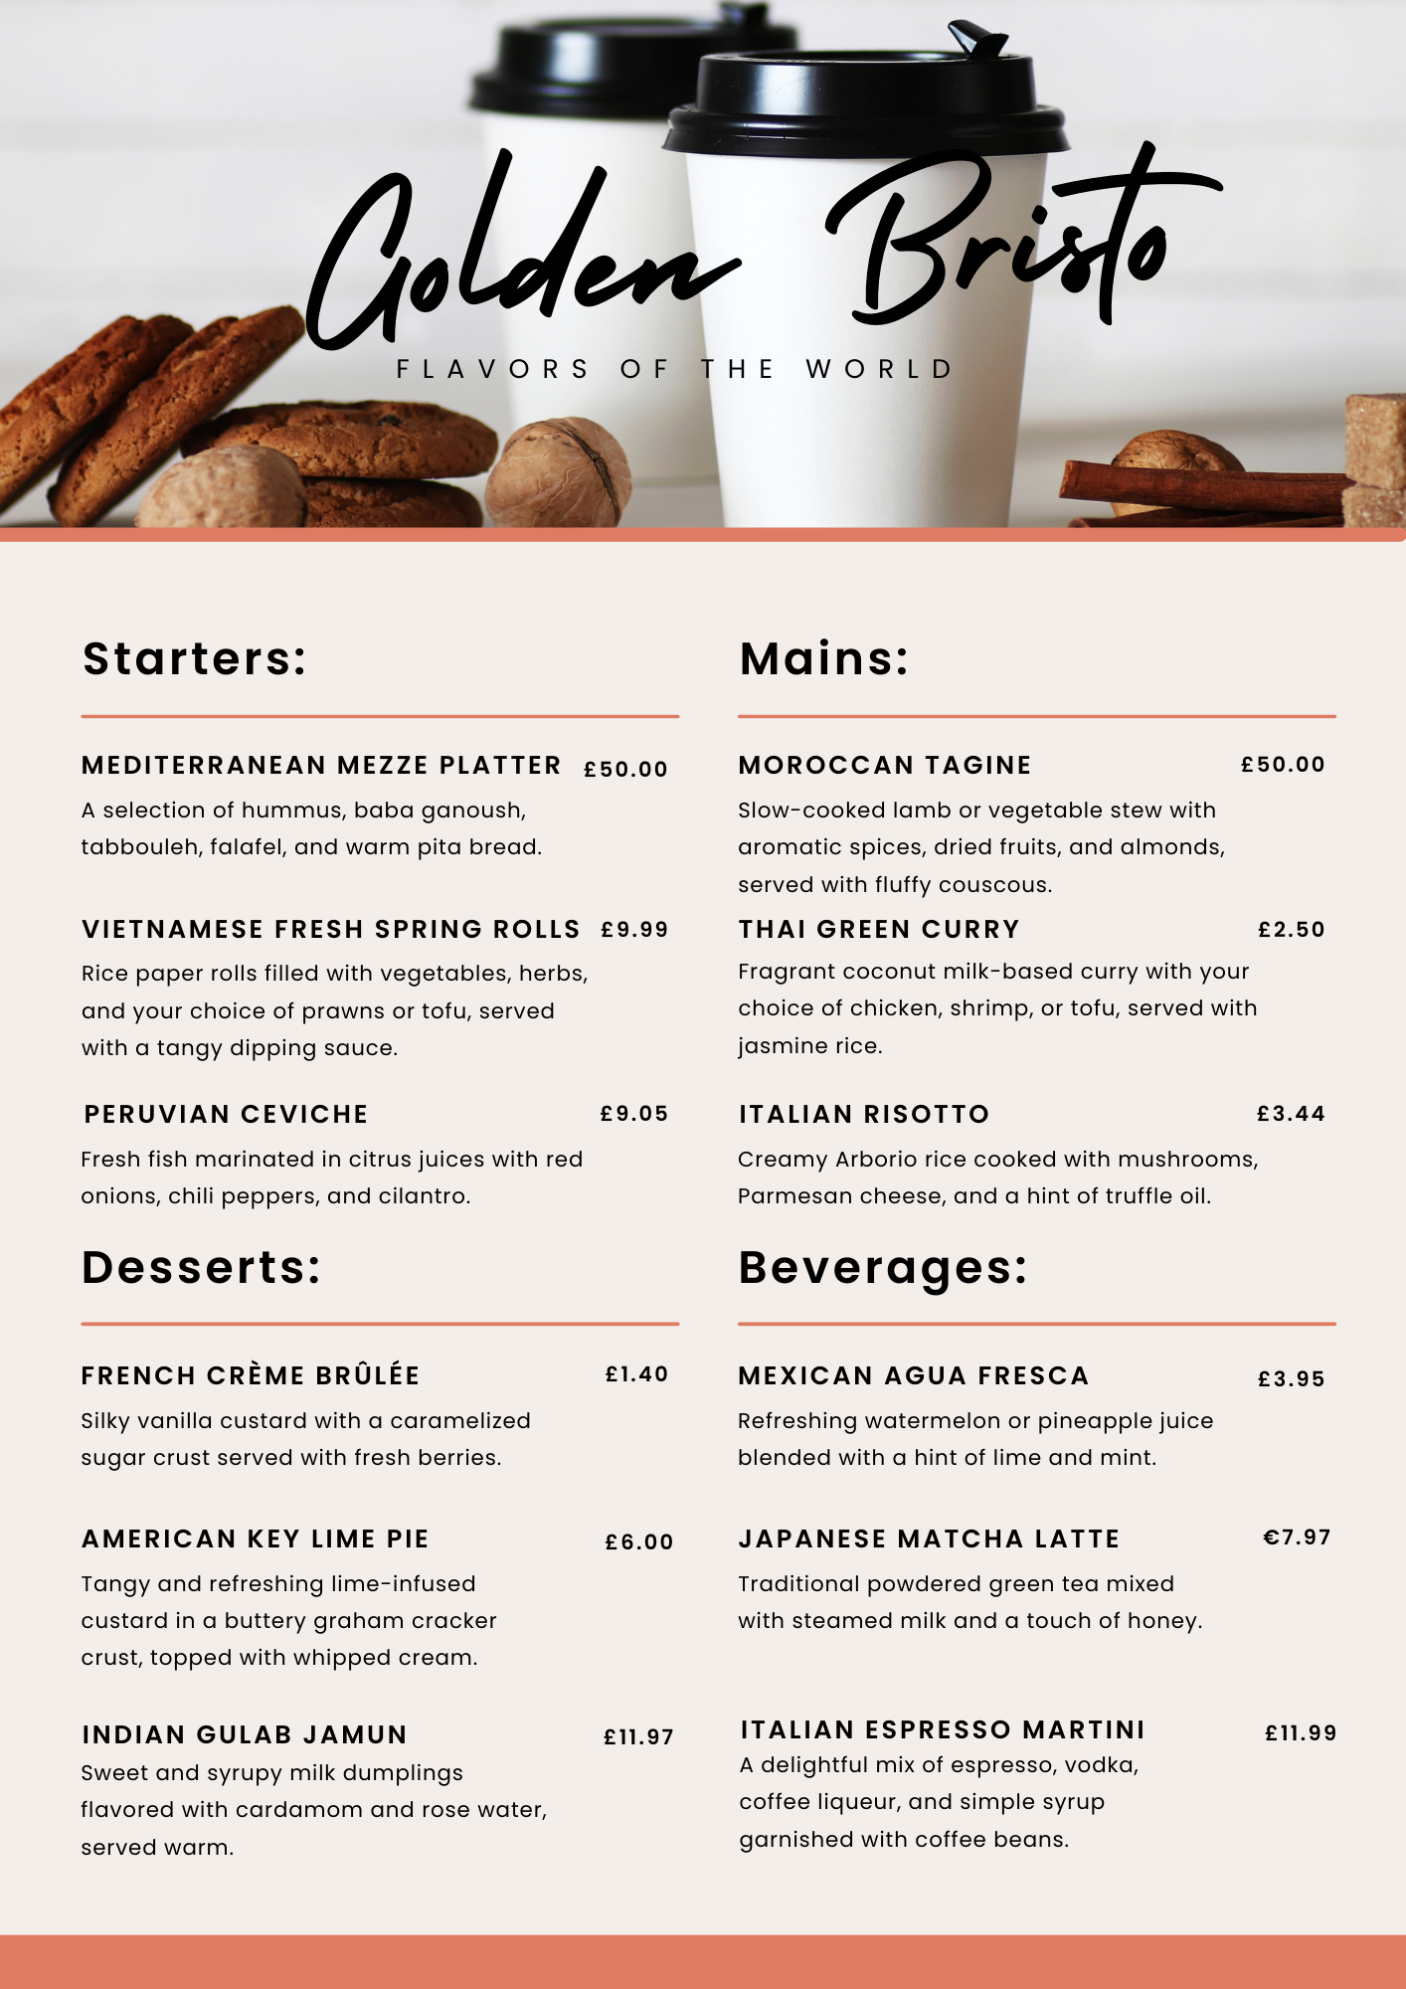
References:
- John C. & David C. (2002) Food and Beverage Management. Pearson Education.
- Michael L. Kasavana & Donald I. Smith. (1982) Menu Engineering | A Practical Guide to Restaurant Pricing. Hospitality Publications.
- John R. et. al. (2007) Study Guide to Accompany The Restaurant: From Concept to Operation, 5e. Wiley.
- Marc G. (2012) Menu Design | What's for Lunch? Monsa.
- Andrew L. & Bernard D. (1994) Food and Beverage Management | A Selection of Readings. 5th ed. Butterworth-Heinemann.
- Tim J. Smith (2017) Pricing Strategy | Setting Price Levels, Managing Price Discounts, & Establishing Price Structures. south-Western Cengage Learning.
- Elevina E. et. al. (2017) Foods for Special Dietary Regimens. Bentham Science Publishers.
- Beverly K. (1985) Menu Design and Layout.
- Rob D. (2017) Never Out of Season | How Having the Food We Want When We Want It Threatens Our Food Supply and Our Future. Little, Brown.
- Wood, R. (2013) Key Concepts in Hospitality Management. London: Sage*

