LEVEL 6 ASSESSMENT SPECIFICATION

Student name: | Hannah Tozer | Student ID number: | 1801327
Programme: | Physical Education and Outdoor Adventure Education
Module: | Curriculum Adventure
Module code: | BMOE6002 | Contribution to Overall Module Assessment (%): | 50%
Lecturer: | Dr Nalda Wainwright | Internal Verifier:
Assignment Title: | Problem Based learning assignment | Word count (or equivalent): | 2500
Submission deadline: | 18th December 2020 | Return date of provisional marks & written feedback:
Submission method: | All written assessments, where practical and possible, must be submitted via Turnitin unless otherwise instructed by the Lecturer. (Please DO NOT put this assessment specification into Turnitin or it will match many similarities with other students’ submissions.)  Alternative submission method (if applicable):  Late submission of the assessment will result in a late penalty mark. Penalties for late submission: Up to one week late, maximum mark of 40%. Over one week late, 0%. Only the Extenuating Circumstances Panel may approve a change to submission dates.
Academic honesty / referencing: | Academic honesty is required. In the main body of your submission you must give credit to authors on whose research and ideas your work is based. Append to your submission a reference list that indicates the books, articles, etc. that you have used, cited or quoted in order to complete this assessment.

Student FEEDBACK FORM

Generic Assessment Criteria | Marks available | Marks  awarded
1. Engagement with Literature Skills
.
 | 30
2. Knowledge and Understanding Skills

 | 20
3. Cognitive and Intellectual Skills

 | 20
4. Practical Application Skills

 | 20
5. Transferable Skills for Life and Professional Practice

 | 10
Assessment Mark (Assessment marks are subject to ratification at the Exam Board. These comments and marks are to give feedback on module work and are for guidance only until they are confirmed. ) | Late Submission Penalties (tick if appropriate) |  | %
 | Up to 1 week late (40% Max) |  | %
 | Over 1 week late (0%) |  | %
This section details the extent to which the assessment criteria are demonstrated by you, which in turn determines your mark. The marks available for each category of skill are shown. Lecturers will use the space provided to comment on the achievement of the task(s), including those areas in which you have performed well and areas that would benefit from development/improvement.

Working collaboratively research relevant information and develop questions to discuss that respond to the following problem.
The following job has been advertised.
Temporary post, one year: Work with the physical education department of TSD secondary school.
The Covid19 pandemic has emphasised the importance of physical activity for supporting a healthy immune system. Added to this the outdoors is deemed a safer space to reduce transmission of the virus.
In light of this and changes in the Curriculum in Wales, the PE department of TSD secondary school are seeking support to develop the Health and Well-being AoLE in the school in a way that supports physical activity with an emphasis on use of the outdoors. Applicants need to demonstrate an understanding of Adventurous Activities and outdoor learning.
Prepare a paper for the senior management team of the school outlining how the school grounds could be developed to support adventurous activities and outdoor learning. Your paper needs to demonstrate how the changes will contribute to the development of physical literacy, and health and well-being.

The use of outdoor learning through physical education and other areas of the curriculum has been suggested to help support the health and well-being of pupils, develop physical literacy of pupils, and contributed to an added opportunity to learn in different ways in a unique environment. There has been an increased emphasis on the use of the outdoors during the Covid19 pandemic, this is due to it being deemed a safer place to reduce the transmission of the virus and also supports a healthy immune system. Throughout this paper, an understanding of how to encourage Adventurous Activities and outdoor learning will be demonstrated through implementing new ways to support pupils’ education in TSD Secondary School. Gill (no date) says that “improving play and learning opportunities for children and young people of all ages and abilities should be a key objective for teachers and practitioners”, in developing the school grounds, this enable teachers to include this type of learning. Outdoor learning can be used throughout the curriculum and is not specific to physical education, throughout the paper, it will be demonstrated how the school can implement this type of learning.

Pump Track
To support physical education and adventurous activities, TSD secondary school can build a pump track, (location shown on map, appendix 1.0) which would undoubtedly encourage pupils to cycle or skate to school more regularly. The investment of mountain bikes would enable the physical education department to use this pump track during lessons and take classes out on local cycle tracks. The new curriculum for Wales says, “learners will be encouraged to develop the confidence, motivation, physical competence, knowledge and understanding that can help them and healthy and active lifestyles” (Welsh Government, 2019). The development of this track on school grounds will help pupils grow in these aspects of physical literacy included in the new curriculum, and inspire them to become adventurous in exploring new tracks outside of school. Wheelchair users can also use the pump track which allows for inclusion of all pupils, including a range of year groups, abilities, and those with disabilities. Goodwin and Watkinson said that “students with physical disabilities were endured in activities, but their participation was not deemed to be essential” (2000, pp.155), the development of this feature would push against this common research finding, as those pupils would also be able to participate and enjoy the track. There are however some hazards that must be considered. It is suggested that a member of staff on playground duty is situated near the pump track in case of an accident, such as a pupil falling off a bike/scooter, colliding with other students or objects on the track which can cause injury. To try and avoid accidents and injury, there should be a limit on the number of students on the track at any one time, and signs around the track can tell students when to slow down. Despite the risk, this physical activity for pupils has its benefits. It has been found that, “when young people’s bodies are engaged, moving and busy, their minds are also active.” (Dyment and Bell, 2008, pp.960), this could result in positive attitudes in the class room as students would have let off energy on the track and triggered an active mind ready for classroom-based learning.

Bouldering Wall
To encourage the participation in different activities, a bouldering wall can be fitted outside the sports hall for free use at break times but can also be used during physical education lessons. A bouldering wall is much like a rock-climbing wall, without the ropes and harnesses, which enables pupils to participate independently. This will help pupils foster “healthy muscles and bones, and helps maintain health and independence in older adults” (Pretty, et al, 2005, pp.320). Gill introduces the idea of a balanced approach towards factors of risk and the benefits in a single process. He continues by writing “recent years have seen the development of risk benefit assessment as the best way to do this.” (no date, pp.6). In relation to this activity, bouldering, pupils are at risk of falling off the wall and landing on others. Although this remains at low risk, to reduce the chance of injury, pupils should be given the opportunity to learn and understand the importance of spotting for one another and the proper technique and stance to do so safely. Also, a soft, spongey floor can be laid to ensure a safer landing, should a student fall. To balance these risks, benefits of installing a bouldering wall on the school ground are that it will increase the strength, endurance and flexibility of those pupils who use it. It can be argued that adults frequently underestimate children’s ability to manage risk. Even so, when students are given the freedom to explore and learn, they will often make mistakes that may lead to accidents. (Gill, no date, pp.4). Through the participation of this activity, pupils will learn how to be safe in challenging environments and develop responsibility by spotting for those on the wall, becoming accountable for their safety.

Chalk and Spray Paint
A cross-curricula way to enhance outdoor learning if through the use of chalk and spray paint. This would be located on the side wall and pavement of the sports hall building (appendix 1.0) and can be developed in the secondary school grounds at a small expense, this type of outdoor learning also comes with no risk to pupils or teachers. Areas such as science and maths could use chalk to educate their classes as it is a unique way of teaching pupils in the fresh air, and is easily removable from surfaces. Mygind found through his research of outdoor and classroom learning that “the children expressed a significantly more positive attitude towards spending time as well as being taught in an outdoor setting” (2009, pp.165), suggesting that pupils may benefit greatly from learning their curriculum subjects in a different environment. However, learning through both chalk and spray paint are weather dependable and are forms of activities that cannot be completed in poor weather conditions. Williams and Wainwright touch on this when discussing a model for adventure, commenting on the challenges presented by weather as a unique concern (2016, pp.591). It is advisable that senior management look into building a canopy or shelter over this area of the school ground to allow for all weather outdoor learning. This creative and artsy way of encouraging learning in the outdoors would be approved by Hyndman and Mahony as they have previously written of the likelihood that to be productive adults, twenty-first century children will need to solve new and unique problems using creative and imaginative skills (2018, pp.244).

Mental Health Area
By renovating the pond on school grounds with a new fountain, shrubbery and a seated area, this space would be perfect for a focus on the health and mental well-being of pupils. The natural environment and its effect on mental health and other personal aspects has been commented on by Pretty, et al, as they write, “it is increasingly well established that the natural and built features of the environment affect behaviour, interpersonal relationships and actual mental states” (2005, pp.320-321). The effects of COVID-19 have shown a drastic effect on many people’s mental health due to “bereavement, isolation, loss of income and fear” (World Health Organization, 2020). These factors have been a trigger in mental health of those who have not had previous mental health conditions, and has intensified existing ones. Pretty, et al, present research that indicates “reduced stress and improved mental well-being in the presence of nature scenes” (2005, pp.321-322), this evidence helps emphasise why during the COVID-19 pandemic it is important to take the opportunity and use outdoors as an escape, while being safe in the fresh air. This comment of reducing stress and improving mental health in nature also links with the new curriculum for Wales. The curriculum states that “by learning how to communicate their feelings, learners will be better placed to create a culture where talking about mental health and emotional well-being is normalised.” (Welsh Government, 2019), this again implies the importance of talking about mental, emotional and physical health. This spot on the school ground has the opportunity to be a quiet and therapeutic environment for pupils to talk privately with support staff, or for a class to attend during well-being lessons. This area around the pond can have an impact on the mental health and welfare of pupils within the secondary school and may also have a “positive effect on self-esteem’ (Pretty, et al, 2005, pp.33). Due to this being a renovation to the area, not a new structure, drainage, access and safety would have already been considered. Risks such as pupils falling into the water can be side-stepped by emphasising the marking of a safe zone around the pond where students shouldn’t cross. Similarly, risks of pupils slipping on wet and uneven ground, can be avoided by laying a non-slip floor and levelling the surrounding earth, which would eliminate these potential issues.

Outdoor Gym
To promote physical education and adventurous activities, TSD Secondary School could invest in an outdoor gym which would offer pupils an experience of exercising using gym equipment outside. This type of outdoor equipment can be purchased through sellers such as ‘Sunshine Gym: Outdoor Gym Equipment’ in packages or individual pieces (appendix.1.1). The outdoor gym could be built, where shown on the map (appendix 1.0), behind the buildings on the spread of greenery. It has been shown through research that “green school grounds stand out from conventional school grounds in terms of landscapes diversity and a multi-purpose design focus” (Dyment and Bell, 2008, pp.956), and so adding fitness equipment to this green area would benefit the physical education department as an extension of their facilities. A development of school grounds in this form will also progress aspects of physical literacy and improve motor skills within pupils. An outdoor gym has the opportunity to provide students with the confidence, physical competence and motivation to participate and engage in a physical and healthy lifestyle (The International Physical Literacy Association, 2017). As well as personal benefits and development of physical literacy in an individual, pupils will notice physical advantages such as an increase in strength, core stability and endurance due to the participation in this type of activity. Members of the physical education department should be given the opportunity to achieve qualifications to allow them to use the outdoor gym and get the best out of the students participating. Alternatively, TSD secondary school could hire a gym instructor with past experience and previous knowledge of the risk of specific pieces of equipment to lead these lessons in replacement of potentially unqualified teachers.

Allotment
Another idea to develop the school grounds is to add an allotment on the greenery by the sports hall. Christian, et al, present current academic literature shows promising data which suggests “school gardening programmes provide an interactive environment that has the potential to change children’s self-efficacy and willingness to try different fruit and vegetables” (2014, pp.2). There is a small risk of students accidentally cutting themselves on gardening equipment and tripping on uneven ground, but the benefits outweigh the low risk. The gardening skills taught, such as planting watering, weeding and harvesting (Christian, et al, 2014, pp.10) create a fundamental level for pupils to be able to take responsibility for the allotment themselves and be independent in their learning. To allow access to disabled pupils and wheelchair users, a path can be paved along the grass towards the allotment, this would eliminate pupils feeling excluded due to not having access to the outside area. Goodwin and Watkinson found in their research that outdoor teaching areas limited pupils with wheelchair’s participation because accessing grassy areas and structures was difficult (2000, pp.153), including a path would remove this limitation for pupils and allow them to be included in this type of outdoor learning. It is also important to remember that the allotment is a long-term commitment and that the garden will require care over the summer months while schools are closed. During this time, the allotment could be opened to pupils and their families and members of the community for the necessary maintenance. Mygind comments of school ground and community projects being linked to the affective domain, which includes feelings, emotions and attitudes, as well as a greater sense of belonging and responsibility (2009, pp.154), being associated with pupils of the school.

Target, Tactics and Puzzles
A final idea to support physical activity within TSD secondary school, and to incorporate learning from other areas of the curriculum, is through the implementation of target, tactic and puzzles on the surrounding MUGA walls. ‘Creative Play’ provide a range of different target and puzzle walls (appendix 1.3) via their website. The development of this type of activity “offer opportunities for forms of active plays that appeal more broadly to children of varying interests and abilities.” (Dyment and Bell, 2008, pp.953). Targets, tactics and puzzles in physical education has the capability to include all pupils in lessons, despite disability or ability level. Stevenson designed the idea of the Inclusion Spectrum which was developed to “empower, deliver and encourage activity involvement of disabled and non-disabled people” (2009, pp.125). Through the targets, tactics and puzzles on the surrounding MUGA wall, participation of all can be achieved. Goodwin and Watkinson found in their research that pupils with disabilities and wheelchair users named a bad day in PE as one with “limited participation” (2000, pp.152), this is something that will be eliminated during this kind of lesson. A benefit of this activity and structure is that it is inclusive to all pupils, it also develops hand-eye coordination and literacy and numeracy through the targets and puzzles. There is a low risk to pupils and teachers of causing harm and injury through this activity, slipping on wet flooring and tripping over equipment are common risks that can occur. However, these can be reduced by ensuring surfaces are dry before the lesson and checking if equipment is not damaged and gets put away after use to be free from a risk of tripping.

Overall, the development of school grounds to promote physical education, health and well-being and outdoor activities across the curriculum can hugely benefit the learning of all pupils throughout the secondary school. Dyment and Bell also conclude that diverse repertoire on school grounds and creating opportunities for boys and girls of all ages does have an influence to their future interests and their ability to be more physically active (2008, pp.952). These main and starting points of development show a range of ways to achieve outdoor learning, through different subject areas as well as creating an outdoor expansion for the physical education department. To support adventurous activities and “the incorporation of outdoor learning into conventional secondary school structures and curricular objectives is now as possible as it is timely.” (Christie, et al, 2016, pp.418), and TSD secondary school has the outdoor space as advantage to achieve great benefits throughout the curriculum.

Word count: 2506
Reference List
Christian, M.S., Evans, C.E., Nykjaer, C., Hancock, N. and Cade, J.E. (2014) ‘Evaluation of the impact of a school gardening intervention on children’s fruit and vegetable intake: a randomised controlled trial’, International Journal of Behavioural Nutrition and Physical Activity, 11(99), pp.1-15.

Creative Play (1991) Goal Ends & Sports Walls. Available at: https://creativeplayuk.com/goal-ends-sports-walls/ (Accessed: 4th December 2020).

Dyment, J. and Bell, A. (2007) ‘Grounds for movement: green school grounds as sites for promoting physical activity, Health Education Research, 23(6), pp.952-962. DOI: 10.1093/her/cym059.

Gill, T. (no date) Balancing Risk and Benefits in Outdoor Learning and play: A briefing with teachers and practitioners working with children. Available at: https://outdoorclassroomday.com/wp-content/uploads/2016/08/OCDay-Balancing-Risks-and-Benefits.pdf (Accessed: 28th November 2020).

Goodwin, D.L. and Watkinson, E.J. (2000) ‘Inclusive Physical Education From the Perspective of Students With Physical Disabilities’, Adapted Physical Activity Quarterly, 17(2), pp.144-160. DOI: https://doi.org/10.1123/apaq.17.2.144.

Hyndman, B. and Mahony, L. (2018) ‘Developing creativity through outdoor physical activities: a qualitative exploration of contrasting school equipment provisions’, Journal of Adventure Education & Outdoor Learning, 18(3), pp.242-256. DOI: 10.1080/14729679.2018.1436078.

Mygind, E. (2009) ‘A comparison of children’s statements about social relations and teaching in the classroom an in the outdoor environment’, Journal of Adventure Education & Outdoor Learning, 9(2), pp.151-169. DOI: 10.1080/14729670902860809.

Pretty, J., Peacock, J., Sellens, M. and Griffin, M. (2005) ‘The mental and physical health outcome of green exercise’, International Journal of Environmental Health, 15(5), pp.319-337. DOI: 10.1080/09603120500155963.

Stevenson, P. (2009) ‘The Pedagogy of inclusive youth sport: working towards real solutions’, in Fitzgerald, H. (ed.) Disability and Youth Sport. London; New York: Routledge.

Sunshine Gym: Outdoor Fitness Equipment (2020) Outdoor Gym Equipment Packages. Available at: https://www.sunshinegym.co.uk/products/outdoor-gym-equipment-packages.html (Accessed: 4th December 2020).

The International Physical Literacy Association (2017) Physical Literacy. Available at: https://www.physical-literacy.org.uk (Accessed: 4th December 2020).

Welsh Government (2019) Health and Well-being. Available at: https://hwb.gov.wales/curriculum-for-wales/health-and-well-being. (Accessed: 1st December 2020).

Williams, A. and Wainwright, N. (2016) ‘A new pedagogical model for adventure in the curriculum: part two’, Physical Education and Sport Pedagogy, 21(6), pp.589-602. DOI:10.108/17408989.2015.1048212.

World Health Organization (2020) COVID-19 disrupting mental health services in most countries, WHO survey. Available at: https://www.who.int/news/item/05-10-2020-covid-19-disrupting-mental-health-services-in-most-countries-who-survey. (Accessed: 12th December 2020).

Appendices
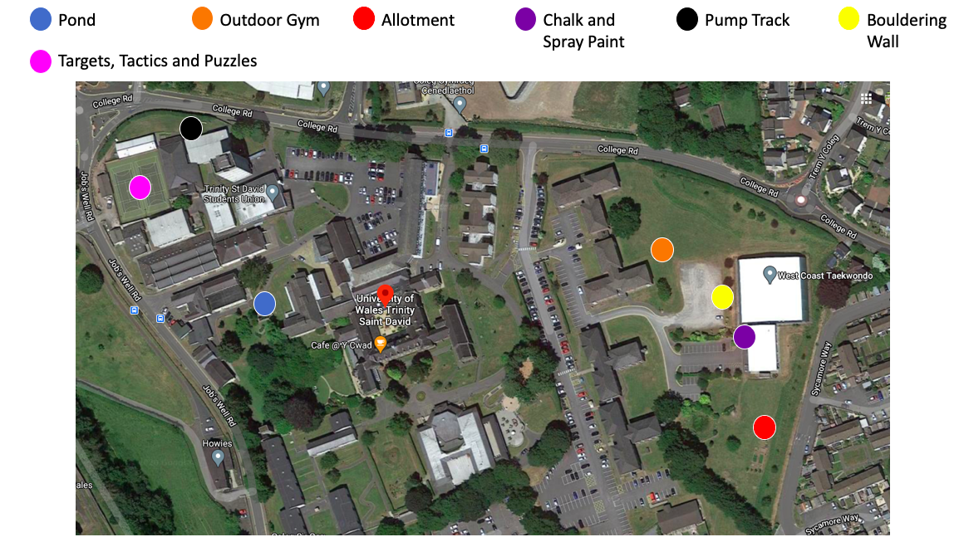
1.0

1.1
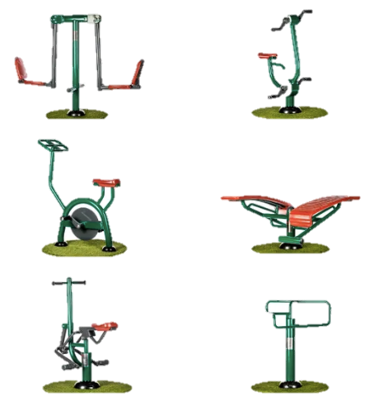
Sunshine Gym: Outdoor Fitness Equipment (2020)
1.2
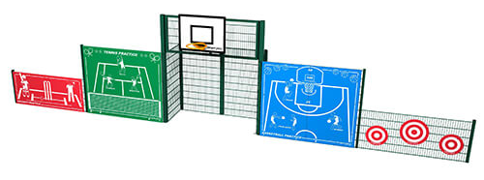
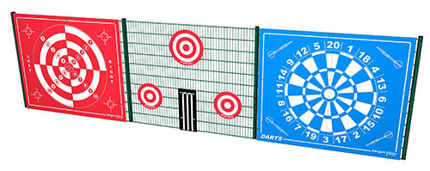

Creative Play (1991)

