Portfolio of evidence.

Introduction.

Due to an interest in teaching as a career, I chose to undertake my ten day placement within a primary school setting. The rural school comprised of less than one hundred pupils and also housed a Local Education Authority resource base for pupils suffering with additional learning needs. Following a discussion with the Headteacher, it was decided that I would integrate within all areas of the school community where possible. Before commencing my placement, I had to produce a copy of my valid Disclosure and Barring Service certificate, in accordance with the school’s Child Protection policy. Over the next ten days, I am going to document all of my experiences.

Day 1.

Upon arriving at the school, I was met by the Headteacher and escorted to the staff room where I was introduced to the other members of staff. I was advised by the Headteacher that I was to be placed in the year five and six class, due to previous working experiences with that age group. Before attending class, I was introduced to the school’s Child Protection Officer who presented me with a series of policies and documents, with which I was to familiarise myself. In addition, I was informed that the document of prime importance was the school’s Child Protection Policy. As a result, this policy became my starting point.
As a volunteer, the relevance of the document soon became apparent as it provided me with the necessary information, enabling me to meet my child protection responsibilities. The Policy clearly explained the school’s commitment to child protection, recognising its statutory and moral responsibilities to safeguarding the welfare of its pupils. In addition, it reinforced the importance of demonstrating and maintaining good practice in an environment where children are valued and respected in accordance with The United Nations Convention on the Rights of The Child (UNCRC) Article 36.

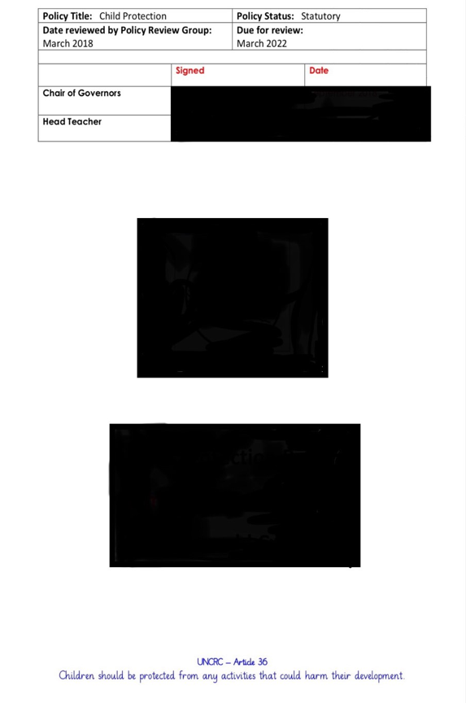

Day 2.

Today, I participated in a group reading session which was designed to support children who require additional help with their reading. The session consisted of four year 5 pupils and a Learning Support Officer (LSO). The school library was used to deliver the thirty-minute session. On entering the library, the children excitedly placed themselves upon brightly coloured bean bags. The children happily chatted in anticipation about the session ahead, whilst the LSO handed out the reading books.
The book was entitled ‘The Clock Strikes’, purchased by the school from the reading scheme series ‘Project X’. In sequence, each child took their turn to read two pages, until the book was completed. During the session, two children required additional support in the pronunciation of words. On each occasion, I encouraged them to decode the word by sounding out the sounds and ‘chunking’ where appropriate.
Upon completion, there was a short discussion regarding the content of the book. Each child contributed by deducing their own opinions regarding the storyline. In addition, the children participated in a paper-based question and answer task which analysed their comprehension levels of understanding.



Day 3.

Today, I was invited to the school’s INSET training day, to participate in Read Write Inc. training. The session was for all staff in accordance with the whole school’s development plan to raise literacy standards. Read Write Inc. is a whole school approach for phonics teaching aimed at four to nine-year olds, to create fluent and confident readers. The morning session began with an introduction to the programme, followed by training on speed sounds, assisted and independent blending. The instructor informed us that pupils on the programme initially learn one sound a day until all forty-one of the initial simple speed sounds are complete. Speed sounds consist of one sound, one grapheme. The session was interactive with a mix of theory and practical tasks.
The afternoon session comprised of assessment and lesson planning. This session was theory-based utilising the interactive training books, provided by the instructor. The books were most useful as they provided a step by step guide to the programme with a notes section on each page to fill in if needed. Once the training was complete, we were allocated a time slot of thirty minutes to plan a lesson. This is the lesson plan I created:

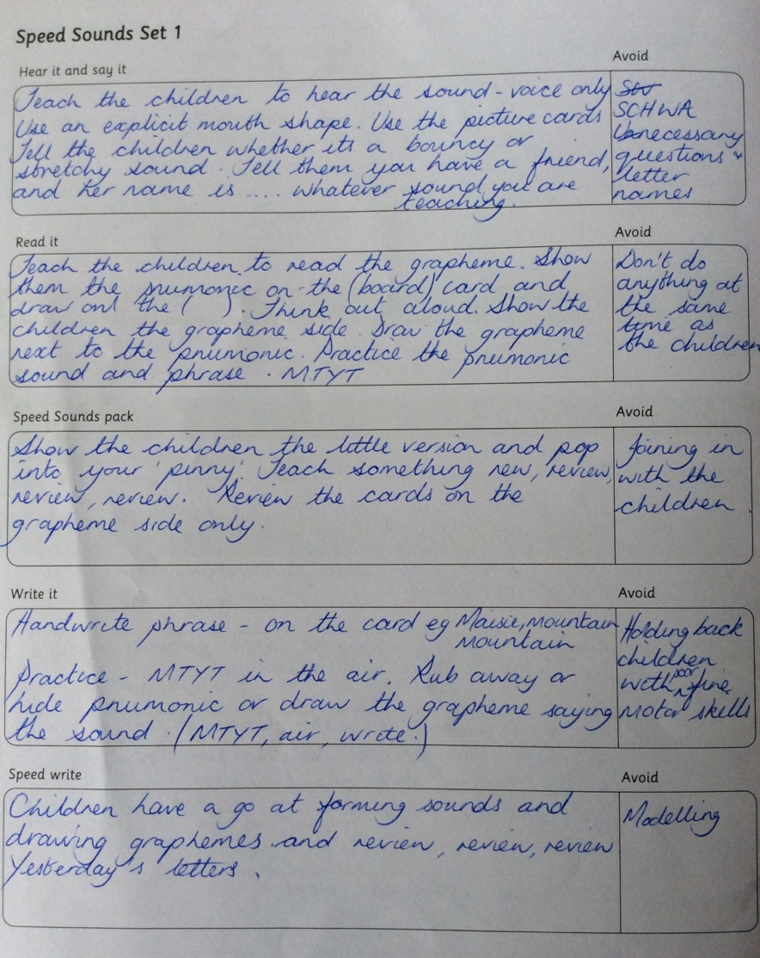

Day 4.

During lunchtime today, I was invited to attend an in-house Super Ambassadors meeting. The Super Ambassadors scheme was introduced by the Children’s Commissioner for Wales to promote children’s rights and responsibilities in accordance with the United Nations Convention on the Rights of the Child (UNCRC). In attendance were two Super Ambassadors, a pupil from each year group, a Learning Support Officer and the year three classroom teacher. The Teacher chaired the meeting and informed the group of the agenda ahead.
The topic of today’s meeting was to devise a ‘Class Charter’ poster for each classroom of the school. The group discussed the purpose of the poster; to design a rights-based poster to highlight some of the articles from the UNCRC. As a group, they decided that each member of the class would countersign the agreement, to demonstrate their understanding of how there are consequences to actions in life. A production timeframe of one month was agreed, as the school were working towards achieving a silver Rights Respecting School award. A Rights Respecting School embeds the UNCRC ethos into its curriculum to ensure children lead healthy, happy lives whilst at school.
Since my placement, the school have received notification of their silver award.

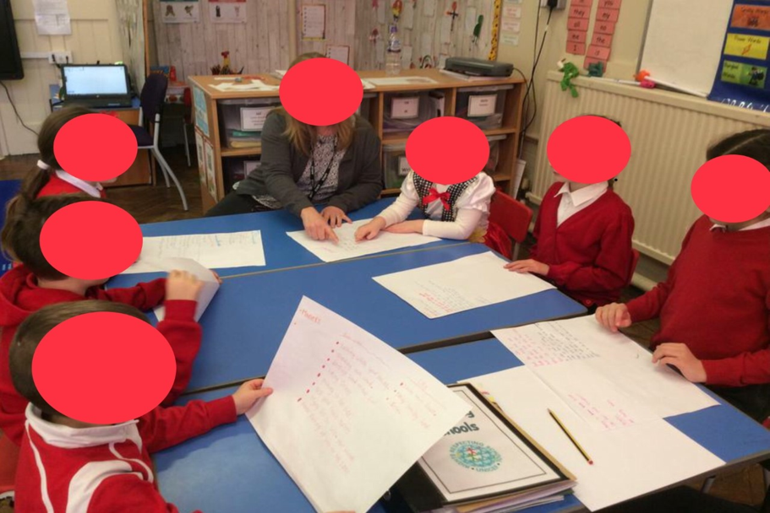

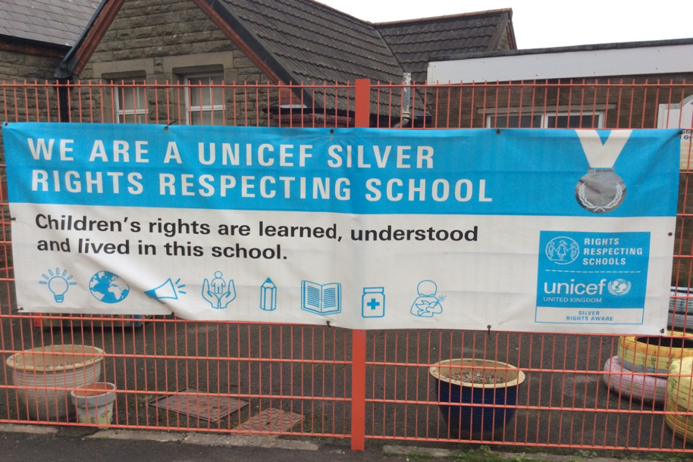
Day 5.

Today, I accompanied a Learning Support Officer and six children to an outdoor learning event. The session was situated in a rural location, which required the use of the school’s minibus. Upon arrival, we were escorted to a roundhouse, where the children excitedly sat upon wooden logs around the campfire.
The first task of the day was to collect small sticks, otherwise known as ‘kindle’, for fuelling the fire. Once the kindle was collected, the facilitator of the event informed the children that it was their responsibility to keep the fire alight for the remainder of the day.
Next, the children chopped up onions, carrots, and peppers in preparation for their spaghetti bolognese lunch. Following a recipe, the children under supervision successfully cooked the meal over the campfire using a tripod. It was delicious!
Following lunch, we participated in a nature walk. During the walk, the children were shown how to identify trees by their leaf structure and were given the opportunity to sample the delights of Sorrel. Sorrel is a common foraging plant which is edible. As a group, we discussed its taste and texture, concluding that it was sweet. A thoroughly enjoyable day, where I observed how happy the children were to participate in outdoor learning.

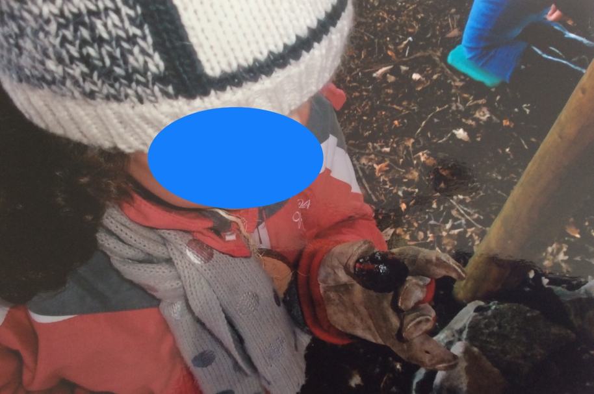

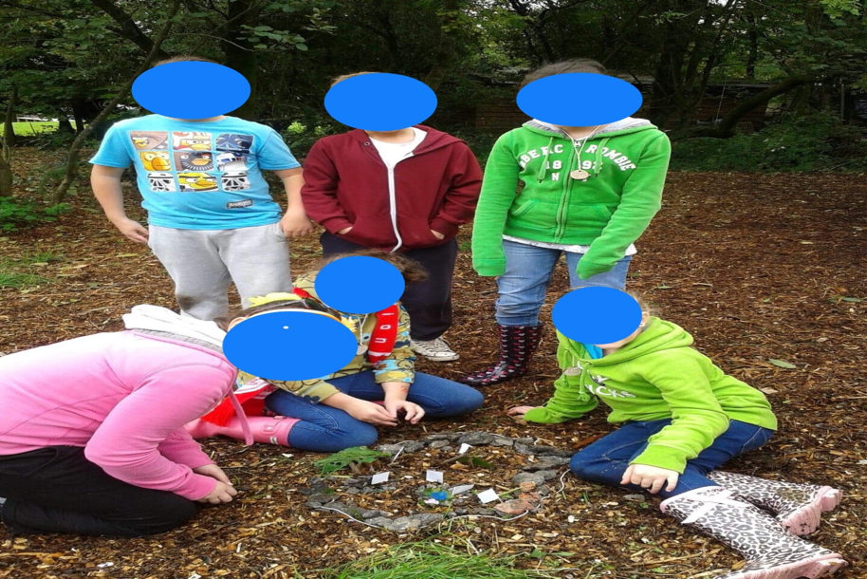
Day 6.

Today, I accompanied children from the school’s Communication and Resource Base to a horse riding school for children with disabilities. The class comprised of eight children, two support staff and a teacher. The adult to children ratio was accountable due to the complex needs of the children. I was informed that six of the children were autistic, whilst the other two children suffered with speech and language difficulties.
Whilst boarding the minibus, the children were clearly showing signs of distress with many shouting out and crying. The class teacher informed me that this behaviour was typical, as they dislike any deviation from their ‘normal’ daily routine. The distress continued throughout the thirty minute journey. On times, it became difficult to hear the teacher’s instructions.
However, upon arrival at the riding school the atmosphere in the minibus altered with eruptions of cheers from the children. Following disembarkment from the minibus, the children were dressed in their appropriate riding attire and escorted to the ring. A riding instructor accompanied each child for the remainder of the session. Once saddled and mounted, every child happily engaged in the riding activity. The session was delightful to witness and highlighted the importance of inclusion. The school currently adhere to guidelines on inclusion and pupil support, as set out by the Welsh Government to ensure the needs of all children are addressed:

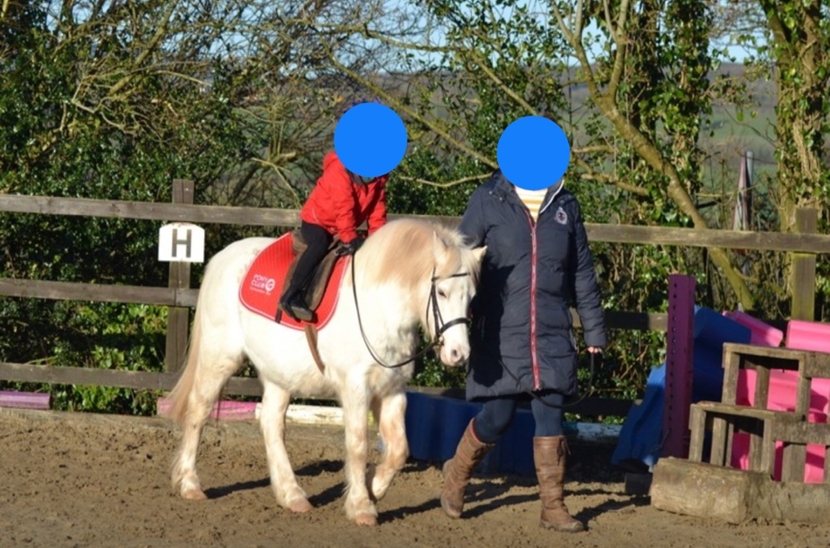

Day 7.

The school today was open to all pupils, with the exception of those who attended the Communication and Resource Base. Staff employed in this area, were today undertaking ELKLAN training to support verbal children with autism spectrum disorder (ASD). As I possess an interest in this area of childhood education, the Headteacher invited me along.
Prior to the session, I sourced additional information on ASD using Government websites and books, to provide me with some background knowledge. The session began with an interactive general overview of ASD and how it affects children. Due to the additional knowledge I had acquired, I was able to effectively contribute to this part of the course, where ideas and opinions were shared.
The remainder of the day’s training involved identifying effective strategies, which can be deployed for use in the classroom by practitioners.
To develop understanding and memory skills, we learned how to use mind maps. Mind maps are an effective aid to visual learning whilst enhancing semantic knowledge. In addition, we acquired training on linguistic sequencing which develops oral skills. The day was most productive and thoroughly enjoyable. All members of staff acquired skills which could be utilised to effectively support children with ASD, in accordance with the school’s approach on Special Educational Needs and inclusion.

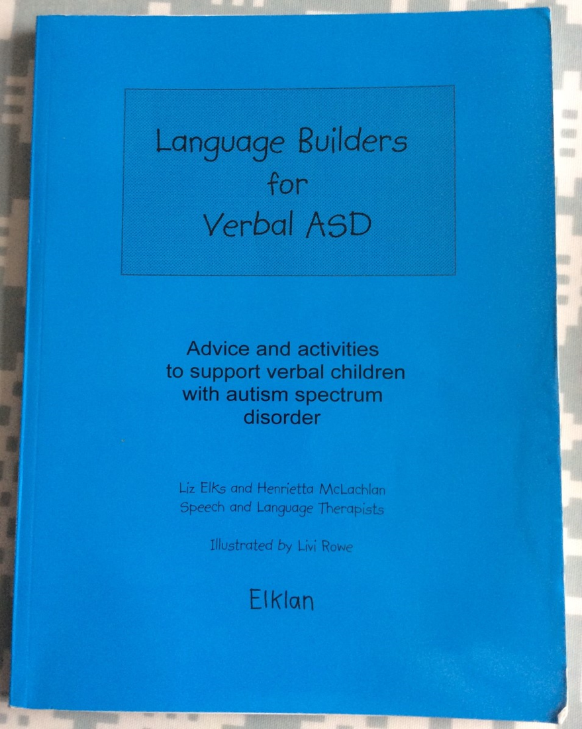

Day 8.

Today, I observed reading test assessments being administered to year five children. The school library was utilised as an assessment area, to deliver the Salford Sentence Reading Test which provides an accurate reading and age for each child and a standardised reading score. The results are then utilised to identify children who may require additional literacy support, in accordance with the school’s developmental plan (SDP).
The school library was utilised to deliver the tests which consisted of an oral reading assessment followed by a comprehension task to determine the child’s level of understanding and inference skills. The tests were delivered by a designated trained member of staff, who explained to each child the purpose of the test. Each test took around five minutes to complete.
Upon witnessing the children undertake the tests, it soon became evident that the range in reading ability across the year group was wide. A few children were identified as high achievers, otherwise known as ‘more able and talented’, whilst others were scored as possessing a reading ability appropriate for their age group. However, a few children received reading ages which were lower than their actual age. Children identified in this group would require additional literacy support in accordance with the SDP.

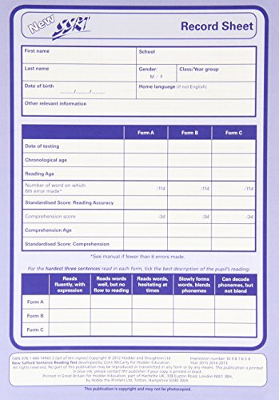

Day 9.

Today, I worked alongside a Learning Support Officer (LSO) to deliver Catch Up Numeracy interventions with pupils aged eight years old. Catch Up Numeracy is an intervention programme used to support children who have been identified as struggling with numeracy after undergoing a Basic Number Screening Test. If a child presents themselves as being more than eighteen months behind their chronological age in the test, they are selected for Catch Up Numeracy sessions in accordance with the School’s Development Plan.
Upon entering the school’s designated support room, Child A appeared to be excited and happy. The session initiated with a quick mental maths warm up, with Child A counting in twos from zero to twenty. The focus of today’s session was to practise number bonding, which was an area highlighted as a difficulty following the test. To overcome this issue, we were going to practise addition using different numbers of objects, to form a total as requested by the LSO. This was an interactive task with Child A revelling in happiness when praised for his achievements. At the end of the session, a quick recap of events with Child A identified him as successfully grasping the concept.

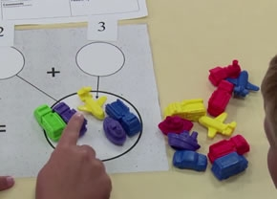

Day 10.

At lunchtime today, I was invited to attend the monthly meeting of the school’s Eco Warriors. The meeting consisted of a class teacher alongside two pupils from each year group. The meeting was chaired by two year six pupils, who initiated the meeting by overviewing the minutes of the last meeting. The attendees overwhelmingly agreed that they were a true and accurate reflection. Next, the Chairpersons announced the meeting agenda for today “How can our school uniform be recycled in a bid to avoid landfill waste?”
To express and share their ideas during, each attendee had to put their hand up and be authorised to speak by the Chairpersons. The pupils expressed some fantastic ideas and were obviously very compassionate about sustainability. To finalise, the Chairpersons suggested a group vote for favourite idea. The pupils waited in anticipation for the final decision, announced by the Chairpersons as “A uniform swap shop day”.
During the meeting, the pupils demonstrated respect for each of their peers’ opinions and views whilst developing their own confidence and team building skills. The group displayed a broad spectrum of knowledge on eco awareness; I was impressed at the school’s ethos towards environmental sustainability.

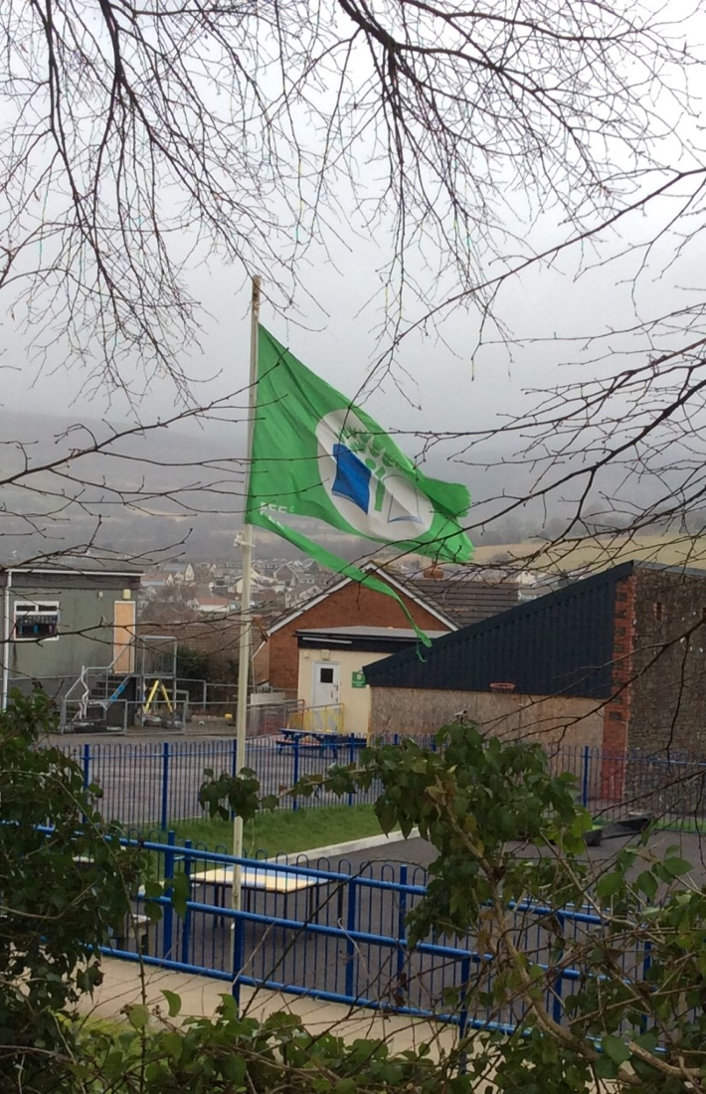

Conclusion.

I thoroughly enjoyed my placement experience which provided me with an invaluable insight into primary education. The experience was rewarding, highlighting the importance of child protection, inclusion, environmental sustainability and children’s rights and responsibilities. The school where I undertook my placement was proactive, exposing children to a variety of experiences which not only impacted positively on their education but also their physical, social, mental and emotional health. However, many of the experiences I witnessed are under threat due to budgetary cuts which could be detrimental both to education and the future lives of children.

