DS 1 Template

My Screenshots/Photos
- Please add 4–6 screenshots or photos of your digital life.
- You can use your phone or laptop.
- For each screenshot, write one or two sentences explaining what it shows.

Screenshot/Photo 1
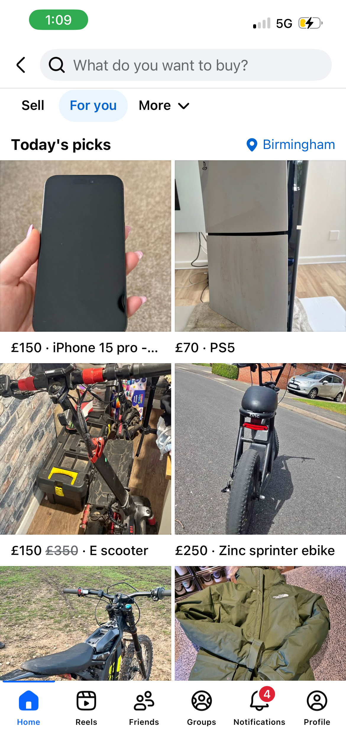
[Insert Photo/Screenshot below]
[Write what this shows of your digital life]
This screen shot shows my Facebook account I use for Facebook market place to buy and sell things such as phones, bikes, cloths, consoles etc to re sell and make profit.

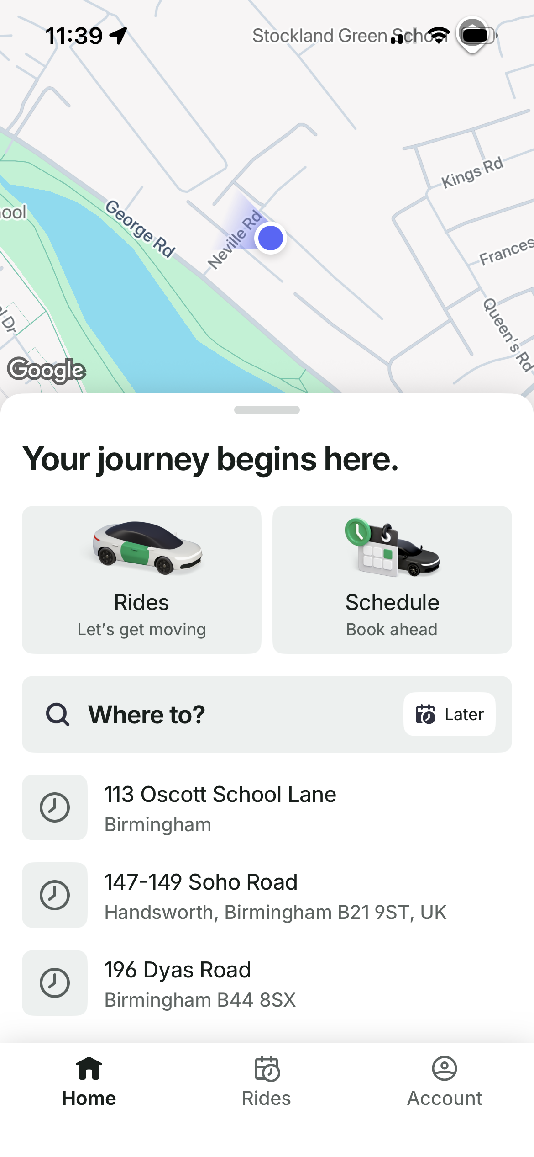
Screenshot/Photo 2
[Insert Photo/Screenshot below]
[Write what this shows of your digital life]
This screen shot shows my bolt account which is a taxi service similar like uber but has better prices I use this every day to get around because I do not drive.

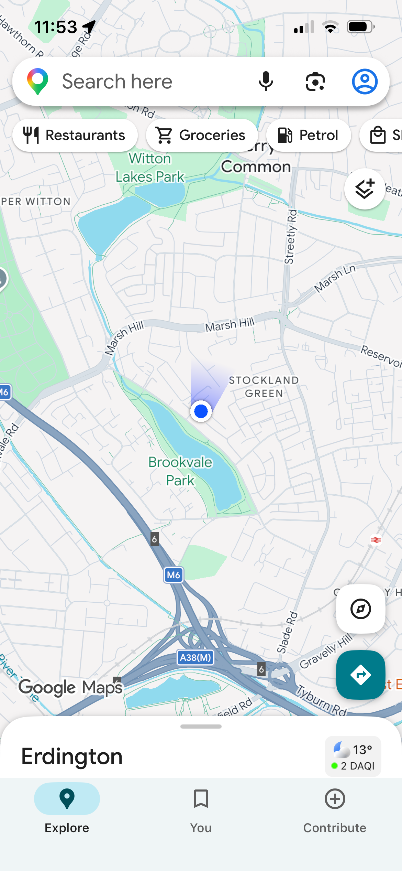
Screenshot/Photo 3
[Insert Photo/Screenshot below]

[Write what this shows of your digital life]
This shows my google maps which I use daily to find bus times and bus routes to get around and to find addresses and locations.

Screenshot/Photo 4
[Insert Photo/Screenshot below]

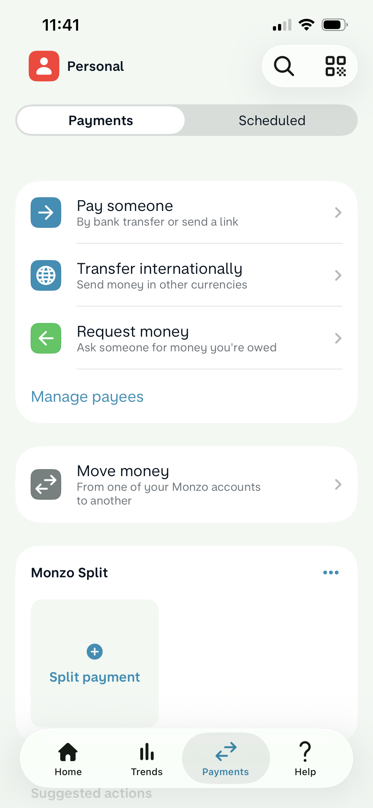
[Write what this shows of your digital life]
This screen shot shows my monzo app which is a bank account I use daily to send and receive money and to pay bills and make purchases.

Screenshot/Photo 5
[Insert Photo/Screenshot below]
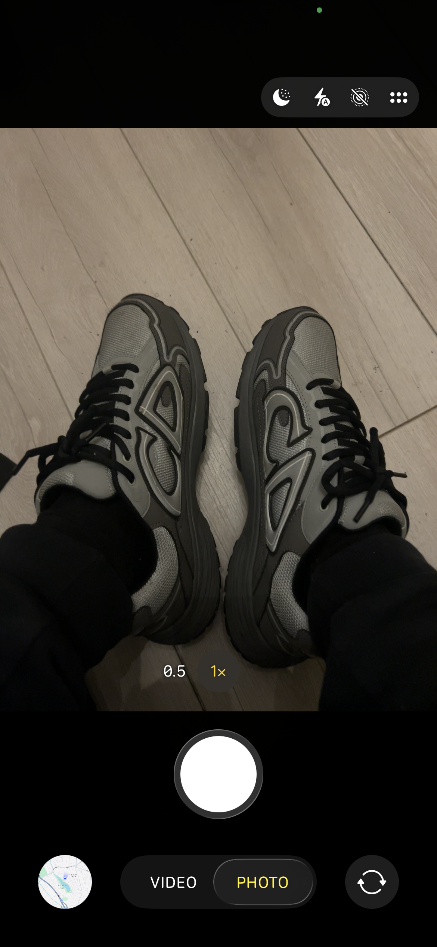
[Write what this shows of your digital life]
This screen shot shows my camera app which I use very regularly to take good high quality pictures of different products I buy and sell to make extra profit on the side.

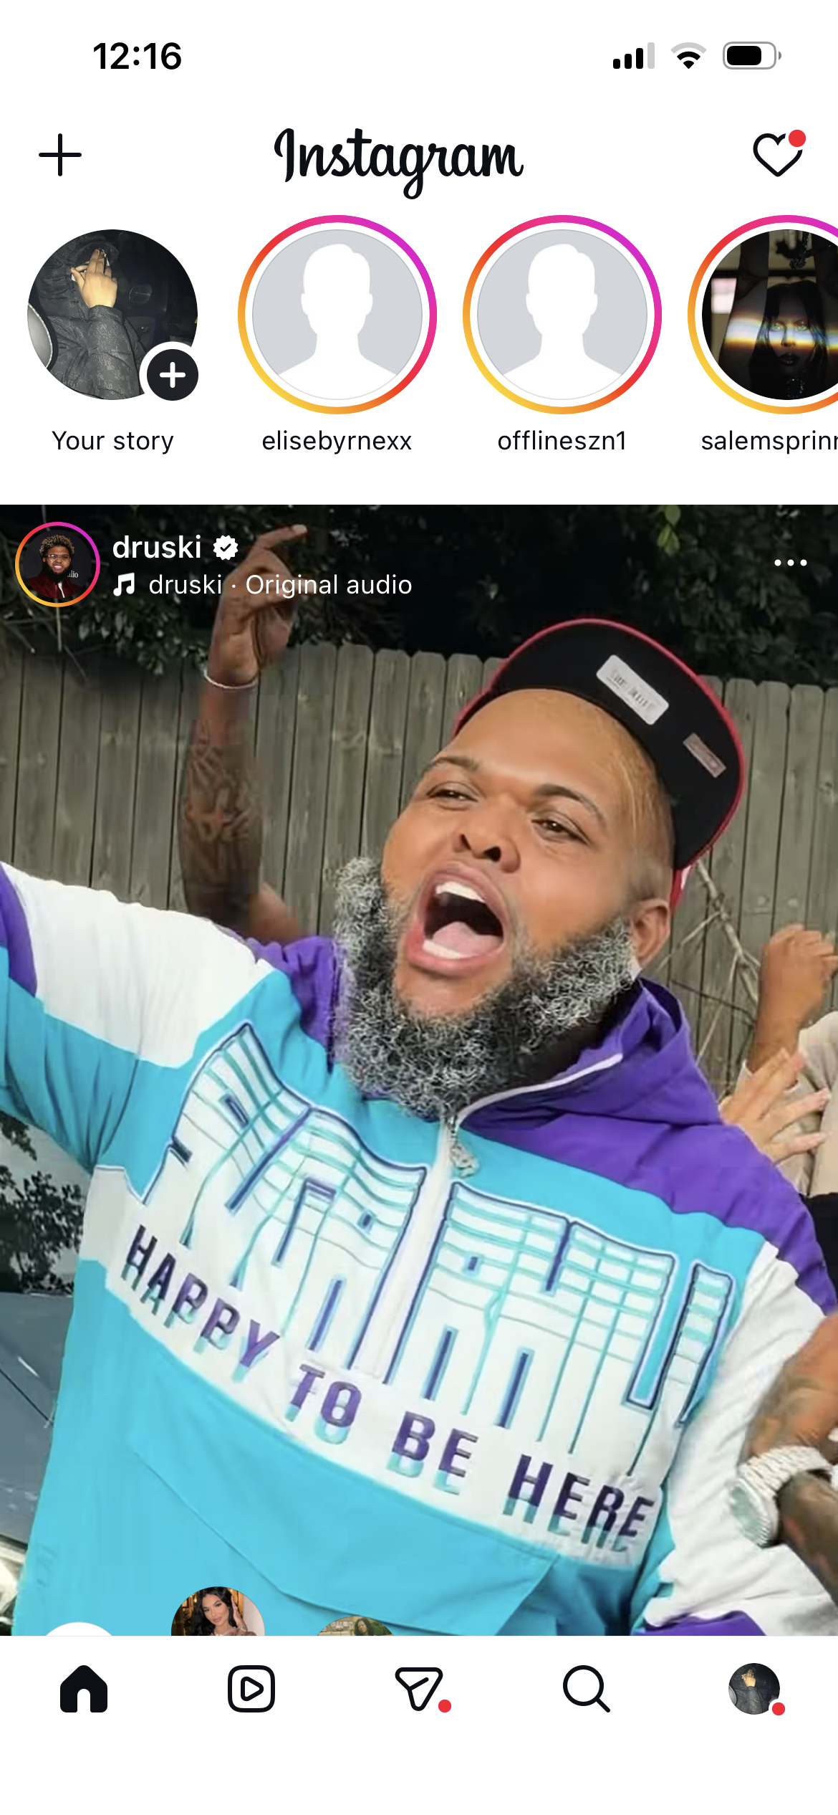
Screenshot/Photo 6
[Insert Photo/Screenshot below]
This screen shot shows my instagram which I use everyday to communicate with friends and family and I also use it for entertainment such as watching content or posting content also to see updates on what’s going on all around the world.

[Write what this shows of your digital life]

My Short Reflection
- Write 5–8 simple sentences about your digital life.
- You can use the sentence starters below if helpful.
I use digital tools to help with everyday life such as communicating with family and friends, entertainment, social media etc. I use apps such as Facebook, bolt, google maps, monzo, instagram and many more but these ones I use daily in life to make life easier. I feel confident using my smart phone and applications very well. I want to improve my digital skills for using apps like Microsoft word as I have not used it for a very long time and was a bit confused t the stat how to use it properly. I sometimes feel nervous about online safety and security on some sites when buying because there are a lot of scammers and I try my best to avoid getting scammed.i hope this module will help me improve my online digital skills to help me in studies at university because I haven’t been in education for a long time. Digital skills are important because they help me with every day life if I didn’t have them life would be a lot harder.

Sentence starters
- I use digital tools to …
- I feel confident when I …
- I want to improve …
- I often use these tools: …
- I sometimes feel nervous about …
- I hope this module will help me …
- Digital skills are important for me because …
You can write more if you want.

Submission Checklist
Before you submit, please check:
​​​ ☒ I added 4–6 screenshots
☒ I wrote short sentences for each screenshot
☒ I wrote my short reflection
☒ My work is my own
☒ My file opens correctly
​​☒ My file opens correctly

