
Master of Business Administration

International Business pathway

Contemporary employability skills
Assessment 1: Individual report. Weight: 100%
Module name: Strategic Management
Module code: LCMB7003
Lecturer name: Dr. Hoang Dang
Student name: Vivekananda Reddy Singireddy
Student ID:252961
Word count: 5,321
Submission date:12th August 2026

AI Use Declaration
I declare that this assignment was written by myself and did not utilize any generative artificial intelligence (AI) tools, including but not limited to AI research, AI paraphrasing, AI analysis, and AI writing, for researching, paraphrasing, analysing or writing the material. All information is sourced from appropriate academic texts such as peer-reviewed journals, books, official publications and credible industry reports and have been referenced appropriately. I have followed the University's academic integrity policy throughout the preparation of this assessment. I understand the importance of academic honesty and confirm that the ideas, analysis and conclusions presented in this submission are based on my own research and understanding of the topic.

Table of Content
Section 1: 4
Organisational Context and Overview 4
Intel Corporation Overview 4
Intel Foundry Business Overview 4
Intel's Current Corporate Strategy and Alignment with Intel Foundry 5
Industry Overview, Key Competitors and Market Position 5
External and Internal Analysis (PESTEL Framework) 5
Political Factor 6
Economic Factor 6
Social Factor 6
Technological Factor 7
Environmental Factor 7
Legal Factor 7
External Analysis of key opportunities and threats 8
Internal Environment Analysis (VRIO Framework) 8
Identification of the Most Important Strengths 10
Identification of the Most Important Weaknesses 11
SWOT Analysis 11
Comprehensive and holistic view of the organisation 13
Evaluation of Corporate Social Responsibility (CSR) Strategy 13
Balanced Scorecard Analysis 14
Financial Perspective 15
Customer Perspective 15
Internal Business Process Perspective 16
Learning and Growth Perspective 16
Strategic Choices and Implementation 17
Evaluation of Intel Foundry's Current Business Level Strategy 17
Industry Competitiveness Analysis (Porter's Five Forces) 17
Strategic Growth Options (Ansoff Matrix) 19
Recommended Strategy 20
Strategy Implementation: Challenges and Recommendations 20
Section 2: 21
Reflection Using Gibbs' Reflective Cycle 21
Description 21
Feelings 22
Evaluation 22
Analysis 22
Conclusion 23
Action Plan 23
References 25

Section 1:

Organisational Context and Overview

Intel Corporation Overview
This report has been prepared according to the viewpoints of a strategic management consultant for Intel’s Board of directors. Established in 1968, Intel Corporation is one of the world's leading semiconductor companies. Its mission is to build world-changing technology to enhance the lives of all people on Earth, and its vision is to be the trusted technology enabler for the future. To respond to increasing artificial intelligence demand, geopolitical supply chain risks, and rising fabrication costs, Intel changed its business model from a traditional Integrated Device Manufacturer (IDM) to its IDM 2.0 concept, which included both internal manufacturing and commercial foundry services (Lenkala, 2026). Intel Foundry was chosen as it is the organisation's strategic shift and future competitive growth.

Intel Foundry Business Overview
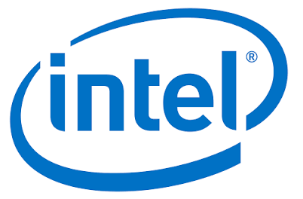
Figure 1: Intel Reports Second-Quarter 2025 Financial Results (2025)
(Source: Intel, 2025)
Intel Foundry is a standalone semiconductor manufacturing company that offers wafer fabrication, advanced packaging, chiplet integration and design enablement for both Intel Products and customers. Unlike traditional foundries, its Systems Foundry approach combines silicon process technology, advanced packaging, software and manufacturing services to provide end-to-end solutions for its customers. While continuing to invest to improve manufacturing capability and attract external customers, Intel Foundry reported US$17.8 billion in revenue in 2025, demonstrating its strategic importance (Intel, 2026a).
The key issue is that Intel is going through a multi-year restructuring that is characterized by market doubts and high capital pressure. Under the leadership of CEO Pat Gelsinger, Intel has been undergoing a dramatic shift in strategy to break its design business from its manufacturing business and go head-to-head with TSMC as a commercial Foundry (contract manufacturer).

Intel's Current Corporate Strategy and Alignment with Intel Foundry
Intel's corporate strategy focuses on (Integrated Device Manufacturing) IDM 2.0, manufacturing leadership, artificial intelligence-driven innovation, advanced packaging, and expanding a customer-centric foundry business supported by significant U.S. manufacturing investment (Lenkala, 2026). Intel Foundry plays a key role in fulfilling these strategic goals by commercialising advanced process technologies, both strengthening domestic semiconductor manufacturing and offering integrated manufacturing solutions to external customers. However, long-term strategic success is not just about technological leadership and the ability to drive the growth of external customers is a key part of Intel Foundry's mission to become an independent commercial foundry to Intel's product divisions (Chen, 2024).

Industry Overview, Key Competitors and Market Position
Intel Foundry is part of the semiconductor foundry industry, which is very capital-intensive, technologically innovative, has high research costs, and requires high economies of scale. The United States is investing in semiconductor manufacturing with the CHIPS and Science Act, which has provided around US$52.7 billion for the growth of semiconductor research, manufacturing and workforce development (Chips Act, 2022). TSMC leads the market, with Samsung as the second largest, and GlobalFoundries, UMC, and SMIC in various technology segments. While Intel Foundry is a new commercial foundry, its competitive strength is bolstered by its secure U.S. manufacturing, government support, and differentiated Systems Foundry capabilities.

External and Internal Analysis (PESTEL Framework)
Intel Foundry is in one of the most strategically importantchip manufacturing business unit in the world today, where government policies, AI-fuelled demand, and technological innovation are changing the semiconductor landscape globally. The macro-environmental factors are becoming more and more important to the investment decisions, competitiveness of manufacturing and market positioning of the contract manufacturer in the context of Intel's IDM 2.0 business model.

Political Factor
Political intervention is playing an increasingly important role as a competitive force in the semiconductor industry. More than US$43 billion in private semiconductor investments have been spurred by the U.S. CHIPS and Science Act, which has allocated US$52.7 billion in funding, strengthening the resiliency of the U.S. supply chain (Chips Act, 2022). However, CHIPS Act guardrails and tougher U.S. export regulations are controlling China's advanced manufacturing growth, adding to geopolitical uncertainty. As a result, Intel Foundry benefits from lower investment risk and increased competitiveness in the domestic market, but changing trade restrictions remain a limiting factor to global market penetration and flexibility.

Economic Factor
The semiconductor manufacturing industry is one of the most capital-intensive industries in the world, with a single leading-edge fabrication facility costing more than US$20–25 billion, and companies spending 20% of their annual revenue on research and development (SIA, 2026). High interest rates raise the costs of financing and increase investment payback periods, but structural demand is very strong. As a result, the growth potential in the long term is huge with the expansion of AI infrastructure, while capital intensity, financing pressure and cyclical demand for semiconductors are also major economic risks.

Social Factor
The global demand for advanced semiconductors is rapidly increasing, fuelled by digital transformation and the rise of AI-powered computing, autonomous vehicles, industrial automation, 5G networks and edge computing. However, Deloitte projects that the U.S. will need about 67,000 more semiconductor professionals by 2030, and the industry needs almost one million more skilled workers around the world to serve future demands (SIA, 2023). As a result, while the adoption of AI offers Intel Foundry a continued path to market growth, a continued shortage of highly skilled engineering talent poses a threat to manufacturing scalability, innovation potential, and long-term competitiveness.

Technological Factor
The main competitive factor for semiconductors is technological leadership. AI chip innovation is being driven by the industry's shift to High-NA EUV lithography systems that cost more than $400 million and advanced packaging (Industry Outlook, 2026). Intel 18A, which combines RibbonFET, PowerVia and Foveros, strengthens performance, efficiency and manufacturing capability, providing an added advantage for Intel to differentiate. But to maintain leadership, ongoing R&D spending and perfect execution is needed, and the pace of innovation by TSMC and Samsung is accelerating the competitive pressure (Raposo García, 2022).

Environmental Factor
Semiconductors are gaining an edge in environmental sustainability. The energy and ultrapure water used by leading-edge fabrication facilities expose them to significant resource scarcity, climate risks and higher operating expenses. At the same time, the rising expectations for ESG drive renewable energy investments, carbon reduction and sustainable manufacturing (Leong, 2024). As a result, Intel Foundry's sustainability efforts build trust among customers, strengthen the supply chain, and ensure compliance with regulations. However, as the environmental standards get tougher and decarbonisation demands get higher, it is driving up capital investments and operating expenses.

Legal Factor
The legal and regulatory environment for semiconductors is becoming more complicated in relation to IP protection, export controls and competition law/gov funding compliance. Manufacturing processes, design architectures and packaging technologies are Intel Foundry's key strategic assets, and strong IP rights continue to be crucial. At the same time, conforming to CHIPS Act funding requirements, U.S. export restrictions and shifting international trade restrictions complicate legal matters and restrict business in sensitive markets (Luo and Van Assche, 2023). As a result, good legal governance strengthens Intel Foundry's innovation capacity and customer trust, but also introduces challenges in terms of growing compliance requirements, IP conflicts and geopolitical trade regulations, thereby adding to the operational risks and strategic uncertainties.

External Analysis of key opportunities and threats
Key opportunities are the CHIPS Act, AI-led semiconductor demand, reshoring of the domestic supply chain, and technology differentiation via Intel 18A, RibbonFET, PowerVia, and Foveros.
Key threats are capital costs for new state-of-the-art fabrication plants, high financing costs, lack of qualified semiconductor experts, and the strict export regulations and strong competition from TSMC and Samsung.
Thus, Intel Foundry's long-term competitiveness will depend on its capacity to drive long-term commercial growth by translating government funding and technological advances into sustainable business and managing financial, geopolitical and operational risks.

Internal Environment Analysis (VRIO Framework)
Resource Based View theory argues that VRIO create sustainable competitive advantage and superior organisational performance. Intel Foundry's competitive advantage depends on its ability to leverage the value of its technological capabilities, advanced manufacturing infrastructure, and innovation resources in the U.S. semiconductor industry. The VRIO framework looks at the sustainable competitive advantage that these strategic resources can provide the company based on four criteria: value, rarity, inimitability and organisational support.
Strategic Resource / Capability | Valuable | Rare | Inimitable | Organised | Competitive Implication
Intel 18A and Intel 14A process technology | ✓ | ✓ | ✓ | ✓ | Sustainable Competitive Advantage
EMIB and Foveros advanced packaging | ✓ | ✓ | ✓ | ✓ | Sustainable Competitive Advantage
U.S. manufacturing facilities | ✓ | ✓ | ✓ | ✓ | Sustainable Competitive Advantage
Research and development capability | ✓ | ✓ | ✓ | ✓ | Sustainable Competitive Advantage
Government support and trusted manufacturing | ✓ | ✓ | ✗ |  | Temporary Competitive Advantage
Financial resources | ✓ | ✗ | ✗ |  | Competitive Parity
Human capital and engineering expertise | ✓ | ✓ | ✓ | ✓ | Sustainable Competitive Advantage
Brand reputation | ✓ | ✗ | ✗ |  | Competitive Parity
Table: VRIO Analysis
The VRIO analysis shows that Intel Foundry has several resources which can provide a sustainable competitive advantage in the U.S. semiconductor industry (Mailani et al., 2024). Intel 18A and Intel 14A process technologies, along with Intel's EMIB and Foveros advanced packaging, allow for the manufacturing of high-performance semiconductors for AI, data centre and automotive applications and for increasingly complex chiplet architectures (Chen et al., 2025). These capabilities are difficult to imitate, they require decades of engineering know-how, exclusive IP and very specific manufacturing expertise. Intel Foundry is also structured to commercialise these capabilities through its integrated systems foundry model, which integrates wafer fabrication, advanced packaging, design enablement and manufacturing services.
At Intel Foundry Direct Connect 2025, the company announced new ecosystem relationships and confirmed some early customer adoption of Intel 14A, which shows increasing industry trust in the company's technology roadmap.
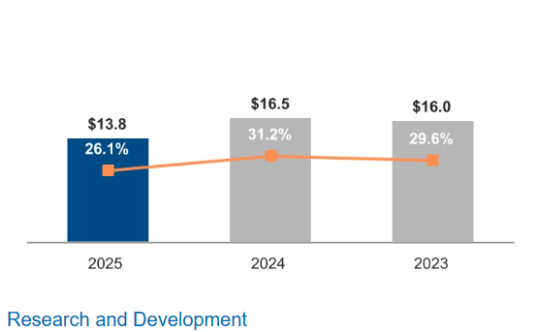
Figure 2: FORM 10-K (2025)
(Source: Intel Corporation, 2025)
Furthermore, Intel's 2025 R&D expenditure of around US$13.8 billion demonstrates its ongoing commitment to innovation, even in the face of fierce competition (Intel Corporation, 2025). However, government support provides a short-term competitive edge, as other domestic manufacturers can enjoy the same advantages, and financial resources and brand reputation can give competitive parity because of the similar capabilities that TSMC and Samsung have. Technological innovation, advanced manufacturing capability, research excellence, and the integration of the production ecosystem are the key factors that allow Intel Foundry to enjoy a sustainable competitive advantage, making it difficult to copy and further enhancing its future competitiveness (Jha and Kunchakuri, 2025).

Identification of the Most Important Strengths
Intel Foundry's key strengths include the advanced process technology, integrated U.S. manufacturing capability, advanced packaging solutions, and robust research strength, which all drive innovation and manufacturing competitiveness. Its trusted domestic production network and strong partnership with government and industry partners further strengthen supply chain resilience and customer confidence. At Intel Foundry Direct Connect 2025, Intel met with more than 1,000 customers and ecosystem partners, a sign of increased market confidence and a testament to Intel Foundry's enduring competitive strength in the U.S. semiconductor market (Intel, 2025a).

Identification of the Most Important Weaknesses
Intel Foundry's main concerns are operating losses, significant capital outlay and manufacturing execution risks. Intel posted operating losses of US$10.3 billion in 2025 compared with losses of US$13.3 billion in 2024 (Intel Corporation, 2025). These are weaknesses due to a small external customer base, which limits profitability, economies of scale, and long-term competitive positioning.

SWOT Analysis
The SWOT framework helps to analyse the interaction between the internal resources of Intel Foundry and the external semiconductor environment, and more importantly, the strategic factors that affect the competitive position of Intel Foundry in the U.S. semiconductor market.
Strengths | Weaknesses
Intel 18A process technology and advanced packaging capabilities | Persistent operating losses and high capital intensity
Integrated system foundry model combining design enablement, wafer fabrication and packaging | Manufacturing yield and execution challenges during technology ramp-up
Strategic U.S. manufacturing footprint supported by federal investment | Limited external customer base compared with TSMC and Samsung
Strong engineering capability and government-backed semiconductor ecosystem | Lower economies of scale and slower commercial expansion
Opportunities | Threats
Growing AI semiconductor demand, CHIPS Act incentives, defence and automotive markets, and expanding external foundry partnerships. | Intense competition from TSMC and Samsung, rapid technology change, geopolitical uncertainty, customer concentration and global supply chain disruptions.
Table: SWOT Analysis
Opportunities and Threats (SWOT Analysis)
Intel Foundry's integrated system foundry model and its growing domestic manufacturing capacity give it a competitive edge to leverage the rising strategic significance of secure U.S. semiconductor manufacturing. The U.S. Department of Commerce has approved US$7.86 billion in CHIPS Act funding for Intel's manufacturing initiatives in Arizona, New Mexico, Ohio and Oregon, strengthening Intel Foundry's ability to expand manufacturing capacity and its strategic role in the national semiconductor ecosystem (Reuters, 2024). However, these benefits will only be realised in sustainable competitive performance if Intel Foundry makes the manufacturing process more efficient, increases the adoption of its external customers and generates better financial results. Without this, however, significant investments in technology may not be enough to ensure commercial success because of high capital needs and strong competition from existing foundries.
Critical Discussion
The SWOT analysis demonstrates that Intel Foundry's competitiveness in the future will depend more on successful commercialisation of the technology than on growing manufacturing capacity in the rapidly competitive U.S. semiconductor industry. While this has helped to improve local manufacturing capacity, sustainable competitive advantage will be achieved through the ability to leverage these assets into profitable customer relationships, improved manufacturing yields and consistent operational performance. This means that Intel Foundry's internal strengths are only valuable when combined with the increasing demand for secure local semiconductor manufacturing and advanced AI production (Otoko, 2025).
The biggest strategic challenge for Intel Foundry is to scale to profitable commercial scale without losing technological edge. Recent developments show that market confidence is improving, as Intel has seen customer engagements for its next-generation 14A manufacturing process and is increasing capital investment to support future production capacity (Taj, 2022). However, management needs to ensure technological innovation is accompanied by operational excellence and better customer acquisition to justify ongoing capital spending.
The strategic priorities, therefore, should be to increase manufacturing yields, increase external foundry customers, strengthen advanced packaging, and deepen ecosystem cooperation to drive revenue diversification. Achievement of these priorities will enhance Intel Foundry's ability to deliver sustainable competitive advantage from technology capability and strengthen its position in the U.S. semiconductor industry (Daniels and Hunt, 2022). The strategic direction and long-term competitive position of Intel Foundry are evaluated in the following section based on this evaluation.

Comprehensive and holistic view of the organisation

Evaluation of Corporate Social Responsibility (CSR) Strategy
The Intel Foundry's Corporate Social Responsibility (CSR) strategy is integrated into the business strategy and is based on the Triple Bottom Line (TBL) framework, which includes People, Planet and Profit, to achieve long-term competitive value, not just to meet regulatory requirements (Nogueira et al., 2023). Sustainability is a strategic capability that affects customer acquisition, operational resiliency and long-term profitability; semiconductor manufacturing is one of the world's most resource-intensive manufacturing processes, consuming high amounts of electricity and ultra-pure water. (Samuel, 2025)
Intel Foundry's Sustainable Foundry strategy aims to achieve 100% renewable electricity and net positive water by 2030, while promoting environmental responsibility and manufacturing resilience from the Planet's point of view. By 2025, Intel had 100% renewable electricity in its U.S. operations and brought back more freshwater than it used in the U.S. in watershed restoration programmes, helping to remove environmental risk and strengthening production continuity (Intel, 2026b). These efforts are also part of a strategic plan, as they would otherwise result in higher operating expenses and a reduction in long-term competitiveness if production capacity were to be expanded without an increase in resource efficiency. Sustainable manufacturing is not just about environmental compliance, it's about operating more efficiently and supporting future capacity growth for Intel Foundry.
The People dimension enhances the value of the stakeholder by implementing responsible supply chain management, the development of the workforce and diversity, access to highly skilled engineering talent, and supplier resilience. However, the most strategic value comes from the union of the Planet and Profit aspects. Cloud providers like Microsoft, Google and Amazon Web Services have set lofty net zero and Scope 3 emissions goals, which are driving greater attention to supplier sustainability in procurement (Korada et al., 2024). Therefore, Intel Foundry's low-carbon manufacturing strategy is directly aligned with its business goal to grow external foundry customers by making it more attractive to environmentally conscious enterprise customers and lowering regulatory and supply chain risks.
Critically, by integrating sustainability into Intel Foundry's commercial strategy, Intel's CSR strategy creates competitive advantage by driving better customer acquisition, operational resiliency, and long-term profitability. Therefore, maintaining the advantage will require the acceleration of supplier decarbonisation and the enhancement of transparency for Scope 3 emissions. Otherwise, customers' trust, competitive advantage, and revenue opportunities will be lost (Flinck Pahkasalo, 2025).

Balanced Scorecard Analysis
The Balanced Scorecard (Kaplan and Norton, 1992) offers a strategic performance management tool that integrates financial and non-financial performance measures to assess if the organisation's activities are aligned with long-term strategic goals. The Balanced Scorecard is different from traditional performance measurement systems, which measure performance mainly in financial terms, because it sets up a cause-and-effect link between four interdependent perspectives: Financial, Customer, Internal Business Processes, and Learning and Growth. For Intel Foundry, this approach connects operational performance to its strategic mission of becoming a globally competitive U.S. contract semiconductor manufacturer, and will lead to sustainable financial performance as the organisation's capabilities, manufacturing excellence and customer relationships continue to improve.
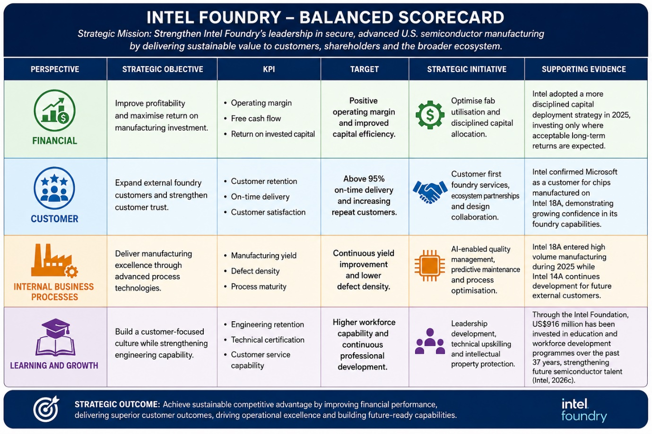
Figure 3: Balance Scorecard Table
Source: By author

Financial Perspective
Intel Foundry's financial goal is to increase profitability by maximising its capital-intensive manufacturing investments. Therefore, operating margin, free cash flow and return on invested capital are better performance metrics than revenue growth. Intel Foundry had reported a loss of US$10.3 billion in 2025 as it generated a revenue of US$17.5 billion, compared to a loss of US$13.3 billion in 2024 (Intel Corporation, 2025). The path to sustainable financial performance and long term competitiveness will depend on the ability to lower operating losses, increased external demand and investment discipline, all while increasing fab utilisation.

Customer Perspective
The key to Intel Foundry's strategy is gaining the trust of external semiconductor designers through providing reliable manufacturing services to the commercial foundry standards. Therefore, customer retention, delivery reliability and customer satisfaction are better measures of strategic performance than contract acquisition alone, as they indicate that the market is confident in the company's performance over time. The fact that the leading technology firms are seeing Intel Foundry's advanced manufacturing capabilities as competitive is now evidenced by the fact that Intel announced that Microsoft will be manufacturing a custom chip using Intel 18A. However, customer-first services, design support from collaboration, and strong ecosystem partnerships directly help Intel Foundry to grow its external customer base and lessen the reliance on the internal product demand (Chen and Zhou, 2025).

Internal Business Process Perspective
The key to Intel Foundry's competitive strategy is operational excellence, which is directly tied to production efficiency, customer trust and technology leadership. Therefore, the successful implementation of the Five Nodes in Four Years roadmap, along with manufacturing yield, defect density and process reliability improvements should continue to be key performance indicators. In 2025, Intel managed to get Intel 18A out of the lab and into high-volume manufacturing, while also developing Intel 14A as the first process node that will be offering dedicated foundry customers (Intel Corporation, 2025). The milestones illustrate advances in moving advanced manufacturing capability to market. Therefore, AI quality control, predictive maintenance and ongoing process optimisation should enhance the operational performance and enable sustainable competitive advantage.

Learning and Growth Perspective
The ability to build organisational capabilities that enable innovation, customer collaboration and operational excellence is vital to Intel Foundry's long-term competitiveness. The company's shift from an IDM to a foundry for its customers means that workforce capability is a critical strategic resource. Thus, engineering retention, specialised technical training, leadership development and protection of intellectual property are key performance indicators. In addition to its investment in capability building, Intel has contributed US$916 million to the education and workforce development and technology access over the last 37 years via the Intel Foundation to build the long-term semiconductor talent pipeline (Intel, 2026c). Such efforts improve organisational learning; employees are technically equipped and customer-oriented to provide trusted manufacturing services.
Critical Evaluation
Strategically aligned financial and non-financial metrics, the Balanced Scorecard illustrates that the ability to build the workforce, along with operational excellence and customer trust, are all key components to building sustainable profitability at Intel Foundry. However, it is important to balance all four perspectives because technological leadership is not enough to guarantee commercial success. Hence, it is crucial to keep the performance indicators in line with changes in market and customer needs for the long-term strategic competitiveness (Babayev and Balajayeva, 2023).

Strategic Choices and Implementation

Evaluation of Intel Foundry's Current Business Level Strategy
Intel Foundry adopts a differentiation strategy, competing through advanced process technologies, integrated packaging solutions, and secure U.S. manufacturing. It offers high performance, trusted manufacturing and a full systems foundry model, which integrates process technology, advanced packaging and design services, as its customer value proposition. This differentiates Intel Foundry apart from others, delivering end-to-end semiconductor solutions on various architectures. Technology leadership has also been strengthened, with over 100 advanced 2.5D packaging designs already in volume production and around three times the 2.5D packaging capacity of competing foundries, which strengthens its manufacturing capability (Intel, 2024). Therefore, differentiation alone is not enough to make the business sustainable, because Intel has to compete with well-established foundries with larger external portfolios. It is therefore essential that it becomes a long-term success by successfully moving the technology to long-term commercialisation, and that is why differentiation is the best business-level strategy while requiring strong customer acquisition and execution.

Industry Competitiveness Analysis (Porter's Five Forces)
Based on Porter's Five Forces, Focused Differentiation is the most suitable business-level strategy for Intel Foundry (Jha and Kunchakuri, 2025). Competing on cost leadership as the established Asian foundries have decades of manufacturing scale, mature supply chains and lower manufacturing costs. Rather, Intel Foundry should differentiate in the U.S market by providing secure domestic manufacturing, resilient supply chains, and integrated systems foundry capabilities that integrate advanced logic, packaging, and design services.
Threat of New Entrants - Low:
The investment, technical knowledge and scale of manufacturing for advanced semiconductor fabrication facilities are very high, making entry barriers extremely high. In the United States, more than 100 semiconductor ecosystem projects have been announced across 28 states, representing over US$500 trillion in private investment, reinforcing the dominance of established manufacturers and making market entry increasingly difficult for new competitors (SIA, 2025).
Bargaining Power of Suppliers - High:
The reliance on a limited number of specialist equipment suppliers, especially ASML on EUV lithography systems, can lead to higher supplier influence and operational risk. Therefore, it is necessary to establish strategic partnerships and long-term procurement contracts in order to ensure continuity of manufacturing and technological competitiveness.
Bargaining Power of Buyers – High:
The large customers of semiconductors and AI have a lot of negotiating leverage because they can switch to other established players such as TSMC or Samsung (Begum and Chowdary, 2024). To be competitive, Intel Foundry must offer trusted U.S. manufacturing, design collaboration, and supply chain resiliency, rather than price.
Threat of Substitute Technologies – Moderate:
The risk of substitution is increased by new manufacturing techniques, chiplet designs and key technology companies developing in-house semiconductors. Investment in advanced packaging and integrated manufacturing services is therefore crucial to preserve the differentiation.
Competitive Rivalry – Very High:
Competition is tough because TSMC and Samsung have more manufacturing capacity and customers. But, what makes Intel Foundry stand out is its ability to manufacture wafers alongside its advanced packaging capabilities and its secure domestic production methods, all of which fall into its systems foundry model (Taj, 2022). This is a response to the increasing customer demand for supply chain diversification and geopolitical resilience, not just on manufacturing cost.
Critical Evaluation: Industry is moderately attractive – high long-term growth potential, but with high competition, high buyer and supplier dependence. As a result, Focused Differentiation is Intel Foundry's best strategic option, as it provides customers with geographic security, advanced manufacturing capabilities, and integrated solutions that are hard for others to copy. The future competitiveness will depend on the ability to convert these differentiated capabilities into a sustained commercialisation and long-term customer relationships, not just on price (More, 2023).

Strategic Growth Options (Ansoff Matrix)
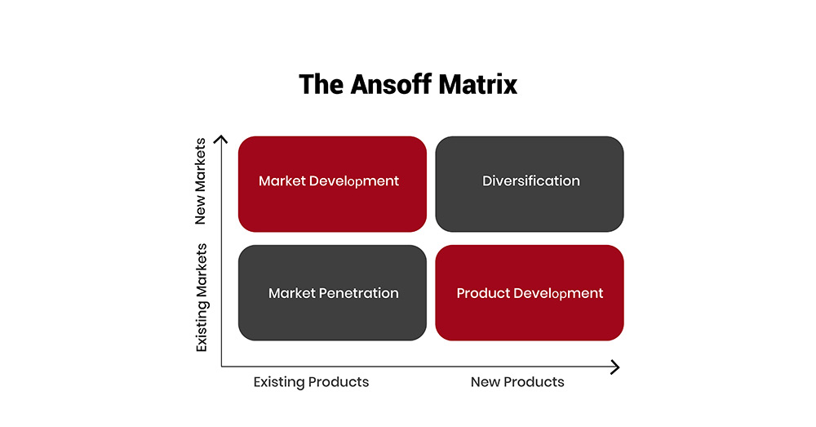
Figure 4: The Ansoff Matrix: A Powerful Tool for Business Strategy and Growth (2024)
(Source: The Strategy Institute, 2024)
Ansoff's Matrix indicates that Product Development and Related Diversification is the most suitable growth option for Intel Foundry (Mesut, 2026).
Market Penetration is the least appropriate option because Intel Foundry would sustain growth through price competition with established Asian foundries that have larger manufacturing scale and a mature customer base.
Market Development may be expanded to include areas such as artificial intelligence, automotive and defence, but new customer markets would not provide any additional competitive advantage unless technological capabilities were improved (Hussain et al., 2023).
Product Development, on the other hand, allows Intel Foundry to bring new process technologies, integrated packaging and systems foundry services to existing Intel business units, adding value to the customers.
Related Diversification is the expansion of these manufacturing capabilities into an entirely new market for fabless semiconductor companies, based on Intel's core competency without straying too far from its technology. The Related Diversification strategy is supported by Intel Foundry's ecosystem of more than IP, EDA, cloud, packaging, and design partners, which accelerate innovation. Thus, the integration of Product Development with Related Diversification offers the best strategic route, with a mix of technological innovation, ecosystem cooperation, and assured U.S. manufacturing, to ensure sustainable competitive advantage and long-term growth (Al-Sulaiti et al., 2024).

Recommended Strategy
Intel Foundry should follow a Focused Differentiation Strategy with Related Diversification, along with secure U.S. manufacturing, advanced systems foundry capability and integrated packaging, to cater to the external fabless semiconductor companies. The Focused Differentiation Strategy with Related Diversification can be seen as an effective way of sustaining the competitive advantage because it is based on the provision of unique value to the customers, which corresponds to the Porter's Generic Strategies and Ansoff's Matrix (Mesut, 2026).

Strategy Implementation: Challenges and Recommendations
The implementation of the Focused Differentiation Strategy supported by Related Diversification requires a lot of structural and competitive challenges to be resolved. It is hard to match TSMC's $100 billion capital investment in the U.S, so it is critical to prioritise investments in discipline and to improve manufacturing yields to ensure long-term competitiveness (WSJ, 2026). Additionally, the external customers like AMD and Nvidia are hard to attract as Intel is also competing in downstream semiconductor markets, giving rise to concerns over confidentiality and strategic neutrality. Intel Foundry should thus further develop its operational independence by establishing transparent governance, powerful IP protection and customer support teams, as well as investing in engineering talent and strategic partnerships. Focusing on high-value markets, including artificial intelligence, automotive and defence, will help to boost commercial uptake, strengthen customer confidence and enhance long-term competitive results.

Section 2:

Reflection Using Gibbs' Reflective Cycle
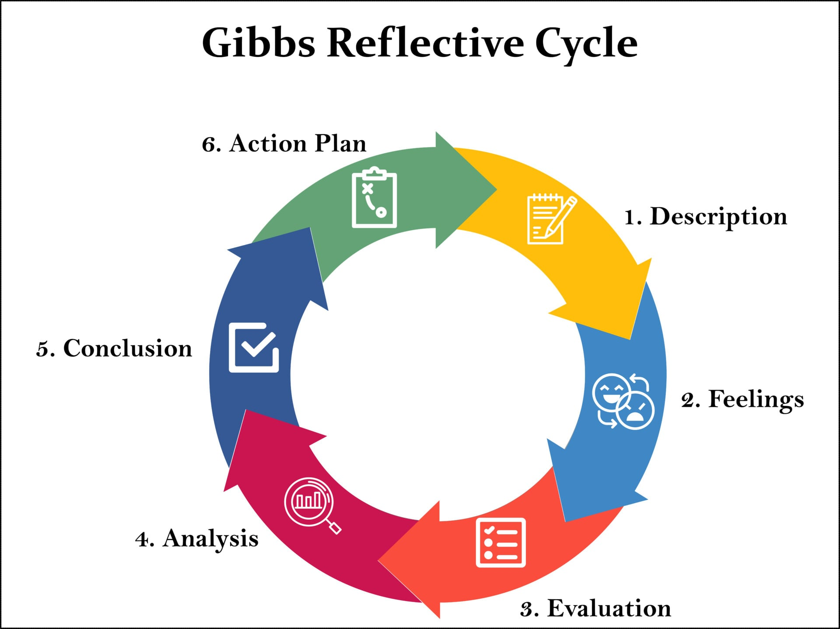
Figure 5: Gibbs Reflective Cycle (2025)
(Source: Saul McLeod, PhD, 2025)

Description
This assessment required me to perform a detailed strategic analysis of Intel Foundry and suggest an appropriate strategy to make it more competitive in the long term. It included research on the semiconductor industry, analysis of the internal and external environment of Intel Foundry, and the application of several strategic management theories in the development of evidence-based recommendations (Dhingra and Sharma, 2026). During the assessment, I used PESTLE, VRIO, SWOT, Balanced Scorecard, Porter's Five Forces, Porter's Generic Strategies and Ansoff's Matrix to analyse various components of the business of Intel Foundry.

Feelings
I was not certain about the opening of the assessment because the semiconductor business is a technical one and extremely dynamic. It was challenging at first to differentiate between descriptive analysis and critical evaluation, especially when using strategic frameworks on a real organisation. I was also concerned to see some credible evidence that would provide an accurate reflection of Intel Foundry's competitive position and not just the company's own publications. As I went on, I became more confident as I learned from a variety of sources, and developed a better understanding of different perspectives and more objective understanding of the strategic issues at Intel Foundry. I also got a sense of confidence by observing the connections between the different frameworks as strategic recommendations were better informed if they were based on the various frameworks being connected and not just one.

Evaluation
Looking back on the whole process, I believe that my best asset was a systematic approach to research before developing my strategic analysis. I have not just taken the information from the Intel Annual Report, but I have corroborated the information with other academic journals, industry reports and independent market evidence to ensure I have a balanced view of Intel Foundry's competitive position. This enhanced the believability of my analysis and diminished the chance of organisational prejudice (Rostami and Vahabie, 2025). However, there were also challenges that I had to deal with when conducting my research. It was important to choose the most suitable strategic frameworks, and to make sure that each one added something new, as a number of models addressed with similar strategic issues. I thus enhanced my analysis by combining the results of the various frameworks and so each model could contribute to the strategic recommendation and not as an independent analysis. This greatly enhanced the coherence, logical flow and critical quality of the report.
Analysis
This assessment has helped me to rethink my concept of strategic management because I understood that successful strategic analysis comes from the synthesis of evidence, theory and critical judgement, not from the use of one of them alone. At first, I focused on each framework individually, but as my research continued, I realised that the strategic recommendations came to light when the findings of the several analyses were logically connected together. For example, the PESTLE and SWOT analyses revealed external factors and opportunities that affected Intel Foundry, and the VRIO analysis showed the internal factors that enabled the recommendation of a Focused Differentiation Strategy with Related Diversification (Morris, 2023).
The research process also helped me to become more critical in my interpretation of evidence. I was taught that information from organisations is not to be accepted on faith, and that information's credibility and strategic value can be checked by comparing it with other independent industry information and academic research. This allowed me to see the competitive advantages of Intel Foundry as well as the structural issues such as the high capital intensity, technology commercialisation and customer acquisition (Chen, 2024). In addition, the report preparation and revision process helped me to enhance my academic writing skills by making me think about presenting concise, evidence-based arguments with logical reasoning rather than descriptive explanations.
Conclusion
In conclusion, I find this assessment was really beneficial to my understanding of the strategic management process. It enhanced my knowledge of strategic frameworks and also strengthened my research skills, and critical interpretation of complex information and the ability to formulate strategic recommendations based on evidence. I have gained confidence in my critical analysis of organisational issues and in developing recommendations which are grounded in theory and in practice, but I have identified areas for further development of my critical writing.
Action Plan
I will research earlier in future strategic management projects to give more time to analyse and compare evidence from academic, industry and organisational sources. I will further develop my critical evaluation skills by questioning assumptions, contrasting different perspectives and emphasising the strategic implications of evidence over the description of organisational activities. I also want to improve my academic writing and improve the logical connection of various strategic frameworks and how each section connects to the overall strategic argument. Lastly, I will use the analytical and evidence-based approach that I have developed during this assessment in my future academic studies and professional decision-making processes, which will allow me to assess complex business environments with greater confidence and make recommendations for sustainable strategic solutions (Odeyemi et al., 2024).

References
Al-Sulaiti, A., Hamouda, A.M., Al-Yafei, H. and Abdella, G.M. (2024). Innovation-based strategic roadmap for economic sustainability and diversity in hydrocarbon-driven economies: the Qatar perspective. Sustainability, 16(9), p.3770. https://doi.org/10.3390/su16093770
Babayev, F. and Balajayeva, T. (2023). Ways of increasing the competitiveness of. International Journal. https://www.academia.edu/download/121053532/2282.pdf
Begum, S. and Chowdary, F. (2024). Competitive Semiconductor Product Management: Navigating the Future of Semiconductor Technology in the AI Era. Springer Nature.
Chen, G., Wang, G., Wang, Z. and Wang, L. (2025). Electronic chip package and co-packaged optics (CPO) technology for modern AI era: a review. Micromachines, 16(4), p.431.https://doi.org/10.3390/mi16040431
Chen, K. (2024). Tower Semiconductor Acquisition: Advancing Intel’s Presence in the Global Market. In SHS Web of Conferences (Vol. 181, p. 01016). EDP Sciences.https://www.shs-conferences.org/articles/shsconf/pdf/2024/01/shsconf_icdeba2023_01016.pdf
Chen, X. and Zhou, Y. (2025). Open-Source Collaboration and Technological Innovation in the Industrial Software Industry: A Multi-Case Study. Systems, 13(6), p.433.https://doi.org/10.3390/systems13060433
Chips Act (2022). U.S. Semiconductor Legislation and Policies. Available at:https://www.european-chips-act.com/USA_Semiconductor_Legislation.html
Daniels, O.J. and Hunt, W. (2022). Sustaining and Growing the US Semiconductor Advantage: A Primer. Center for Security and Emerging Technology. https://cset.georgetown.edu/wp-content/uploads/CSET-Sustaining-Growing-US-Semiconductor-Advantage-A-Primer.pdf
Dhingra, G. and Sharma, N. (2026). Strategic Management of Nanotechnology Innovation: Bridging Scientific Discovery and Commercial Value Across Industries. Int. J. Sci. R. Tech, 3(2), p.2.https://www.ijsrtjournal.com/assetsbackoffice/uploads/article/Strategic+Management+of+Nanotechnology+Innovation+Bridging+Scientific+Discovery+and+Commercial+Value+Across+Industries.pdf
Flinck Pahkasalo, A. (2025). Leveraging relational buyer-supplier collaboration for supplier sustainability development: Towards Scope 3 emission reductions.https://osuva.uwasa.fi/server/api/core/bitstreams/96b9b4f7-423c-4542-a672-994be49ff0e5/content
Hussain, H.N., Alabdullah, T.T.Y., Ries, E. and Jamal, K.M. (2023). Implementing technology for competitive advantage in digital marketing. International Journal of Scientific and Management Research, 6(6), pp.95-114.https://www.researchgate.net/profile/Tariq-Alabdullah/publication/382094043_Implementing_Technology_for_Competitive_Advantage_in_Digital_Marketing/links/668d425fc1cf0d77ffc88f1e/Implementing-Technology-for-Competitive-Advantage-in-Digital-Marketing.pdf
Industry Outlook (2026). ASML's High-NA EUV Machine Set to Rewrite AI Chip Production. Available at: https://www.theindustryoutlook.com/machinery-and-equipment/innovations/asml-s-highna-euv-machine-set-to-rewrite-ai-chip-production-nwid-16650.html
Intel (2024). Intel Foundry is the world’s first systems foundry designed for the AI era.. Available at: https://www.intel.com/content/www/us/en/foundry/library/fact-sheet.html?
Intel (2025a). Press Kit: Intel Foundry Direct Connect 2025. Available at:https://newsroom.intel.com/press-kit/intel-foundry-direct-connect-2025
Intel (2025b). Intel Reports Second-Quarter 2025 Financial Results. Available at:https://www.intc.com/news-events/press-releases/detail/1745/intel-reports-second-quarter-2025-financial-results
Intel (2026a). Intel Reports Fourth-Quarter and Full-Year 2025 Financial Results. Available at:https://www.intc.com/news-events/press-releases/detail/1759/intel-reports-fourth-quarter-and-full-year-2025-financial
Intel (2026b). Committed to Sustainable Semiconductor Manufacturing. Available at:https://www.intel.com/content/www/us/en/foundry/manufacturing/sustainability.html
Intel (2026c). Intel Advances Responsible Business Practices and AI-Driven Growth in 2025–2026 Corporate Responsibility Report. Available at:https://newsroom.intel.com/corporate/intel-advances-growth-in-ai-era-2025-2026-csr-report
Intel Corporation (2025). FORM 10-K. Available at:https://www.sec.gov/Archives/edgar/data/50863/000005086326000011/intc-20251227.htm
Jha, A. and Kunchakuri, A. (2025). A Strategic and Valuation Analysis of Intel Corporation Amidst Industry Disruption. Authorea Preprints.https://www.authorea.com/doi/full/10.22541/au.175251287.74947127/v1
Kaplan, R.S. and Norton, D.P. (1992) ‘The Balanced Scorecard: Measures That Drive Performance’, Harvard Business Review, 70(1), pp. 71–79. https://steinbeis-bi.de/images/artikel/hbr_1992.pdf
Korada, L., Sikha, V.K. and Somepalli, S. (2024). Digital transformation balanced with sustainability goals. J. Eng. App. Sci. Technol, 6(5), pp.2-7.https://www.researchgate.net/profile/Laxminarayana-Korada/publication/383359211_Digital_Transformation_Balanced_with_Sustainability_Goals/links/66c967eec2eaa50023135b2c/Digital-Transformation-Balanced-with-Sustainability-Goals.pdf
Lenkala, H.R. (2026). Intel's Strategic Transformation: Financial Analysis and Valuation of the IDM 2.0 Foundry Strategy. Available at SSRN 6400578.
Leong, W.Y. (2024). ESG and green sustainable technology: Catalysts for the next production revolution. ESG Innovation for Sustainable Manufacturing Technology: Applications, Designs and Standards, 27, p.75. https://www.researchgate.net/profile/Wai-Yie-Leong-2/publication/384648372_ESG_and_green_sustainable_technology_catalysts_for_the_next_production_revolution/links/670556437d49be5c483e6f50/ESG-and-green-sustainable-technology-catalysts-for-the-next-production-revolution.pdf
Luo, Y. and Van Assche, A. (2023). The rise of techno-geopolitical uncertainty: Implications of the United States CHIPS and Science Act. Journal of international business studies, p.1.doi: 10.1057/s41267-023-00620-3
Mailani, D., Hulu, M.Z.T., Simamora, M.R. and Kesuma, S.A. (2024). Resource-based view theory to achieve a sustainable competitive advantage of the firm: Systematic literature review. International Journal of Entrepreneurship and Sustainability Studies, 4(1), p.1.https://search.proquest.com/openview/715f70158b1b2ea8c9e077e44585c6ba/1?pq-origsite=gscholar&cbl=7201586
Mesut, C. (2026). Competitive Advantage Through Strategic. Bridging Traditional Theory and Emerging Corporate Strategies, 111.
More, A.B. (2023). Implementing digital age experience marketing to make customer relations more sustainable. In New Horizons for Industry 4.0 in modern business (pp. 99-119). Cham: Springer International Publishing.https://www.researchgate.net/profile/Amrita-More-2/publication/368398507_Implementing_Digital_Age_Experience_Marketing_to_Make_Customer_Relations_More_Sustainable/links/691d48621555db2ebd607e63/Implementing-Digital-Age-Experience-Marketing-to-Make-Customer-Relations-More-Sustainable.pdf#page=109
Morris, J. (2023). Strategic management. Oregon State University.
Nogueira, E., Gomes, S. and Lopes, J.M. (2023). Triple bottom line, sustainability, and economic development: What binds them together? A bibliometric approach. Sustainability, 15(8), p.6706. https://doi.org/10.3390/su15086706
Odeyemi, O., Usman, F.O., Mhlongo, N.Z., Elufioye, O.A. and Ike, C.U. (2024). Sustainable entrepreneurship: A review of green business practices and environmental impact. World Journal of Advanced Research and Reviews, 21(2), pp.346-358.https://pdfs.semanticscholar.org/7685/ef94653fbd45b599b092d42ce0f417f3ee28.pdf
Otoko, J. (2025). Microelectronics cleanroom design: precision fabrication for semiconductor innovation, AI, and national security in the US tech sector. Int Res J Mod Eng Technol Sci, 7(2).https://www.researchgate.net/profile/Jemimah-Otoko/publication/391279757_MICROELECTRONICS_CLEANROOM_DESIGN_PRECISION_FABRICATION_FOR_SEMICONDUCTOR_INNOVATION_AI_AND_NATIONAL_SECURITY_IN_THE_US_TECH_SECTOR/links/68113e79ded43315573e863c/MICROELECTRONICS-CLEANROOM-DESIGN-PRECISION-FABRICATION-FOR-SEMICONDUCTOR-INNOVATION-AI-AND-NATIONAL-SECURITY-IN-THE-US-TECH-SECTOR.pdf
Raposo García, M. (2022). Supply resilience strategies in the high-tech industryhttps://upcommons.upc.edu/server/api/core/bitstreams/c1cac0ff-ab90-45c5-8834-14fc07500846/content
Reuters (2024). US finalizes $7.86 billion chips manufacturing award for Intel. Available at:https://www.reuters.com/technology/us-finalizes-786-billion-chips-manufacturing-award-intel-2024-11-26
Rostami, S. and Vahabie, A.H. (2025). Review of methods for reducing prejudice and in-group bias. Journal of Cognitive Science Research, 1(1), pp.61-75.https://www.academia.edu/download/125428761/JCSR_Volume_1_Issue_1_Pages_62_76.pdf
Samuel, N. (2025). Sustainability and Business.https://www.preprints.org/manuscript/202512.1441
Saul McLeod, PhD (2025). Gibbs Reflective Cycle. Available at:https://www.simplypsychology.org/gibbs-reflective-cycle.html
SIA (2023). America Faces Significant Shortage of Tech Workers in Semiconductor Industry and Throughout U.S. Economy. Available at: https://www.semiconductors.org/america-faces-significant-shortage-of-tech-workers-in-semiconductor-industry-and-throughout-u-s-economy/
SIA (2025). 2025 State of the U.S. Semiconductor Industry. Available at:https://www.semiconductors.org/2025-state-of-the-u-s-semiconductor-industry
SIA (2026). Testimony of the Semiconductor Industry Association (SIA) Before the Senate Committee on Environment & Public Works A Legislative Hearing to Examine a Discussion Draft “S.__ the Toxic Substances Control Act Fee Reauthorization and Improvement Act of 2026”. Available at: https://www.semiconductors.org/wp-content/uploads/2026/03/Senate-EPW-testimony-3.4.2026.pdf
Taj, M.N. (2022). Intel Chip Manufacturing Technology Roadmap [online]https://www.researchgate.net/profile/Md-Nasim-Afroj-Taj-2/publication/359862158_Intel_Chip_Manufacturing_Technology_Roadmap/links/625354264f88c3119cf133ef/Intel-Chip-Manufacturing-Technology-Roadmap.pdf
The Strategy Institute (2024). The Ansoff Matrix: A Powerful Tool for Business Strategy and Growth. Available at: https://www.thestrategyinstitute.org/insights/the-ansoff-matrix-a-powerful-tool-for-business-strategy-and-growth
WSJ (2026). TSMC to Invest a Further $100 Billion in U.S. After AI Fuels Surge in Earnings. Available at: https://www.wsj.com/tech/tsmcs-earnings-streak-continues-on-robust-ai-demand-1f6b0fe1

