Georgiana-Andreea Ene

1813123

Introducing the Modern Workplace

Module number: LCBB4003

Lecturer: Kenny Tang

STRUCTURE AND CULTURE IN MERCEDES BENZ

Table of Contents
Introduction……………………………………………………………………………………4
1. Relationship between structure, culture, people and organizational performance 4
Organizational structure 4
Organizational culture 6
People 7
Organizational performance 7
2. Nature of managerial work 8
Role of leadership 9
Variables that determine effective management and leadership 10
3. Evaluation of behavioral approach to management 11
Conclusion 13
Reference List 14

Introduction

This report provides an analysis of the relationship between structure, culture, people and organizational performance. The leading organization Mercedes Benz is chosen for the analysis. The study analyses the concept of leadership and management by evaluating different theories and models. The chain of command and span of control theory is used to evaluate structure of Mercedes. The culture of this company is analysed using the Hofstede’s Cultural Dimension theory. In the past decades, the concept of organization structure and culture has gained high popularity among business organizations. According to Bustinza et al. (2015), organization structure refers to the categorization of an organization based its goals. On the other hand, culture is important for improving the internal environment of an organization. The essay is prepared using the PEEL structure of effective essay writing.

1. Relationship between structure, culture, people and organizational performance

Organizational structure

A business organization needs a good structure to grow and be profitable. Planning an effective structure ensures that, human resources are assigned to different roles based on their skill and to accomplish company goals (Eva et al. 2018).

Looking into the structure of Mercedes Benz, it follows the “Functional Structure”. That means, the employees of this company are distributed as per their departmental roles and responsibilities. The functional structure allows their employees to work together under same department and share knowledge.

Researchers have developed various theories to understand organizational structure and its working process. For example – the Span of Control (SOC) theory suggest the number of employees that a leader is supervision under an organization structure (Benzer et al. 2017).

According this theory; the layer or hierarchy increases when an organization gets larger. That means, a large organization like Mercedes Benz has a higher Span of control – in the diagram shown, it is 5. It leads to flatter organization which results in lower cost for the company. Similarly, the Chain of Command theory (COC) is also associated with this context. The chain of command visualizes the order in which an organization is delegated from top hierarchy to the bottom. Mercedes' culture ensures clear chair of command which reduces work load and stress and increases opportunities of promotion.

Apart from that, Hofstede has provided insights on country comparison using dimensions. These includes – power distance, individualism, masculinity, uncertainty avoidance, long term orientation and indulgence. For example – the power distance measures the differences in power among the members of institution. Comparing UK and Germany, the power distance is same among these countries which relatively lower than other countries. Similarly, the individualism or the level of independence is much higher in UK compared to Germany.

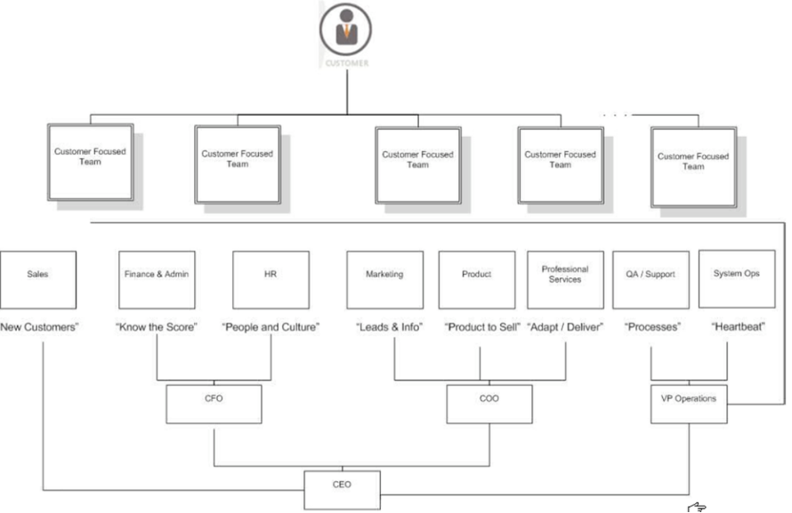Figure 1: Organization structure of Mercedes Benz

(Source: http://mercedesbenzcanada.weebly.com/uploads/1/2/9/0/12908800/9596544_orig.png)

Another industrialist Fatehi (1996) has focused on different internal and external factors that impact organizational culture. According to Product, Function and Geography are the main three components of organization structure. Moreover, factors like world view and attitudes, value systems, deep culture differences can influence structure. According to Fatehi these factors have a great impact on how business is conducted in different geographical locations and cultures.

Organizational culture
The organizational culture is closely related to the structure of an organization. Alvesson and Sveningsson (2015) opined, the departmental hierarchy can reflect the power structure and authority level of supervisors which in turn impacts their values and principles. An organization culture is largely dependent on the working styles of the management and their values.

The company Mercedes Benz uses the Bureaucratic culture. According to this cultural theory, an organization has tight control and there is policies and procedure for everything. Bureaucratic culture also reflects the structure of an organization. In Bureaucratic organizations, the level of management starts with CEO as seen in the structure of Mercedes in figure 1.

Apart from that, the Hofstede’s Cultural Dimension theory is a popular theory which can be used to evaluate the culture of an organization. According to Hofstede there are six dimensions of culture. These are - Power Distance, Uncertainty Avoidance, Individualism vs. Collectivism, Masculinity vs. Femininity, Long-Term vs. Short-Term Orientation and Indulgence vs. Restraint (O'Neill et al. 2016).

Considering Mercedes' culture, there is less power distance among the employees. It is because the company follows Bureaucratic culture which provides administrative authorities to each employee now and then. Similarly, regarding individualism vs. collectivism, Mercedes culture emphasizes collectivism and promotes effective teamwork.

People

The human resources are the main component of an organization. The structure of an organization and its work culture can influence the working condition of people. An effective structure ensures that, organization functions are divided to people according to their skills and experiences. On the other hand, a positive work culture can provide job satisfaction to employees (Shin and Konrad, 2017). Job satisfaction is one of the key strengths of Mercedes.

The company emphasizes the expectation of their employees and builds trust. With its good structure and culture, Mercedes has developed a positive business relationship between the management and people. It also promotes diversity among the workforce which a sigh of good culture. Today, Mercedes Benz is connected with 145,400 employees from different corners of the world (). Overall it can be stated, people and their commitment level for an organization largely depended on its structure and culture.

Organizational performance

It has been noticed organization culture and structure are strongly linked to organizational performance. In addition, individual skills, competencies and commitment level can be contributor to improving company performance. As stated by Shanker et al. (2017), organizational performance comprises real results or outputs compared with intended outputs. In other words, organizational performance is the performance of a firm against its goals and objectives. It can be evaluated by various factors such as customer value, financial performance and market performance.

Customer value is the greatest strength of Mercedes. Over the years, the company has introduced premium quality automobiles which comprises of excellent fuel efficiency, premium design and robust build quality. Financial performance of the company indicates high profitability of their business in the UK and other countries. As per Daimler's 2018 Annual report, Mercedes Benz has generated revenue of $93,103 in 2018 (Daimler.com, 2018).

From 2016 to 2019, Mercedes has a market share between 5.17% and 8.9% which indicate efficient market performance. It can be assumed that, having a committed workforce, good structure and an effective culture is the main reason behind this impressive performance. Thus, the overall discussion indicates that, structure, culture, people and organizational performance are related to each other.

2. Nature of managerial work
The primary purpose of managerial works is to satisfy a range of stakeholders. Typically, it involves value creation, ensure reasonable cost, rewarding employees and increase overall organizational profit. Therefore, the nature of managerial work is important to enhance organization performance and satisfy stakeholders.

Mercedes has noticed increased dynamism and the challenges of the automotive sector require a fast pace of innovation and agile action that is aligned with markets and customers. For this reason, the organization has introduced a new Managerial culture under Leadership 2020 program (Daimler.com, 2019).

It aims to reinforce entrepreneurial spirit, improving motivational skills of managers, bring inspiration and creating greater space for innovation. Involving employee and encouraging them to share new ideas should be an essential nature of managers. It promotes good collaboration between the management and employees.
Thus, Mercedes Benz is focusing on changing their Managerial nature to more supportive culture with their new programme.

The organization is aware of the fact that world is changing rapidly, it can no longer use the same leadership and management approaches used in the past. The company prefers to work on project virtually and digitally. The managers are trying to increase flexibility of working in the company as per changing expectation of customers.

Role of leadership
The role of leadership in an organization is numerous. Amanchukwu et al. (2015) defined; Leadership is the activity of leading people towards achieving organization goal and success. The main function of leaders is to influencing employee behaviour in order to improve their performance.

A good leader aims to set clear vision for organizational success, motivate employees, build morale and guide them towards the goal. Setting clear vision means, encouraging people to understand and accept the organization decisions and its future state. To ensure, that, leaders tries to meet the needs and wants of workers which motivate them to provide contribution to the company (Eva et al. 2018). Moreover, recognizing good work and providing constructive feedback is also the role of leaders.

A good leader must consider the learning opportunities of employees; provide training and guiding them towards a greater career.
Looking into leadership role of Mercedes Benz, the company has defined eight new leadership principles. It includes Purpose, Empowerment, Agility, Pioneering, Driven-to-win, Learning, Co-Creation, Spirit, and Customer Orientation (Daimler.com, 2019).

A new leadership culture will take time to develop; however, it can encourage more collaboration, team work and innovation in Mercedes.
The company regularly reviews the positioning of leadership. It helps them to find out new ways for team members to easily perform cross functional and international moves.

Variables that determine effective management and leadership

There are various determinants exists which ensures effective leadership and management. These may include:

Characteristic traits - The main factors which can drive the effectiveness of leadership and management is characteristic traits of leaders. It has been noticed that a good leader is self-confident, adaptability, greater cooperative and hard working. They also possess excellent communication skills which helps them to influence others.

Leadership style - There are various types of leadership style used by leaders such as autocratic, democratic, transactional, situational and supportive leadership (Bustinza et al. 2015). Choosing the right leadership style according to work environment is a major factor. For example - autocratic provides the control of making all important decision to the leaders. It can be used when employees are inexperienced and needs to be controlled.

Transparent communication - An effective leadership and management must ensure transparent communication between the employees, departments and other organizational systems. Transparent communication among the stakeholder is an essential factor to engage resources. It ensures that necessary information is being delivered to each organizational system to achieve organizational goal. In accordance with O'Neill et al. (2016) an open management culture with transparent communication involves high engagement of stakeholders and share of ideas and knowledge.

Sense of teamwork - A good leadership and management approach must enforce effective teamwork and collaboration. Leaders should be able to aligning goal among multiple teams to achieve a common business goal. On the other hand, management should be to create communication between these groups. It makes them feel responsible to each other and helps them to collaborate. Sense of team is therefore a key factor of effective management and leadership.

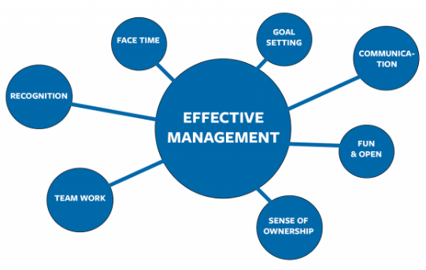
Figure 2: Determinants of leadership and management
(Source: http://www.trindent.com/7-factors-for-effective-management/)

3. Evaluation of behavioral approach to management
Researchers have shown that behavior of managers much change according to different factors. The trait theory suggests that, managers have individual personality which depends on some organizational aspects. These are as follow:

Occupational category and level in the hierarchy – In a large organization like the Mercedes Benz, same supervision level is not applied to all employees. The management professionals possess higher authority than regular employee which changes their behavior. People in the management hierarchy generally show significant autonomy in their functions (Shin and Konrad, 2017). They have freedom to make their own decisions and take initiatives. Hierarchy level also allows them to direct lower level employees towards company goals and objectives.

Inherent structure of Jobs: Another factor affecting individual behavior of managers is the inherent structure of jobs. It determines the coordinating mechanisms of managers such as direct supervision or mutual adjustments. Mercedes Benz is a Bureaucratic organization, in which jobs are highly structured. In this type of jobs, managers generally use direct supervision. It allows them to enforce autonomy while performing jobs.

Organizational and national culture – Organizational and national culture has a direct impact of people’s thinking, perception and the way of doing jobs. Amanchukwu et al. (2015) identified, it varies country to country and develops different insights and beliefs among people. Similarly, in business context, individual behavior of managers can be affected by organizational and national culture. For example – in autocratic culture, manager behavior changes more towards dictatorship. They expect that employees will perform only as per instructed.

Information and technological change – Technological changes are becoming common in every business sector. The management style is being changed due to the introduction of different management tools and software. Technology has automated many repetitive tasks of managers and changed the way they perform their jobs. Managerial activities have become more dependent on technology.

Conclusion
It can be concluded from this essay that, organizational structure, culture, people and its performance are strongly connected with each other. It is found from the examples of Mercedes that; the company implements an effective structure and culture. It also has a trusted and committed workforce.
These components have helped them improve their business performance over the years. The essay has also highlighted different theories related to these aspects such as SOC and COC theory, Hofstede’s Cultural Dimension Theory and the Fatehi Theory. It is identified that; leadership and management play a key role in organizations. Factors such as characteristic traits, leadership style, sense of teamwork and transparent communication are some key drivers of effective leadership and management.

Reference List
Alvesson, M. and Sveningsson, S., 2015. Changing organizational culture: Cultural change work in progress. Routledge.
Amanchukwu, R.N., Stanley, G.J. and Ololube, N.P., 2015. A review of leadership theories, principles and styles and their relevance to educational management. Management, 5(1), pp.6-14.
Benzer, J.K., Charns, M.P., Hamdan, S. and Afable, M., 2017. The role of organizational structure in readiness for change: A conceptual integration. Health services management research, 30(1), pp.34-46.
Bustinza, O.F., Bigdeli, A.Z., Baines, T. and Elliot, C., 2015. Servitization and competitive advantage: the importance of organizational structure and value chain position. Research-Technology Management, 58(5), pp.53-60.
Daimler.com, 2018. Mercedes Benz 2018 Annual Report Available at: https://www.daimler.com/documents/investors/reports/annual-report/daimler/daimler-ir-annual-report-2018.pdf
Eva, N., Sendjaya, S., Prajogo, D., Cavanagh, A. and Robin, M., 2018. Creating strategic fit: Aligning servant leadership with organizational structure and strategy. Personnel Review, 47(1), pp.166-186.
O'Neill, J.W., Beauvais, L.L. and Scholl, R.W., 2016. The use of organizational culture and structure to guide strategic behavior: an information processing perspective. Journal of Behavioral and Applied Management, 2(2), p.816.
Shanker, R., Bhanugopan, R., Van der Heijden, B.I. and Farrell, M., 2017. Organizational climate for innovation and organizational performance: The mediating effect of innovative work behavior. Journal of vocational behavior, 100, pp.67-77.
Shin, D. and Konrad, A.M., 2017. Causality between high-performance work systems and organizational performance. Journal of Management, 43(4), pp.973-997.

