Student Number: 2312265

Promoting the understanding of effective communication for young children’s learning and development during transitions.

Image: (The OT Toolbox, 2023)

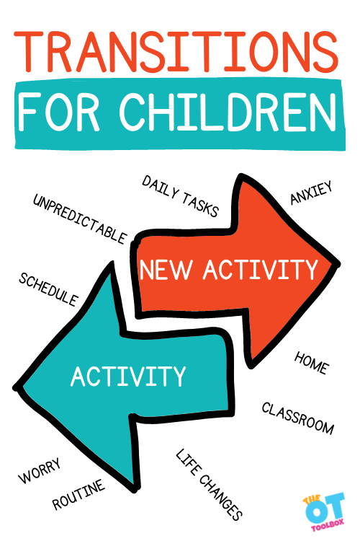

Contents Page
Section Title Page Number

- Introduction to transitions in the early years 3

- Role of the Adult 4

- Needs of a child 5 – 6

- Working in partnerships 7

- Interventions 8

- Outcomes 9

- Reference list 10 - 11

- Introduction to transitions in the early years

  - Aims
The aim of the handbook is to support all early year’s practitioners with transitions from early home life to starting in nursery and schools. Throughout the handbook, it will look at what transition is, the role of the adult, the needs of a child, working in partnerships, interventions and the overall outcomes.
  - What is transition?
According to Cambridge Dictionary, transition is “to change, or make someone or something change, from one form or situation to another” (Cambridge Dictionary).
Another definition of transition is from Flying Start. Flying Start Transition Guidance (2017) mentions that transitions are a key event or change through life. Examples of Flying Start transitions would be the child moving from home to one of their settings or from a health visitor to a school nurse. Furthermore, the guidance handbook also refers to the length of time it takes children to make a change. An example of this which is mentioned in the handbook is the pre-transition visits with parents or guardians to when they are fully enrolled children. Pre-transition visits gives the parents or carers the opportunity to meet the practitioners within the setting and socialise with other parents or guardians.
  - What is transition in the early years?
Transitions can sometimes play a big part in every child’s life and can come in many ways. Education Scotland (2017) gives examples of what transitions can be seen within a child’s life. These are moving from a home to an early year setting, from early years to primary school and from stage to stage within a school setting. Education Scotland also mentions what parents can do to help children transition as smoothly as possible. These include topics such as talking to them about what is going to happen, encourage them to ask questions and talk about any concerns they may have, share any concerns with the relevant people and finally, to help them become familiar with the setting they are transitioning to. All examples spoken about above show different ways that a child can be introduced to a setting and how transition can have a positive impact on both the child and family.

- The role of the adult

Throughout a child’s transition, adults play a big part in many ways. Adults can take up roles that are different from the roles they would usually hold. During transition, adults strive to be flexible and respond to children’s needs, help children to overcome any uncertainty they may have and to build individual resilience. There are several adults who play a part in a child’s transition. These are parents, teachers, nursery nurses, support workers and multi-agency workers, to name but a few. (Adult Roles in a Child’s Transition)
When adults help the transition periods of children, there are several processes which they should consider and undertake. Patel.A (2019), speaks about how adults should aim to build relationships with each other to enable positive transitions for the child in her article named The Teach Early Years. Parents like to ensure that they have a comfortable relationship with the practitioner that their child is transitioning to, to make sure the child settles well. Patel, also speaks about an appropriate handover that should be organised before a transition happens so that children’s needs are met and new relationships are strengthened.
In the same article, Patel (2019) also discusses that adults should create environments for children that encourage friendship building and development following a transition. It is important for children to feel safe and comfortable in the setting and that families are given opportunities to visit the new setting to help both them and the child to adjust.
Main. P (2022) outlines Vygotsky’s theory in depth and what each stage involves. Vygotsky’s theory links to the role of the adult and how adults can impact both learning and development during transitions. Lev Vygotsky is a psychologist whose theory highlights culture in a child’s development of their cognitive abilities. For example, reasoning and communication. According to Vygotsky’s theory, adults advance cognitive development in children by getting them involved in meaningful and challenging activities. His theory talks about three different stages which are cognitive, motoric and sociocultural. The cognitive stage is about ideas, motoric is about moving and sociocultural is about interacting with others. The theory suggests that every stage builds upon the one mentioned before and Vygotsky believes that adults learn from observing children, another way of describing this is by saying children ‘scaffold’ what they do. This theory can tell practitioners that they can support a child’s development and transition by watching what the child does, communicating with them, learning from it and then planning their next steps from what they have observed.

- Needs of a child

Throughout a child’s life, there are many obstacles that they will overcome. Everyone will have needs which need to be met. GOV.UK (2022) discusses ways that children’s needs can be met to achieve the best outcome. Firstly, the article mentions the importance of supporting children to build strong foundations. This would be to help them learn and thrive in different ways. Practitioners should get to know each child as thorough as possible to see how each one develops and at what rate. By doing this, practitioners are able to plan appropriate activities and curriculum activities to meet their needs.
Secondly, to build a clear picture of children’s needs, partnership working between the practitioner, Special Educational Needs Coordinator and any relevant agencies outside of the setting who may need to be involved with the child is important. This is so that every professional can make accurate assessments of the child and come up with various ways forward to support them. For children with additional learning needs, partnerships should be formed if children require special furniture to aid their needs. For example, this could be chairs to help with posture support or standing frames to help with strengthening muscles.
The final part of the article is all about resources to help support children. Practitioners should create a curriculum that supports the needs of all children which includes the children with additional learning needs. Practitioners can gather a variety of resources which can be tailored to individual needs and also set up daily interventions.
Kurt.S (2021) speaks about a hierarchy of needs being created by Abraham Maslow based on achieving goals in 1943. Maslow’s hierarchy is split up in to five levels. These five are physiological needs, safety needs, love and belonging, esteem and self-actualization which can be seen below in the image.
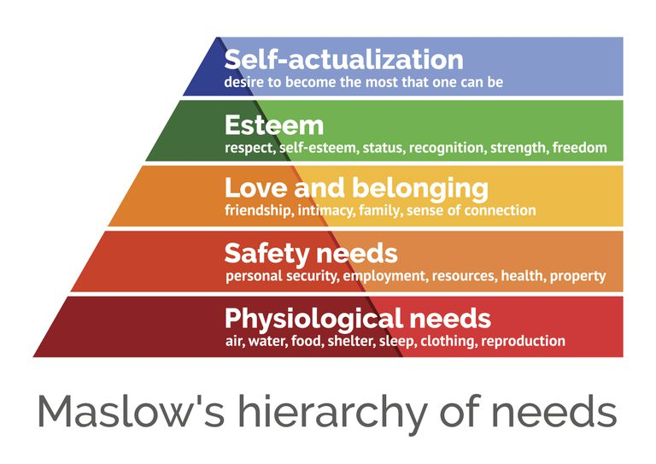
Image: (Education Library, 2020)

Each stage of the hierarchy starts at the bottom where actions will first satisfy the lower needs and over time will move up to the higher needs. The first four stages of can been seen as deprivation needs. Meaning, if those needs are not met sufficiently, it will encourage people to meet their highest needs. The final stage which tops the hierarchy, self-actualization, this is made up of all four of the stages below it to define a person’s overall potential.
Maslow’s Hierarchy can link to children’s needs in different ways. Each child has physiological needs which need to be met daily. Some examples of these needs are food, water, shelter and clothing. The next step in the hierarchy is safety needs. Children need to be kept daily and examples of this is personal security and health. The third stage which children require is love and belonging. This includes friendship, family, intimacy and connections. An important stage which children need in life is esteem. Children often thrive off respect, recognition, strength and freedom. This can be seen in both early years before they have started nurseries and schools and as they move through school life. The final stage of the hierarchy which children need in life is self-actualization. This allows them to be the best possible version of themselves. To achieve this, children need to have all of the first four stages before they can reach the top. Maslow’s theory builds a solid foundation for a child’s development for them to flourish and grow over time.

- Working in partnerships

Working in partnerships can play a big part in a child’s development and transition period. Every setting has a culture that is created by children, practitioners, parents and other outside agencies.
The Welsh Government (2008) expresses how significant adults are in a child’s life to allow the child to achieve the best outcomes. This means that adults are responsible for the upbringing of children and by being accountable for this, children can be supported to reach their full potential. Adults who play a part in this are not just parents, but nursery practitioners, teachers and other agencies.
Another article by GOV.UK (2021) talks about the benefits of good and strong partnerships between settings and parents and carers. The benefits of this are:

- Inviting the families to visit the setting so that they have a feel for the surroundings that they are letting their child join.
- Find out about their family and personal history.
- It gives them the opportunity to get involved in every step of their child’s transition and learning journey.
- Parents and carers can share the child’s interests with the practitioners so that they are able to help the child transition into the setting as positively as possible.
- Finally, practitioners can find out how best to support the child’s learning.

There are a wide range of ways in which parents and carers can have strong partnerships with practitioners in the setting. Some of which are by having daily conversations with them, volunteering at the setting once the child has settled in, phone calls home to parents from the practitioners, attending workshops which include parents, practitioners and child on the different areas of their learning.

- Interventions

NSPCC Learning (2023) explores interventions in the early years and how they provide support for children to help improve outcomes.
These early interventions are available at any stage in a child’s life from the early years, right through to their adolescence years. They can be provided for the parents, the individual child or the whole family.
In the same article, NSPCC Learning mentions how early interventions are important to identify and address a child or family’s needs as early as possible and can increase the factors that have a positive effect on a child’s overall wellbeing. Interventions before and during transition can come in different ways. These could be to:

- Protect children from harm.
- Improve children’s long-term outcomes.
- Improve children’s home and family life.
- Support children to develop strengths and skills to prepare them for adult life.

The Early Intervention Foundation (2018) describes what four areas early interventions focus on when supporting a child’s development. The four different areas are physical, cognitive, behavioural and social and emotional. These have the capability to achieve the biggest difference in a young person’s life.
Physical development involves a child’s physical health and maturity and forms the basis for positive development in other areas. Intervention activities can include improving birth outcomes and reducing childhood obesity.
Cognitive development includes children’s development of speech and language, the ability to read and write and their numeracy and problem-solving skills. Interventions of this area can include standardised tests and school achievements.
Behavioural development involves children being able to regulate their behaviour, attention and impulses and monitor it. Interventions in this section can involve reducing antisocial behaviour and aggression in the settings.
The final area is social and emotional development. This includes a child being aware of their own emotional needs and the needs of others around them. Interventions in this area help a child become more social with others around them, improve self-esteem and reduce the chances of child mental health problems.

- Outcomes

To conclude the overall assignment, practitioners should be able to observe how the role of the adult, the needs of a child, working in partnerships and interventions all create a positive and effective outline for children’s learning and development during transitions.
Having a clear understanding of what a transition is will help practitioners identify what they can do to help and further a child’s learning. Two separate sources which were looked at were from Flying Start and Education Scotland. Both sources show similarity as both discuss the different types of transitions and the impact all families can have.
Practitioners should strive to recognise how reassuring their involvement can be to children during transition. An article which was looked at describes the way in which adults should aim to build a positive and confident relationships with children, as well as creating engaging and encouraging surroundings for them to learn and thrive in. Psychologist, Vygotsky, has a theory which discusses how adults can help develop cognitive skills within children by setting out a range of activities to challenge them.
Throughout a child’s life, there are different needs that a child requires to develop. These needs were looked at in an article by GOV.UK. The article talks about three separate ways in which a child’s needs can be met. A theory which was looked at was Maslow’s Hierarchy of Needs. The hierarchy has five levels which discuss different needs that everybody is entitled to. Each section of Maslow’s hierarchy links to a child’s development and their transition.
Partnership working is something that practitioners should carry out professionally. In an article which was looked at by Welsh Government, they give examples of the adults who work in a partnership to help children reach their full potential. Another article by GOV.UK looked at the benefits of strong partnership working between families and the setting. Each benefit not only supports the partnership, but the transition to.
Finally, the assignment has looked at reasons why interventions should take place and four areas the interventions focus on to support child development. The four areas are physical, cognitive, behavioural and social and emotional.

- Reference List
“Adult Roles in a Child’s Transition” FutureLearn, www.futurelearn.com/info/courses/coping-with-changes/0/steps/160348#:~:text=Keep%20in%20mind%20that%20during.
(Date Accessed: November 10th 2023)
Cambridge Dictionary. “TRANSITION | Meaning in the Cambridge English Dictionary” Cambridge.org, 29 Jan. 2020, https://dictionary.cambridge.org/dictionary/english/transition
(Date Accessed: November 8th 2023)
“Early Help and Early Intervention” NSPCC Learning (2023), https://learning.nspcc.org.uk/safeguarding-child-protection/early-help-and-early-intervention#:~:text=Why%20are%20early%20help%20and,impacting%20a%20child's%20life%20negatively.
(Date Accessed: 24th November 2023)
Flying Start (May 2017). “Transition Guidance” https://www.gov.wales/sites/default/files/publications/2019-07/flying-start-transition-guidance-for-professionals.pdf
(Date Accessed: 20th November 2023)
GOV.UK. “Meeting the Needs of All Children - Help for Early Years Providers - GOV.UK” Help-For-Early-Years-Providers.education.gov.uk, 2022, http://help-for-early-years-providers.education.gov.uk/get-help-to-improve-your-practice/meeting-the-needs-of-all-children
(Date Accessed: November 16th 2023)
Kurt, Serhat. “Maslow’s Hierarchy of Needs in Education” Education Library, 2020, http://educationlibrary.org/maslows-hierarchy-of-needs-in-education/.
(Date Accessed: November 16th 2023)
Main, Paul. “Vygotsky’s Theory” Www.structural-Learning.com, 18 Oct. 2022, www.structural-learning.com/post/vygotskys-theory.
(Date Accessed: 21st November 2023)
Patel, Anjali. “Supporting Transitions in the Early Years” Teach Early Years, Teach Early Years Magazine, 2019, www.teachearlyyears.com/a-unique-child/view/supporting-transitions-in-the-early-years.
(Date Accessed: November 12th 2023)

“What Are Transitions? | Transitions | My Child | Parent Zone” Education.gov.scot, 1 Jan. 2017, https://education.gov.scot/parentzone/my-child/transitions/what-are-transitions/#.
(Date Accessed: November 8th 2023)
“What Is Early Intervention?” Early Intervention Foundation, 8 Jan. 2018, www.eif.org.uk/why-it-matters/what-is-early-intervention#:~:text=Early%20intervention%20approaches%20often%20focus.
(Date Accessed: 24th November 2023)
Welsh Assembly Government (2008) “Framework for children's learning for 3-7 year olds in Wales”. Cardiff: WAG.
(Date Accessed: 22nd November 2023)
“Working in Partnership with Parents and Carers - Help for Early Years Providers - GOV.UK” Help-For-Early-Years-Providers.education.gov.uk, 2021
http://help-for-early-years-providers.education.gov.uk/get-help-to-improve-your-practice/working-in-partnership-with-parents-and-carers
(Date Accessed: 22nd November 2023)

Image: Beck, Colleen. “Transitions for Children” The OT Toolbox, 27 Feb. 2023, www.theottoolbox.com/transitions-for-children/.
(Date Accessed: November 8th 2023)
Image: Education Library, 2020, http://educationlibrary.org/maslows-hierarchy-of-needs-in-education/.
(Date Accessed: November 16th 2023)

