Understanding and engaging in the customer experience
BMSW5013

BA (Hons) Leadership and Management – Skills for the Workplace University of Wales Trinity Saint David

February 25, 2022
Authored by: Zujaja T Kharal 1919419

Understanding and engaging in the customer experience

BMSW5013

Executive Summary
CRM can be simplified with this Quote “It makes me smile when people call Club card an outstanding loyalty program. In reality, a loyalty program by itself is insufficient, neither a TV commercial nor a promotion can guarantee loyalty. What counts is the entire customer experience. (Phillips, 2008).”
The research found that CRM can be as simple as 123 depending on the mood and trends or as difficult as a cup of tea on a rocking boat, the secret is a focus point, adaptability to quick change and application of the right tools. Nevertheless, keep a cushion (a saucer) to fall on and get up quickly to avoid crushes (spilling).
Tesco has somewhat improved its trust and communication with its stakeholders by keeping commitments and fulfil its promises. But it can’t be said that Tesco has done a very good job as the graph on page 5 & 6 tell the true story, but it won’t be wrong to say that Tesco is trying its best to keep its place constant in the current market. Introducing more products such as Tesco Bank, Tesco insurance over the years has increased customers comfort and loyalty. Tesco actively participate in sustainability, examples can be found on page 7 of this report

- Introduction
As requested by the Chief Executive Officer of Marketing Week (an online journal) published by Tesco, this report is being written to explore the impact of ethical trading and sustainability policies and practices on Customer Relationship Management performance. Contribute to this research by composing a report that outlines:
- Ethical policies and practices
- Sustainability policies and practices
- Influences of segmentation and the loyalty ladder

This report is a detailed analyze of a customer experiences of a company to develop and maintain good customer relationships by evaluating the benefits and challenges by critical thinking when it comes to quality management in the workplace supported with examples of current good practice from other organizations based within the same sector.
This report is being written in the month of February to be presented to Maria Heffernan (Lecturer) / Christian Felices (internal Verifier) on 25th of February 2022 by Zujaja Tabassum Kharal Student ID 1919419.

- Findings
It all started in 1960 as customer loyalty currency in face of Green shield stamps (Phillips et al., 2008), from 1963 who ever shopped at Tesco was rewarded with a sheet of stamps, customers would lick and stick the stamps in a book also bought from Tesco, once the book was filled with the stickers it could be exchanged with different kind of gifts such as garden tools, transistor radio etc.
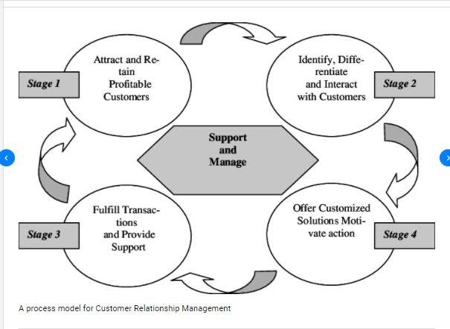
( Kadiyala & Srivastava)
Every organization needs marketing to reach its target customers. The focus of this report is on Tesco stores, Tesco is a very customer-oriented organization and one of the largest retailers in the region selling a wide variety of household goods. Retail businesses are characterized by direct contact with their customers, so Customer Relationship Management (CRM) is critical to the success of these businesses.

By gaining a deeper understanding of the customer and their needs, as well as their buying behaviour, purchase habits, and other factors influencing the customer's purchase, CRM enriches and enhances the relationship an organization has with its customers.

Ethical policies and practices

The Tesco brand was first introduced in 1924. Tesco was founded by Jack Cohen, a Jewish emigrant from Poland, who began selling surplus groceries in 1919 at Well Street Market, Hackney. A shipment of tea, bought by Jack Cohen from Thomas Edward Stockwell, gave him the name. Labels bearing the supplier's name (TES) and his surname (CO) were created, forming the word TESCO. In Burnt Oak, Edgware, Middlesex, Tesco opened its first store in 1929. The London Stock Exchange listed Tesco Stores (Holdings) Limited in 1947. There were first self-service stores in St Albans in 1956, the first supermarket in Maldon in 1956, and the first self-serve store in St Albans in 2010 (which remained open until 2013 before moving to larger premises on the same street). (2020)
Sustainability policies and practices

Below is the chart to see the percentage change in sales at Tesco in Great Britain compared in recent years.
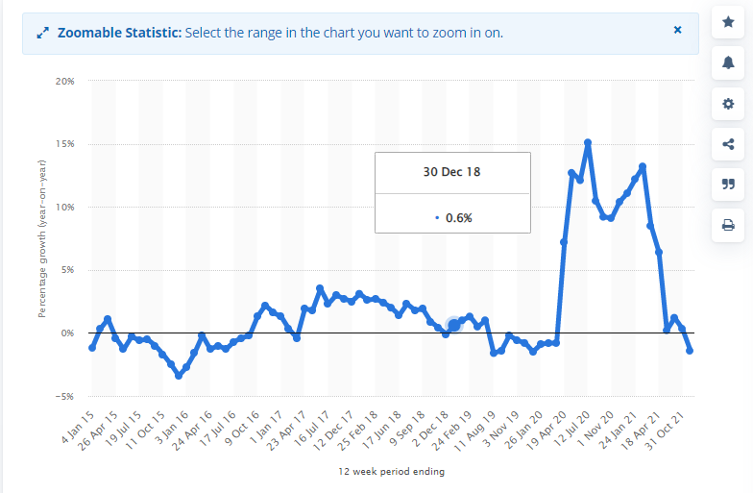 (Bedford, 2022)

The chair man of Tesco (the supermarket that dominates the sector) Mr John Allan shows his concern toward the customers on the lowest income in the interview given to BBC on 06th of February 2022, and explains how Tesco is continually trying ways to help as he predicts that worst is yet to come as food prices might increase by 5 percent.

According to Mr Allan Tesco has very active and good commodity research group who tracks the pricing of the ingredient which go into the food to justify the price from the supplier and to the customer. he also ensure that Tesco is and will keep on pulling the prices down where ever it can and also helping 5700 local charities by providing the surplus food available to them as well as given £90m in recent years the different knowledge groups and local projects to educate customers about food wastage and how to prevent it happening .

Mr Allan shows his value toward the employees and says that Tesco will not hold up the employees pay rise and will go ahead with it even if government is asking or enforcing not to for the sac of inflation rate (2022).

As part of its loyalty scheme, Tesco Club card includes a rewards program that goes beyond the simple relationship between Tesco and its customers. In this way, a brand or relationship web introduces customers and other businesses, and thereby builds brand experiences for each.

Tesco collects Customer data through Club card, online customer accounts, shopping, Apps and communication mediums like phone, email and social media to strengthens its relationship with customers.

Data mining helps Tesco analyse and process the data, making it easier for the business to interact with customers and future clients, that way Tesco or any other company can study historical data and information about their customer and input them into the tool for a better process. (United Kingdome 2014).

According to the statistics below, the following list of leading supermarkets in the United Kingdom (UK) in 2017 is based on customer satisfaction with their in-store experience: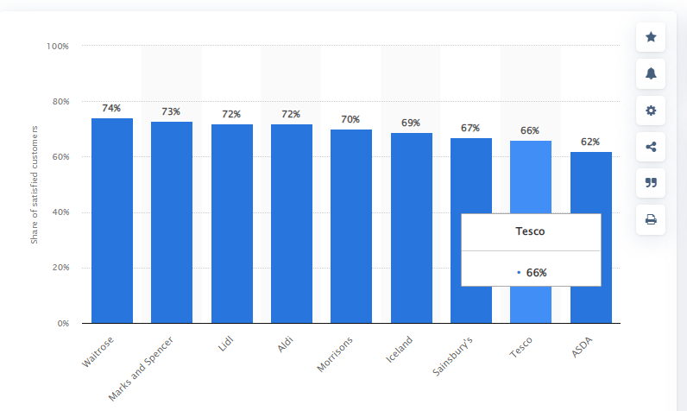

(Bedford & 14, 2022)

Some Examples of Sustainability at Tesco
- From March 14, all plastic baby wipes will be scrapped by Tesco.
- Tesco is testing a plant-based method of keeping fruit fresh for up to twice as long. Since launching its 4Rs - Remove, Reduce, Re-use, Recycle - packaging strategy,
- Tesco has now removed more than one and a half billion pieces of plastic from its business in the UK. With its 2190 defibrillators,
- Tesco has become the first UK retailer to start registering them in a new national database. This could improve cardiac arrest survival rates in the country. This is the largest addition of defibrillators to the database so far.
- Tesco has introduced accessible cards priced at just $1.50 to help those with visual impairments celebrate. As the cards feature dedications to ‘My Husband’ and ‘My Wife’, along with ‘Be Mine?’, anyone feeling the romance is encouraged to share the moment on Valentine's Day. Additionally, the range includes cards to the ‘Amazing Friend’ and the 'One I Love', so customers can give gift cards to all the people they care about.
- With over 900 stores now collecting soft plastic for recycling, Tesco has rapidly expanded the number of soft plastic collection points. Currently, over 850 tonnes of soft plastic have been collected and several recycling solutions are being developed with partners.

2.3 Influences of segmentation and the loyalty ladder

In their Little Helps Plan, published a year ago, Tesco has already demonstrated its commitment to its customers, the communities it serves, and the environment. Tesco has pledged to eliminate deforestation from their products by 2020 and to make their packaging fully recyclable or compostable by 2025. To achieve this goal Tesco has partnered with WWF to accelerate their progress towards these environmental targets. The work will focus on three key areas: helping customers to eat more sustainably, restoring nature in food production and eliminating waste. (WWF).
Tesco is the target of several ethical issues highlighted by Ethical Consumer (a not-for-profit, multi-stakeholder co-op based in Manchester), including climate change, palm oil, environmental reporting, habitats and resources, pollutions and toxics, human rights, worker's rights, irresponsible marketing, animal rights, animal testing, factory farming, use of controversial technologies, political activities, and anti-social finance.
The report also informs that Tesco and other supermarkets, including Marks & Spencer, Sainsbury's, and Asda, ordered their food from farms where gang-controlled workers worked, but "the companies involved say they did not know the workers were being exploited, and several said they only learned the truth after being contacted by journalists.
Although Tesco sells a wide range of own-brand electronics, it does not hold a policy on conflict minerals. Specifically, these are minerals mined in conditions of armed conflict and human rights violations, particularly in the eastern provinces of the Democratic Republic of Congo. It is necessary for any company manufacturing electronics to have a policy regarding conflict minerals.
When it comes to envoirment Tesco received worst rating in September 2019 from Ethical Consumer as company had no policy on the use of toxic chemical in its electronic products.

The fixed cut off date for animal testing of own-brand products was removed for the company in August 2019, which resulted in an unexpected dip in the company's animal testing rating. Despite this, Tesco continues to sell products branded by companies that still test on animals.

Shareholder groups raised concerns about Tesco's remuneration report in 2015, which revealed it paid its CEO Dave Lewis £4.13m in bonuses for his first six months of work and a £1.2m payout for his predecessor who oversaw dives in sales and profits.

According to a September 2019 report, Dave Lewis received £4,600,000 between 2018 and 2019. In the Anti Social Finance category, Tesco lost half a mark since we consider amounts over £1,000,000 a year to be excessive. (2020)
  - Tesco Loyalty Ladder

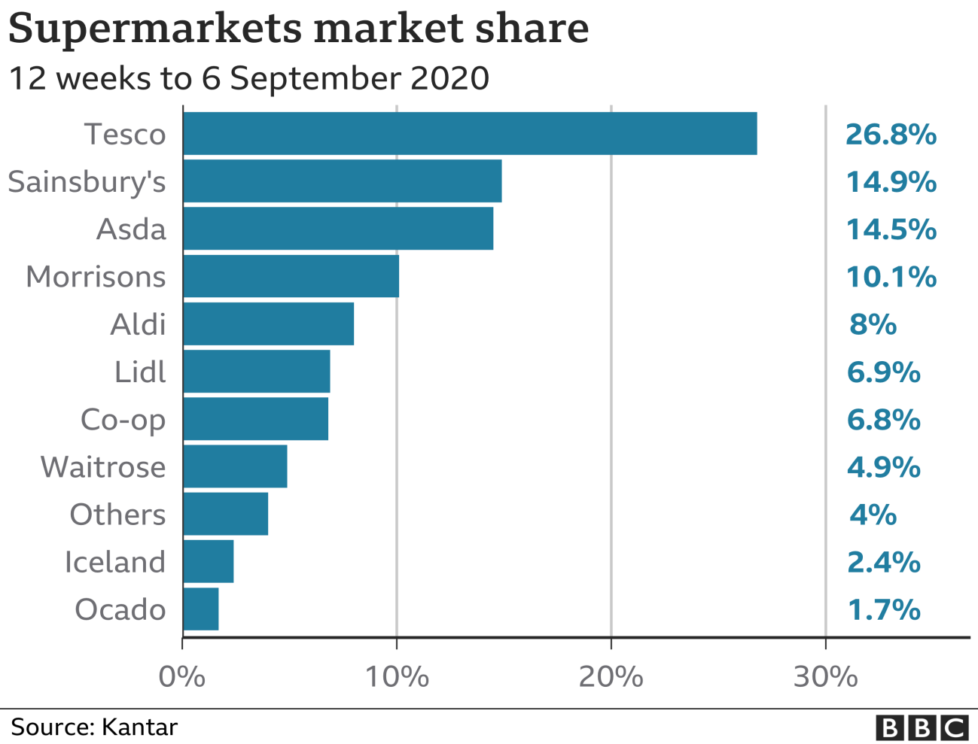
Requirements of Relationship Marketing are all about making bridge between buyer and seller, which is characterized by Trust, and commitment (Morgan and Hunt, 1994) Communication and promise fulfillment (Gummesson, 1994). Trust is the first aspect of relationship in any field of life, trust increase dedication to maintain relationship and make the relation strengthen which ultimate result is success of relationship marketing. Trust means that customers are loyal to the company whereas, Commitment is considered as a compliment in buyer seller relationship and important for distinguishing between “stayers” and “leavers” (Wilson and Munmalananeni, 1986). Commitment considers the important variable for strong relationship marketing and useful tools to measuring loyalty of the customer. So, affective commitment helps to remain customer with the organization due to strong emotional bonding with the organization. Communication is another important aspect of Relationship Marketing. Communication implies that the ability of discharging information to the customer, but it has to be timely and trustworthy. Communication is the important way to building awareness, understanding customer preference, convenience for the customer, and motivate to repeat purchase. An effective communication between customer and company helps to build strong relationship and result in more loyalty to the company.
Promise fulfillment: Gronroos (1994) strongly emphasize the fulfilling promises for the strong relationship with customer. An organization generally attract new customer by giving preoccupied promises, however, if the organization breach the promises that badly affect on developing and maintaining evolving relationship. A promise fulfilling has significant contribution to provide high level customer satisfaction which led to be loyal to the organization that ensures the profitability.

In what ways does TESCO segment its customers, and how does it use the loyalty ladder to improve customer relationship management?
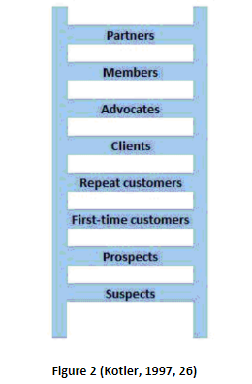
Tesco's health and beauty range use experiential positioning to attract customers. An alternative form of positioning, multi-segment positioning targets several segments at once with multiple products. Tesco uses multi-segment positioning extensively.

Different supermarket chains in the UK target different customer segments. As an example, Waitrose supermarket chains have a target customer segment of individuals who prioritize quality over price. Therefore, Waitrose stores are more spacious than many other supermarkets, and this extra space comes at an extra cost for consumers.
In addition to Tesco and Waitrose, Lidl and ALDI serve different customer segments. Specifically, Lidl has a more cost-effective strategy than Tesco, and as a result, Lidl's target customer segment includes individuals that may be willing to compromise on quality for price.
Consumer behaviour has a direct impact on marketing activities across a wide range of buying situations. In the UK, the recent pandemic, financial and economic crisis had some implications on consumer buyer behaviour, reducing consumer spending. The focus of Tesco marketing management has been to address this specific change in buyer behaviour through integrated marketing communication practices that emphasize cost-effectiveness.
In order to position a product appropriately and effectively, it must take into account all elements of the marketing mix. Targeting the target customer segment is one of Tesco's positioning strategies.
Tesco Finest products are sold using functional positioning. In this way, the high quality of this range of products serves as a key advertising point for certain segments of the market. Tesco's functional positioning products are generally more expensive in comparison to their basic ranges because higher quality and improved functionality can only be achieved at a cost.
Symbolic positioning is Instinctive, based on the values and aims and endeavour customers. This type of positioning is utilised by Tesco in relation to its Fair Trade range of products in the food and grocery sector. In relation to clothing products as well by refusing the use of cotton grown in countries where child labour is used in cotton production. Tesco sells Fair Trade product range to a narrow customer segment for higher prices so satisfy their self-perception as responsible buyers.
Price positioning, the company maintains an affordable price for its products and service and does not compromise on quality by continuously working with its supplier to make the supply chain efficient to reduce the price
Experiential positioning is used by Tesco to target customers for its health and beauty range
Multi-segment positioning is used by Tesco to target several segments at the same time with different products and services, with this positioning Tesco offer its customers a verity of choice in not only price but quality and satisfy their need under one roof, it also helps Tesco keep its customer and keep the customer happy.

Tesco offers shoppers the ability to create their own Web fashion space, its biggest venture into customer relationship management (CRM). Clothing at Tesco has created Fashionphile, an interactive fashion program, in partnership with Warl. It aims to provide an online loyalty program to over 600,000 Tesco customers, as well as members of the Save in Style program. The database members will automatically become members of Fashionphile and be invited to open their own online space through an email program. (IN BRIEF,2007).

3.1 Conclusion

As per the studies and research conducted in this report it is learned that Tesco’s CRM program is one of its most important features, which enables segmentation of customers according to how they spend in store. Tesco prioritizes clients based on the amount of business they bring to the store. It launched its club card in 1995.
Tesco uses customer analysis as well as grouping customers into hundreds of different segments based on factors like regency, value, frequency, lifestyles, promotional responsiveness, lapse rates, coupon redemption, and behavior among others as a tactic to increase sales.

The Tesco Club card also has some additional advantages, including the ability to buy goods and services from other retailers at Tesco Club card points; the use of reward points in a variety of leisure and other outlets; and the e*loyalty component.

Tesco need to decide what rewards customers are most likely to value. How can company create a gold standard currency, customers will be enthusiastic about collecting and using? Loyalty currencies can be categorized into four types: points-led, discount-led, information-driven, and privilege-driven. Most major loyalty programmes offer all four benefits together to create a rounded benefits package for their members. (Phillips et al., 2008)

4.0 Recommendation
- The making of Tesco : a story of British shopping
Sarah Ryle author
2013; Bantam Press

(Ryle, 2013)

Book: Scoring points: how Tesco continues to win customer loyalty

Humby, Clive

6.0 Reference
Anon, 2020. Tesco. CompaniesHistory.com - The largest companies and brands in the world. Available at: https://www.companieshistory.com/tesco/ [Accessed February 9, 2022].
Anon, 2022. Sunday morning feb 6 2022 #sundaymorning #marr. YouTube. Available at: https://www.youtube.com/watch?v=HBG2y-cp9cs [Accessed February 9, 2022].
Anon, 2020. How ethical is Tesco plc? Ethical Consumer. Available at: https://www.ethicalconsumer.org/company-profile/tesco-plc [Accessed February 28, 2022].
Bedford, E.B., 2022. Tesco sales growth Great Britain 2021. Statista. Available at: https://www.statista.com/statistics/386598/tesco-sales-percentage-change-great-britain-uk/ [Accessed February 9, 2022].
Bedford, E. & 14, J., 2022. Customer satisfaction rates of leading supermarkets 2017. Statista. Available at: https://www.statista.com/statistics/661074/customer-satisfaction-loyalty-index-uk/ [Accessed February 28, 2022].

Gummesson, E. (1994) “Broadening and specifying relationship marketing” Australia marketing journal, 2(1), pp.31-43.

IN BRIEF: Tesco launches fashion CRM strategy. 2007. Precision Marketing, , pp. 5.
Kadiyala, S.S. & Srivastava, A., A process model for customer relationship management ... Available at: https://researchgate.net/figure/A-process-model-for-Customer-Relationship-Management_fig2_297898260 [Accessed March 1, 2022].

Kotler, P. (1997) ‘Method for the millennium’, Marketing Business, February, p 26
Morgan, R. M. and Hunt, S. D. (1994) “The commitment-trust theory of relationship Marketing”,Journal of marketing, 58(1), pp. 20-38.
Phillips, T., 2008. In Scoring points - how Tesco continues to win Customer Loyalty. Kogan Page Ltd, pp. 5–5.
Phillips, T., 2008. In Scoring points - how Tesco continues to win Customer Loyalty. Kogan Page Ltd, pp. 20–21.
Phillips, T., 2008. In Scoring points - how Tesco continues to win Customer Loyalty. Kogan Page Ltd, pp. 33–33.
Ryle, S., 2013. The making of tesco: A story of British shopping, London: Bantam.
United Kingdom : TESCO contacts major CRM agencies for input on loyalty program. 2014. MENA Report,

Wilson, D. T. and Mummalanen, V. (1986) “Bonding and Commitment in Buyer –seller relationship: A preliminary conceptualization”,Industrial marketing and purchasing, 1(3), pp. 44-58.
WWF, W.W.F., Three ways we're fighting for Your World with Tesco. WWF. Available at: https://www.wwf.org.uk/updates/three-ways-were-fighting-your-world-tesco [Accessed February 28, 2022].

