The Impact of Virtual Learning Environment (VLE) – Moodle on students’ learning experience at the University of Wales Trinity Saint David London Campus.

Module Title: Digital Skills and Research Methods

Module Code: BMSW4003

Student’s name: Ovidiu-Dragos Stinga

Student’s ID :1906862

Lecture’s Name: Amitave Banik

Introduction

VLE stand for Virtual Learning Environment and is represented by a series of tools which provides a delivery mechanism, enable management of online learning, student tracking, assessments, and access to resources for essays and reports. VLE is providing areas for participants to engage in asynchronous communication, provide learning material in HTML or other Web-based technologies or allow assessment of the students. The internet offers new ways of communicating, flexible access, facilitate the communication between students and lecturers, however for the lecturers to set in place creative materials to captivate the attention of the students can be time consuming and require considerable expertise. All the applications that permits the interaction with the computing environments and the work of other users, like Moodle, Blackboard, Web CT, chat, email or document sharing applications are all examples of virtual environments. Moodle is a web-based platform implemented for the aspect of digital courses of study with theoretical resources, providing interactions and activities within a course structure, which include different stages of training and assessment. The environment created by Moodle is designed to help teachers in facilitating the education activities for their students, especially by helping teachers administrating and managing their courses.

Methods

The concept of Virtual Learning was established to change the student’s passive learning to active learning. The critical thinking is a necessary skill that need to be gained in order to implement the active learning. Critical thinking means to objectively evaluate and analyse an issue to get to form a judgement. In nowadays, it can be one of the most important skills that someone can develop because is a way of thinking in which the person have an attitude which involves questions arguments and conclusions and not simply accept all the conclusions and arguments on a certain topic. In addition to have a critical thinking, the scepticism, the curiosity and humility are to core skills that need to possess and use. The reasons of this report are to demonstrate the impact of Virtual Learning Environment using Moodle based on student’s learning experience, to show that can effectively increase communication between students or with their lecturers and to explain why the students need to adapt and use Virtual Learning especially in the pandemic situation the world is facing in 2020. In addition, the report will show how the Virtual Learning can improve the life of a student or a professional gaining new skills and aptitudes based on Autodidacticism using search engines like Google and YouTube. This report will use Primary Data collected from the University of Wales Trinity Saint David London’s students using a questionnaire formed from nine carefully chosen questions to reveal the student’s opinion and how they handle the Virtual Learning Environment in University’s context. In addition, the questionnaire will reveal the percentage of students that prefer to study online and the percentage that prefer a face to face approach, how often VLE is accessed in order to complete an assessment or to study a topic and in the and to conclude if the VLE improved the learning experience. The second method which will be used is Secondary Data which represent data already collected through primary sources and made it available for people to use it for their own next research, basically this type of data can be collected before by somebody for a specific project or just in general and made it available for the rest of the public. The type of Secondary Data can include government records, websites, books, journals, newspapers or personal sources.

Results

Primary Data

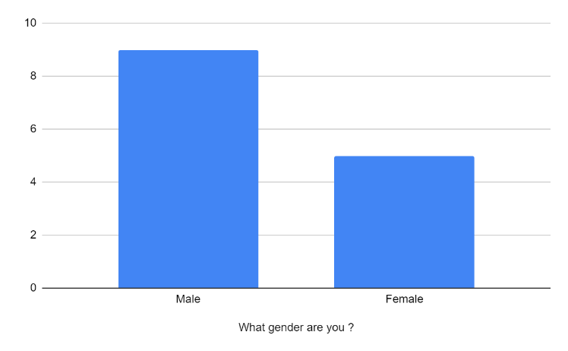
In the graph attached below we can clearly see that most of the students are males and there are only 5 are females. Which means in this specific course there are more males that female enrolled for The Certificate of Higher Education in skills for the Workplace.

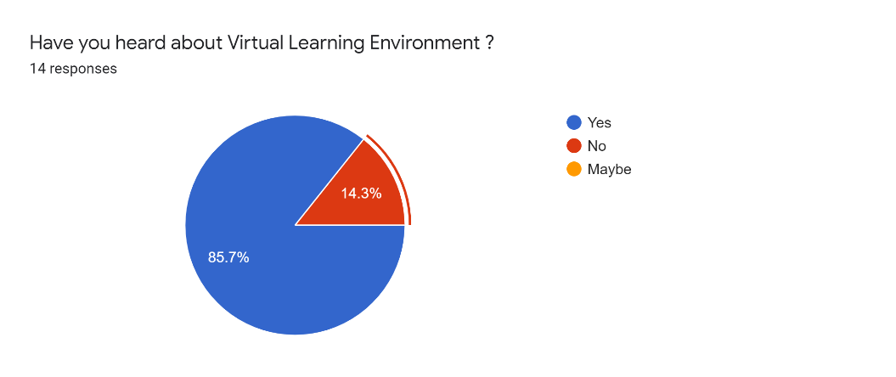
After finishing the questionnaire on the students from the University of Wales Trinity Saint David London, from the results can tell the majority of the students heard about the term of VLE and just two persons were unaware of this term, representing just 7.2% from the total on the people who have been interrogated.

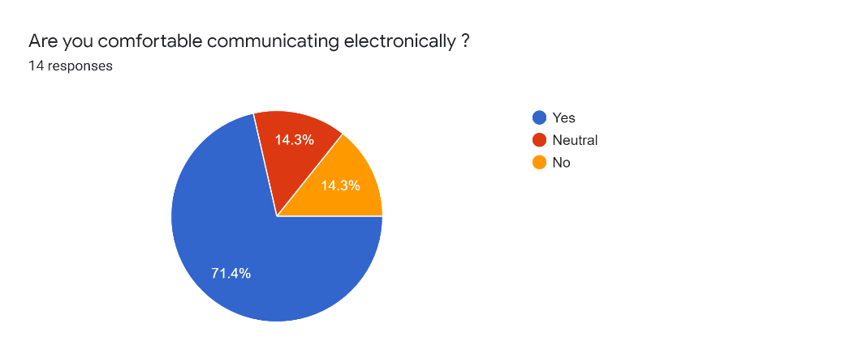
Here, most of the students which represent 71.4% responded that is easy for them to communicate via email, social media and Moodle. Whoever for 14.3% of them represent a difficulty to communicate in the virtual environment and 14.3% said for them is neutral meaning that they struggle sometimes but not often.

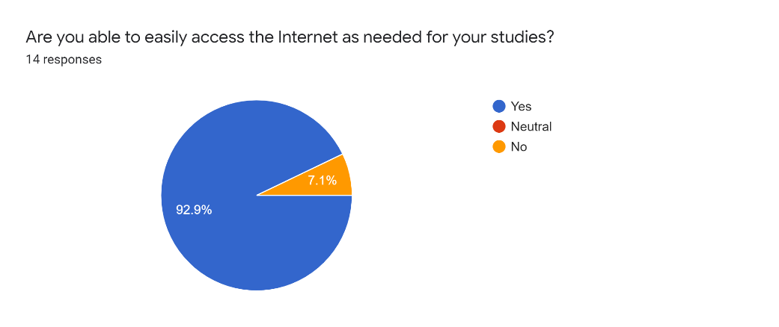
In the next question most of the students responded that they can easily access the internet in order to study and do their assessments.

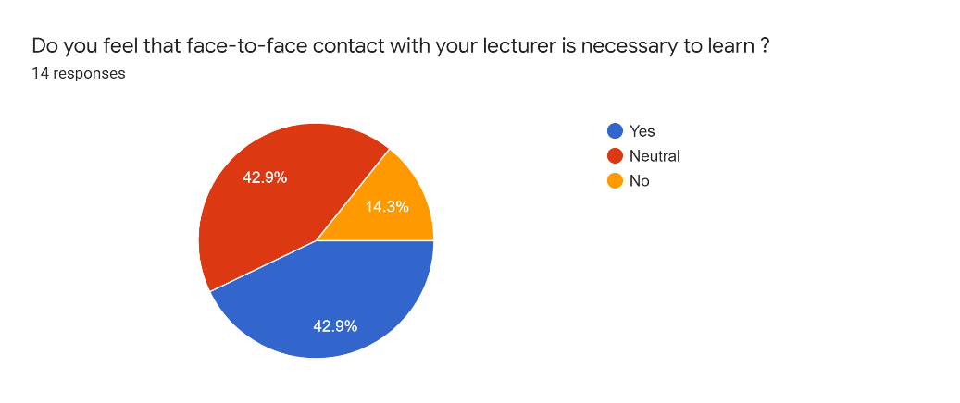
When asked if is necessary the face to face approach with the lecturer in order to learn better and to be more proactive, the same amount of students responded with Yes and Neutral, meaning that a good percentage appreciate more the old face to face approach which it used to be before the Covid-19 Pandemic and only just 2 of them responded with No, that is not necessary to return to the old fashion way of teaching.

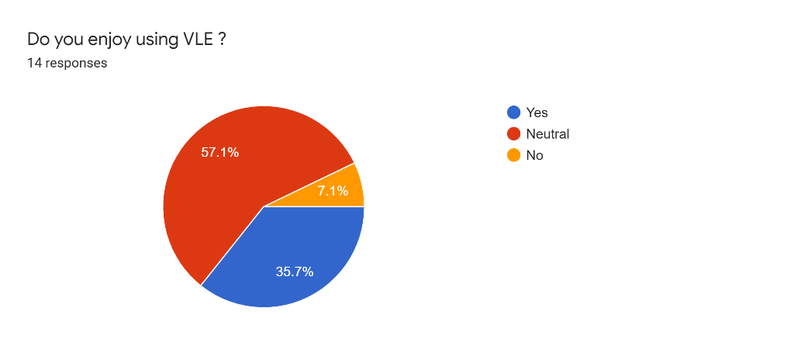
This question strengthens the previous one which show that the majority of the students are neutral when using VLE and because the majority of the current students are born in the age of technology and do not represent a joy but neither a pleasure to use VLE. With only 35.7% of students that really enjoy this virtual environment and just 7.1% do not enjoy using Moodle and supported the previous question with the face to face teaching.

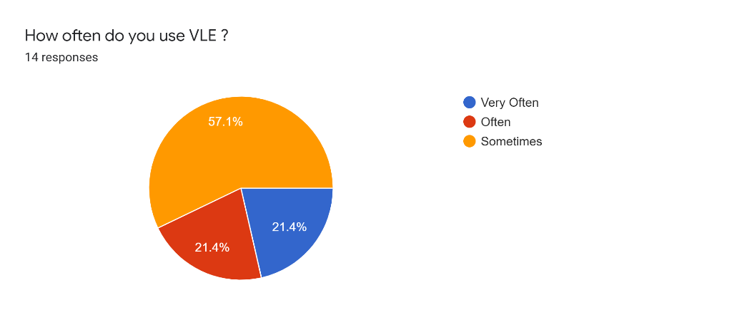
When they have been asked about how often they use VLE the majority of 57.1% responded that sometimes use the Moodle to research and learn from websites. With only 21.4% that use the VLE very often is and 21.4% that use it often.

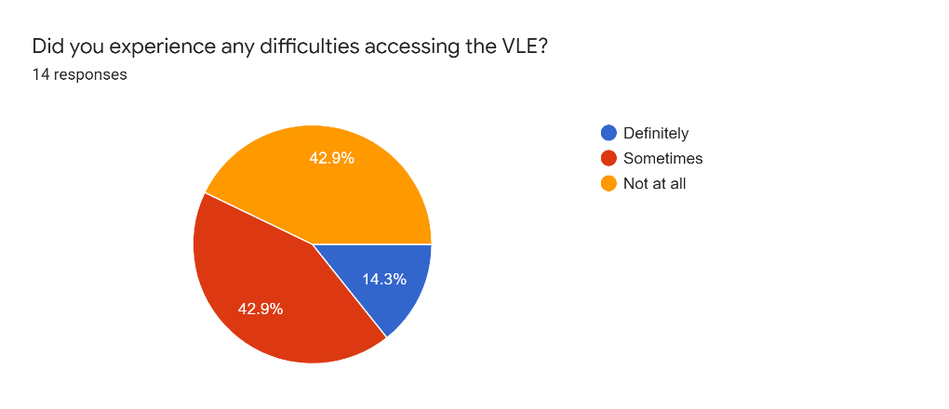
In this chart can see 42.9 % of the students do not have problems accessing the virtual learning environment, in this example accessing Moodle. The other majority is represented by 42.9% of students that admit they have difficulties sometimes and only 14.3% said they definitely experienced difficulties using Moodle and the experience of virtual environment is hard for them.

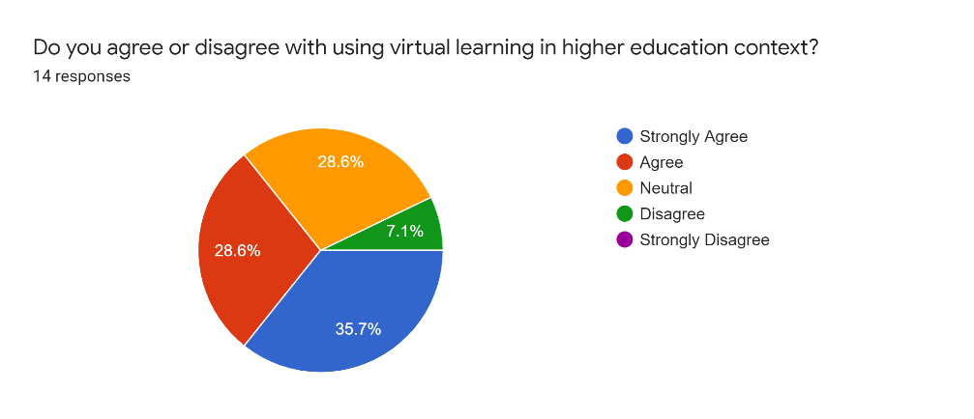
The students were asked if they agree or disagree with VLE in higher education context, and the majority of 35.7% strongly agreed, and 28.6% agreed, representing 64.3% pointing that is necessary in higher education and can help the students to their research and learn easier than before. The next 28.6% responded with neutral, which means these students like the Virtual Environment but do not mind learning and research in the library.

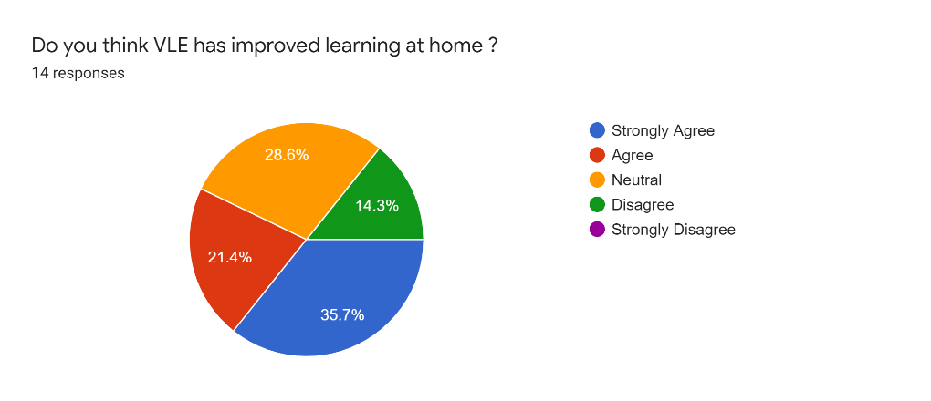
Based on the final question, after the overall experience with virtual learning experience the students were asked if the VLE improved their learning from home and the majority of 35.7% percent responded strongly positive and 21.4% positive. The rest of 28.6% of students responded with neutral which means they did not feel a difference and 14.3% disagreed with the virtual learning environment.

Secondary Data

The current pandemic situation forced most of the schools and universities to switch their form of teaching in a virtual environment. This situation comes with many advantages for the students and professor such as mutual support, flexibility, continuity but also comes with disadvantages as well such as the difficulty to ensure that all the eyes are pointing to the lecturer and the engagement is difficult to maintain. Based on an online survey that reveals the opinion of 67% of lecturers saying that in this period was the first time when they experienced online teaching, 25% having some previous experience and just 6% having massive experience. (SchoolEducationGateway, 2020)
According to (Kelly, 2020) students are not pleased with some points about the virtual learning environment. First thing the students are affected by is the social interactions experience, the humans are social creatures, so it understandable that some of students can develop things like worry, anxiety or annoyance. More than 85% of the students pointed that they miss the interaction with the other students, the virtual environment decreased their ability to stay connected with other classmates and more than 50% of students reported that they are impacted by the lack of regular access and interaction with their classmates. The second thing reported by students is the increased difficulty to complete multiple tasks for every course. Taking into consideration most of the students live with roommates or with their families and cannot go anywhere, lead to noisy and distracted courses during the University term and 24% of them reported bad connection to the interned during the courses and experienced difficulties when learning online and because of this lack of good internet connection most of them started to develop some sort of anxiety and worrying about their ability to study and pass the term. Another thing that students complained about, is the engaging experience, the lack of engaging in-class experience affected the majority of the students reporting that 77% chose the in-class courses. It can be that some of them are not comfortable to used tools such as Zoom or Microsoft Meets to engage effectively, or it may be that the University need to find more effective engagement techniques.
After one full semester of online study, most of the students are decided to continue their studies and continue to attend school even if it is online but one third of the students is experiencing confusion and the lack of engagement or the fear of not being able to afford the tuition fees in this time of insecurity. In addition, the rest of the students said that is unlikely, very unlikely to attend the next year of University and they did not commit to return to their Universities. However, when asked about carrying on with the studies, some of the students asked if they can extend their fall tuition fee because the unemployment in the family or because of the tight family budgets. Some of them asked for more support for the connection with the staff on campus but most of them accepted this situation and oriented for something else, choosing to drop out.

Conclusion

In conclusion, the Virtual Learning Environment came as an extension for the normal in-class experience and it turned out it was the online viable solution during the pandemic Covid-19. Based on the Primary Data, most of the students heard before about Virtual Learning Environment but most of them used this environment just sometimes before the current pandemic. They also experienced sometimes difficulties when using Moodle and this is another reason that students prefer in-class experience rather than Virtual Learning Environment. For the majority of the world came as the only solution and all the Universities tried to be as professional as possible, providing tools and materials for the students to give them all they need in order to learn and pass the term. Some of them embrace it and were glad that they can finally access their class straight from their homes and enjoyed this new and challenging experience. Whoever, most of the students did not embrace it so well, experimenting hard times and some of them even decided to give up on their studies because of the impossibility to learn via Moodle and Microsoft Teems.

Appendices
Timestamp | Have you heard about Virtual Learning Environment ? | Are you able to easily access the Internet as needed for your studies? | Are you comfortable communicating electronically ? | Do you feel that face-to-face contact with your lecturer is necessary to learn ? | Do you enjoy using VLE ? | How often do you use VLE ? | Did you experience any difficulties accessing the VLE? | Do you agree or disagree with using virtual learning in higher education context? | Do you think VLE has improved learning at home ? | What gender are you ?
 | No | Yes | No | Yes | Neutral | Often | Not at all | Neutral | Neutral | Male
 | Yes | Yes | Yes | Neutral | Neutral | Sometimes | Not at all | Agree | Agree | 9
 | Yes | Yes | Yes | Neutral | Neutral | Sometimes | Not at all | Agree | Disagree | Female
 | Yes | Yes | Yes | No | Neutral | Sometimes | Not at all | Strongly Agree | Strongly Agree | 5
 | Yes | Yes | Neutral | Neutral | Neutral | Often | Not at all | Agree | Agree
 | Yes | Yes | Yes | Yes | Neutral | Often | Sometimes | Agree | Agree
 | Yes | No | Yes | No | Yes | Sometimes | Definitely | Strongly Agree | Strongly Agree
 | Yes | Yes | Yes | Neutral | Yes | Very Often | Sometimes | Strongly Agree | Strongly Agree
 | Yes | Yes | Yes | Yes | Yes | Very Often | Not at all | Strongly Agree | Strongly Agree
 | Yes | Yes | Yes | Yes | Neutral | Sometimes | Sometimes | Neutral | Neutral
 | Yes | Yes | No | Yes | No | Sometimes | Sometimes | Disagree | Disagree
 | Yes | Yes | Yes | Yes | Neutral | Sometimes | Sometimes | Neutral | Neutral

References
Bates, T., 2018. International Journal of Educational Technology in Higher Education. [Online]
Available at: https://educationaltechnologyjournal.springeropen.com/articles/10.1186/s41239-018-0112-3
[Accessed 22 August 2020].
DeLecce, T and Pisano, G., n.d.. What is Critical Thinking? - Definition, Skills & Meaning. [Online]
Available at: https://study.com/academy/lesson/what-is-critical-thinking-definition-skills-meaning.html#:~:text=ignores%20critical%20thinking.-,Critical%20Thinking%20Defined,questioning%20such%20arguments%20and%20conclusions.
[Accessed 21 August 2020].
ElectronicsNewsweekly, 2019. Patent Issued for Method And System For Learning And Cognitive Training In A Virtual Environment. [Online]
Available at: https://search-proquest-com.ezproxy.uwtsd.ac.uk/docview/2251378900?OpenUrlRefId=info:xri/sid:primo&accountid=130472
[Accessed 22 August 2020].
Formplus, 2020. What is Secondary Data? + [Examples, Sources, & Analysis]. [Online]
Available at: https://www.formpl.us/blog/secondary-data#:~:text=Secondary%20data%20is%20the%20data,been%20collected%20in%20the%20past.
[Accessed 21 August 2020].
Kelly, K., 2020. Results from Top Hat’s COVID-19 Student Survey about Online Learning. [Online]
Available at: https://philonedtech.com/results-from-top-hats-covid-19-student-survey-about-online-learning/
[Accessed 23 August 2020].
Pickell, D., 2019. Qualitative vs Quantitative Data – What’s the Difference?. [Online]
Available at: https://learn.g2.com/qualitative-vs-quantitative-data
[Accessed 21 August 2020].
Pozgaj, Z. and Knezevic, B., 2007. E-Learning: Survey on Students' Opinions. [Online]
Available at: https://www.researchgate.net/publication/4266153_E-Learning_Survey_on_Students'_Opinions
[Accessed 22 August 2020].
Rouse, M., n.d.. virtual learning environment (VLE) or managed learning environment (MLE). [Online]
Available at: https://whatis.techtarget.com/definition/virtual-learning-environment-VLE-or-managed-learning-environment-MLE
[Accessed 21 August 2020].
Ryan, E. and Poole, C., 2019. EP-2211 Impact of virtual learning environment on students’ satisfaction, engagement, recall and retention. [Online]
Available at: https://www-sciencedirect-com.ezproxy.uwtsd.ac.uk/science/article/pii/S0167814019326313
[Accessed 21 August 2020].
Salkind, N., 2010. Primary Data Source. [Online]
Available at: https://methods.sagepub.com/Reference/encyc-of-research-design/n333.xml
[Accessed 21 August 2020].
SchoolEducationGateway, 2020. Survey on online and distance learning – Results. [Online]
Available at: https://www.schooleducationgateway.eu/en/pub/viewpoints/surveys/survey-on-online-teaching.htm
[Accessed 23 August 2020].

