The role of iron and the implications of iron deficiency
within the body
Wang et al (2020), indicates that iron is an indispensable trace element responsible for essential metabolic processes including; oxygen regulation, DNA synthesis and electron transport. However, Lean and Combet (2017) explain between seventy and ninety percent of iron absorbed mediates the production and regulation of erythrocytes, which are responsible for transporting oxygen around the body to be synthesised into tissues and muscles which is essential to life. This production is mediated through dietary iron containing either haem iron or non-haem iron. Young et al (2018) explain that in a typically omnivorous diet, haem iron whilst only making up 10-15% of intake through diet, contributes 40% or more to total iron absorbed by the body, indicating its importance as a micronutrient in order for the body to undertake vital metabolic processes. Once in the body this haem iron is used primarily in the production and regulation of erythrocytes (red blood cells). Haem is combined with globin to manufacturer haemoglobin (Sturgeon, 2018. Lean and Combet, 2017) (see Figure 1). These haem groups allow attachment to oxygen molecules and the transportation of oxygen throughout the body. This polypeptide is an essential component of erythrocytes, engineered to carry oxygen from the lungs to bodily tissues, whilst additionally transporting carbon dioxide back to the lungs for disposal through exhalation (Sturgeon, 2018). This assignment will discuss the process of iron production, the biological and physiological consequences that occur from an imbalance in iron homeostasis.
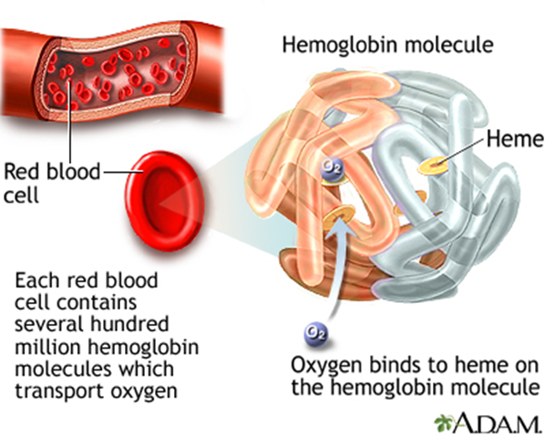
Figure 1: Structure of haemoglobin. (Cleveland Clinic Indian River Hospital, 2019)
Kogho et al (2008), expresses that iron is regulated in a recyclable fashion and holds no passive excretory system to aid in maintaining homeostasis, whilst additionally preventing organ damage. According to Knovich et al (2009) transferrin (TF) an iron binding protein, is responsible for regulating iron distribution throughout the body in order to generate iron homeostasis, whilst storing additional iron in an inert form for release when necessary. Imam and Zhang (2017), explain this is conducted in a systematic process, allocating iron to the bone marrow for erythrocyte manufacturing whilst, transmitting the expended iron used within erythrocyte production (erythropoiesis) to the spleen for recycling. Additionally, excess iron is primarily stored within the liver as ferritin, serving as an iron reserve which correlates with transferrin when insufficient dietary iron is absorbed. Lean and Combet (2017), indicate that 25-30 mg of iron per day is transported around the body, contributing to 24mgs used by the bone marrow to manufacture haemoglobin in erythrocytes. Due to its complex structure and role, erythrocytes live for an average of 120 days before being recycled and disposed of through faeces, skin cells and hair (Lean and Combet, 2017) (See Figure 2). Lean and Combat (2017) suggests that maintaining a balance between the quantity of erythrocytes produced and the disposal of damaged cells is imperative in preventing iron deficiency or toxicity.

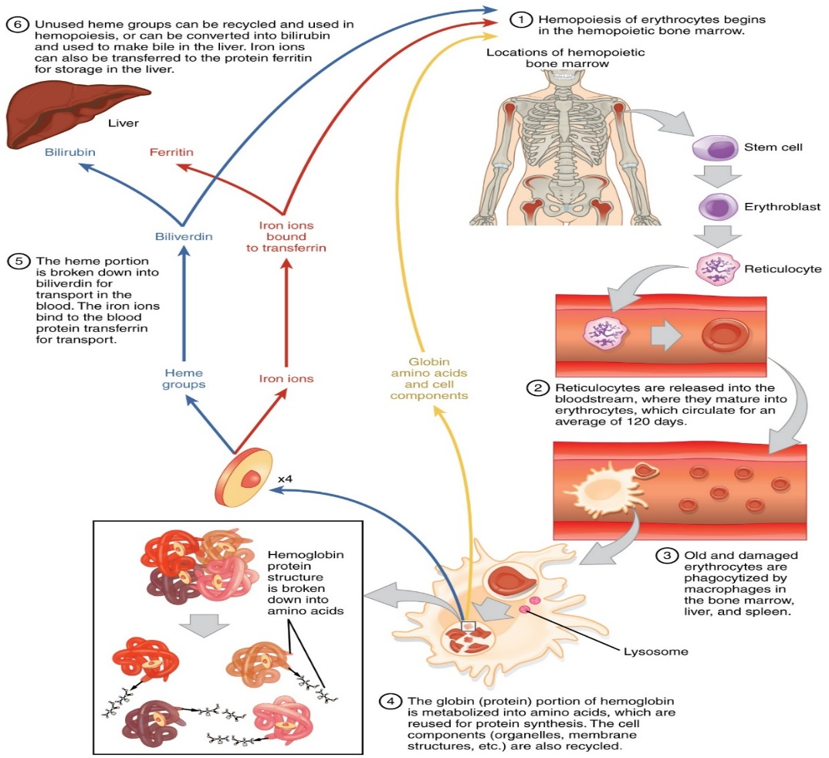
Figure 2: The Erythrocyte life cycle (Wikimedia, 2017).
Baragan-Ibanez, Sanchez and Penafiel (2016), suggest that iron deficiency anaemia (IDA), is generally found within high risk individuals for example pregnant women, children and vegetarians. According to Finberg et al (2008), this is due to extreme blood loss, inadequate dietary intake or iron malabsorption progressing from an iron deficiency (Camaschella, 2015). This consequently induces the body to use its ferritin iron stores due to the depletion in bioavailability of dietary iron. The primary stage of iron synthesis and erythropoiesis is initiated by a transcription factor that is highly operational within hypoxic cells and are manufactured within the kidneys, this is called Hypoxia-inducible factor (HIF). According to Shah and Xie (2014), When HIF detects a decline within oxygen in the blood stream it transcribes a gene called erythropoietin. Erythropoietin (EPO) is responsible for regulating the production of erythrocytes manufactured and secreted into the blood stream (Shah and Xie, 2014). Once oxygen homeostasis is restored, the hypoxia inducible factor terminates transcribing consequently preventing additional erythrocyte production (Figure 3). However, Miller (2013) indicates when there is a deficiency or depletion within ferritin iron stores, the body acquires recycled erythrocyte iron and dietary iron to meet its demands. Furthermore, the author explains this can interrupt the production in erythropoiesis by producing insufficient quantities of haemoglobin due to the inadequate bioavailability of iron which provokes smaller erythrocytes transporting inadequate concentrations of haemoglobin around the body (DeLoughery, 2014). This low iron level also interferes with HIF production in transcribing for EPO when oxygen levels in the blood are low (See figure 3) (Joharapurkar, et al, 2018). In this scenario, HIF is prevented from termination, as erythrocytes do not contain correct haemoglobin levels to carry adequate oxygen, See Figure 3 (Clark, S, 2008). The production of incompetent erythrocytes into the blood stream, continues, and so do the hypoxic conditions inside the body (Higgins, 2010). According to Cafasso and Nall (2020) this body state can be caused by extreme loss of blood, lung problems or trauma and asthma, and can have serious consequences. Within humans, hypoxia can induce iron deficiency anaemia which generates symptoms of oxygen deprivation, fatigue, pale skin, weakness, cold hands and feet, difficulty breathing, dizziness and reduced immunity (Cafasso and Nall (2020), but can lead to pulmonary difficulties if not treated (Ebner and Haehling, 2019).
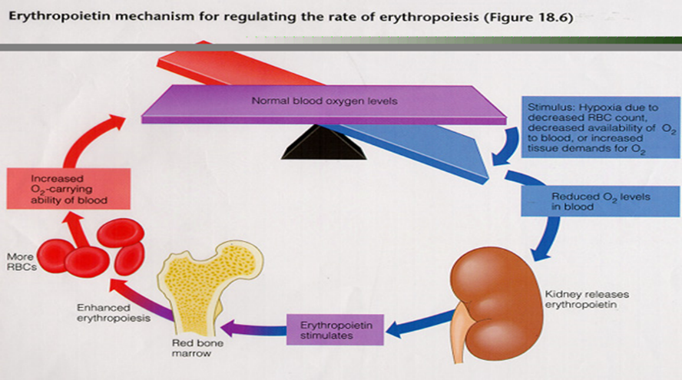
Figure 2: Erythropoietin for regulating the rate of erythropoiesis.
Lesjak, et al (2018), indicates that iron deficiency anaemia is the most prevalent nutritional disorder worldwide, effecting on average 30% of the population. The National Heart, Lung and Blood institute (N/D) explain treatment for this condition is dependent on the severity of the deficiency. If the deficiency is low to moderate either dietary alterations or iron supplements are recommended. However, if the deficiency has reached the severe stage of IDA, red blood cell transfusions will be essential in preventing serious consequences. Simpson, Ross and Malmanche (2017), state that investigations into identifying the stage of IDA and diagnosis, is conducted in evaluating the ferritin levels found within the bloods plasma which will give an insight into the quantity of iron stored within its ferritin storage sites. This knowledge helps to provide appropriate treatments.
In Conclusion, iron plays multiple important roles within the body and as a result there is a fine homoeostatic balance of iron in the body, with mechanisms to excrete excess iron and absorb dietary iron for physiological processes occurring within the body. Lack of iron has a variety of associated symptoms and deficiencies can have serious detrimental effects, even leading to death if not treated or resolved, with diet playing an important role in providing much of the iron absorbed by the human body, treatment through dietary plans as long as there are no problems with iron uptake and usage, can help to alleviate low iron conditions within the body.

Word count: 1100

Reference List
Arosio, P. Elia, L. Maura, P. (2017). Ferritin, cellular iron storage and regulation. IUMBMB journals. 69(6), p. 414-442.
Baragan-Ibanez, G. Santoyo-Sanchez, A. Ramos-Panefiel, . (2016). Iron deficiency anaemiaAnaemia por deficiencia de hierro. Science Direct . 79 (2), p.88-97.
Cafasso, J., Nall, R. (2020). Iron Deficiency Anemia. Available: https://www.healthline.com/health/iron-deficiency-anemia. Last accessed 8th June 2020.
Camaschella, C., (2015). Iron deficiency: new insights into diagnosis and treatment. Hematology, 2015(1), p.8-13.
Clark, S.F., (2008). Iron deficiency anemia. Nutrition in clinical practice, 23(2), p.128-141.
Cleveland Clinic Indian River Hospital. (2019). Hemoglobin. Available: https://www.indianrivermedicalcenter.com/articles/564/. Last accessed 29th May 2020.
Ebner, N. and von Haehling, S., (2019). Why is Iron Deficiency Recognised as an Important Comorbidity in Heart Failure?. Cardiac failure review, 5(3), p.173.
Finberg, K.E., Heeney, M.M., Campagna, D.R., Aydınok, Y., Pearson, H.A., Hartman, K.R., Mayo, M.M., Samuel, S.M., Strouse, J.J., Markianos, K. and Andrews, N.C., 2008. Mutations in TMPRSS6 cause iron-refractory iron deficiency anemia (IRIDA). Nature genetics, 40(5), p.569.
Higgins, C. (2010). Blood oxygenation and spurious hypoxemia. Available: https://acutecaretesting.org/en/articles/blood-oxygenation-and-spurious-hypoxemia. Last accessed 8th June 2020.
Joharapurkar, A.A., Pandya, V.B., Patel, V.J., Desai, R.C. and Jain, M.R., (2018). Prolyl hydroxylase inhibitors: a breakthrough in the therapy of anemia associated with chronic diseases. Journal of medicinal chemistry, 61(16), p.6964-6982.
Knovich, M.A., Storey, J.A., Coffman, L.G., Torti, S.V. and Torti, F.M., (2009). Ferritin for the clinician. Blood reviews, 23(3), p.95-104.
Lean, M. Combet, E. (2017). Barasi's Human Nutrition A health perspective. Croydon: Taylor and Francis group,LLC. p. 247.
Lesjak, M., Balesaria, S., Skinner, V., Debnam, E.S. and Srai, S.K.S., (2019). Quercetin inhibits intestinal non-haem iron absorption by regulating iron metabolism genes in the tissues. European journal of nutrition, 58(2), p.743-753.
Saito, H., (2014). Metabolism of iron stores. Nagoya journal of medical science, 76(3-4), p.235.
Shah, Y.M. and Xie, L., (2014). Hypoxia-inducible factors link iron homeostasis and erythropoiesis. Gastroenterology, 146(3), p.630-642.
SIMPSON, J., ROSS, B. and Malmanche, J.D., (2017). Iron deficiency: how to detect it, how to correct it.
Sturgeon, D (2018). Introduction to Anatomy and Physiology for Healthcare Students. New York: Routledge. p. 79.
Yatrik M, S. Liwei, X. (2013). Hypoxia-Inducible Factors Link Iron Homeostasis and Erythropoiesis. US National Library of Medicine National Institutes of Health. 146(3), p. 630-642.
Young, I., Parker, H.M., Rangan, A., Prvan, T., Cook, R.L., Donges, C.E., Steinbeck, K.S., O’Dwyer, N.J., Cheng, H.L., Franklin, J.L. and O’Connor, H.T., (2018). Association between haem and non-haem iron intake and serum ferritin in healthy young women. Nutrients, 10(1), p.81.

Personal Evaluation – to support your academic progress please complete the section below BEFORE submitting your work.
What do you consider to be the best aspects of this work?
Which aspects do you consider could have been improved in this piece of work?
What have you found most satisfying whilst undertaking this submission?
ASSESSMENT CRITERIA | Learning  Outcomes |  | GRADE
ASSESSMENT CRITERIA |  |  | Poor  0-25% | Unsatisfactory  26-39% | Satisfactory  40 – 49% |  | Good  50 – 59% | Very Good  60 – 69% | Excellent  70 – 85% |  | Exceptional  86– 100% | %
Theoretical explanation | 1 |  |  |  |  |  |  |  |  |  |  | 70%
Use and appropriateness of references | 2 |  |  |  |  |  |  |  |  |  |  | 20%
Structure and flow of answer | 1 |  |  |  |  |  |  |  |  |  |  | 10%
It is expected that students will present work that is proof read, correctly referenced and adheres to the Assessment Checklist. Therefore a range of 0 – 10 marks will be deducted for non-completion of any of the points on the checklist below.
TUTOR COMMENTS:

Submission date:  via Turnitin |  | Return date:  (at least within 4 weeks) |  |  |  | Tutor: |  |  |  | Mark:

