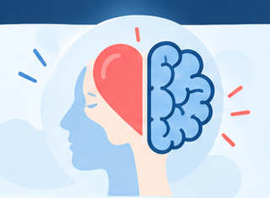  EMOTIONAL INTELLIGENCE  AND ACADEMIC SUCCESS | 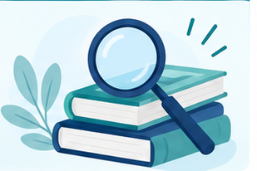  3 ANALYSE EMOTIONAL AWARENESS  When I face several deadlines, stress can make an assignment feel overwhelming, which sometimes leads me to procrastinate and make rushed decisions. I have found that recognising this emotional response helps me pause, identify the cause of my stress and break the task into smaller steps.  I can further develop emotional awareness by reflecting on patterns in my behaviour, using an emotion diary, naming specific emotions and noticing physical signs of stress. These strategies help me recognise triggers earlier and consider my response before acting. This improves my self-regulation because I can respond more deliberately rather than automatically. Emotional intelligence supports the management of emotions and decision-making in challenging situations (Machová et al., 2020). However, awareness alone is not enough; I also need planning, time management and appropriate breaks.  4 EVALUATION OF EI IN ACADEMIC SUCCESS  Academic success is influenced by emotional factors such as stress, motivation, resilience and impulse control. Effective stress management can support concentration and decision-making, while motivation encourages persistence and resilience helps students recover from setbacks. The module materials also indicate that students who manage emotions effectively tend to perform better academically.  Emotional intelligence can be applied to challenges such as procrastination, anxiety and low motivation by recognising emotional triggers, setting realistic goals, planning tasks, monitoring progress and using strategies to reduce stress. Machová et al. (2020) also explain that emotional intelligence supports emotional control, decision-making and adaptation in challenging situations.  Critical point: Emotional intelligence can support academic success, but it should be combined with effective study habits, planning and appropriate support rather than viewed as a single solution.    TRANSITION TO WORKPLACE  Self-awareness, adaptability and emotional regulation can support calm decision-making, communication and relationships at work (Bar-On, 2006).  KEY TAKEAWAY  Emotional Intelligence is most useful when emotions are noticed, interpreted and converted into deliberate action. These skills can support study now and transfer to workplace judgement, adaptability and relationships.  REFERENCES  Bar-On, R. (2006) ‘The Bar-On model of emotional-social intelligence (ESI)’, Psicothema, 18(Suppl.), pp. 13–25.  Kabat-Zinn, J. (2003) ‘Mindfulness-based interventions in context: Past, present, and future’, Clinical Psychology: Science and Practice, 10(2), pp. 144–156.  Machová, R., Zsigmond, T., Lazányi, K. and Krepszová, V. (2020) ‘Generations and emotional intelligence: A pilot study’, Acta Polytechnica Hungarica, 17(5), pp. 229–247.  Salovey, P. and Mayer, J.D. (1990) ‘Emotional intelligence’, Imagination, Cognition and Personality, 9(3), pp. 185–211.–247.
  Name: Mohammed Razzaque | Student Number: 2126598
  Module: LCLM5006 - Developing Emotional Intelligence Skills – C1 | Lecturer: Dr Chinomso Nwagboso
  Emotional intelligence (EI) involves recognising, understanding and using emotions to guide thinking and action (Salovey & Mayer, 1990). Emotions can shape attention, judgement and behaviour, so managing them may influence how effectively students respond to academic demands.  Critical perspective. EI is not a substitute for knowledge or academic ability; it is better understood as a set of skills that can support how students use their abilities under pressure. | • Reviewed module slides and the assessment brief.  • Compared four scholarly sources on EI, mindfulness and academic performance.  • Focused on self-awareness, stress, motivation, resilience and self-regulation.  • Used reflective practice to connect theory with my learning experience.
    1 Introduction
    2 Method
  5 Critical Reflection on Personal Experience
  During a demanding assignment, feeling overwhelmed encouraged avoidance and reduced my concentration. A short mindfulness pause helped me notice the emotion before reacting, then break the task into a smaller first step.  Mindfulness supports present-moment awareness and can reduce automatic reactivity (Kabat-Zinn, 2003). Breathing and reflective journaling helped me recognise triggers and choose a more deliberate response. However, mindfulness worked best alongside planning, feedback and breaks. | 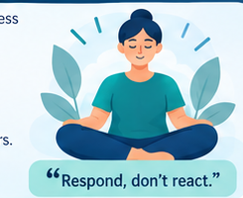  “Respond, don’t react.”

